Ready Steady Bang

**By**

**Chandra S S Vamsi**

**Aarti Barai**

**Piyush Kashyap**

**T. Monica**

**Sathya Sree**

**Surya Penmetsa**

Game Description :

1. There are two soldiers on the two opposite sides of the screen over a pure white background of whom, only one is controlled by the player and the other is a system automated one.



2. In between the two players, exactly at the center of the screen, first appears a

pop-up saying ‘Ready’ and then one more saying ‘Steady’ in the first two seconds after the start.

3. After the appearance of ‘Steady’, a pop-up written ‘BANG’ on a gray background appears at the same place. The time delay between the ‘Steady’ and ‘BANG’ varies each time from 1-4 seconds.

4. As soon as the ‘Bang’ appears, the players are allowed to shoot. The player is equipped with only one bullet. The aim of the player is to shoot the opponent before the opponent shoots him (tap to shoot).

5. There are several levels and the time delay between the ‘Steady’ and the ‘BANG’ varies with each level from 0.16 – 0.325 seconds.

6. The one who shoots first gets a point, and the one who reaches first five points, wins the game.

Requirements :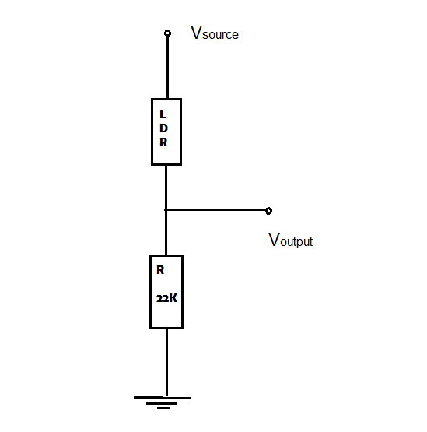

1. Perfectly working Arduino Board and readily installed Arduino Software.

2. An Android Device with the ‘Ready Steady Bang’ game installed on it.

Turn on the Developer options for better visualization.

3. Breadboard, 22k Resistor, LDR, Relay, Connecting wires, a conducting metal coin.

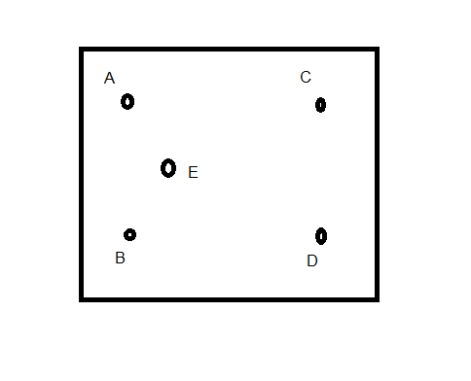

Set-up:

1. Build a voltage dividing circuit with LDR, Resistor and the power source as shown.

2. Connect the 5v output from Arduino to the Vsource and the output from the circuit, Voutput to one of the Analog Pins of Arduino ‘A0’. A digital pin ‘4’ of the Arduino is connected to one of the Relay pins A.

3. The other relay pins B and D are grounded and C is left Open Circuited while E is the output.

4. The output of the relay is connected to the Metal coin which is placed on the screen where the pop-ups appear.

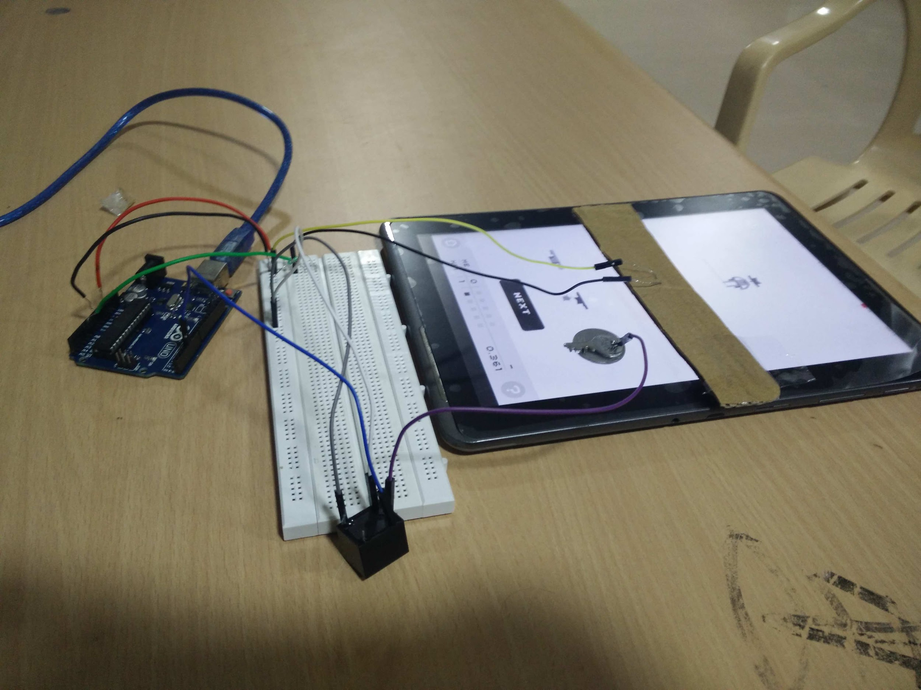

Description :

1. The LDR is fixed on a cardboard and it is placed on the device such that the LDR exactly points to the center of the screen and outside light has less effect on it.

2. When the ‘BANG’ appears in Gray, the white light from the background decreases and so the resistance of the LDR increases. This leads to large voltage drop across the LDR and so the Voutput is low.

3. From observations, find out the point of change of voltage which shall be used in forming the condition in the Arduino Code.

4. Initially, the digital pin ‘4’ is set to HIGH and so the relay is set to open circuit.

5. If the ‘BANG’ is detected, the output at A0 will be lowered and so by using this condition, when the voltage drops, the pin ‘4’ is set to LOW and then back to HIGH which results in a Virtual Electronic Touch Simulation on the screen.

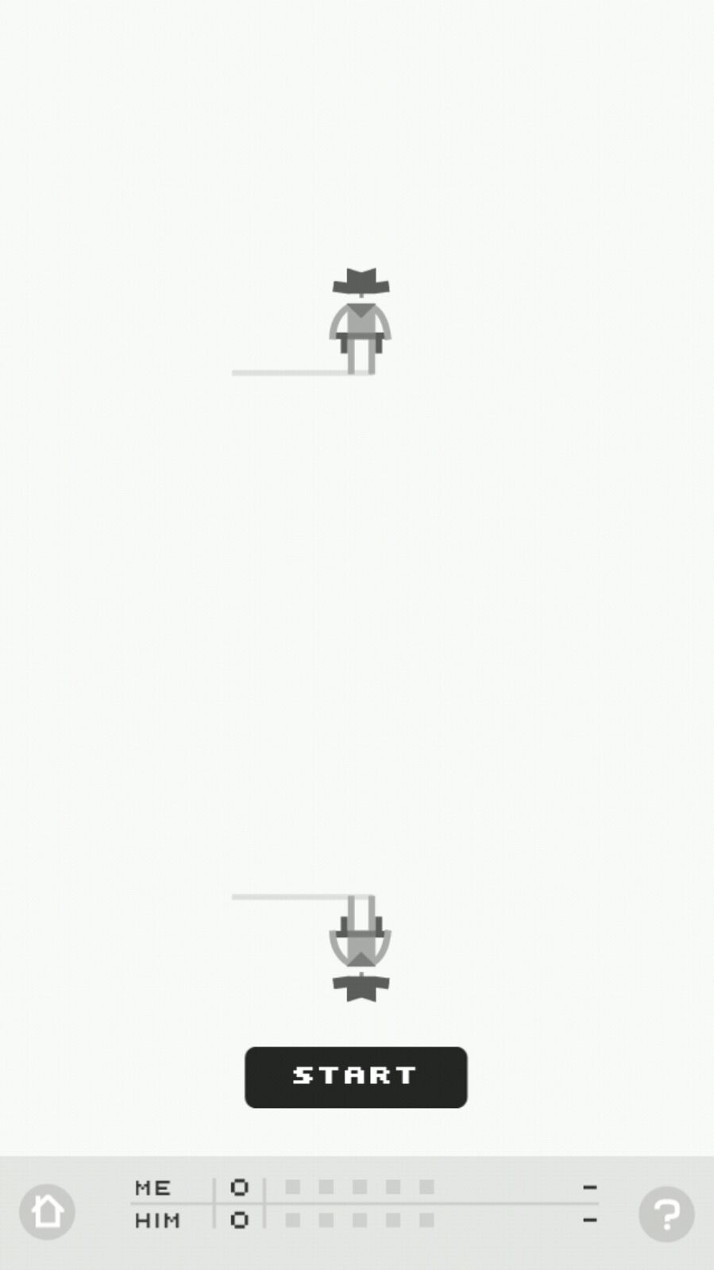

**Computer**

**Player**

And here we killed the Computer!