**TIC TAC TOE**

**GAME SOLVER**

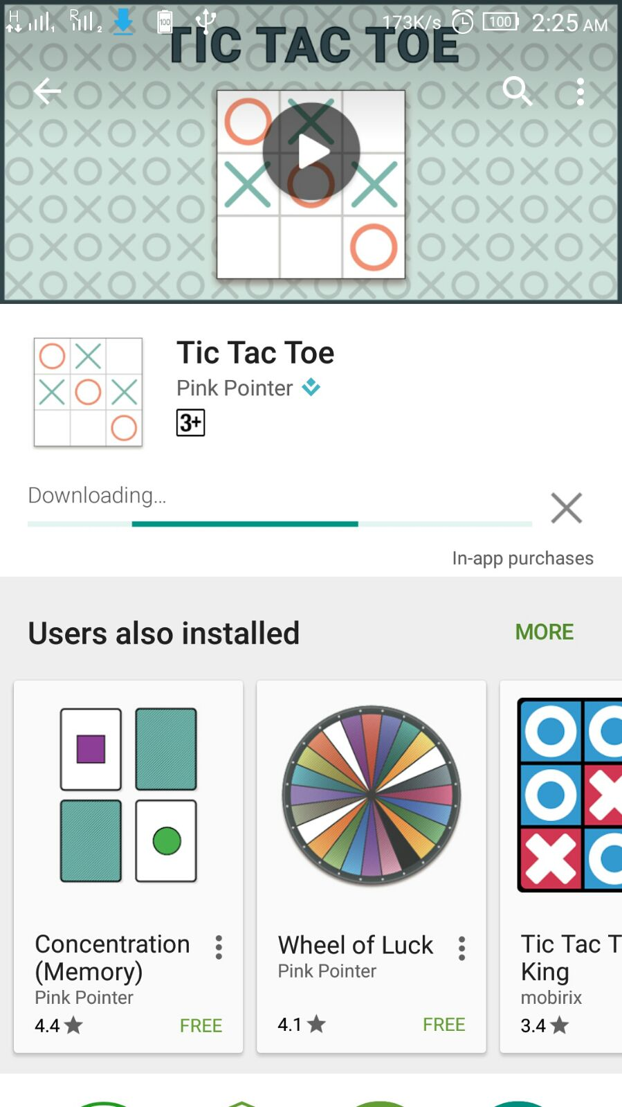

**By**

**Chandra S S Vamsi**

**Aarti Barai**

**Piyush Kashyap**

**T. Monica**

**Sree Sathya**

**Surya Penmetsa**

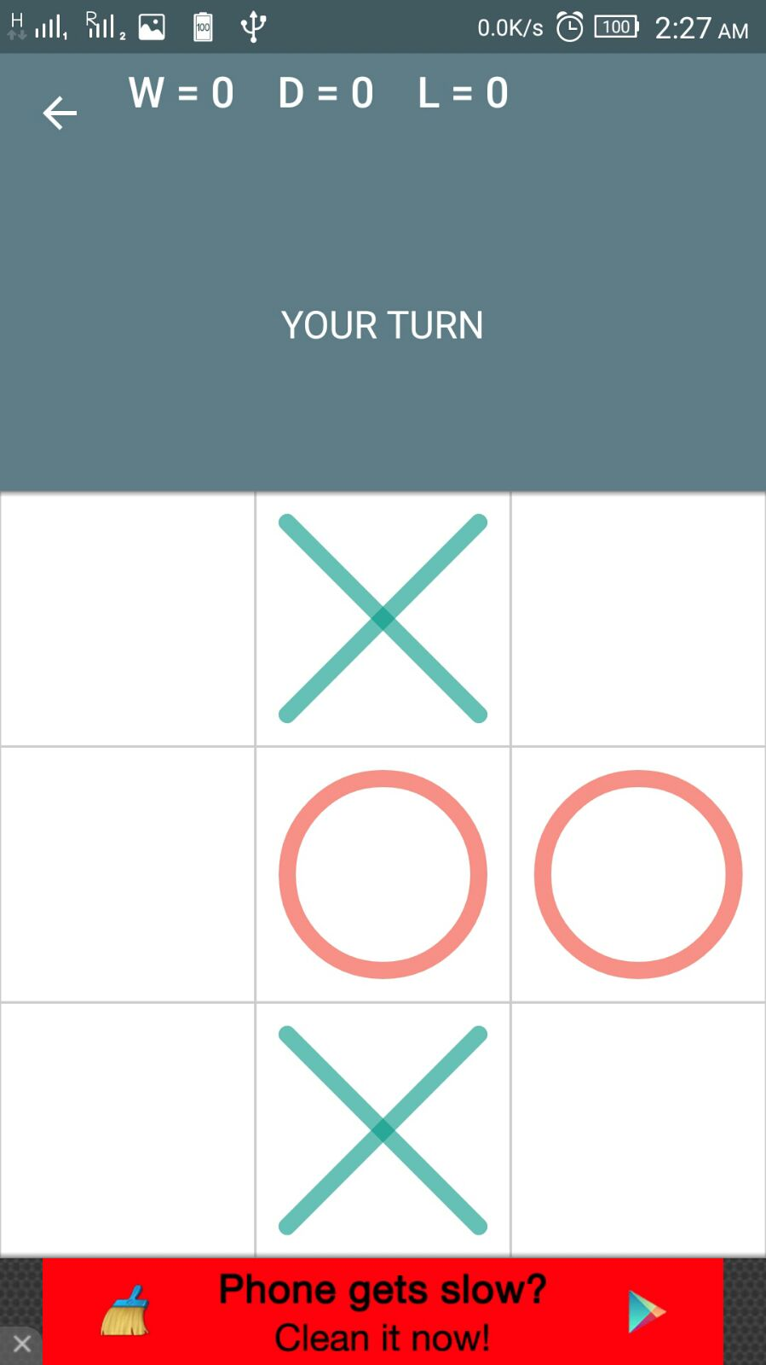

**Introduction:**

Playing Android Games is the most efficient way to relax ourselves.But sometime we get stuck up in a particular level of

the game.So, do you need to have a **walkthrough** to games?

Your answer might be "**YES**"

So here comes our "Game Solver" using **MATLAB** and **ADB tool**.

**Initial Steps:**

So our first step was selecting a game which have much colour contrast in it and it shouldnt be time bounded. We devoted a lot of time in that and finally we selected "**TIC TAC TOE** " game which is quite a famous.

**Game Description:**

TIC TAC TOE is a **X's** and **O's** game whose aim is to align either three **X's** or **O's** in a line. **X's** will be played by one player and **O's** by other. Whoever gets it first wins the game and else its drawn.

**Requirements :**

**1. ADB tool**

**2. MATLAB software**

**3. Android device**

**4. Laptop**

**5. Zeal to work on.**

So let us discuss the steps which we followed to have a game solver for TIC TAC TOE.

**Platform establishment part :**

**1.** Install ADB driver from the [ADB driver link](http://adbdriver.com/downloads/)

**2.** Connect your android device and install in it.

For installing the ADB tool follow this [YouTube Link](https://www.youtube.com/watch?v=afrvSGiMAtk)

**Image Processing through MATLAB and ADB tool part:**

**3.** We will be playing our move first. Our main motive here is to detect the move of other player**,** so in order to do that we are checking the pixel values of a particular coordinates of all 9 boxes. We have denoted each boxes with a particular coordinates which is generally a leftmost point of red **O's.**

**\*NOTE:** In order to use ADB tool in your Matlab make sure to include all important directories related to it.

**Algorithm part:**

**4.** Go through the link to have a deeper insight to our algorithm, goto the **LINK below:**

file:///G:/main.m

file:///G:/screenpic.m

WON!