**PLOTS (Q4)**

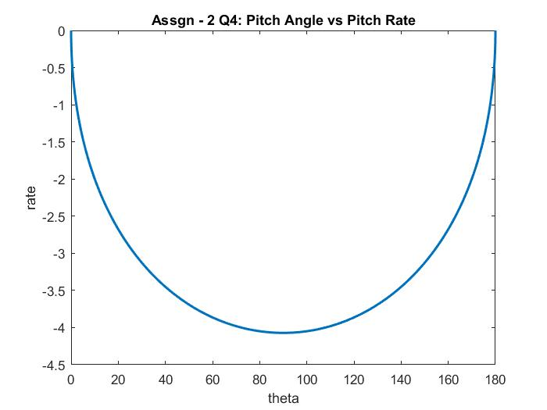

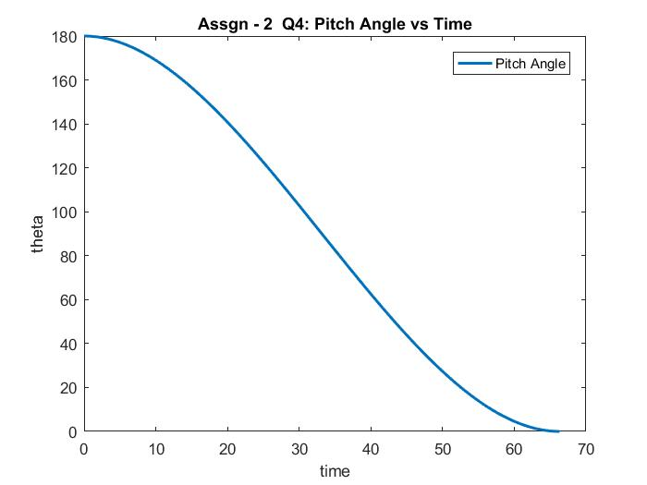

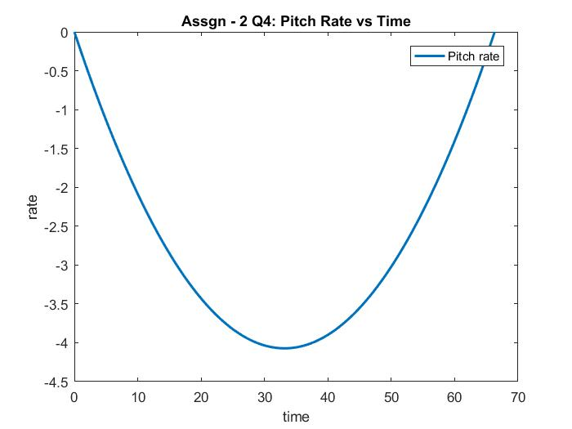

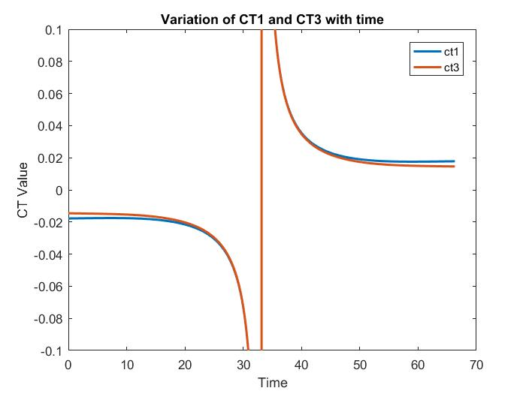

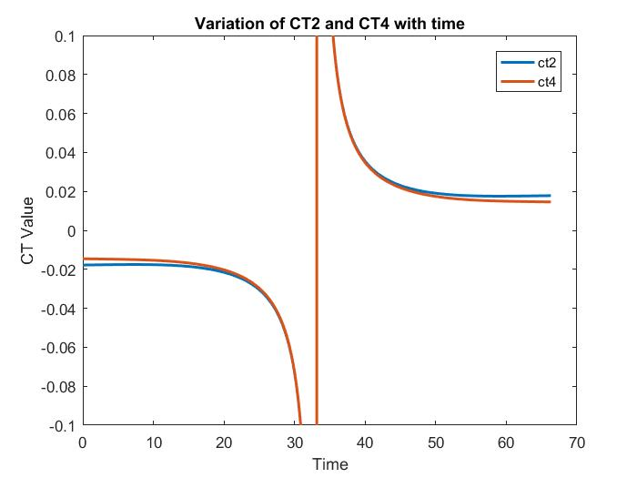

**Note:** Since the values of Ct1, Ct2, Ct3, Ct4 are rising beyond the limit of 0.1, in reality we may have to limit the values by brute force method for about 4-5 seconds (Here the pitch angle is near 90 degrees)