RUBY ON RAILS
TASK MANAGER
Illustrated setup, CRUD, MVC and browser troubleshooting guide

Application | task_manager
Runtime | Ruby 3.4.12
Framework | Rails 8.1.4

Purpose
A practical reference for creating a Rails application, generating a Task scaffold, understanding request flow, verifying SQLite migrations, starting Puma, and diagnosing “This site can’t be reached.”

1. Lab environment and project status
The supplied terminal notes show a Rails application named TaskManager created under the task_manager directory. The environment reported Rails 8.1.4 and Ruby 3.4.12. The generated project includes Puma, SQLite, Importmap, Turbo, Stimulus, Solid Queue, Solid Cache, Solid Cable and Kamal.
Component | Role in this lab
Ruby 3.4.12 | Language runtime
Rails 8.1.4 | Web application framework
Puma | HTTP application server
SQLite | Development database
Importmap / Turbo / Stimulus | JavaScript loading and interactive page behaviour
Solid Queue / Cache / Cable | Background jobs, caching and real-time communication
Kamal | Deployment tooling generated by the Rails setup

Project directory
/task_manager
├── app/
│ ├── controllers/ # Request handling
│ ├── models/ # Data and business logic
│ ├── views/ # HTML templates
│ ├── jobs/
│ └── assets/
├── bin/ # Project command wrappers
├── config/
│ ├── routes.rb # URL-to-controller mapping
│ ├── database.yml # Database configuration
│ └── puma.rb # Puma configuration
├── db/ # Migrations, schema and seeds
├── test/ # Automated tests
├── Gemfile # Ruby dependencies
└── Dockerfile # Container build instructions

The generated bin/ directory also contains helper executables such as bin/rails, bin/rake, bin/brakeman, bin/bundler-audit, bin/rubocop, bin/dev and bin/thrust. The asterisk shown after a filename by ls -F indicates an executable file; it is not part of the filename.

2. Generate the Task module (scaffold)
Run this from the project root:
bin/rails generate scaffold Task title:string description:text status:string

A scaffold is a Rails generator that creates a starting set of files for a resource. It normally creates:
- Task model (app/models/task.rb)
- Tasks controller (app/controllers/tasks_controller.rb)
- CRUD templates under app/views/tasks/
- A database migration under db/migrate/
- RESTful routes in config/routes.rb
- Test files / fixtures appropriate to the app's test setup
The scaffold command generates the migration file; it does not, by itself, guarantee that the database table has been created. The migration must be applied.

Apply the database migration
bin/rails db:migrate

A quiet command that immediately returns to the shell can be normal when there are no pending migrations. Verify rather than assuming:
bin/rails db:migrate:status
ls db/migrate

Look for a CreateTasks migration and an up status. If the migration is down, run bin/rails db:migrate again and read any error. If no CreateTasks migration exists, verify that the scaffold generator ran in the correct project directory.

Verify SQLite directly
bin/rails dbconsole
.tables
.schema tasks
SELECT * FROM tasks;
.exit

Inside SQLite, .tables lists tables, .schema tasks prints the tasks table definition, and SELECT * FROM tasks; displays records. Replace the example placeholder table_name with the actual table name tasks.

3. Start the web server correctly
From the task_manager project root, run:
bin/rails server

Keep this terminal open. Puma runs in the foreground. Do not press Ctrl+C while you want the site to remain available.
The supplied log proves that Puma did start successfully at one point:
=> Booting Puma
=> Rails 8.1.4 application starting in development
* Puma version: 8.0.2
* Environment: development
* PID: 12100
* Listening on http://127.0.0.1:3000
* Listening on http://[::1]:3000
Use Ctrl-C to stop

The same log then shows a GET / request completed with HTTP 200, followed by Ctrl+C and a graceful Puma shutdown. This is important: the server was stopped at that point. If the browser is opened after the shutdown, the browser will report that the site cannot be reached. Start the server again and leave it running.

Open the Task page
http://localhost:3000/tasks

Use localhost because the supplied Puma output binds to the loopback addresses 127.0.0.1 and ::1. That is correct when the browser and Rails server are running on the same Ubuntu machine. Binding to 0.0.0.0 is only needed when another machine/container must reach the server, and then firewall/network access must also be considered.

4. Understand the Rails MVC request flow
When a browser requests GET /tasks, Rails routes the request to the TasksController index action. The controller obtains Task records through the model, and Rails renders the index view as HTML.
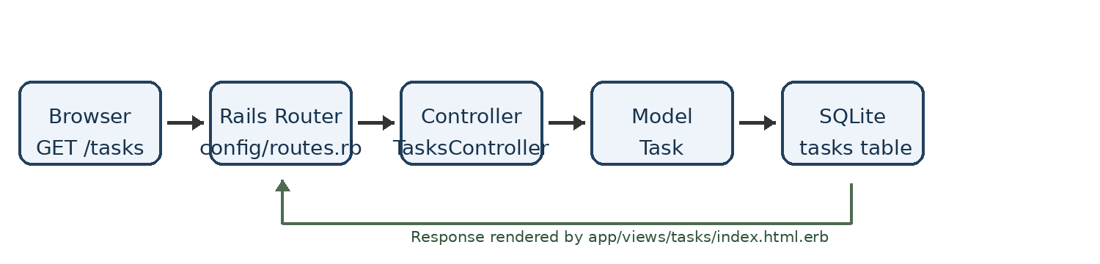
MVC part | Responsibility
Model | Database access and domain data (Task)
View | HTML presented to the user (for example, tasks/index.html.erb)
Controller | Handles the request and coordinates model/view work (TasksController)

5. Task CRUD routes
The route output supplied in the notes confirms that Rails generated the standard RESTful Task routes:
HTTP method | Path | Action | Purpose
GET | /tasks | index | List tasks
GET | /tasks/new | new | Show create form
POST | /tasks | create | Save a new task
GET | /tasks/:id | show | Show one task
GET | /tasks/:id/edit | edit | Show edit form
PATCH / PUT | /tasks/:id | update | Save changes
DELETE | /tasks/:id | destroy | Delete a task
Verify routes any time with:
bin/rails routes | grep tasks

6. Troubleshooting: “This site can’t be reached”
Follow this sequence in order. Use two terminal windows: Terminal A runs Puma; Terminal B runs diagnostic commands.

A. Terminal A — start and leave Puma running
cd "/home/piyushkhr/Documents/Practise /task_manager"
bin/rails server

Wait for the Listening on http://127.0.0.1:3000 line. Keep this terminal open. If Rails prints an exception, copy the complete error and resolve it before testing the browser.

B. Terminal B — check the listening port
sudo ss -lntp | grep ':3000'

Expected: a LISTEN entry for 127.0.0.1:3000 (or another local binding on port 3000) and a Puma process. No output usually means no process is listening on that port.

C. Test HTTP without the browser
curl -v http://127.0.0.1:3000/tasks

Interpretation:
Result | Interpretation / next step
HTTP 200 | The server responded successfully; retry the browser at http://localhost:3000/tasks.
HTTP 302 | The server responded and redirected; inspect the Location header / browser destination.
HTTP 404 | The server is reachable; investigate the requested route or resource.
Connection refused | Nothing is accepting connections at that address/port; start Puma and check the listening port.
Timeout | Investigate process health, network path, proxy or firewall; for same-machine localhost, first confirm Puma is listening.

D. Check whether another process owns port 3000
sudo lsof -i :3000

If port 3000 is already in use, do not kill an unknown process blindly. Either stop the known old Rails process safely or start Rails on another port:
bin/rails server -p 3001
curl -v http://127.0.0.1:3001/tasks

Then open http://localhost:3001/tasks.

E. Verify routes and migration state
bin/rails routes | grep tasks
bin/rails db:migrate:status
ls db/migrate

The routes output already supplied in the notes shows index, create, new, edit, show, update and destroy routes. That confirms route generation, but it does not prove that Puma is currently running or that the tasks table exists.

F. Inspect the Rails log if the request reaches Rails but fails
tail -f log/development.log

Keep this command running in a separate terminal, then refresh /tasks. Look for the exception and the request path. Stop tail with Ctrl+C; this does not stop Puma in the other terminal.

7. Validate the Task Manager in the browser
Once /tasks loads, test the full CRUD lifecycle:
- Create: choose New Task, enter a title, description and status, then save.
- Read: confirm the task appears in the task list and open its Show page.
- Update: edit the task and save a changed value.
- Delete: delete a test task and confirm it disappears.
The supplied ODT contains screenshots of the Tasks index page and a task detail page after creation. They illustrate the expected basic scaffold interface and a successful create action.
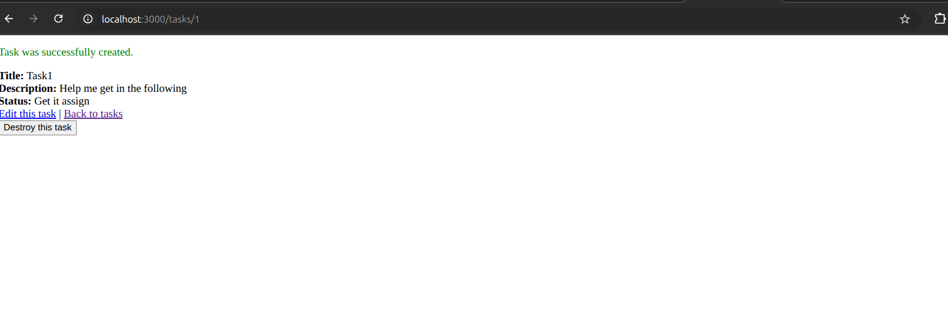
Figure 1. Screenshot supplied with the lab notes.
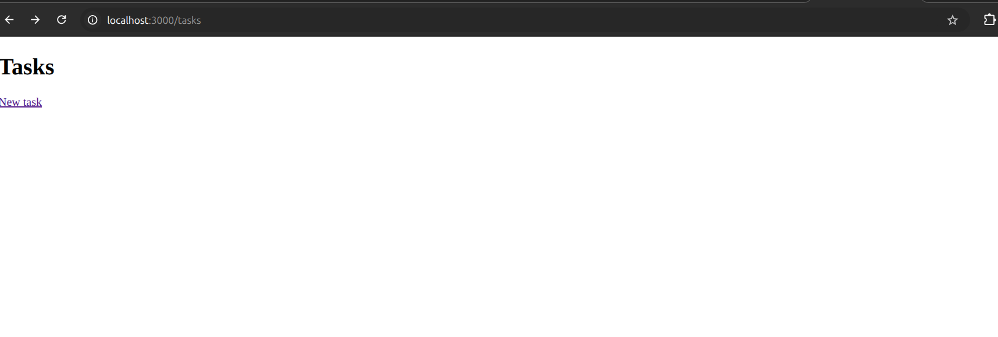
Figure 2. Screenshot supplied with the lab notes.

8. Useful Rails commands
Command | Purpose
bin/rails -v | Show Rails version
bin/rails server | Start Puma / Rails server
bin/rails console | Open interactive Rails console
bin/rails generate model | Generate a model
bin/rails generate controller | Generate a controller
bin/rails generate scaffold | Generate model, controller, views, migration and routes
bin/rails db:migrate | Apply pending database migrations
bin/rails db:migrate:status | Show migration status
bin/rails routes | List application routes
bin/rails test | Run the Rails test suite
bin/rails db:rollback | Roll back the most recent migration
bin/rails dbconsole | Open the configured database console

9. DevSecOps extension path
The supplied screenshot/notes outline a possible delivery path from developer commit through GitLab CI/CD, quality and security checks, image build, registry and Kubernetes/OpenShift deployment. Treat this as a proposed learning pipeline, not as evidence that these jobs are already configured.
Developer
|
v
GitLab repository
|
v
GitLab CI/CD pipeline
|----------------------|
v v
Automated tests Code quality
(Rails tests) (RuboCop)
| |
+----------+-----------+
v
Security scanning
(Brakeman / dependency audit)
|
v
Docker image build
|
v
Container registry
|
v
Kubernetes / OCP
|
v
Application

Suggested next stages: add Rails tests, RuboCop, Brakeman (Rails static analysis), Bundler Audit (Ruby dependency vulnerability checks), Docker image build and container registry push. Add deployment to Kubernetes/OpenShift only after the image and pipeline are validated.

10. Quick diagnosis checklist
- ☐ Am I in the task_manager project directory?
- ☐ Did bin/rails server print a Listening address?
- ☐ Is the Puma terminal still running (not stopped with Ctrl+C)?
- ☐ Does ss show a LISTEN socket on port 3000?
- ☐ Does curl http://127.0.0.1:3000/tasks return an HTTP response?
- ☐ Does bin/rails routes | grep tasks show the Task routes?
- ☐ Does db:migrate:status show the CreateTasks migration as up?
- ☐ Does the SQLite .tables command show tasks?
- ☐ Does log/development.log show an application exception?

Evidence-based conclusion from the supplied logs
The supplied terminal transcript shows Puma successfully listening on 127.0.0.1:3000 and serving GET / with HTTP 200. It also shows Ctrl+C followed by a graceful Puma shutdown. Therefore, the most direct explanation for a later browser connection failure is that the server was no longer running. Start bin/rails server again, leave it running, and test /tasks from the browser. If the problem persists while Puma remains running, use the port and curl checks in Section 6 to isolate the failure.
This guide does not assume that the current server is running or that the tasks migration is applied; those states must be verified on the machine.

