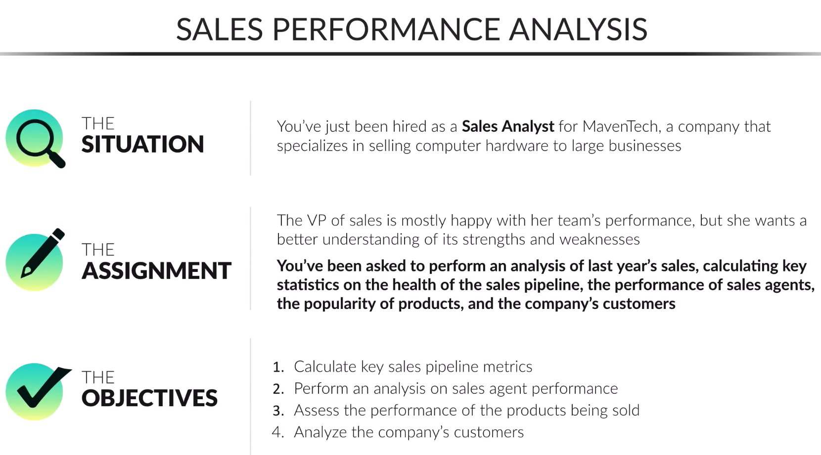

B2B sales pipeline data from a fictitious company that sells computer hardware, including information on accounts, products, sales teams, and sales opportunities.
Recommended Analysis
- How is each sales team performing compared to the rest?
- Are any sales agents lagging behind?
- Are there any quarter-over-quarter trends?
- Do any products have better win rates?

Absolutely — in that case, let's slow down and keep this beginner-friendly.
You do not need complicated SQL, views, CTEs, window functions, or advanced techniques for your first project.
Your goal should be:
Write simple queries → understand what they do → get useful results → explain those results.
Your project can be very simple
You have 4 tables:
- accounts
- products
- sales_teams
- sales_pipeline
And your 4 questions:
- How is each sales team performing?
- Are any sales agents lagging behind?
- Are there quarter-over-quarter trends?
- Do any products have better win rates?
That's enough for a very good first SQL project.

Step 1 — Start with the sales pipeline
Forget the other tables for the moment.
Let's first understand sales_pipeline.
Run:
SELECT *
FROM sales_pipeline
LIMIT 10;
Look at the results.
You should see columns such as:
opportunity_id
sales_agent
product
account
deal_stage
engage_date
close_date
close_value
Think of sales_pipeline as:
"A list of all the sales opportunities the company has."

Step 2 — Find out the different deal stages
This should be your first analysis query:
SELECT
deal_stage,
COUNT(*) AS number_of_deals
FROM sales_pipeline
GROUP BY deal_stage;
Don't worry if GROUP BY is new.
It basically means:
"Put the rows into groups based on deal_stage."
So if you have:
Won
Won
Lost
Won
Engaging
Lost
SQL groups them:
Won 3
Lost 2
Engaging 1
That's it.

Step 3 — Get a basic overview
Next:
SELECT
COUNT(*) AS total_deals,
SUM(close_value) AS total_value
FROM sales_pipeline;
This answers:
How many opportunities are there?
and
What is the total value of those opportunities?
Very simple.

Step 4 — Look at won deals
Now:
SELECT
COUNT(*) AS won_deals,
SUM(close_value) AS won_value
FROM sales_pipeline
WHERE deal_stage = 'Won';
This answers:
How many deals have we won?
What is the value of those wins?
You're now starting to produce actual business insights.

Step 5 — Look at sales agents
Now we'll bring in your sales_agent column.
Start very simply:
SELECT
sales_agent,
COUNT(*) AS number_of_deals
FROM sales_pipeline
GROUP BY sales_agent
ORDER BY number_of_deals DESC;
This tells you:
How many opportunities does each sales agent have?
Then:
SELECT
sales_agent,
COUNT(*) AS won_deals
FROM sales_pipeline
WHERE deal_stage = 'Won'
GROUP BY sales_agent
ORDER BY won_deals DESC;
Now you're answering:
Which agents have the most won deals?
That's already enough to start your second analysis question.

Step 6 — Then we'll use sales_teams
Only after you're comfortable with the above, we'll introduce your second table.
Remember:
sales_pipeline
|
| sales_agent
↓
sales_teams
So we can connect them with:
JOIN sales_teams
ON sales_pipeline.sales_agent = sales_teams.sales_agent
But don't worry about JOIN yet.
We'll get there step-by-step.

Your learning path
I'd recommend doing the project in this exact order:
1. SELECT
↓
2. WHERE
↓
3. COUNT / SUM
↓
4. GROUP BY
↓
5. ORDER BY
↓
6. JOIN
↓
7. Date / quarter analysis
You don't need to learn everything in SQL before starting the project.
Learn each SQL concept when the project needs it.

Your first assignment
For now, just run these three queries:
Query 1
SELECT *
FROM sales_pipeline
LIMIT 10;
Query 2
SELECT
deal_stage,
COUNT(*) AS number_of_deals
FROM sales_pipeline
GROUP BY deal_stage;
Query 3
SELECT
COUNT(*) AS total_deals,
SUM(close_value) AS total_value
FROM sales_pipeline;
Send me the results of those three queries.
Then we'll take one tiny step at a time. I'll explain every SQL keyword we use, so by the end you'll understand the project rather than just having a bunch of SQL copied from me.

