Online Bookstore

Website: Online Bookstore

Project Description: Online bookstore that allows users to browse available books and place orders. Users can filter by genre, price, and release date. Search function allows users to search by title or description. Users must register in order to place orders or view order histories.

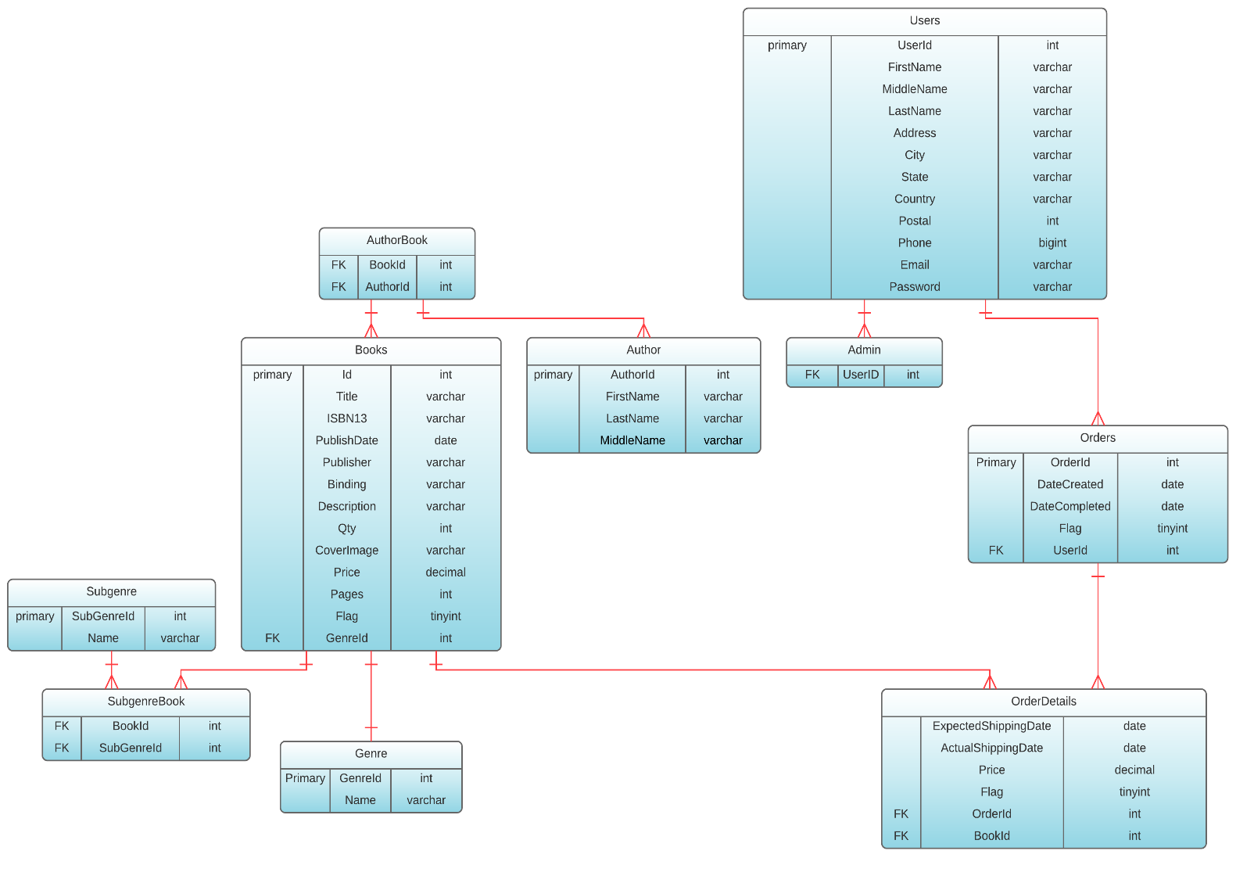Database Design:

Languages/frameworks used:

* PHP
* HTML
* CSS
* JQuery
* Ajax
* Did not use any frameworks
* <http://www.codexworld.com/ajax-pagination-with-search-filter-php/> This tutorial was used for the implementation of the pagination/search box.

Team Members:

Melissa Dagley [mxd153730]

Piyush Kumar [pxk152030]

Work Division:

Pages:

* User Registration [HTML/CSS: Melissa]
  + Check Username and Email to see if they already exist in the system [Piyush, Ajax]
  + Check that all mandatory fields are filled out using JQUERY [Melissa, JQuery]
  + Check that password is strong enough using JQUERY [Melissa, JQuery]
  + Store hashed version of password [Piyush, PHP]
* Product Listing Page [HTML/CSS: Melissa]
  + Available to all users, including guests [Melissa]
  + Allow Product Filtering [Melissa, Ajax/PHP]
  + Allow Product Search [Melissa, Ajax/PHP]
  + Paging Functionality [Melissa, Ajax/PHP]
  + ADMIN: [HTML/CSS: Melissa]
    - List All Items [Melissa, PHP]
    - Update Item [Melissa, JQuery/Ajax/PHP]
    - Delete Item [Melissa, JQuery/Ajax/PHP]
    - Add Item [Melissa, JQuery/Ajax/PHP]
* User Login [HTML/CSS: Melissa]
  + Verify Login Information [Piyush, PHP]
  + Start new user session [Piyush, PHP]
* Checkout [HTML/CSS: Melissa]
  + Add items to cart [Piyush, Cookies/PHP]
  + Show total for cart items [Piyush, Cookies/PHP]
  + Update inventory when purchases are made [Piyush, PHP]
* Order History [HTML/CSS: Melissa]
  + Load Order History from database [Melissa, PHP/Ajax]
  + Allow user to select specific order [Melissa, Ajax/PHP]

Database Design: Piyush [Relational Database, PHPMyAdmin]

Screenshots:

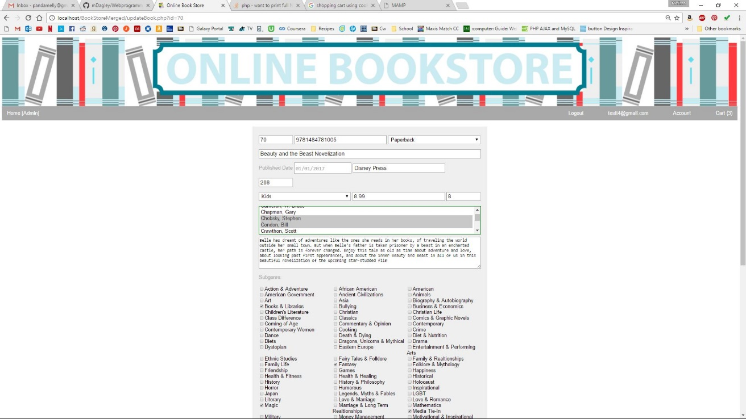

Figure Edit Book Form - Pre-fills with data

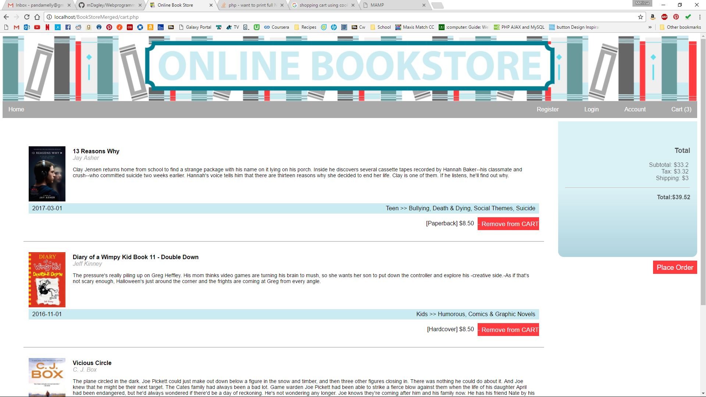

Figure Cart

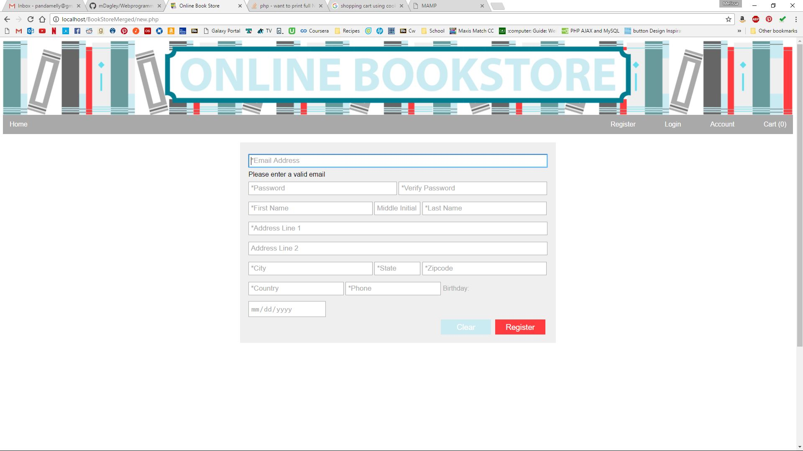

Figure Registration Form

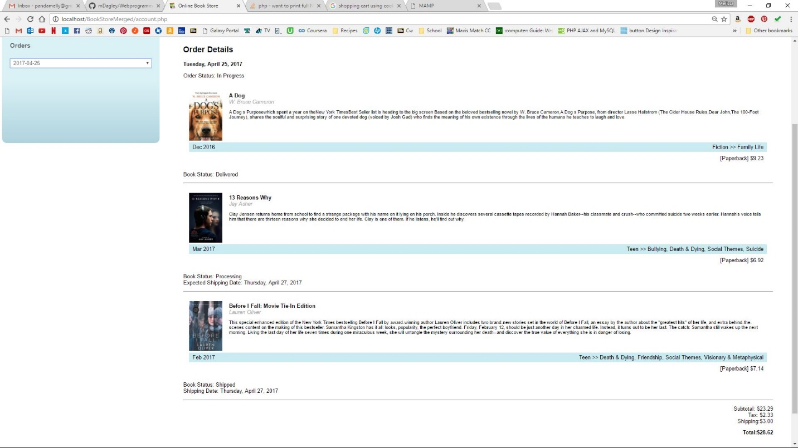

Figure Order History Page, with full detail listing

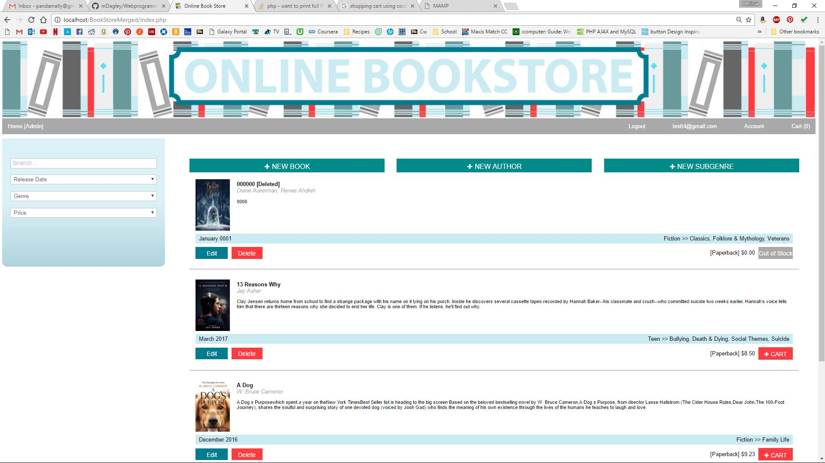

Figure Book Listing for admin user

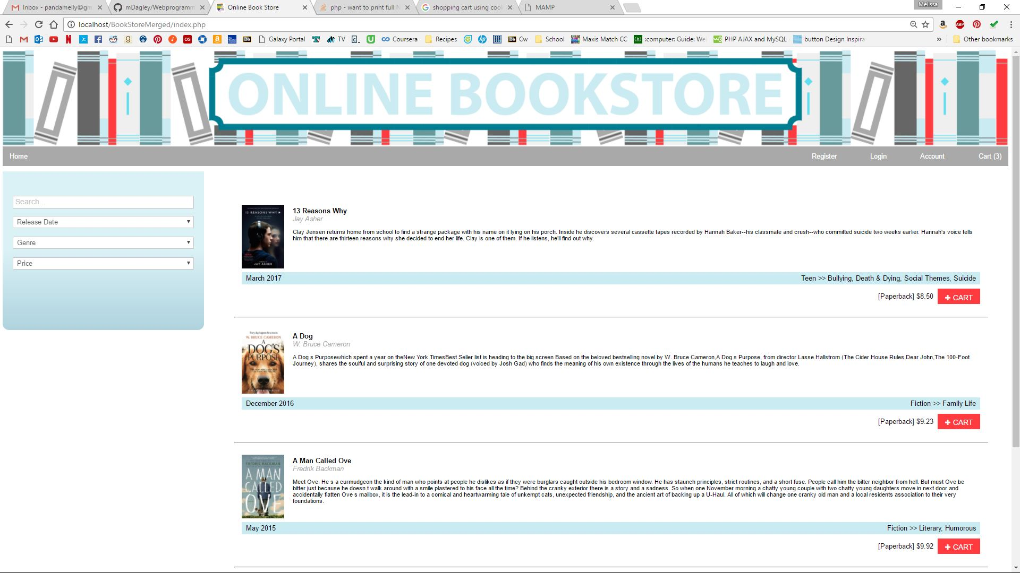

Figure Book Listing for Guest User