CloudSheer HRMS
What has been built, how to use it, and what comes next
A guide for HR, employees and administrators
No technical knowledge assumed
Prepared | 6 September 2026
Status | Leave and attendance live. Payroll not built.
Reaches today | 2 of 28 employees, pending email addresses
Next step | Hand over for testing

Contents
# | Section | What it covers
1 | What this system is | The idea in one page
2 | The three places it lives | Slack, the portal, Salesforce
3 | What is built today | The full list
4 | How it compares with Keka | Same, missing, and better
5 | What we do that Keka does not | Where we are ahead
6 | Who can do what | Access levels explained
7 | How HR uses it | Step by step
8 | How an employee uses it | Step by step
9 | How the administrator uses it | Step by step
10 | How a leave request travels | Start to finish
11 | How a working day is measured | Clocking and breaks
12 | What is not built | Honestly listed
13 | The plan from here | Four phases
14 | Three user stories | How it feels in practice
15 | Handover for testing | What to test and how
16 | What we need from you | Before this can go live

1. What this system is
CloudSheer HRMS is a replacement for the employee-facing half of Keka. It does the things people do every day: applying for leave, getting it approved, clocking in and out, and checking balances.
The important difference is where the work happens. In Keka, an employee opens an app, signs in, finds the right screen and fills a form. Here, they type one command in Slack and the manager approves it with a button in a direct message. Nobody signs in to anything for the everyday tasks.
Behind Slack, Salesforce holds every record: leave balances, punches, approvals, employee details. It is the single copy. Nothing is stored twice, so nothing can disagree with itself.
The one-sentence version
Employees and managers work in Slack, HR works in Slack and the web portal, and Salesforce quietly keeps the record straight underneath both.

What is genuinely finished
Leave and attendance are complete, tested and working. That covers what an employee touches almost every day of the year.

What is genuinely not
Payroll is not built. Neither are expenses, documents, onboarding checklists, assets, performance reviews or the HR helpdesk. Keka is still needed for those. Section 12 lists everything honestly.

What is blocking it right now
This system currently reaches two people. Twenty-six of twenty-eight employees still have placeholder email addresses like emp012@test.com, and Slack accounts are matched to employees by email. Real addresses fix both problems in one step, and no other work can be judged properly until that is done.

2. The three places it lives
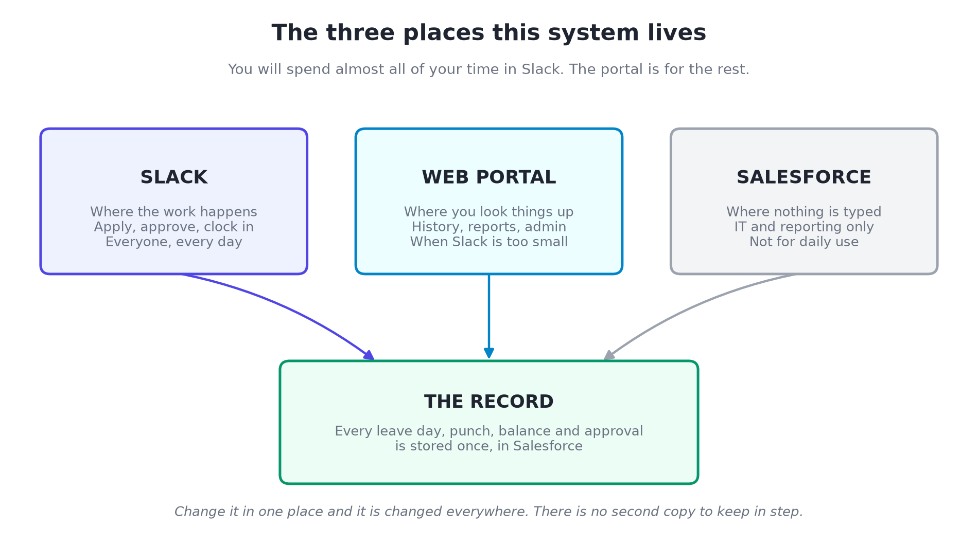

Slack: where the work happens
Almost everything an employee or manager does happens here. Six commands cover it:
Type this in Slack | And you get
/myleave | Your leave balance, and a button to apply
/attendance | Clock in, clock out, or see today's punches and break
/approvals | Everything waiting for your decision
/whosout | Who is on leave today
/regularize | Fix a day where you forgot to clock in or out
/hrdash | The company-wide HR dashboard (HR and admin only)

The web portal: where you look things up
The portal is for the things that do not fit in a chat window: a month of attendance at a glance, the employee directory, the org chart, payslips, the holiday calendar, and the administration screens. HR will use it regularly. Most employees will visit it rarely.

Salesforce: where nothing is typed
Salesforce is the filing cabinet, not a place to work. Nobody in HR needs to open it day to day. It matters for two reasons: it is where hiring and interviews already live, so a candidate becoming an employee is a simple move rather than an export from one system and an import into another; and it is where reports can be built when you need something the portal does not show.
Why this matters for adoption
Keka fails quietly when people cannot be bothered to log in. A leave request that takes one line in Slack and one button press to approve does not get forgotten for three days.

3. What is built today
Everything in this section has been tested end to end and is live.

Leave
What | Where | Notes
Check your balance | Slack, portal | Five types: Annual 18, Casual 12, Sick 12, Comp Off 6, Work From Home 24
Apply for leave | Slack, portal | Checks dates, working days, holidays and your balance before it will accept
Half day leave | Slack, portal | First half or second half of the 10:00 to 19:00 shift
Approve or reject | Slack, portal | Buttons in a direct message; they disappear once decided
Cancel before approval | Slack, portal
Cancel after approval | Slack, portal | The days go back onto the balance automatically
Balance updates itself | Automatic | Nobody adjusts a spreadsheet
HR and manager both told | Slack | The moment it is submitted
Employee told the outcome | Slack | The moment it is decided
Daily who-is-out message | Slack #hrms | Arrives at 09:00 every working day
Holiday calendar | Portal | Leave applications skip holidays automatically

Attendance
What | Where | Notes
Clock in and out | Slack, portal | Refuses nonsense, such as clocking in twice in a row
Confirmation on every punch | Slack | A direct message with your time and running total
Break time | Automatic | Worked out from the gaps between punches; no break button
Hours worked vs hours present | Automatic | Breaks excluded from hours worked
Today's punch log | Slack, portal | Every punch in order with the break before each return
Monthly attendance | Portal | Break, hours worked and time on premises per day
Late arrival flag | Automatic | At or after 11:00
Short day flag | Automatic | Under 8 hours actually worked
Flags correct themselves | Automatic | Fix a punch and the flag clears
Regularisation request | Slack, portal | Three per month, and a rejected one still uses up the allowance

People and records
What | Where | Notes
Employee records | Portal | 29 records, 28 active
Departments | Portal | 7, fully editable by the admin
Designations | Portal | 14, fully editable by the admin
Reporting lines and org chart | Portal | 7 people currently have direct reports
Employee directory | Portal
Edit your own profile | Portal
Birthdays and work anniversaries | Portal | Anniversaries work now; birthdays need real dates of birth
Who is on leave or remote today | Portal | Read from approved leave

Security
What | How it works
Sign in | Email and password; passwords are stored scrambled, never in readable form
Locked pages | Anyone not signed in is sent to the login page, checked and confirmed
Sensitive data | Bank account, PAN and Aadhaar are visible only to you, HR and the admin
A manager's limits | Can see a report's employment details, never their bank or ID numbers
Self-approval | Impossible for everyone, including HR and the administrator
Password reset | Does not reveal whether an address exists, so it cannot be used to find staff
Session length | 8 hours, then you sign in again

4. How it compares with Keka
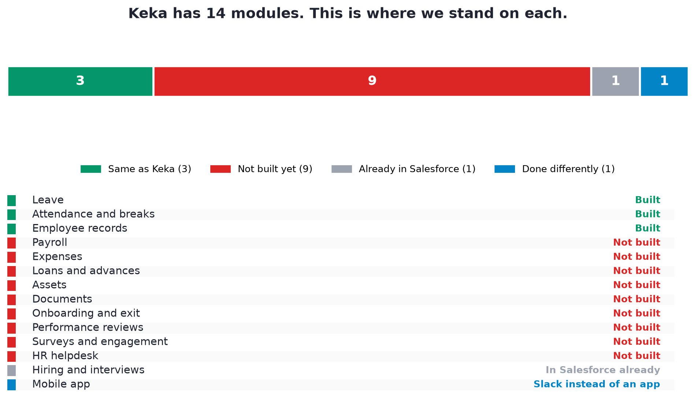

Where we match Keka
These three modules are what employees touch every day, and they are done.
Module | How complete | What is still missing inside it
Leave | Working fully | Automatic monthly accrual, carry-forward, and comp-off earning rules
Attendance | Working fully | Shift rosters, overtime, and a biometric device
Employee records | Working fully | Document storage and onboarding checklists

Where Keka is ahead of us
Module | What Keka does | How badly we need it
Payroll | Salary processing, payslips, PF, ESI, TDS, Form 16 | Blocking. Cannot leave Keka without it
Documents | Offer letters, ID proofs, contracts | Blocking. We cannot store a file at all
Expenses | Claims, approval, reimbursement | Painful, workable by hand
Onboarding and exit | Joining checklists, full and final settlement | Painful, workable by hand
Assets | Who has which laptop | Painful, workable by hand
Performance | Goals, reviews, feedback | Not missed yet
Surveys | Engagement and pulse surveys | Not missed yet
HR helpdesk | HR ticket queue | Not missed yet; Slack covers it informally
Loans | Advances and repayment schedules | Not missed yet at this headcount

Where the comparison does not apply
Module | Why
Hiring and interviews | Already runs in Salesforce. A candidate who is hired becomes an employee in the same system, with no export and re-import
Mobile app | We use Slack instead. Most people already have Slack on their phone, so there is no new app to install and no new password

5. What we do that Keka does not
The comparison is not one-directional. Five things here are genuinely better.

1. It lives where people already are
Applying for leave is one line in Slack. Approving it is a button in a direct message. There is no app to open, no password to remember and no tab to keep open. This is the single biggest reason requests get decided in minutes rather than days.

2. Break time is worked out, not declared
Nobody presses a break button, because there is no break button. Clock out when you step away and clock in when you come back, and the gap is your break. There is nothing to remember to do and nothing to forget.

3. Flags correct themselves
If a day is flagged for short hours and the punch was wrong, correcting the punch clears the flag automatically. There is no stale mark on a record to argue about at the end of the month.

4. Managers are told, not expected to check
Requests arrive in the manager's direct messages. A summary of who is off arrives in the #hrms channel every morning at nine. Nobody has to remember to go and look.

5. Hiring and HR are one system
Because interviews already run in Salesforce, a new hire does not need to be exported from one product and imported into another. The record simply continues.
And one more, which matters over time
It is yours. No per-person licence fee, no waiting for a vendor to agree that a feature is worth building, and no limit on what can be changed.

6. Who can do what
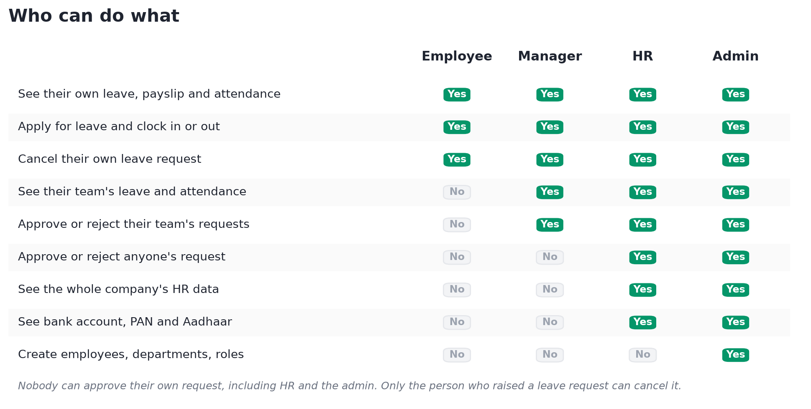

The four levels, in plain terms
Level | Who has it today | What it means
Employee | Everyone by default | Sees and manages only their own leave, attendance and profile
Manager | 7 people with direct reports | Everything an employee has, plus their team's requests to approve
HR | 1 person (Arihanta Jain) | Sees the whole company, can approve anything, sees sensitive details
Admin | 1 person (Piyush Kumar Singh) | Everything HR has, plus creating employees, departments and roles

Being a manager is not a setting anyone switches on. If someone is named as another person's reporting manager, they get their team's requests. Nothing else needs doing.

Three rules that never bend
- Nobody approves their own request. Even HR and the administrator cannot approve their own leave. Somebody else always decides.
- Only the person who raised a leave request can cancel it. Not HR, not the administrator. If a request needs withdrawing on someone's behalf, it is rejected rather than cancelled.
- A manager never sees bank or government ID details. A manager can see a team member's leave, attendance and employment details. Their bank account, PAN and Aadhaar stay hidden, because nothing in approving leave requires them.
Worth fixing before go-live
Twenty of the twenty-eight employees have no role set at all. The system treats them as ordinary employees, which is the safe outcome, but the roles should be set deliberately rather than left to a default.

7. How HR uses it
This section is written for the HR team. You will use two of the three places: Slack for the daily flow, the portal for anything you need to look up or change.

Every morning, without doing anything
At 09:00 a message arrives in the #hrms Slack channel listing everyone on leave that day. You do not have to ask for it or go and look.

When somebody applies for leave
- The request appears in #hrms at the same moment it reaches the manager.
- Normally the manager decides and you do nothing.
- If the manager is away or slow, you can press Approve or Reject yourself. Your decision counts exactly the same.
- Once anyone decides, the buttons disappear for everybody, so two people cannot decide the same request.

Things you can do that others cannot
What you want | Where | How
The company HR dashboard | Slack | Type /hrdash
Approve anything, for anyone | Slack or portal | The buttons work for you on every request
See anyone's leave balance | Portal | Employee directory, then open the person
See anyone's attendance month | Portal | Attendance page
See bank, PAN and Aadhaar | Portal | On the employee's profile
Approve regularisation requests | Slack or portal | Same buttons as leave
The holiday calendar | Portal | Me, then Holidays
Who is off or remote today | Portal or Slack | The dashboard, or /whosout

Things you cannot do
- Approve your own leave. Ask another approver.
- Cancel somebody else's leave request. Reject it instead, or ask them to cancel it.
- Create a new employee, department or designation. That is the administrator.
- Change anyone's salary, run payroll or issue a payslip. Not built yet.
- Upload or store a document. Not built yet.
You do not need Salesforce
Everything in your day is in Slack and the portal. Salesforce is where the data is kept, not where you work. If somebody asks you to open it, ask why first.

8. How an employee uses it
For most people this is the whole system: five commands in Slack.

Applying for leave
- Type /myleave in Slack. Your balance appears with an Apply button.
- Press Apply. A short form opens: leave type, from, to, reason.
- Half day? Choose the custom option and pick the first or second half of the shift.
- Submit. Your manager and HR are told immediately.
- When somebody decides, you get a message. Your balance updates on its own.

Changing your mind
Type /myleave and cancel it. This works before approval and after it. If the leave was already approved, the days go straight back onto your balance.

Clocking in and out
- Type /attendance in when you start.
- Type /attendance out when you step away or finish.
- Type /attendance in again when you come back.
- Type /attendance to see your punches, your break so far and your hours.
You can do exactly the same in the web portal, on the Clock In / Out page. Either way you get a Slack message confirming it.

If you forgot to clock in
Type /regularize and explain. Your manager approves or rejects it. You get three a month, and one that is rejected still uses up one of the three, so do not use them to test the system.

The five commands, in full
Command | What it does
/myleave | Balance, apply, cancel, and your leave history
/attendance | Clock in or out, and see today's punches and break
/approvals | Anything waiting for you (only if you manage someone)
/whosout | Who is on leave today
/regularize | Fix a day where a punch is missing

9. How the administrator uses it
The administrator does everything HR can, plus the setup that HR cannot.

Only the administrator can
Task | Where | Notes
Create or edit an employee | Portal | Admin, then Employees
Create departments | Portal | Admin, then Departments. Seven exist
Create designations | Portal | Admin, then Designations. Fourteen exist
Set who reports to whom | Portal | On the employee record. This is what makes somebody a manager
Set a person's role | Portal | Employee, HR or Admin
Link an employee to Slack | Script | Matches on email address, so real addresses are needed first

Settings that change behaviour without a code change
These are held as settings in Salesforce and can be changed without anybody rebuilding the system.
Setting | Now | What it controls
Shift start | 10:00 | When the day is expected to start
Shift end | 19:00 | Used to describe half-day sessions
Grace period | 15 minutes | How late is still on time
Late penalty time | 11:00 | Arriving at or after this is flagged
Minimum hours worked | 8 | Below this the day is flagged
Break allowance | 60 minutes | Break the shift includes
Regularisations per month | 3 | Per employee
Time zone | Asia/Kolkata | All dates and times are counted in this

10. How a leave request travels
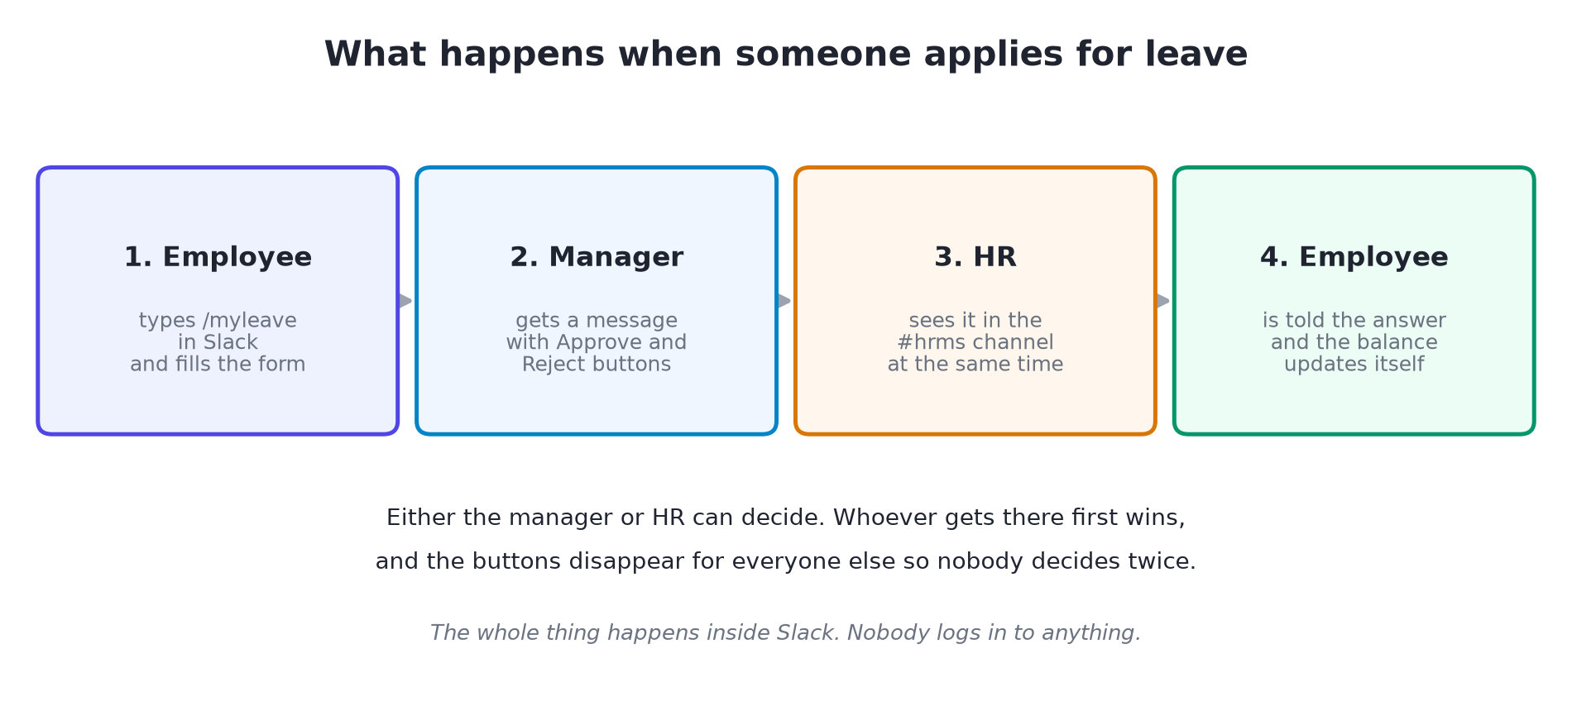

What happens behind each step
Step | What the system does
Submitted | Checks the dates make sense, counts only working days, skips weekends and holidays, and refuses if the balance is too low
Notified | Sends the manager a direct message and posts to the #hrms channel at the same time
Decided | Records who decided, removes the buttons from every copy of the message so it cannot be decided twice
Balance | Recalculates the balance from scratch rather than adding or subtracting, so it cannot drift
Told | Messages the employee with the outcome

If it is cancelled
Before approval, the request simply stops. After approval, the days are added back to the balance and the manager is told. Either way the balance is recalculated, never patched.

11. How a working day is measured
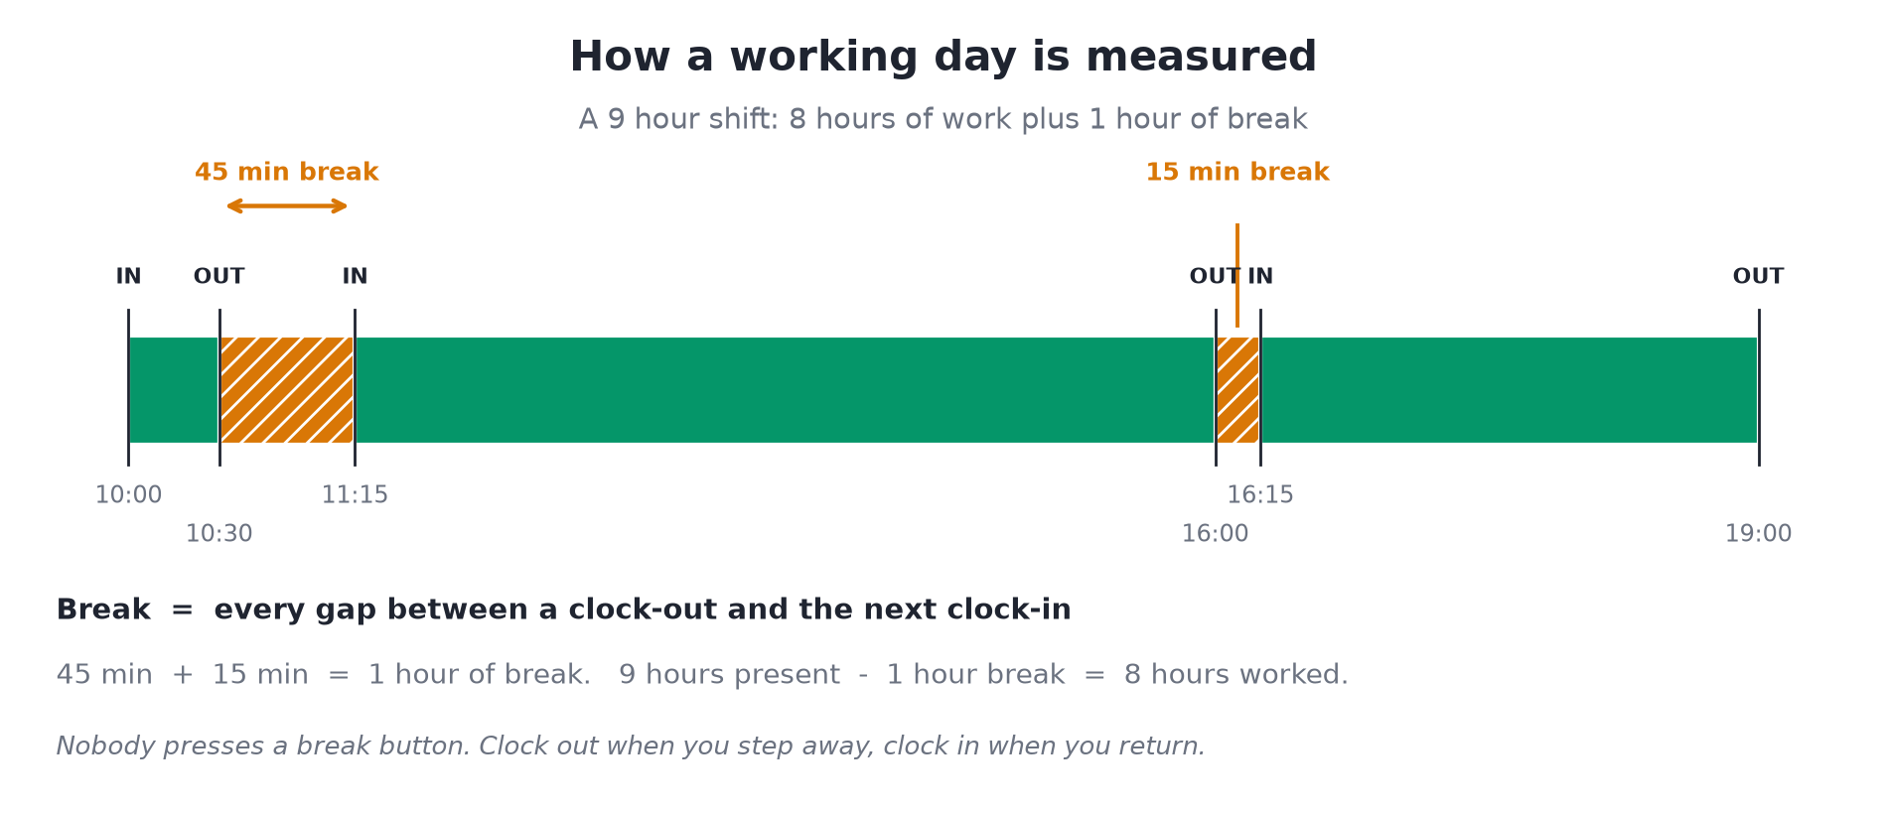

The two numbers on every day
Number | Means | Example above
Hours worked | Time actually worked, breaks taken out. This is what the rules measure | 8 hours
Time on premises | First clock-in to last clock-out, breaks included | 9 hours
Break | Every gap between a clock-out and the next clock-in, added up | 1 hour

When a day gets flagged
Flag | When | What it says
Late arrival | First clock-in at or after 11:00 | arrived at 11:45, at or after 11:00
Short day | Under 8 hours actually worked | worked 7.00 of 8 effective hours (2h break, over the 1h allowance)

Taking more than an hour of break is not a flag on its own. Somebody who takes ninety minutes and stays ninety minutes later has still done the work. It only matters if the hours worked fall short, and then the break is named as the reason.
A flag is not a punishment
It is a note on the day. It disappears the moment the underlying punches are corrected, so a forgotten clock-out does not leave a permanent mark.

12. What is not built
Listed plainly, because a demo that hides these will embarrass everybody later.

Not started at all
Area | State today
Payroll | No salary processing, no calculation, no statutory deductions, no Form 16
Payslip generation | 69 payslip records exist from test data, with no line items behind them
Salary structures | No structure definitions exist at all
Documents | No file can be uploaded or stored anywhere in the system
Expenses | Screens exist; no approval route and no reimbursement
Loans and advances | Screens exist; no way to request, approve or repay
Assets | Screens exist; no way to assign or return anything
Onboarding | No checklists, no templates, no task tracking
Offboarding and exit | Nothing
Performance and goals | Nothing
Surveys and engagement | Nothing
HR helpdesk | Nothing
Shift rosters | Everybody is measured against one default 10:00 to 19:00 shift
Overtime | Not measured
Leave accrual and carry-forward | Balances are set once, not earned monthly or carried over
Reporting beyond the Slack dashboard | Nothing

Built but switched off
Thing | Waiting on | Effect today
Email invitations | An email provider | Nobody can be invited by email
Password reset emails | An email provider | The link is generated but cannot be delivered
Login CAPTCHA | Security keys | Login works, with no bot protection
Biometric clock-in | Choosing a device | The connection point exists; no machine is attached

No email has been sent to anybody at any point. The system is deliberately configured to send nothing rather than fail noisily.

Screens that look finished but are not
Screen | The problem
Upload Document | The button does nothing at all
New Onboarding Template | The button does nothing at all
Clock In page | Says GPS will be captured on punch. It is not, and no punch has ever carried a location
Tax Declarations | Shows a declaration but there is no way to create, edit, submit or attach proof
Assets and Loans | Show empty lists with no way to add anything

13. The plan from here
Four phases, smallest and most valuable first. Nothing here is committed; it is a recommendation for the decision.

Phase 0: get it in front of people (days, not weeks)
- Real email addresses for all 28 employees
- Link everyone to Slack, which follows automatically from the addresses
- Set roles deliberately for the 20 people who currently have none
- Fill in department, designation and manager for the six new joiners
- Choose an email provider so invitations can actually be sent
- Remove or build the GPS claim on the clock page, and the two dead buttons
Nothing else can be judged properly until this is done. It is data entry and configuration, not building.

Phase 1: close the everyday gaps
- Document storage, so offer letters and ID proofs have a home
- Onboarding checklists, so a new joiner does not arrive with no department or manager
- Expense claims with a real approval route
- Asset assignment and return
After this phase, HR would open Keka only for payroll.

Phase 2: the parts of leave and attendance Keka still does better
- Monthly leave accrual, carry-forward and encashment
- Comp-off earning rules
- Shift rosters, so people on different schedules are judged fairly
- A biometric device, once one is chosen
- Overtime

Phase 3: payroll, or not
Payroll is a project in its own right and carries statutory compliance risk that nothing else here carries. It is the only thing standing between running both systems and leaving Keka entirely. This is a business decision rather than a technical one, and it should be taken on its own.

The three options, plainly
Option | What it means | Cost
A. Run both | This for leave and attendance, Keka for payroll | Cheapest. Two systems holding the same people, kept in step by hand
B. Phase 1 and 2 | HR mostly off Keka; payroll stays | Moderate. Keka reduced to a payroll tool
C. Everything | Build payroll, leave Keka entirely | Largest by a wide margin, with compliance risk

14. Three user stories
How the system feels in practice, written as the person experiences it.

Story 1: Priya needs a day off next Tuesday
It is Thursday afternoon. Priya types /myleave in Slack. Her balance appears: 14 annual days left. She presses Apply, picks Annual Leave, chooses next Tuesday for both dates, types "family function" and submits.
Her manager Rajat is in a meeting, but his phone buzzes with a direct message showing the request and two buttons. He presses Approve between agenda items. At the same moment the request had also appeared in the #hrms channel, so HR already knew.
Priya gets a message: approved. Her balance now reads 13. On Friday morning at nine, the #hrms channel lists her among next week's absences. Nobody opened a portal, and nobody updated a spreadsheet.
What this shows: a leave request from start to finish in under two minutes, entirely inside Slack.

Story 2: Arjun takes a long lunch and worries about it
Arjun clocks in at 10:00. At 13:00 he clocks out to meet a friend. He gets back at 15:00 and clocks in, then works until 19:00 and clocks out.
His confirmation message tells him the truth: 2 hours of break, 7 hours actually worked against the 8 expected. The day is flagged, and the reason says exactly why, naming the two-hour break.
He mentions it to his manager, who agrees he can make the time up. The following week Arjun stays late twice. Those days show 9 hours worked and are not flagged. Nothing needed adjusting by hand, and nobody had to remember the conversation.
What this shows: break time is measured without anybody declaring it, and the system explains itself rather than just marking a day red.

Story 3: Arihanta covers for a manager on holiday
Bharat is on leave for a week and two of his team need days off. Their requests sit in his direct messages unanswered.
Arihanta, in HR, sees both in the #hrms channel. She presses Approve on each. The system records that HR decided rather than the named manager, and the buttons vanish from Bharat's copy of the message, so he does not decide them again when he returns.
One of the two then changes her mind. She cancels it herself with /myleave, and her balance is restored. Arihanta could not have cancelled it for her, by design.
What this shows: cover works without special arrangements, and the rule that only the requester may cancel prevents leave quietly disappearing from someone's record.

15. Handover for testing
What follows is what a tester should try, what should happen, and what is already known to be wrong so it is not raised again.

Before testing starts
- A tester needs a portal login and a Slack account linked to an employee record
- At least two testers are needed: one as an employee, one as their manager
- Only two employees are linked to Slack today, so Slack testing is limited until real email addresses are loaded
- Nothing sends email, so any test involving an invitation or a reset link will stop at the point of sending

Leave: what to test
Test | Expected result
Apply for leave with enough balance | Accepted; manager and #hrms both notified
Apply for more days than you have | Refused, with the balance stated
Apply with the end date before the start | Refused
Apply across a weekend or holiday | Only working days are counted
Apply for a half day | Half a day deducted, session shown
Approve as the manager | Employee told; balance drops; buttons disappear
Try to approve your own request | Refused
Approve as HR when you are not the manager | Allowed, and recorded as an HR decision
Press an already-decided button | Refused politely, no double decision
Cancel before approval | Request withdrawn
Cancel after approval | Days returned to the balance
Try to cancel somebody else's request | Refused

Attendance: what to test
Test | Expected result
Clock in | Confirmed in Slack with the time
Clock in twice in a row | Refused
Clock out without clocking in | Refused
Clock out, then in again | The gap is counted as break
Take several short breaks | All gaps added together
Clock in after 11:00 | Day flagged as a late arrival
Work under 8 hours | Day flagged as short, break named if there was one
Correct a wrong punch | Flag clears itself
Clock out at the end of the day | Shows hours worked, not 'on a break'
Check /attendance today | Full punch log with breaks and totals
Four regularisation requests in a month | The fourth is refused
A rejected regularisation | Still uses one of the three

Access: what to test
Test | Expected result
Open any page while signed out | Sent to the login page
As an employee, open another person's profile | No bank, PAN or Aadhaar shown
As a manager, open a report's profile | Employment details shown, bank and ID hidden
As HR, open anyone's profile | Everything shown
As an employee, try /hrdash | Refused
As an employee, try to reach the admin pages | Refused
Reset a password for an address that does not exist | Same message as a real one, revealing nothing

Known issues: please do not raise these
Known issue | Why
No birthdays appear | The feature works. Every test date of birth falls in April to June, so with today in September none are within the 30-day window
Upload Document does nothing | Not built. Documented
New Onboarding Template does nothing | Not built. Documented
The clock page mentions GPS | It does not capture GPS. Known and documented
Tax declarations cannot be edited | Read-only by design today. A decision is pending
Assets, Loans and Expenses are empty | No process behind them yet
No email arrives, ever | Deliberate. No provider is configured

How to report a problem
For each issue please give: what you did, step by step; what you expected; what actually happened; which of Slack or the portal you were in; your role; and the time, so the record can be found.

16. What we need from you
Six things. The first is worth more than the other five together.
# | What is needed | Why it matters | Who
1 | Real email addresses for 26 employees | Slack accounts are matched by email. Until this is done the system reaches 2 people and nothing can be judged properly | HR
2 | An email provider | Nothing can be sent: no invitations, no password resets | IT
3 | Roles set for 20 employees | They currently default to plain employee, which is safe but not deliberate | HR and admin
4 | Department, designation and manager for 6 new joiners | They are in the system with none of these, so they have no approver | HR
5 | Real dates of birth, or confirmation the current ones are fake | Birthdays will not appear until real dates exist | HR
6 | A decision on tax declarations | View only, employees declare, or full flow with proof upload | HR and finance

And one decision, when you are ready
Whether to run both systems, close the everyday gaps, or build payroll and leave Keka entirely. Section 13 sets out the three options. That decision does not need to be taken today, but it does need to be taken before Phase 1 starts.

Prepared 6 September 2026. Figures in this document were taken from the live system on that date, not from notes. Counts will drift as the system is used.

