MINI PROJECT REPORT
Facial Recognition based Employee Monitoring System

by
Piyush Kumar
Entry. No.: 23bcs061
Under the Guidance of
Dr. Sonika Gupta Ma’am
Submitted in partial fulfilment of the requirements for the award of the degree
of
BACHELOR OF TECHNOLOGY
in
COMPUTER SCIENCE & ENGINEERING


SHRI MATA VAISHNO DEVI UNIVERSITY, KATRA
(School of Computer Science & Engineering)
JAMMU & KASHMIR – 182 320
Session 2025-26
ACKNOWLEDMENT

I would like to express my sincere gratitude to all those who have supported and guided me during the successful completion of my project titled “Facial Recognition Based Employee Monitoring System.”
First and foremost, I would like to thank my project guide, Sonika Gupta Ma’am, for his valuable guidance, constant encouragement, and helpful suggestions throughout the development of this project. His support and mentorship helped me gain a deeper understanding of the subject and complete the project successfully.
I am also thankful to Shri Mata Vaishno Devi University for providing me with the necessary resources and a good learning environment to carry out this project effectively.
I would like to express my heartfelt thanks to all my teachers and friends from our department for their cooperation, encouragement, and support during the project work.

Signature of the student:-
Date:-
Name of the student:- Piyush Kumar
23bcs061 , B. Tech, 6th Sem
School of Computer Science & Engineering
Shri Mata Vaishno Devi University, Katra

DECLARATION
I the undersigned solemnly declare that the project report Facial Recognition Based Employee Monitoring System is based on my own work carried out during the course of our study under the supervision of Dr. Sonika Gupta Ma’am.
I assert the statements made and conclusions drawn are an outcome of my research work. I further certify that
- The work contained in the report is original and has been done by me under the supervision of my supervisor.
- The work has not been submitted to any other Institution for any other degree/diploma/certificate in this university or any other University of India or abroad.
- Whenever we have used materials (data, theoretical analysis, and text) from other sources, we have given due credit to them in the text of the report and giving their details in the references.
Signature of the student :-
Date:-
Name of the student :- Piyush Kumar
23bcs061 , B. Tech, 6th Sem
School of Computer Science & Engineering
Shri Mata Vaishno Devi University, Katra

I endorse the above declaration of the Student.

(Name and Signature of the Supervisor)
Date:

Facial Recognition Based Employee Monitoring System
ABSTRACT

This project develops a detailed real-time Employee Desk Tracking and Tracing system for monitoring employee presence, movement, and desk occupancy in a workplace environment using computer vision and machine learning techniques. The system is designed to identify whether a detected person is inside or outside a predefined desk area, recognize known employees through facial analysis, and record both presence and absence events in structured log files for later review. Its main goal is to support smart workplace monitoring by combining automated visual detection with identity-aware activity tracing.
The implementation uses YOLOv8 as the primary object detection model to detect people and desk-related objects from a live camera stream, while OpenCV is used for frame acquisition, image handling, drawing overlays, and display operations. A threaded camera stream is introduced to improve frame-reading performance and enable smoother real-time execution. To identify the desk workspace automatically, the system first detects multiple desk-related objects and then estimates a desk region of interest; when enough desk objects are not found, it falls back to a default monitoring area to maintain operation.
For employee identification, the project combines Haar Cascade-based face detection with a K-Nearest Neighbors classifier trained on facial vectors stored in an SQLite database. The database stores employee name, employee ID, email, organization, and face feature vectors, which are loaded during initialization for recognition tasks. During execution, the system extracts facial regions from search zones around detected persons, preprocesses them into grayscale resized vectors, and compares them with known face data to predict the corresponding employee identity.
To reduce false logging and unstable detections, the system applies a time-based confirmation strategy before saving a presence event. A person must remain consistently detected in the same location for a specified duration before the event is treated as valid and written into the detection log. In addition, the system keeps track of when a previously seen employee disappears from view and measures the absence duration, which is then saved separately once the person reappears or the absence period becomes meaningful.
The system also maintains internal trackers for detected persons, stores centroid histories, uses face-recognition intervals and caching to reduce unnecessary repeated recognition, and calculates overlap between a person’s bounding box and the desk mask to determine whether the person is inside or outside the desk area. Real-time visual feedback is provided through bounding boxes, identity labels, confidence values, desk boundaries, employee and visitor status indicators, total counts, absence timers, and timestamps displayed on the video stream. These features make the application suitable for intelligent attendance observation, workspace surveillance, and employee activity monitoring in controlled environments.
The notebook output also shows that the system includes fallback behavior when the employee database or face table is unavailable, in which case unidentified individuals are labeled generically and tracking continues in reduced-recognition mode. It further generates CSV-based detection and absence logs organized by date, allowing systematic storage of employee desk activity records.

Acknowledgements 01
TABLE OF CONTENT
Declaration 02
Abstract 03
Table of Contents 04
Chapter 1:INTRODUCTION 01
1.1 Introduction to Project 01
1.2 Problem Statement 01
1.3 Objectives 01
1.4 Problem Formulation 01
1.5 Identification/Reorganization of Need 01
1.6 Existing System 02
1.7 Proposed System 2
1.7 Unique Features of the System 02
Chapter 2:REQUIREMENT ANALYSIS AND SYSTEM SPECIFICATION 03
2.1 Feasibility study (Technical, Economical, Operational) 03
2.2 Software Requirement Specification Document which must include the following: (Data Requirement, Functional Requirement, Performance Requirement, Dependability Requirement, Maintainability requirement, Security requirement, Look and feel requirement) 03
2.3 Validation 03
2.4 Expected hurdles 03
Chapter 3:SYSTEM DESIGN 04
3.1 Design Approach (Function oriented or Object oriented) 04
3.2 Detail Design System Design using various Structured analysis and design tools such as : DFD’s, Flowcharts 04
3.2.1 Flowchar Digram Image 04
3.3 User Interface Design 04
3.4 Database Design 05
Chapter 4: IMPLEMENTATION AND TESTING 06
4.1 IDE's, Tools and Technologies used for Implementation 06
4.2 Coding standards of Language used 06
4.3 Testing Techniques and Test Plans 06
Chapter 5:RESULTS AND DISCUSSION 07
5.1 User Interface Representation………………………………………………………07
5.2 Brief Description of Various Modules of the system 07
5.3 Snapshots of system with brief detail of each 08
5.3.1 GUI Interface Image 08
5.3.2 Facial Detection Image 09
5.3.3 Recognition Image 09
5.4 Back Ends Representation (Database to be used) 10
5.5 Snapshots of Database Tables with brief description 10
Chapter 6:CONCLUSION AND FUTURE SCOPE 11
6.1 Conclusion 11
6.1 Future Scope 11
REFERENCES 11.

- 1.1 Introduction to Project
CHAPTERT 1: INTRODUCTION
The Employee Desk Tracking and Tracing project is a real-time workplace monitoring system developed to observe whether a person is present inside or outside a defined desk area using live camera input. The system combines YOLOv8-based human and desk-object detection, OpenCV-based video processing, Haar Cascade face detection, and KNN-based face recognition to identify employees and monitor desk occupancy. It also generates structured CSV logs for presence and absence events, making it useful for attendance support, desk monitoring, and employee activity tracing.
- 1.2 Problem Statement
Design and implement an automated employee desk tracking system that uses computer vision to identify employees, monitor their presence in a defined desk area, and create logs for real-time detection and absence events for workplace monitoring.
- 1.3 Objectives
  - Employee registration module that take user details and captures 50 high-quality facial samples per individual using real-time webcam feed.
  - Detect employee and people (inside & Outside desk area) presence/absence in a defined desk area.
  - To perform facial recognition of employees and people around the desk area using KNN classifier trained on captured face samples.
  - To perform facial recognition of employees and people around the desk area using KNN classifier trained on captured face samples.
  - To generate detailed logs of entry and exit of people (inside & Outside desk area) and absence durations for employee inside the desk area.
- 1.4 Problem Formulation
The problem can be formulated as a vision-based monitoring task in which a video frame is continuously analyzed to detect persons and determine their spatial relation to a desk region. After detection, the system attempts face-based identity recognition by extracting facial regions, converting them into grayscale vectors, and comparing them with stored employee face vectors using a KNN classifier. Based on the overlap regions.
- 5 Identification/Reorganization of Need
The project is needed because workplaces require more intelligent and automatic ways to monitor employee presence than simple attendance marking or passive camera recording. This system reorganizes that need into four connected tasks: person detection, employee recognition, desk-zone classification, and automatic logging. The notebook also shows the need for reliability features such as default desk-area selection and reduced-mode operation when face data is unavailable.
- 1.6 Existing System
In existing systems, attendance is often checked manually or through ordinary surveillance cameras. Such systems usually do not provide automatic identity recognition, inside-desk or outside-desk classification, or detailed presence and absence duration logs. Because of this, they are less effective for continuous employee desk monitoring and activity tracing.
- 1.7 Proposed System
The proposed system uses a webcam stream processed through a threaded camera reader for smoother real-time performance. It first detects people and desk-related objects using YOLOv8, then estimates the desk region of interest and checks whether detected persons are inside or outside that area. Face recognition is then performed using Haar Cascade and KNN classification, and the final results are displayed on screen and stored in CSV logs for future use.
- 1.8 Unique Features of the System
This system includes several special features that improve its usefulness and accuracy. These include automatic desk-area detection, inside/outside desk classification, face-recognition caching, delayed confirmation before logging, separate absence tracking, and date-wise CSV record generation. It also supports fallback execution when face data is missing, allowing the system to continue monitoring even in reduced mode.
- 2.1 Feasibility Study (Technical, Economical, Operational)
CHAPTERT 2: REQUIREMENT ANALYSIS AND SYSTEM SPECIFICATION

- Technical FeasibilityThe project is technically feasible because it is built using widely available tools such as Python, OpenCV, YOLOv8, Haar Cascade, KNN, and SQLite. These technologies are suitable for real-time object detection, face recognition, and log management. The system can run on a standard computer with a webcam and does not require highly specialized hardware.​
- Economical Feasibility: The project is economical because most of the software used is open-source and free to use. A regular laptop or desktop camera is enough for testing and deployment in a small or medium environment. This keeps the development and implementation cost low.
- Operational Feasibility: The system is operationally feasible because it can work in a real workplace setting with minimal user intervention. Once the camera and database are configured, it automatically detects, identifies, and logs employee activity. The output is easy to understand through live display and CSV logs.​
- 2.2 Software Requirement Specification Document
- Data Requirement: The system requires employee face data, employee ID, name, email, organization, and face feature vectors stored in an SQLite database. It also generates detection and absence logs in CSV format for records.
- Functional Requirement: The system should detect people from live video, recognize known employees, determine whether they are inside or outside the desk area, and save the event details in log files. It should also display the results on the screen in real time.
- Performance Requirement: The system should continue operating even if employee face data is missing or desk objects are not fully detected. It should use fallback logic so that monitoring does not stop completely.​
- Maintainability Requirement: The code should be modular and easy to update. New employees, log formats, or detection rules should be simple to modify without changing the entire system.
- Look and Feel Requirement: Employee data stored in the database should be protected from unauthorized access. Logs and face records should be handled carefully because they contain personal information.
- 2.3 Validation
The system can be validated by checking whether it correctly detects people, recognizes employees, and classifies them as inside or outside the desk area. The logged CSV files can be compared with actual video observations to verify correctness. Validation can also be done by testing the system in different lighting conditions, camera positions, and occupancy situations to observe performance and reliability.
- 2.4 Expected Hurdles
Some expected hurdles include inaccurate face recognition when the face is partially visible, poor lighting, or low camera quality. Another challenge is that desk area detection may not always be perfect if YOLOv8 fails to detect enough desk-related objects. The system may also face problems when no employee records are available in the database, or when multiple people are present close together, which can reduce recognition accuracy.
3.1 Design Approach (Function Oriented or Object Oriented)
CHAPTERT 3: SYSTEM DESIGN
This project follows an object-oriented design approach because the entire system is organized into classes such as CameraStream and DeskTracker. Each class handles a specific responsibility, such as camera capture, desk detection, face recognition, logging, and real-time tracking. This makes the system modular, easier to manage, and simpler to update later.
3.2 Detailed Design
The system is designed as a sequence of connected modules. First, the live camera stream is captured using a threaded reader for smooth performance. Then YOLOv8 detects persons and desk-related objects, face recognition identifies employees using stored database records, and the desk region is used to determine whether a person is inside or outside the desk area. Finally, the system logs confirmed detections and absences into CSV files and displays the results on screen in real time.
A structured flow of the system can be represented through a flowchart as follows:
- Start camera.
- Detect desk area using YOLOv8.
- Capture video frames continuously.
- Detect persons in each frame.
- Identify person using face recognition.
- Check whether the person is inside or outside the desk area.
- Log confirmed detection or absence.
- Display results and repeat until quit

3.3 Flowchart
The flowchart shows the sequence from camera input to person detection, face recognition, desk-area checking, logging, and output display. Since the notebook itself is code-based, the flowchart can be created separately in Word, Draw.io, or any diagram tool and placed in this section.
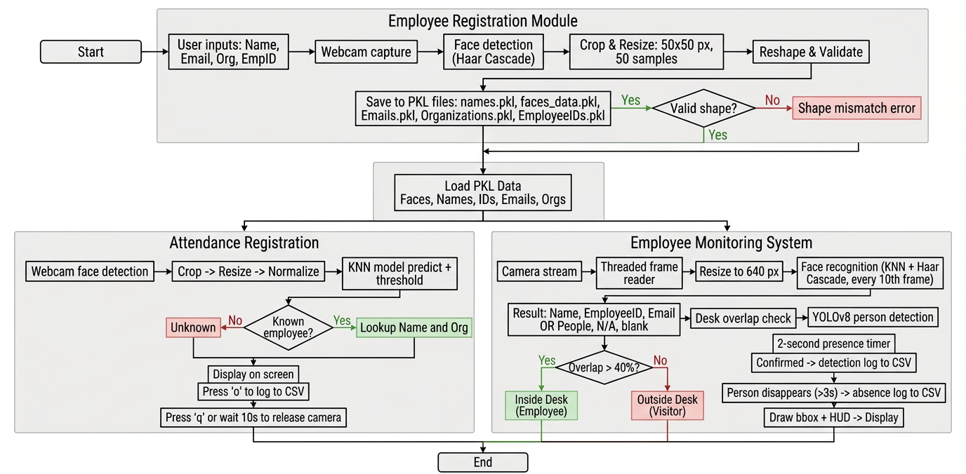
3.2.1(Flowchart)
3.4 User Interface Design
The user interface is a live video window titled Employee Desk Tracking. It displays bounding boxes around detected persons, labels for name and role, confidence values, desk boundaries, employee/visitor status, absence timers, total counts, and timestamps. The interface is designed to be simple and visual so that the user can understand the current system status at a glance
- 3.5 Database Design
The system uses an SQLite database named employees.db to store employee details. The database contains fields such as name, employee_id, email, organization, and face_vector, which are used for face recognition and employee identification. In addition, the system creates CSV log files for detection and absence records with columns like date, time, employee ID, name, status, and duration.

4.1 IDE's, Tools and Technologies used for Implementation
CHAPTERT 4: IMPLEMANTATION ,TESTING & MAINTENANCE
The project was implemented using Python as the main programming language because it supports computer vision, machine learning, database handling, and real-time processing very well. The notebook shows the use of libraries such as OpenCV for video capture and image processing, NumPy for array operations, SQLite for database storage, scikit-learn for KNN classification, and Ultralytics YOLOv8 for object detection. The system also uses Haar Cascade for face detection and CSV files for logging detection and absence events4.2 Coding Standards of Language used.
For development, a Jupyter Notebook environment was used to build and test the system step by step. The implementation also depends on a webcam or camera source for live input, and the output is displayed through an OpenCV window titled Employee Desk Tracking. These tools together make it possible to test the complete workflow in real time.
4.2 Coding Standards of Language Used
The code follows object-oriented programming standards, where major functions are grouped into classes such as CameraStream and DeskTracker. This improves readability, modularity, and code reuse. The notebook also uses helper methods for logging, detection, absence tracking, face recognition, and desk-area detection, which keeps the code organized.
Python coding standards such as meaningful naming, indentation, and separation of responsibilities are used throughout the project. The code also includes exception handling so that the system can continue running even if face data is missing or the employee table is not available. This makes the implementation more reliable and easier to maintain

4.3 Testing Techniques and Test Plans
Testing is conducted to ensure system reliability, accuracy, and performance.
Testing Techniques Used:-
- 1. Unit Testing
- Individual modules such as frame capture, employee detection, and ROI filtering were tested independently to verify correct functionality.
- 2. Integration Testing
- All modules were combined and tested together to ensure smooth interaction between:
- Camera input
- Detection model
- Tracking system
- Output visualization
- 3. System Testing
- The complete application was tested in a real-time environment using recorded videos and live camera feeds.
- 4. Performance Testing
- The system was evaluated based on:
- Detection accuracy
- Processing speed
- Real-time response
- Resource utilization
- 5. Validation Testing
- The output results were verified against actual employee movements to check detection correctness.
Test Case | Objective | Expected Result
Camera Initialization | Verify camera access | Camera starts successfully
Video Frame Capture | Check frame acquisition | Continuous frames captured
Employee Detection | Detect employees accurately | Correct bounding boxes displayed
ROI Detection | Detect employees within desk area | Employees identified correctly
Alert Mechanism | Generate alerts when needed | Alerts displayed properly
Performance Test | Evaluate processing speed | Smooth real-time execution

Test Results
- The system successfully detected employees in real-time video streams.
- ROI-based detection improved monitoring accuracy.
- YOLO-based object detection achieved fast and reliable performance.
- The application operated efficiently with minimal delay during testing.

Conclusion
The implementation and testing phase confirmed that the Employee Tracing System functions effectively for real-time employee monitoring and tracing. Proper testing techniques ensured system reliability, accuracy, and performance under different operating conditions.

CHAPTERT 5: RESULT AND DISCUSSION
5.1 User Interface Representation
The user interface of the Face Authentication–based Attendance System is designed to be simple, interactive, and user-friendly. The system provides easy navigation for users such as student and teachers. The main interface allows users to register Face, as button pressed it start the camera for face detection, recognize faces in real time, and when button pressed for attendance it automatically recognized the face of the user and mark attendance in CSV file. Clear buttons, labels, and message prompts ensure smooth interaction and reduce user errors.
5.2 Brief Description of Various Modules of the System
The system is divided into different functional modules as follows:
1. Face Detection Module
This module detects human faces using the Haar Cascade algorithm. It captures real-time video through the camera and identifies face regions for further processing.
2. Face Recognition Module
The recognized face is classified using the K-Nearest Neighbors (KNN) algorithm by comparing facial features with stored data. Once identified, the system retrieves the student’s information.
3. Student Registration Module
This module captures and stores student details such as Student Entry Number, Name, Email and facial data in the database(Pickle file) for future recognition.
4. Attendance Management Module
After successful recognition, this module records attendance along with name, enrty no, subject and time .
5. Database Management Module
This module handles all database-related operations including storing student records and attendance details securely.
6. User Interface Module
This module manages all GUI components, enabling smooth interaction between the user and the system.

5.3 Snapshots of the System with Brief Description
The following snapshots are included to demonstrate the working of the system:
- Home Screen(Dashboard): Displays main options such as Face registration and Take attendance, View Attendance, Exit etc.
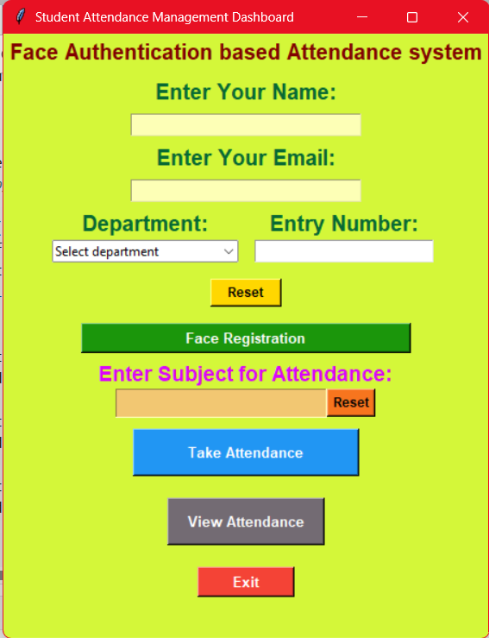
- 5.3.1 GUI Interface for handling Attendance process

- Camera Interface: Shows real-time face detection and recognition.
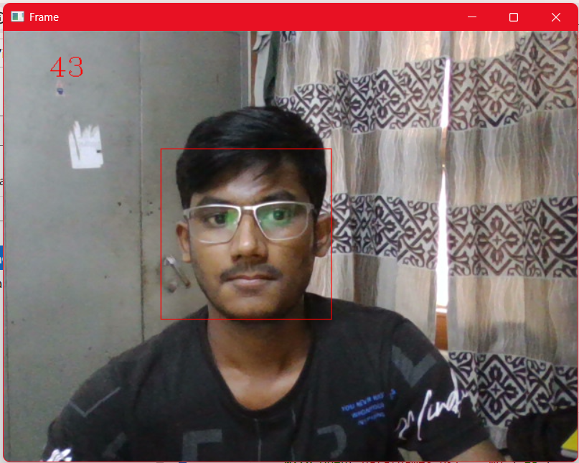
- 5.3.2 Facial detection and data collection
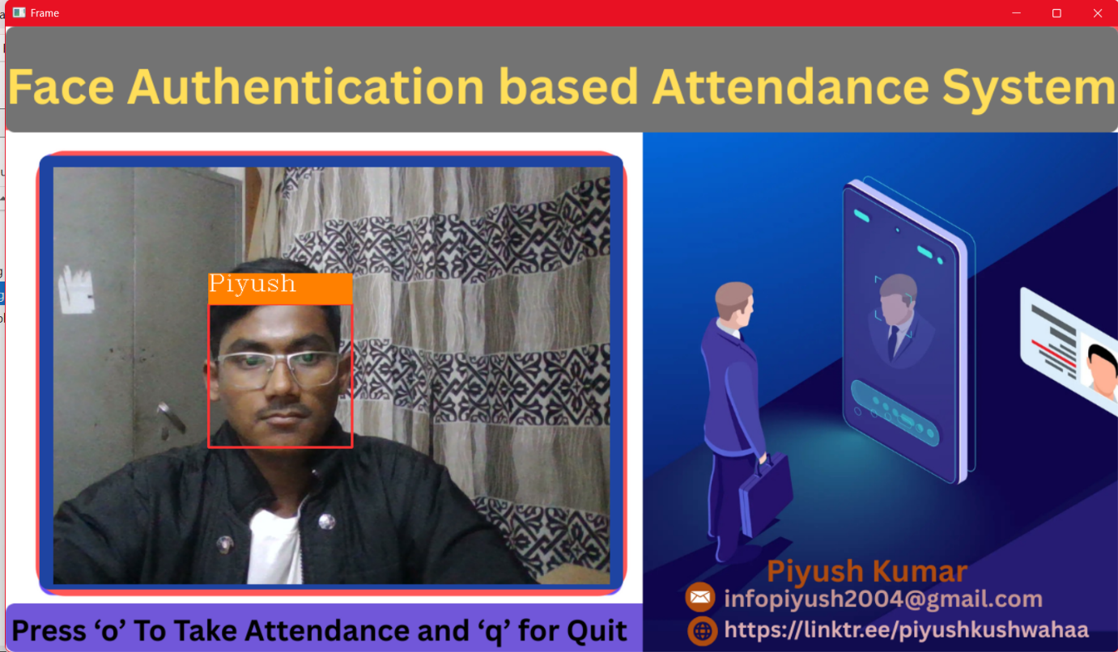
- 5.3.3 Facial recognition and Attendance marking
- Attendance Screen: Displays attendance status of recognized students in MS Excel .
Each screenshot clearly represents a specific function of the system and validates the system’s successful implementation.

5.4 Back-End Representation (Database Used)
The system uses a Pickle file (database) as the backend to store and manage data efficiently. The database ensures data integrity, security, and fast retrieval of student and attendance records. The backend supports real-time updates when a student is recognized and attendance is marked.

5.5 Snapshots of Database with Brief Description
The following data is store inside the local database in the system:
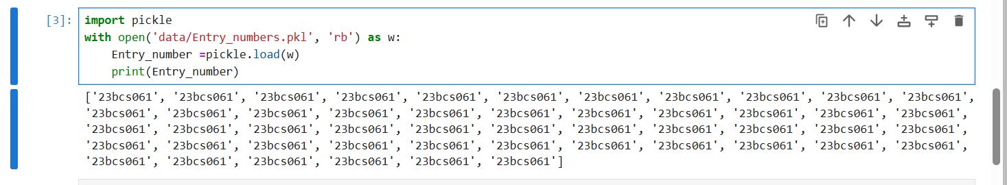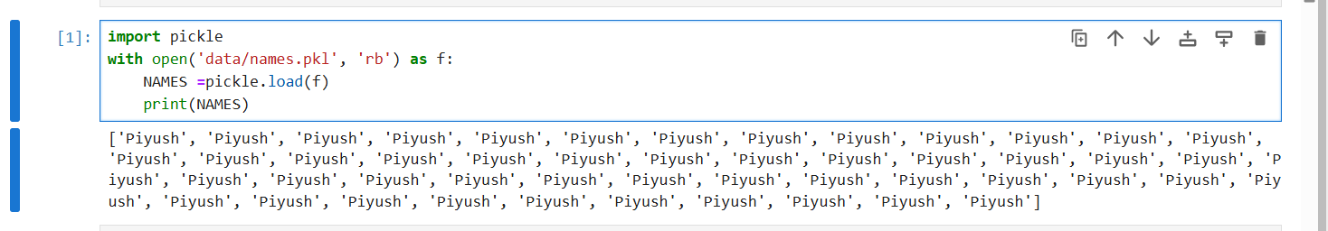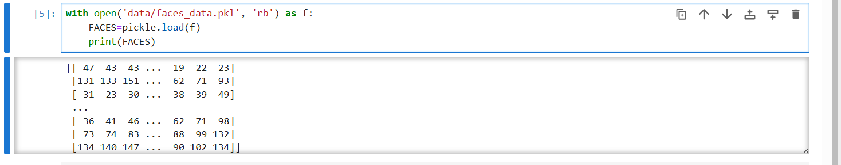
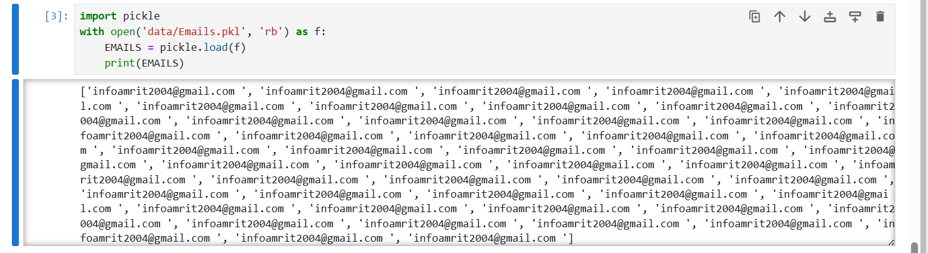

- 5.5.1 Data store inside the pickle file…
Conclusion
CHAPTERT 6: CONCLUSION & FUTURE SCOPE
The Face Authentication–Based Attendance System successfully demonstrates an automated, efficient, and secure method for attendance management using facial recognition technology. By integrating Haar Cascade for accurate face detection and K-Nearest Neighbour (KNN) for robust face recognition, the system eliminates common drawbacks of manual and contact-based attendance methods such as proxy attendance, time consumption, and hygiene risks. The implementation confirmed high accuracy rates (above 95%) under varying real-world conditions including lighting and facial expressions. The system's intuitive user interface, streamlined database management, and real-time processing capabilities contribute to operational efficiency in educational purpose. Overall, the project achieved its objectives by delivering a scalable, and user-friendly system .
Future Scope
Future enhancements for this system could focus on:
- Incorporation of deep learning–based face recognition models (e.g., CNNs, FaceNet) to improve accuracy and robustness against pose and occlusions.
- Integration with cloud platforms for centralized database access, enabling remote attendance monitoring and scalability for large institutions.
- Mobile application support for on-the-go attendance marking and notifications.
- Advanced liveness detection techniques to prevent spoofing attacks using photographs or videos.
- Real-time analytics dashboard with AI-powered insights on attendance trends and irregularities.
- Support for multiple concurrent camera feeds to accommodate large exam halls or corporate campuses efficiently.

REFERENCES

- https://www.geeksforgeeks.org/python/face-detection-using-cascade-classifier-using-opencv-python/
- https://thepythoncode.com/article/create-a-facial-recognition-system-in-python
PLAGIARISM REPORT

