**Kabaddi Fantasy League(KFL) Design Document**

**Introduction:**

This document covers the high level or strategic design for KFL. Tactical design can be covered in the next iteration after finalizing the details in each subdomain.

**Problem Statement:**

Create a fantasy league for the game Kabaddi. So people can compete with friends as well as the world. Develop the solution for KFL so that it can generate revenue for sustainability.

**High Level Requirements:**

Based on the problem statement. Following high level requirements can be jotted down.

1. At this point we consider only two types of user for the system. Application user(game user) who will play the game. Admin user who will set up the game metadata and help run the application.
2. Admin users can create the new kabaddi tournament based on the real world tournament and announce the fantasy league to game users.
3. Game users can create and register their team with the new KFL. Game users can join multiple groups for competition. Single team will be part of the multiple groups for competition.
4. Game users can add the players into their team provided by the game admin.
5. Admin users will update the points/rating of the player based on the real world performance.
6. Admin users will calculate the score of each team based on the players current points and rating.
7. Game users can track their team score and their position in each group.
8. At the end of the tournament, admin users will find the winner of each group.
9. Each winner should be credited with appropriate rewards.
10. For this design document only core requirements are considered secondary requirements like users management, marketing and data analytics can be considered in later iternation.

**Use Case Diagrams:**

Following diagram shows different use cases generated from the high level requirement.

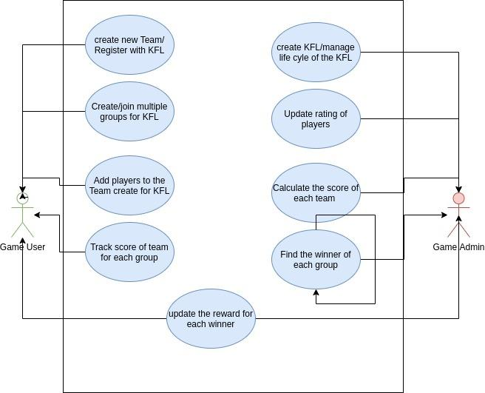

**Discovering Sub Domain:**

Following diagram shows different sub domains generated from the use cases.

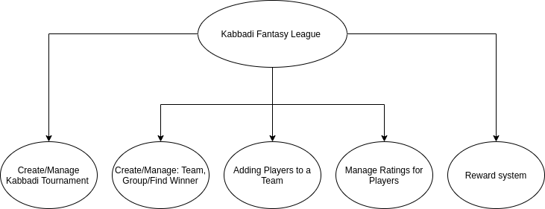

|  |  |  |
| --- | --- | --- |
| **Sub Domain** | **Use Cases** | **Description** |
| Create/Manage  Kabaddi Tournament | Create KFL/Manage life cycle of of the KFL | This subdomain deals with all the functionality creating kabaddi tournaments.  What is the tournament name?  Who can participate in this tournament?  What are the basic rules?  Who are the players available for the team?  What is the entry and reward system?  How to manage the lifecycle of the Tournament(Start/In running/Stop) |
| Create/Manage:Team, Groups/Find Winner | Create New Team/Register with KFL  Create/Join multiple groups for KFL  Track score of a team for each group  Calculate score of each team  Find the winner of each group. | This subdomain manages the functionality related to Team and group. |
| Adding Players to a team | Adding players to a team created for KFL | This subdomain is carved out of the previous subdomain.  This subdomain gives the competitive edge to the application and additional revenue source for the system.  Idea is to create the scarcity of the demanding players and then convert the scarcity into a bidding process to generate the revenue for the application. |
| Manage Ratings for Players | Update Rating of Players | This subdomain updates the rating of the players based on the rating system defined. |
| Reward System | Update the reward for each winner | This subdomain handles the functionality related to finding/transferring/app commision of reward points. This system can be centralized or based on any cryptocurrency blockchain. |

**System Flow Diagram:**

Following diagram shows the sequence of events performed during KFL.

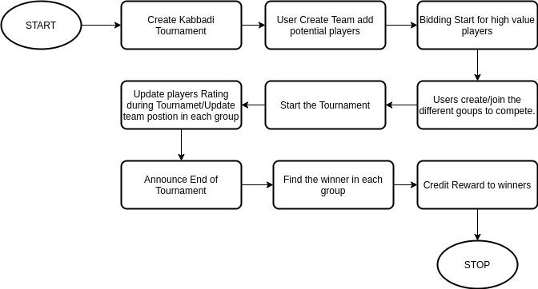

**Component Diagram:**

Following diagram shows the different components generated from sub domains and the dependency between the components.

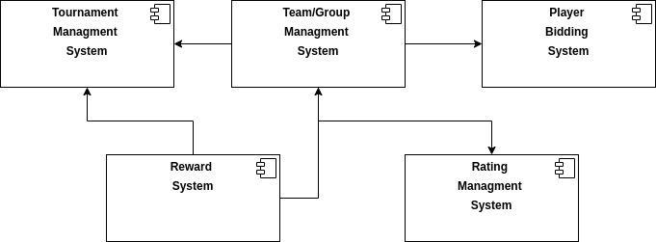

**Note**: As a part of this exercise only one sub domain has been explored for the tactical or low level design (Tournament Management System) . Below text describes the tactical design.

**Bounded Context for Tournament Management System:**

Tournament Management System is mapped to single bounded context Tournament Management Bounded Context.

**Domain Model for Tournament Management Bounded Context:**

**Aggregates/Entity Objects/Value Objects:**

Following image shows different objects that can be part of this bounded context.

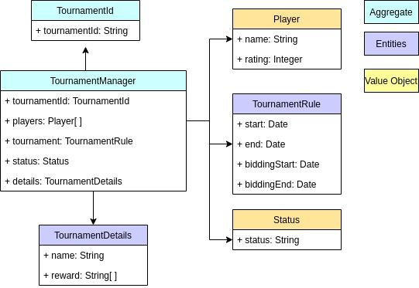

**Command/Queries:**

Following image shows the different command/queries part of this bounded context.

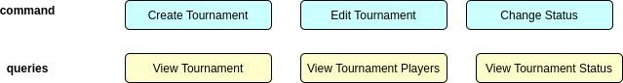

**Events:**

Following events are generated by this bounded context during its life cycle.

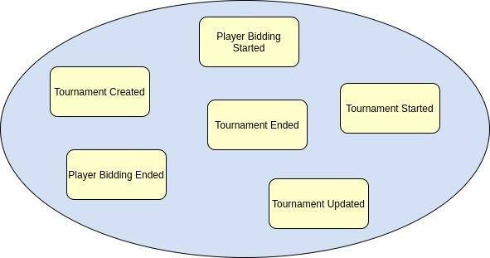

**Saga/Event :**

Following image shows the flow of events for this bounded context and their interaction with other bounded contexts.

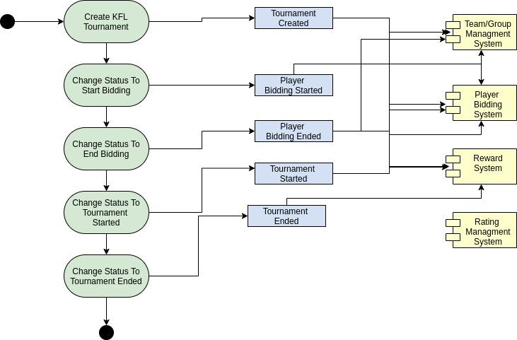

**Revenue Generation:**

To run the KFL, the following primary source of revenues can be used.

* **Bidding of Players:** By creating scarcity for the high demanding player. We can develop a bidding system. App users can bid for these players and revenue can be generated from this. Consider this as a stock market where a whole new system can be built around it.
* **Commission from the Group Winner:** KFL can take some part of the winning reward as commision.
* **Advertising**: Revenue can be generated from advertising by showing ads on the UI.