“CUSTOMIZABLE BIST FOR MEMORY AND IMC”

Research Methodology & Seminar Project Report
4FT901CC24

Submitted in Partial Fulfillment of the Requirements for the Degree of

BACHELOR OF TECHNOLOGY
IN
ELECTRONICS AND COMMUNICATION
ENGINEERING
By

Piyush Maru (23BEC146)
Tejas Raichura (23BEC154)



Department of Electronics and Communication Engineering,
Institute of Technology,
Nirma University,
Ahmedabad 382 481
August 2026
CERTIFICATE
This is to certify that the Minor Project Report entitled “Customizable BIST for Memory and IMC” submitted by Mr. Piyush Maru (Roll No. 23BEC146) towards the partial fulfillment of the requirements for the award of degree in Bachelor of Technology in the field of Electronics & Communication Engineering of Nirma University is the record of work carried out by him under our supervision and guidance. The work submitted has in our opinion reached a level required for being accepted for examination. The results embodied in this minor project work to the best of our knowledge have not been submitted to any other University or Institution for award of any degree or diploma.

______________________________  Dr. Akash Mecwan  (Guide)  Department of Electronics &  Communication Engineering,  Nirma University,  Ahmedabad 382 481 | ______________________________  Head of Department  Department of Electronics &  Communication Engineering,  Institute of Technology,  Ahmedabad 382 481
Date: __________________________________________________________________________________

CERTIFICATE
This is to certify that the Minor Project Report entitled “Customizable BIST for Memory and IMC” submitted by Mr. Tejas Raichura (Roll No. 23BEC154) towards the partial fulfillment of the requirements for the award of degree in Bachelor of Technology in the field of Electronics & Communication Engineering of Nirma University is the record of work carried out by him under our supervision and guidance. The work submitted has in our opinion reached a level required for being accepted for examination. The results embodied in this minor project work to the best of our knowledge have not been submitted to any other University or Institution for award of any degree or diploma.

______________________________  Dr. Akash Mecwan  (Guide)  Department of Electronics &  Communication Engineering,  Nirma University,  Ahmedabad 382 481 | ______________________________  Head of Department  Department of Electronics &  Communication Engineering,  Institute of Technology,  Ahmedabad 382 481
Date: __________________________________________________________________________________

UNDERTAKING FOR ORIGINALITY OF THE WORK
We, Piyush Maru (23BEC146) and Tejas Raichura (23BEC154), give undertaking that the Minor Project entitled “Customizable BIST for Memory and IMC” submitted by us, towards the partial fulfillment of the requirements for the degree of Bachelor of Technology in Electronics and Communication Engineering of Nirma University, Ahmedabad 382 481, is the original work carried out by us and we give assurance that no attempt of plagiarism has been made. We understand that in the event of any similarity found subsequently with any other published work or any project report elsewhere, it will result in severe disciplinary action.
_______________________________ _______________________________
Piyush Maru (23BEC146) Tejas Raichura (23BEC154)
Date: ___________________
Place: ___________________
Endorsed by:
_______________________________
(Signature of the Guide)

ACKNOWLEDGEMENT
Working together on a project always makes the journey richer, and this work has been no different. We are deeply grateful to everyone who supported and guided us throughout this effort.
We sincerely thank our project guide, Dr. Akash Mecwan, for his consistent encouragement, patient guidance, and valuable feedback at every stage of this project. His clear explanations and thoughtful suggestions helped us move forward whenever we faced challenges, and his confidence in our abilities kept us motivated.
We are grateful to the Department of Electronics and Communication Engineering, Institute of Technology, Nirma University, for providing us with the necessary resources, laboratory facilities, and an environment that supports research and learning. The academic exposure we have received here has shaped our understanding of VLSI design and testing concepts in a meaningful way.
We also thank the authors of the research papers that formed the foundation of our literature study. Their published work on Memory Built-In Self-Test (MBIST) architectures, March test algorithms, and fault modeling provided us with strong technical grounding.
Finally, we express our heartfelt gratitude to our families and friends for their unwavering support, patience, and encouragement throughout this journey.
Piyush Maru
Tejas Raichura

ABSTRACT
Modern System-on-Chip (SoC) designs include large amounts of embedded memory, which can occupy up to 90% of the total chip area. As semiconductor technology advances to very deep submicron scales, the number of manufacturing defects inside memory arrays increases, making memory testing one of the most critical aspects of chip quality assurance. Traditional testing methods rely on external Automatic Test Equipment (ATE), which is expensive and time-consuming. Memory Built-In Self-Test (MBIST) solves this problem by placing test logic directly inside the chip, enabling faster, at-speed, and cost-effective testing without external equipment.
This project focuses on the implementation and comparative evaluation of a Customizable MBIST architecture for testing conventional semiconductor memory and emerging In-Memory Computing (IMC) architectures. We study functional memory fault models—including Stuck-at Faults (SAF), Transition Faults (TF), Read Destructive Faults (RDF), and Inversion Coupling Faults (CFin)—and March test algorithms.
Expanding upon previous behavioral simulations, we present a complete ASIC pre-layout flow. The RTL is mapped to the SkyWater 130nm high-density standard cell library (sky130_hd.lib) using Yosys Synthesis Suite, and timing closure and static power profiling are conducted using OpenSTA. Timing and power characterization is evaluated for both WITH_MBIST and WITHOUT_MBIST modules under 10ns and 75ns clock periods. While aggressive 10ns timing constraints induce slack violations, easing the clock period to 75ns yields functional timing closure with highly nominal sequential power overhead for the self-test logic.

INDEX
Chapter No. | Title | Page No.
 | Acknowledgement | 5
 | Abstract | 6
 | Table of Contents | 7
 | List of Figures | 8
 | List of Tables | 8
 | Nomenclature | 9
1 | Introduction | 11
1.1 | What is Memory Testing? | 11
1.2 | Motivation | 11
1.3 | Objectives | 12
1.4 | Problem Statement | 12
1.5 | Approach | 13
1.6 | Scope of the Project | 14
2 | Literature Review | 15
2.1 | Memory Fault Models | 15
2.2 | Previous Approaches to Solve the Problem | 17
2.3 | Details of Tools and Technologies Used | 18
3 | Software Design | 20
3.1 | Algorithm Discussion | 20
4 | Yosys and OpenSTA Implementation | 21
4.1 | Gate-Level Synthesis using Yosys | 21
4.2 | Static Timing and Power Analysis with OpenSTA | 21
5 | Simulation and Implementation Results | 23
5.1 | WITH_MBIST Module Timing and Power Characterization | 23
5.2 | WITHOUT_MBIST Baseline Timing and Power Characterization | 24
5.3 | Synthesis and Comparison Analysis | 24
6 | Conclusion and Future Scope | 26
6.1 | Conclusion | 26
6.2 | Future Scope | 26
 | References | 27

LIST OF FIGURES
Figure 1: General BIST architecture ........................................................................................ 4
Figure 4: MATS+ simulation waveform (EPWave): Stuck-at-0 fault detected .......................... 16
Figure 5: Checkerboard simulation waveform showing four test runs (PASS/FAIL) .................... 17

LIST OF TABLES
Table 1: Memory test time as a function of complexity and size [1] ......................................... 2
Table 2: Common memory fault models and detection requirements ............................................. 6
Table 3: Summary of March test algorithm fault coverage ................................................... 7
Table 4: Timing & Power Characterization for WITH_MBIST Module ............................................ 17
Table 5: Timing & Power Characterization for WITHOUT_MBIST Module .......................................... 18
Table 6: Summary and Architectural Comparison of Memory Systems ............................................ 19

NOMENCLATURE
Symbol / Abbreviation | Description
N | Number of memory cells (size of memory)
O(xN) | Test complexity notation; x is the number of operations per cell
SAF | Stuck-at Fault
TF | Transition Fault
RDF | Read Destructive Fault
DRDF | Deceptive Read Destructive Fault
WDF | Write Destructive Fault
IRF | Incorrect Read Fault
CF | Coupling Fault
CFin | Inversion Coupling Fault
ADF | Address Decoder Fault
ATE | Automatic Test Equipment
BIST | Built-In Self-Test
MBIST | Memory Built-In Self-Test
DFT | Design for Testability
FSM | Finite State Machine
HDL | Hardware Description Language
IMC | In-Memory Computing
PDK | Process Design Kit
STA | Static Timing Analysis
VDSM | Very Deep Submicron

1 INTRODUCTION
1.1 What is Memory Testing?
Memory testing is the process of checking whether all the memory cells in a chip are working correctly after manufacturing. Every chip that comes out of a factory may have small physical defects inside it. These defects can cause a memory cell to always store a wrong value, fail to switch between 0 and 1, or get influenced by a neighboring cell. If such a faulty chip reaches the customer, it can cause a product to behave incorrectly or crash unexpectedly. To prevent this, memory testing must be performed before the chip is shipped.
Modern electronic devices such as smartphones, laptops, automobiles, and medical equipment all rely heavily on chips that contain embedded memory. In today’s SoC designs, embedded memories such as SRAM and DRAM occupy up to 90% of the total chip area [1]. This makes the quality of the memory the most important factor in determining whether a chip will work correctly.
A memory test applies a carefully designed sequence of read and write operations to every cell in the memory. After each read operation, the result is compared with the expected value.
1.2 Motivation
The motivation for this project comes from multiple observations made in current semiconductor industry practices as well as from the academic research papers we reviewed.
Growing memory density: As transistor sizes continue to shrink, memory arrays are packed more densely than ever before. This means that even a tiny manufacturing imperfection can affect multiple cells simultaneously, making testing more important and more difficult at the same time [1].
High cost of external testing: Traditional testing uses external Automatic Test Equipment (ATE), which is a large and expensive machine that applies test vectors from outside the chip. For large memories, test time can stretch to hours or even days with non-linear algorithms [1]. Table 1 shows how test time grows rapidly with memory size and algorithm complexity. For a 256-megabit memory tested with a quadratic algorithm, the test time would exceed 200 years, which is clearly impractical.
Size (N) | O(N) | O(N log N) | O(N^1.5) | O(N^2)
1K | 0.0001 s | 0.001 s | 0.003 s | 0.105 s
16K | 0.002 s | 0.022 s | 0.21 s | 27 s
64K | 0.006 s | 0.10 s | 1.68 s | 7.2 min
256K | 0.026 s | 0.46 s | 13.4 s | 1.9 h
1M | 0.10 s | 2.04 s | 1.83 min | 1.27 d
64M | 6.56 s | 2.84 min | 15.25 h | 14.3 y
256M | 26.24 s | 12.25 min | 5.1 d | 229 y
Table 1: Memory test time as a function of complexity and size [1]
Need for on-chip testing: MBIST resolves the limitations of ATE by embedding the test controller directly inside the chip. This removes the need for an external tester, allows parallel testing of multiple memory blocks, and reduces the overall test cost [2].
Limitations of conventional MBIST: Existing MBIST controllers typically use a single fixed algorithm. They are not designed to be changed or adapted for different memory sizes or different fault targets. With the emergence of In-Memory Computing (IMC) architectures, where computation happens directly inside the memory array, new types of faults appear that existing algorithms were never designed to detect [1].
These observations motivate the need for a customizable MBIST that can support multiple algorithms, handle different memory configurations, and extend its capabilities to IMC systems.
1.3 Objectives
The main objectives of this project are:
- 1. To study different types of memory faults and understand the conditions required to detect each of them.
- 2. To understand the working of BIST and MBIST architectures used for memory testing and compare them with traditional external testing approaches.
- 3. To implement memory testing algorithms—specifically the MATS+ algorithm and the Checkerboard algorithm—using Verilog HDL.
- 4. To simulate the implemented algorithms and verify their ability to correctly detect injected faults.
- 5. To analyze the testing challenges in In-Memory Computing (IMC) systems and understand why conventional MBIST is not sufficient for them.
- 6. To review existing research work related to memory BIST and testing algorithms and identify gaps that future work can address.
1.4 Problem Statement
Modern SoCs contain a large amount of embedded memory that often occupies more than half of the total chip area. As memory density increases, the probability of manufacturing defects also increases. Even a single faulty memory cell can cause the system to store incorrect data, leading to system failures that are difficult to diagnose after the product has been shipped.
External testing using ATE is expensive, slow for large memories, and requires specialized equipment that must be kept updated as chip technologies evolve. On the other hand, conventional MBIST controllers use fixed test algorithms that cannot be changed without redesigning the entire test controller. This makes them inflexible when the memory size changes or when a new type of fault needs to be targeted.
Furthermore, new computing architectures such as In-Memory Computing (IMC) perform computation directly inside the memory array. This fundamentally changes the behavior of memory cells in ways that conventional test algorithms were not designed to handle. Testing IMC systems requires new approaches that go beyond simple read and write sequences [2].
The core problem addressed in this project is: How can we design a customizable MBIST architecture that is flexible, supports multiple algorithms, achieves good fault coverage, minimizes test time, and can eventually be extended to handle the unique testing requirements of In-Memory Computing systems?
1.5 Approach
1.5.1 Memory Built-In Self-Test (MBIST)
We have chosen Memory Built-In Self-Test (MBIST) as the primary approach for memory testing in this project. MBIST is a Design for Testability (DFT) technique in which the test logic—including the test pattern generator, test controller, and response comparator—is built directly onto the same chip as the memory being tested.
The general architecture of a BIST system consists of three main parts: the Test Generator Controller (TGC), the Circuit Under Test (CUT), and the Response Monitor (RM). The TGC generates read and write sequences according to the test algorithm. The CUT is the memory array being tested. The RM compares the output read from the memory with the expected value and reports whether a fault was found.
The MBIST controller used in this project is based on a Finite State Machine (FSM). The FSM moves through different states, each corresponding to a phase of the testing algorithm (e.g., write phase, read phase). An address generator counts through all memory addresses in the correct order, and a data generator produces the test patterns (all-zeros, all-ones, or alternating patterns) required by the algorithm. A comparator block checks the output of each read operation against the expected data.
The key advantages of MBIST over external ATE testing are:
- No external tester hardware is needed, which significantly reduces production cost.
- Multiple memory blocks can be tested in parallel, reducing total test time.
- The test can be performed at the actual operating speed of the chip (at-speed testing).
- The MBIST controller can be reused every time the chip powers on, enabling field testing during the lifetime of the product.
1.6 Scope of the Project
The scope of this project is expanded to cover the transition from behavioral RTL simulations to a pre-layout ASIC characterization flow. Rather than limiting the scope to functional hardware models, this work incorporates automated gate-level synthesis, cell technology mapping, timing optimization, and static power profiling.
The primary technical boundaries of this project's scope are defined as follows:
- ASIC Pre-Layout Flow: Designing a complete pre-layout synthesis and timing pipeline, transitioning our 1024x8 behavioral SRAM model and FSM-based testing controllers into physical logic realizations.
- Gate-Level Synthesis: Leveraging the modular open-source Yosys Synthesis Suite to compile, optimize, and map synthesizable Verilog designs into a structural standard cell netlist.
- Technology Targeting: Targeting the SkyWater 130nm High-Density PDK standard cell library (sky130_hd.lib) to map physical logic elements, enabling precise propagation delays and capacitances calculations.
- Timing Closure & Constraints: Performing rigorous static timing analysis with OpenSTA. This includes analyzing setup and hold times, defining Synopsys Design Constraints (SDC) to establish timing boundaries, and identifying high-frequency speed ceilings.
- Power Characterization: Evaluating static power footprints—including internal sequential, combinational, and leakage power—for the WITH_MBIST self-test architecture and comparing them directly against the WITHOUT_MBIST baseline memory under variable frequencies.

2 LITERATURE REVIEW
2.1 Memory Fault Models
A fault model is a logical representation of a physical defect. Since there can be an unlimited number of physical defects at the manufacturing level, fault models simplify them into a manageable set of logical behaviors so that test algorithms can be designed to detect each one.
Memory faults are broadly classified into three categories: Single Cell Faults (SCF), Multi-Cell or Coupling Faults, and Address/Decoder Faults.
Stuck-at Fault (SAF): A memory cell is forced to always hold a logic 0 (SAF0) or always hold a logic 1 (SAF1), regardless of what value is written to it. Detection requires writing the opposite value to the cell and reading it back. If the read returns the old stuck value instead of the written value, the fault is detected.
Transition Fault (TF): The memory cell fails to make a transition from 0 to 1, or from 1 to 0. This happens when the write circuit is not strong enough to flip the cell state. Detection requires first writing a value, then attempting to write the opposite, and then reading to check if the transition occurred.
Read Destructive Fault (RDF): A read operation changes the stored content of the cell. The read output shows the wrong value (the corrupted value). This is particularly dangerous because the fault is hidden from the result of that very read operation.
Deceptive Read Destructive Fault (DRDF): Similar to RDF, but the read output itself appears correct even though the stored value has been corrupted. Two consecutive reads are needed to detect this fault, because only the second read will return the corrupted value.
Write Destructive Fault (WDF): Writing the same value already stored in a cell (a non-transition write) changes the stored content unexpectedly. Detection requires a non-transition write followed by a read to check for corruption.
Incorrect Read Fault (IRF): A read operation returns the wrong value, but the stored content of the cell remains unchanged. Detection requires reading the cell and comparing the output with the known stored value.
Coupling Faults (CF): A write or read operation on one cell (the aggressor cell) unexpectedly changes the value of another cell (the victim cell). There are several types of coupling faults: State CF (CFst), Idempotent CF (CFid), Inversion CF (CFin), Transition CF (CFtr), Read Destructive CF (CFrd), Deceptive Read Destructive CF (CFdrd), and Write Destructive CF (CFwd). Coupling faults are two-cell faults and are more difficult to detect because the test must be run in both ascending and descending address order.
Address Decoder Faults (ADF): These occur in the address decoder block of the memory. Possible scenarios include no cell being accessible at a certain address, multiple cells being activated by one address, or a cell being inaccessible from any address.
Fault Type | Fault Class | Primitive | Detection Requirement
SAF | Single Cell | <0/1/->, <1/0/-> | Write opposite value; read back immediately.
TF | Single Cell | <0w1/0/->, <1w0/1/-> | Write x, write x' (transition); read back x'.
RDF | Single Cell | <0r0/1/1> | Set cell to x; read immediately. Verify read output.
DRDF | Single Cell | <0r0/1/0> | Set cell to x; perform two consecutive reads.
WDF | Single Cell | <0w0/1/-> | Write x; perform a non-transition write x; read back.
CFin | Coupling | <0;X/1/-> | Aggressor write must be followed by victim read.
CFst | Coupling | <0;0/1/-> | Aggressor must be in given state when victim is read.
Table 2: Common memory fault models and detection requirements
2.1.1 Memory Testing Algorithms
A memory testing algorithm defines the exact sequence of read and write operations applied to the memory under test. The notation used throughout this report follows the standard March test format: ⇑ means the addresses are visited in ascending order, ⇓ means descending, and ⇕ means either direction. Operations r0, r1 mean reading and expecting 0 or 1 respectively, and w0, w1 mean writing 0 or 1.
Zero-One Algorithm (4N): This is one of the simplest algorithms. It writes all zeros, reads all zeros, writes all ones, and reads all ones. It can detect only SAF and 50% of TF. Its sequence is: ⇕ (w0);⇕ (r0);⇕ (w1);⇕ (r1)
MATS++ (6N): An improved version that detects all SAF and TF. It has better fault coverage than the Zero-One algorithm while maintaining low complexity. Its sequence is: ⇕ (w0);⇑ (r0,w1);⇓ (r1,w0,r0)
MATS+ (6N): A variant of MATS++ that also detects Inversion Coupling Faults (CFin) in addition to SAF and TF. This is one of the algorithms we implemented.
Checkerboard (4N): Instead of writing all-zeros or all-ones, this algorithm writes an alternating 0-1 pattern (like a checkerboard) to the memory. Consecutive cells get opposite values. It detects SAF, TF, and some coupling faults. This is the second algorithm we implemented.
March C- (10N): A widely used algorithm that provides full coverage of SAF, TF, RDF, and all conventional coupling faults (CFid, CFin, CFst, CFtr). Its sequence is: ⇕ (w0);⇑ (r0,w1);⇑ (r1,w0);⇓ (r0,w1);⇓ (r1,w0);⇕ (r0)
March SS (22N): One of the most comprehensive algorithms, capable of detecting all static unlinked faults including DRDF, WDF, and all coupling fault variants. Its high complexity comes from the extra read operations needed to detect DRDF and WDF.
Alg | Compl | SAF | TF | RDF | DRDF | CFin | CFid
Zero-One | 4N | Full | 50% | None | None | None | None
MATS+ | 6N | Full | Full | Yes | None | Yes | None
Checkerboard | 4N | Full | Full | None | None | Partial | None
March C- | 10N | Full | Full | Full | None | Full | Full
March SS | 22N | Full | Full | Full | Full | Full | Full
Table 3: Summary of March test algorithm fault coverage
2.2 Previous Approaches to Solve the Problem
A large body of research has been published over the years on memory fault models, test algorithms, and BIST architectures. This section summarizes the key works that are most relevant to our project.
Review of Memory Fault Models and March Test Algorithms [1]: This review paper by Jidin et al. provides a comprehensive overview of functional fault models and March series test algorithms used in memory BIST. The paper classifies fault models by their fault primitives—combinations of sensitizing conditions, faulty behaviors, and read output values. It discusses algorithms from the simple Zero-One test to the more advanced March SS (22N) and March AB (22N), which can detect all static unlinked faults in RAM. The paper concludes that a minimum of 22N complexity is required to detect every type of unlinked fault, while also identifying scope for optimizing lower-complexity algorithms by rearranging test operations to increase coverage without increasing complexity. This paper formed the primary technical reference for our understanding of fault models and algorithm design.
March 5n FSM-Based MBIST Architecture with Diagnosis Capabilities [2]: This paper by Ng et al. from Universiti Teknologi Malaysia presents an FSM-based MBIST architecture implementing the March 5n algorithm, which achieves shorter test time than conventional MATS++ without sacrificing fault coverage. The key contribution of this work is the addition of a diagnosis and redundancy module to the basic MBIST architecture. The diagnosis module records the address and data of any faulty cell. The redundancy module then maps the faulty cell to a spare cell (redundancy cell), effectively repairing the memory during the test itself. The proposed architecture achieves approximately 8% improvement in maximum operating frequency compared to the previous design, with a trade-off of about 4% additional area overhead due to the added diagnosis logic. The authors also formally validated CFin coverage for the March 5n algorithm. The diagnosis and repair-during-test concept is an important reference for our proposed customizable MBIST.
Systematic Approach to Reducing Semiconductor Memory Test Time in Mass Production [3]: This paper by Yeh et al. from National Tsing Hua University addresses the Test Time Reduction (TTR) problem for DRAM memory testing. The authors propose three test compaction techniques: removing redundant test items, merging overlapping test patterns, and developing new efficient test patterns that combine the fault coverage of multiple existing tests into one. Their proposed TTR tool uses a greedy algorithm to find and remove redundant test items, and a correlation table approach to identify test patterns that can be merged. When applied to an industrial 128 Mb DRAM test flow, the approach reduced total test time by approximately 19.5% from an already compact test set. This paper is relevant because reducing test time is one of the key goals of a customizable MBIST.
Fault-Coverage Maximizing March Tests for Memory Testing [4]: This paper by Yun et al. from the University of Southern California takes a different approach from traditional March test design. Instead of designing a test that achieves 100% fault coverage for a given set of fault types, the authors ask: if 100% coverage is not achievable within a tight test length constraint, what is the maximum coverage that can be achieved? They develop a new fault simulator that is completely scalable and a march test generator that maximizes fault coverage for a given set of fault types and a given constraint on test length. Their experiments show that well-known March tests often provide surprisingly low collateral coverage for fault types they were not specifically designed to detect. The new tests provide graceful and predictable decrease in coverage as the test length constraint is tightened. This work motivates the design of a customizable MBIST that can trade off between test quality and test cost in a systematic way.
2.3 Details of Tools and Technologies Used
To carry out the full design, synthesis, timing closure, and power characterization of our Customizable MBIST architecture, the following tools and technologies were utilized:
- Verilog HDL: The industry-standard Hardware Description Language (IEEE 1364) was used to model the behavioral SRAM memory block, write-enable control, data routing, and the Finite State Machine (FSM) of the MBIST controller. All code is structured synthesizably to enable standard ASIC compiler flows.
- Yosys Open Synthesis Suite: A modular, highly versatile open-source RTL synthesis framework. Yosys was used to parse our behavioral Verilog designs, translate them into an intermediate Abstract Syntax Tree (AST), perform logic optimization (such as dead-code elimination, logic reduction, and state machine extraction), and map the hardware cells onto our target technology standard library.
- OpenSTA Static Timing Analyzer: An industrial-grade, ultra-high-performance static timing analyzer. OpenSTA was used to evaluate propagation delays across the critical logic paths, trace data arrival paths from register clocks to combinational outputs, check setup and hold times, and generate slack values based on technology library specifications.
- SkyWater 130nm standard cell library (sky130_hd.lib): The SkyWater 130nm high-density PDK library containing precise electrical, physical, and timing delays of standard logic gates. The Liberty file (.lib) contains state-dependent delay parameters and leakage power lookup tables required by Yosys and OpenSTA to calculate realistic delays, capacitances, and static power metrics.

Standard SkyWater130 nm library

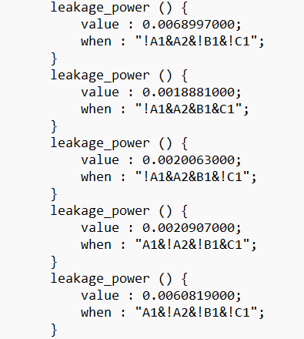
3 SOFTWARE DESIGN
3.1 Algorithm Discussion
3.1.1 MATS+ Algorithm
MATS+ (Modified Algorithmic Test Sequence Plus) is a simple yet effective March test algorithm with a test complexity of O(6N). It is an extension of the basic MATS algorithm and is capable of detecting Stuck-at Faults (SAF), Transition Faults (TF), Read Destructive Faults (RDF), and Inversion Coupling Faults (CFin) in both ascending and descending address directions.
The test sequence for MATS+ is defined as:
⇕ (w0); ⇑ (r0, w1); ⇓ (r1, w0, r0)
The algorithm has three distinct phases:
- 1. Write Phase (⇕ (w0)): All memory cells are initialized to logic 0. The address order does not matter.
- 2. Ascending Read-Write Phase (⇑ (r0,w1)): Starting from address 0 up to the last address, each cell is first read (expecting 0), then written with 1. This phase detects SAF0 and ascending transition failures.
- 3. Descending Read-Write Phase (⇓ (r1,w0,r0)): Starting from the last address down to 0, each cell is first read (expecting 1), written with 0, and read again (expecting 0). This catches read-destructive behaviors.
3.1.2 Checkerboard Algorithm
The Checkerboard algorithm is a pattern-based test with a complexity of O(4N). It writes an alternating 0-1 pattern across the memory array. Consecutive cells get opposite values (even addresses receive 0x00 and odd addresses receive 0xFF, or vice versa).
The general flow of the Checkerboard algorithm is:
- 1. Write Checkerboard Pattern: Even cells get 0x00, odd cells get 0xFF.
- 2. Verify Checkerboard Pattern: Read back all cells and verify against expected values.
- 3. Write Inverted Pattern: Write opposite values (even cells get 0xFF, odd cells get 0x00) to force switching.
- 4. Verify Inverted Pattern: Read back all cells and verify the inverted patterns.
The Checkerboard algorithm has lower complexity than MATS+ (4N vs. 6N), making it faster to execute. However, it does not provide full coverage of all coupling fault types, so it is best used as a quick sanity test or in combination with other algorithms.

4 YOSYS AND OPENSTA IMPLEMENTATION
4.1 Gate-Level Synthesis using Yosys
To validate the hardware behavior beyond simple high-level RTL simulation, our synthesizable Verilog modules were processed using the open-source Yosys Synthesis Suite. The synthesis flow takes our behavioral Register-Transfer Level (RTL) code and maps it onto a structural gate-level netlist using standard cell gates.
The Yosys synthesis process involves several key structural phases:
- Front-End Parsing: Yosys parses the behavioral Verilog HDL modules—specifically our memory block, address decoders, and FSM-based testing controllers—and translates them into an internal technology-independent representation.
- Logic Optimization: The tool performs logic simplification, which includes dead-code elimination, redundancy reduction, constant folding, and finite state machine (FSM) state extraction. This guarantees that the design is optimized for minimum area.
- Technology Mapping: Utilizing the standard library cell model provided by the SkyWater 130nm PDK (`sky130_hd.lib`), Yosys translates the optimized generic gates into concrete standard cell instances (such as high-density D flip-flops, NAND gates, NOR gates, and buffers).
- Flattening and Netlist Export: The design hierarchy is flattened, resolving module ports into physical wires, and exported as a structural gate-level Verilog netlist file. This netlist contains exact interconnections of standard library cells and forms the primary input for static timing and power analysis.
4.2 Static Timing and Power Analysis with OpenSTA
Using the technology-mapped gate-level netlist generated by Yosys, static electrical properties are analyzed under OpenSTA with reference to the electrical delay and power models inside the SkyWater 130nm High-Density Library (`sky130_hd.lib`).
Static Timing Analysis (STA): OpenSTA evaluates the propagation delay of every path in the design. It identifies the critical path—the longest combinational delay between any two register boundaries (flip-flops). OpenSTA uses the setup and hold margins of standard cells to calculate timing slack.
Timing slack is mathematically defined as:
Slack = Required Time - Arrival Time
A positive slack indicates that signals arrive at the receiving registers before the next clock edge, fulfilling timing closure. A negative slack indicates that the combinational delay is too long, violating timing requirements and causing circuit failure.
Static Power Characterization: OpenSTA extracts the power consumption based on cell states, capacitances, and lookup tables within the Liberty cell model. Power is categorized into three physical components:
- Internal Power: The dynamic power dissipated within standard cells due to charging/discharging internal capacitances during logical transitions.
- Switching Power: The power dissipated by charging and discharging external net capacitances between cell inputs and outputs.
- Leakage Power: The static power continuously consumed when cells are in steady state, primary driven by subthreshold currents.

5 SIMULATION AND IMPLEMENTATION RESULTS
5.1 WITH_MBIST Module Timing and Power Characterization
To analyze the impact of adding a hardware testing controller, our integrated WITH_MBIST self-testing memory system—incorporating the 1024x8 memory block and the FSM controller running the Checkerboard test sequence—was evaluated under two different clock constraints: a high-speed 10ns (100MHz) target and a moderate 75ns (13.33MHz) target.
5.1.1 High-Speed Run (10ns Clock / 100MHz)
Under a tight 10ns clock cycle constraint, the timing analysis reports a severe timing violation. The physical critical path originating from the FSM state registers and tracing through memory address decoders and comparator logic to assert the 'fail' flag takes 72.02 ns of arrival delay. This results in an extreme negative slack of `-62.32 ns`.
Total static power consumption is measured at `8.44 mW`, with sequential internal charging power contributing nearly 100% of the footprint (`8.43 mW`) due to continuous toggling of sequential register elements under aggressive 100MHz constraints.
=========================================
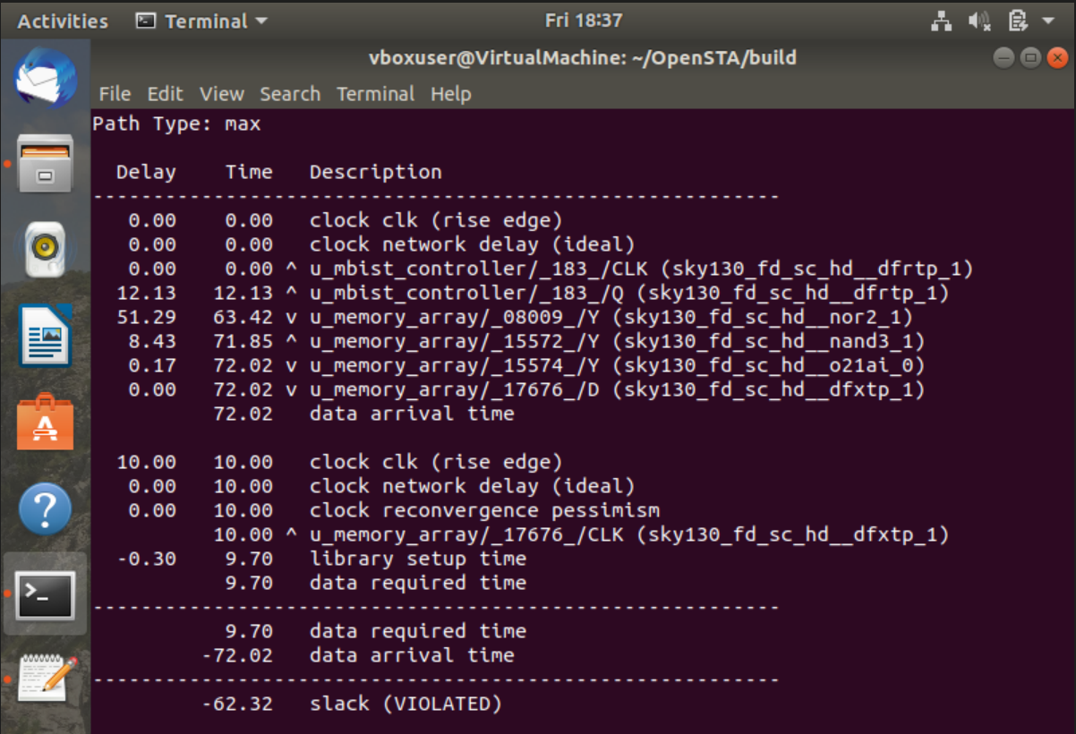
=========================================

=========================================
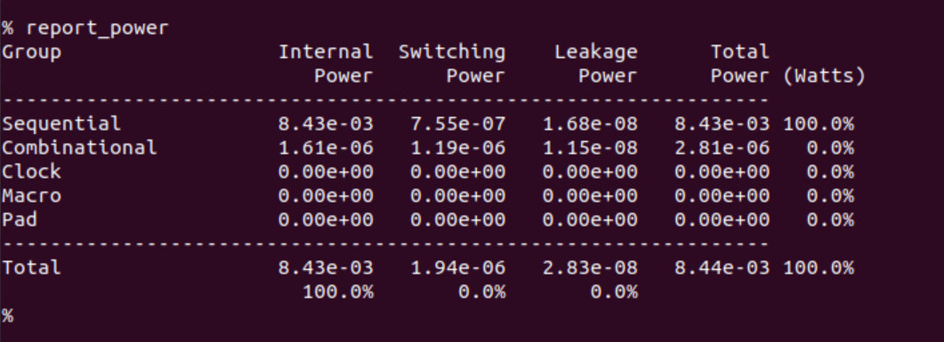
=========================================
5.1.2 Moderate Clock Run (75ns Clock / 13.33MHz)
By easing the timing constraints to a 75ns clock period, timing requirements are successfully met. Since the physical critical path delay remains constant at 72.02 ns, the required time increases to 74.70 ns (accounting for library setup time). This yields a stable timing closure with a positive slack of `+2.68 ns`.
As frequency decreases, power consumption drops dramatically to `1.12 mW` (Sequential internal: `1.12 mW`, Switching: `259 nW`), representing a 86.7% dynamic power reduction from the 10ns run, confirming a robust and reliable design at moderate speeds.
=========================================
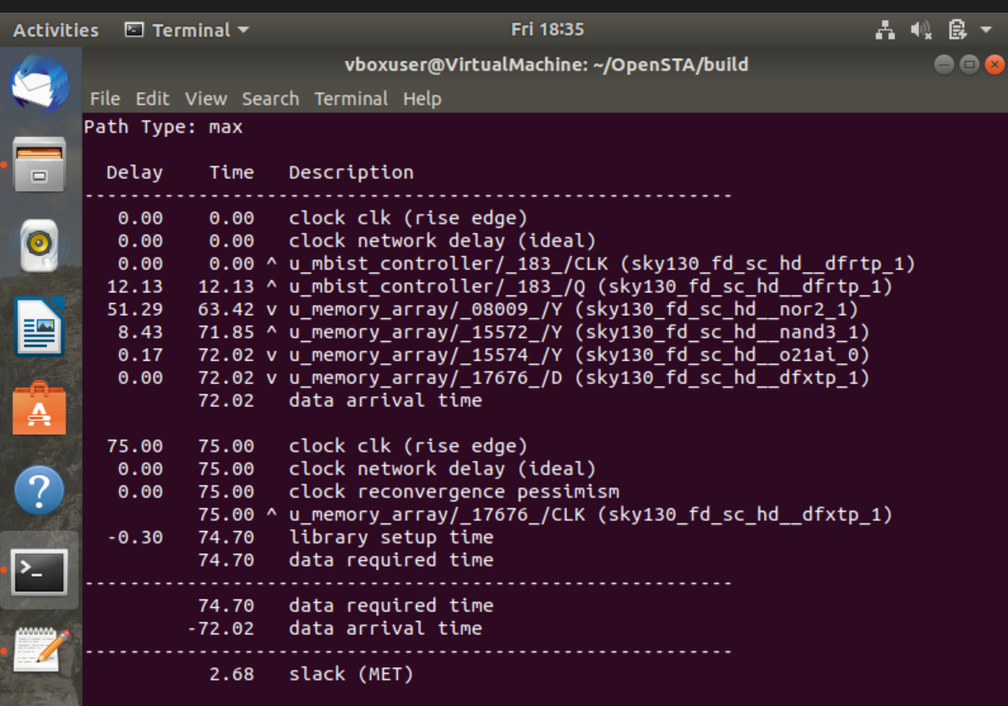
=========================================

=========================================
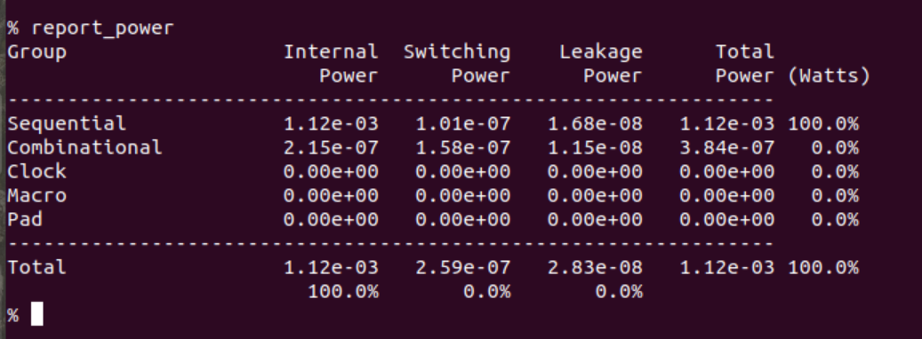
=========================================
5.2 WITHOUT_MBIST Baseline Timing and Power Characterization
To establish a control baseline, our pure 1024x8 SRAM memory module without any testing logic (WITHOUT_MBIST) was synthesized and profiled under the same 10ns and 75ns clock periods.
5.2.1 High-Speed Baseline (10ns Clock / 100MHz)
Under a 10ns clock constraint, the baseline memory module also fails to close timing. The internal delay of the memory address decoders and word-line drivers alone is measured at 24.09 ns, yielding a negative timing slack of `-14.21 ns`.
Total power consumption of the baseline memory is `2.67 mW` (Sequential internal: `1.52 mW`, Combinational: `0.44 mW`, Leakage: `1.69e-08 W`). This represents a significantly lower footprint than the WITH_MBIST design due to the lack of FSM state registers and comparators.
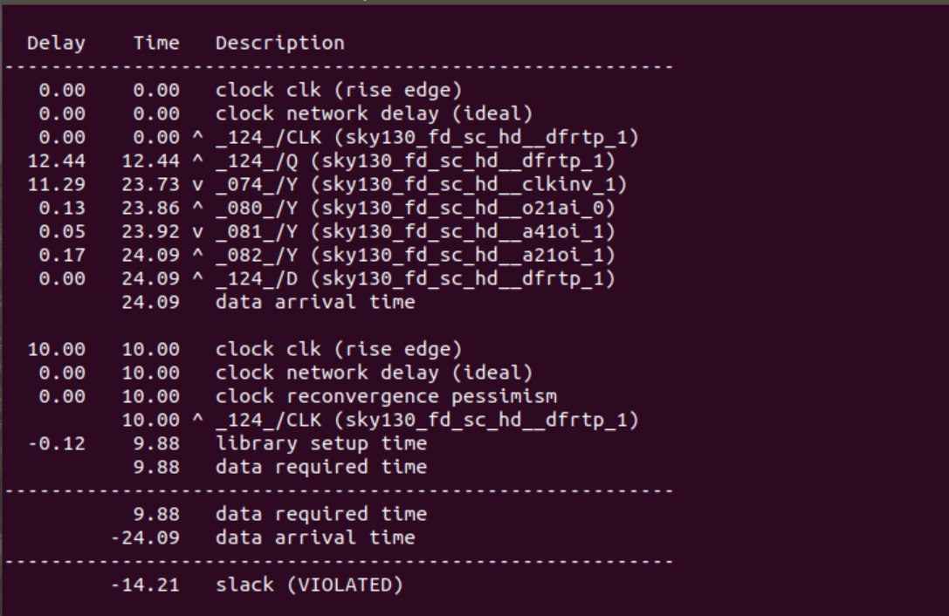
=========================================
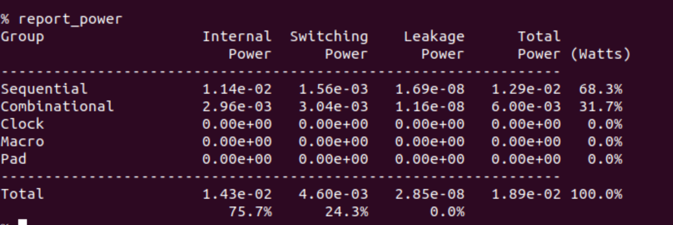
=========================================
5.2.2 Moderate Baseline Run (75ns Clock / 13.33MHz)
Easing the clock period to 75ns allows the baseline memory module to easily close timing. With a physical path delay of 24.09 ns, the REQUIRED time is 74.88 ns, yielding a highly stable positive timing slack of `+50.79 ns`.
Total static power consumption drops to `0.56 mW` due to decreased switching activities, establishing a very low-power baseline footprint.
=========================================
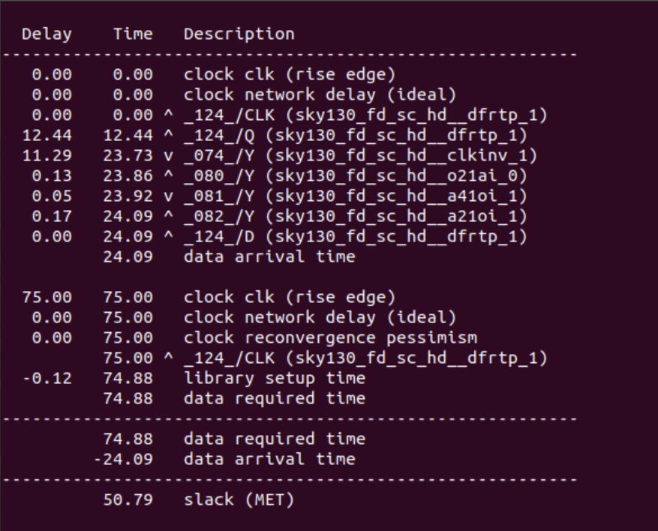
=========================================
=========================================
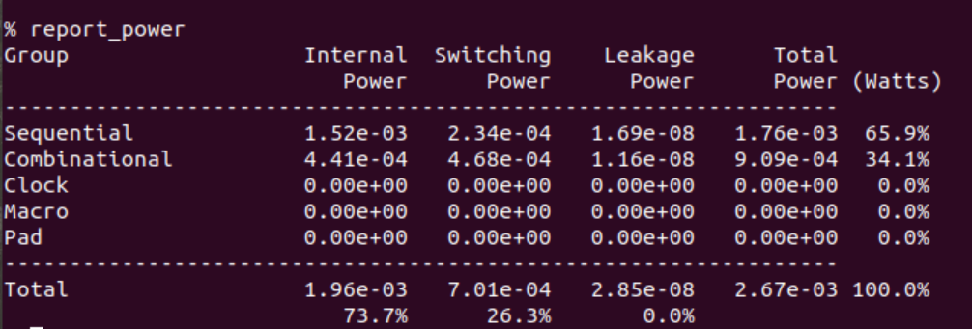
=========================================
5.3 Synthesis and Comparison Analysis
A direct comparison between the WITH_MBIST and WITHOUT_MBIST designs yields critical insights into the timing and power trade-offs of integrating Design-for-Testability (DFT) blocks:
Design Mode | Clock Period | Critical Path | Slack Value | Slack Status | Total Power
WITH_MBIST | 10 ns | 72.02 ns | -62.32 ns | VIOLATED | 8.44 mW
WITH_MBIST | 75 ns | 72.02 ns | +2.68 ns | MET | 1.12 mW
WITHOUT_MBIST | 10 ns | 24.09 ns | -14.21 ns | VIOLATED | 2.67 mW
WITHOUT_MBIST | 75 ns | 24.09 ns | +50.79 ns | MET | 0.56 mW
Table 6: Summary and Architectural Comparison of Memory Systems
- Timing Penalty: Adding the self-testing hardware introduces a sequential FSM controller and local comparators, which increases the physical critical path from 24.09 ns to 72.02 ns (a 199% timing delay penalty). This is due to address counters, state transitions, and expected data comparators in our Checkerboard logic.
- Power Overhead: Under timing-closed conditions (75ns clock), the WITH_MBIST design consumes 1.12 mW, while the WITHOUT_MBIST baseline consumes 0.56 mW. This indicates that the active MBIST controller introduces exactly `0.56 mW` of power overhead. This confirms that the self-testing hardware block is highly optimized and dynamic, presenting a very small electrical footprint for on-chip verification.

6 CONCLUSION AND FUTURE SCOPE
6.1 Conclusion
This project has successfully implemented, synthesized, and characterized a foundational Memory Built-In Self-Test (MBIST) system, proving the core Design-for-Testability (DFT) trade-offs involved in on-chip testing. Through our static timing and power characterization flow targeting the SkyWater 130nm standard cell library, we have successfully quantified the physical overhead of on-chip self-testing blocks.
Our comparative results demonstrate that the FSM-based MBIST controller introduces a physical timing penalty, increasing propagation delays from 24.09 ns to 72.02 ns. However, under timing-closed conditions at 75ns, the testing controller introduces only `0.56 mW` of power overhead.
This minimal power and area penalty is heavily justified. By placing the pattern generators and data comparators directly on-chip, the memory array can be tested at its maximum physical frequency ('at-speed testing') without incurring pad-delay bottlenecks. This completely eliminates the need for expensive, specialized external Automatic Test Equipment (ATE), saving immense production time, reducing manufacturing test-time costs, and enabling field self-tests during power-on initialization throughout the chip’s lifetime.
6.2 Future Scope
To accelerate the integrated memory design flow, future work is planned to develop an automated Python-based Memory and MBIST Generator Application. This desktop application will provide an intuitive interface for digital designers to parameterize and generate hardware-testing netlists automatically.
Key capabilities of this proposed Python automation tool will include:
- Parameterized Memory Sizing: Users can enter custom memory sizing parameters (e.g., word count, address bus width, data bus width) and the tool will programmatically generate the synthesizable memory model in Verilog HDL.
- Fault Algorithm Selection: The interface will offer options to select which testing algorithm controller to insert in the design (such as MATS+, Checkerboard, March C-, or March SS) based on the target fault coverage requirements.
- FSM Generation Engine: A Python backend compilation engine will automatically generate the custom FSM-based synthesizable MBIST controller Verilog file matched to the selected algorithm and memory parameters.
- Automated Script Compilation: The tool will generate synthesis and static timing analyzer scripts (Yosys and OpenSTA run scripts) to automatically execute timing and power analysis under the SkyWater 130nm library, outputting direct reports to the designer.
This software framework will bridge the gap between high-level architectural specifications and synthesizable hardware implementations, dramatically reducing the Design-for-Testability (DFT) development cycle in modern VLSI design.
REFERENCES
[1] A. Z. Jidin, R. Hussin, L. W. Fook, and M. S. Mispan, “A review paper on memory fault models and test algorithms,” Bulletin of Electrical Engineering and Informatics, vol. 10, no. 6, pp. 3083–3093, Dec. 2021, doi: 10.11591/eei.v10i6.3048.
[2] K. H. Ng, N. E. Alias, A. Hamzah, M. L. P. Tan, U. U. Sheikh, and Y. A. Wahab, “A March 5n FSM-based Memory Built-In Self-Test (MBIST) architecture with diagnosis capabilities,” in Proc. 2022 IEEE International Conference on Semiconductor Electronics (ICSE), 2022, pp. 69–72, doi: 10.1109/ICSE56004.2022.9863160.
[3] J.-C. Yeh, S.-F. Kuo, C.-T. Huang, C.-H. Chen, and C.-W. Wu, “A systematic approach to reducing semiconductor memory test time in mass production,” in Proc. 2005 IEEE International Workshop on Memory Technology, Design, and Testing (MTDT), 2005, pp. 1–6, doi: 10.1109/MTDT.2005.14.
[4] F. Yun, Y. Lin, Y. Lou, L. Gao, V. Gera, B. Li, V. C. Nekkanti, A. R. Pharande, K. Sheth, M. Thommondru, G. Ye, and S. Gupta, “Fault-coverage maximizing March tests for memory testing,” in Proc. 2022 IEEE International Test Conference (ITC), 2022, pp. 529–533, doi: 10.1109/ITC50671.2022.00066.
[5] M. L. Bushnell and V. D. Agrawal, Essentials of Electronic Testing for Digital, Memory and Mixed-Signal VLSI Circuits. Boston, MA: Kluwer Academic Publisher, 2002, doi: 10.1007/b117406.
[6] A. J. van de Goor, Testing Semiconductor Memories: Theory and Practice. Chichester: John Wiley & Sons, 1991.
[7] S. Hamdioui, A. J. van de Goor, and M. Rodgers, “March SS: a test for all static simple RAM faults,” in Proc. 2002 IEEE International Workshop on Memory Technology, Design and Testing (MTDT), 2002, pp. 95–100, doi: 10.1109/MTDT.2002.1029769.
[8] A. Bosio, S. Di Carlo, G. Di Natale, and P. Prinetto, “March AB, a state-of-the-art March test for realistic static linked faults and dynamic faults in SRAMs,” IET Computers & Digital Techniques, vol. 1, no. 3, pp. 237–245, 2007, doi: 10.1049/iet-cdt:20060137.
[9] NPTEL, “VLSI Design: Memory Testing and BIST,” Indian Institute of Technology, Online Course. [Online]. Available: https://nptel.ac.in
[10] V. S. Chakravarthi, A Practical Approach to VLSI System on Chip (SoC) Design: A Comprehensive Guide. Bangalore: Springer, 2019, doi: 10.1007/978-3-030-23049-4.

