ψ  

Piyush Modani
CSAI-D Roll-no -19
import pandas as pd import numpy as np
import matplotlib.pyplot as plt import seaborn as sns

from sklearn.model_selection import train_test_split
from sklearn.preprocessing import StandardScaler, LabelEncoder from sklearn.metrics import accuracy_score, classification_report from sklearn.linear_model import LogisticRegression
data = {
"EmpID": [1,2,3,4,5,6,7,8,9,10,10],
"Name": ["Amit", "Neha ", "RAHUL", "Pooja", None, "Suresh", "suresh", "Kiran", "Rohit", "Meena", "Meena
"Department": ["IT", "HR", "it ", "Finance", "IT", "HR", "HR", "Finance", "IT", "IT", "IT"],
"Experience": [2, 5, -1, 7, 0, 4, 4, 6, 3, None, None],
"Salary": [30000, 45000, 40000, 60000, 30000, 42000, 42000, "55000", 38000, 50000, 50000],
"Rating": [3, 4, 2, 5, 3, 4, 4, 5, 3, 4, 4],
"Promoted": ["Yes", "Yes", "No", "Yes", "No", "Yes", "Yes", "Yes", "No", "Yes", "Yes"]
}

df = pd.DataFrame(data)

summary = pd.DataFrame({
"Minimum": df.select_dtypes(include=np.number).min(), "Maximum": df.select_dtypes(include=np.number).max(), "Mean": df.select_dtypes(include=np.number).mean(),
"Range": df.select_dtypes(include=np.number).max() - df.select_dtypes(include=np.number).min()
})

print(summary)
df.describe(include='object')

 | EmpID | Experience | Rating
count | 11.000000 | 9.000000 | 11.000000
mean | 5.909091 | 3.333333 | 3.727273
std | 3.176619 | 2.645751 | 0.904534
min | 1.000000 | -1.000000 | 2.000000
25% | 3.500000 | 2.000000 | 3.000000
50% | 6.000000 | 4.000000 | 4.000000
75% | 8.500000 | 5.000000 | 4.000000
max | 10.000000 | 7.000000 | 5.000000

 | Minimum | Maximum | Mean | Range
EmpID | 1.0 | 10.0 | 5.909091 | 9.0
Experience | -1.0 | 7.0 | 3.333333 | 8.0
Rating | 2.0 | 5.0 | 3.727273 | 3.0

 | Name | Department | Salary | Promoted
count | 10 | 11 | 11 | 11
unique | 9 | 4 | 8 | 2
top | Meena | IT | 30000 | Yes
freq | 2 | 5 | 2 | 8

df["Salary"] = pd.to_numeric(df["Salary"], errors="coerce")
print("Minimum Salary:", df["Salary"].min())
print("Maximum Salary:", df["Salary"].max())
print("Mean Salary:", df["Salary"].mean())
Minimum Salary: 30000
Maximum Salary: 60000
Mean Salary: 43818.181818181816
print("Median Salary:", df["Salary"].median())
print("Mode Department:", df["Department"].mode())
Median Salary: 42000.0
Mode Department: 0 IT
Name: Department, dtype: object
print("Salary Range:", df["Salary"].max() - df["Salary"].min())
Salary Range: 30000
print("Variance:", df["Salary"].var())
print("Standard Deviation:", df["Salary"].std())
Variance: 90163636.36363637
Standard Deviation: 9495.453457504616
print("25th Percentile:", df["Salary"].quantile(0.25)) print "50th Percentile:", df["Salary"].quantile(0.50))

25th | Percentile: | 39000.0
50th | Percentile: | 42000.0
75th | Percentile: | 50000.0

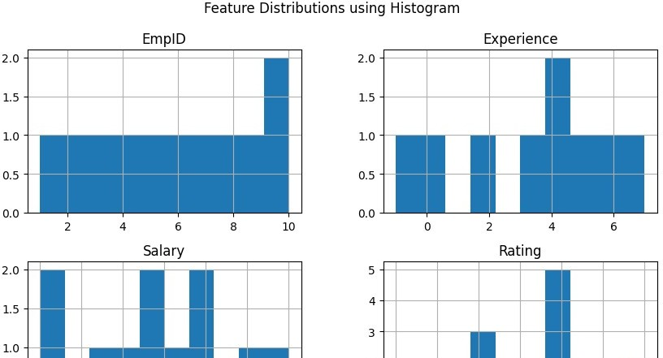
numerical_df = df.select_dtypes(include=np.number)
print("75th Percentile:", df["Salary"].quantile(0.75))

numerical_df.hist(bins=10, figsize=(10,6)) plt.suptitle("Feature Distributions using Histogram") plt.show()

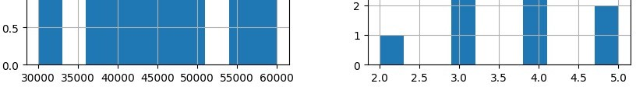

df["Name"].fillna("Unknown", inplace=True) df["Experience"].fillna(df["Experience"].mean(), inplace=True)

/tmp/ipython-input-1719797850.py:1: FutureWarning: A value is trying to be set on a copy of a DataFrame or S The behavior will change in pandas 3.0. This inplace method will never work because the intermediate object

For example, when doing 'df[col].method(value, inplace=True)', try using 'df.method({col: value}, inplace=Tr

df["Name"].fillna("Unknown", inplace=True)
/tmp/ipython-input-1719797850.py:2: FutureWarning: A value is trying to be set on a copy of a DataFrame or S The behavior will change in pandas 3.0. This inplace method will never work because the intermediate object

For example, when doing 'df[col].method(value, inplace=True)', try using 'df.method({col: value}, inplace=Tr

df["Experience"].fillna(df["Experience"].mean(), inplace=True)
df.drop_duplicates(inplace=True)
df.loc[df["Experience"] < 0, "Experience"] = 0
df["Name"] = df["Name"].str.strip().str.title() df["Department"] = df["Department"].str.strip().str.upper()

dept_location = {
"Department": ["IT", "HR", "FINANCE"],
"Location": ["Pune", "Mumbai", "Delhi"]
}

df_dept = pd.DataFrame(dept_location)
df = pd.merge(df, df_dept, on="Department", how="left")
from sklearn.preprocessing import LabelEncoder

encoder = LabelEncoder()
df["Promoted"] = encoder.fit_transform(df["Promoted"]) df["Department"] = encoder.fit_transform(df["Department"])
from sklearn.preprocessing import StandardScaler

scaler = StandardScaler()
df[["Experience", "Salary", "Rating"]] = scaler.fit_transform( df[["Experience", "Salary", "Rating"]]
)
from sklearn.model_selection import train_test_split from sklearn.linear_model import LogisticRegression
from sklearn.metrics import accuracy_score, classification_report

X = df[["Experience", "Salary", "Rating"]] y = df["Promoted"]

y_pred = model.predict(X_test)

print("Accuracy:", accuracy_score(y_test, y_pred)) print(classification_report(y_test, y_pred))
/usr/local/lib/python3.12/dist-packages/sklearn/metrics/_classification.py:1565: UndefinedMetricWarning: Pre
_warn_prf(average, modifier, f"{metric.capitalize()} is", len(result))
/usr/local/lib/python3.12/dist-packages/sklearn/metrics/_classification.py:1565: UndefinedMetricWarning: Pre
_warn_prf(average, modifier, f"{metric.capitalize()} is", len(result))
/usr/local/lib/python3.12/dist-packages/sklearn/metrics/_classification.py:1565: UndefinedMetricWarning: Pre
_warn_prf(average, modifier, f"{metric.capitalize()} is", len(result))
X_train, X_test, y_train, y_test = train_test_split(
X, y, test_size=0.2, random_state=42
)
▾ LogisticRegression
i ?
LogisticRegression()
model = LogisticRegression() model.fit(X_train, y_train)

Accuracy: 0.5 | precision | recall | f1-score | support
0 | 0.00 | 0.00 | 0.00 | 1
1 | 0.50 | 1.00 | 0.67 | 1
accuracy |  |  | 0.50 | 2
macro avg | 0.25 | 0.50 | 0.33 | 2
weighted avg | 0.25 | 0.50 | 0.33 | 2

