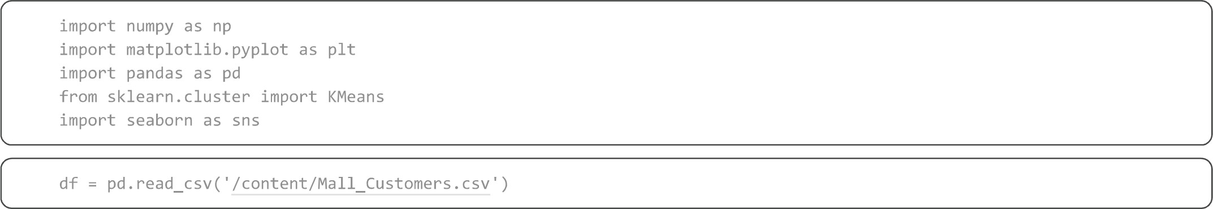
print(df)
CustomerID  1  - 2  - 3  - 4  - 5  - 196  - 197  - 198  - 199  - 200  [200 rows x 5 | Genre  Male  Male  Female  Female  Female  Female  Female  Male Male  columns] | Age 19  21  20  23  31  35  45  32  32  30 | Annual | Income | (k$)  15  15  16  16  17  120  126  126  137  137 | Spending Score | (1-100)  39  81  6  77  40  79  28  74  18  83
df.head() df.tail()
CustomerID Genre Age Annual Income (k$) Spending Score (I-lee)
- 196 Female 35 120 79
- 197 Female 45 126 28 197 198 Male 32 126 74
- 199 Male 32 137 18
- 200 M ale 30 137 83
sns . boxplot (df)
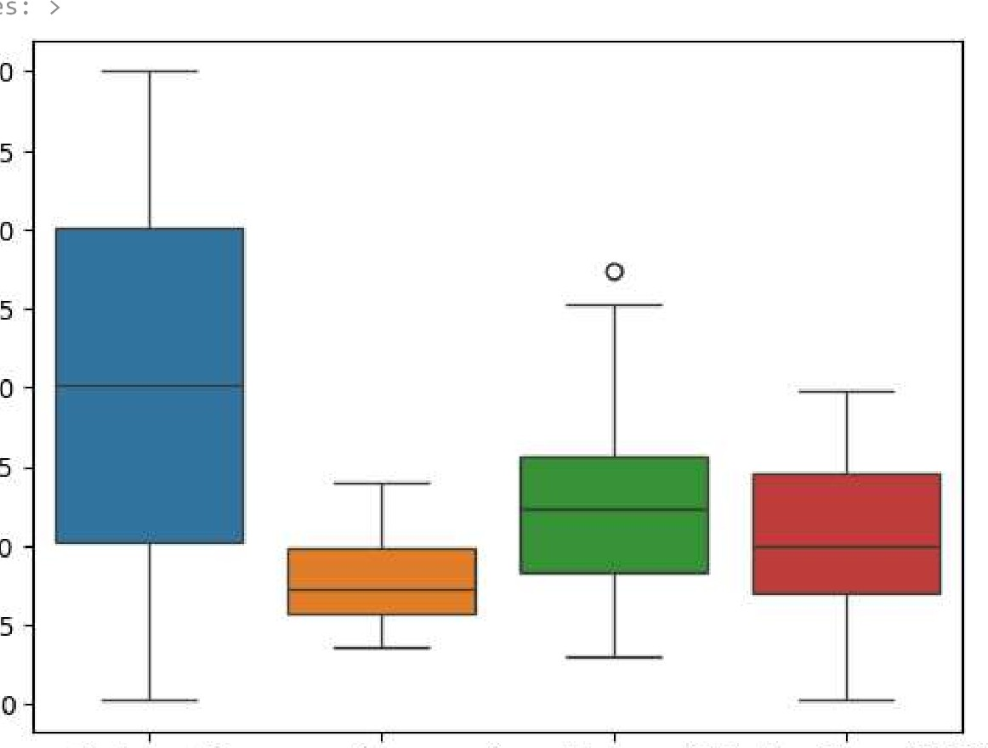
<Axes :
200
175
150
125
100
75
50
25
CustomerlD Age Annual Income $$nding Score (1-100)

Q3 = numeric_df.quanti1e(Ø.75)  IQR = QB - QI  # Remove outliers clean df =  print (clean_df) |  | (numeric_df |  | - 1.5*1QR)) | (numeric_df > (Q3 + 1. 5*IQR) ) ) .any(axis=1)]
CustomerID  1  - 2  - 3  - 4  - 5  - 194  - 195  - 196 196 197  197 198  [198 rows x 4 | Age 19  21  20  23  31  38  47  35  45  32  columns] | Annual Income | (k$)  15  15  16  16  17  113  120  120  126  126 | Spending Score | (1-100)  39  81  6  77  40  91  16  79  28  74
sns . boxplot (df)
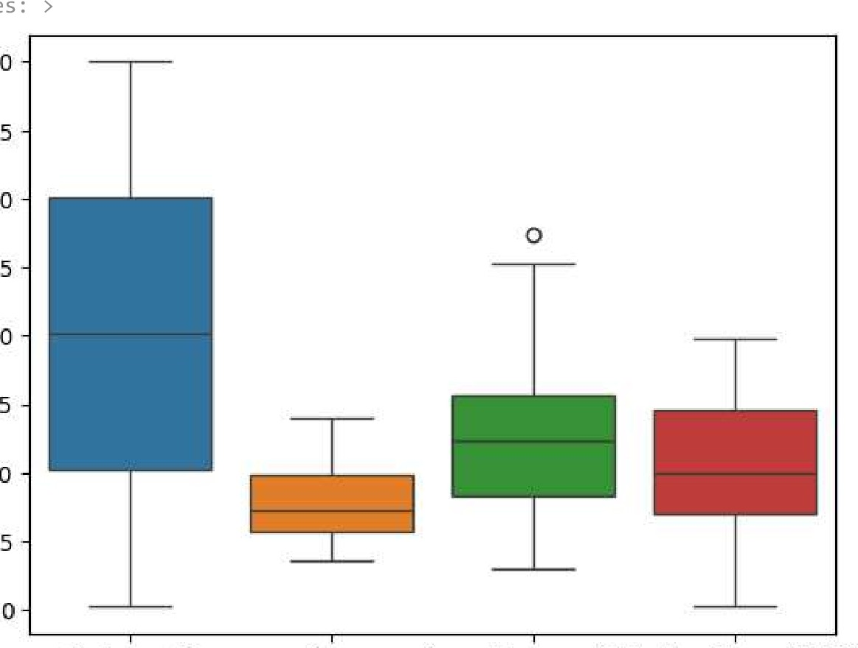
<Axes :
200
175
150
125
100
75
50
25
CustomerlD Age Annual Income $$nding Score (1-100)
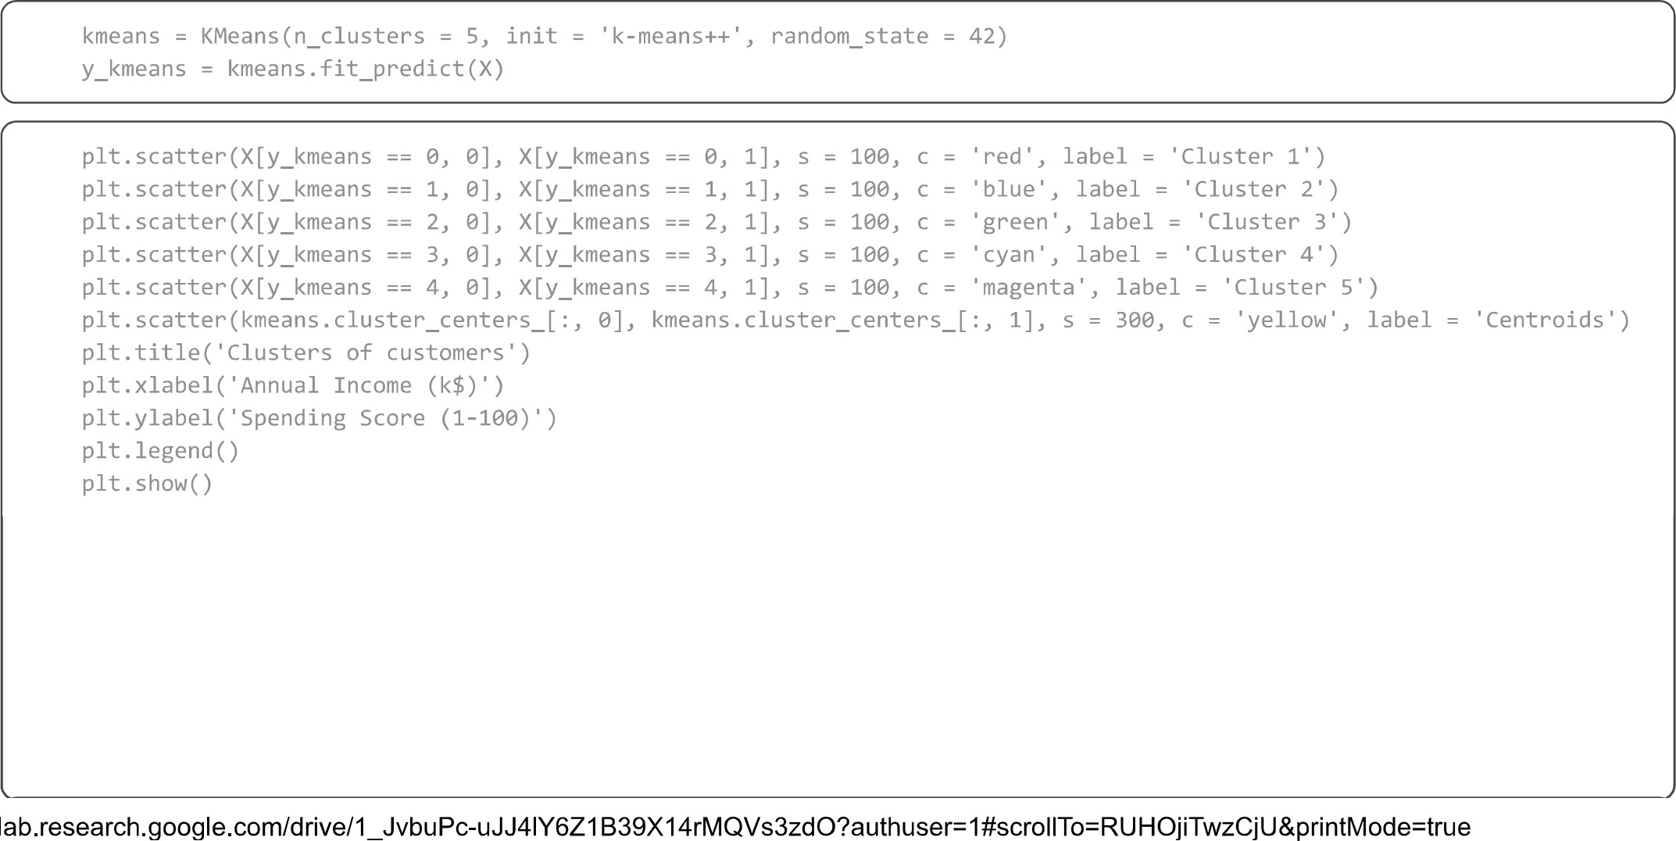
Clusters of customers
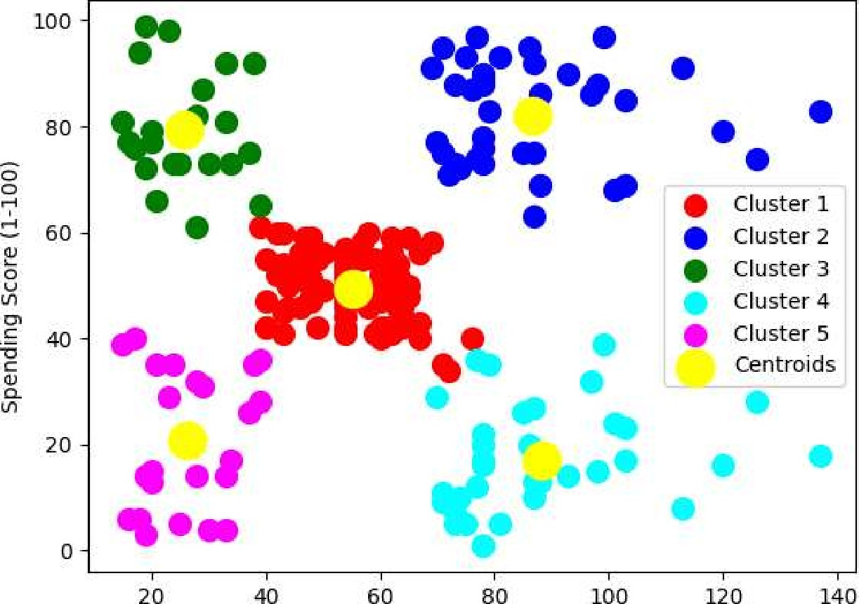
Annual Income (1<$)

