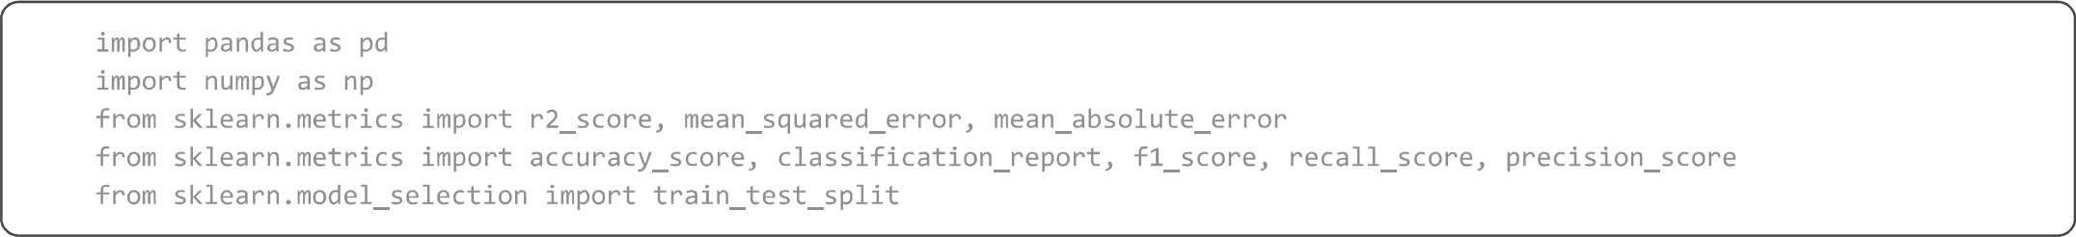
pd . read_csv( ' / content/ temperatures . csv ' ) df. head()
JAN- MAR- JUN- OCT-
YEAR JAN FEB MAR APR MAY JUN JUL AUG SEP OCT NOV DEC ANNUAL
FEB MAY SEP DEC
o 1901 22.40 24.14 29.07 31 .91 33.41 33.18 31 .21 30.39 30.47 29.97 27.31 24.49 28.96 23.27 31.46 31.27 27.25
- 1902 24.93 26.58 29.77 31.78 33.73 32.91 30.92 30.73 29.80 29.12 26.31 24.04 29.22 25.75 31.76 31.09 26.49
- 1903 23.44 25.03 27.83 31.39 32.91 33.00 31.34 29.98 29.85 29.04 26.08 23.65 28.47 24.24 30.71 30.92 26.26
- 1904 22.50 24.73 28.21 32.02 32.64 32.07 30.36 30.09 30.04 29.20 26.36 23.63 28.49 23.62 30.95 30.66 26.40
- 1905 22.00 22.83 26.68 30.01 33.32 33.25 31.44 30.68 30.12 30.67 27.52 23.82 28.30 22.25 30.00 31.33 26.57
print(df. info() ) print(df.describe())
- FEB  - MAR  - APR  - MAY  - JUN  - JUL  - AUG  - SEP  - OCT  - NOV  - DEC  13  14  15  16  17 dtypes:  memory None  count mean std min 25%  50% 75% max  count mean std min  25%  50 % 75% max  count mean std min 25%  50 % | 117  117  117  117  117  117  117  117  117  117  117 ANNUAL 117  JAN-FEB 117  MAR-MAY 117  JUN-SEP 117  OCT-DEC 117 float64(17), usage: 16.6  YEAR 117. ooeeee  1959. eoeeee  33. 919021  1901. ooeeee  1930. 000000  1959. ooeeee  1988. ooeeee  2017. ooeeee  MAY 117. oooeee  33.565299  o. 724905  31.930000  33 . 110000  33 . 510000  34.030000  35 .840000  NOV 117. oooeee  27 . 285470 o. 714518  25 .700000  26. 790000  27 . 300000 | non-null non-null non-null non-null non-null non-null non-null non-null non-null non-null non-null non-null non-null non-null non-null non-null int64(1)  KB  JAN 117. eooooo  23 .687436 e. 834588  - .000000 23 . 100000  - .680000  24. 180000  26 .940000  JUN 117. eeoooo  32 . 774274 e. 633132  31.100000  32 . 340000  - .730000  - .180000  34.480000  DEC 117. eeøøoo  24. 608291  782644  23 .020000  24.040000  24.660000 | float64 float64 float64 float64 float64 float64 float64 float64 float64 float64 float64 float64 float64 float64 float64 float64  FEB 117. oooeee  25. 597863  1.150757  22 . 830000  24. 780000  - .480000  - . 310000  29 . 720000  JUL 117. oooeee  31.035897  0.468818  29 . 760000  - 740000  31.000000  - 330000  32 . 760000  ANNUAL 117. oooeee  29.181368  0.555555  28 . 110000  - . 760000  - .090000 | MAR  117. eeeeee  29 .085983  1 .068451 26 .680000 28 .  29 .040000 29 .  32 .620000  AUG  117. eeeeee  30 . 507692  0.476312  - .310000  - . 180000  30 . 540000  30.76eeee  31.840000  JAN-FEB  117. eeeeee  24.629573 e. 911239  22 .250000  24. 110000  24. 530000 | APR 117. oeeooe  31.975812  o. 889478  30.010000 31 .460000  31.950000  32 .420000  35 . 380000  SEP 117. oeeeoo  30.486752 e. 544295  - .070000  - . 120000  30 . 520000  30 .810000  32 . 220000  MAR-MAY 117. oeeeoo  31 . 517607 e. 740585  29 .920000  31 . 040000  31.470000 | OCT 117. eooeee  29 . 766581 e. 705492  27 .900000  29. 380000  29 .780000  32.290000  JUN-SEP  117. eooeee  31 . 198205  0.420508  30 .240000  30. 920000  31 .190000
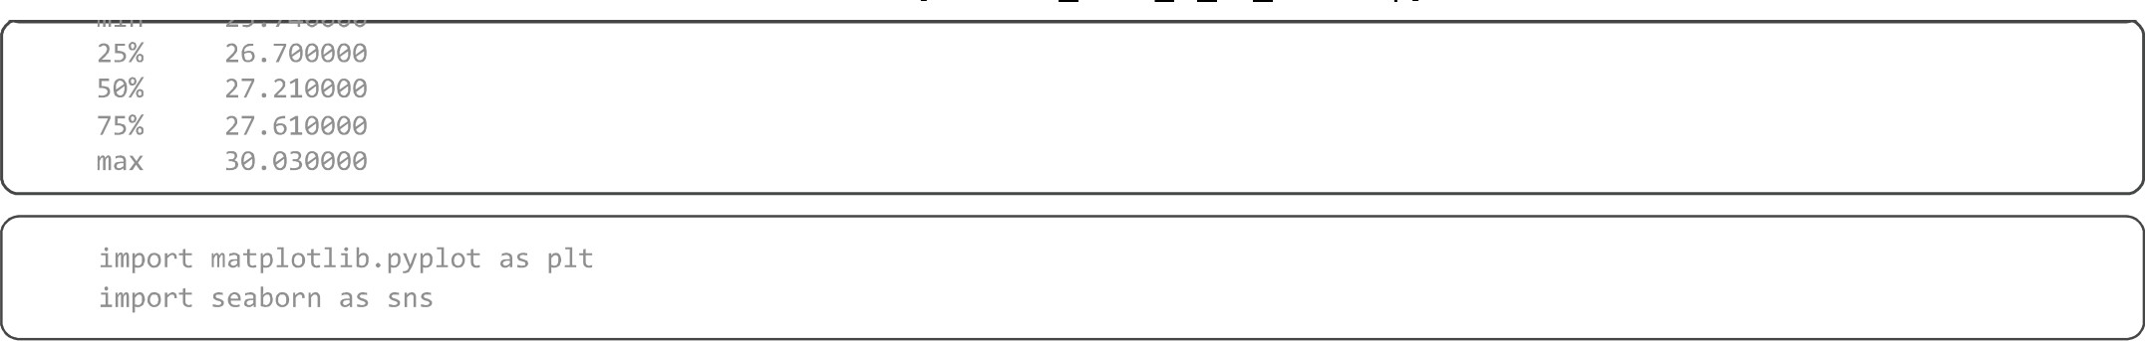
numerical cols = [ ' JAN' , ' FEB' , 'MAR' , 'APR , 'MAY' , ' JUN' , 'JUL' , ' AUG' , 'SEP' , 'OCT' , 'NOV' , 'DEC' , print(f"Shape of DataFrame: {df.shape}") df cleaned = df.copy()  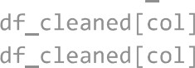  for col in numerical cols:  = . quanti1e(0.25)  Q3 = . quanti1e(0.75)  IQR = QB - QI lower_bound = QI - 1.5 * IQR upper_bound = Q3 + 1.5 * IQR  df cleaned = df_cleaned[(df_cleaned[col] >= lower_bound) & (df_cleaned[col] <= upper_bound) ] print(f"Shape of DataFrame outlier removal: {df_cleaned.shape}") df = df_cleaned.copy() | ' ANNUAL ' ]
Shape of DataFrame: (117, 18)
Shape of DataFrame outlier removal: (101, 18)
plt.figure(figsize=(8, 6)) sns. ' ANNUAL ' ] ) plt.title( 'Boxplot of Annual Temperature plt.ylabel( ' Annual Temperature' ) linestyle=' - ' alpha=e . 7) plt. show()
Boxplot of Annual Temperature
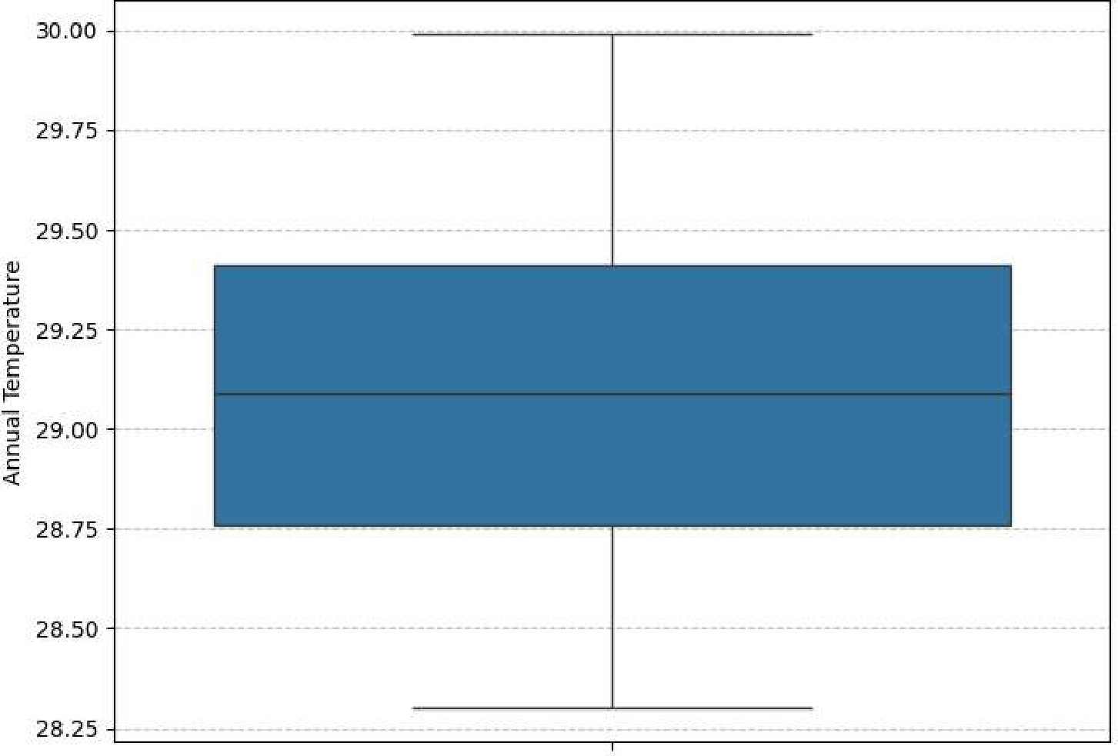
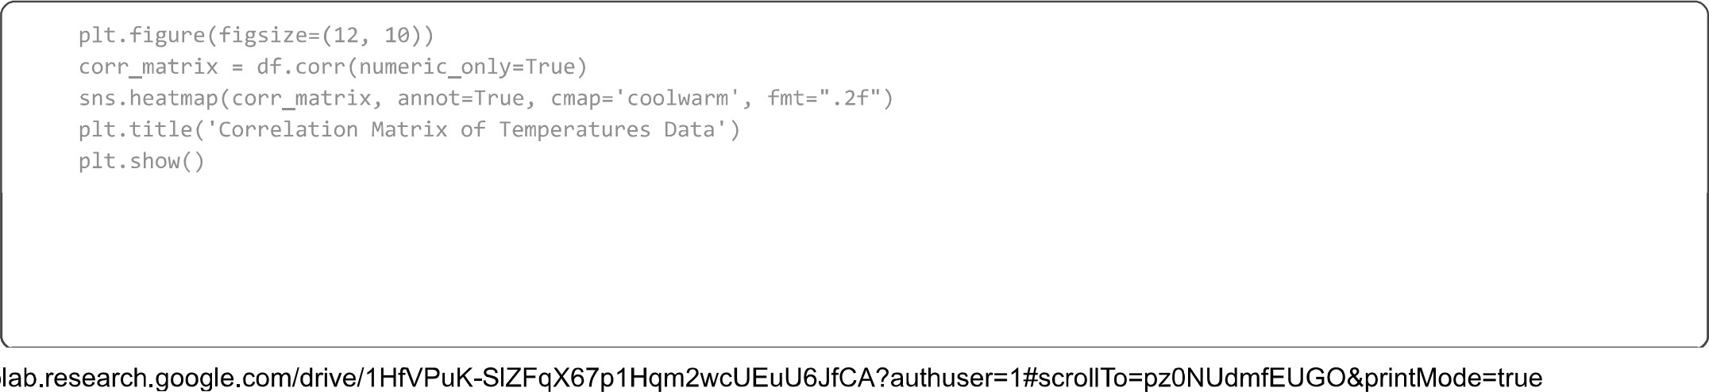

YEAR  JAN 0.48  FEB - 0.58  MAR 0.48  APR 0.41  MAY 0.34  JUN 0.27  JUL 0.39  AUG 0.60  SEP 0.60  OCT- 0.53  NOV 0.67  DEC 0.70  ANNUAL  IAN-FEB 0.63  MAR-MAY - 0.58  JUN-SEP 0.64  OCT-DEC 0.75 | 0.48  0.46  0.28  0.40  0.12 o. 35  0.34  0.40  0.60  0.36  0.30  0.41 | 0.58  0.46  0.49 o. 37  -0.23  0.35  0.32  0.36  0.46  0.72  0.51  0.42  0.47  ca | 0.48  0.28  0.49  1.00  0.45  0.11  0.05  0.13  0.30  0.35  0.59  0.46  0.34 | 0.41  0.40  0.37  1.00  0.12  0.06  0.30  0.23  -4  0.31  0.35  0.62  0.48  0.37 | Correlation  0.34  1.00  0.12  0.16  0.42  0.35  0.48  0.58  0.30  0.36 | 0.12  0.12  1.00  0.34  0.29  0.37  0.66 | Matrix  0.39  0.32  0.06  0.16  0.54  0.44  0.48  0.47  0.29  0.47  0.29  0.45 | of  0.60  o. 35  0.54  o. 55  0.54  0.48  0.48  0.67  0.37  0.42  0.56 | 0.60  0.35  0.32  0.44  0.55  0.56  0.59  0.50  0.63  0.39  0.28  0.68  0.64 | Temperatures  0.53  0.29  0.35  0.48  0.54  0.56  0.69  0.62  0.64  0.28  0.31  0.56 | 0.67  0.34  0.36  0.30  0.31  0.35  0.29  0.47  0.48  0.59  0.69  0.67  0.73  0.40  0.41  0.62  0 | Data  0 70  0.40  0.46  0.35  0.35  ț0Jż9  0.48  o. 50  0.62  0.67  1.00  o. 76  o. 50  0.45  0.50 | 0.60  o. 72  0.59  0.62  0.48  0.37  0.47  0.67  0.63  0.64  0.73  0.77  o. 74  Z | 0.63  0.46  0.48  029  0.37  0.39  10.28  0.40  0.53  0.43  0.50  Z | 0.58  0.36  0.51  0,80  0,58  0.42  0.28  0.31  0.41  0.77  0.53  0.35  0.48 | 0.64  0.30  0.42  0.21  0.30  0.66  0,75  0,68  0.56  0.62  0 74  0.43  0.35  1.00  0.62  z | o. 75  0.41  0.47  0.3î  0.21  0.4  0.56  o. 64 o.B9  0.50  0.48  1.00 | 1.0  0.8  - 0.6  - 0.4  0.2
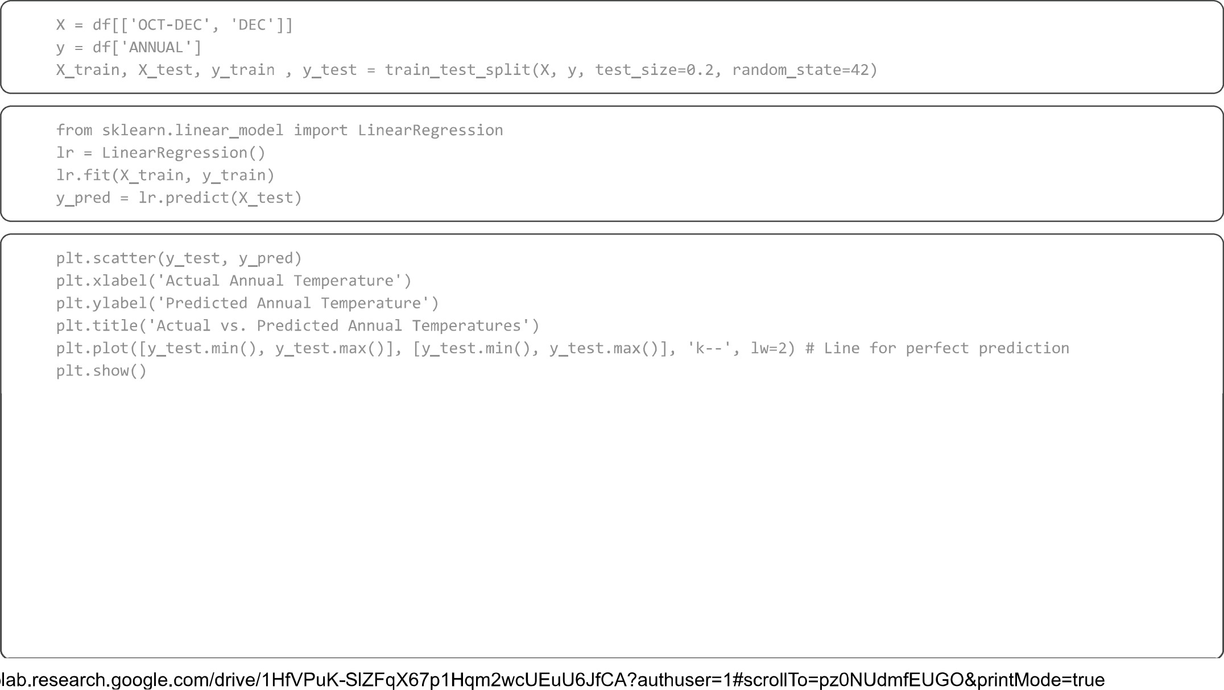
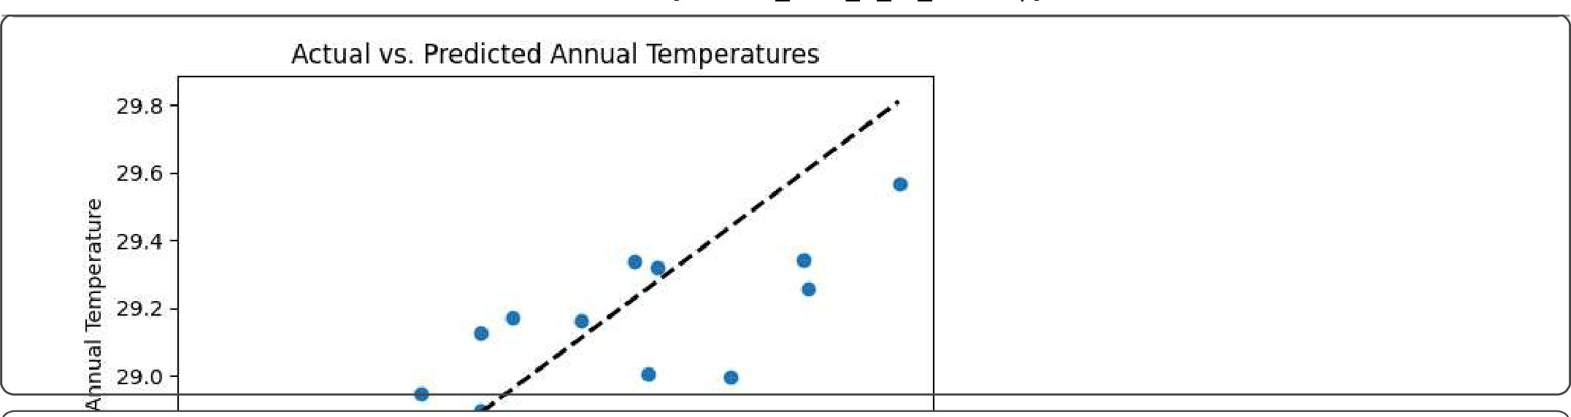
r2 = r2_score(y_test, y_pred) print( 'R2 Score:
mse = mean_squared_error(y_test, y_pred) print( 'Mean Squared Error: ' , mse)
Mean Squa | 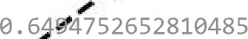  ed'Error: e. 05143334480482687
wcss = max k = 10
for i in range(l, max_k + 1) :
kmeans model = KMeans(n_c1usters=i, random state=42, n_init=10) kmeans_model . fit (X) wcss . append (kmeans_model . inertia_)
plt.figure(figsize=(10, 6)) plt.plot(range(l, max_k + 1) , wcss, marker='o' linestyle= ' -- ' ) plt.tit1e('E1bow Method for Optimal K' ) plt.x1abe1('Number of Clusters (K) plt.ylabel( 'WCSS (Within-Cluster Sum of Squares) ' ) plt.grid(True, linestyle= ' -- ' , alpha=Ø.6) plt.xticks(range(l, max_k + 1) ) plt . show( ) print("lnterpret the plot above to find the 'elbow' point, which suggests the optimal number of clusters. ")
Elbow Method for Optimal K
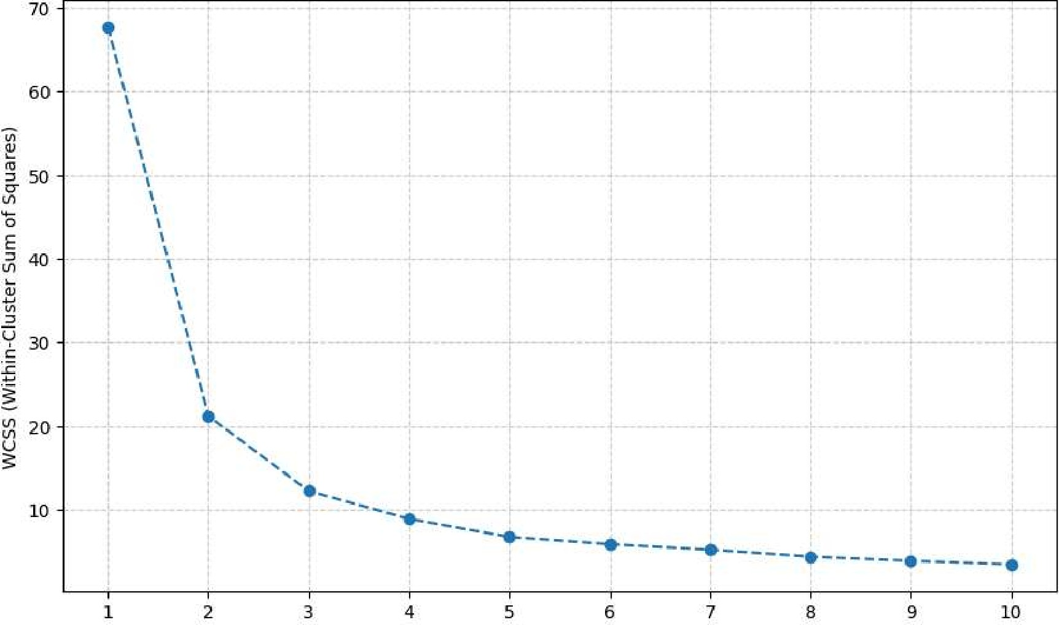
Number of Clusters (K)
Interpret the plot above to find the ' elbow ' point, which suggests the optimal number of clusters.
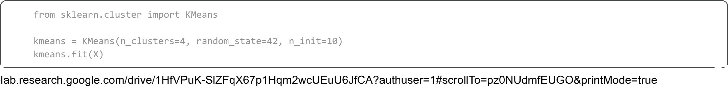
clusters = kmeans.labels
df clustered = df.copy() df_clustered[ ' Cluster' ] = clusters
plt.figure(figsize=(10, 7)) sns. OCT-DEC' , DEC' , hue= 'Cluster' , data=df_clustered, palette= 'viridis' , Flee, alpha=e . 8) plt . scatter(kmeans . : , 0], kmeans.cluster_centers_[:, s=300, red' , marker='X', label='Centroids' ) plt.title( 'K-Means Clustering of Temperature Data (OCT-DEC vs. DEC) with 4 Clusters' ) plt.xlabel( 'OCT-DEC Temperature' ) plt.ylabel( 'DEC Temperature' ) PIt . legend() plt.grid(True, linestyle=' -- ' , alpha-0.6)
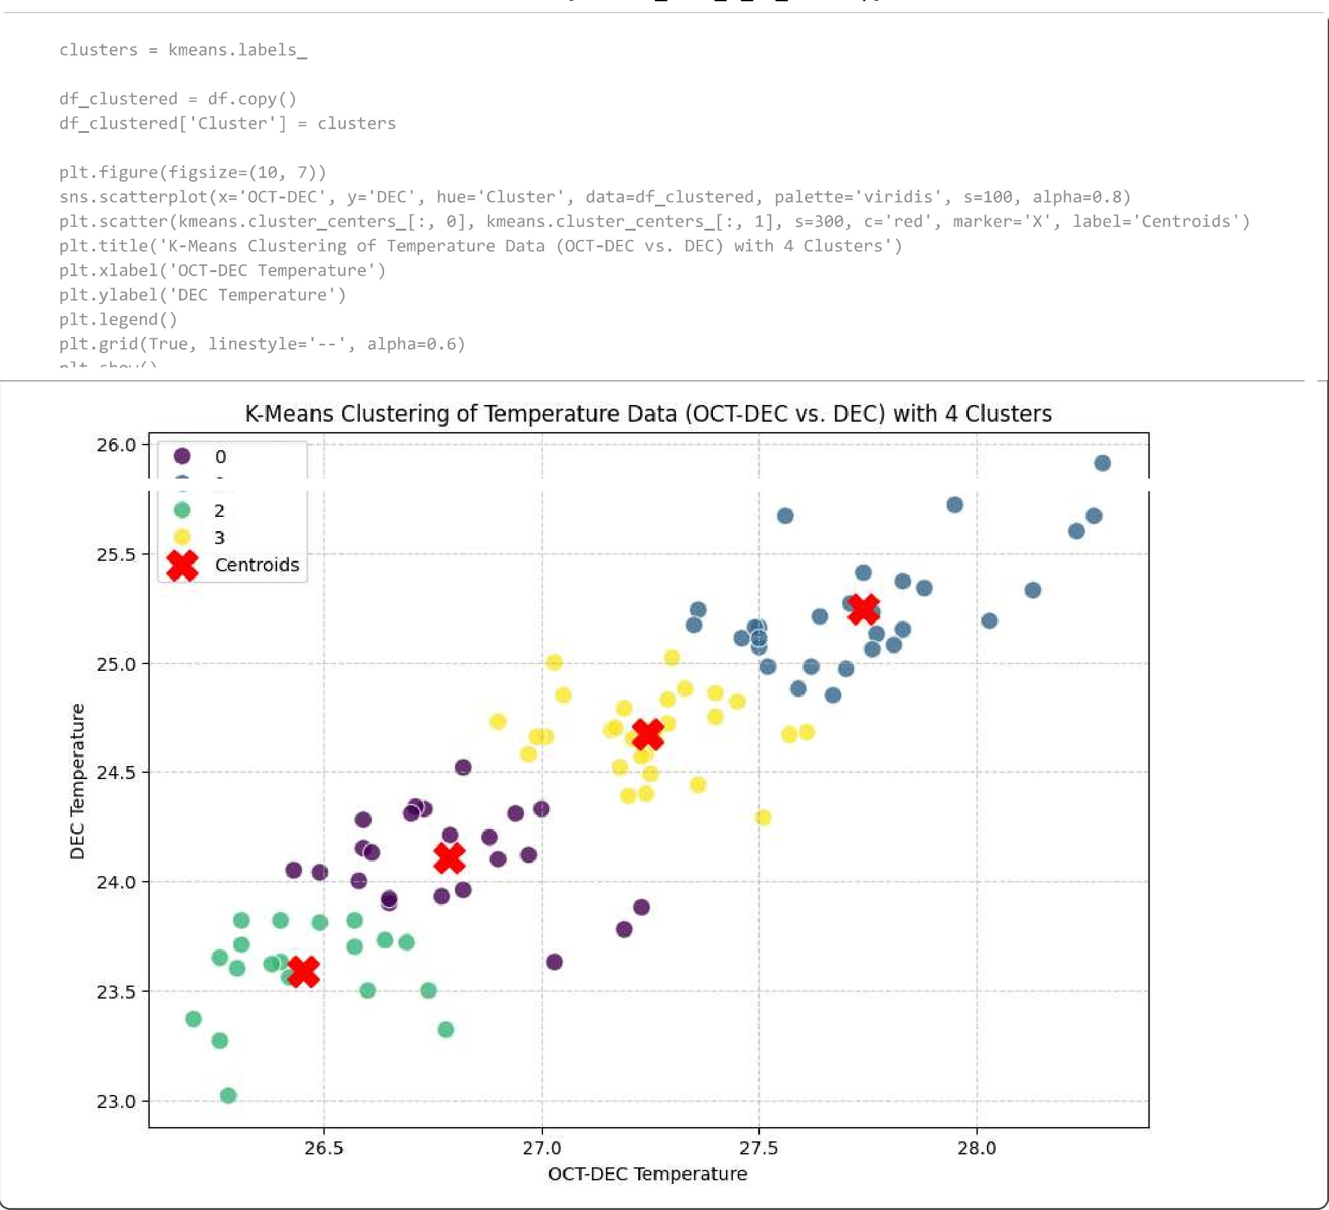
from sklearn.metrics import silhouette_score
score = silhouette_score(X, clusters) print(f"Si1houette Score for 4 clusters: {score:
Silhouette Score for 4 clusters: 0.4379

