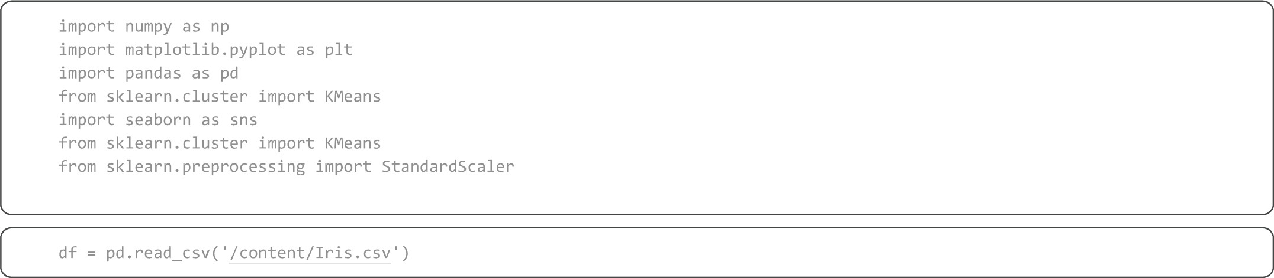
print(df)
o  1  2  3  4  145  146  147  148  149  1  2  3  4  145  146 147  148  149  [150 | Id SepalLengthCm  1  2  3  4  5  146  147  148  149  150  Species  Iris-setosa  Iris-setosa  Iris-setosa  Iris-setosa  Iris-setosa  Ins• -virginica Irxs• -virginica Iris-virginica Iris-virginica Iris• -virginica  rows x 6 columns] | 5.1  4.9  4.6  5 .0  6. 3  6. 5  6.2  5.9 | SepalWidthCm 3. 5  3.0  3. 2  3. 1  3. 6  3.0  2. 5  3.0  3.4  3.0 | PetalLengthCm  1.4  1.4  1.3  1. 5  1.4  5 .2  5 .0  5 .2  5 .4  5 .1 | PetalWidthCm  0. 2  0. 2  0. 2  0. 2  0. 2  2. 3  1.9  2.0  2. 3  1.8
df. head() df.tail()
Id SepalLengthCm SepalWidthCm PetalLengthCm PetalWidthCm Species
- 146 6.7 3.0 5.2 2.3 Iris-virginica
- 147 6.3 2.5 5.0 1.9 Iris-virginica
- 148 6.5 3.0 5.2 2.0 Iris-virginica
- 149 6.2 3.4 5.4 2.3 Iris-virginica
- 150 5.9 3.0 5.1 1.8 Iris-virginica

1/4
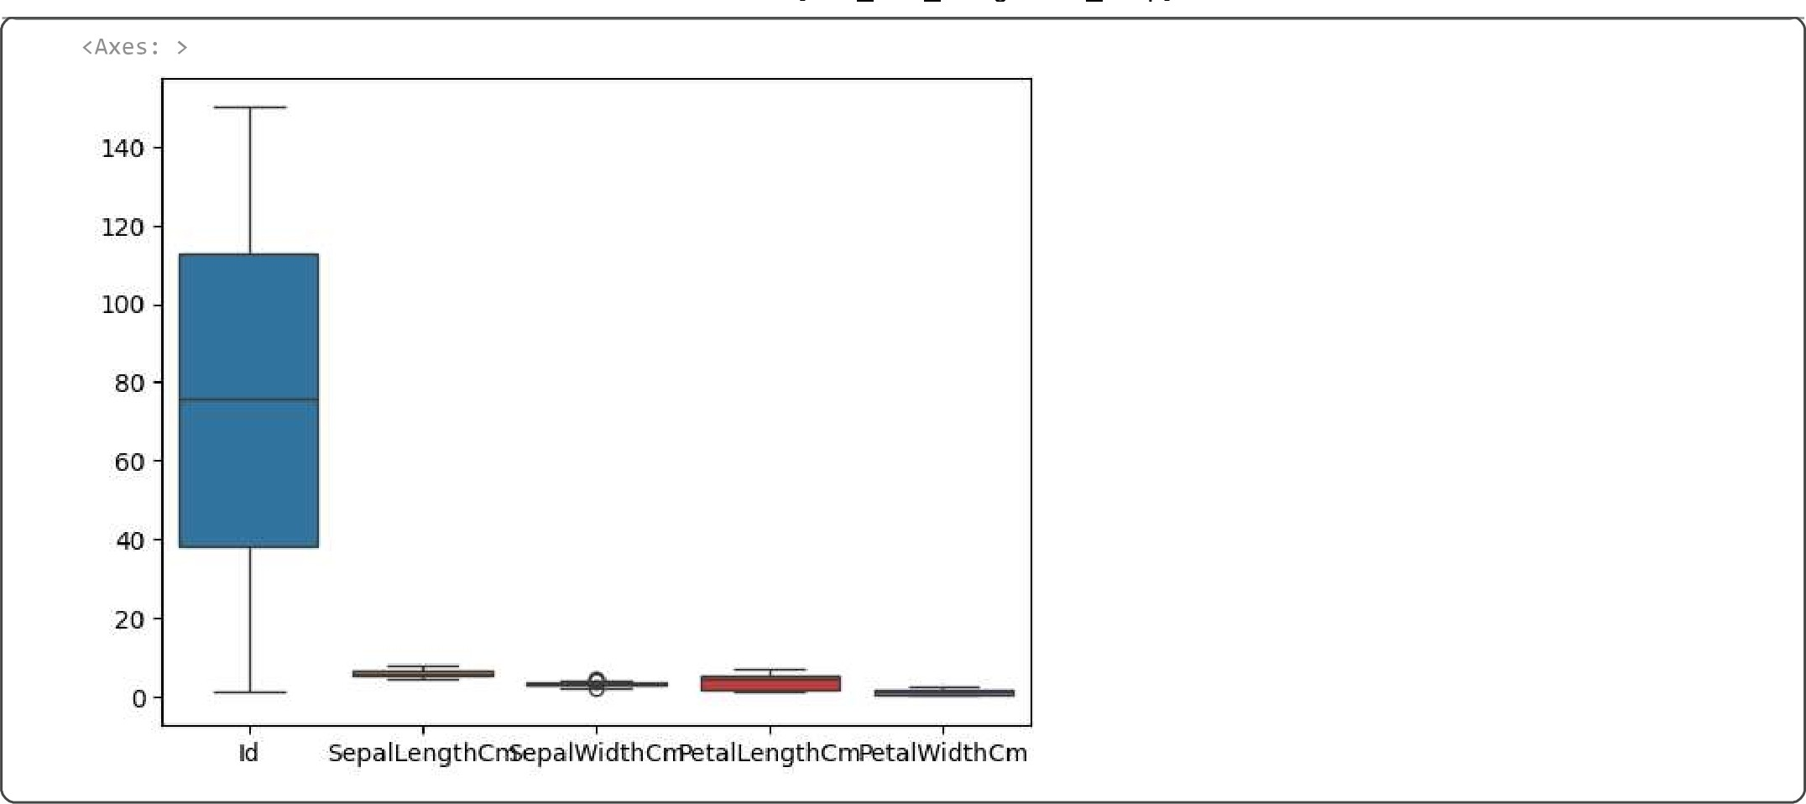
numeric df = df . select_dtypes  = numeric_df.quanti1e(0.25) numeric_df . quanti1e(Ø . 75)  IQR  # Remove outliers clean df  print(clean_df) |  |  | ' number ' ] )  (QI - 1.5*1QR)) I (numeric_df > (Q3 + 1.5*IQR))) .any(axis=1)]
o  1  2  3  4  145 146 147  148  149  [146 | Id Sepal LengthCm  - 5.1  - 4.9  3  - 4.6  - 5.0  146  - 6. 3  - 6.5  - 6.2 150 5.9  rows x 5 columns] | SepalWidthCm  3.5  3.0  3.2  3. 1  3.6  3.0  2.5  3.0  3.4  3.0 | Petal LengthCm PetalWidthCm  1.4 0.2  1.4 0.2  1.3 0.2  - 5 0.2  1.4 0.2  5.2 2.3  5.0 1.9  5.2 2.0  5.4 2.3  5 .1 1.8
sns. boxplot(df)
(Axes 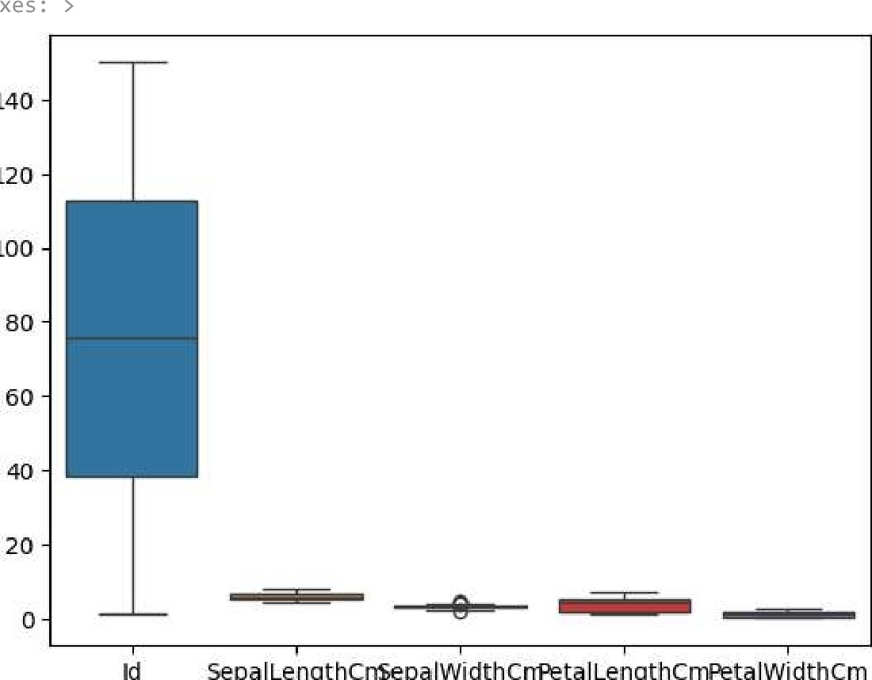:
140
120
100
SepalLengthCnSepalWidthCnPetalLengthCmPetalWidthCm
wcss
for i in range(l, 11) :
kmeans = KMeans(n_c1usters=i, random state=42, kmeans . fit (X) wcss.append(kmeans.inertia )
import matplotlib. pyplot as PI t
plt.plot(range(l, 11), wcss, marker='o' ) plt.title( ' Elbow Method' ) plt.x1abe1( 'Number of Clusters' )
PIt . y label( ' WCSS' ) plt . show( )
Elbow Method
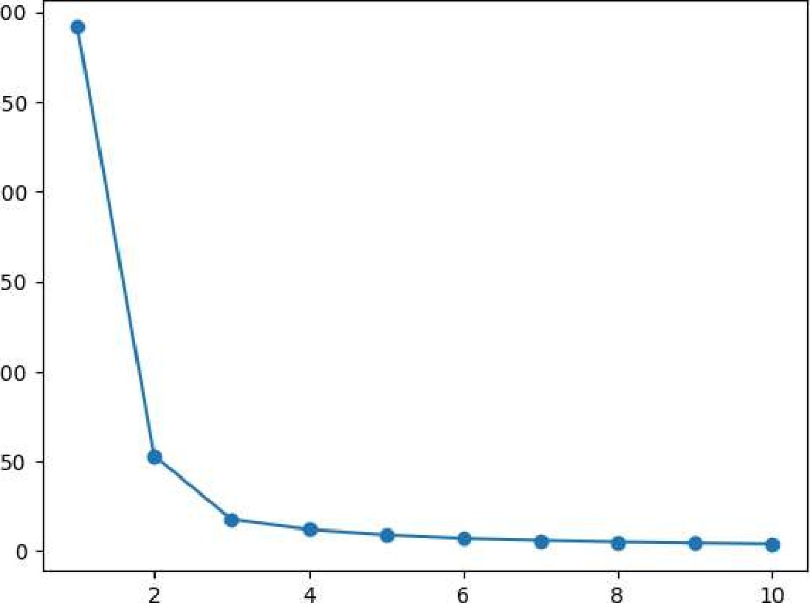
300
250
200
150
100
8
10
Number of Clusters

from sklearn.metrics import silhouette_score
score - silhouette_score(X, y_kmeans) print(f"Si1houette Score for 3 clusters: {score:
Silhouette Score for 3 clusters: 0.6551
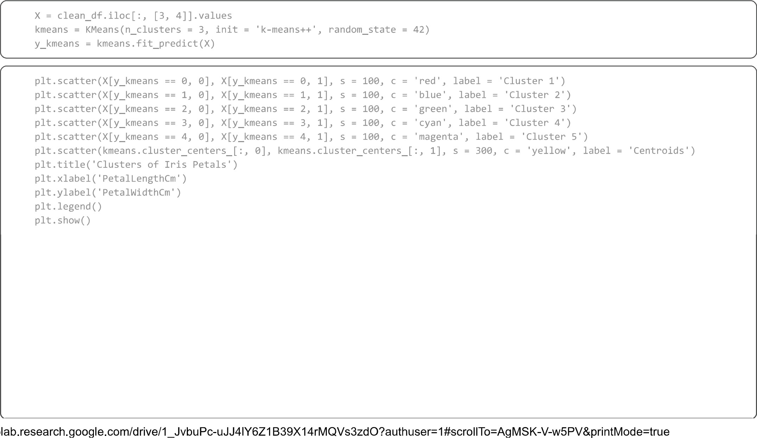
3/4
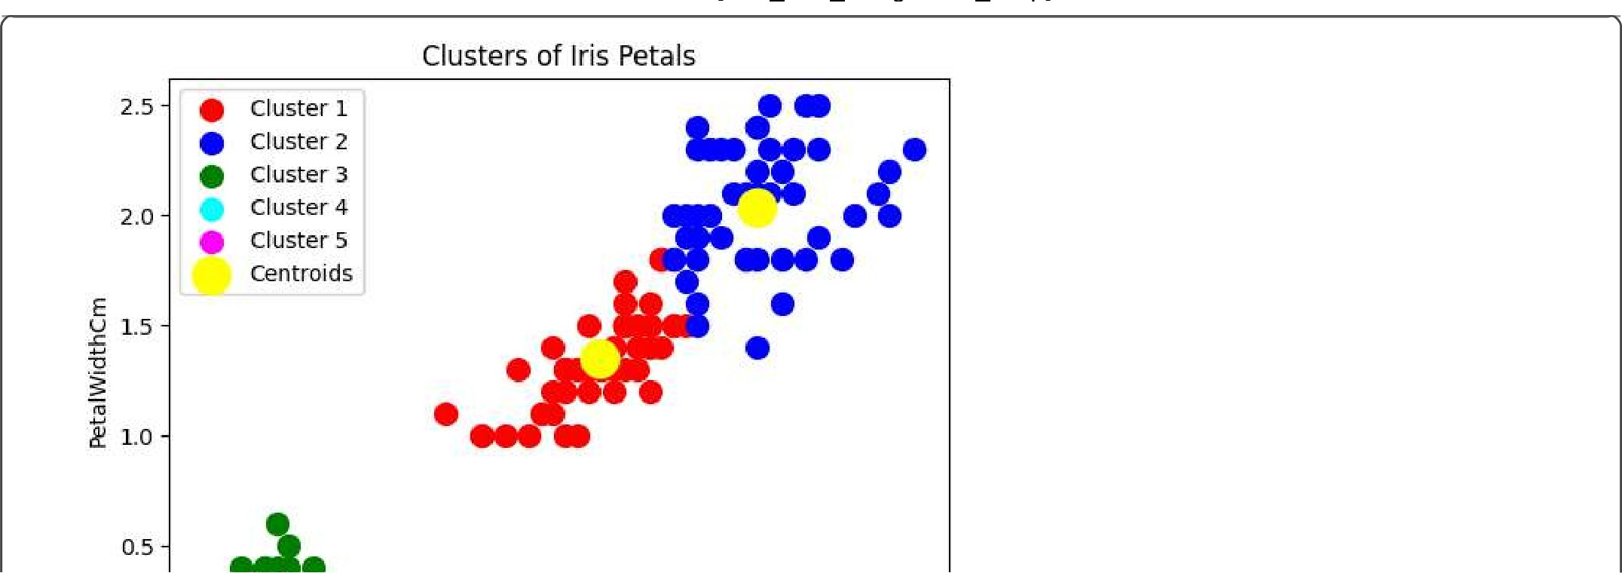
4/4

