ITW2 Assignment Lab 2

Name: Piyush Moolchandani (BT17CSE033)
Batch: A2 (CSE 2nd Year)

Question 1. Collect the following basic information about your machine using proc. How many CPU cores does the machine have? How much memory, and what fraction of it is free? How many context switches has the system performed since bootup? How many processes has it forked since bootup?

Answer:
Traverse to proc directory using command: cd /proc, and after that:

1. For number of cpu cores:
Command:
1. cat cpuinfo
2. grep ‘cpu cores’ cpuinfo

Output:
cpu cores : 6
cpu cores : 6
cpu cores : 6
cpu cores : 6
cpu cores : 6
cpu cores : 6
cpu cores : 6
cpu cores : 6
cpu cores : 6
cpu cores : 6
cpu cores : 6
cpu cores : 6

This shows total number of cores are 6 and total 12 outputs show total number of threads are 12, 2 for each core.

2. For total memory and free memory:
Command:
1. cat meminfo
2. * grep MemTotal meminfo, * grep MemFree meminfo

Output:
MemTotal: 16056732 kB (Total Memory)
MemFree: 12067388 kB (Free Memory)

3. For total context switches:
Command: grep ctxt stat
Output:

ctxt 13830066

Here ctxt is for number of context switches which are 13830066 as shown here.

4. For total number of forks since bootup:
Command:
1. grep processes stat
2. vmstat -f

Ouptut: processes 30906
This gives total number of processes system has forked since bootup which is 30906.

Question 2. Recall that every process runs in one of two modes at any time: user mode and kernel mode. It runs in user mode when it is executing instructions / code from the user. It executes in kernel mode when running code corresponding to system calls etc. Compare (qualitatively) the programs cpu and cpu-print in terms of the amount of time each spends in the user mode and kernel mode, using information from the proc file system. For examples, which programs spend more time in kernel mode than in user mode, and vice versa? Read through their code and justify your observations.

Answer:
1. cpu:
PID: 1043
Time spent in user mode (Field 14) : 21437
Time spent in kernel mode (Field 15): 0

Command: cat /proc/1043/stat
Output:
1043 (cpu) R 975 1043 975 34818 1043 4194304 70 0 0 0 21437 0 0 0 20 0 1 0 1871605 4321280 157 18446744073709551615 4194304 4196028 140720458467280 0 0 0 0 0 0 0 0 0 17 0 0 0 0 0 0 6295056 6295600 33927168 140720458470235 140720458470241 140720458470241 140720458473458 0

This is quite obvious as the program cpu.c does not includes anything that must be executed in kernel mode, such as printf. All the instruction given in the program are executed in user mode.

2. cpu-print:
PID: 1221

Time spent in user mode (Field 14) : 630
Time spent in kernel mode (Field 15): 3066

Command: cat /proc/1221/stat
Output:
1221 (cpu-print) R 1193 1221 1193 34818 1221 4194304 79 0 0 0 630 3066 0 0 20 0 1 0 1928464 4456448 181 18446744073709551615 4194304 4196308 140730110748512 0 0 0 0 0 0 0 0 0 17 7 0 0 0 0 0 6295056 6295616 20914176 140730110755657 140730110755669 140730110755669 140730110758892 0

Here this process would spend more time in kernel mode than user mode, as gettimeofday() and printf()(As printf itself involves a big process to be executed for successful operation, it takes more time than other calls such as incrementation of i) system calls are executed in kernel mode, which dominate the time required by other instruction executed in the program which are executed in user mode.
Question 3. Open a bash shell. Find its pid. Write down the process tree starting from the first init process (pid = 1) to your bash shell, and describe how you obtained it. You may want to use the pstree command.

Answer:
To find pid use command: ps -l
It gives pid of bash as 31244.

To find process tree of process: pstree -p -s 31244
In command, pstree shows the tree of processes, -p is for PID of the process and -s is to obtain parent process of the specified process.
Output:

To find process tree starting from first init:
command: pstree -p -s 1

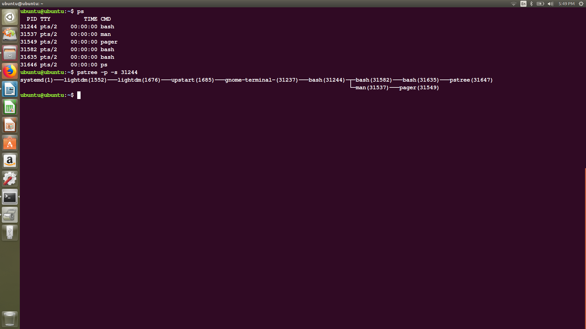

Question 4. Consider the following commands that you can type in the bash shell: cd, ls, history, ps. Which of these are system programs that are simply executed by the bash shell, and which are implemented by the bash code itself?

Answer:

* Some commands are inbuilt commands and they are already present to the bash in the executable form. No new process is created to execute that command.
* While, other commands are not inbuilt and a new process is created while executing them, and code of these are present inside /bin directory.

Also this command gives inbuilt commands: compgen -b
So,
1. cd: present in the compgen -b list, hence inbuilt and simply executed.

2. ls: not present in compgen -b list, but there is a file named ls in /bin directory, hence this is not executed as a built-in command and is implemented creating a new process by bash.

3. history: present in the compgen -b list, hence inbuilt and simply executed.

4. ps: not present in compgen -b list, but there is a file named ps in /bin directory, hence this is not executed as a built-in command and is implemented creating a new process by bash.

Question 5. Run the following command in bash.
$./cpu-print > /tmp/tmp.txt &

Find out the pid of the new process spawned to run this command. Go to the proc folder of this process, and describe where its I/O file descriptors 0, 1, 2 are pointing to. Can you describe how I/O redirection is being implemented by bash?

Answer:

Here PID for this process is 32377
For this process I/o file descriptor,
0: isn’t pointing to anything because no input operation is being performed and hence has pos = 0.
1: is pointing to a output port as it is continuously writing something to the file.
2: has pos = 0, as process is not producing any error

* I/O redirection implementation : Here bash is redirecting the output of cpu-print process to the file tmp.txt as asked to do so by the redirection operator and output is received at pos: 8212402176 as visible in the screen -shot.

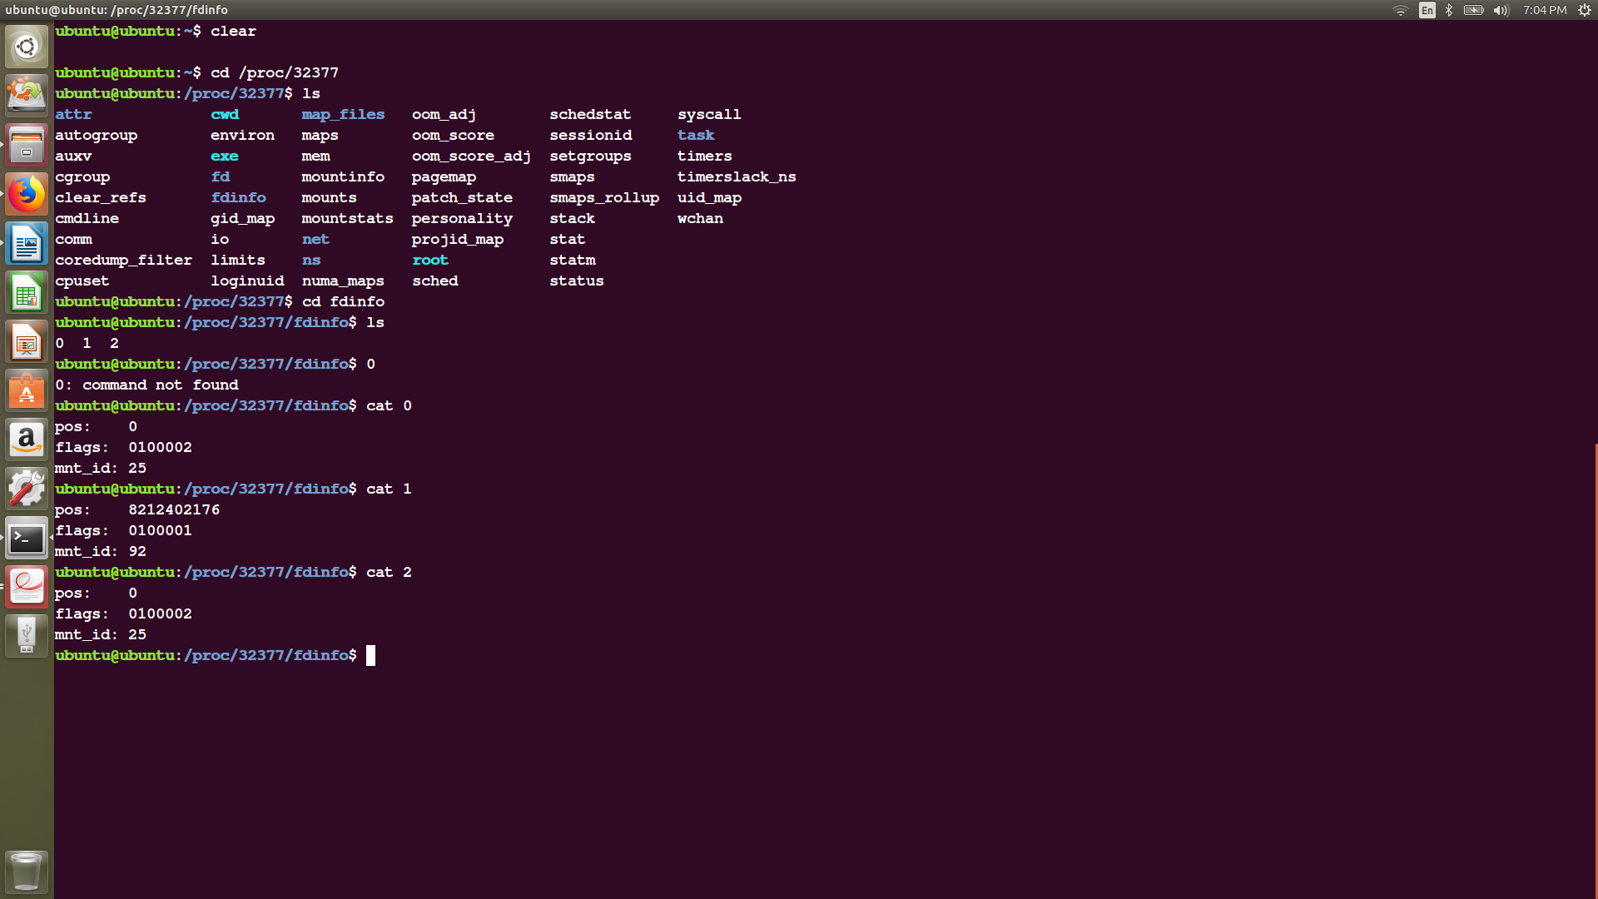

Question 6. 8. Run the following command with cpu-print.
$./cpu-print | grep hello

Once again, identify which processes are spawned by bash, look at the file descriptor information in their proc folders, and use it to explain how pipes work in bash.

Answer:
PID of new process spawned: 355
New processes spawned to run this command:
1. cpu-print (PID: 355)
2. grep (PID: 356)

File discriptors:
0: pos = 0, as not input operation is being performed.
1: pos = 0, as no output operation is being performed.
2: pos = 0, as no error is generated.

Working of pipes in bash:

Pipe is used to combine two or more commands, and in this, the output of one command acts as input to another command, and this command’s output may act as input to the next command and so on. It can also be visualized as a temporary connection between two or more commands/ programs/ processes. The command line programs that do the further processing are referred to as filters.
This direct connection between commands/ programs/ processes allows them to operate simultaneously and permits data to be transferred between them continuously rather than having to pass it through temporary text files or through the display screen.
Pipes are unidirectional i.e data flows from left to right through the pipeline.
Syntax :
command_1 | command_2 | command_3 | .... | command_N
