Question 1: FORK1
Answer:
In output, printing statement of parent is executed first, and then of child. But it’s not necessary, as both the processes are running concurrently (Absence of wait() system call), upon different executions, order of printing statements (the order of execution of child and parent process) might differ form this, and either can be executed first.
But however, if parent process is taking a lot of time(can be checked by running a big loop inside a parent process), output of child process will come first, as cpu scheduling will be done. While child process might finish it’s execution as soon as cpu is assigned to it, parent process can still be running as cpu is not given to only one process, for as long as it demands, in case of preemptive scheduling.

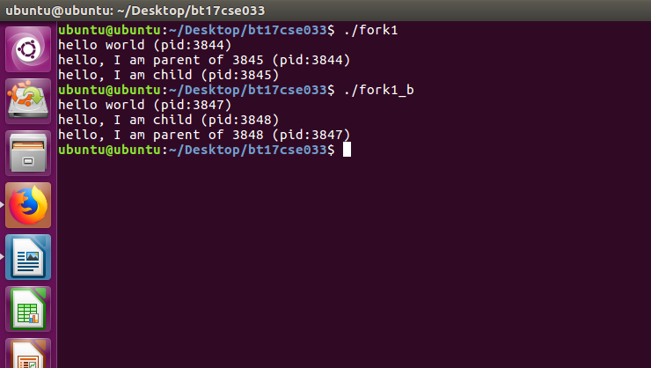

Here, fork1 gives output of FORK1 code provided, while fork1_b gives output of modified code with a big loop inside parent process.

Question 2: FORK2
Answer:

