RC-1 AI Campus: Grid-to-Chip Request for Proposal (Synthetic)
October 13, 2026

Notice and reading guide
RC-1 is a synthetic request for proposal for a hypothetical 120 MW AI training campus, written as a realistic test case for bid-intake and evaluation tools. No real owner, site or supplier stands behind it.
- Shall marks a mandatory requirement, and a bid that fails one is non-responsive. Should marks a scored target.
- The Basis column cites a source code (S1 to S15) and a section. Appendix B lists the sources.
- PA means project assumption: a value set for RC-1 that no source states.
- Requirement IDs run by lot, for example L2.04. Interface IDs read IF-01.
- The industry documents cited are early revisions. Each bidder shall state the revision it designs to.

1. Project and scope
RC-1 asks for one complete power and cooling chain, from the utility connection to the compute rack, procured in six lots for a 120 MW critical IT load.
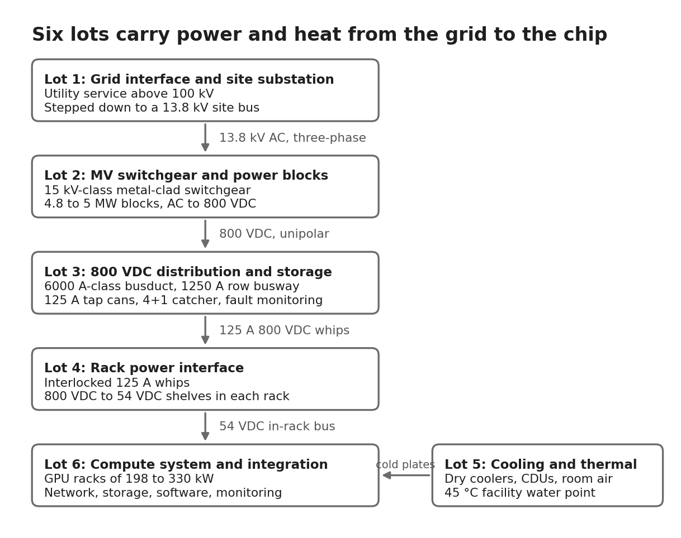
Power flows through Lots 1 to 4 to the compute racks of Lot 6, and Lot 5 removes the heat at the chip and in the room.
Lot | Scope | From | To
1 | Grid interface and site substation | Utility service | 13.8 kV site bus
2 | MV switchgear and 800 VDC power blocks | 13.8 kV site bus | 800 VDC at block output
3 | 800 VDC distribution, protection and storage | Block output | Tap cans at the row
4 | Rack power interface and in-rack conversion | Tap can | 54 VDC rack bus
5 | Cooling and thermal | Heat at cold plates and in room air | Heat rejected to ambient
6 | Compute system and integration | 54 VDC compute trays | Workloads, monitoring and security

ID | Procurement model | Basis
PM-01 | Bids may cover one or more lots, and each lot's qualification rules apply separately | PA
PM-02 | The Owner furnishes major equipment for the Contractor to install, and the equipment is integrated into the overall data center design | S14
PM-03 | An independent design consultant owns the overall campus design | S14
PM-04 | Contractors shall provide training with their lot | S15 §1.6

2. Design basis
The design basis fixes the load, voltages and availability that every lot designs to. Values marked PA are project assumptions.
ID | Design basis | Basis
DB-01 | Critical IT load of 120 MW for AI training, in six deployment units of about 20 MW each | PA; S5 Option C
DB-02 | Utility service above 100 kV is stepped down to a 13.8 kV site bus with two buses, one for core network and mechanical loads and one for GPU compute loads | PA; S6; S13
DB-03 | All medium-voltage equipment is 15 kV class | S2 §4.2; S10; S13
DB-04 | Distribution to the rack is 800 VDC nominal, two-wire, inside the 1500 VDC low-voltage limit | S5; S3 §5.2.1
DB-05 | Baseline rack cabinets are 198 to 330 kW TDP, and designs shall allow growth to 570 kW per rack position and to native 800 VDC racks | S6; S5
DB-06 | The availability target is 99.9% for a training campus, with concurrent maintainability as the design intent | S3 §4.2; S14
DB-07 | Each deployment unit uses block redundancy with a catcher: four power blocks of about 4.8 MW plus one catcher | S5 Option C
DB-08 | The liquid cooling design point is facility water at 45 °C | S6
DB-09 | Design ambient is 35 °C for extended periods, with peaks of 38 to 40 °C on single days | S15 §1.14.2.10; PA
DB-10 | Outdoor equipment is rated −30 to 40 °C with derating stated above 40 °C, up to 1,000 m with derating above, corrosion class C5, seismic design category D and 120 mph wind | S2 §6; PA
DB-11 | The Owner holds the utility interconnection agreements and secures permits for the campus | S9; PA
DB-12 | The Owner publishes PUE per cooling technique and the energy price during dialogue, for total cost of ownership | S15 §2.16.6

3. Lot 1: Grid interface and site substation
Lot 1 delivers the utility connection and the medium-voltage backbone. The Owner holds the interconnection agreement, and the Contractor supports the studies.
ID | Requirement | Basis
L1.01 | The Contractor shall deliver a service substation that lands the utility lines above 100 kV and steps them down through HV-to-13.8 kV transformers to the site MV backbone | PA; S6
L1.02 | The substation shall provide two MV buses so that core network and mechanical loads and GPU compute loads take separate paths | S6
L1.03 | On-site generation, if used, and energy storage shall connect to the MV bus, making the substation the integration point for flexible power and grid services | S6
L1.04 | MV switchgear shall be 15 kV-class metal-clad with arc-rated construction (Type 2B), draw-out breakers, protective relays, instrument transformers, a control power transformer and battery-backed DC control power, housed in a walk-in enclosure with 2-hour fire-rated walls | S10; S14 §2.1
L1.05 | Main and feeder ratings shall be stated by the bidder from the Owner's load schedule. As a size reference, one public lineup uses a 2,000 A main, four 1,200 A feeders and five 1,200 A transfer bus switches | S10; PA
L1.06 | Bidders shall state the switchgear short-circuit rating in kA for 1 s, subject to calculation | S14
L1.07 | The campus shall take dual concurrently maintainable MV feeds, run below ground on diverse paths with concrete encasement | S14 §2.1, §2.3
L1.08 | MV control power shall be 110 VDC backed by a battery unit | S14; S10
L1.09 | Relays shall support communications and event recording, with a relay acting as a remote terminal unit where the Owner specifies | S11
L1.10 | Backup generation shall be proposed by the bidder. The reference arrangement is central standby generators in N+2 at the MV switchgear, supporting 99.999% for critical core network and mechanical loads. An alternative is prefabricated generators in distributed redundancy. Fuel autonomy shall meet Tier III intent under EN 50600 Class 3 | S6; S14 §2.2
L1.11 | The Contractor shall support the Owner's interconnection studies and supply protection-coordination data for the serving utility | S9; PA

4. Lot 2: Medium-voltage switchgear and 800 VDC power blocks
Lot 2 converts 13.8 kV AC to 800 VDC in blocks of 4.8 to 5 MW. Transformer-rectifier units and solid-state transformers both qualify if they meet the same grid-facing and output requirements.
ID | Requirement | Basis
L2.01 | The Contractor shall supply power blocks that convert MV AC to 800 VDC. Transformer-rectifier units and solid-state transformers are both accepted | S2 §3; S5
L2.02 | Each block shall deliver 4.8 to 5 MW at the DC output from an input of 13.8 kVac ±10%, three-phase three-wire plus PE | S2 §4.2; S5
L2.03 | Input frequency shall be 57 to 63 Hz with a rate of change up to 5 Hz/s. Power factor shall exceed 0.99 at full load, 0.98 from 20% load and 0.95 below 20% | S2 §4.2
L2.04 | Harmonics shall meet IEEE 519, IEC 61800-3 Category C4, and IEC 61000-6-2 and -6-4 | S2 §4.2
L2.05 | Short-circuit withstand shall be 18 to 40 kA symmetrical at 13.8 kV, with duration stated by the bidder, and the basic impulse level shall be at least 110 kV | S2 §4.2
L2.06 | MV system grounding is low-resistance or solid, as set by the utility design | S2 §4.2, §5.1.1
L2.07 | Blocks shall suit load acceptance and rejection of about 20 to 50 MW/min on utility supply | S2 §4.2, §5.3
L2.08 | Voltage ride-through: full output at 0.9 to 1.2 pu. In the first low-voltage range the block draws no more than nominal input current while supplying 100% of load. In the second it draws none, and storage carries 100% of load. Operation restores without state changes. Frequency ride-through is continuous at 58.8 to 61.2 Hz and lasts 299 s at 57.0 to 58.8 Hz and 61.2 to 61.8 Hz | S2 §5.1.2, §5.1.3
L2.09 | Output shall be 800 VDC nominal, unipolar, with ripple ±0.5%, static regulation ±1% and dynamic regulation ±3%. Sources shall not produce 800 VDC plus 10%, and setpoints shall stay below 1500 VDC | S2 §4.3; S3 §5.7
L2.10 | DC grounding shall be IT, floating or high-resistance, with detection and protection coordinated across the 800 VDC system | S2 §4.3
L2.11 | Overload shall be 150% for 150 ms in constant-current mode and 120% for 5 s in constant-voltage mode, with output DC link capacitance of at most 10 mF per 4 MW | S2 §4.3
L2.12 | Efficiency shall be at least 98% between 50% and 100% utilization, counting power train loss only | S2 §4.3
L2.13 | Blocks shall support fast shutdown by shunt trip and internal disconnect, and shall limit DC fault current with a current-limiting stage | S5
L2.14 | Outdoor enclosures shall be NEMA 3R, rated −30 to 40 °C with derating stated above 40 °C, corrosion class C5, seismic design category D and 120 mph wind, with a design life of 15 years or more within a 10 to 20 ft by 8 ft by 8.5 ft envelope | S2 §4.3, §6
L2.15 | Each block shall report a state machine of off, standby, precharged, on, fault and warning over Modbus TCP/IP. A permanent failure shall require manual validation, service and reset before the block returns to on | S2 §4.3, §7.1
L2.16 | Auxiliary power shall come from 480 Vac backed by the data center UPS, plus an internal source | S2 §4.3
L2.17 | Major blocks shall be built from sub-blocks that can be swapped live | S3 §4.2
L2.18 | Equipment shall comply with NFPA 70 and 70E, UL 347A, UL 508C, UL 840, UL 1741, IEEE 519, IEEE 1547 and IEEE 1584 | S2 §8
L2.19 | Bidders shall state product maturity and field references for the offered input class. Commercial SSTs are mostly 15 kV-class, so an SST proposal for a higher class shall show type-test evidence | S5; PA
L2.20 | Lot 2 includes the 15 kV-class switchgear lineups at each deployment unit that feed the power blocks, built to L1.04 to L1.06 | PA; S10

5. Lot 3: 800 VDC distribution, protection and storage
Lot 3 carries 800 VDC from the power blocks to the tap cans at each row, protects it, and holds the facility's energy storage.
ID | Requirement | Basis
L3.01 | 800 VDC two-wire distribution shall run from the power-block output through DC switchboards and 6000 A-class busduct to parallel 1250 A row busways with 125 A tap cans | S5 Option C
L3.02 | Each deployment unit shall use a 4+1 block-redundant arrangement with a DC static transfer switch, built from semiconductor OR-ing or adjustable DC/DC catcher paths | S5; S3 §4.2
L3.03 | The design shall reach 99.9% availability. Because DC distribution allows no UPS-style maintenance bypass, redundancy shall sit at power-block level and, where needed, at distribution level, and a catcher shall protect the conversion block from single points of failure | S3 §4.2
L3.04 | Operation shall stay inside the voltage band: no setpoint above 1500 VDC, no average above 1500 VDC, no extended excursion above it, and 840 VDC as the overvoltage disconnect hinge | S3 §5.6, §5.7
L3.05 | Earthing shall be TN-S or IT. Bidders shall propose high-resistance midpoint, high-resistance return, floating or solid grounding, with fault-current, detection and personnel-safety analysis | S3 §6.2; S5
L3.06 | Multiple solid earth points shall be avoided, and the potential drop between housings and the central earth point shall stay below 200 mV | S3 §6.2.2.2, §6.2.4
L3.07 | IT systems shall have insulation monitoring that detects a first ground fault, with impedance typically above 100 ohm per volt DC | S3 §6.2.3
L3.08 | Protection shall use two zones: facility distribution, from source output to tap-can input, with insulation monitoring and fast source shutdown on overcurrent, and the rack interface, from tap can to rack, with residual current monitoring | S5
L3.09 | Tap-can branch protection shall be an MCCB or a solid-state breaker. Bidders shall state clearing times and the redundancy or holdup that covers a clearing time of up to about 20 ms | S5
L3.10 | Solid-state breakers shall target 125 A air-cooled ratings for 800 V to 54 V shelves and 1250 A liquid-cooled ratings for native 800 VDC racks | S5
L3.11 | Series arcing shall be mitigated with connector temperature monitoring and high-frequency sensing at the rack interface and at converter outputs | S5
L3.12 | Isolation shall be provided where MV AC connects to the 800 VDC system through a converter or dedicated transformer, and each separately derived system shall state its grounding compatibility on the nameplate | S3 §6.2.1.1, §5.5.2
L3.13 | Clearance and creepage shall follow IEC 60664-1 for the working voltage, using overvoltage category III in the power room, category II in the data room, pollution degree 2 in racks and pollution degree 3 in ancillary zones | S3 §6.3
L3.14 | Overcurrent protection shall cover all ungrounded poles unless the authority having jurisdiction accepts otherwise | S3 §6.3
L3.15 | Facility storage shall provide a buffer, abnormal-event response, bridge power and grid dispatchability. It may be AC-coupled at the MV bus or DC-coupled on the 800 VDC backbone, and it shall connect through a converter, not directly | S6; S4; S3 §3.2
L3.16 | Storage shall comply with UL 9540, UL 9540A, UL 1973, IEC 62133, NFPA 855 and UN 38.3, with fire propagation tests per UL 9540A at cell, module and rack level | S1 §11.1
L3.17 | The bus shall tolerate this reference load profile: steps up to 175% of rack TDP in under 2 ms, 180% in under 0.5 ms and 150% in under 50 ms, holding ±3% with 3 ms settling | S1 §7.3.2, §7.3.3; S2 §4.3; PA
L3.18 | The Contractor shall deliver a system-level simulation covering dynamic response, source output impedance and module sharing, distribution inductance and ripple, and shall support DC arc-flash and fault-current studies | S5
L3.19 | Telemetry and control shall use open standards with Redfish recommended, and signals shall integrate with the Owner's electrical power management system | S1 §9; S14

6. Lot 4: Rack power interface and in-rack conversion
Lot 4 connects each rack to the 800 VDC row and converts the power to 54 VDC inside the rack. Two variants cover phased delivery and a ±400 VDC alternative.
ID | Requirement | Basis
L4.01 | The Contractor shall supply 125 A 800 VDC power whips hardwired to the tap can behind a normally open contactor that closes only when the rack-side connector is mechanically locked and opens before the connector unlocks | S5
L4.02 | Connectors shall latch with an integrated switch so a cable cannot be removed until source and load are off, shall de-energise when unplugged, and shall carry short pins to prevent arcing | S1 §8.4; S5
L4.03 | Each compute rack shall hold an 800 VDC to 54 VDC power shelf. The baseline is six 15 kW converters, and bidders shall state the shelf output voltage and converter count | S5
L4.04 | Rack designs shall accommodate cabinets of 198 to 330 kW, growth to 570 kW per rack position with liquid-cooled power shelves, and native 800 VDC distribution inside the rack | S6; S5
L4.05 | Rack input power shall be smooth: localized peak shaving, power smoothing and slew-rate control using minimal storage, such as electrolytic capacitors, in or near the rack | S5
L4.06 | Branch protection for in-rack shelves shall target 125 A air-cooled solid-state breakers | S5
L4.07 | Phase 1 variant: where DC busway is not yet in place, 800 VDC power racks may feed adjacent compute racks. Each takes 415 to 480 VAC true three-phase without neutral through 12 whips of 100 A, supports about 660 kW, and uses shelves of six 18.3 kW converters | S5 Option A
L4.08 | Each power-rack converter shall hold 1,200 J of energy storage to smooth AC input current. Optional battery backup is four 20 kW units giving 80 kW for 60 s, tied to a 125 A 800 VDC cross cable | S5 Option A
L4.09 | ±400 VDC variant: a bidder proposing ±400 VDC sidecar racks shall name the rack input that accepts ±400 VDC three-wire, or the conversion to 800 VDC. The Owner accepts ±400 VDC only on that evidence | S1; S4; PA
L4.10 | An accepted ±400 VDC variant shall deliver 410 V at no load and 400 V at full load, ±0.5%, with 10 V built-in droop, using 1OU power shelf modules of 25 to 30 kW, a three-conductor vertical busbar of up to 1.1 MW and cables of 50 kW (63 A) or 100 kW (125 A). End-to-end efficiency shall exceed 95% at 20% load, 98% (480 V) or 97% (415 or 400 V) at 50%, and 97% or 96.5% at 100% | S1 §7.3, §8
L4.11 | Rack power equipment shall use UL 62368-1 methods, with leakage of at most 3.5 mA AC and 10 mA DC, and shall meet EMC Class A to CISPR 32 and 35 | S1 §11; S5
L4.12 | Rack power equipment shall report telemetry over Redfish, PMBus, Modbus or CANbus | S1 §9

7. Lot 5: Cooling and thermal
Lot 5 removes heat at the chip, in the rack and in the room, and rejects it to ambient with liquid cooling as the main path.
ID | Requirement | Basis
L5.01 | Heat rejection shall use closed-circuit dry coolers, with no cooling-tower blowdown in the base design. Bidders proposing adiabatic assist for peak ambient shall state annual water use | S6; S14 §2.4.1; PA
L5.02 | Central utility buildings shall house chillers, pumps and facility water distribution serving the CDUs and room air handlers. Chillers may run on a decoupled 4.16 kV bus, with pumps, coolers and controls on 480 V | S6
L5.03 | The liquid cooling design point shall be facility water up to 45 °C, and bidders shall state maximum water inlet and expected outlet temperatures | S6; S15 Annex 10C
L5.04 | CDUs shall be liquid-to-liquid, modular and placed in mechanical galleries with N+1 group redundancy. They take facility water on the primary side and cool a separate technical-grade secondary loop that serves GPU cold plates at a design flow of at least 1.5 LPM per kW | S6; S14
L5.05 | CDU data shall state rated kW, pump type and count, primary and secondary supply and return temperatures, secondary flow in L/min, available lift in kPa, filter mesh, pipe routing and power supply | S14
L5.06 | The heat-rejection and water loops shall be concurrently maintainable in a ring with N+1 redundancy | S14 §2.4.1
L5.07 | Room air handlers on medium-temperature facility water shall cool air-cooled equipment and occupied spaces. Air-side capacity shall be at least 15% of room load, and bidders shall state the liquid-captured fraction, with 90% as the target | S6; S14 §2.4.1; S15 §1.14.2.10
L5.08 | The plant shall reject the full heat load at 35 °C ambient for extended periods and at 40 °C on peak days, and bidders shall show approach temperatures for both cases | S15 §1.14.2.10; PA
L5.09 | Air-cooled equipment shall operate with ASHRAE A2 supply air, and operation at A3 is preferred. Auxiliary racks above 20 kW sustained may need additional liquid cooling | S8 §C.7
L5.10 | The GPU-side cooling plant is not UPS-backed in the reference design and relies on loop thermal mass until backup generation restarts it. Bidders shall state the thermal ride-through time at full load and the automatic restart sequence | S6; PA
L5.11 | The Contractor shall deliver a chemical management plan covering additives and cooling-water properties, including transport, storage, filling, draining and disposal, nine months before delivery | S7 App B.5
L5.12 | Cooling shall be measured per node and per loop, with sampling frequency, accuracy and timestamps stated | S7 §5.5.2; S15 §1.14.2.10
L5.13 | Piping routes, floor loading and weight per rack in t/m² shall be stated for each hall | S15 Annex 10C
L5.14 | Prefabricated cooling equipment shall suit outdoor use at −20 to +45 °C, or the local 20-year extreme if more stringent, with corrosion protection tested to ISO 12944-6 or equivalent | S14

8. Lot 6: Compute system and integration
Lot 6 supplies the compute system and integrates it with the power and cooling chain. Power budgets, metering and resilience terms tie it to the other lots.
ID | Requirement | Basis
L6.01 | The compute system shall comprise a control plane of at least five servers, a GPU accelerator partition in direct-liquid-cooled cabinets, a CPU data-preparation partition, a high-speed interconnect, multi-tier storage and cloud-like services (virtual machines, Kubernetes and Slurm) | S15 §1.14.2.1 to §1.14.2.4
L6.02 | Each accelerator shall have at least 192 GB of high-bandwidth memory, each node shall have local NVMe, and each GPU shall have a direct high-speed network connection | S15 §1.14.2.3
L6.03 | Compute racks shall accept 800 VDC input, and bidders shall state rack TDP. Racks with an AC input option shall list it separately | S5; S6
L6.04 | The maximum power of each deployment unit under any workload, including storage and network, shall not exceed 20 MW, and bidders shall state it in total and per partition | S7 §8.3.1; S15 Annex 10C; PA
L6.05 | Power controls shall exist at system, rack, board, node, component and sub-component level, with reaction times stated | S7 §8.3.2
L6.06 | The system shall give advance warning of power-draw changes above 1 MW over 15 minutes, or a similar criterion the bidder proposes | S7 §8.3.3
L6.07 | Energy shall be measured per node and made available to users for their jobs. Power, voltage, cooling and temperature shall be measured across the system, with sampling frequency, accuracy and timestamps stated | S15 §1.14.2.10; S7 §5.5.2
L6.08 | The system shall support sequenced full-system power up and power down, with timings described | S7 §5.1.2, §8.1.4
L6.09 | No single point of failure shall cause an outage. The system shall stay operational or degraded after the failure of any single field-replaceable unit, server or switch, and shall support rolling upgrades while at least half stays in production | S7 §5.3.2, §5.4.1
L6.10 | Bidders shall propose system availability, mean time between interrupts and job mean time to interrupt, and explain how they derived them | S7 §8.1
L6.11 | Security shall be compatible with ISO/IEC 27001, with strict isolation of tenants, including their network traffic. Firmware, drivers and software shall be patched, and high or critical vulnerabilities shall be fixed under the Owner's policy | S15 §1.14.2.9
L6.12 | Storage shall be multi-tier, with a POSIX parallel file system and capacity object storage, expandable without interruption and using POSIX, NFS and S3 standards | S15 §1.14.2.5
L6.13 | The control-plane network shall be separate from the compute and storage network, with secure partitioning of tenants. Links between halls shall stay within 500 m | S15 §1.14.2.7; S6
L6.14 | Software shall offer Slurm and Kubernetes with GPU passthrough, a self-service portal and APIs, monitoring and accounting | S15 §1.14.2.8
L6.15 | Maintenance and support shall run five years from acceptance, 24 by 7, with a four-hour response and concurrent maintenance. Cabinet-level concurrent repairs get 6 hours and other repairs 2 hours | S7 §8.4.1, App B.9
L6.16 | The Contractor shall hold an on-site parts cache covering two weeks of normal repairs, and spare nodes of at least 1% of each node type | S7 App B.9
L6.17 | Bidders shall run these benchmarks: MLPerf Storage, IOR, BigDataBench, Ray Train, Horovod, MLPerf Training and MLPerf Inference. The Owner may extend the list | S15 Annex 13
L6.18 | The system shall be delivered in phases. Core components, such as control plane, storage and network with a minimal number of compute nodes, may come first, and a test system with a minimal management stack shall follow contract signing as fast as possible | S15 §1.16

9. Interfaces between lots
These interfaces fix what each lot hands to the next. A Contractor's equipment shall tolerate any disturbance that is foreseeable within these limits.
ID | Interface | Value at the handoff | Basis
IF-01 | Utility to Lot 1 | Service above 100 kV. The Owner holds the interconnection agreement | S9; PA
IF-02 | Lot 1 to Lot 2 | 13.8 kV ±10%, three-phase three-wire plus PE, 57 to 63 Hz, with low-resistance or solid MV grounding | S2 §4.2
IF-03 | Lot 2 to Lot 3 | 800 VDC nominal, unipolar, with ripple ±0.5%, static regulation ±1%, dynamic regulation ±3% and IT grounding | S2 §4.3
IF-04 | Inside Lot 3 | 6000 A-class busduct, 1250 A row busway and 125 A tap cans | S5
IF-05 | Lot 3 to Lot 4 | 125 A 800 VDC interlocked whip behind a normally open contactor | S5
IF-06 | Lot 4 to Lot 6 | 54 VDC in-rack bus from the 800 to 54 VDC shelf | S5
IF-07 | Lot 5 to Lot 6 | Facility water up to 45 °C to the CDU primary side, and a technical-grade secondary loop to cold plates at 1.5 LPM per kW or more | S6
IF-08 | Lot 1 to Lot 5 | Cooling plant supply at 480 V, with chillers optionally on a 4.16 kV bus | S6
IF-09 | Lots 2, 3 and 5 to Lot 6 | Telemetry and control over Modbus TCP/IP from power blocks and Redfish, PMBus, Modbus or CANbus elsewhere, integrated with the Owner's electrical power management system | S2 §4.3; S1 §9; S14

10. Testing, acceptance and deliverables
Acceptance runs from factory tests through a 30-day availability test, and deliverables are timed against award and first delivery.
Testing and acceptance
ID | Requirement | Basis
TA-01 | Equipment shall pass a witnessed factory test for the first unit of each type and factory acceptance tests for repeat units, followed by site acceptance and commissioning procedures that the manufacturer offers | S14
TA-02 | A pre-delivery assembly, quality assurance and factory test plan shall be agreed at least 30 days before the factory test. It covers burn-in, benchmarks and fault injection, such as disconnecting cables, powering down subsystems and installing known bad parts | S7 App A.2
TA-03 | Pre-delivery tests shall cover power up, power down, monitoring, reset, power cycling from the console, failover and resilience, benchmarks, and a 72-hour test under constant load | S7 App A.2
TA-04 | The acceptance period shall target 60 days and shall include a functionality demonstration, a system test with two cold boots, a resilience test with fault injection, a performance test running each benchmark at least five times, and an availability test of 30 contiguous days | S7 App A.4
TA-05 | During the availability test no upgrades are allowed in the last seven days, no critical bugs may be open in the last seven days, and any repair that causes downtime counts as an outage | S7 App A.4.5
TA-06 | Power-chain tests shall cover block step-load and pulse profiles at the reference load profile in L3.17, voltage and frequency ride-through events, protection coordination, ground-fault detection and end-to-end validation from MV input to the GPU | S1 §7.3.3; S2 §5.1.2; S5
TA-07 | A system-level simulation shall be accepted before delivery, covering dynamic response, source output impedance, distribution inductance and ripple | S5
TA-08 | Delivery shall run in three phases: integration, validation and operational readiness. Operational readiness is declared when the integrated system can serve users while meeting the offer's specifications | S15 §1.16
Deliverables
ID | Deliverable | Timing | Basis
DL-01 | Kickoff meeting | Within 45 days of award | S7 §13.0.4
DL-02 | Risk management plan and risk register | Within 30 days of award, with the register updated monthly | S7 App B.3
DL-03 | Project plan | Within 90 days of award, updated quarterly | S7 App B.1
DL-04 | Technical decision point to fix the final configuration and turn performance targets into requirements | 9 to 12 months before delivery | S7 §13.0.1
DL-05 | Facilities and site preparation plan | Preliminary one year before first delivery, final nine months before | S7 App B.4
DL-06 | Acceptance test plan | One year before first delivery | S7 App B.8
DL-07 | Delivery and installation plan | Preliminary one year before first delivery, final 90 days before each delivery | S7 App B.7
DL-08 | Network plan | Draft six months and final four months before installation | S7 App B.6
DL-09 | Chemical management plan | Nine months before delivery | S7 App B.5
DL-10 | Guaranteed delivery dates, which the Owner may fit the project schedule around | With the tender | S12

11. Commercial terms
Commercial terms combine firm all-inclusive pricing with performance guarantees and service-level damages.
ID | Term | Basis
CT-01 | Prices shall be firm, all-inclusive and quoted in US dollars, free of taxes, and shall cover delivery to site, installation, commissioning and training | S15 §2.9; S12; PA
CT-02 | The price schedule shall separate equipment, freight, installation, commissioning, spares and five years of maintenance, with any extension beyond five years priced as an option | S12; S7 §8.4.1; S15 §2.16.6
CT-03 | Prices shall be unconditional. Statements such as 'to be discussed', or references to a separate contract, disqualify an offer | S15 §2.9
CT-04 | Offers shall stay valid for at least four months after the submission deadline | S15 §1.13
CT-05 | The successful bidder shall provide a performance guarantee of 10% of contract value at signature. A pre-financing guarantee shall cover up to 30% of the price if pre-financing is requested | S15 §1.8
CT-06 | The successful bidder shall also provide performance and payment bonds in a form the Owner approves | S12; S13
CT-07 | Liquidated damages shall reduce prices when service level requirements are missed, capped by an at-risk amount: a percentage of monthly recurring prices for continuous services and a per-service cap for discrete services. Delay penalties scale with the length of the delay and the seriousness of the breach | S15 §1.1, §1.6
CT-08 | Commercial exceptions shall be listed in a separate schedule. Exceptions on payment, cancellation charges, warranty or liquidated damages are assessed for economic risk and can make a bid non-responsive | S12; S13; PA
CT-09 | Warranty is included within the five-year maintenance period, and component warranties run inside it | S7 App B.9
CT-10 | Failures caused by disturbances that are foreseeable within the interface limits of Section 9 are the Contractor's responsibility | S7 App B.9; PA
CT-11 | The Contractor shall guarantee supply-chain security for each component for the expected lifetime of the system, with a risk plan and mitigation for sensitive components | S15 §1.6
CT-12 | Bidders shall state the share of work they subcontract. Subcontractors above 15% of price, or whose capacity is needed to qualify, shall sign the confidentiality agreement and give a written undertaking to make their resources available | S15 §2.14.3, §2.14.5
CT-13 | Entities subject to applicable sanctions or restrictive measures shall not take part in any capacity | S15 §1.5; PA
CT-14 | The bidder bears all costs of bidding. The Owner may abandon the procurement before signature without compensation | S15 §1.9
CT-15 | Information exchanged is confidential and used only to prepare the bid | S15 §2.3; S14

12. Bidder qualification
Bidders qualify on financial capacity, comparable references, support capability and staff. Each lot applies the same gates to its own scope.
ID | Requirement | Basis
BQ-01 | Annual turnover over the last two closed financial years shall exceed one-third of the lot value, combined across a group, supported by profit and loss accounts | S15 §2.14.5.2; PA
BQ-02 | Manufacturers shall have at least five years designing, building and testing the offered equipment for data centers, and shall supply a reference list of installed units | S14
BQ-03 | Each bidder shall provide three reference forms for work executed in the previous four years, at least one from the bidder itself rather than another entity | S15 §2.14.5.3
BQ-04 | Lot 6 references shall be AI installations with at least 500 AI-optimised GPUs tightly interconnected on a low-latency network, with storage suited to AI workloads | S15 §2.14.5.3
BQ-05 | Lot 2 and Lot 3 references shall be data center or utility installations of comparable power-conversion or distribution scale at the offered voltage class | PA
BQ-06 | The bidder shall run a support centre in the site's region for more than two years, serving at least two similar clients with at least six English-speaking staff | S15 §2.14.5.3; PA
BQ-07 | The bidder shall hold relevant certifications, such as ISO 9001 quality, ISO 27001 security, ISO 14001 environmental management and ISO 45001 safety | S15 §2.14.5.4; S14
BQ-08 | Experts with at least three years in role, each a different person, shall cover systems architect, systems engineer, data center infrastructure specialist, application and benchmarking specialist, and project manager | S15 §2.14.5.4
BQ-09 | An in-house designer accredited by the Uptime Institute as a Tier Designer is preferred | S14
BQ-10 | A group's composition shall not change between submission and award, and the group leader shall supply at least one reference | S15 §2.3, §2.14.5.3

13. Evaluation
Tenders are scored on technical value, cost performance, delivery quality and safety readiness, with a minimum required in every criterion. The structure follows S15 §2.16.4, and the weights are project assumptions.
Criterion | Points | Minimum
1. Technical value of the design | 40 | 20
1.1 Power and cooling chain, including facility integration | 20 | 10
1.2 Compute, software and security | 15 | 7
1.3 Supply-chain security | 5 | 3
2. Cost performance: total cost of ownership and AI performance per watt | 35 | 18
3. Quality of delivery and services: installation and project plan, maintenance and support, collaboration, training, risk management | 15 | 8
4. Safety, certification and standards readiness: DC protection, certification path, arc-flash and fault-current studies | 10 | 5
Total | 100 | 66 overall

ID | Method | Basis
EV-01 | Award goes to the tender with the best price-quality ratio, after legal and technical responsiveness is confirmed | S15 §2.16.2; S12
EV-02 | Each category is scored from 0 (requirements insufficiently met) to 60 (met to fullest satisfaction) and then weighted | S15 §2.16.5; PA
EV-03 | A tender needs at least the minimum in every criterion and at least 66 points overall | S15 §2.16.4; PA
EV-04 | Ties are broken by the higher mark in criterion 1, then 2, 3 and 4 | S15 §2.16.9
EV-05 | Repeating a mandatory requirement without detail scores low, and anything offered beyond the minimum becomes binding | S15 §2.16.4
EV-06 | Cost performance sums capital cost (system acquisition, infrastructure preparation such as floor, cooling and power, and maintenance and licences) and operating cost (energy, complementary staff, user support and maintenance beyond five years) | S15 §2.16.6
EV-07 | Energy cost uses the Owner's PUE per cooling technique and energy price. Bidders commit energy-to-solution and time-to-solution on the Owner's workload, which yields an AI-performance-per-watt metric | S15 §2.16.6
EV-08 | Guaranteed delivery dates enter the evaluation, and the Owner may adjust the project schedule to fit them | S12
EV-09 | The Owner compares each lump-sum price with its own engineer's estimate | S12; S13
EV-10 | Bids with no price, or a refusal of liquidated damages, are non-responsive | S13
EV-11 | During dialogue the Owner may discard or reduce the solutions under discussion by applying the award criteria | S15 §2.15.1

14. Response format and process
Bids follow a three-step competitive dialogue, and responses obey strict length and format rules.
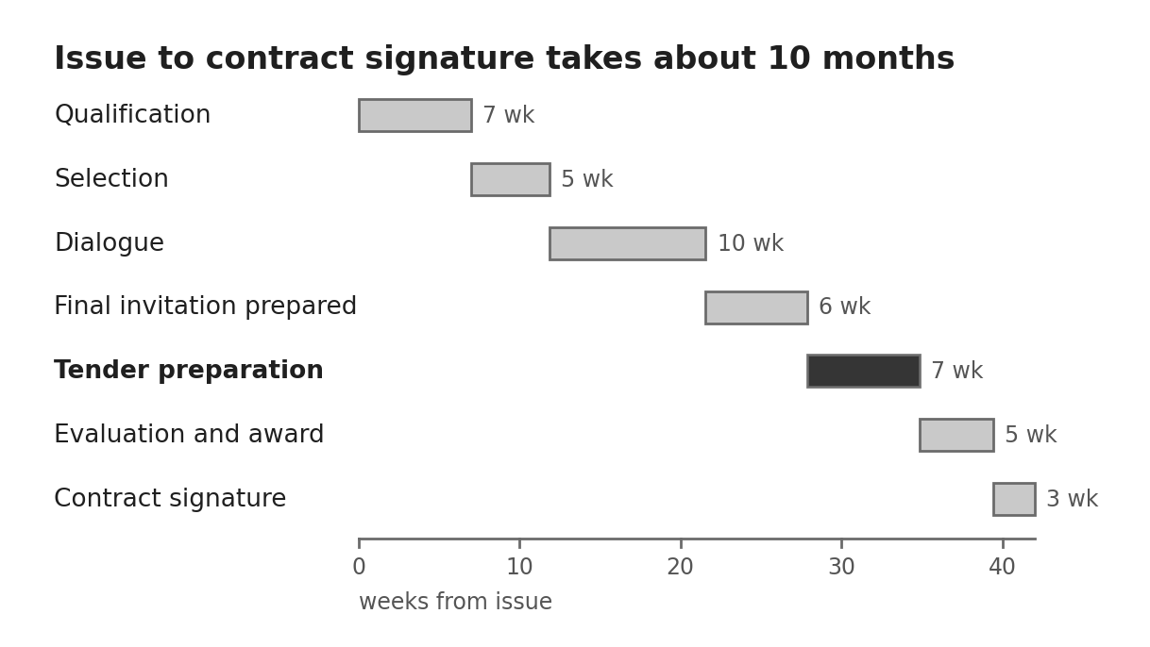
The darker bar is the seven-week window in which bidders prepare the final tender. Durations follow the provisional schedule in S15 §2.2.
ID | Requirement | Basis
RF-01 | The technical tender shall not exceed 300 pages, on A4 with 10 pt body text and margins of at least 15 mm, written concisely with no brochure summaries, no generic diagrams and no cross-references between documents. Material beyond the limits is not considered | S15 §2.7, §2.16.10
RF-02 | All technical assumptions go in the assumptions section of the technical tender, and pricing assumptions go in the financial model | S15 §2.16.10
RF-03 | A tender comprises the completed technical specification, the technical tender, the financial offer model, the data summary sheet in Appendix A and a security self-assessment | S15 §2.16.3, §2.16.10
RF-04 | Questions go in writing through the Owner's portal by the stated deadline, and answers are published anonymously to all bidders | S15 §2.8
RF-05 | Bidders shall use a single point of contact, and soliciting information from anyone else can lead to exclusion | S15 §2.4
RF-06 | The procedure is a competitive dialogue in three steps: qualification, dialogue with at least two sessions per candidate and one mandatory site visit, and final tender. Up to three candidates advance, and only invited candidates may submit a final tender | S15 §2.1, §2.14.6, §2.15

Appendix A: Data summary sheet
Every tender includes this sheet, completed in total and per partition. The fields mirror the summary sheets used in S14 and S15.
Group | Field | Unit | Basis
Compute | Number of nodes, in total and by type | count | S15 Annex 10C
Compute | Peak performance, in total and per partition | PFlop/s | S15 Annex 10C
Compute | Memory bandwidth and byte-addressable capacity, in total and per node type | TiB/s; TB | S15 Annex 10C
Compute | Accelerator and processor types | text | S15 Annex 10C
Compute | Network type, topology, latency and bisection bandwidth | text; µs; Tb/s | S15 Annex 10C
Storage | Bandwidth, IOPS and usable capacity per tier | GB/s; IOPS; GB | S15 Annex 10C
Site | Total floor size including service area | m² | S15 Annex 10C
Site | Maximum power under any workload, in total and per partition | kW | S15 Annex 10C
Site | Number of racks, rack TDP and maximum weight per rack | count; kW; t/m² | S15 Annex 10C; S6
Power chain | Rated DC output of each power block | MW | L2.02
Power chain | Efficiency at 50% and 100% load | % | S2 §4.3
Power chain | Output regulation, static and dynamic, and ripple | % | S2 §4.3
Power chain | Short-circuit rating | kA for 1 s | S14
Power chain | Breaker clearing time and the holdup that covers it | ms | S5
Power chain | Ingress protection and lead time delivered duty paid | IP rating; weeks | S14
Cooling | CDU rated capacity and secondary flow | kW; L/min | S14
Cooling | Primary and secondary supply and return temperatures | °C | S14
Cooling | Maximum water inlet and expected outlet temperatures | °C | S15 Annex 10C
Cooling | Liquid-captured fraction of rack heat | % | L5.07; PA
Cooling | Thermal ride-through at full load without cooling power | minutes | L5.10; PA
Cooling | Annual water use | m³ | L5.01; PA

Appendix B: Sources and standards
Every basis code in this document resolves to one of the fifteen sources below. Sources S1 to S3 are early revisions, and S3 is cited only for sections 1 to 6.
Code | Source | Used for
S1 | OCP Diablo 400 base specification v0.7.0 | Rack power variant, load profile, safety
S2 | OCP solid-state transformer specification v0.3.0 | Lot 2 converter requirements
S3 | OCP LVDC white paper v1.0 | Availability, voltage band, earthing
S4 | OCP blog on 800 VDC alignment | DC-coupled storage, ±400 VDC variant
S5 | NVIDIA 800 VDC white paper, Industry Alignment and Execution | Deployment unit, distribution, protection, rack power
S6 | NVIDIA DSX facilities infrastructure reference design overview | Substation, cooling plant, CDUs, rack power
S7 | NERSC-10 Technical Requirements Document v6.0 | Compute, acceptance, deliverables, maintenance
S8 | NERSC-10 Appendix C clarification | Air-side conditions
S9 | DOE Paducah request for offer | Owner-held interconnection
S9 | DOE Idaho request for application | Owner-held interconnection
S10 | Clark Public Utilities switchgear solicitation abstract | 15 kV-class lineup
S11 | City of Austin IFB 1100 PAB1003 | Relay and RTU communications
S12 | OPPD RFP 6115 award package | Price schedule, delivery dates, evaluation
S13 | OPPD RFP 5933 award package | Responsiveness, bonds, 161 kV substation
S14 | PPC request for information NGAPD-3004 | Procurement model, MV, cooling modules
S15 | EuroHPC AI:AT descriptive document EUROHPC/2026/CD/0002, March 27, 2026 (public tender, uploaded copy) | Compute, process, scoring, commercial terms

Standards cited in the requirements are NFPA 70, 70E and 855; UL 347A, 508C, 840, 1741, 1973, 9540, 9540A and 62368-1; IEEE 519, 1547 and 1584; IEC 60664-1, 61000-6-2, 61000-6-4, 61800-3 and 62133; CISPR 32 and 35; UN 38.3; ISO 9001, 14001, 27001, 45001 and 12944-6; EN 50600; and ASHRAE classes A2 and A3.

