//\*\*\*\*\*\*NAGIOS INSTALLATION STEPS\*\*\*\*\*\*\*\*//

7) Install below packages on server.

dnf install php perl httpd wget unzip glibc automake glibc-common gettext autoconf php php-cli gcc gd gd-devel net-snmp openssl-devel unzip net-snmp postfix net-snmp-utils -y

Install below development packages on server.

dnf groupinstall "Development Tools" -y

8) Start php & httpd services on server,

sudo systemctl enable --now httpd php-fpm

9) Use the below link to download nagios 4.4.6 on server,

https://github.com/NagiosEnterprises/nagioscore/

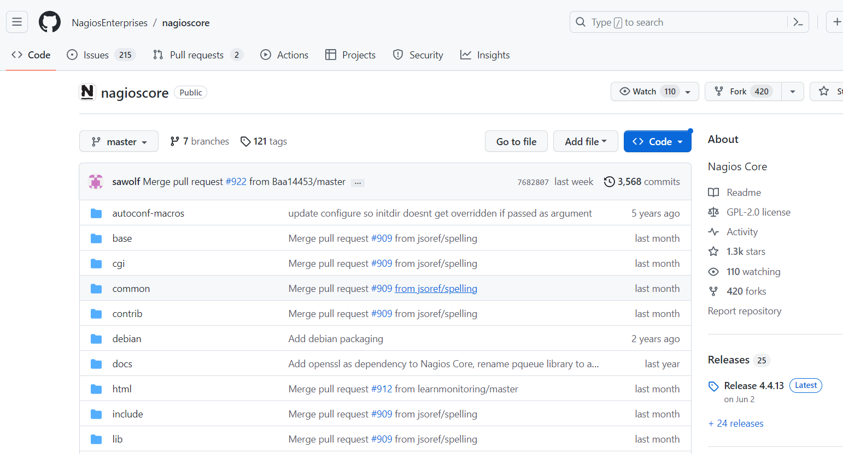

Go to release section & search for 4.4.6 version. Copy link address of tar file.

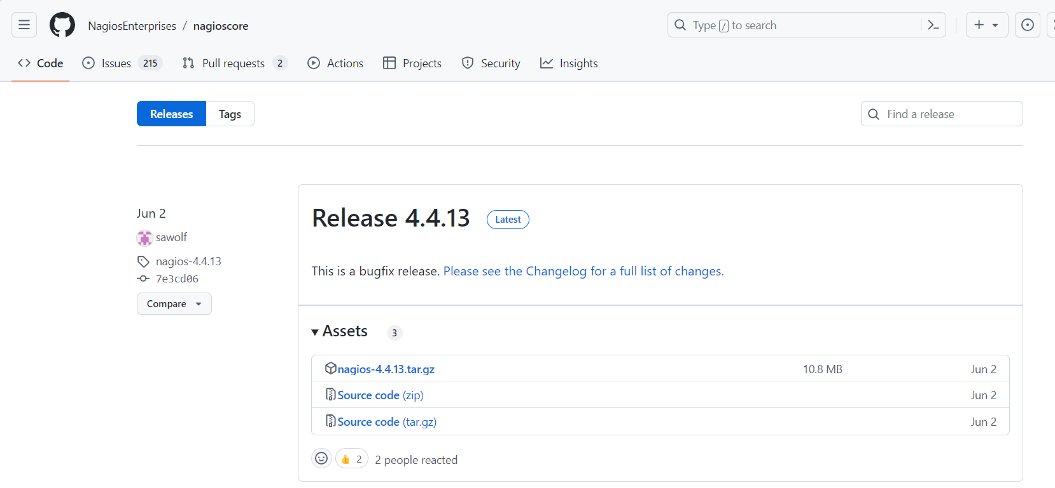

Use wget/curl command to download tar file in home directory.

wget https://github.com/NagiosEnterprises/nagioscore/releases/download/nagios-4.4.6/nagios-4.4.6.tar.gz

tar -xvzf nagios-4.4.6.tar.gz

Finally navigate to the nagios-4.4.6 folder extracted.

10) Execute configure file on server,

./configure

11) After this do the make all command & compile the code on server,

make all

After sometime you will see the "compile finish" on the screen.

12) Make users & groups on server,

make install-groups-users

13) Next add apache user in nagios group on server,

usermod -a -G nagios apache

14) Install nagios base by below command on server,

make install

15) Install scripts installation on server,

make install-daemoninit

16) Install command mode on server,

make install-commandmode

17) Install config files on server,

make install-config

18) Install web interface on server,

make install-webconf

19) Install exfoliation theme on server,

make install-exfoliation

20) Set password on server,

sudo htpasswd -c /usr/local/nagios/etc/htpasswd.users nagiosadmin

21) Restart httpd on server,

sudo systemctl restart httpd

22) Pre-flight check for Nagios :-

/usr/local/nagios/bin/nagios -v /usr/local/nagios/etc/nagios.cfg

If total warnings and errors are 0 then we are good.