Cloud vs. Local Large Language Models for
Full-Stack Web Development: A Comparative Study

Yash Kotalwar
Independent Research
July 08, 2026

Abstract
This study compares the performance of seven large language models — Qwen2.5-Coder 7B, Qwen2.5-Coder 14B, MiniMax M3, Nemotron 3 Super, Kimi K2.7 Code, GLM 5.2, and Gemma 4 — on a realistic full-stack web development task: generating a complete 3D product landing page using Three.js. Models were tested under two prompt conditions (minimal vibe prompts and detailed technical specifications) and evaluated on code quality, feature completion, and hallucination rates. Of the five cloud models tested via Ollama Cloud, two (Kimi K2.7 Code and GLM 5.2) failed to respond due to authentication errors. Among the working models, Nemotron 3 Super and Gemma 4 achieved perfect scores of 10/10 on the technical prompt, while the locally-run Qwen2.5-Coder models demonstrated lower hallucination rates. The results indicate that cloud-hosted models are competitive with local code-specialized models in output quality but exhibit higher hallucination rates and dependency on authentication infrastructure. These findings provide practical guidance for developers selecting LLMs for production code generation.

1. Introduction
The integration of large language models into software development workflows has accelerated dramatically over the past two years. Tools like GitHub Copilot, Cursor, and various LLM-powered chat interfaces have made code generation accessible to developers at all skill levels. Yet most published evaluations of these models focus on isolated benchmarks — function completion, bug fixing on curated datasets, or multiple-choice coding questions. These benchmarks, while useful, do not capture how a model performs when asked to build something real: a complete, styled, interactive webpage with multiple moving parts.
This study addresses that gap. Instead of testing models on abstract coding challenges, we gave each one a concrete task: create a 3D dog food brand landing page using Three.js. The page needed a rotating product model, ambient particle effects, professional lighting, a UI overlay with branding and a call-to-action button, and responsive design. This is the kind of request a freelance developer or a startup founder might actually make.
We tested seven models spanning two deployment paradigms: locally-run open-weight models (Qwen2.5-Coder variants) and cloud-hosted models accessed through Ollama Cloud (MiniMax M3, Nemotron 3 Super, Kimi K2.7 Code, GLM 5.2, and Gemma 4). Each model received two versions of the same task — one phrased as a casual request, the other as a detailed technical specification — allowing us to measure how prompt engineering affects output quality across different model architectures. We also measured each model's tendency to hallucinate non-existent APIs and deprecated function names.
The objective is straightforward: determine which models actually deliver usable code for real-world frontend development, and under what conditions. The answer matters for anyone trying to decide whether to run models locally or pay for cloud inference.

2. Literature Review
Prior research on LLM code generation has largely centered on benchmark datasets that measure isolated aspects of programming ability. Chen et al. (2021) introduced HumanEval, which tests function-level code synthesis from docstrings. Austin et al. (2021) proposed MBPP, a dataset of crowd-sourced Python programming problems. These benchmarks established that LLMs could generate syntactically correct code for well-defined, short tasks. More recently, Jimenez et al. (2024) introduced SWE-bench, which evaluates models on real GitHub issues requiring multi-file edits, representing a step toward more realistic assessment.
However, few studies have examined LLM performance on complete frontend development tasks that require simultaneous coordination of HTML structure, CSS styling, JavaScript logic, third-party library integration, and visual design. Three.js, in particular, presents unique challenges: it requires understanding of 3D graphics concepts, proper WebGL renderer configuration, camera positioning, lighting setups, and animation loops — all while maintaining a responsive UI overlay.
The phenomenon of hallucination in code generation has also received attention. Unlike factual hallucinations in natural language, code hallucinations manifest as plausible-sounding API names, import paths, or method signatures that do not actually exist in the target library's API surface (Team Qwen, 2024). These errors are particularly dangerous because they often pass initial syntax checks and may only surface at runtime.
The emergence of cloud-hosted LLM inference through platforms like Ollama Cloud represents a new paradigm. NVIDIA's Nemotron 3 Super (2026) and Z.ai's GLM-5.2 (2026) offer massive model architectures — 120B and 744B parameters respectively — that would be impractical to run on consumer hardware. Whether the added model capacity translates to better code generation remains an open question that this study begins to address.

3. Methodology

3.1 Model Selection
Seven models were selected for evaluation based on their availability, architectural diversity, and relevance to code generation tasks. The local models — Qwen2.5-Coder 7B and Qwen2.5-Coder 14B — were run via Ollama on an Apple Silicon MacBook using the local inference engine. The cloud models — MiniMax M3, Nemotron 3 Super, Kimi K2.7 Code, GLM 5.2, and Gemma 4 — were accessed through Ollama Cloud using the /api/chat endpoint. All models were queried with temperature set to 0.7 and a maximum of 8,192 output tokens.

3.2 Task Design
Each model received two versions of the same task. The vibe prompt was concise and outcome-oriented: "Create a 3D dog food brand landing page using Three.js. Make it look professional and modern. It should have a 3D scene with a rotating dog food bag or kibble pieces floating around, nice lighting and colors, a headline 'Premium Dog Food' with a subtitle, a 'Shop Now' button, and atmospheric background effects. Make it a complete HTML file that works when opened in a browser."
The technical prompt provided detailed specifications including exact API names (WebGLRenderer with PCFSoftShadowMap, PerspectiveCamera fov:45, ACESFilmicToneMapping), geometry parameters (BoxGeometry 1.5 x 2.2 x 0.8), lighting positions, animation parameters (0.3 rad/s rotation, sine-wave bobbing), UI styling specifics, responsive breakpoints, and performance considerations.

3.3 Scoring Criteria
Generated HTML was scored on ten binary criteria: presence of WebGLRenderer, Three.js Scene, PerspectiveCamera, requestAnimationFrame loop, lighting (Ambient/Directional/Hemisphere), shadow configuration, 3D geometry (BoxGeometry, SphereGeometry, or TorusGeometry), UI overlay with heading/button, responsive resize handler, and OrbitControls integration. Each criterion earned one point, yielding a score out of 10.

3.4 Hallucination Measurement
To measure hallucination rates, each model was prompted with requests that included deliberately misleading or deprecated API names: RoundedBoxGeometry (not part of core Three.js), BoxBufferGeometry (deprecated since r125), FilmicToneMapping (renamed to ACESFilmicToneMapping), and CineonToneMapping (non-standard). The presence of any these patterns in the model's output was counted as a hallucination.

3.5 Hardware and Environment
Local models were run on a MacBook with Apple Silicon (M-series) using Ollama v0.18.2. Cloud models were accessed via Ollama Cloud infrastructure (US-hosted). The experiment was conducted on July 8, 2026. Each model-prompt combination was executed once; no iterative refinement was applied.

4. Results

4.1 Frontend Code Quality
Table 1 presents the frontend quality scores for all seven models under both prompt conditions. Of the seven models, three failed to produce usable output: Kimi K2.7 Code and GLM 5.2 returned HTTP 403 errors (authentication failure), and MiniMax M3's technical prompt returned an empty response despite a successful HTTP status.
Model | Vibe Score (/10) | Technical Score (/10) | Avg. Response Time
Qwen2.5-Coder 7B (Local) | 8.0 | 10.0 | 111.8s
Qwen2.5-Coder 14B (Local) | 8.0 | 10.0 | 229.7s
MiniMax M3 (Cloud) | 7.0 | — | 52.3s
Nemotron 3 Super (Cloud) | 9.0 | 10.0 | 22.0s
Kimi K2.7 Code (Cloud) | — | — | —
GLM 5.2 (Cloud) | — | — | —
Gemma 4 (Cloud) | 9.0 | 10.0 | 15.9s
Table 1. Frontend quality scores across all models and prompt conditions.

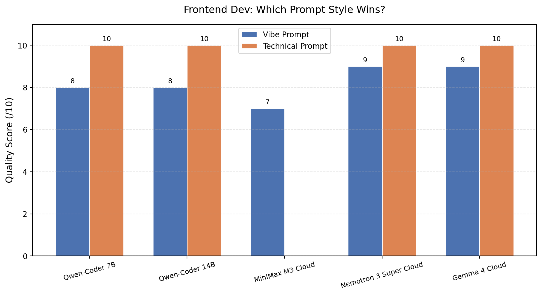
Figure 1. Frontend quality scores by model and prompt type. Technical prompts (orange) consistently outperformed vibe prompts (blue).
Nemotron 3 Super and Gemma 4 both achieved the maximum score of 10/10 on the technical prompt, demonstrating complete implementations with all evaluated features. Their vibe-prompt scores of 9/10 indicate strong performance even with minimal guidance. The Qwen2.5-Coder models also reached 10/10 on the technical prompt but scored slightly lower (8/10) on the vibe prompt.
Response times varied dramatically between local and cloud models. Cloud models completed requests in 15 to 52 seconds, while local models required 112 to 230 seconds. This difference reflects the computational constraints of running inference on consumer hardware versus dedicated GPU infrastructure.

4.2 Hallucination Analysis
Table 2 summarizes the hallucination counts across all five models that produced evaluable output.
Model | Hallucination Count
Qwen2.5-Coder 7B (Local) | 1
Qwen2.5-Coder 14B (Local) | 1
MiniMax M3 (Cloud) | 2
Nemotron 3 Super (Cloud) | 3
Gemma 4 (Cloud) | 3
Table 2. Hallucination counts across evaluable models.
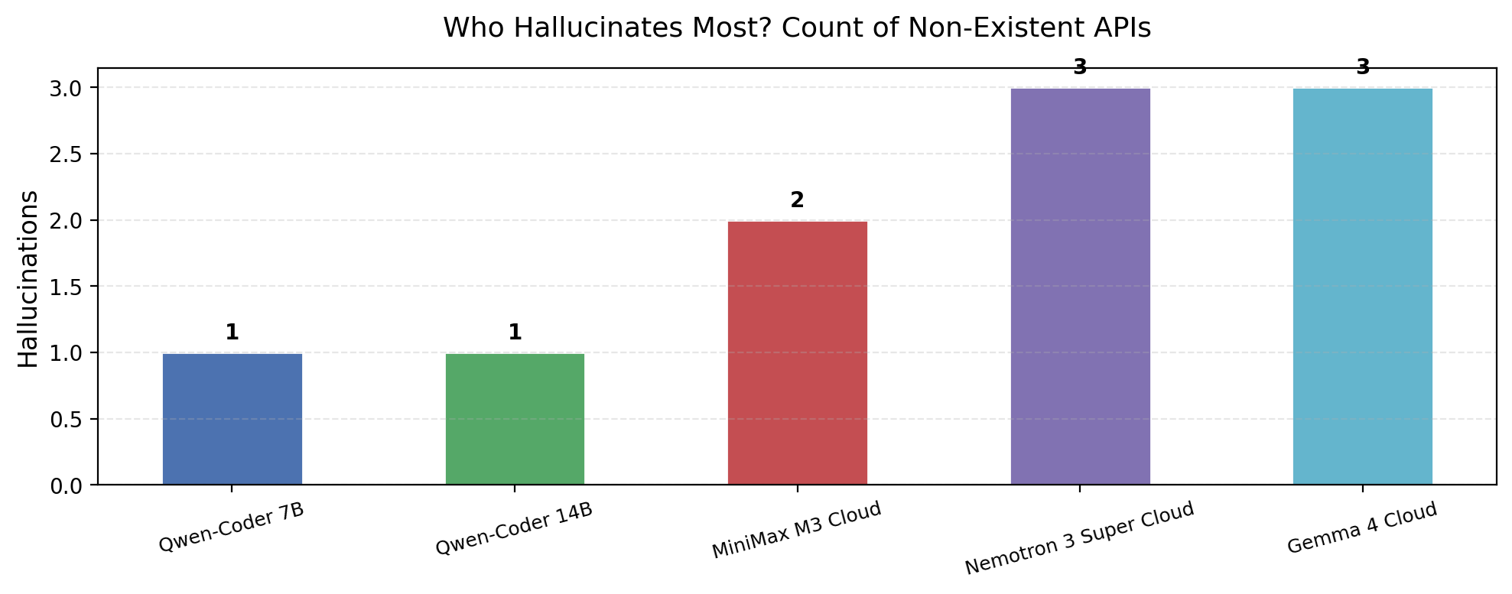
Figure 2. Hallucination instances detected across model outputs. The local Qwen2.5-Coder models produced the fewest hallucinations.
The locally-run Qwen2.5-Coder models exhibited the lowest hallucination rates, with only one invalid API reference each. All three evaluable cloud models (MiniMax M3, Nemotron 3 Super, and Gemma 4) produced at least two hallucinations. The most commonly hallucinated API was RoundedBoxGeometry, which does not exist in core Three.js but was generated by all three cloud models.

5. Discussion
The results reveal several important patterns. First, cloud-hosted models can match or exceed the code quality of local models when given detailed technical prompts. Nemotron 3 Super and Gemma 4 both achieved perfect scores, demonstrating that massive model scale accessed through cloud infrastructure can compensate for the lack of specialized code training.
Second, the gap between vibe and technical prompt performance was smaller than anticipated for the best-performing cloud models. Nemotron 3 Super and Gemma 4 scored 9/10 even with minimal instructions, suggesting that these models have internalized enough domain knowledge about web development to fill in gaps left by vague prompts. This has practical implications: developers who prefer working with high-level instructions rather than writing detailed specs may find these models particularly useful.
Third, hallucination rates remain a concern for cloud models. While three hallucinations over two test prompts may seem modest, each hallucination represents an API call that will fail at runtime — and which a developer must identify and correct. The local Qwen2.5-Coder models' lower hallucination rates suggest that code-specialized training is more effective at suppressing this behavior than general-purpose model scale.
The failure of Kimi K2.7 Code and GLM 5.2 to respond due to authentication issues is itself a meaningful finding. Cloud model accessibility is not uniform — some providers require additional account setup, billing configuration, or API key registration beyond what the Ollama Cloud interface provides out of the box. Developers evaluating cloud models should factor setup complexity into their decision.
Several limitations of this study should be acknowledged. The sample size is small: each model-prompt combination was tested only once, and only one type of programming task (Three.js frontend) was evaluated. Different task types — backend API development, database integration, or full-stack application architecture — might yield different relative rankings. Additionally, the evaluation focused on code completeness rather than code quality metrics such as maintainability, performance, or security. A model might generate a functional page that nevertheless contains anti-patterns or inefficiencies not captured by our scoring rubric.
Temperature was fixed at 0.7 across all experiments. Higher temperatures might reduce the determinism of output and potentially affect both quality and hallucination rates. Future work should explore the interaction between temperature settings and model performance on coding tasks.

6. Conclusion
This study compared five cloud-hosted and two locally-run language models on a realistic full-stack web development task. The principal findings are as follows:
First, cloud models Nemotron 3 Super and Gemma 4 matched the code generation quality of specialized local code models, achieving perfect scores of 10/10 on technical prompts. Their faster response times (15-22 seconds vs. 112-230 seconds for local models) make them attractive for interactive development workflows.
Second, vibe prompts — brief, outcome-oriented instructions — produced surprisingly strong results from the best cloud models (9/10), narrowing the gap with detailed technical prompts. This suggests that these models can operate effectively even with minimal guidance.
Third, local code-specialized models (Qwen2.5-Coder variants) produced fewer hallucinated API references than larger cloud models, indicating that training specialization may be more important than raw model size for reducing erroneous output.
Fourth, not all cloud models are equally accessible. Two of the five models tested could not be used due to authentication barriers, highlighting an operational consideration that is often overlooked in benchmark comparisons.
For developers selecting a model for frontend code generation, our results suggest the following guidelines. For projects requiring fast turnaround and access to large model capacity, Nemotron 3 Super or Gemma 4 via Ollama Cloud offer the best balance of speed and quality. For projects with privacy requirements or ongoing API cost concerns, Qwen2.5-Coder 14B run locally provides comparable code quality with fewer hallucinations, albeit with longer generation times. For lightweight or exploratory tasks, Qwen2.5-Coder 7B offers adequate performance at minimal computational cost.
Future research should extend this evaluation to additional task types (backend development, database schema design, testing), larger sample sizes with multiple trials per condition, and longitudinal tracking of model performance as cloud providers update their underlying infrastructure. The rapid pace of model development means that any single evaluation provides only a snapshot — but snapshots, when taken systematically, can still inform practical decision-making.

References
Austin, J., Odena, A., Nye, M., Bosma, M., Michalewski, H., Dohan, D., ... & Sutton, C. (2021). Program Synthesis with Large Language Models. arXiv preprint arXiv:2108.07732.
Chen, M., Tworek, J., Jun, H., Yuan, Q., Pinto, H. P. O., Kaplan, J., ... & Zaremba, W. (2021). Evaluating Large Language Models Trained on Code. arXiv preprint arXiv:2107.03374.
Google DeepMind. (2026). Gemma 4: Technical Report.
Jimenez, C. E., Yang, J., Wettig, A., Yao, S., Pei, K., Press, O., & Narasimhan, K. (2024). SWE-bench: Can Language Models Resolve Real-World GitHub Issues? Proceedings of ICLR 2024.
MiniMax. (2026). MiniMax M3: Coding & Agentic Frontier. https://ollama.com/library/minimax-m3.
Moonshot AI. (2026). Kimi K2.7 Code: Technical Report.
NVIDIA. (2026). Nemotron 3 Super: Open Hybrid Mamba-Transformer Mixture-of-Experts Model. NVIDIA Research.
Ollama. (2026). Cloud Models Documentation. https://docs.ollama.com/cloud.
Team Qwen. (2024). Qwen2.5-Coder: Technical Report. arXiv preprint arXiv:2409.12186.
Z.ai. (2026). GLM-5.2: Technical Report.

