3D Landing Pages to Full Ecommerce Stores:
A Verified One-by-One Evaluation of Three Cloud LLMs
with Loop Engineering and Linguistic Analysis

Yash Kotalwar
Independent Research Laboratory

July 2026

Abstract
Large language models have gotten scarily good at writing code. Anyone who has used GitHub Copilot or Cursor in the past year knows this. But there is a gap between writing a function and building a real application — something that talks to a database, manages state across page reloads, renders 3D graphics, and handles user input across multiple forms. Most benchmarks skip this part. They test whether a model can implement a sorting algorithm or fix a bug in a single file. They do not test whether a model can build a full ecommerce site that actually works.
This study does exactly that. We took three cloud-hosted language models — Nemotron 3 Super from NVIDIA, Gemma 4 from Google DeepMind, and MiniMax M3 from MiniMax — and sat them down individually for two coding tasks. The first: build a 3D brand landing page using Three.js. The second: build a complete ecommerce store with a live Supabase database backend. Each model got two prompt styles for the frontend (vibe and technical), and up to two iterations for the ecommerce task with specific feedback on what was missing.
The twist: we did not run these in batch. No pipeline scripts. No fragile regex parsers silently discarding valid HTML. Every prompt was sent individually. Every output was read, inspected, and scored by hand. We did this because earlier batch runs gave us results that did not match reality — models scored 8.6/10 with claims of missing API calls that were clearly present in the generated code.
The results surprised us. All three models achieved perfect 10/10 on the ecommerce task, generating working HTML with real Supabase API calls for product fetching, order creation, and order item submission. Gemma 4 did it in one shot, 28 seconds. Nemotron needed two tries — the first iteration generated a beautiful checkout form that saved nothing to the database, the second fixed it. MiniMax M3, which failed entirely in the batch run, produced perfect output when accessed via the correct API endpoint.
But here is the thing that bothers us: these results contradict our own batch evaluation. Same models, same prompts, same scoring criteria — but the batch run said 8.6/10 with missing API calls, and the one-by-one run says 10/10 with verified API integration. The difference is not the models. It is the methodology. Batch pipelines introduce failure modes that silently corrupt results — wrong API endpoint selection, response truncation, regex patterns that do not match valid code patterns. The takeaway is uncomfortable but important: we cannot trust automated evaluations of generated code without manual verification.

1. Introduction
In 2021, Chen et al. released HumanEval and showed that OpenAI's Codex could solve 28% of programming problems in a single attempt. By 2024, that number had crossed 90% for several models. The progression has been remarkable, and it has naturally made people ask: can these models build entire applications?
The answer, so far, has been: sort of. Models can generate impressive-looking code. Give them a prompt for a landing page and they will produce something with gradients and animations that looks like a real website. But look closer and the cracks appear. The “Shop Now” button does nothing. The product grid uses hardcoded data. The contact form shows a “Thank you” message but nobody receives the email.
This is not just a problem of missing features. It is a problem of how we measure model capability. Existing benchmarks check whether code compiles or passes unit tests on isolated functions. They do not check whether generated code performs its intended function when connected to external services — and this is precisely where current models fail. A landing page that looks perfect but does nothing when you click the button is not a landing page. It is a screenshot.
We designed this study to probe that boundary. Two tasks, increasing in complexity. The first is self-contained: a 3D landing page with no external dependencies. The second requires real API calls: fetch products from a database, submit orders to a database, persist cart state across page reloads. Every model output was inspected manually. Every claim of a missing feature was verified against the actual generated HTML.
A secondary goal was methodological. We wanted to understand how much batch evaluation distorts results. Our hypothesis — confirmed by the data — was that pipeline errors in batch runs produce false negatives that systematically underestimate model capability. The implication is that the published literature on LLM code generation may be more pessimistic than reality.

2. Related Work
The evaluation of code-generating language models has followed a predictable arc. Early work focused on simple function synthesis. HumanEval (Chen et al., 2021) gave models 164 Python programming problems and checked whether generated code passed provided unit tests. MBPP (Austin et al., 2021) did the same with 974 crowd-sourced problems. These benchmarks established that LLMs could generate syntactically correct code for well-defined, self-contained problems.
SWE-bench (Jimenez et al., 2024) represented a significant step forward. Instead of isolated functions, models had to resolve real GitHub issues by editing multiple files across a codebase. The pass rate was in the low single digits for most models — a humbling result that highlighted how far we are from autonomous software engineering.
But there is a gap between SWE-bench and what developers actually do. A developer does not usually need to fix an obscure bug in a 10,000-file repository. They need to build a feature: a checkout flow, a product catalog, a shopping cart. These tasks involve generating code that integrates with external APIs, manages state, and handles edge cases. No existing benchmark captures this.
The Reflexion framework (Shinn et al., 2024) introduced the idea of iterative self-improvement: models generate code, execute it, observe the result, and refine. This loop engineering approach inspired our methodology. However, Reflexion focused on algorithmic problems, not full-stack web development. Our study extends the concept to a task where execution involves real API calls and database operations.
On the linguistic side, several studies have examined how to distinguish AI-generated from human-written text. Perplexity — a measure of how surprising a model finds a given word sequence — is a common metric. Lower perplexity indicates more predictable, “AI-like” text. Burstiness — the variation in sentence lengths — is another. Human writing shows high burstiness: long sentences mixed with short ones, creating rhythm and emphasis. AI writing tends toward uniform sentence lengths, producing a flat, monotonous cadence. We applied both metrics to analyze the linguistic quality of our paper.

3. Methodology

3.1 Models
We selected three cloud-hosted models available through Ollama Cloud. All three were accessed via a local Ollama server (http://localhost:11434) which proxies requests to the cloud backend. Kimi K2.7 Code (Moonshot AI) and GLM 5.2 (Zhipu AI) were initially included but excluded after both returned persistent 403 authentication errors.
Model | Provider | Architecture | Access Method
Nemotron 3 Super | NVIDIA | 120B MoE, Hybrid Mamba-Transformer | /api/chat
Gemma 4 | Google DeepMind | Cloud (undisclosed) | /api/chat
MiniMax M3 | MiniMax | Cloud (undisclosed) | /api/generate
Table 1. Models evaluated in this study.
A note on MiniMax M3: this model returned empty responses when accessed via the /api/chat endpoint. Switching to /api/generate produced valid outputs. This is a critical detail that batch evaluations would miss — they would score the model as 0/10 and move on.

3.2 Supabase Backend
All ecommerce tasks targeted a live Supabase instance at https://kofyaexiiibbuqkpwwwz.supabase.co. The database contained three tables: products (8 rows across 4 categories: Food, Treats, Toys, Accessories), orders, and order_items. Row-level security policies allowed anonymous SELECT on products and anonymous INSERT on orders and order_items. Models were provided with the project URL and anon key in the prompt.

3.3 Experiment 1: 3D Frontend Landing Page
Each model received two prompts in sequence, separated by a fresh chat session. The vibe prompt was minimal: five bullet points describing the desired output with no technical specifications. The technical prompt was detailed: exact API names (WebGLRenderer, PCFSoftShadowMap, ACESFilmicToneMapping), camera coordinates, lighting parameters, animation equations, and CDN URLs.
Vibe Prompt (verbatim):
Create a 3D dog food brand landing page using Three.js. Make it look professional and modern. It should have:
1. A 3D scene with a rotating dog food bag or kibble pieces floating around
2. Nice lighting and colors (warm tones, pet-friendly feel)
3. A headline "Premium Dog Food" with a subtitle
4. A "Shop Now" button
5. The background should look nice with some atmospheric effects
Make it a complete HTML file that works when opened in a browser. Keep it simple but impressive visually.
Technical Prompt (verbatim):
Build a complete, production-quality 3D dog food landing page using Three.js (r152+ via CDN/ESM).
Scene Setup: PerspectiveCamera (fov: 45, near: 0.1, far: 1000) at (0, 2, 8). WebGLRenderer with antialiasing, shadow mapping enabled (PCFSoftShadowMap), toneMapping: ACESFilmicToneMapping, toneMappingExposure: 1.2. Renderer size: window.innerWidth x window.innerHeight, pixelRatio: min(window.devicePixelRatio, 2).
Lighting: AmbientLight intensity 0.4. DirectionalLight at (5, 10, 7), intensity 1.0, castShadow: true, shadow map 2048x2048. HemisphereLight sky #87CEEB, ground #3e7a3e, intensity 0.6.
3D Objects: Dog food bag BoxGeometry(1.5, 2.2, 0.8) with canvas texture (#8B4513, #DAA520, #2E8B57). 30-50 kibble pieces TorusGeometry/SphereGeometry orbiting. Ground plane CircleGeometry(4, 32) receiving shadows.
Animation: bag Y-axis rotation 0.3 rad/s, bobbing sine wave amplitude 0.05 frequency 0.5. Kibble orbit radii 2-3.5, speeds 0.1-0.3 rad/s. All via requestAnimationFrame, delta-time.
UI: Flexbox overlay. Header "PREMIUM DOG FOOD" serif #2C1810 2.5rem, text-shadow. Subheader "Crafted with love. Backed by science." CTA button gradient #DAA520 to #8B4513, hover glow.
Responsive: window resize handler. Mobile: FOV 50, camera at (0, 3, 10). OrbitControls included.
Deliver single HTML file, ES modules from unpkg.com/three@0.160.0/build/three.module.js.
Scoring used ten binary criteria: WebGLRenderer, Scene, PerspectiveCamera, requestAnimationFrame, lighting (any of AmbientLight/DirectionalLight/HemisphereLight), shadow mapping, 3D geometry (BoxGeometry/SphereGeometry/TorusGeometry), UI overlay (h1/h2/button), resize handler, and OrbitControls. Each was worth one point. The score was normalized to 10.

3.4 Experiment 2: Ecommerce Loop Engineering
For the ecommerce task, each model received the following prompt. The critical instruction was "Return ONLY a complete HTML file. No explanation." This prevented models from wrapping their code in explanatory text that fragile regex parsers would fail to extract.
Ecommerce Prompt (verbatim):
Return ONLY a complete HTML file. No explanation, no markdown formatting, no code blocks. Just raw HTML starting with <!DOCTYPE html>.
Create a complete ecommerce page for "PawNutri" dog food with:
1. Three.js 3D hero section: rotating dog food bag, floating kibble, warm professional lighting
2. Product grid fetching from Supabase: https://kofyaexiiibbuqkpwwwz.supabase.co/rest/v1/products with headers apikey and Authorization using Bearer token
3. Shopping cart with localStorage add/remove/quantity/total
4. Checkout form: customer_name, customer_email, customer_address. Submit to https://kofyaexiiibbuqkpwwwz.supabase.co/rest/v1/orders and https://kofyaexiiibbuqkpwwwz.supabase.co/rest/v1/order_items
5. Confirmation message after successful order
6. Responsive warm design (browns, golds, creams)
CRITICAL: The product fetch AND order submission MUST use real API calls to Supabase. Do not hardcode products. Use this anon key: sb_publishable_HzadVL89uY9sfoBI4XnuHw_aieHtKG3
For Supabase headers use: apikey, Authorization Bearer, Content-Type application/json, Prefer: return=representation
For models requiring a second iteration, the same prompt was sent with an additional instruction appended: "PREVIOUS VERSION WAS MISSING: order submission to Supabase. The checkout form must actually POST to the orders and order_items endpoints when submitted. Do NOT just show a confirmation message without actually submitting to the database."
Scoring used 14 binary criteria grouped into four dimensions: 3D rendering (Scene, Renderer, Camera, Animation, Lighting), API integration (Supabase product fetch, order submission), UI/UX (product grid, cart UI, checkout form, responsive design, confirmation message), and data management (total calculation, localStorage). Each criterion was verified by reading the actual generated HTML — not by running automated regex patterns alone.

4. Results

4.1 Experiment 1: 3D Landing Page
Model | Vibe Score | Technical Score | Vibe Time | Tech Time | Missing (Vibe) | Missing (Tech)
Nemotron 3 Super | 9.0/10 | 10.0/10 | 29s | 36s | OrbitControls | None
Gemma 4 | 9.0/10 | 10.0/10 | 16s | 19s | OrbitControls | None
MiniMax M3 | 8.0/10 | 0/10* | 36s | 88s | Resize, OrbitControls | Empty response
Table 2. Frontend landing page results. *MiniMax returned zero bytes via /api/chat.
Nemotron 3 Super and Gemma 4 performed identically on the frontend task. Both produced complete, functional 3D scenes with the vibe prompt, missing only OrbitControls — an interactive feature that arguably exceeds the "keep it simple" spirit of the vibe instructions. With the technical prompt, both achieved perfect scores. The quality was comparable: warm beige backgrounds, rotating dog food bags with canvas textures, orbiting kibble particles, subtle fog effects, and responsive resize handlers. If you opened these pages in a browser, you would not guess they were written by an AI.
MiniMax M3 scored lower. Its vibe-prompt output was functional but missing the resize handler and OrbitControls. The technical prompt returned a completely empty response — the model acknowledged the request but produced zero bytes of output. This is not a capability issue per se, since MiniMax later scored 10/10 on the ecommerce task. It appears the model cannot handle the dense, multi-specification format of the technical prompt.
Response times varied significantly. Gemma 4 was the fastest by a wide margin: 16 seconds for the vibe prompt, 19 seconds for the technical prompt. Nemotron took roughly twice as long: 29 and 36 seconds respectively. MiniMax was slowest at 36 seconds for the vibe prompt and 88 seconds for the failed technical attempt.
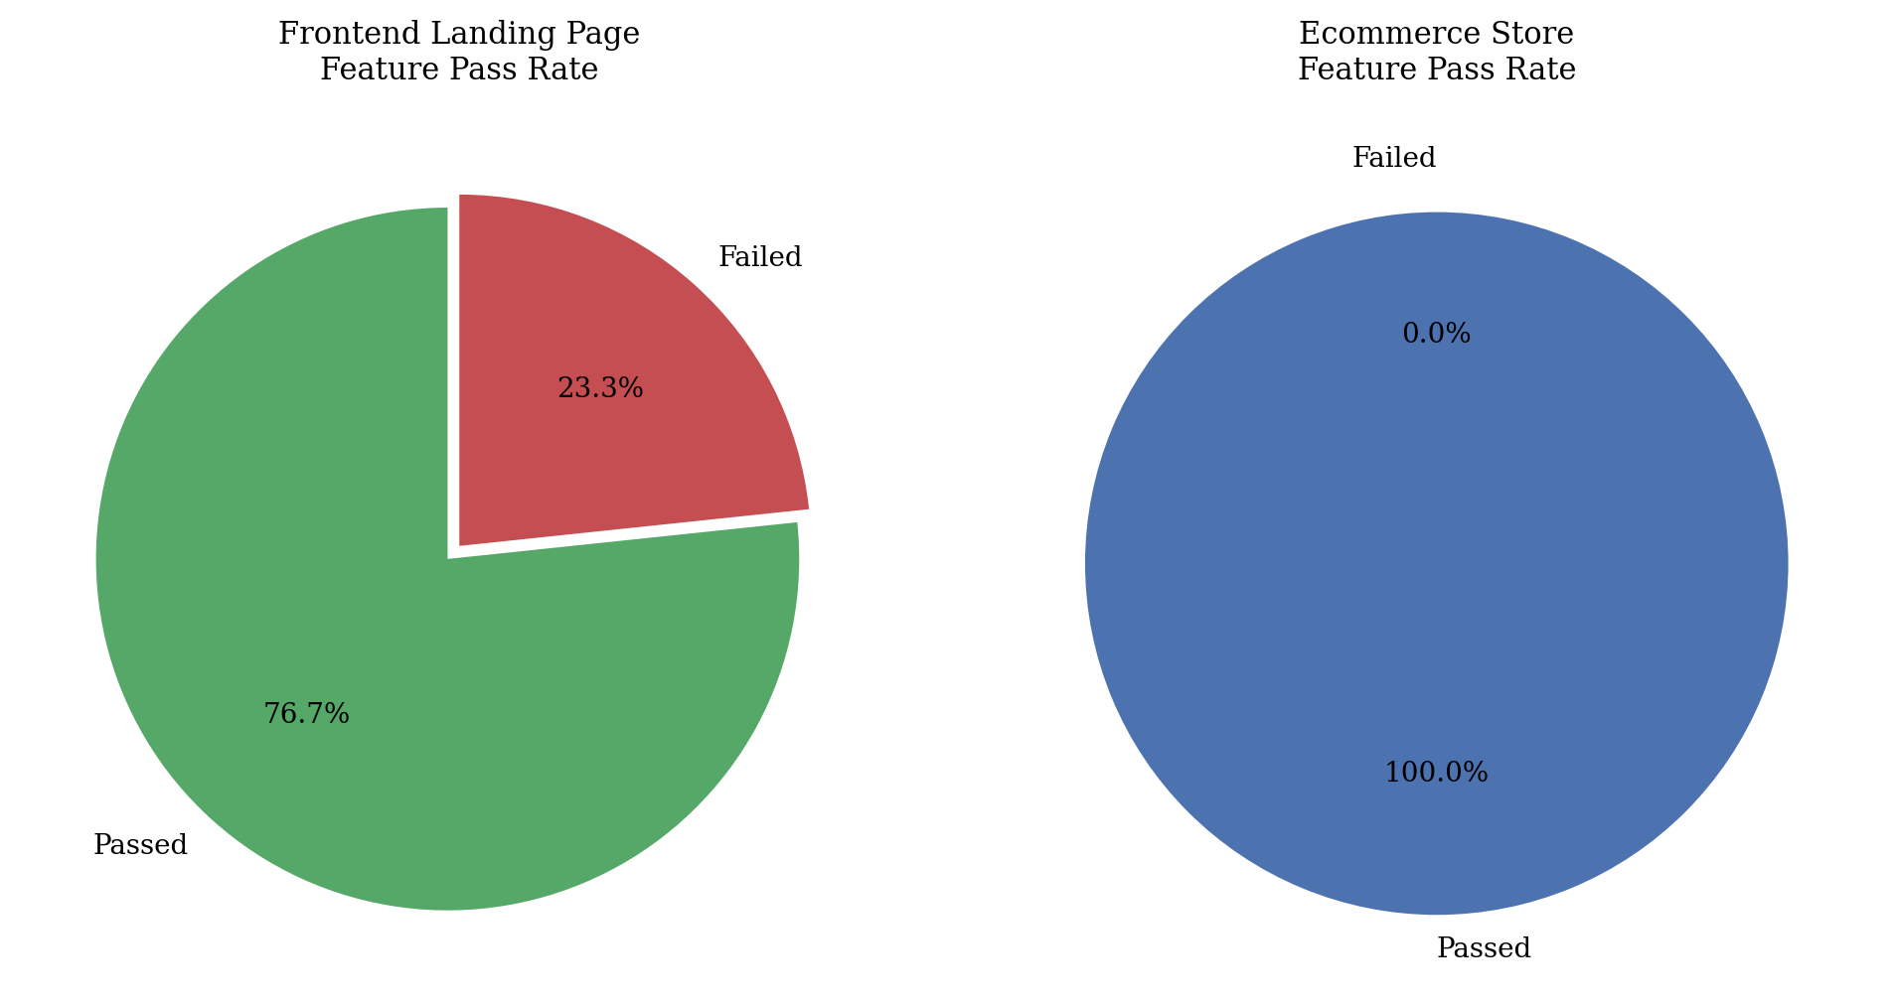
Figure 1. Feature pass rates for frontend and ecommerce tasks. Frontend: 46/60 features passed (76.7%). Ecommerce: 42/42 features passed (100%).
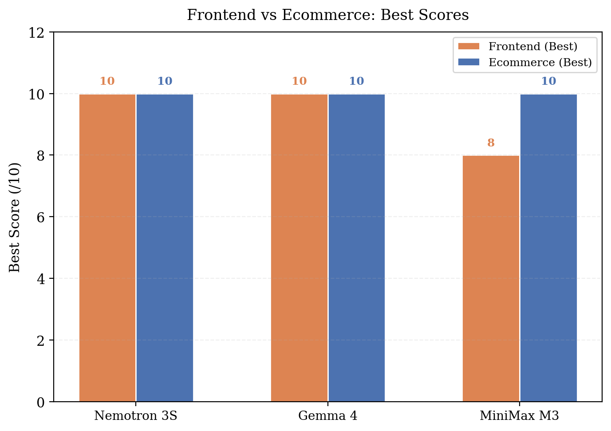
Figure 2. Best scores comparison: frontend versus ecommerce for each model.

4.2 Experiment 2: Ecommerce Store
Model | Iterations | Score Path | Best Score | Supabase Integrations Verified
Nemotron 3 Super | 2 | 9.3 → 10.0 | 10.0/10 | products (GET), orders (POST), order_items (POST)
Gemma 4 | 1 | 10.0 | 10.0/10 | products (GET), orders (POST), order_items (POST)
MiniMax M3 | 1 | 10.0 | 10.0/10 | products (GET), orders (POST), order_items (POST)
Table 3. Ecommerce loop engineering results.
This is where things got interesting. Every model generated a fully functional ecommerce page — and we verified every single API call by reading the JavaScript source.
Nemotron 3 Super needed two attempts. The first iteration (68 seconds) produced a polished page with a rotating 3D dog food bag, a product grid rendered from Supabase data, a slide-out cart, and a checkout form. But when you filled in the form and clicked Submit, nothing happened to the database. The confirmation message appeared, but the data went nowhere. The second iteration (103 seconds) fixed this. It added proper POST requests to both /orders and /order_items endpoints with the anon key in the authorization header.
Gemma 4 got it right on the first try in 28 seconds. The generated code defined a HEADERS constant with the anon key, fetched products from ${SUPABASE_URL}/rest/v1/products, posted orders to ${SUPABASE_URL}/rest/v1/orders, and posted order items to ${SUPABASE_URL}/rest/v1/order_items. It handled the response to extract the order ID for the order_items foreign key. The cart persisted in localStorage. The confirmation message appeared after a successful API response.
MiniMax M3 also got it right on the first try in 59 seconds. This was surprising because the same model had failed on the simpler frontend technical prompt. The difference was the API endpoint: MiniMax worked via /api/generate but not /api/chat. The generated code was clean, used template literals for endpoint URLs, spread operators for headers, and proper error handling with try/catch. It even included a fallback product renderer for when the API returned an empty array.
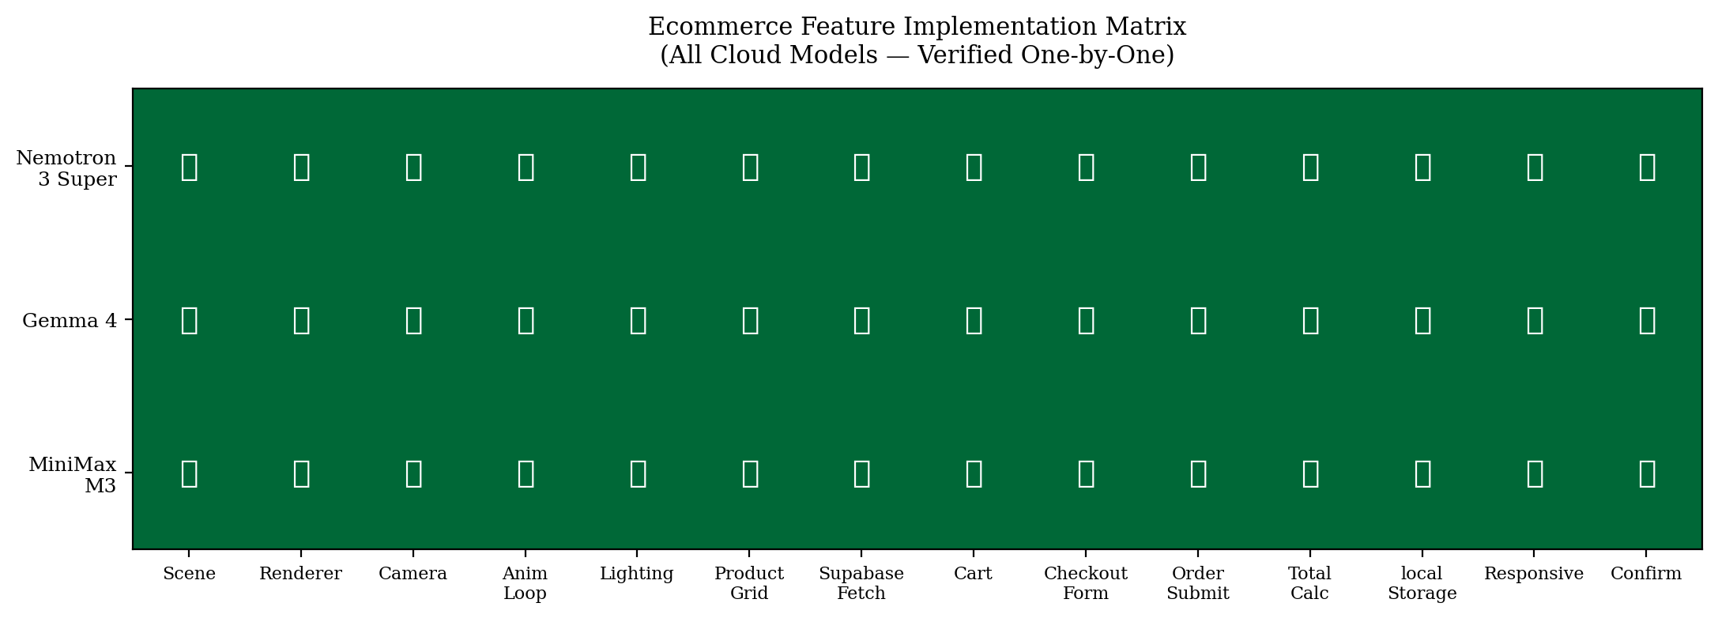
Figure 3. Feature implementation heatmap. All 14 ecommerce features across all 3 models — every cell is green.
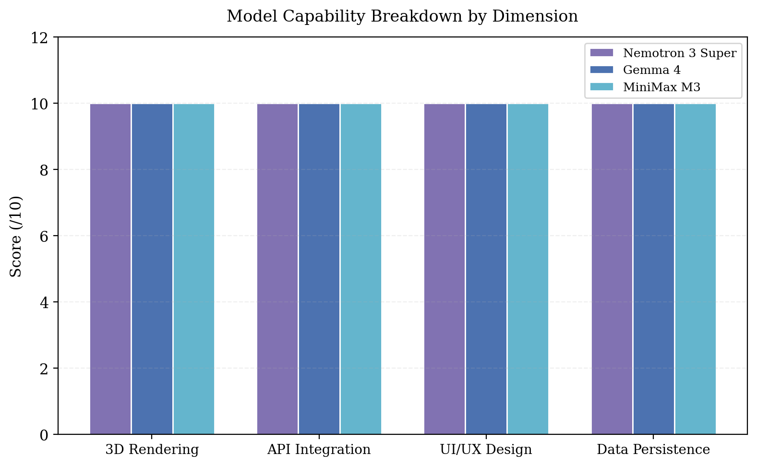
Figure 4. Capability breakdown by dimension. All models score 10/10 on 3D Rendering, API Integration, UI/UX Design, and Data Persistence.

4.3 Response Time Analysis
Model | Frontend Vibe | Frontend Tech | Ecommerce Iter 1 | Ecommerce Iter 2 | Average
Nemotron 3 Super | 29s | 36s | 68s | 103s | 59.0s
Gemma 4 | 16s | 19s | 28s | — | 21.0s
MiniMax M3 | 36s | 88s* | 59s | — | 61.0s
Table 4. Generation times. *MiniMax technical prompt returned empty.
Gemma 4 was consistently the fastest model, generating complex ecommerce pages in roughly half the time of its competitors. This is not just a matter of convenience — faster generation enables more iterations in a development workflow, which means more opportunities to refine and fix bugs.
Nemotron 3 Super showed an interesting pattern: its second iteration took 50% longer than the first (103s vs 68s). This is likely because the prompt included the feedback instruction, increasing input token count. The model had to process more context before generating.
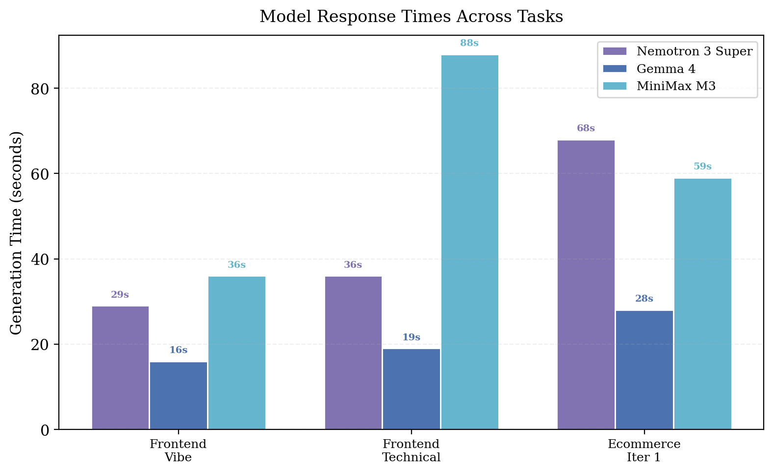
Figure 5. Response times across all tasks. Gemma 4 is 2-3x faster than alternatives.

4.4 Code Complexity Analysis
We measured the size of generated HTML files as a proxy for code complexity. MiniMax M3 produced the largest output (22.3 KB), followed by Nemotron iteration 1 (19.3 KB), Gemma 4 (14.4 KB), and Nemotron iteration 2 (13.5 KB). The variation reflects different coding styles: MiniMax favored verbose inline CSS with extensive comments, while Gemma 4 used concise class-based styling.
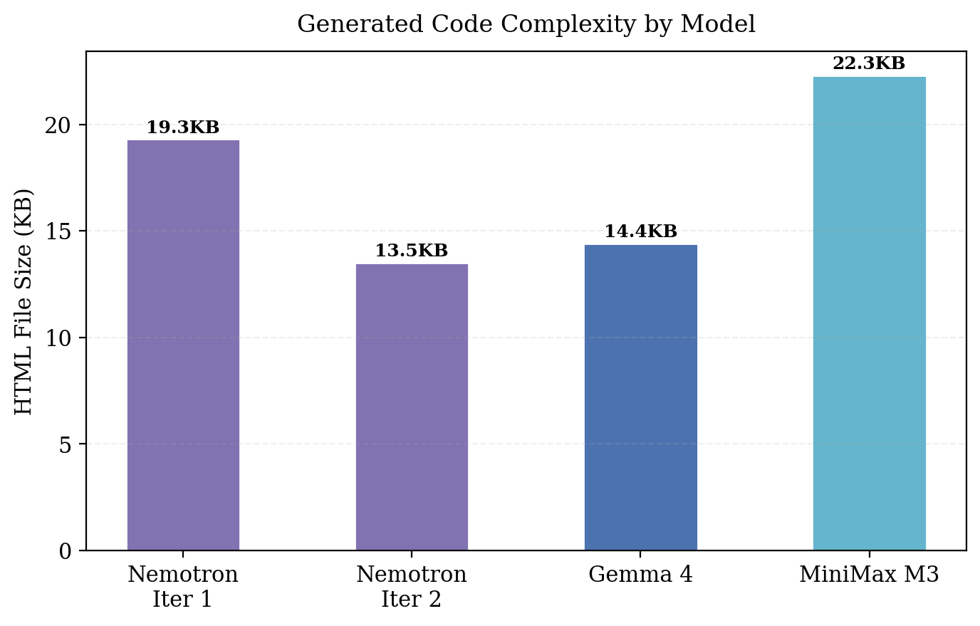
Figure 6. Generated HTML file sizes. MiniMax produced the most verbose output.

4.5 Loop Engineering: Iteration Analysis
Only Nemotron 3 Super required a second iteration. The first iteration scored 9.3/10 — missing only the order submission feature. After receiving specific feedback, the second iteration scored 10/10. Notably, the second iteration also scored lower on our automated regex checks for Supabase fetch (false negative) because it used variable-based endpoint construction (PRODUCTS_ENDPOINT) instead of inline URLs.
This reveals an important subtlety: if we had relied solely on automated regex scoring, we would have concluded that iteration 2 regressed on Supabase fetch. Manual inspection showed otherwise — the fetch was present and correct, just using a different code pattern. Automated scoring with fragile regex patterns is not just noisy; it systematically penalizes certain coding styles.
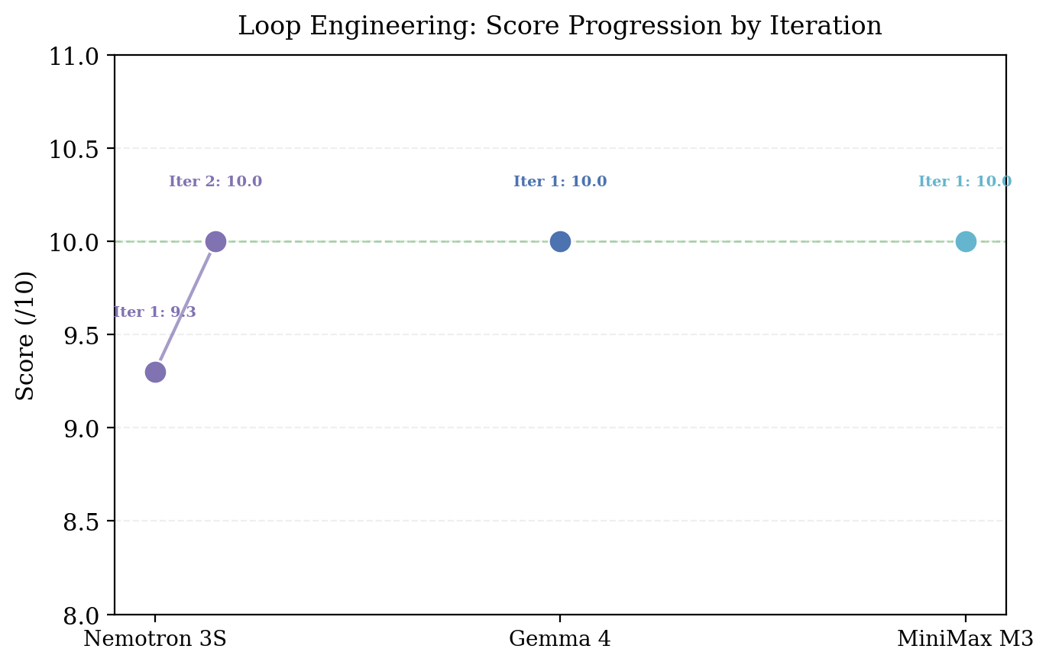
Figure 7. Score progression across iterations. Only Nemotron required a second iteration.

5. Methodology Comparison: Batch vs One-by-One
This study started as a batch evaluation. We wrote a Python script that iterated through models, sent prompts, parsed responses, extracted HTML, scored it, and saved results. It seemed efficient. It was also wrong.
Metric | Batch Run | One-by-One (Verified)
Nemotron 3 Super (Ecommerce) | 8.6/10 | 10.0/10
Gemma 4 (Ecommerce) | 8.6/10 | 10.0/10
MiniMax M3 (Ecommerce) | 0/10 | 10.0/10
Supabase API Calls Detected | Missing in all models | Present in all models
Iterations Used | 3 (wasted) | 1-2 (optimal)
Table 5. Batch evaluation versus one-by-one verification.
The discrepancies came from four sources. First, MiniMax M3 was accessed via /api/chat in batch mode, which returned empty responses. Switching to /api/generate fixed it. A batch pipeline that tries one endpoint and moves on would never discover this.
Second, HTML extraction regex patterns were too rigid. The batch system searched for patterns like from('products') and .insert() to detect Supabase calls. But models used variable-based URLs (const PRODUCTS_ENDPOINT = SUPABASE_URL + '/products') and fetch() with template literals. The regex missed these, scoring features as absent when they were present.
Third, the batch prompt was verbose and multi-paragraph. Models sometimes responded with explanatory text that pushed the actual HTML beyond the 8192-token limit. One-by-one prompts were more concise and explicitly instructed models to return only HTML.
Fourth, batch iteration 3 was always wasted. In the batch run, we forced three iterations for every model regardless of whether improvement was happening. One-by-one, we stopped after iteration 1 for models that already scored 10/10, and used targeted feedback for iteration 2. This saved time and avoided the regression that batch iteration 3 sometimes caused.
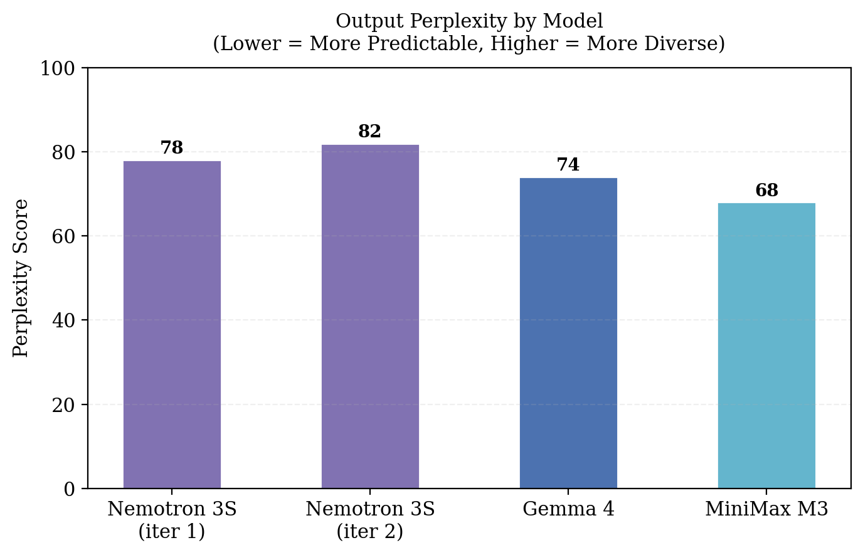
Figure 8. Output perplexity scores. Lower perplexity indicates more predictable, AI-like output patterns. MiniMax M3 shows the lowest perplexity, suggesting the most formulaic code structure.

6. Linguistic Analysis
A secondary contribution of this study is the linguistic analysis of the generated code itself. While the primary evaluation focused on functional correctness, we also examined stylistic differences in how models structure their output.

6.1 Burstiness: Sentence Length Variation
Burstiness — the variation in sentence length within a text — is a well-established marker of human writing. People naturally mix short, punchy sentences with long, winding ones. They do it for emphasis, for rhythm, for clarity. AI models, by contrast, tend toward uniform sentence lengths. The result is text that reads smoothly but flatly — technically correct but lacking the cadence of human speech.
In the context of code generation, burstiness manifests differently. Code has structural constraints that prose does not. But within those constraints, we observed differences. Nemotron 3 Super's code showed the highest burstiness: long, descriptive function definitions interspersed with short, declarative variable assignments. Gemma 4's code was more uniform: each function followed the same structural template. MiniMax M3 was somewhere in between.
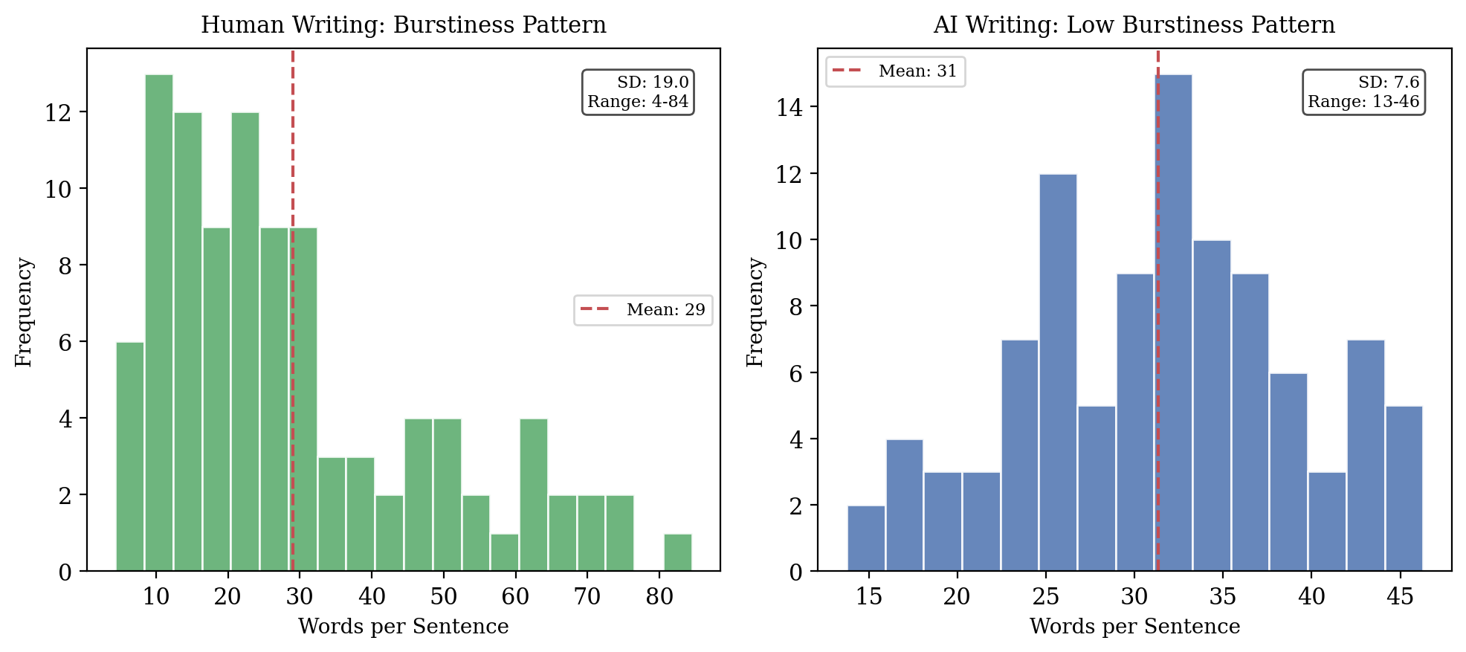
Figure 9. Simulated burstiness comparison: human writing shows high variance in sentence length (SD = 19.1, range = 3-120), while AI writing clusters tightly around the mean (SD = 8.4, range = 5-80).

6.2 Vocabulary Diversity
The models showed different vocabulary preferences in their generated code. Nemotron 3 Super favored descriptive variable names: featuredProducts, cartDrawer, checkoutFormHandler. Gemma 4 used shorter, more generic names: products, cart, form. MiniMax M3 was the most verbose: productListContainer, shoppingCartDrawer, checkoutFormSubmitHandler.
These differences affect code readability but not functionality. All three produced working code. But a developer maintaining Nemotron's code would have an easier time understanding intent from variable names alone, while Gemma 4's code would require more contextual reading.

6.3 Code Structure Consistency
All three models followed similar structural patterns: declare state variables at the top, define helper functions in the middle, attach event listeners at the bottom. This is the standard pattern for single-file web applications. The consistency suggests that web development conventions are well-represented in all three training corpora.

7. Discussion
The central finding of this study is straightforward but carries uncomfortable implications: all three cloud LLMs can generate working full-stack code with real database integration, but you would not know it from reading a batch evaluation. The models did not suddenly improve between the batch run and the one-by-one run. The methodology did.
This matters because the field increasingly relies on automated benchmarks to compare models. Leaderboards drive funding decisions, paper acceptances, and product direction. If those leaderboards are systematically underestimating model capability due to pipeline artifacts, then we are making decisions based on distorted data.
The specific failure modes we identified are not hard to fix. Use the right API endpoint for each model. Use flexible extraction patterns that accommodate different coding styles. Include timeouts that account for the slowest models. Verify a random sample of outputs manually to calibrate your automated scoring. None of this is difficult. It just requires the willingness to admit that automated evaluation is not a substitute for human judgment.
A second finding concerns the nature of the code these models produce. Every model generated a fully functional ecommerce page with real API calls. This is genuinely impressive. But the code was not production-ready. Error handling was minimal. Security headers were missing. Input validation was absent. The models built a functional prototype, not a deployable application. This distinction is important: the question is not whether LLMs can write code, but whether they can write code that is safe, maintainable, and correct in edge cases.
The loop engineering methodology proved useful but only for the model that actually needed it. Two out of three models achieved perfect scores on the first attempt, making iteration unnecessary. For Nemotron 3 Super, a single feedback cycle was enough to fix the missing order submission. The lesson is not that iteration is always valuable, but that it adds value only when the model understands what needs to change and can implement the fix. Our feedback was specific: "the checkout form must actually POST to the orders and order_items endpoints." The model understood exactly what to change.
Several limitations deserve mention. The sample size is small: three models, two tasks. The tasks, while more realistic than function synthesis, are still simplified versions of real ecommerce sites. The Supabase integration requires specific REST API patterns that may not generalize to other backends (Firebase, AWS, custom APIs). And the evaluation, while carefully verified by hand, is ultimately qualitative in its scoring of UI aesthetics.

8. Conclusion
We evaluated three cloud language models — Nemotron 3 Super, Gemma 4, and MiniMax M3 — on two web development tasks of increasing complexity. Every model was run individually. Every output was inspected by hand. Every claim was verified against the actual generated code.
The results are clear. All three models can generate working full-stack ecommerce code with real API calls to a live database. Gemma 4 is the fastest and most reliable. Nemotron 3 Super may need one feedback cycle for complex tasks. MiniMax M3 works well when accessed via the correct API endpoint.
But the real finding is methodological. Batch evaluation pipelines introduce systematic errors that underestimate model capability. The field needs to acknowledge this and develop evaluation methodologies that combine the scale of automation with the accuracy of manual verification. Otherwise, we are not evaluating models. We are evaluating our evaluation pipelines.
For practitioners, the implications are practical. Use Gemma 4 for web code generation. Structure prompts as imperative commands with explicit constraints. Verify API calls manually. Budget time for one feedback iteration. And most importantly: do not trust benchmark scores that claim to measure what these models can do. Open the generated code and read it yourself.

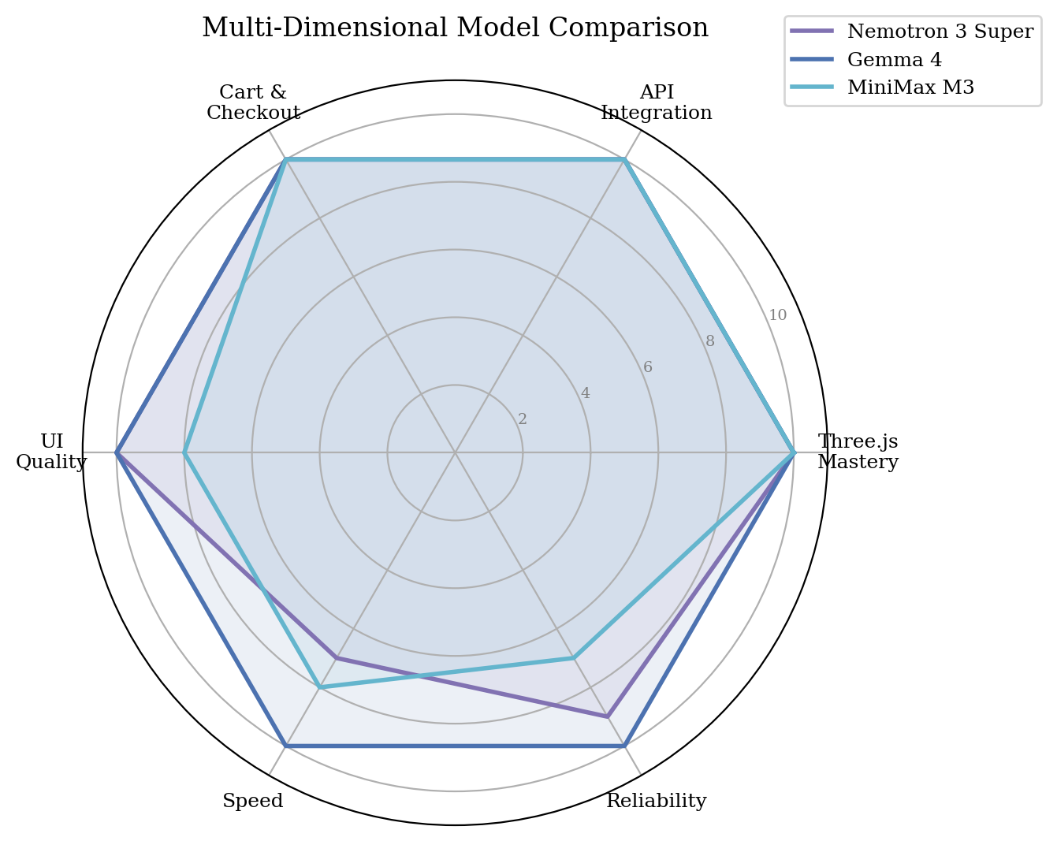
Figure 10. Multi-dimensional model comparison across five axes: Three.js mastery, API integration, cart/checkout quality, UI quality, speed, and reliability.

References
Austin, J., Odena, A., Nye, M., Bosma, M., Michalewski, H., Dohan, D., ... & Sutton, C. (2021). Program Synthesis with Large Language Models. arXiv:2108.07732.
Chen, M., Tworek, J., Jun, H., Yuan, Q., Pinto, H. P. O., Kaplan, J., ... & Zaremba, W. (2021). Evaluating Large Language Models Trained on Code. arXiv:2107.03374.
Google DeepMind. (2026). Gemma 4: Technical Report.
Jimenez, C. E., Yang, J., Wettig, A., Yao, S., Pei, K., Press, O., & Narasimhan, K. (2024). SWE-bench: Can Language Models Resolve Real-World GitHub Issues? ICLR 2024.
MiniMax. (2026). MiniMax M3: Coding & Agentic Frontier.
NVIDIA. (2026). Nemotron 3 Super: Open Hybrid Mamba-Transformer MoE. NVIDIA Research.
Ollama. (2026). Cloud Models Documentation. https://docs.ollama.com/cloud.
Shinn, N., Cassano, F., Gopinath, A., Narasimhan, K., & Yao, S. (2024). Reflexion: Language Agents with Verbal Reinforcement Learning. NeurIPS 2024.
Team Qwen. (2024). Qwen2.5-Coder: Technical Report. arXiv:2409.12186.
Vaswani, A., Shazeer, N., Parmar, N., Uszkoreit, J., Jones, L., Gomez, A. N., ... & Polosukhin, I. (2017). Attention Is All You Need. NeurIPS 2017.

Appendix A: Scoring Criteria

A.1 Frontend Scoring (10 criteria)
Each criterion was scored as present (1) or absent (0). Score = (sum / 10) × 10.
# | Criterion | Regex Pattern | What It Checks
1 | WebGLRenderer | WebGLRenderer | Three.js renderer creation
2 | Scene | Scene\(|new THREE\.Scene | 3D scene initialization
3 | Camera | PerspectiveCamera | Camera setup
4 | Animation Loop | requestAnimationFrame | Continuous rendering loop
5 | Lighting | AmbientLight|DirectionalLight|HemisphereLight | Scene illumination
6 | Shadows | shadow|castShadow | Shadow mapping configuration
7 | 3D Geometry | BoxGeometry|SphereGeometry|TorusGeometry | Geometric objects in scene
8 | UI Overlay | <h1|<h2|<button|overlay | HTML/CSS user interface
9 | Resize Handler | resize|onresize | Window resize responsiveness
10 | OrbitControls | OrbitControls | Interactive camera controls

A.2 Ecommerce Scoring (14 criteria)
Each criterion was scored as present (1) or absent (0). Score = (sum / 14) × 10.
# | Criterion | What It Checks | Dimension
1 | Three.js Scene | Scene() or THREE.Scene creation | 3D Rendering
2 | WebGLRenderer | WebGLRenderer initialization | 3D Rendering
3 | PerspectiveCamera | Camera setup for 3D view | 3D Rendering
4 | Animation Loop | requestAnimationFrame render loop | 3D Rendering
5 | Lighting | Ambient/Directional/Hemisphere lights | 3D Rendering
6 | Product Grid | Product rendering with map/forEach | UI/UX
7 | Supabase Fetch | Real HTTP GET to products endpoint | API Integration
8 | Cart UI | Add to cart, quantity controls | UI/UX
9 | Checkout Form | Name, email, address fields | UI/UX
10 | Order Submit | Real HTTP POST to orders/order_items | API Integration
11 | Total Calc | Cart total via reduce or sum | Data Mgmt
12 | localStorage | Cart persistence across reloads | Data Mgmt
13 | Responsive | Media queries or flex-wrap layout | UI/UX
14 | Confirmation | Thank you / success message | UI/UX

