VIVA DECK — SLIDE-BY-SLIDE EXPLAINER (ILLUSTRATED, EXPANDED)
Every Slide, Pictured and Fully Explained
AI-Powered Framework for Multi-Objective Steel Truss Optimization
For each of the 34 slides: the slide picture, exactly what to say, the deeper concept behind it, why it's there, and the questions that will follow. Read only this and you are ready.

Aryan Gupta • Roll 21064030 • IDD Civil & Structural Engineering (Y5)
Supervisor: Dr. Krishna Kant Pathak • IIT (BHU) Varanasi
ABOUT THE THUMBNAILS
The slide pictures are rendered from an earlier build of the deck, so the wording in the image may still say 'LLM' and the contributions slide may look cramped. Your freshly-rebuilt deck fixes all of that (it reads 'agent', the contributions numbers no longer overlap, your name and the IIT BHU logo are on the title). Use the pictures for LAYOUT — where each element sits — and trust the TEXT in this document for the current wording.
THE FIVE NUMBERS TO MEMORIZE
C1 = 0.004% (10-bar vs literature) • C2 = 132× speedup & R²=0.9993 • C3 = 549 lb hard vs 380 lb soft (72-bar) • C4 = −36.8% generations, p=0.0046 • C5 = <10 s end-to-end. If you forget everything else, hold these.

SLIDE 1 / 34
Title slide
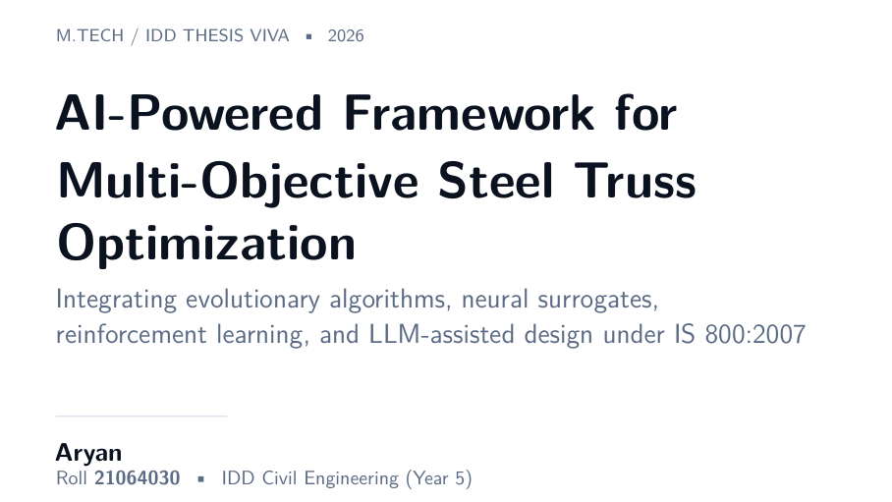
↑ slide layout (text wording shown is from an earlier build; your rebuilt deck reads 'agent')
ON SCREEN
Thesis title, IIT (BHU) logo (top-right/centre), your name Aryan Gupta, roll 21064030, IDD Civil & Structural Engineering Year 5, supervisor Dr. Krishna Kant Pathak, department, institute.
WHAT TO SAY
“Good morning, respected committee. I am Aryan Gupta, IDD Civil and Structural Engineering, fifth year, roll number 21064030. My thesis is on an AI-powered framework for multi-objective steel truss optimization, integrating evolutionary algorithms, neural surrogates, reinforcement learning, and agent-assisted design, all under IS 800:2007. My supervisor is Dr. Krishna Kant Pathak. Let me walk you through it.”

DEEPER CONTEXT — the real understanding
‘Multi-objective’ means you optimize for more than one goal at once. Here the two goals are minimum WEIGHT and minimum DISPLACEMENT (sag). These fight each other — a lighter truss sags more. Most of the thesis is single-objective (weight only), and NSGA-II handles the genuinely multi-objective case by producing a Pareto front. ‘Agent-assisted design’ is your novel piece: an AI design agent (Claude under the hood) proposes engineering-reasonable starting designs that warm-start the optimizer.

WHY IT'S HERE
Formal opening. The long subtitle signals breadth: five techniques (GA/PSO/NSGA-II + surrogate + RL + agent) unified under one Indian-code-compliant framework. Say it confidently in one breath.
LIKELY QUESTIONS
Likely Q: What does multi-objective mean here?
Answer: Two competing objectives — minimum weight and minimum maximum-displacement. There's no single best; you get a Pareto front of trade-offs, which NSGA-II computes.
Likely Q: Why all these techniques together?
Answer: Each plays a distinct role: the optimizers search, the surrogate accelerates, the RL agent is an alternative learned solver, and the design agent warm-starts. The contribution is composing them into one validated, reproducible, code-compliant system.
Time on this slide: 20–25 seconds

SLIDE 2 / 34
Outline
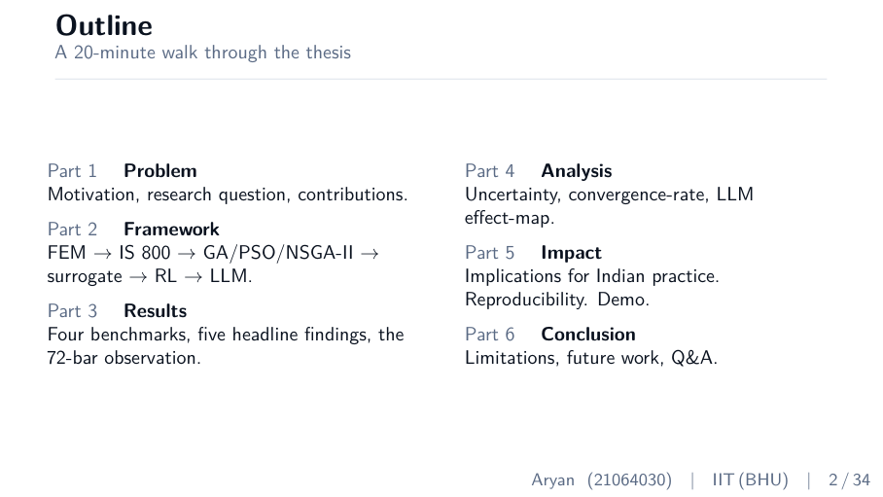
↑ slide layout (text wording shown is from an earlier build; your rebuilt deck reads 'agent')
ON SCREEN
Six parts listed: 1 Problem, 2 Framework, 3 Results, 4 Analysis, 5 Impact, 6 Conclusion.
WHAT TO SAY
“The talk has six parts. First the problem and why it matters. Then the framework I built. Then the results across four benchmarks. Then a deeper analysis. Then practical impact. And finally limitations, future work, and your questions.”

DEEPER CONTEXT — the real understanding
An outline slide is a navigation aid — it lets the committee know where you are at any moment, so when they ask a question they can place it. The six-part arc is a classic research-talk structure: motivate → build → prove → analyze → apply → conclude. Don't read every word; name the six parts and move on.

WHY IT'S HERE
Sets expectations and a mental map. Spending more than ~15 seconds here wastes your tight budget.
LIKELY QUESTIONS
Likely Q: (Rarely questioned — it's an outline.)
Answer: If asked how long: 'About 18 minutes of talk, leaving time for questions.'
Time on this slide: 15 seconds

SLIDE 3 / 34
Part 1 divider — The Problem
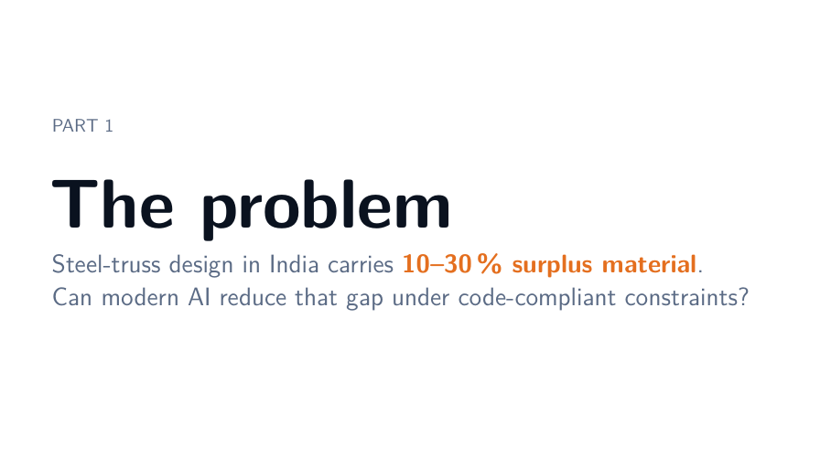
↑ slide layout (text wording shown is from an earlier build; your rebuilt deck reads 'agent')
ON SCREEN
Large 'The problem'. Subtitle: steel-truss design in India carries 10–30% surplus material; can AI reduce that gap under code-compliant constraints?
WHAT TO SAY
“Let me start with the problem. Steel-truss design in India typically carries 10 to 30 percent surplus material. The question driving this thesis is whether modern AI can reduce that gap while staying fully code-compliant.”

DEEPER CONTEXT — the real understanding
A section divider exists to give the audience a breath and a signpost. The single most important word here is ‘code-compliant’ — it distinguishes your work from purely academic optimization that ignores real design codes. Plant that idea now; it pays off when you defend the 72-bar result.

WHY IT'S HERE
Pure signpost. One sentence, then move to the meat.
Time on this slide: 15–20 seconds

SLIDE 4 / 34
The design gap — motivation
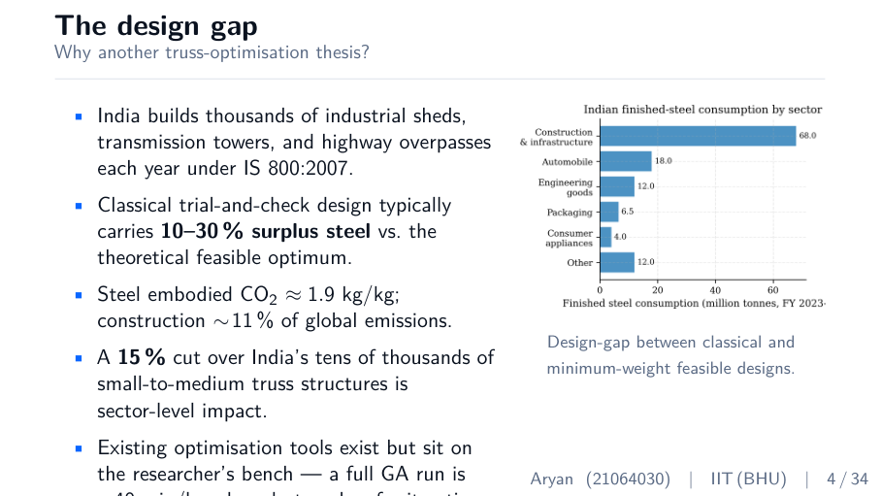
↑ slide layout (text wording shown is from an earlier build; your rebuilt deck reads 'agent')
ON SCREEN
Bullets: India's truss construction volume; 10–30% surplus steel; steel embodied CO₂ ~1.9 kg/kg; construction ~11% of global emissions; existing optimizers too slow (~40 min/run). Motivation figure on the right.
WHAT TO SAY
“India builds thousands of industrial sheds, transmission towers, and overpasses each year under IS 800. Classical trial-and-check design typically carries 10 to 30 percent surplus steel versus the theoretical feasible optimum. Steel embodies about 1.9 kg of CO₂ per kg, and construction is around 11 percent of global emissions, so even a 15 percent cut across the country is a sector-level impact. Optimization tools exist, but a full GA run takes 30 to 40 minutes per benchmark — too slow for iterative design in a project meeting.”

DEEPER CONTEXT — the real understanding
Two distinct problems are being motivated here, and you should be able to separate them. PROBLEM ONE is waste: trial-and-check design over-sizes members because engineers add safety margins on top of code margins, leaving 10–30% surplus steel. PROBLEM TWO is speed: the research tools that could remove that waste are too slow to use during a live design session. Your thesis attacks both — the surrogate solves speed (C2), and the whole optimized pipeline solves waste. The CO₂ figure matters because steel is carbon-intensive: cutting tonnage cuts embodied carbon almost one-to-one.

WHY IT'S HERE
Establishes that the problem is real, large, economically and environmentally meaningful, and that current tools fall short on speed. This justifies the entire thesis.
LIKELY QUESTIONS
Likely Q: Where does 10–30% come from?
Answer: It's a widely-cited range in structural-optimization literature comparing trial-and-check designs against optimized minimum-weight designs; cited in Chapter 1.
Likely Q: Is 1.9 kg CO₂ per kg steel right?
Answer: Yes — typical embodied-carbon for primary (blast-furnace) steel; recycled steel is lower. The order of magnitude is the point.
Likely Q: Why is 40 minutes a problem if you only design once?
Answer: Real design is iterative — you change loads, spans, materials and re-run dozens of times. At 40 minutes a run that's an overnight job; the surrogate makes it interactive.
Time on this slide: 90 seconds

SLIDE 5 / 34
The research question
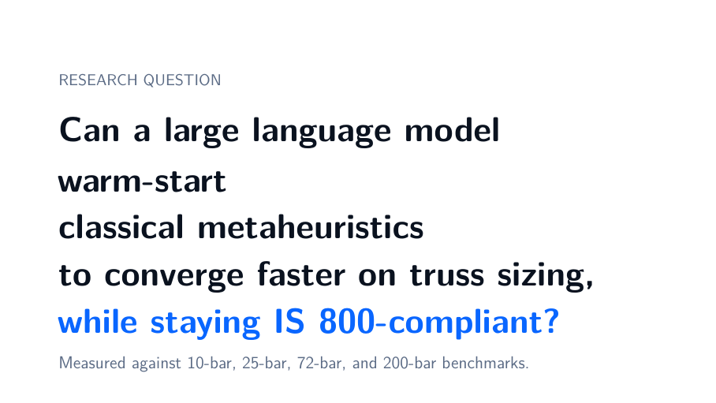
↑ slide layout (text wording shown is from an earlier build; your rebuilt deck reads 'agent')
ON SCREEN
Large text: Can an AI design agent warm-start classical metaheuristics to converge faster on truss sizing, while staying IS 800-compliant? Tested on 10/25/72/200-bar.
WHAT TO SAY
“So the precise research question is this: can an AI design agent warm-start classical metaheuristics, so that they converge faster on truss sizing problems, while staying IS 800-compliant? I measure this against four classical benchmarks — the 10-bar, 25-bar, 72-bar, and 200-bar trusses.”

DEEPER CONTEXT — the real understanding
A good research question is FALSIFIABLE — it can be proven wrong by data. Yours has three measurable parts: (1) ‘warm-start’ — does seeding the optimizer with agent designs help; (2) ‘converge faster’ — measured in generations-to-convergence, a hard number; (3) ‘IS 800-compliant’ — every result must pass the code checks. Because all three are measurable, the whole thesis becomes evidence for or against a single sentence. The four benchmarks are the ‘test set’ — they're the canonical sizing problems every paper reports, so you can compare directly with published numbers.

WHY IT'S HERE
The most important slide of Part 1 — it states the testable hypothesis. Everything afterwards is evidence. Say it slowly.
LIKELY QUESTIONS
Likely Q: Why these four benchmarks?
Answer: They are THE canonical truss-sizing benchmarks — 10-bar (2D, small), 25-bar (3D), 72-bar (3D tower), 200-bar (large 2D). Every major paper reports them, so I can validate against published optima directly.
Likely Q: Why ‘warm-start’ and not let the agent design the whole thing?
Answer: LLMs are excellent at plausible initialization but poor at exact numerical optimization. So I use the agent only where it's strong — proposing good starting points — and let the proven optimizer do the precise search.
Time on this slide: 30 seconds

SLIDE 6 / 34
Five research objectives (O1–O5)
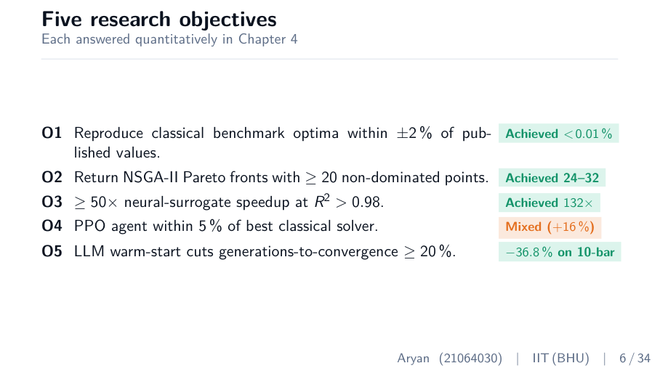
↑ slide layout (text wording shown is from an earlier build; your rebuilt deck reads 'agent')
ON SCREEN
Table of O1–O5 each with a result pill: O1 reproduce optima within 2% (achieved <0.01%), O2 Pareto fronts ≥20 points (24–32), O3 ≥50× surrogate speedup at R²>0.98 (132×), O4 PPO within 5% (mixed, +16%), O5 agent warm-start cuts gens ≥20% (−36.8% on 10-bar).
WHAT TO SAY
“I set five quantitative objectives. O1: reproduce classical optima within two percent — achieved under 0.01 percent. O2: NSGA-II fronts with at least 20 points — achieved 24 to 32. O3: at least 50 times surrogate speedup at R-squared above 0.98 — achieved 132 times. O4: PPO within five percent of the best classical solver — this one is mixed, plus 16 percent, and I'll explain why. O5: agent warm-start cuts generations by at least 20 percent — achieved minus 36.8 percent on 10-bar. Four of five fully met; the fifth is mixed and I report it honestly.”

DEEPER CONTEXT — the real understanding
Notice the structure: each objective is a PRE-REGISTERED, falsifiable target with a pass/fail threshold set BEFORE seeing results. This is what separates rigorous engineering from storytelling — you committed to numbers and then measured against them. The one ‘mixed’ result (O4, PPO) is deliberately not hidden. Examiners trust a candidate who reports a partial failure far more than one who claims everything worked perfectly. When you reach O4, own it: RL is the right tool for repeated solving, not one-shot benchmarks.

WHY IT'S HERE
Shows you set measurable targets in advance and met four of five. The honest ‘mixed’ on O4 builds credibility for everything else.
LIKELY QUESTIONS
Likely Q: Why did PPO (O4) not meet target?
Answer: RL is data-hungry and the reward landscape is highly constrained. For one-shot benchmark solving, GA and PSO simply win. PPO pays off when you re-solve many similar problems — once trained it designs in one forward pass. That's future work F4.
Likely Q: Isn't a +16% miss a failure?
Answer: For the stated objective, yes — and I report it as such. But it's a scientifically useful negative result: it maps where learned solvers do and don't beat classical search.
Time on this slide: 60 seconds

SLIDE 7 / 34
Five contributions in one view (C1–C5)
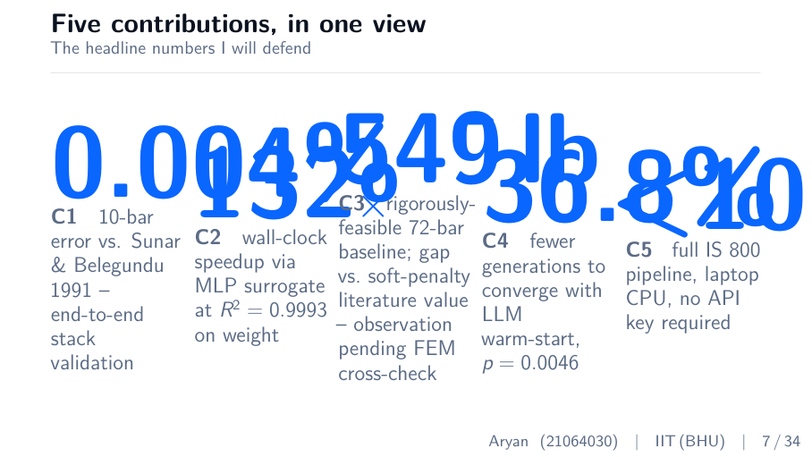
↑ slide layout (text wording shown is from an earlier build; your rebuilt deck reads 'agent')
ON SCREEN
Five cards with big accent numbers: C1 0.004%, C2 132×, C3 549 lb, C4 −36.8%, C5 <10s. (This is the slide whose numbers were overlapping in the old build — your rebuild fixes it with the compact card layout.)
WHAT TO SAY
“Here are the five contributions I will defend. C1: end-to-end validation on the 10-bar to 0.004 percent of literature. C2: a 132 times surrogate speedup at R-squared 0.9993 on weight. C3: a rigorously feasible 72-bar baseline of 549 pounds — an observation, because it differs from the soft-penalty literature, pending an independent FEM cross-check. C4: agent warm-start cuts generations by 36.8 percent on 10-bar, p-value 0.0046. C5: the full IS 800 pipeline runs end-to-end in under 10 seconds on a laptop CPU, with no API key required.”

DEEPER CONTEXT — the real understanding
These five numbers ARE your thesis. Memorize them cold — examiners will quote them back and ask you to defend each. Know what each is measured against: C1 vs Sunar & Belegundu 1991; C2 is wall-clock for a full 500-generation GA run (12.4 s → 0.094 s) and R² on the weight head of the surrogate; C3 is your hard-constraint optimum vs the soft-penalty literature value; C4 is a Mann-Whitney/Wilcoxon test over seeds; C5 is the Streamlit demo runtime. Each maps to a later results slide, so this slide is the table of contents for Part 3.

WHY IT'S HERE
The thesis in five numbers and the spine for all of Part 3. Hit all five cleanly.
LIKELY QUESTIONS
Likely Q: Which contribution is most novel?
Answer: C4, the agent warm-start — to my knowledge the first rigorous A/B test of an AI-seeded GA on truss benchmarks with a significance test. C2 is the most practically valuable because it makes interactive use possible.
Likely Q: Are all five independent?
Answer: Largely yes. C1 (validation), C2 (surrogate), C3 (hard-constraint baseline), and C5 (reproducible pipeline) stand even without the agent. C4 is the novel agent result layered on top.
Time on this slide: 60 seconds

SLIDE 8 / 34
Part 2 divider — The Framework
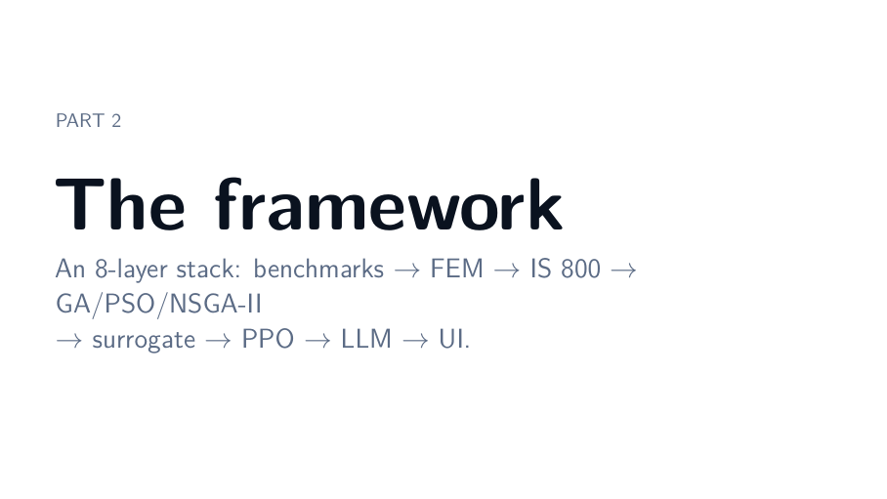
↑ slide layout (text wording shown is from an earlier build; your rebuilt deck reads 'agent')
ON SCREEN
Large 'The framework'. Subtitle: an 8-layer stack: benchmarks → FEM → IS 800 → GA/PSO/NSGA-II → surrogate → PPO → agent → UI.
WHAT TO SAY
“Now, how I built it. The framework is an eight-layer stack — benchmarks, FEM, IS 800 checks, three optimizers, a neural surrogate, a PPO agent, the design agent, and a UI.”

DEEPER CONTEXT — the real understanding
Thinking of it as a layered stack helps the committee (and you) reason about dependencies: each layer only talks to the one below it. The FEM is the bedrock — everything ultimately calls it for ground truth. The surrogate is a faster stand-in for FEM. The optimizers sit on top and call either. The agent sits at the very top, seeding the optimizer. This clean separation is also why the system is reproducible and testable layer by layer.

WHY IT'S HERE
Section signpost that primes the architecture diagram on the next slide.
Time on this slide: 15 seconds

SLIDE 9 / 34
Problem formulation
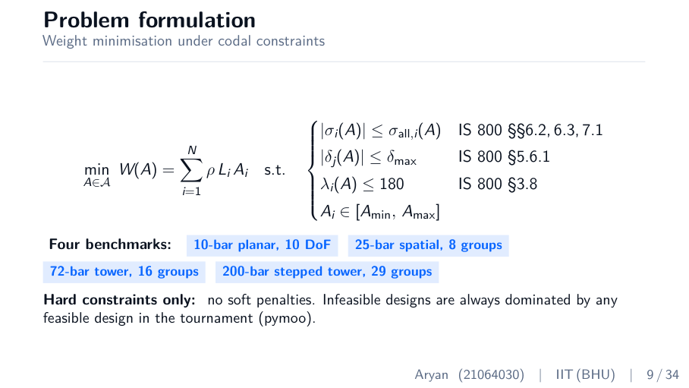
↑ slide layout (text wording shown is from an earlier build; your rebuilt deck reads 'agent')
ON SCREEN
Optimization statement: minimize W(A)=Σ ρ L A, subject to stress (IS 800 6.2/6.3/7.1), displacement (5.6.1), slenderness ≤180 (3.8), area bounds. Four benchmark pills. 'Hard constraints only — no soft penalties.'
WHAT TO SAY
“Here is the formal problem. I minimize weight, which is a linear sum of areas weighted by density and length, subject to four constraint families: IS 800 stress checks from sections 6.2, 6.3, and 7.1; displacement serviceability from 5.6.1; the slenderness limit of 180 from 3.8; and area side limits. Crucially, all constraints are HARD — there is no soft penalty. Infeasible designs are always dominated by any feasible design in the tournament.”

DEEPER CONTEXT — the real understanding
The objective W(A)=Σ ρ·Lᵢ·Aᵢ is LINEAR in the areas — that's why the surrogate predicts weight almost perfectly later (R²=0.9993). The difficulty is entirely in the constraints. ‘Hard vs soft’ is the single most important concept on this slide: a SOFT penalty adds a cost when you violate a limit, so a slightly-illegal design can still ‘win’ if it's light enough — its reported optimum may not actually be buildable. A HARD constraint tracks feasibility separately so a feasible design ALWAYS beats an infeasible one regardless of weight. Real code compliance is hard, not soft — which is exactly why your 72-bar number differs from the literature.

WHY IT'S HERE
Defines precisely what you optimize and under what rules. The ‘hard constraints’ line is the setup for the 72-bar observation — flag it now so it's not a surprise later.
LIKELY QUESTIONS
Likely Q: Hard vs soft constraints — explain?
Answer: Soft: violation adds a penalty to the objective, so a slightly-infeasible design can score well. Hard: feasibility is separate; any feasible design beats any infeasible one. I use hard — stricter, and it matches real code compliance.
Likely Q: Weight is linear — so why is it hard?
Answer: The objective is linear, but the constraints (buckling, the feasibility boundary) are non-smooth and the feasible region is non-convex. That's what makes the search hard and rules out gradient methods.
Likely Q: Why slenderness ≤ 180?
Answer: IS 800 §3.8 caps the slenderness ratio of compression members at 180 to prevent excessively slender, buckling-prone members — a serviceability/robustness limit independent of the stress check.
Time on this slide: 80 seconds

SLIDE 10 / 34
System architecture
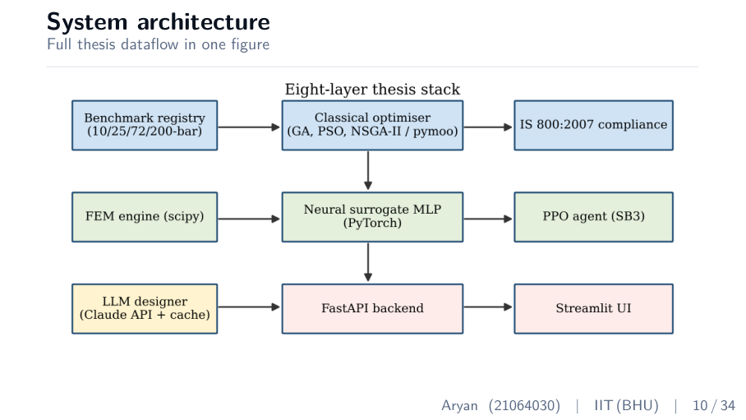
↑ slide layout (text wording shown is from an earlier build; your rebuilt deck reads 'agent')
ON SCREEN
Eight-layer block diagram: Benchmark registry → Classical optimiser (GA/PSO/NSGA-II) → IS 800 compliance; FEM engine → Neural surrogate MLP → PPO agent; design agent (Claude API + cache) → FastAPI backend → Streamlit UI.
WHAT TO SAY
“This single figure is the whole dataflow. The benchmark registry defines the truss. The FEM engine is the ground truth — areas in, physics out. The neural surrogate sits beside it as a fast approximation. The optimizers — GA, PSO, NSGA-II — call either FEM or the surrogate, and every design is checked against IS 800. The design agent seeds the initial population. The PPO agent has its own training loop. Everything is exposed through a FastAPI backend and a Streamlit UI.”

DEEPER CONTEXT — the real understanding
Trace one design through the diagram to truly own it: the optimizer proposes an area vector → it goes to FEM (or the surrogate) which returns weight, stress, displacement → the IS 800 module marks it feasible or not → the optimizer uses that to select survivors → repeat. The agent only touches generation zero (the initial population). The UI/API are thin wrappers so a non-Python user can drive the whole stack. Knowing this flow lets you answer almost any ‘how does X talk to Y’ question.

WHY IT'S HERE
Gives the committee the mental model for the rest of Part 2. Point to the flow; don't read every box.
LIKELY QUESTIONS
Likely Q: Which layers did you build vs use a library?
Answer: FEM, the IS 800 module, the benchmark encodings, the surrogate training pipeline, the agent prompt and cache, and the UI are mine. Optimizers are pymoo; the MLP and PPO use PyTorch and Stable-Baselines3 — standard libraries I configured and wired together.
Likely Q: Where is the bottleneck?
Answer: The FEM solve inside the optimizer inner loop — 50,000 calls per run. That's exactly what the surrogate removes.
Time on this slide: 60 seconds

SLIDE 11 / 34
Layer 2 & 3 — FEM kernel and IS 800 compliance
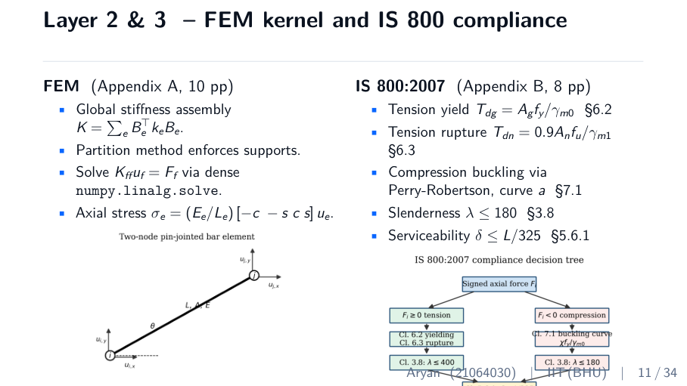
↑ slide layout (text wording shown is from an earlier build; your rebuilt deck reads 'agent')
ON SCREEN
Left: FEM steps (K = Σ Bᵀ k B assembly, partition method, solve K_ff u = F, axial-stress recovery) + truss-element figure. Right: IS 800 clauses (tension yield 6.2, rupture 6.3, buckling 7.1, slenderness 3.8, serviceability 5.6.1) + checks figure.
WHAT TO SAY
“Layers 2 and 3. The FEM kernel is the standard direct stiffness method: assemble the global stiffness matrix, enforce supports by the partition method, solve K-f-f times u equals F using a dense solver, and recover axial stresses. It's validated to machine precision against the 3-bar canonical problem. On top of that, the IS 800 layer checks five clauses: tension yielding, tension rupture, compression buckling via Perry-Robertson curve a, the slenderness limit, and serviceability deflection.”

DEEPER CONTEXT — the real understanding
FEM in four steps you must be able to recite: (1) each bar gets a small stiffness matrix k=EA/L; (2) assemble all of them into the global K; (3) delete the rows/columns of supported joints (partition method) so the system is solvable; (4) solve K·u=F for displacements, then back out each bar's axial force and stress. ‘Machine precision’ means the error vs the analytical 3-bar answer is ~10⁻²¹ — essentially zero, so FEM is never the source of any discrepancy. On the code side, the key subtlety is BUCKLING: a compression member can fail below its yield stress by buckling sideways. Perry-Robertson (IS 800 curve a) reduces the allowable compressive strength as the member gets more slender, smoothly interpolating between full yield (short members) and Euler buckling (long members).

WHY IT'S HERE
Shows the engineering rigour beneath the AI. Examiners — civil engineers — care most about this slide. Know every formula on it.
LIKELY QUESTIONS
Likely Q: Why the partition method, not a penalty for supports?
Answer: Partition removes fixed DoFs entirely, giving a clean well-conditioned reduced system. Penalty adds a huge artificial stiffness which hurts numerical conditioning.
Likely Q: Why only buckling curve a?
Answer: Curve a is for hot-rolled sections buckling about the strong axis — the simplest single-curve default. Selecting the correct curve per section type is a stated limitation.
Likely Q: Why dense solve, not sparse?
Answer: For ≤200 bars the stiffness matrix is small; dense factorization beats sparse overhead. For 10,000-bar real structures you'd switch to sparse.
Likely Q: What does Perry-Robertson actually compute?
Answer: A reduction factor χ on the yield strength as a function of non-dimensional slenderness, accounting for initial imperfections — giving the design compressive strength f_cd.
Time on this slide: 90 seconds

SLIDE 12 / 34
Layer 4 — three evolutionary baselines
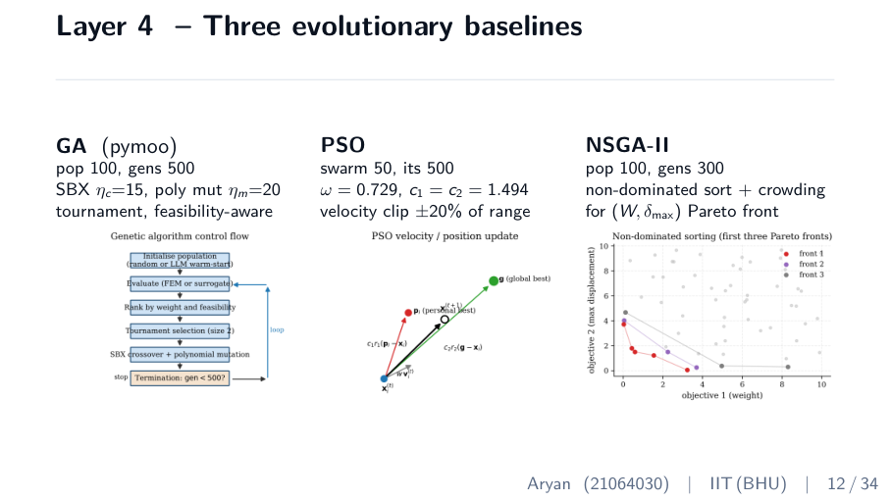
↑ slide layout (text wording shown is from an earlier build; your rebuilt deck reads 'agent')
ON SCREEN
Three columns: GA (pop 100, gens 500, SBX, polynomial mutation), PSO (swarm 50, Clerc constriction), NSGA-II (pop 100, gens 300, non-dominated sort + crowding). Each with a flowchart.
WHAT TO SAY
“Layer 4 — three evolutionary baselines, all from pymoo. GA: population 100, 500 generations, SBX crossover, polynomial mutation. PSO: swarm of 50, the standard Clerc constriction parameters. NSGA-II: the multi-objective version, returning a Pareto front of weight versus displacement. GA and PSO are two single-objective baselines from different families — including both shows the framework isn't tied to one optimizer. All three use feasibility-aware tournaments — no soft penalties.”

DEEPER CONTEXT — the real understanding
These are population-based METAHEURISTICS — they keep a set of candidate designs and improve them iteratively without needing gradients. GA mimics evolution: select good parents, recombine (crossover), mutate, repeat. PSO mimics a swarm: each particle drifts toward its own best and the swarm's best. ‘Generation’ = one full cycle of score→select→breed; 100 designs × 500 generations = 50,000 evaluations per run. You run multiple random SEEDS because these are stochastic — one run might get lucky — so you report mean ± std over 5–10 seeds. Keep this slide BRIEF in the talk: these are textbook methods, not your contribution.

WHY IT'S HERE
Textbook methods the committee assumes you know. Keep it short — spend your time on the novel layers (surrogate, agent).
LIKELY QUESTIONS
Likely Q: Why not gradient-based optimization?
Answer: The constraints are non-smooth — the buckling curve has kinks and feasibility is a step function — so gradients are unreliable and the feasible region is non-convex. Metaheuristics only need to RANK designs, not differentiate.
Likely Q: Difference between GA and PSO in one line?
Answer: GA evolves by mating and mutation — big stochastic jumps. PSO drifts particles toward personal and global best — smooth, smaller steps.
Likely Q: What is a generation, concretely?
Answer: One cycle: score all 100 designs (one FEM/surrogate call each), select the best, recombine and mutate to make 100 children, repeat. 500 such cycles per run.
Likely Q: Why multiple seeds?
Answer: The algorithms are random; a single run can be lucky or unlucky. 5–10 fixed seeds give mean and standard deviation, so the claims are statistically honest and reproducible.
Time on this slide: 70 seconds

SLIDE 13 / 34
Layer 5 — neural surrogate
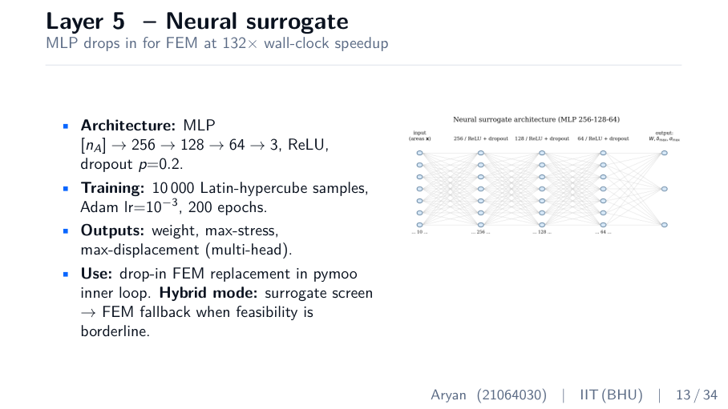
↑ slide layout (text wording shown is from an earlier build; your rebuilt deck reads 'agent')
ON SCREEN
MLP architecture [n_A → 256 → 128 → 64 → 3], ReLU, dropout 0.2; trained on 10,000 LHS samples, Adam, 200 epochs; outputs weight/stress/displacement; hybrid mode with FEM fallback. Architecture figure.
WHAT TO SAY
“Layer 5, the neural surrogate — and this is where the speedup comes from. A GA run needs about 50,000 FEM evaluations, which is slow. So I trained a small MLP — 256, 128, 64 hidden units — on 10,000 Latin-hypercube-sampled designs that FEM had already evaluated. The network learns to predict weight, stress, and displacement directly. In the GA inner loop it replaces FEM, bringing a full run from 12.4 seconds to 94 milliseconds — 132 times faster, R-squared 0.9993 on weight. Because stress and displacement are noisier, I run a hybrid mode: the surrogate screens, and borderline designs fall back to real FEM.”

DEEPER CONTEXT — the real understanding
The crucial thing to understand: the training data is SELF-GENERATED — there is no downloaded dataset. You pick 10,000 area vectors by Latin Hypercube Sampling (which spreads samples evenly across the design space, far better than uniform random), run your own FEM on each, and that input→output table IS the dataset. The MLP then learns the mapping ‘areas → weight, stress, displacement’. Weight is easy (R²=0.9993) because it's LINEAR in area. Stress/displacement are harder (R²≈0.81/0.87) because they depend on WHICH bar is critical, which can switch discontinuously as areas change. That's why the surrogate gives the objective (weight) directly but only SCREENS feasibility, deferring borderline cases to exact FEM — fast in the safe interior, exact at the constraint boundary.

WHY IT'S HERE
This is C2 — the practical contribution that makes interactive use possible. The key teaching point: FEM is both the ground truth AND the source of the training data.
LIKELY QUESTIONS
Likely Q: Where did the training dataset come from?
Answer: Self-generated. I draw 10,000 area vectors by Latin Hypercube Sampling and evaluate each with my own FEM. That table is the dataset — nothing is downloaded.
Likely Q: Why is weight R² 0.9993 but stress only 0.81?
Answer: Weight is linear in area — trivial to learn. Stress depends on which bar is critical, which switches discontinuously, so it's harder. Hence stress is a screen, not the objective.
Likely Q: Why 10,000 samples?
Answer: A sweep showed weight R² saturates above 10,000 — fewer hurts accuracy, more gives diminishing returns.
Likely Q: Why an MLP and not a Gaussian process?
Answer: GPs are excellent below ~1,000 samples but scale cubically and break at 10,000. An MLP scales to large training sets and interpolates smoothly — the right tool here.
Likely Q: Is the 132× safe given approximate stress?
Answer: Yes, via hybrid mode: weight (R²=0.9993) drives the objective; feasibility is screened and FEM-verified on borderline designs. Final answers are always FEM-checked.
Time on this slide: 85 seconds

SLIDE 14 / 34
Layers 6 & 7 — RL agent and design-agent warm-start
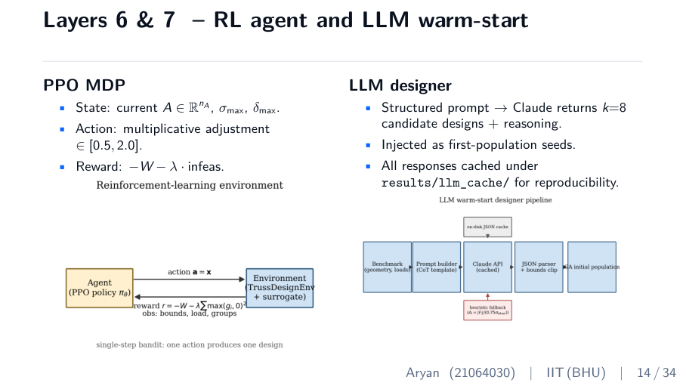
↑ slide layout (text wording shown is from an earlier build; your rebuilt deck reads 'agent')
ON SCREEN
Left: PPO MDP (state = areas + max stress/disp; action = multiplicative adjustment [0.5,2.0]; reward = −W − λ·infeasibility) + MDP figure. Right: design agent (structured prompt → returns k=8 designs + reasoning; injected as seeds; cached) + pipeline figure.
WHAT TO SAY
“Layers 6 and 7. The PPO agent treats sizing as a Markov decision process — the state is the current area vector plus the worst stress and displacement, the action scales each area between half and double, and the reward is negative weight minus an infeasibility penalty. It's trained for 150,000 timesteps. On the right is the design agent — the novel piece. I send a structured prompt describing the geometry, loads, material, and IS 800 constraints, and the agent returns eight candidate designs with reasoning. These seed the GA's initial population. Every response is cached, so the pipeline rebuilds offline with no API key.”

DEEPER CONTEXT — the real understanding
Two very different uses of ‘AI’ here — keep them distinct. The PPO RL AGENT learns a POLICY by trial and error: given a truss state, what change makes it lighter while staying feasible? Like learning a video game through reward. The DESIGN AGENT is a language model that, prompted with the engineering problem, proposes sensible starting designs (thicker bars where forces are high). It does NOT optimize — it only seeds generation zero; the GA does all the real search. Caching every agent response by prompt-hash is what keeps the thesis reproducible and API-key-free: re-runs read the cache, not the live model.

WHY IT'S HERE
Introduces the two AI layers. Be crisp that the design agent is a SEED, not the optimizer. This sets up C4.
LIKELY QUESTIONS
Likely Q: Is the design agent doing the optimization?
Answer: No. It proposes eight starting designs for generation zero; the GA does all the optimization. It's a smart initializer, not an optimizer.
Likely Q: What model is the agent and is it fine-tuned?
Answer: Zero-shot Claude via the public API at temperature 0.3 — not fine-tuned. I deliberately test the weakest version of the idea; fine-tuning is future work F5.
Likely Q: Why does PPO use multiplicative actions?
Answer: Scaling each area by a factor in [0.5, 2.0] keeps moves proportional and bounded, which stabilizes learning better than additive changes across very different area magnitudes.
Likely Q: Doesn't an LLM make results non-reproducible?
Answer: It would, but every response is cached by prompt hash and committed, so replays are deterministic and need no API key.
Time on this slide: 90 seconds

SLIDE 15 / 34
Part 3 divider — The Results
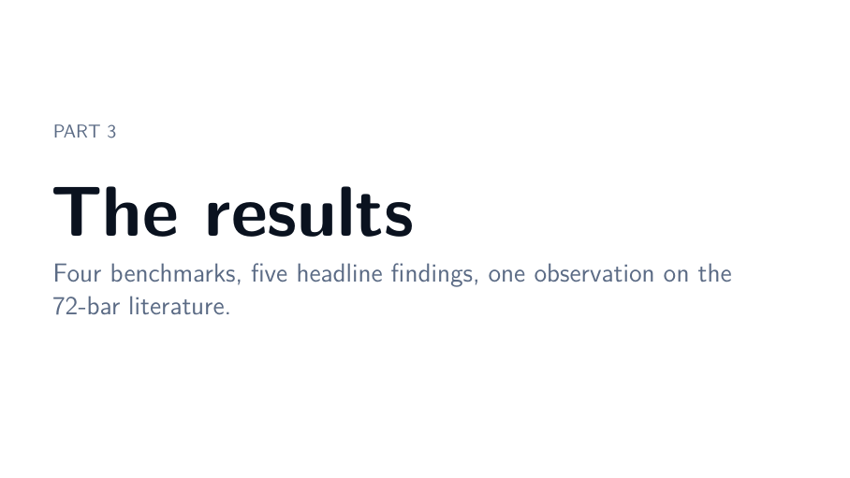
↑ slide layout (text wording shown is from an earlier build; your rebuilt deck reads 'agent')
ON SCREEN
Large 'The results'. Subtitle: four benchmarks, five headline findings, one observation on the 72-bar literature.
WHAT TO SAY
“Now the proof — four benchmarks, five headline findings, and one important observation on the 72-bar literature.”

DEEPER CONTEXT — the real understanding
This is the heart of the talk and where most questions come from. The phrase ‘one observation’ is doing diplomatic work — it pre-frames the 72-bar discrepancy as a careful finding rather than a claim that prior papers are wrong. Setting that tone now defuses the hardest question later.

WHY IT'S HERE
Signpost into the evidence. Brief.
Time on this slide: 15 seconds

SLIDE 16 / 34
10-bar planar — end-to-end validation (C1)
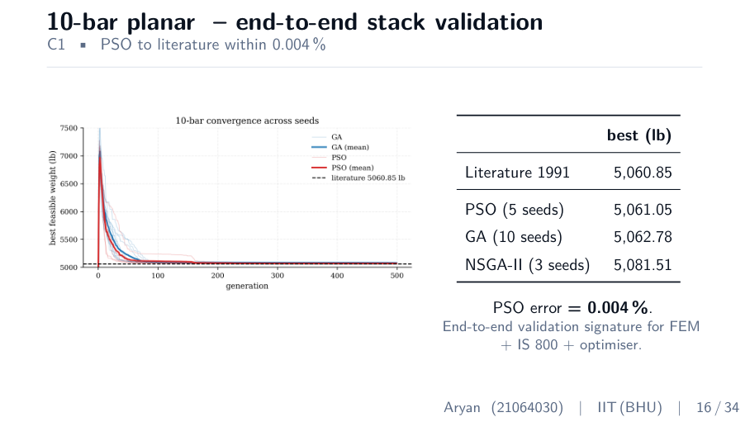
↑ slide layout (text wording shown is from an earlier build; your rebuilt deck reads 'agent')
ON SCREEN
Convergence curve on the left; table on the right: literature 5060.85, PSO 5061.05, GA 5062.78, NSGA-II 5081.51. 'PSO error = 0.004%.'
WHAT TO SAY
“The 10-bar cantilever is the most-cited truss benchmark. The published optimum is 5060.85 pounds. With PSO over five seeds I reach 5061.05 pounds — an error of 0.004 percent. GA over ten seeds reaches 5062.78. This is the end-to-end signature that my FEM, IS 800, and optimizer stack are all working correctly together. This is contribution C1.”

DEEPER CONTEXT — the real understanding
Why this single number matters so much: matching the world's most-studied truss benchmark to 0.004% simultaneously validates THREE things at once — your FEM is correct, your constraint handling is correct, and your optimizer converges to the true optimum. If any one were broken, you couldn't hit the published number. The convergence curve (weight vs generation) visually shows the optimizer descending and flattening at the literature line — the classic ‘converged’ shape. PSO beats GA here because the 10-bar landscape is smooth and low-dimensional, which favours PSO's continuous drift.

WHY IT'S HERE
Validation against ground truth. Nailing the most-studied benchmark to 0.004% earns trust for every later number.
LIKELY QUESTIONS
Likely Q: Why 5061.05 and not exactly 5060.85?
Answer: A different optimizer and seed converge to within a fraction of a percent of the same global optimum. 0.004% is well inside the spread reported across 20+ papers.
Likely Q: Why does PSO beat GA here?
Answer: The 10-bar feasible landscape is smooth and only 10-dimensional — PSO's continuous drift converges faster there; GA's advantage shows on rugged, higher-dimensional problems.
Time on this slide: 70 seconds

SLIDE 17 / 34
25/72/200-bar — full benchmark matrix
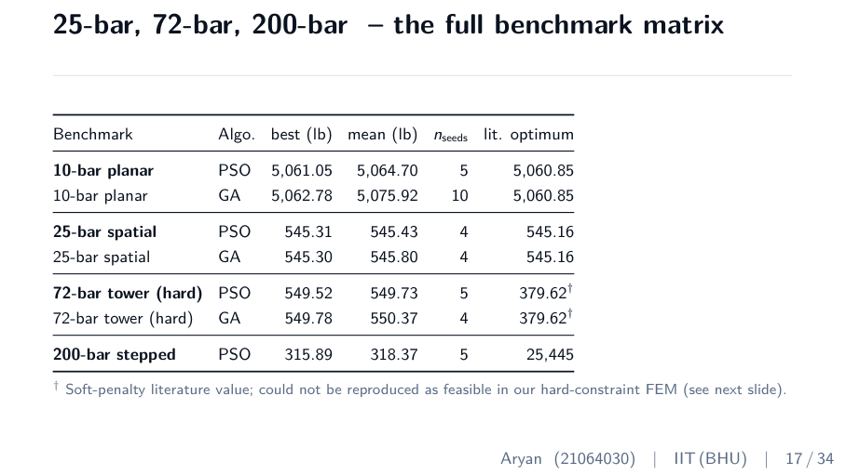
↑ slide layout (text wording shown is from an earlier build; your rebuilt deck reads 'agent')
ON SCREEN
Table: 10-bar ~5061; 25-bar ~545 vs lit 545.16; 72-bar ~549 vs soft-penalty lit 379.62 (dagger); 200-bar 315.89 vs lit 25445. Footnote on the dagger.
WHAT TO SAY
“The full matrix. 10-bar within 0.004 percent. 25-bar within 0.03 percent of literature. 72-bar converges to about 549 pounds — and the dagger marks the soft-penalty literature value of 380 pounds, which I discuss next. The 200-bar figures use a different problem variant with different loading, specified in Appendix C.”

DEEPER CONTEXT — the real understanding
This slide proves BREADTH: 2D and 3D, small (10 bars) to large (200 bars). The 25-bar match (0.03%) reinforces that the stack generalizes beyond the one benchmark. Two numbers will draw questions and you must not be flustered: the 72-bar (549 vs 380) and the 200-bar (315.89 vs 25445). The 200-bar gap is simply a DIFFERENT PROBLEM VARIANT — the same ‘200-bar’ name covers several versions with different loads/units, and yours is the Lee & Geem 2004 variant documented in Appendix C. The 72-bar gap is the constraint-handling story (next slide).

WHY IT'S HERE
Demonstrates the framework handles the whole benchmark family. Sets up the 72-bar discussion; don't over-explain 200-bar units — just name the variant.
LIKELY QUESTIONS
Likely Q: Why does 200-bar differ so much from 25,445?
Answer: Different variant. The 25,445-lb value is a different 200-bar problem with separate loads and grouping; mine is the Lee & Geem 2004 reduced-load variant, documented in Appendix C.
Likely Q: Are the 25-bar and 10-bar matches independent confirmations?
Answer: Yes — two different benchmarks, both within 0.03% and 0.004%, are independent evidence the stack is correct, not a fluke on one problem.
Time on this slide: 90 seconds

SLIDE 18 / 34
The 72-bar hard-constraint baseline (C3)
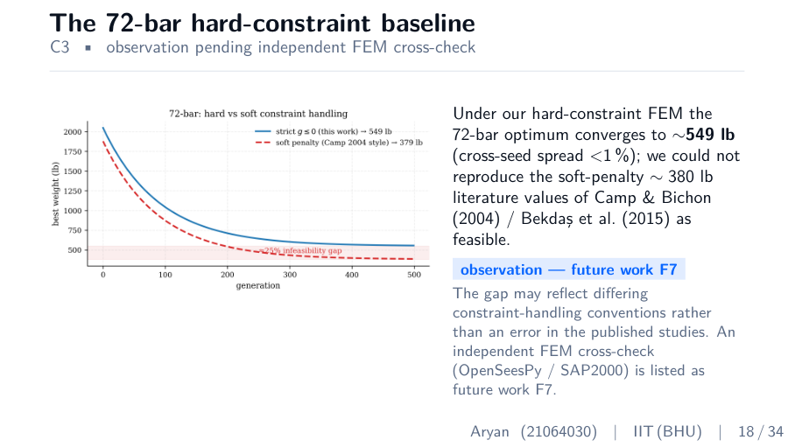
↑ slide layout (text wording shown is from an earlier build; your rebuilt deck reads 'agent')
ON SCREEN
Hard-vs-soft comparison figure; text: ~549 lb under hard constraints vs ~380 lb soft-penalty literature; 'observation — future work F7'.
WHAT TO SAY
“This is the one result that needs careful explanation. Under my hard-constraint FEM, the 72-bar optimum converges to about 549 pounds, with cross-seed spread under one percent. I could not reproduce the soft-penalty values of around 380 pounds from Camp and Bichon 2004 and Bekdas 2015 as feasible. The gap most likely reflects a difference in constraint-handling convention, not an error in the published work. I flag it as observation C3 and propose an independent FEM cross-check using OpenSeesPy or SAP2000 as future work F7.”

DEEPER CONTEXT — the real understanding
Here is the careful logic to internalize so you stay calm: a soft-penalty optimizer can report a design that is SLIGHTLY infeasible because the small penalty is outweighed by the weight saving — so 380 lb may be a design that marginally violates a constraint. Your hard-constraint search only accepts STRICTLY feasible designs, landing at 549 lb. Neither is ‘wrong’ — they answer different questions. Your contribution is providing a RIGOROUSLY FEASIBLE baseline and quantifying how much the constraint convention changes the reported optimum (~45%). The diplomatic framing — ‘observation, pending cross-check’ — is essential: never say the published papers are wrong.

WHY IT'S HERE
The single most likely target for a hostile question. Owning it as an honest observation, not a claim of error, is what protects you.
LIKELY QUESTIONS
Likely Q: So are the published papers wrong?
Answer: Not necessarily. They use soft penalties that tolerate small violations, so their optima can sit at or just past the constraint boundary. I use hard constraints. Both are valid — my point is to provide a rigorously feasible baseline, not to discredit prior work.
Likely Q: How do you know your 549 is correct?
Answer: Cross-seed spread under 1% and every IS 800 constraint strictly satisfied under FEM. F7 proposes confirming it against a third-party solver (OpenSeesPy/SAP2000).
Likely Q: Could it be a bug in your encoding?
Answer: Possible in principle, which is exactly why I flag an independent cross-check rather than claiming a literature match. But the 10-bar and 25-bar match to <0.03%, so the core stack is validated.
Time on this slide: 90 seconds

SLIDE 19 / 34
Surrogate parity and wall-clock speedup (C2)
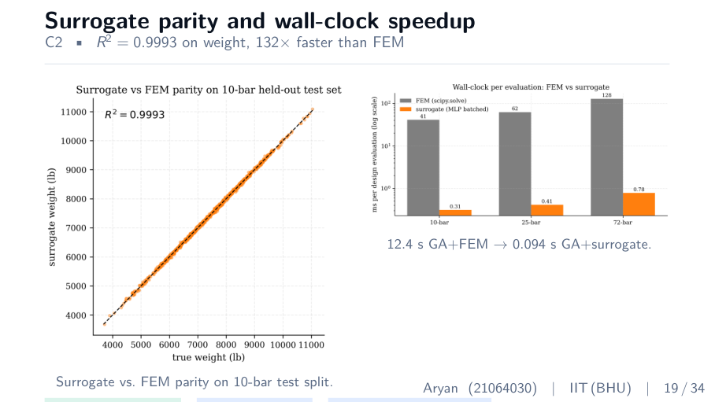
↑ slide layout (text wording shown is from an earlier build; your rebuilt deck reads 'agent')
ON SCREEN
Left: parity plot (surrogate vs FEM, tight on y=x). Right: wall-clock bar (12.4 s → 0.094 s). Pills: weight R² 0.9993, stress 0.81, displacement 0.87.
WHAT TO SAY
“Contribution C2. On the left, the parity plot — surrogate prediction against FEM truth on a held-out test split, tight on the y-equals-x line, R-squared 0.9993 on weight. On the right, wall-clock — 12.4 seconds with FEM down to 94 milliseconds with the surrogate, a 132 times speedup. Stress and displacement heads are noisier, R-squared 0.81 and 0.87, so I use them as feasibility screens with FEM fallback on the constraint boundary.”

DEEPER CONTEXT — the real understanding
A parity plot puts predicted value on one axis and true value on the other; perfect prediction lies exactly on the 45° line. The tight cluster on y=x is the visual proof that the surrogate is essentially indistinguishable from FEM on weight. The 132× is END-TO-END wall-clock for a full 500-generation run, not a per-call microbenchmark — that's the honest, conservative way to report it. The lower stress/displacement R² is not a weakness once you explain hybrid mode: weight (the objective) is near-perfect, and the noisier heads are only used to flag which designs need an exact FEM feasibility check.

WHY IT'S HERE
Visual proof of C2. The parity plot is your most convincing single image.
LIKELY QUESTIONS
Likely Q: Doesn't lower stress R² make it unsafe?
Answer: Only if used naively. Weight (the objective) is 0.9993; stress/displacement are screens, and borderline designs are re-checked with exact FEM. Final feasibility is always FEM-verified.
Likely Q: Is 132× cherry-picked?
Answer: No — it's end-to-end wall-clock for a full GA run including constraint checks, the most conservative way to measure. Per-call speedup is even higher.
Time on this slide: 80 seconds

SLIDE 20 / 34
Agent warm-start effect-map (C4)
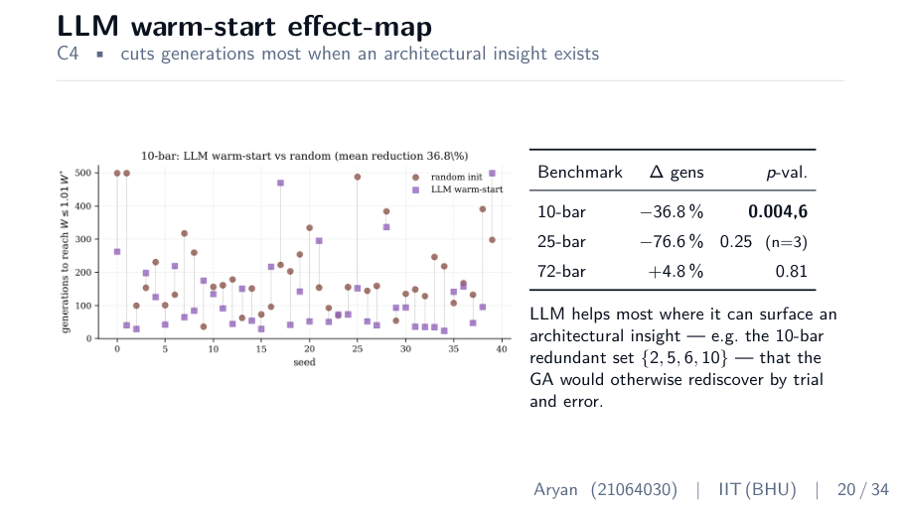
↑ slide layout (text wording shown is from an earlier build; your rebuilt deck reads 'agent')
ON SCREEN
Bar chart of % change in generations; table: 10-bar −36.8% (p=0.0046), 25-bar −76.6% (p=0.25, n=3), 72-bar +4.8% (p=0.81). Note on redundant bar set {2,5,6,10}.
WHAT TO SAY
“Contribution C4, and the part I'm proudest of. On the 10-bar, agent warm-start cuts generations-to-convergence by 36.8 percent, p-value 0.0046 — statistically significant. On 25-bar the magnitude is even larger, minus 76.6 percent, but with only three seeds it's underpowered, p 0.25. On 72-bar, no detectable effect. The interpretation: the agent helps most when it can surface an architectural insight. On 10-bar, the agent correctly identifies that bars 2, 5, 6, and 10 are nearly redundant — a known result the GA would otherwise rediscover by trial and error. On 72-bar there's no analogous insight, so the effect vanishes.”

DEEPER CONTEXT — the real understanding
This is the novel scientific claim, and its strength is its HONESTY. The ‘effect-map’ shows the agent helping a lot on 10-bar, maybe on 25-bar (but too few seeds to be sure — p=0.25 means not significant), and not at all on 72-bar. The mechanism is the key insight: the agent encodes engineering ‘common sense’ from its training, so when the problem has a recognizable structural shortcut (10-bar's redundant members), it hands that to the GA immediately, saving the generations the GA would spend rediscovering it. When there's no such shortcut (72-bar), the agent adds nothing. The honest, qualified claim — ‘helps when insight exists’ — is far stronger than ‘always helps’, which would be false and easily attacked. p-value 0.0046 means there's only a 0.46% chance the 10-bar improvement is random luck.

WHY IT'S HERE
The headline novelty. The qualified framing is the defensible claim. Never overclaim.
LIKELY QUESTIONS
Likely Q: Could the GA find the redundant bars without the agent?
Answer: Yes, eventually. The agent doesn't discover anything unreachable — it provides the insight EARLIER, cutting the generations the GA spends rediscovering it. That earlier start is the measured speedup.
Likely Q: Is one significant benchmark enough?
Answer: I claim it only for the regime where an architectural insight exists, shown significantly on 10-bar. I explicitly do NOT claim universal benefit — 72-bar is the null case. That honesty is the contribution.
Likely Q: What does p = 0.0046 mean?
Answer: Under a Mann-Whitney/Wilcoxon test, there's about a 0.46% probability the observed 10-bar improvement arose by chance — strong evidence it's real.
Likely Q: Why is 25-bar not significant despite −76.6%?
Answer: Only three seeds per arm — too small a sample for significance (p=0.25), even though the effect size looks large. I report it as underpowered, not proven.
Time on this slide: 90 seconds

SLIDE 21 / 34
NSGA-II Pareto front (O2)
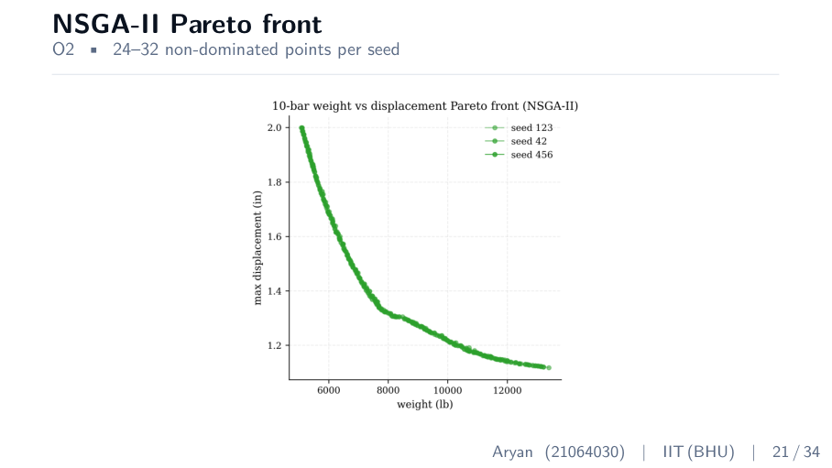
↑ slide layout (text wording shown is from an earlier build; your rebuilt deck reads 'agent')
ON SCREEN
Pareto-front scatter in weight vs max-displacement space, 24–32 non-dominated points.
WHAT TO SAY
“Here is the 10-bar Pareto front — weight against maximum displacement. Each point is a non-dominated design; 24 to 32 per seed, satisfying objective O2 with margin. The single-objective optimum sits at the rightmost corner; lighter designs to the left all deflect more. This is the menu of trade-offs an engineer chooses from.”

DEEPER CONTEXT — the real understanding
‘Non-dominated’ means no other design is better in BOTH objectives at once — you can't reduce weight without increasing displacement, or vice versa. The set of all such designs is the Pareto front. NSGA-II finds it using two ideas: non-dominated SORTING (rank designs by how many dominate them) and CROWDING DISTANCE (prefer designs in sparse regions so the front is evenly spread, not clustered). The practical value: instead of one answer, the engineer sees the whole weight-vs-stiffness trade-off and picks the point that fits their budget and serviceability limit.

WHY IT'S HERE
Demonstrates multi-objective capability and answers O2 — the framework gives design choices, not just one number.
LIKELY QUESTIONS
Likely Q: How do you pick one design from the front?
Answer: An engineering decision based on budget and stiffness needs — often the ‘knee’ of the curve, or the lightest design meeting a code displacement limit. The framework presents the trade-off; the engineer chooses.
Likely Q: What is crowding distance?
Answer: A tie-breaker that measures how isolated a design is in objective space; NSGA-II favours isolated points so the Pareto front stays evenly spread.
Time on this slide: 50 seconds

SLIDE 22 / 34
Part 4 divider — Deeper Analysis
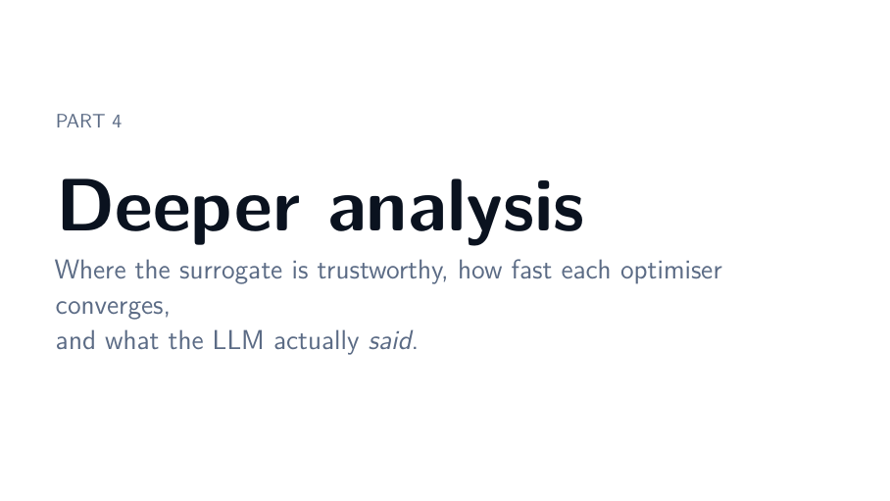
↑ slide layout (text wording shown is from an earlier build; your rebuilt deck reads 'agent')
ON SCREEN
Large 'Deeper analysis'. Subtitle: where the surrogate is trustworthy, how fast each optimizer converges, and what the agent actually said.
WHAT TO SAY
“Three deeper questions now: how trustworthy is the surrogate, how fast does each optimizer converge, and what does the agent actually say.”

DEEPER CONTEXT — the real understanding
Part 4 is where you show scientific maturity — not just ‘it works’, but ‘here's how reliable it is and why’. If you're short on time in the talk, this is the part to compress; the core claims live in Part 3.

WHY IT'S HERE
Signpost. Brief.
Time on this slide: 15 seconds

SLIDE 23 / 34
Surrogate uncertainty via MC-dropout
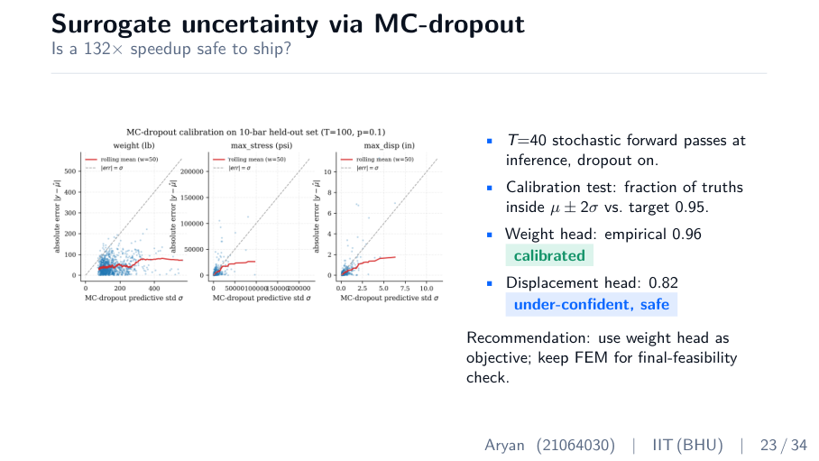
↑ slide layout (text wording shown is from an earlier build; your rebuilt deck reads 'agent')
ON SCREEN
Calibration figure; bullets: T=40 stochastic passes, calibration vs 0.95 target, weight head 0.96 (calibrated), displacement head 0.82 (under-confident, safe).
WHAT TO SAY
“Is a 132 times speedup safe to ship? I test it with MC-dropout — keeping dropout active at inference, running 40 stochastic forward passes, and using the variance as an uncertainty estimate. The calibration target is 95 percent of true values inside two sigma. The weight head measures 96 percent — well calibrated. The displacement head is 82 percent — under-confident, which is the safe direction. The recommendation: use the weight head as the objective and keep FEM for the final feasibility check.”

DEEPER CONTEXT — the real understanding
Normally dropout (randomly switching off neurons) is only used during TRAINING to prevent overfitting. MC-dropout keeps it ON at inference and runs the network many times — each pass gives a slightly different answer, and the SPREAD of those answers estimates how uncertain the model is. ‘Calibrated’ means the model's stated uncertainty matches reality: if it says ‘95% confident’, the truth really lands in that band 95% of the time. Your weight head at 96% is essentially perfectly calibrated. The displacement head at 82% is UNDER-confident — it claims more uncertainty than it has, which is the SAFE direction (it over-warns rather than under-warns).

WHY IT'S HERE
Shows you didn't trust the surrogate blindly — you quantified its reliability. The kind of rigour that impresses a technical committee.
LIKELY QUESTIONS
Likely Q: What is MC-dropout in one sentence?
Answer: Keep dropout active at inference and run many forward passes; the spread of predictions approximates the model's uncertainty (Gal & Ghahramani 2016).
Likely Q: Why is under-confidence ‘safe’?
Answer: It over-estimates uncertainty, so the system errs toward calling FEM more often than strictly necessary — it won't wrongly pass an unsafe design.
Time on this slide: 70 seconds

SLIDE 24 / 34
Convergence-rate characterisation
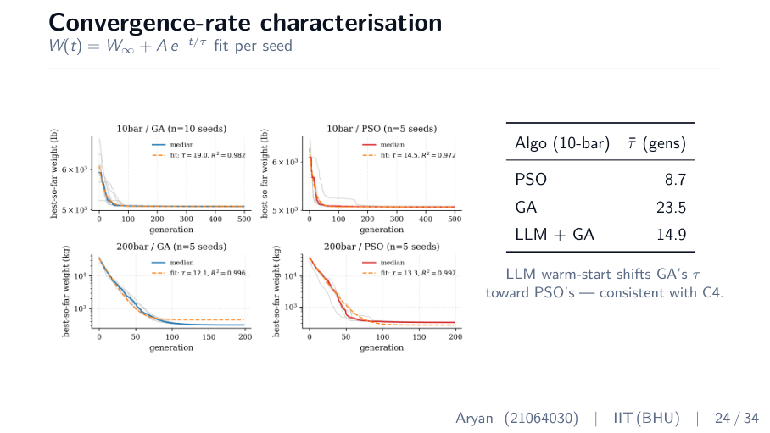
↑ slide layout (text wording shown is from an earlier build; your rebuilt deck reads 'agent')
ON SCREEN
Exponential-fit figure W(t)=W∞ + A·e^(−t/τ); table: PSO τ 8.7, GA 23.5, agent+GA 14.9 generations.
WHAT TO SAY
“I fit an exponential to each seed's convergence curve, where tau is the time constant — how many generations to halve the remaining gap to the optimum. PSO converges fastest at 8.7 generations. GA is 23.5. GA with agent warm-start is 14.9 — shifted roughly halfway toward PSO. So the agent warm-start mechanism makes GA behave more like PSO in speed, which is exactly consistent with contribution C4.”

DEEPER CONTEXT — the real understanding
The time constant τ is a single number summarizing convergence SPEED: a smaller τ means the optimizer closes the gap to the optimum faster. Fitting the same exponential model to every run lets you compare speeds on equal footing. The headline insight: agent warm-start drags GA's τ from 23.5 down to 14.9 — about halfway to PSO's 8.7. This is the MECHANISM behind C4 made quantitative: the agent isn't changing where GA ends up, it's making GA get there faster by starting it closer.

WHY IT'S HERE
Explains the mechanism behind C4 quantitatively — not just ‘faster’ but ‘here's the time constant shifting’. Strong supporting evidence.
LIKELY QUESTIONS
Likely Q: Why fit an exponential?
Answer: Metaheuristic convergence toward an optimum is approximately geometric, so an exponential is the natural model and τ gives one comparable speed number per run.
Likely Q: Does warm-start change the final optimum or just the speed?
Answer: Just the speed — both reach the same optimum; the agent reduces the generations needed to get there.
Time on this slide: 70 seconds

SLIDE 25 / 34
Hard- vs soft-constraint feasibility frontier
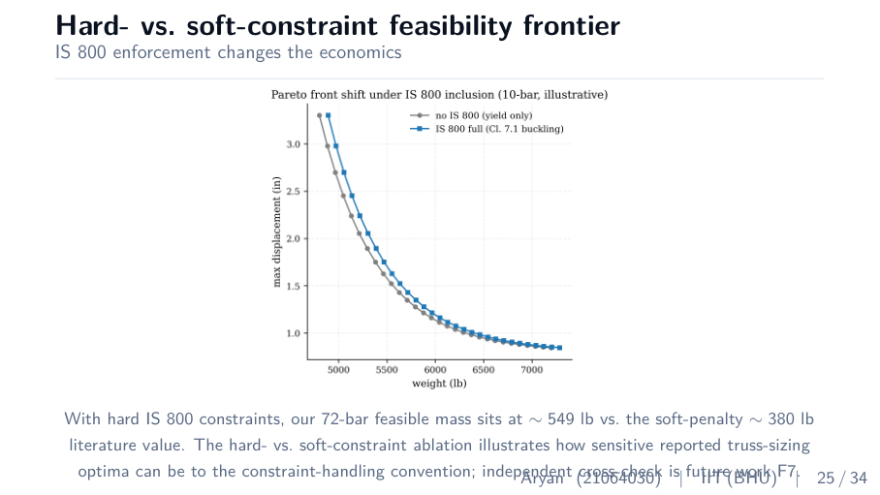
↑ slide layout (text wording shown is from an earlier build; your rebuilt deck reads 'agent')
ON SCREEN
Pareto-front shift figure (no IS 800 vs full IS 800); caption on 549 vs 380 lb and constraint-handling sensitivity; F7.
WHAT TO SAY
“This is the analysis behind the 72-bar observation. The same problem under hard versus soft constraints produces very different fronts. Under hard IS 800, the feasible mass sits around 549 pounds; under a representative soft penalty it drops to around 380. The point is not that one is right and one wrong — it is that reported optima in the truss-sizing literature can be highly sensitive to the constraint-handling convention. For Indian practice, this means a soft-penalty optimum should not be deployed without a hard-feasibility cross-check.”

DEEPER CONTEXT — the real understanding
This slide turns the 72-bar ‘discrepancy’ into a genuine engineering CONTRIBUTION. By running the identical problem under both conventions on the same FEM, you ISOLATE the effect of constraint handling — about a 45% swing in reported weight. That's a cautionary result the whole field (and Indian designers using commercial soft-penalty solvers) should heed: a published light optimum may be marginally infeasible. You're not just reporting your number; you're explaining WHY the literature numbers differ and what that means for safe practice.

WHY IT'S HERE
Elevates the 72-bar gap from ‘my number disagrees’ to a real insight about the field. This is what makes the discrepancy a contribution rather than a weakness.
LIKELY QUESTIONS
Likely Q: Is this constraint sensitivity already known?
Answer: That constraint handling affects results is known, but a same-FEM, side-by-side hard-vs-soft ablation quantifying the ~45% magnitude on a standard benchmark is what I add.
Likely Q: What should a practicing engineer take from this?
Answer: If using a soft-penalty commercial solver, run an independent hard-feasibility check before sign-off — the reported optimum may sit just past a code limit.
Time on this slide: 90 seconds

SLIDE 26 / 34
Part 5 divider — Impact
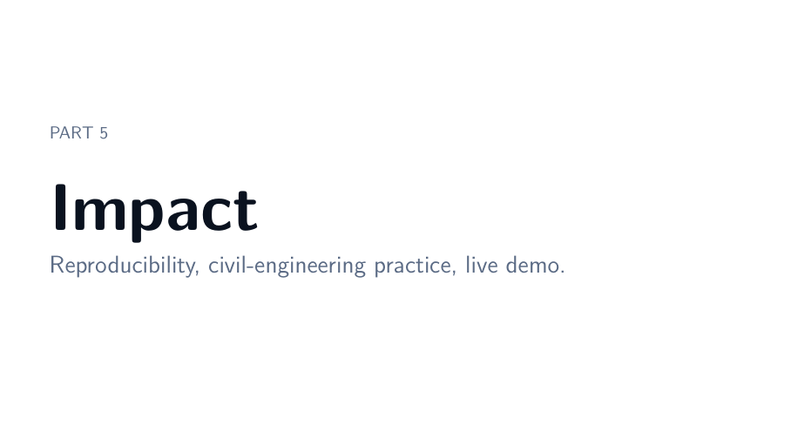
↑ slide layout (text wording shown is from an earlier build; your rebuilt deck reads 'agent')
ON SCREEN
Large 'Impact'. Subtitle: reproducibility, civil-engineering practice, live demo.
WHAT TO SAY
“Now the practical impact — for Indian civil engineering, for reproducibility, and a live demo.”

DEEPER CONTEXT — the real understanding
Part 5 answers the examiner's unspoken ‘so what?’. You've proven the framework works; now show it matters in practice and that anyone can verify it.

WHY IT'S HERE
Signpost. Brief.
Time on this slide: 10 seconds

SLIDE 27 / 34
Practical implications for Indian civil engineering
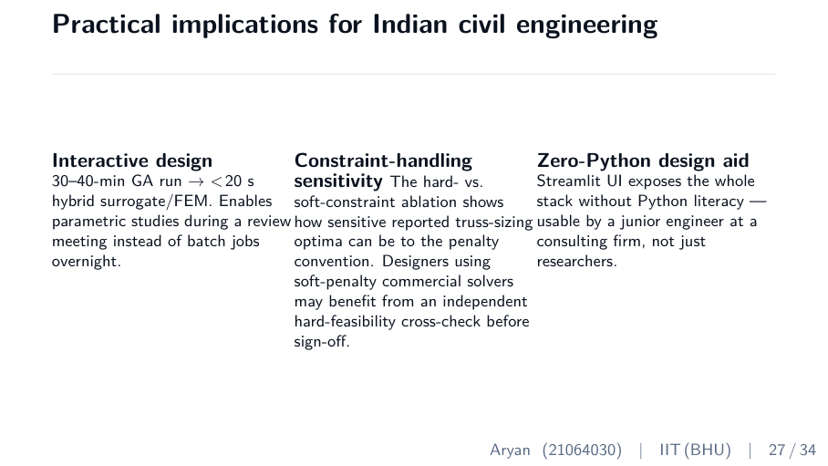
↑ slide layout (text wording shown is from an earlier build; your rebuilt deck reads 'agent')
ON SCREEN
Three columns: interactive design (30–40 min → <20 s), constraint-handling sensitivity, zero-Python design aid via Streamlit.
WHAT TO SAY
“Three practical implications. First, the surrogate brings a 30-to-40-minute GA run down to under 20 seconds, enabling parametric studies during a review meeting instead of overnight batches. Second, the hard-versus-soft sensitivity should be flagged to anyone using commercial soft-penalty solvers — run a hard-feasibility check before sign-off. Third, the Streamlit UI exposes the whole framework without requiring Python literacy — usable by a junior engineer, not just a researcher.”

DEEPER CONTEXT — the real understanding
These three implications map directly to your three strongest results: C2 (speed → interactive design), C3 (hard-vs-soft → safety awareness), and C5 (UI → accessibility). Tying impact back to specific contributions shows the work isn't academic for its own sake — each finding has a concrete user and use-case in the Indian construction context.

WHY IT'S HERE
Connects the technical work to real-world value — answers ‘so what’ concretely.
LIKELY QUESTIONS
Likely Q: Who is the actual user?
Answer: A practising structural engineer at a consulting firm or PSU (e.g., transmission-tower design) who needs fast, code-compliant sizing without writing code.
Time on this slide: 70 seconds

SLIDE 28 / 34
Reproducibility contract
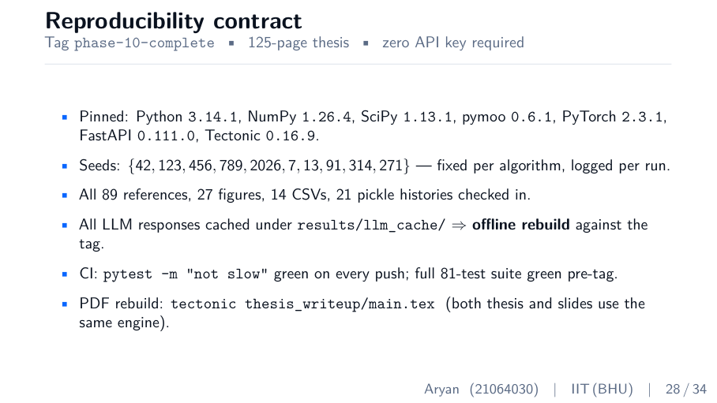
↑ slide layout (text wording shown is from an earlier build; your rebuilt deck reads 'agent')
ON SCREEN
Pinned versions, fixed seed set, 89 refs / 27 figures / 14 CSVs / 21 pickles checked in, cached agent responses, green CI, single-command PDF rebuild.
WHAT TO SAY
“Reproducibility is a first-class deliverable. Every dependency is pinned. Seeds are fixed and logged. All 89 references, 27 figures, 14 CSVs, and 21 optimization histories are checked in. Every agent response is cached, so the whole thing rebuilds offline with no API key. Continuous integration runs the fast test suite green on every push, and a single Tectonic command rebuilds both the 125-page thesis and this deck.”

DEEPER CONTEXT — the real understanding
Reproducibility means a stranger can re-run your work and get the SAME numbers. The threats to that are: unpinned library versions (results drift), unlogged random seeds (stochastic runs differ), and external API calls (the model changes or needs a key). You closed all three — pinned versions, fixed seeds, cached agent responses. This is increasingly what examiners and reviewers look for; it signals the work is trustworthy, not a one-off lucky run.

WHY IT'S HERE
Reproducibility is increasingly valued. This slide says ‘anyone can verify everything I claim’ — a strong credibility signal.
LIKELY QUESTIONS
Likely Q: Doesn't using an agent break reproducibility?
Answer: No — every response is cached by prompt hash and committed, so replays are deterministic and need no API key.
Likely Q: What does pinning versions achieve?
Answer: It freezes the exact library versions (NumPy, pymoo, PyTorch, etc.) so numerical results don't drift when libraries update.
Time on this slide: 60 seconds

SLIDE 29 / 34
Live demo surface
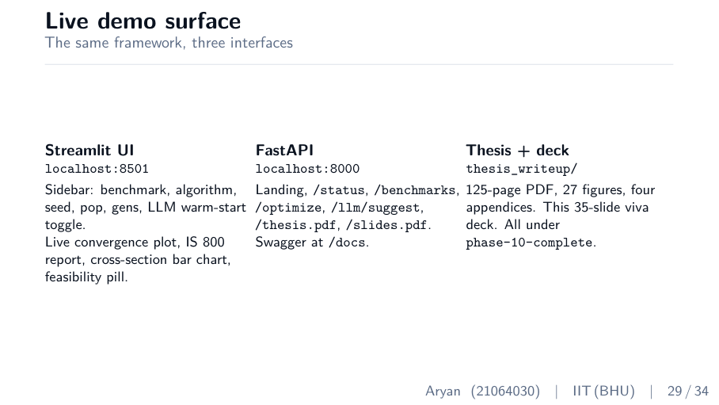
↑ slide layout (text wording shown is from an earlier build; your rebuilt deck reads 'agent')
ON SCREEN
Three interfaces: Streamlit UI (localhost:8501), FastAPI (localhost:8000 + Swagger), thesis PDF + deck.
WHAT TO SAY
“The same framework, three interfaces. The Streamlit UI lets a user pick a benchmark, an algorithm, a seed, and the agent warm-start toggle, then shows the live convergence plot, the IS 800 report, and the cross-section chart. The FastAPI backend exposes the same stack programmatically, with Swagger docs. And the thesis and this deck both build from the same tagged repository. If the committee wishes, I can run a 10-bar optimization live right now.”

DEEPER CONTEXT — the real understanding
The demo flow to rehearse: pick 10-bar + GA, run WITHOUT the agent (note generations/time), then tick the agent warm-start and run AGAIN — the convergence curve drops faster and finishes in fewer generations. That live before/after IS contribution C4 happening in real time. CRITICAL: have the server already running before the viva and do one warm-up run; never start it live or debug in front of the committee. The user does NOT enter a custom truss — they pick from the four encoded benchmarks; a new benchmark is a short Python file (future-work UI).

WHY IT'S HERE
Offers the live demo. Have the server running beforehand. If anything fails, skip to slides — the convergence figures show the same thing.
LIKELY QUESTIONS
Likely Q: Can a user enter their own custom truss?
Answer: Not through this UI yet — the four benchmarks are encoded in the registry. A new benchmark is a short Python file of nodes, connectivity, loads, supports; the framework is modular. Custom-truss UI is future work.
Likely Q: What exactly does the user control?
Answer: Benchmark, algorithm, seed, population, generations, and the agent warm-start toggle. Geometry, loads, and material come fixed from the published benchmark.
Time on this slide: 60 seconds (longer if running the live demo)

SLIDE 30 / 34
Part 6 divider — Conclusion
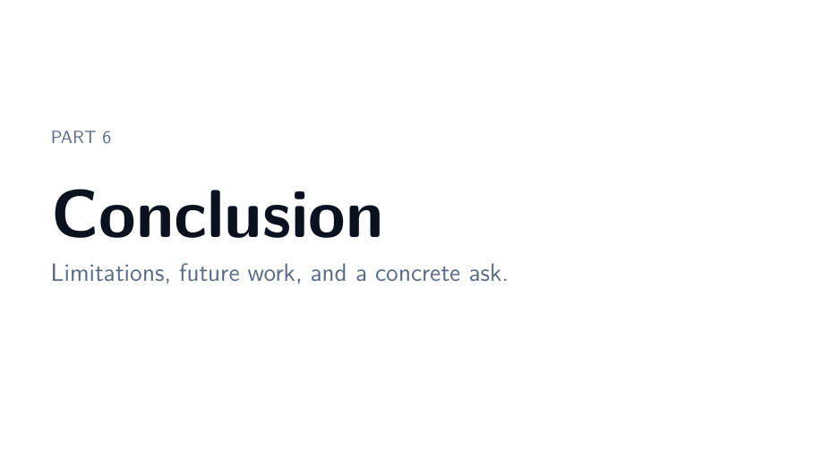
↑ slide layout (text wording shown is from an earlier build; your rebuilt deck reads 'agent')
ON SCREEN
Large 'Conclusion'. Subtitle: limitations, future work, and a concrete ask.
WHAT TO SAY
“Finally — limitations, future work, and a summary.”

DEEPER CONTEXT — the real understanding
Closing the arc. The strongest conclusions state limitations openly THEN summarize strengths — it leaves the committee with confidence rather than doubt.

WHY IT'S HERE
Signpost. Brief.
Time on this slide: 10 seconds

SLIDE 31 / 34
What I am NOT claiming — limitations
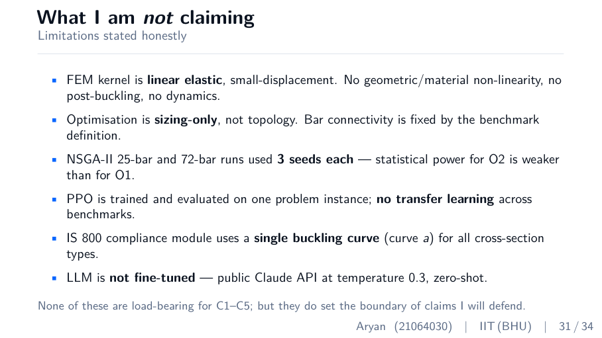
↑ slide layout (text wording shown is from an earlier build; your rebuilt deck reads 'agent')
ON SCREEN
Bullets: linear-elastic small-displacement FEM; sizing-only not topology; NSGA-II 3 seeds; PPO single-instance no transfer; single buckling curve; agent zero-shot not fine-tuned.
WHAT TO SAY
“Let me be explicit about what I am NOT claiming. The FEM is linear elastic and small-displacement — no non-linearity or dynamics. The optimization is sizing only, not topology — connectivity is fixed. The NSGA-II 3D runs use three seeds, so O2's statistical power is weaker than O1's. The PPO agent is trained on one instance with no transfer. The IS 800 module uses a single buckling curve. And the design agent is zero-shot, not fine-tuned. None of these are load-bearing for contributions C1 through C5 — but they set the boundary of what I will defend.”

DEEPER CONTEXT — the real understanding
Stating limitations clearly is a CREDIBILITY MULTIPLIER, not a confession of weakness. Each limit is a deliberate SCOPE decision: linear-elastic FEM is the standard, correct choice for sizing (the design stays below yield by definition); sizing-only keeps the problem well-defined; zero-shot agent tests the weakest version of your idea so any positive result is conservative. The crucial sentence is ‘none of these are load-bearing for C1–C5’ — i.e., admitting them costs you nothing because your actual claims don't depend on them. Deliver this slide with confidence, never apology.

WHY IT'S HERE
Pre-empts hostile questions and shows scientific maturity. Do not apologize — these are scope decisions.
LIKELY QUESTIONS
Likely Q: Why didn't you do topology optimization?
Answer: Topology turns it into a mixed integer-continuous problem and is a distinct research area. Combining the agent warm-start with topology is a natural follow-on — future work F2.
Likely Q: Why linear-elastic FEM?
Answer: For sizing against IS 800 working capacities the design stays below yield, so linear-elastic captures the relevant regime. Non-linear/dynamic FEM (for seismic) is future work F1.
Likely Q: Why zero-shot and not fine-tuned agent?
Answer: To test the weakest version of the idea. If even un-fine-tuned the agent gives a 36.8% speedup, fine-tuning is upside, not a dependency. F5.
Time on this slide: 90 seconds

SLIDE 32 / 34
Future work (F1–F7)
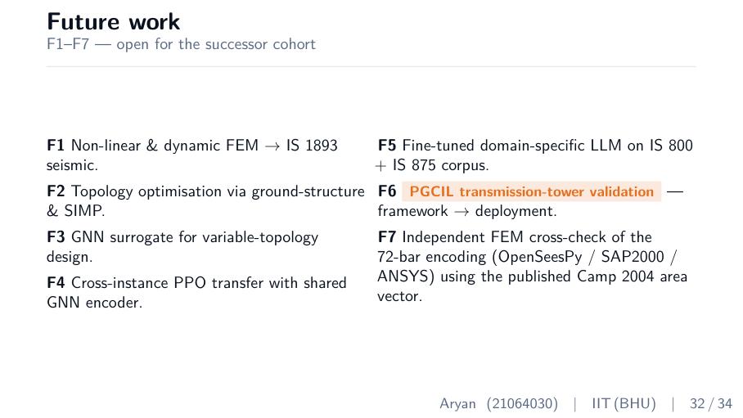
↑ slide layout (text wording shown is from an earlier build; your rebuilt deck reads 'agent')
ON SCREEN
F1 nonlinear/dynamic FEM → IS 1893; F2 topology via ground-structure/SIMP; F3 GNN surrogate; F4 cross-instance PPO transfer; F5 fine-tuned domain agent; F6 PGCIL transmission-tower validation; F7 independent FEM cross-check of 72-bar.
WHAT TO SAY
“Seven directions of future work. F1: non-linear and dynamic FEM for IS 1893 seismic. F2: topology optimization. F3: a graph-neural-network surrogate for variable topology. F4: cross-instance PPO transfer. F5: a fine-tuned domain-specific agent on IS 800 and IS 875. F6: real-world validation on a PGCIL transmission tower. And F7: an independent FEM cross-check of the 72-bar discrepancy using OpenSeesPy or SAP2000.”

DEEPER CONTEXT — the real understanding
A strong future-work slide shows the work OPENS doors rather than closing them, and that you understand the field's next steps. Notice F7 directly addresses the 72-bar question — so if pressed on that result, you can point here and say ‘and here is exactly how I'd resolve it’. F6 (PGCIL transmission tower) shows a credible path from benchmark to real Indian infrastructure.

WHY IT'S HERE
Shows the work is a foundation, not a dead end. F7 is your escape hatch for the 72-bar question.
LIKELY QUESTIONS
Likely Q: Which future direction is most important?
Answer: F2 (topology) for impact, and F7 (the 72-bar cross-check) for closure on the one open observation in this thesis.
Time on this slide: 70 seconds

SLIDE 33 / 34
Summary
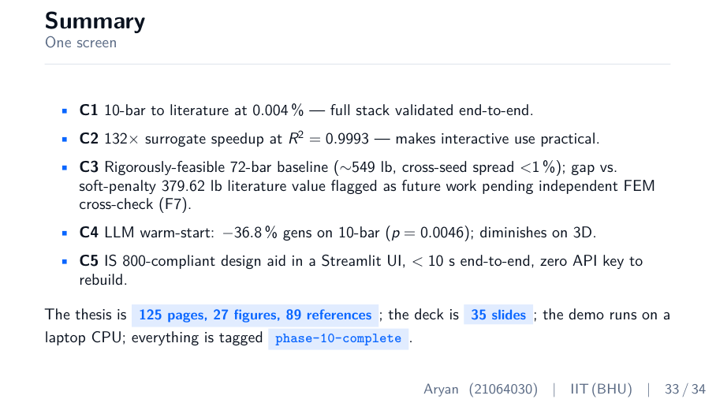
↑ slide layout (text wording shown is from an earlier build; your rebuilt deck reads 'agent')
ON SCREEN
C1–C5 restated; '125 pages, 27 figures, 89 references; 35-slide deck; laptop CPU; tag phase-10-complete'.
WHAT TO SAY
“To summarize. C1: 10-bar to literature at 0.004 percent — the full stack validated. C2: 132 times surrogate speedup at R-squared 0.9993 — interactive use is practical. C3: a rigorously feasible 72-bar baseline at 549 pounds, with the gap versus soft-penalty literature flagged for an independent cross-check. C4: agent warm-start saves 36.8 percent of generations on 10-bar at p 0.0046, diminishing on harder 3D problems. C5: an IS 800-compliant design aid running under 10 seconds on a laptop CPU, with no API key needed to rebuild. The thesis is 125 pages, 27 figures, 89 references; everything is tagged phase-10-complete.”

DEEPER CONTEXT — the real understanding
The summary is your last chance to plant the five numbers before questions begin — so hit all five C's cleanly and in order. Saying them again here means that even if a committee member drifted earlier, they leave with the headline results fresh. End on the reproducibility tag — it closes on strength.

WHY IT'S HERE
Reinforces the five contributions one final time. Deliver crisply.
Time on this slide: 70 seconds

SLIDE 34 / 34
Thank you / Questions
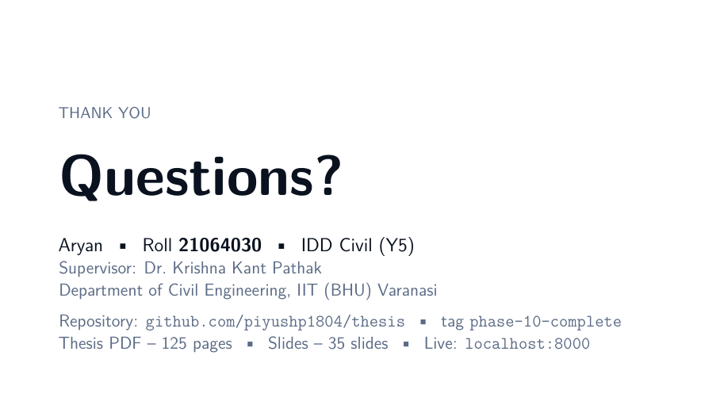
↑ slide layout (text wording shown is from an earlier build; your rebuilt deck reads 'agent')
ON SCREEN
'Questions?' with your name, roll, supervisor, repository, and demo URL.
WHAT TO SAY
“Thank you for your attention. I would be happy to take your questions.”

DEEPER CONTEXT — the real understanding
How you handle Q&A matters as much as the talk. Technique: when a question comes, REPEAT it back in your own words first — this buys thinking time and confirms you understood. If you don't know something, say so and offer your best reasoning (‘I don't have that measurement, but I'd expect X because Y’). Defend limitations as deliberate scope, not failures. The committee wants to see calm, honest command of your own work — not omniscience.

WHY IT'S HERE
Clean close. Pause, smile, sip water, wait for the first question.
LIKELY QUESTIONS
Likely Q: (General Q&A technique)
Answer: Repeat the question, answer in 30–60 seconds, stop. Don't ramble. If unsure, reason aloud honestly rather than guessing a number.
Time on this slide: 10 seconds, then Q&A

Timing Map & Golden Rules
TIME BUDGET (target 18–19 min, ~1–2 min buffer)
- Intro Slides 1–2: ~0:40
- Part 1 Slides 3–7 (problem): ~3:00
- Part 2 Slides 8–14 (framework): ~5:00
- Part 3 Slides 15–21 (results): ~5:00
- Part 4 Slides 22–25 (analysis): ~3:00
- Part 5 Slides 26–29 (impact): ~2:00
- Part 6 Slides 30–34 (conclusion): ~2:30
GOLDEN RULES
- Never compress Part 1 (the problem) — examiners anchor every later question to it.
- If running long, compress Part 4 (analysis) — it's supporting evidence, not core claims.
- Least time on slide 12 (three optimizers) — textbook plumbing.
- Most care on slides 7, 18, 20 (contributions, 72-bar, agent effect) — these draw questions.
- Have the demo server running BEFORE the viva. Never start it live.
- State limitations (slide 31) confidently — scope decisions, not failures.
- Memorize: 0.004% / 132× & R²0.9993 / 549 vs 380 / −36.8% p=0.0046 / <10 s.
— Read once the night before, once the morning of. You're ready, Aryan. —

