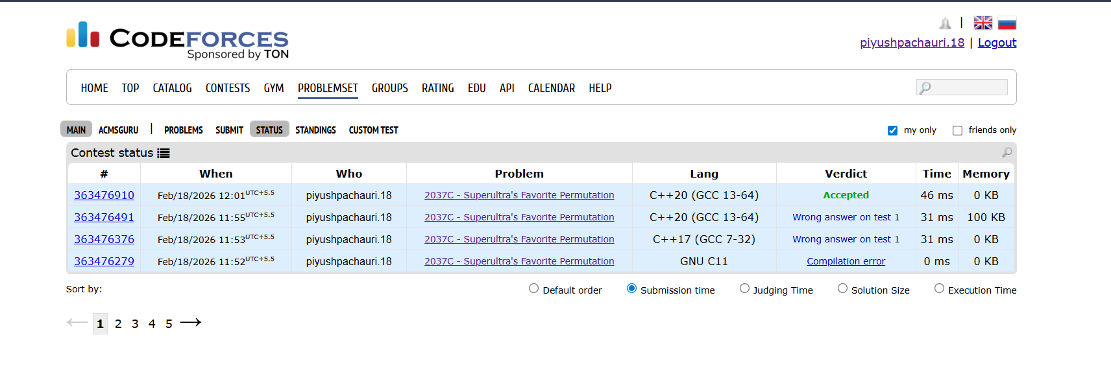

#include<iostream>
using namespace std;
int main()
{
int t;
int n;
cin>>t;
while(t--)
{
cin>>n;
if(n<=3)
{
cout<<-1;
continue;
}
for(int i=2;i<=n;i+=2)
{
cout<<i<<" ";
}
for(int i=1;i<=n;i+=2)
{
cout<<i<<" ";
}
cout<<'\n';
}
return 0;
}

