**GITHUB AND JENKINS LINK**

1. Setting up GitHub
2. Creating a repository

1. Repository created.

1. Connect IntelliJ with using via log in GitHub

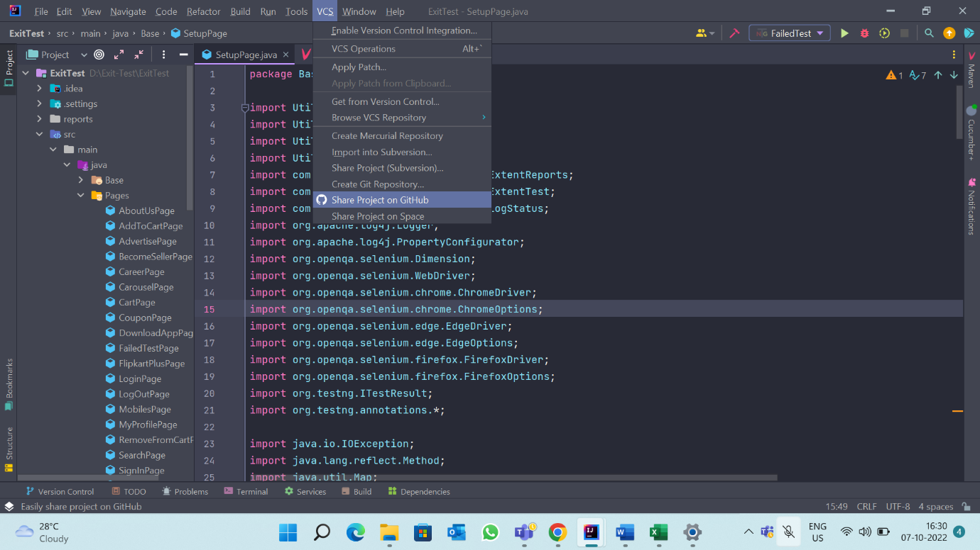

1. Log in to your GitHub account using IntelliJ.

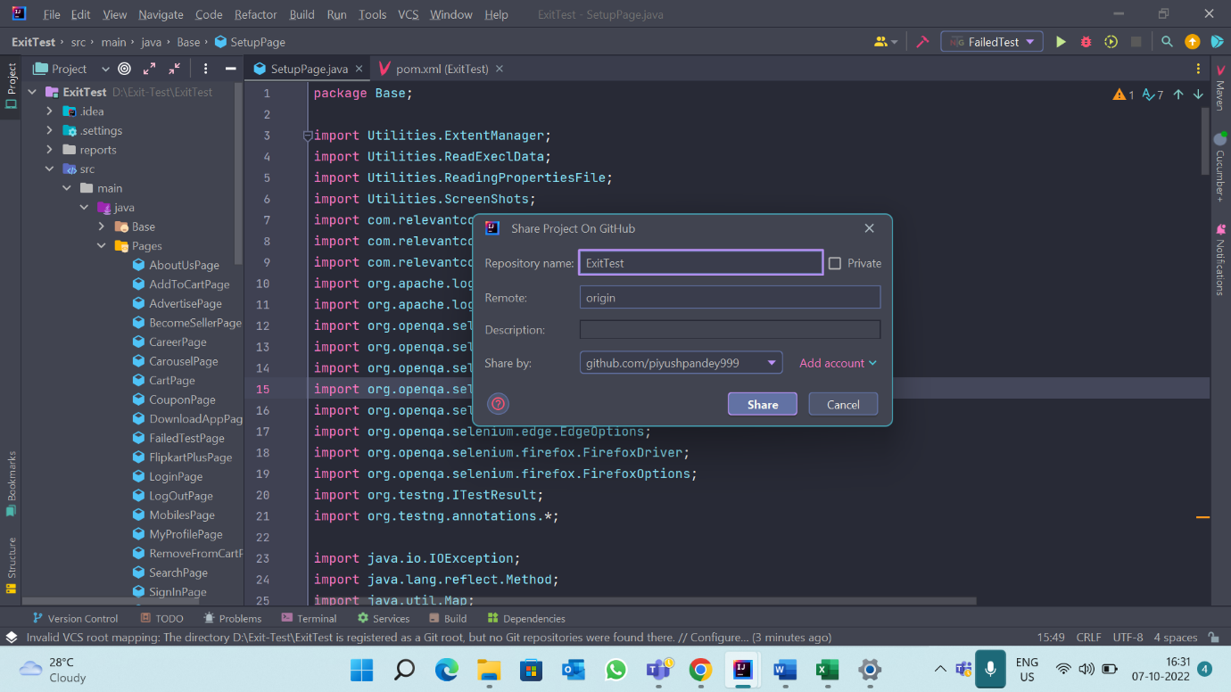

1. Commit and push the project.

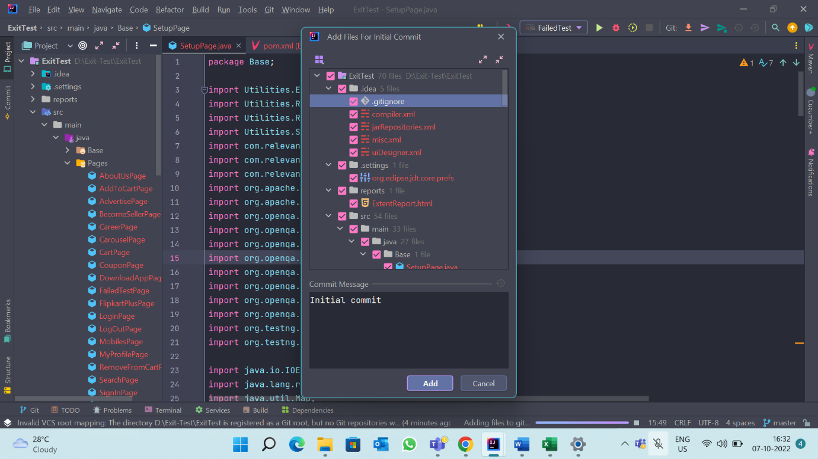

1. Project is pushed to GitHub.

1. Your files are now deployed to your GitHub repository.

1. Setting up GitHub
2. Go to your Jenkins webpage

1. Create a new item.

1. The select GitHub project and pass the link to you

1. Under source code management select git and pass the repository url and mention the name of the branch you’re working on.

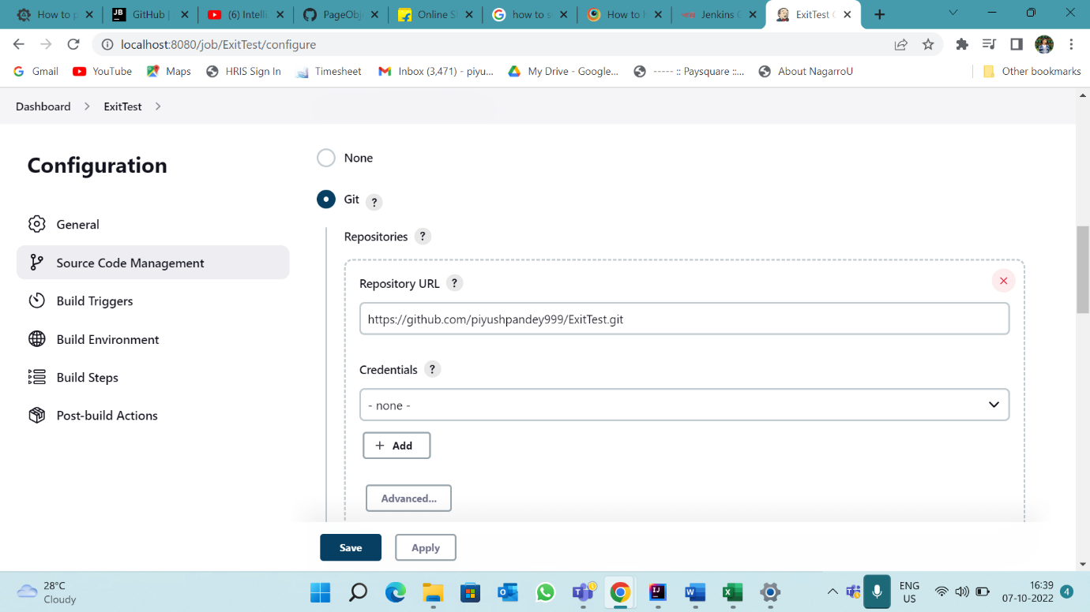

1. Save the project and build it.

1. Graphical user interface, text, application, email

   Description automatically generated
2. Now your GitHub and Jenkins are linked, and at every push event in GitHub triggers the Jenkins.