FALSE DEMAND WITHDRAWAL

Process FLOW:

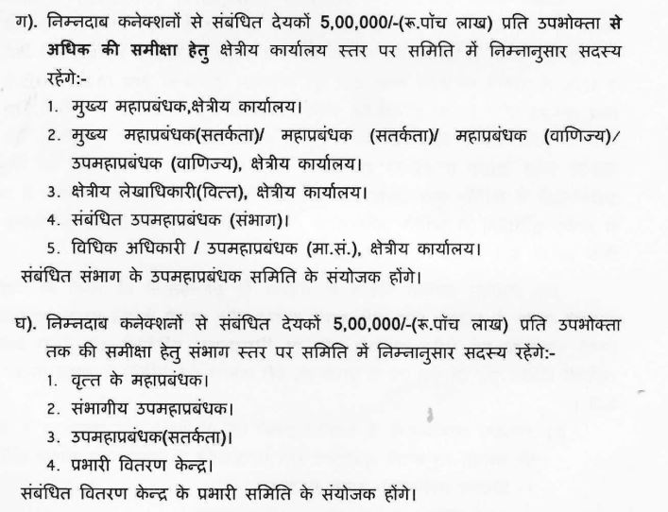

Over the User Interface:

- Visit the Login on BCP, and OAG/ARO will be Login , the below page will be displayed.
Where the user will be required to click on the False Demand WithDrawal link

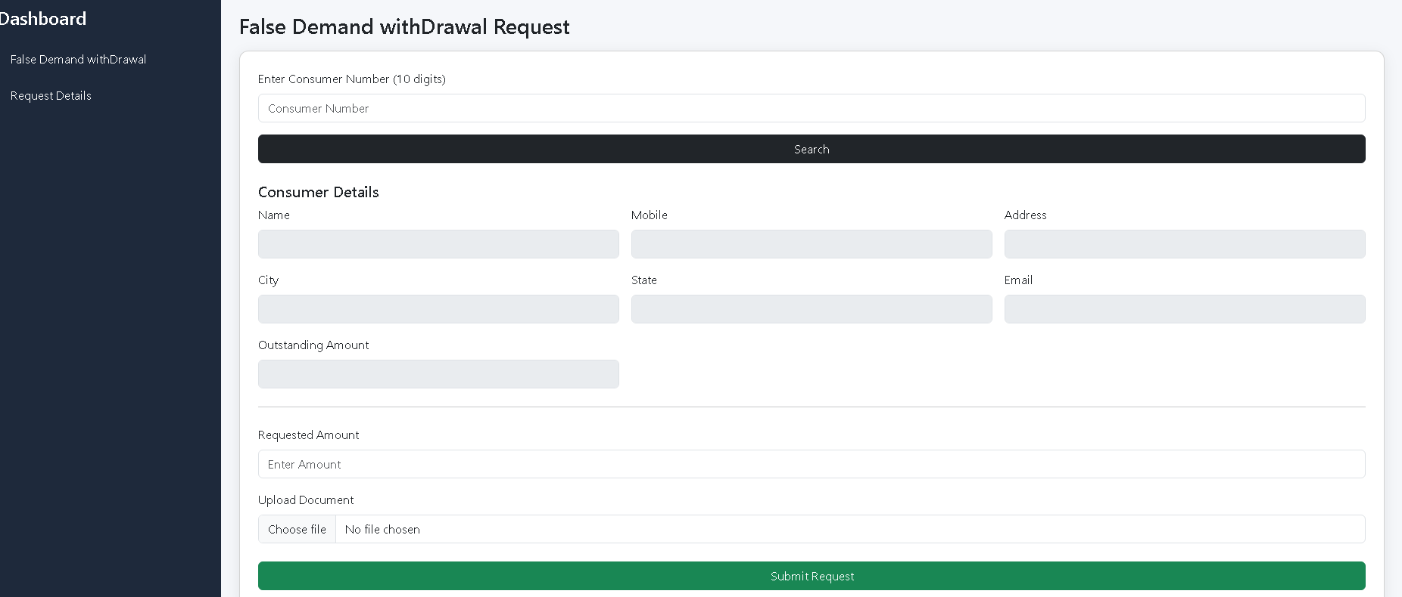

- The user Will enter the Consumer number Corresponding detail will be pulled from billing system with the current outstanding amount of the Consumer.

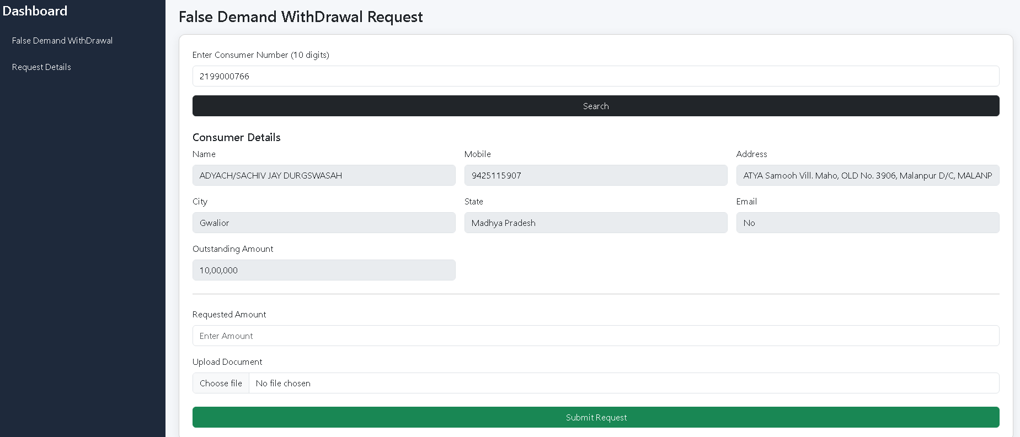

- The amount to be withdrawal and the supporting documents will be put by the imitator and click on the submit button.

Committee Members:

- Visit the Login on BCP, login with BCP credentials as an officer, the below page is displayed.
- To View a particular request, we need to click on Action Button…view. At this Page additional information will be displayed as

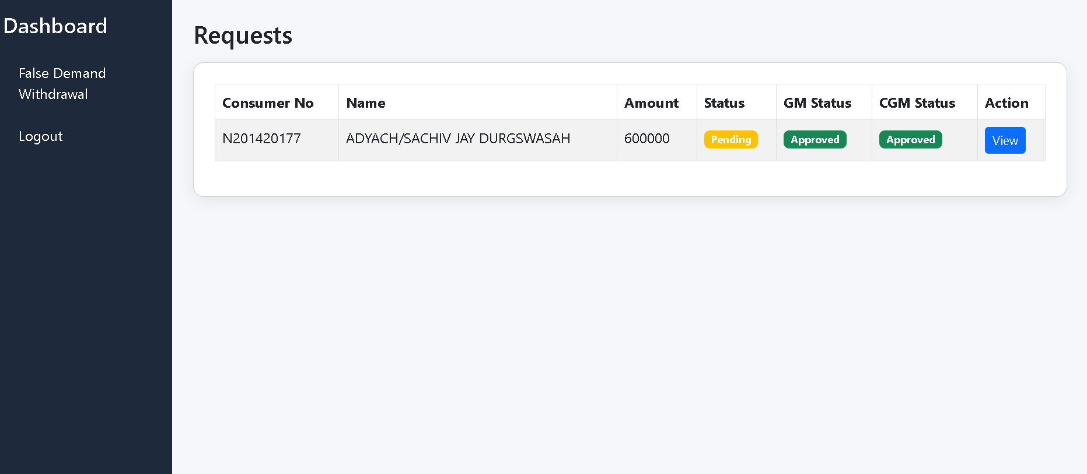

- Upon clicking on view Following will be displayed depicting all the action takes places in the system along with the documents been uploaded by the Other committee members.

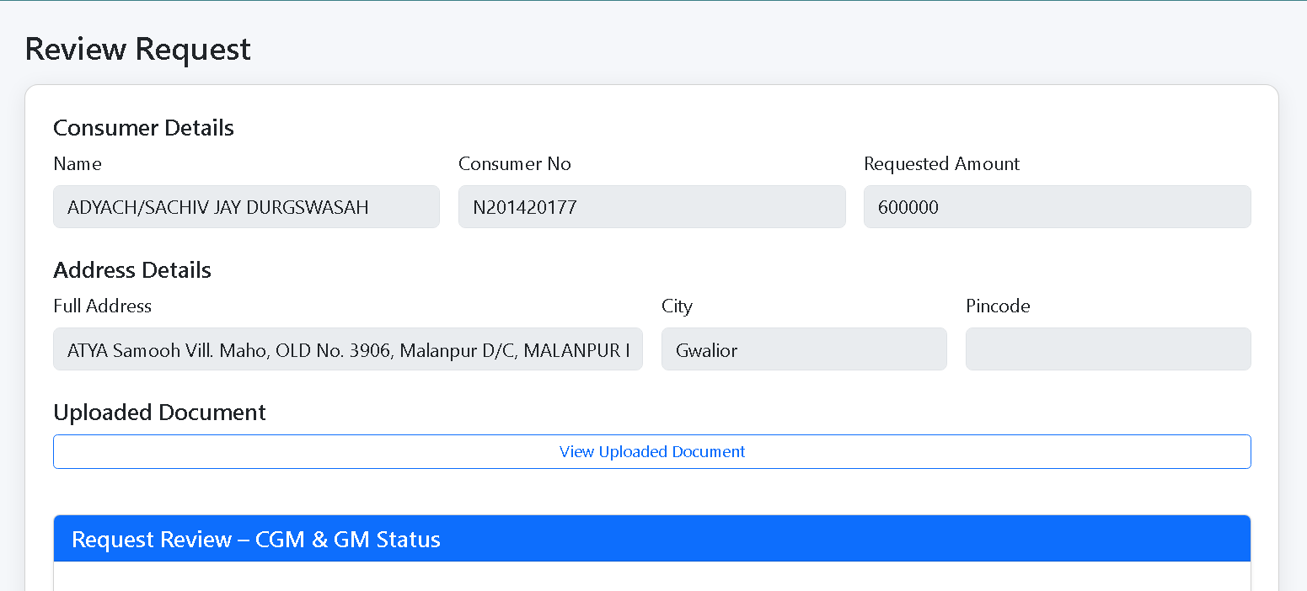

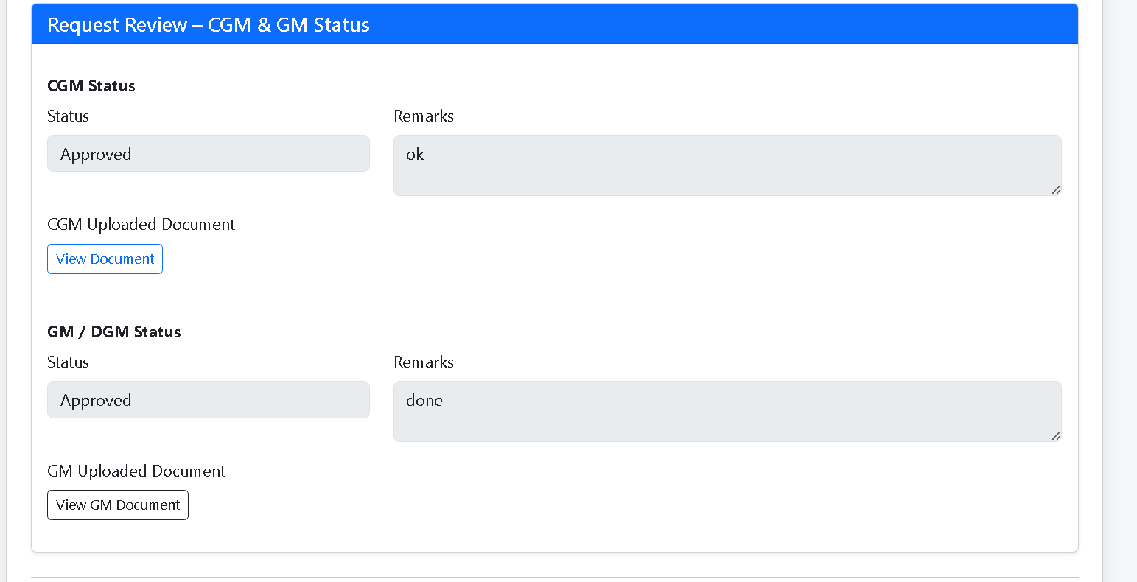

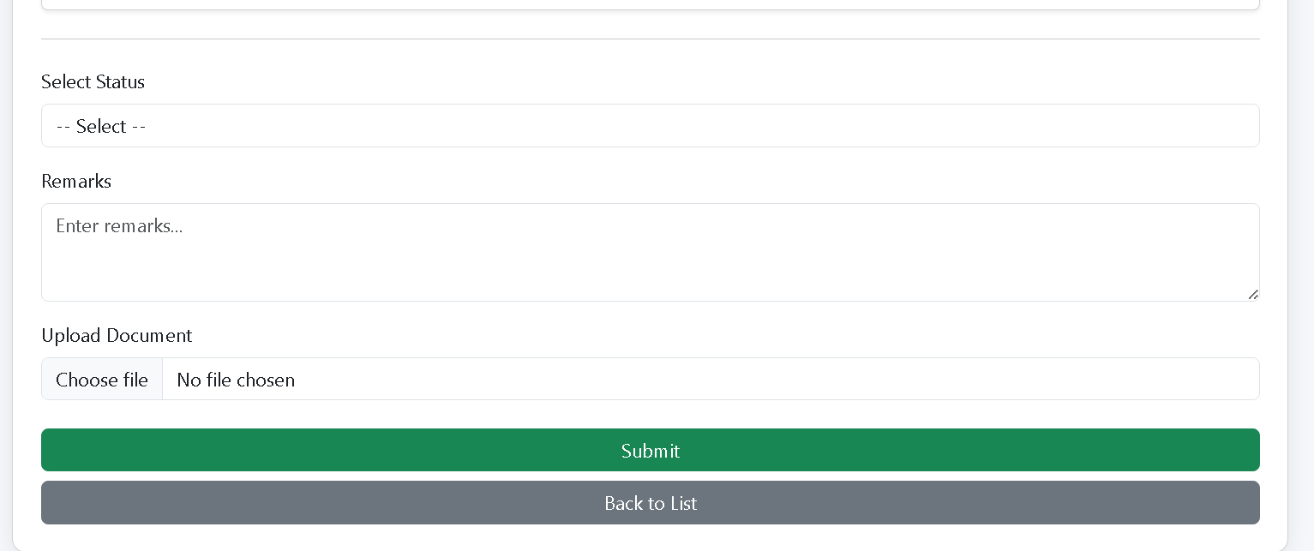

- The user will get the Option of Status as Approved/ Rejected/ Send Back
- Approved: --- If the Individual Feels is correct.
- Rejected: --- If the Individual Feels is Incorrect.
- Send Back: --- If the Individual Feels the additional Information is needed for more clarification for the Conveyor (DGM Abv 5L / JE upto 5L), All the committee member will be notified and they can their Status.