Set Up of online-training-portal in Local system
Before project setup in the local, the system should contain below tools:
1. jdk1.8
2. Eclipse
3. Oracle Database
4. Maven and maven plugin in eclipse
5. Git
6. Install ojdbc jar in local maven repository if it is not already installed
Steps to set up project in local system:
- Clone online-training-portal repository in your local directory of system of your choice using github desktop application.
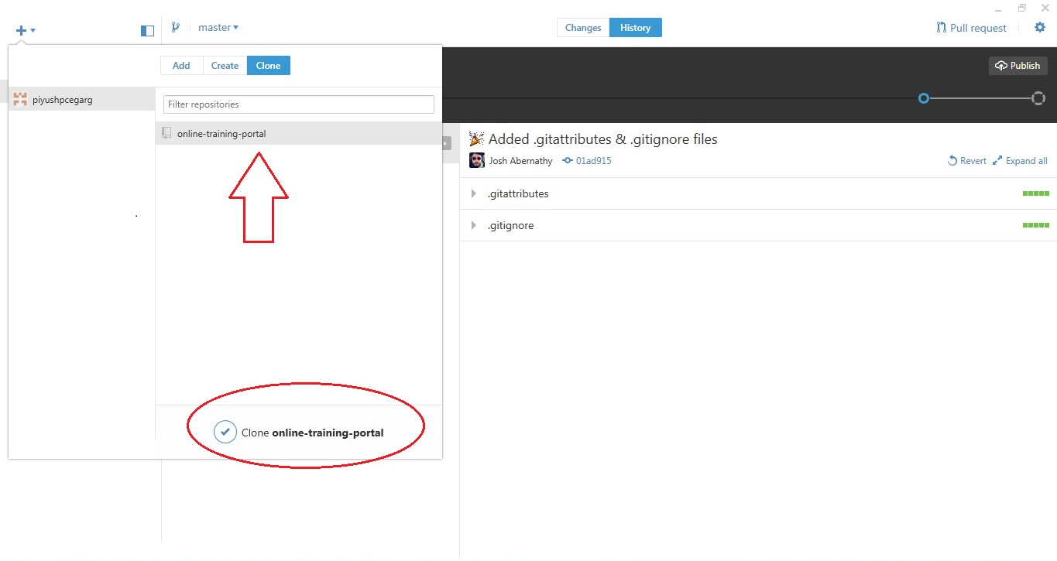

- Select local directory where you want to clone this repository . Workspace of eclipse is chosen in this tutorial.
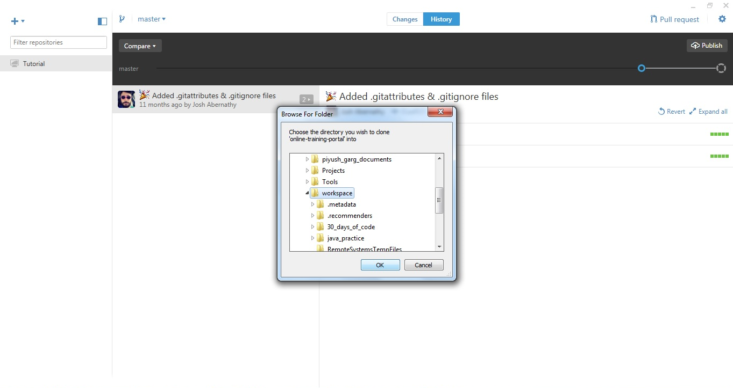

3. Create new branch(give appropriate name) of this repository from master branch using github desktop .
This will allow you to make some local changes and play with it. Later you can send pull request of your local changes so those can be merged in master branch.

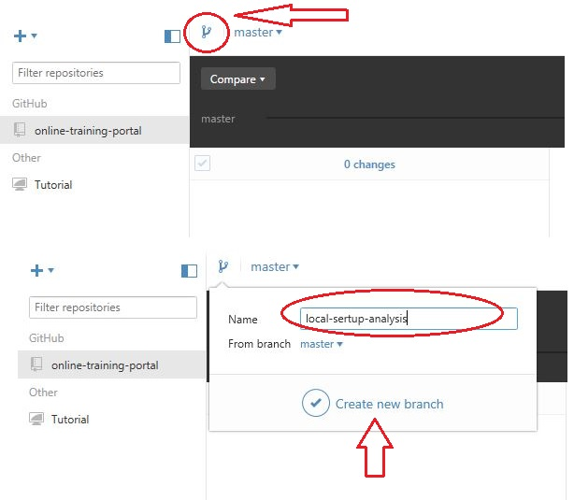

- Import online-training-portal as "Existing Maven Projects" in your working workspace
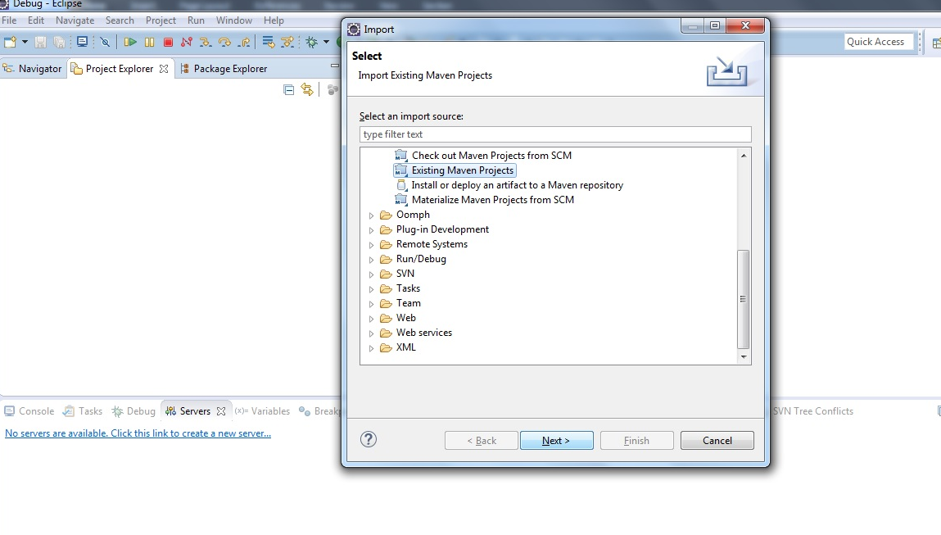
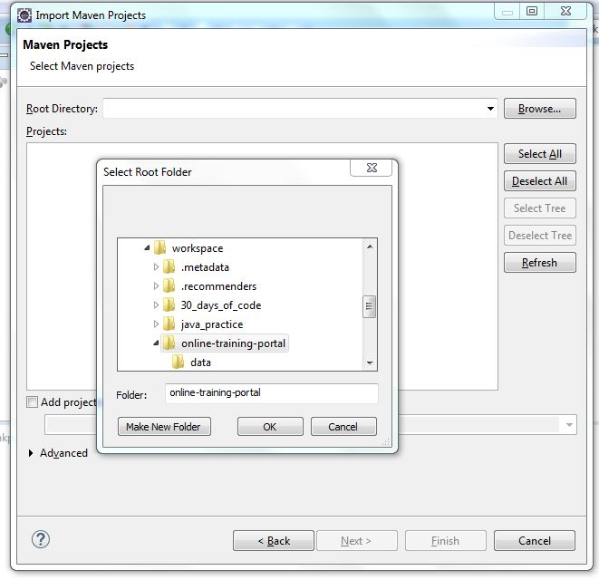
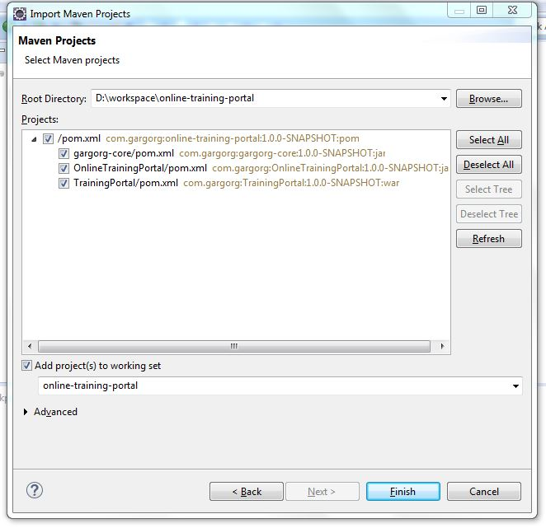

5. This will create "online-training-portal" as a maven project.
Along with above project, 3 new projects will be created in workspace with below name:
a) gargorg-core(jar)
b) OnlineTrainingPortal(jar)
c) TrainingPortal(war)

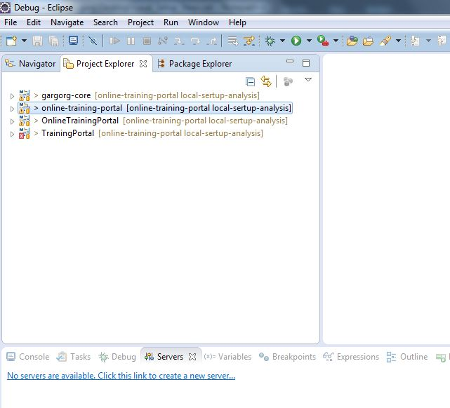

- Select "online-training-portal" project. Right click on this project. Go to maven menu then update project.
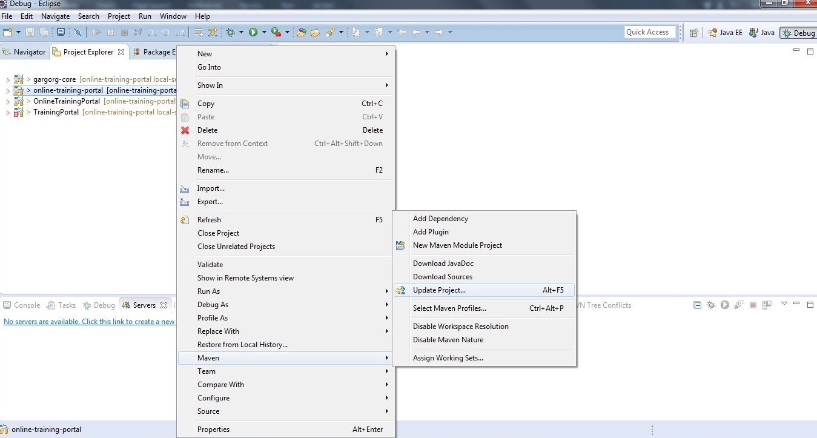

Above activity will convert maven projects to appropriate project like java and web project. This activity will also add appropriate maven dependency in all projects.

- Execute goal "Maven clean" on online-training-portal project.

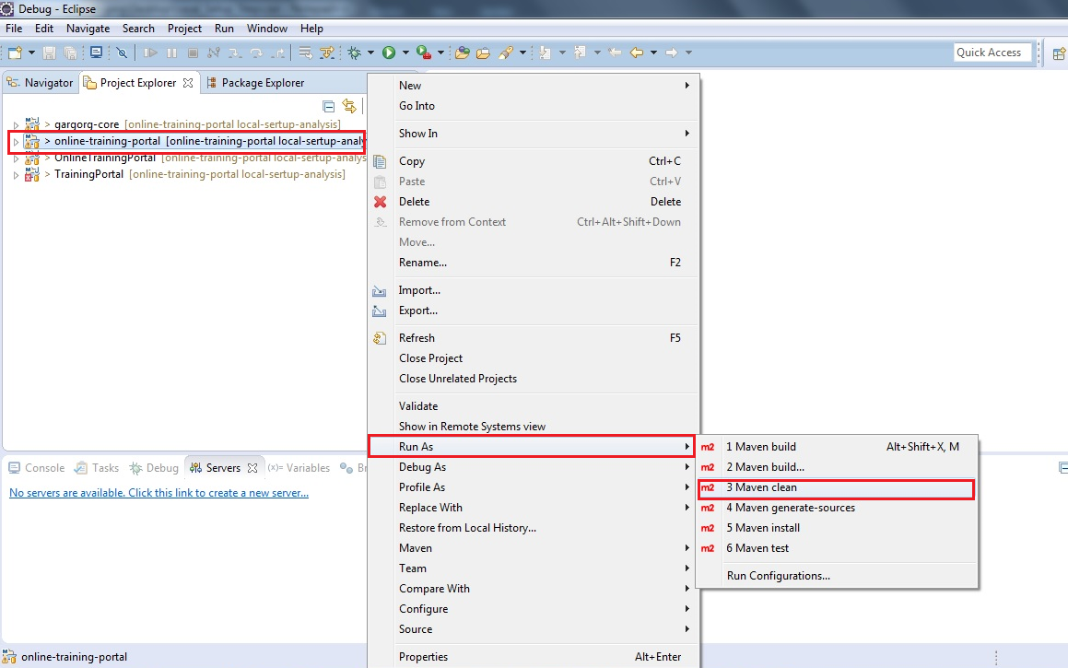

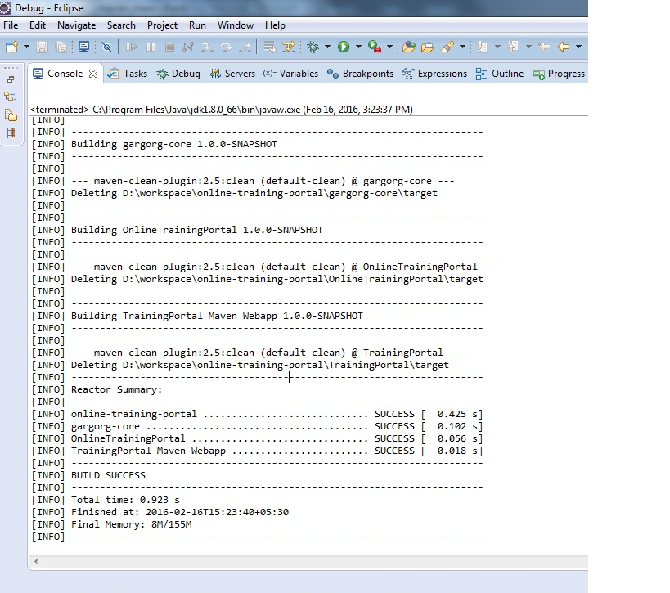

Above process will clean parent project (online-training-portal) and all its modules (gargorg-core , OnlineTrainingPortal , TrainingPortal)

- Execute goal "Maven install" on online-training-portal project. This step will build parent project (online-training-portal) and all its modules (gargorg-core , OnlineTrainingPortal , TrainingPortal).
After this step 2 jars will be created with name gargorg-core-1.0.0-SNAPSHOT.jar and OnlineTrainingPortal-1.0.0-SNAPSHOT.jar. OnlineTrainingPortal-1.0.0-SNAPSHOT.jar is depended on gargorg-core-1.0.0-SNAPSHOT.jar.
Along with this TrainingPortal.war will be created which will contain above mentioned jars.

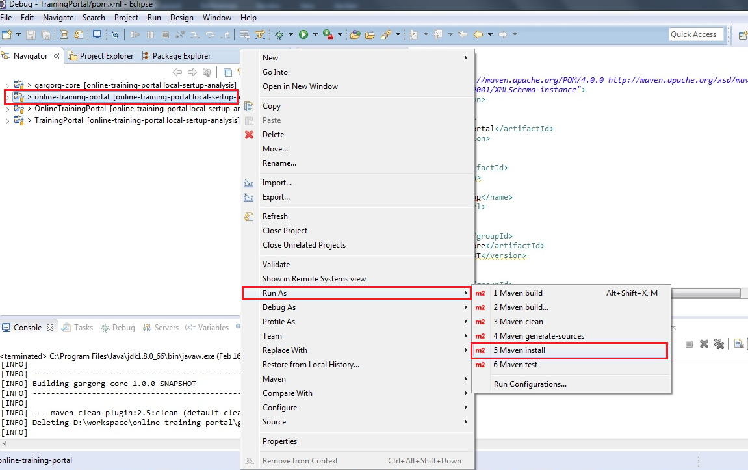

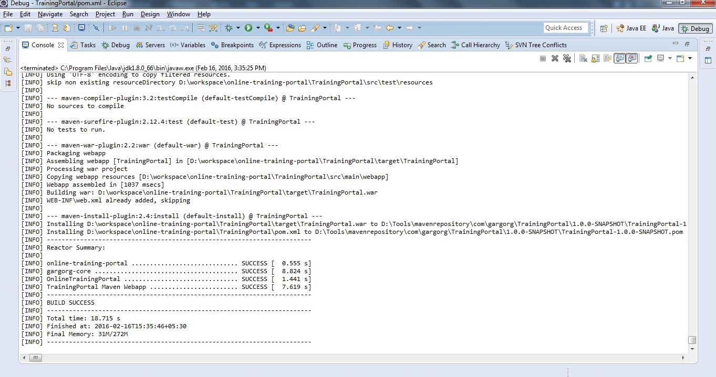

- Now we will have to set up the database. This project supports 2 type of database : oracle and mysql.
According to the database type which you are using execute below scripts in the database after creating proper user
- Framework_Complete_Schema_Oracle.sql for oracle and Framework_Complete_Schema_Mysql.sql for mysql database.
- Training_Portal_Schema_Oracle.sql for oracle and Training_Portal_Schema_Mysql.sql for mysql database

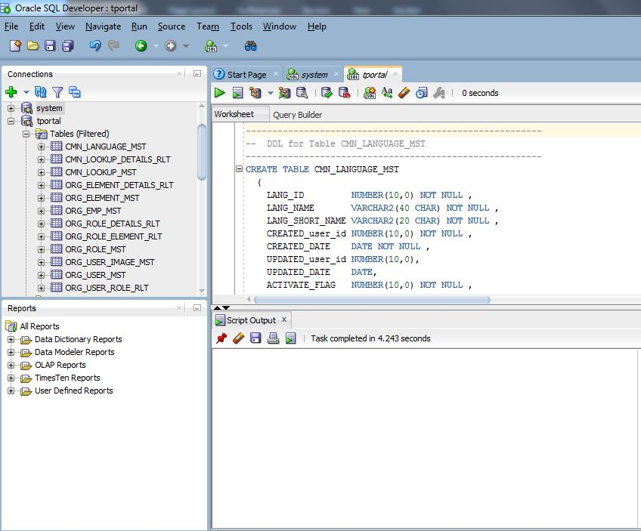

- Now add tomcat in eclipse to run TrainingPortal web project on server
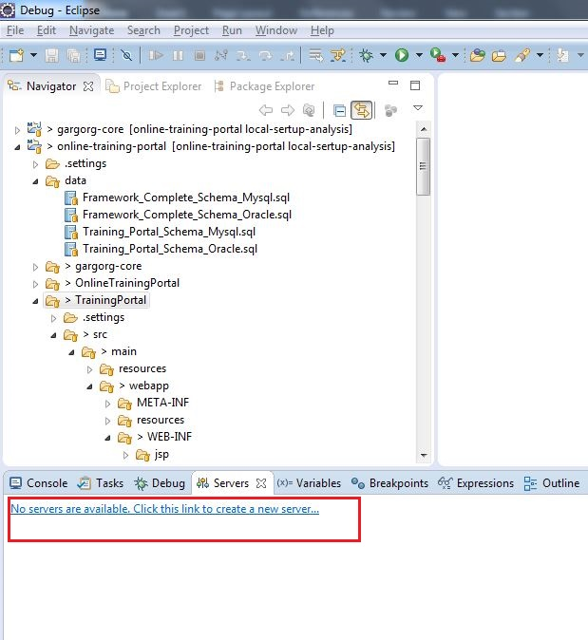

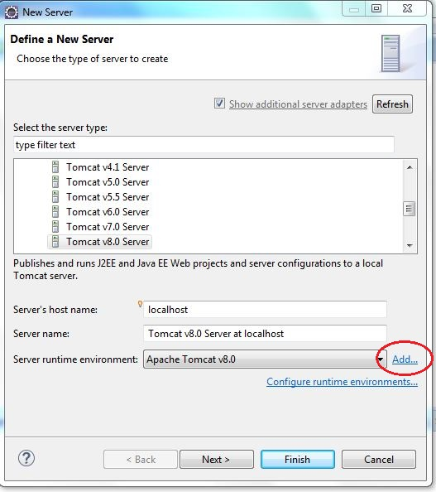
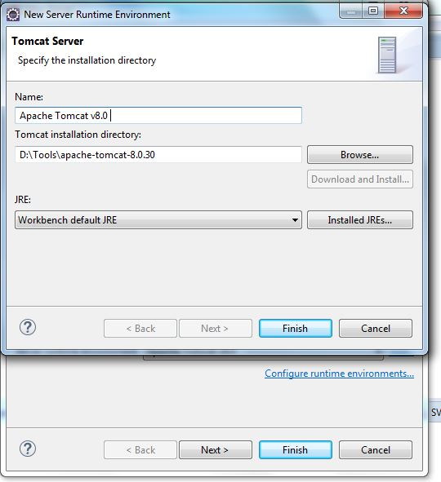
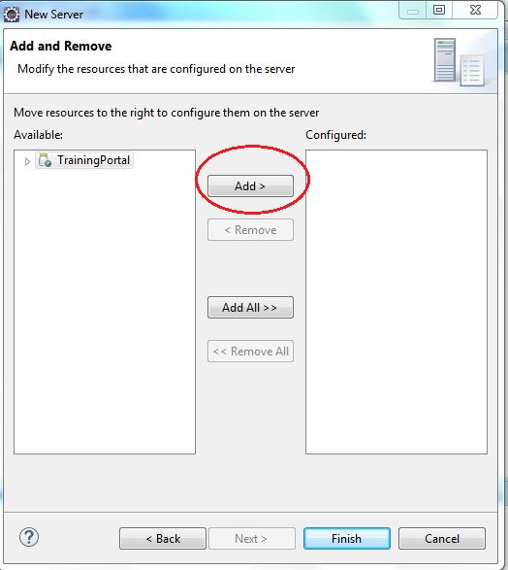
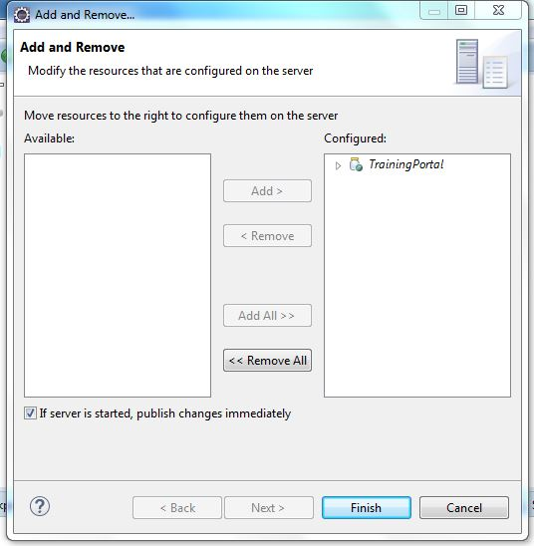
- Change jdbc.properties (/TrainingPortal/src/main/webapp/WEB-INF/jdbc.properties) according to database setup.
- Run ImageInsertionUtility (/gargorg-core/src/main/java/com/gargorg/common/Utils/ImageInsertionUtility.java). This utility will insert one dummy image in the database.
Follow instructions given on console to change the path properly.
- Now run the tomcat.
Note : In the whole setup source files will be replicated twice so you should change files inside module projects (e.g. TrainingPortal) . Changes will be automatically reflected to parent project .
Always build parent project (online-training-portal) and all modules will be build automatically.
DO NOT build module project individually. Keep this in mind.

