

INTERNSHIP REPORT
ON
TECHNOLOGY EDUCATION INTERNSHIP
Submitted to
SCHOOL OF COMPUTER SCIENCE AND ENGINEERING
IILM UNIVERSITY, GREATER NOIDA, U.P.
In partial fulfilment of the requirements for the degree of
BACHELOR OF TECHNOLOGY
(COMPUTER SCIENCE & ENGINEERING)
Submitted By
PIYUSH PODDAR
Roll No.: 25SCS1003002333 | Section: 2CSE14
Batch: 2025–2029
INTERNSHIP PERIOD
01 JULY 2026 – 31 JULY 2026
Nav Jyoti Children’s Academy
Sapaha Road, Kasia, Kushinagar
CBSE Affiliated

1. Candidate’s Declaration

I, Piyush Poddar, student of B.Tech (Computer Science & Engineering), IILM University, Greater Noida, hereby declare that this internship report titled “Technology Education Internship” is a record of the work, activities, observations, and learning acquired during my internship at Nav Jyoti Children’s Academy, Kasia, Kushinagar, from 01 July 2026 to 31 July 2026.
This report has been prepared for academic submission and reflects my internship experience in supporting technology-based learning for students of Classes 8 to 10. The report has been written for the purpose of documenting the practical exposure and professional learning gained during the internship.
Signature: ______________________________
Name: Piyush Poddar
Roll No.: 25SCS1003002333

2. Acknowledgement

I sincerely acknowledge the support and guidance received during my Technology Education Internship at Nav Jyoti Children’s Academy, Kasia, Kushinagar. The internship provided me with an opportunity to connect my academic background in Computer Science and Engineering with practical technology education in a school environment.
I am grateful to Mr. R.K. Singh, Principal, Nav Jyoti Children’s Academy, and the school staff for providing a supportive environment and the opportunity to work with students of Classes 8 to 10. Their cooperation helped me understand the importance of practical, accessible, and student-centred technology learning.
I also express my sincere appreciation to the School of Computer Science and Engineering, IILM University, Greater Noida, for its academic direction and encouragement. I am thankful to my family and everyone who supported me throughout the internship and the preparation of this report.
Signature: ______________________________
Piyush Poddar

Table of Contents

No. | Section | Page
1 | Candidate’s Declaration | 2
2 | Acknowledgement | 3
3 | Internship Completion Certificate | 5
4 | Project / Work Description | 6
4.1 | Introduction | 6
4.2 | Organization Profile | 6
4.3 | Role and Responsibilities | 6
4.4 | Objectives | 6-7
4.5 | Scope of the Internship | 7
4.6 | Tools and Platforms Used | 7
4.7 | Work Done / Methodology | 7-8
4.8 | Learning Outcomes | 8
4.9 | Activities | 8
5 | Conclusion | 9
6 | Bibliography / References | 9

3. Internship Completion Certificate

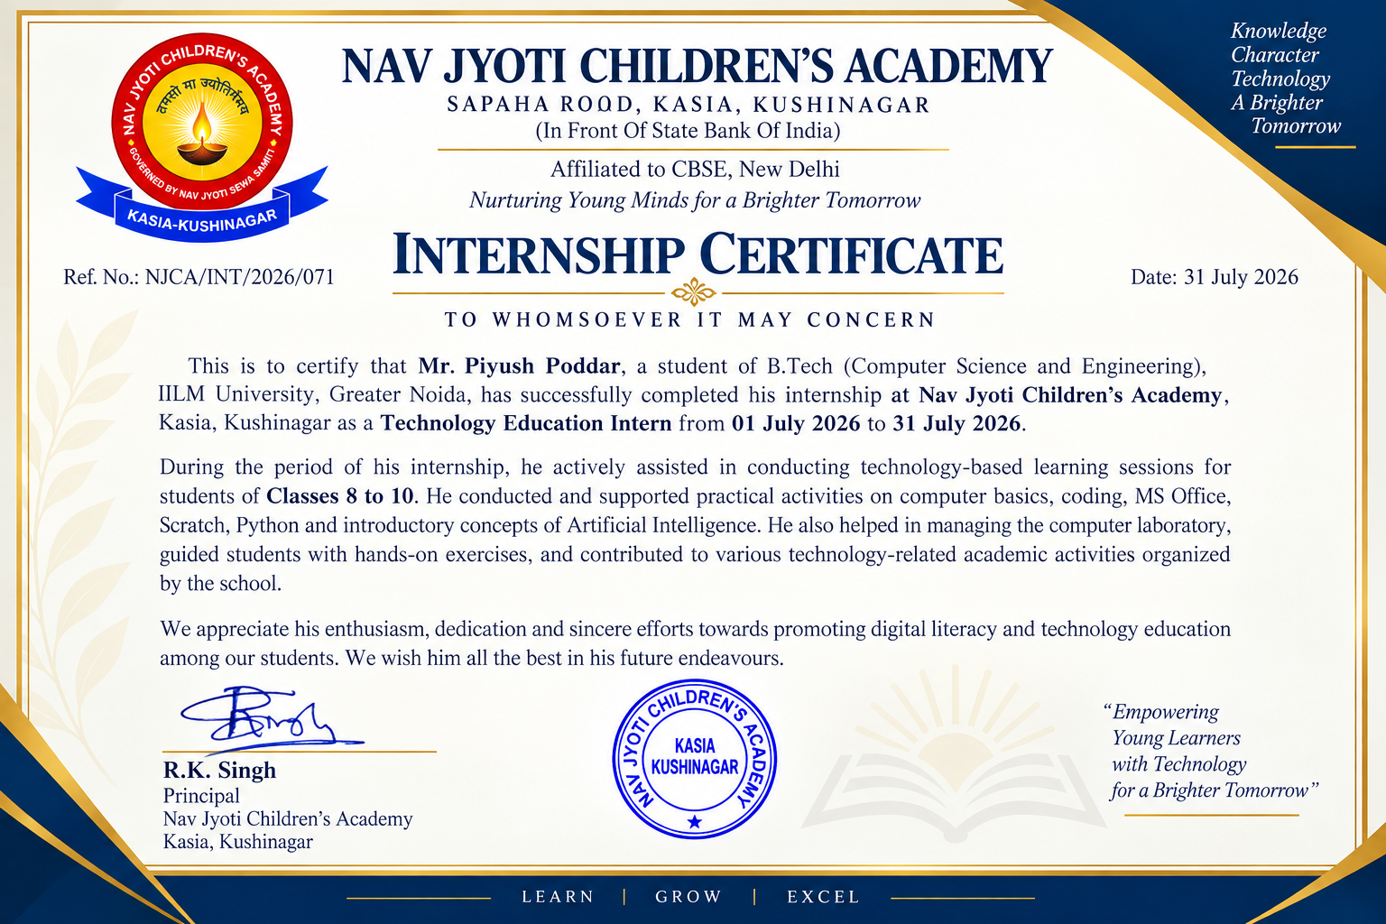

4. Project / Work Description

4.1 Introduction
The Technology Education Internship was undertaken at Nav Jyoti Children’s Academy, a CBSE-affiliated school located at Sapaha Road, Kasia, Kushinagar, in front of the State Bank of India. The internship was completed from 01 July 2026 to 31 July 2026 as part of the B.Tech (Computer Science & Engineering) programme at IILM University, Greater Noida.
As a Technology Education Intern, I supported technology-based learning for students of Classes 8 to 10. The internship involved explaining computer fundamentals, assisting with coding and practical exercises, supporting MS Office learning, introducing Scratch and Python at a foundational level, and discussing introductory Artificial Intelligence concepts. Practical computer-laboratory activities formed an important part of the experience.
Internship focus: Connecting computer science knowledge with clear explanations, demonstrations, practical activities, and student guidance.

4.2 Organization Profile
Nav Jyoti Children’s Academy is a CBSE-affiliated school situated at Sapaha Road, Kasia, Kushinagar, in front of the State Bank of India. The school provides an academic environment in which students develop subject knowledge alongside practical skills.
Technology education at the school provides students with opportunities to build foundational computer knowledge and engage with digital tools. The internship contributed to this learning environment through computer-laboratory activities, coding practice, digital productivity exercises, and introductory exposure to emerging technology concepts.

4.3 Role and Responsibilities
- Supported computer science and technology learning for students of Classes 8 to 10.
- Explained computer fundamentals and digital concepts using simple, student-friendly examples.
- Assisted students during practical activities in the computer laboratory.
- Guided students through beginner-level coding and programming logic using Scratch and Python.
- Supported practical learning activities involving MS Office applications.
- Introduced students to basic, age-appropriate concepts related to Artificial Intelligence.
- Demonstrated technology activities before students performed guided hands-on exercises.
- Answered student questions and provided individual assistance during practical work.
- Supported teachers in organizing and conducting technology-related learning activities.

4.4 Objectives
- To gain practical exposure to technology education within a school environment.
- To strengthen the ability to communicate computer science concepts in a clear and accessible manner.
- To provide students with practical exposure to computer fundamentals and digital tools.
- To develop familiarity with beginner-level programming activities using Scratch and Python.
- To support practical learning through computer laboratory activities and guided exercises.
- To introduce students to basic concepts of Artificial Intelligence in an age-appropriate manner.
- To develop mentoring, classroom coordination, presentation, and problem-solving skills.
- To understand how activity-based technology education can improve student engagement and practical learning.

4.5 Scope of the Internship
The scope of the internship covered technology education and practical computer learning for students of Classes 8 to 10. It combined basic technical instruction with hands-on laboratory activities and student support.
- Technology education: supporting students in understanding and applying computer-related concepts.
- Computer laboratory support: assisting students during practical sessions and helping them follow activity instructions.
- Programming fundamentals: introducing logical thinking and basic coding through Scratch and Python.
- Digital learning: supporting the use of MS Office and common digital resources for educational activities.
- Student mentoring: responding to questions, providing guidance, and encouraging students during practical work.

4.6 Tools and Platforms Used

Tool / Technology | Area | Purpose
Computer Systems / Lab | Practical Learning | Hands-on computer activities and student guidance
MS Office | Digital Productivity | Practical exercises with common office applications
Scratch | Block-Based Coding | Introducing programming logic through visual coding
Python | Programming | Beginner-level programming concepts and exercises
Artificial Intelligence Concepts | Emerging Technology | Introductory, age-appropriate AI awareness
Internet / Digital Resources | Digital Learning | Supporting explanations and technology-based learning

4.7 Work Done / Methodology
The internship followed a practical and student-centred learning approach. Activities were structured so that students could first understand a concept, observe a demonstration, and then attempt the activity with guidance. This approach helped connect theoretical explanations with practical computer use.
1. Planning: Selected and organized topics and activities appropriate for students of Classes 8 to 10.
2. Topic Introduction: Introduced the purpose and basic terminology of the topic before practical work.
3. Explanation: Explained concepts using simple language, examples, and step-by-step instructions.
4. Demonstration: Demonstrated computer operations, coding activities, or application features before practice.
5. Hands-on Activity: Students performed guided exercises in the computer laboratory.
6. Student Guidance: Provided support to students who required clarification or assistance.
7. Practice: Encouraged students to repeat activities and apply the concepts independently.
8. Feedback: Observed common difficulties and clarified concepts during or after activities.
Overall workflow: Planning → Topic Introduction → Explanation → Demonstration → Hands-on Activity → Student Guidance → Practice → Feedback

4.8 Learning Outcomes

Technical Skills
- Improved understanding of how computer fundamentals can be explained through practical examples.
- Strengthened familiarity with beginner-level programming concepts and coding logic.
- Developed greater confidence in guiding Scratch-based activities.
- Improved understanding of basic Python exercises and programming fundamentals.
- Enhanced practical familiarity with MS Office as a digital productivity tool.
- Gained experience in introducing basic Artificial Intelligence concepts to school students.
- Developed a clearer understanding of digital literacy and responsible technology use.

Professional Skills
- Improved verbal communication and the ability to explain technical concepts clearly.
- Developed student mentoring and one-to-one guidance skills.
- Improved presentation and demonstration skills through practical sessions.
- Strengthened time management and classroom coordination.
- Developed patience and adaptability while working with students with different learning needs.
- Improved problem-solving skills through practical troubleshooting and student support.

4.9 Activities
• Computer Basics
• MS Office Practical Activities
• Scratch Programming
• Python Basics
• Introduction to Artificial Intelligence
• Computer Lab & Hands-on Activities
• Student Guidance & Doubt Solving

5. Conclusion
The Technology Education Internship at Nav Jyoti Children’s Academy provided valuable practical exposure to the role of technology in school education. Working with students of Classes 8 to 10 created an opportunity to connect concepts from Computer Science and Engineering with practical, student-centred learning.
The internship covered computer fundamentals, coding, MS Office, Scratch, Python, and introductory Artificial Intelligence concepts. Practical laboratory activities helped strengthen technical understanding, while student guidance improved communication, mentoring, presentation, patience, and problem-solving skills.
Overall, the internship was a meaningful academic experience that demonstrated how technology can be introduced through simple explanations, demonstrations, and hands-on activities. It strengthened my confidence in communicating technical ideas and provided useful professional exposure that complements my B.Tech Computer Science and Engineering studies.

6. Bibliography / References
- Nav Jyoti Children’s Academy — School-provided information and internship activities.
- IILM University, Greater Noida — Academic programme information.
- Microsoft Office — Official learning resources.
- Scratch — Official learning and programming resources.
- Python — Official documentation and learning resources.

