|  |
| --- |
| Space Craft Games |
| Assignment 2 |
| **SpaceCraft** |
| Version #1  All work Copyright © 2012 by SpaceCraft Games.  All rights reserved. |
| **Piyush Sehli** |
| **300984528** |

|  |
| --- |
| July 30, 2018 |

**Table of Contents**

Contents

Version History 3

Game Description: 4

I. Game Overview 4

II. Game Play Mechanics 4

III. Screens 4

IV. Controls 6

V. Interface Sketch 7

VI. Menu and Screen Descriptions 7

VII. Game World 7

VIII. Levels 8

IX. Characters 10

X. Non-player Characters 11

XI. Enemies 11

XII. Weapons 11

XIII. Abilities 11

XIV. Scoring 11

XV. Sound Index 12

XVI. Art / Multimedia Index 12

XVII. Future Features 12

# Version History

**Github Repository:** [**https://github.com/piyushsehli/piyushsehli.github.io/**](https://github.com/piyushsehli/piyushsehli.github.io/)

**Github Page: https://piyushsehli.github.io/**

Third Commit: Adding sounds

@piyushsehli

piyushsehli committed 19 hours ago

Second Commit: Adding an enemy ship

@piyushsehli

piyushsehli committed 19 hours ago

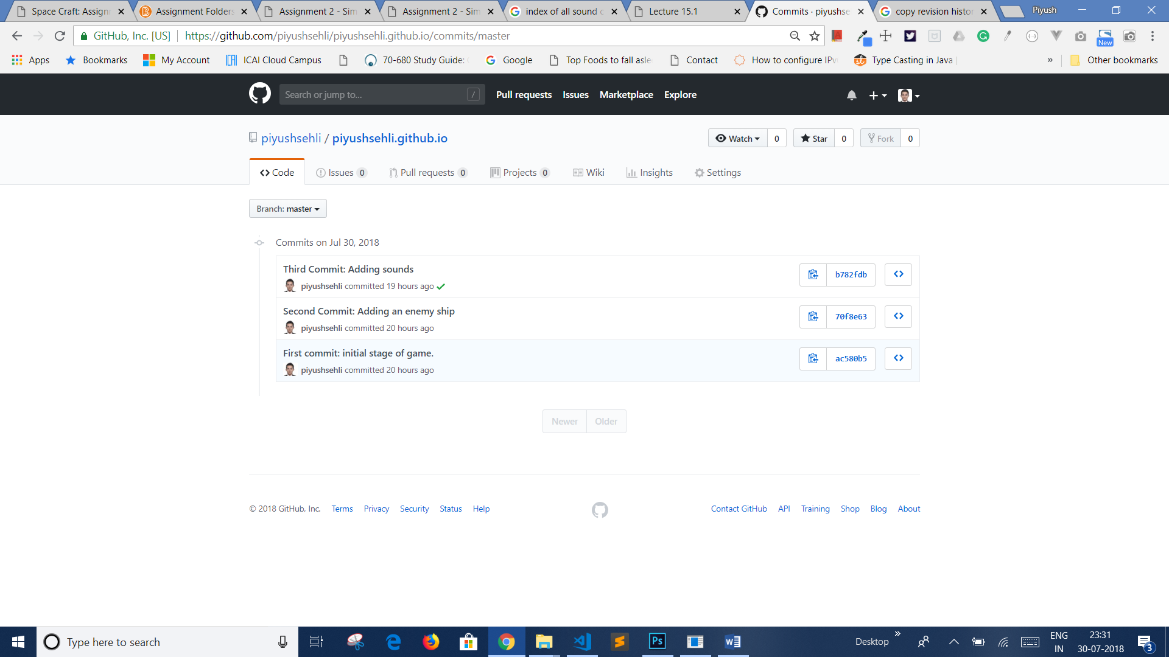 First commit: initial stage of game.

# Game Description:

## Game Overview

*(ensure you mention the goal of the game and how to win if applicable)*

The goal of the game is to destroy the space ships of all the enemies by simply clicking the mouse. To maintain their life scores, star ship must avoid collision with the meteors and enemy ships. To gain score, the ship must hover over the circular ship.

## Game Play Mechanics

This game consists of star ship which is controlled by mouse in order to move the player’s ship. Each enemy and meteor might collide with the player’s ship to destroy it which will also reduce life count of player’s ship by 1. Each round shaped ship carries scores so hovering over it will increase the scores by 100.

## Screens

*(Point of View)*

**Start Screen**

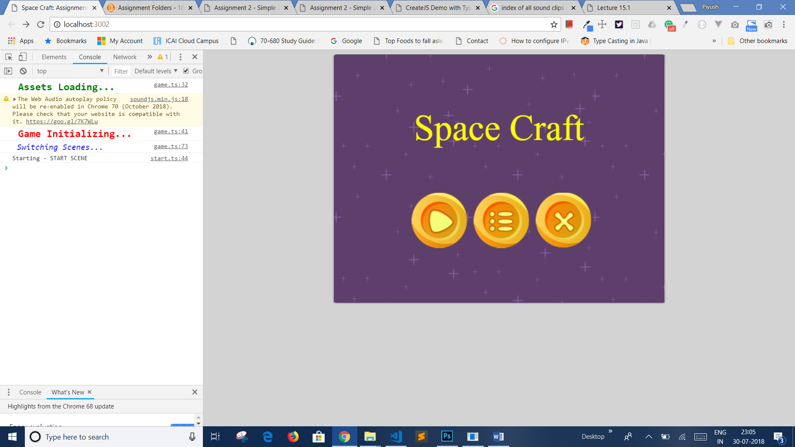

**Play Screen**

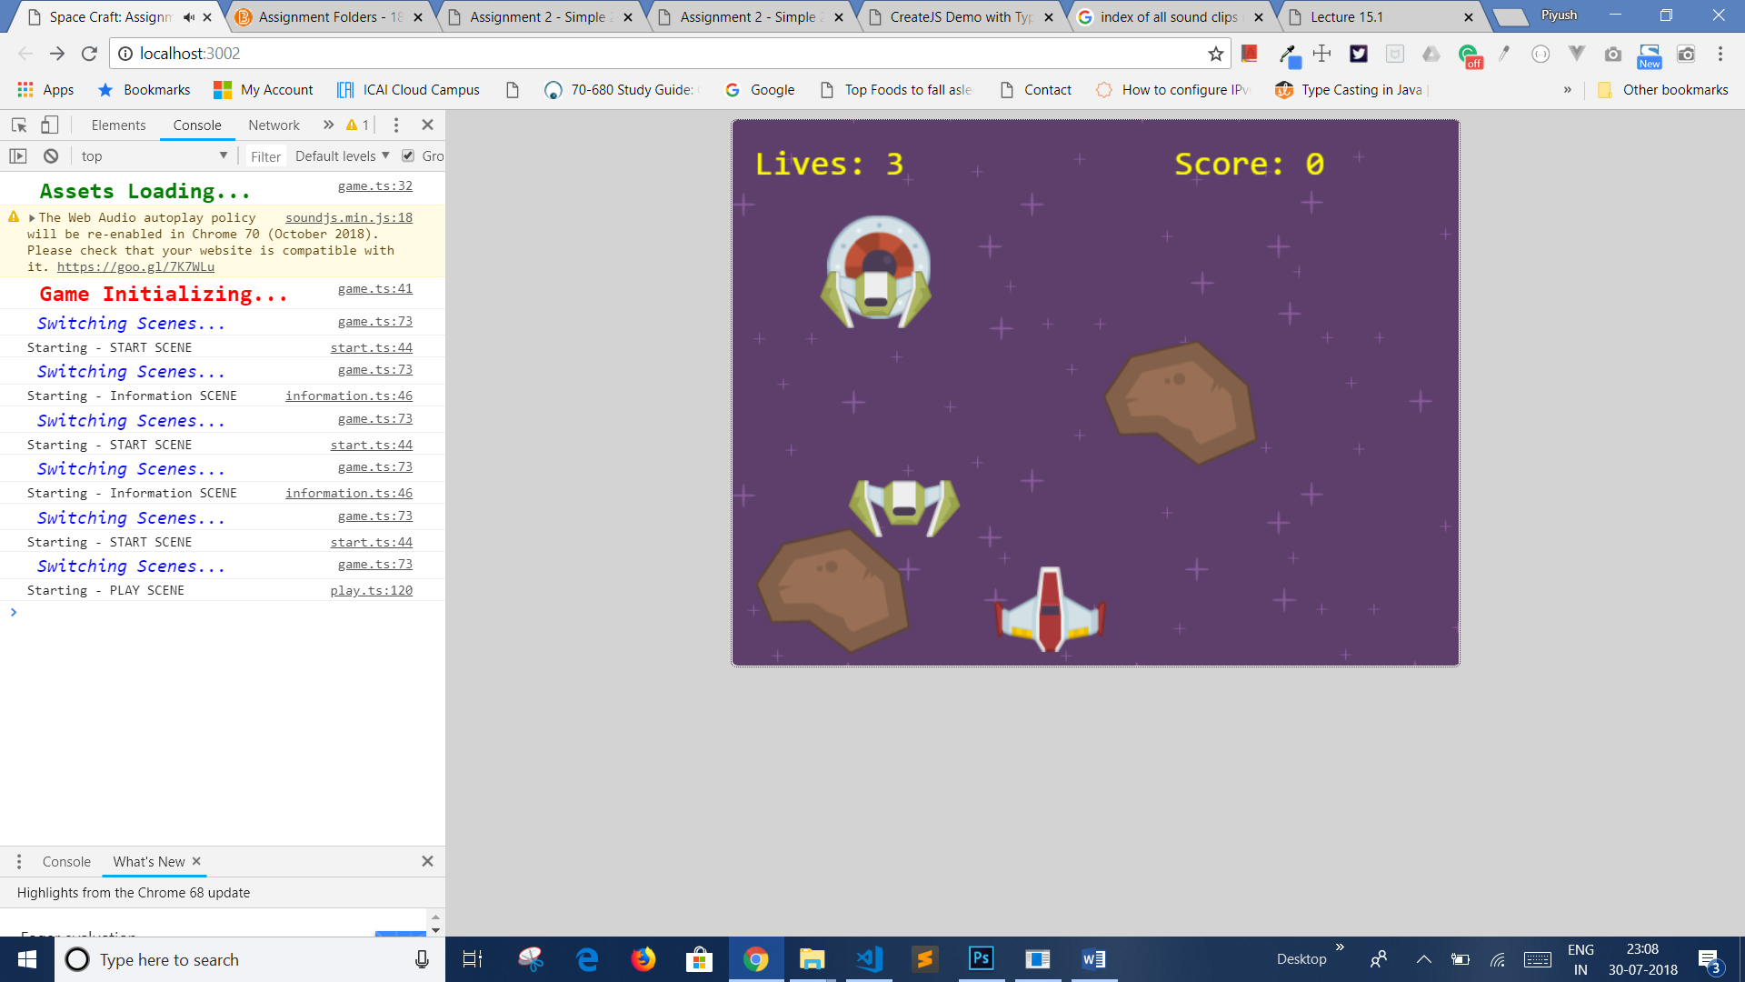

**Information Screen**

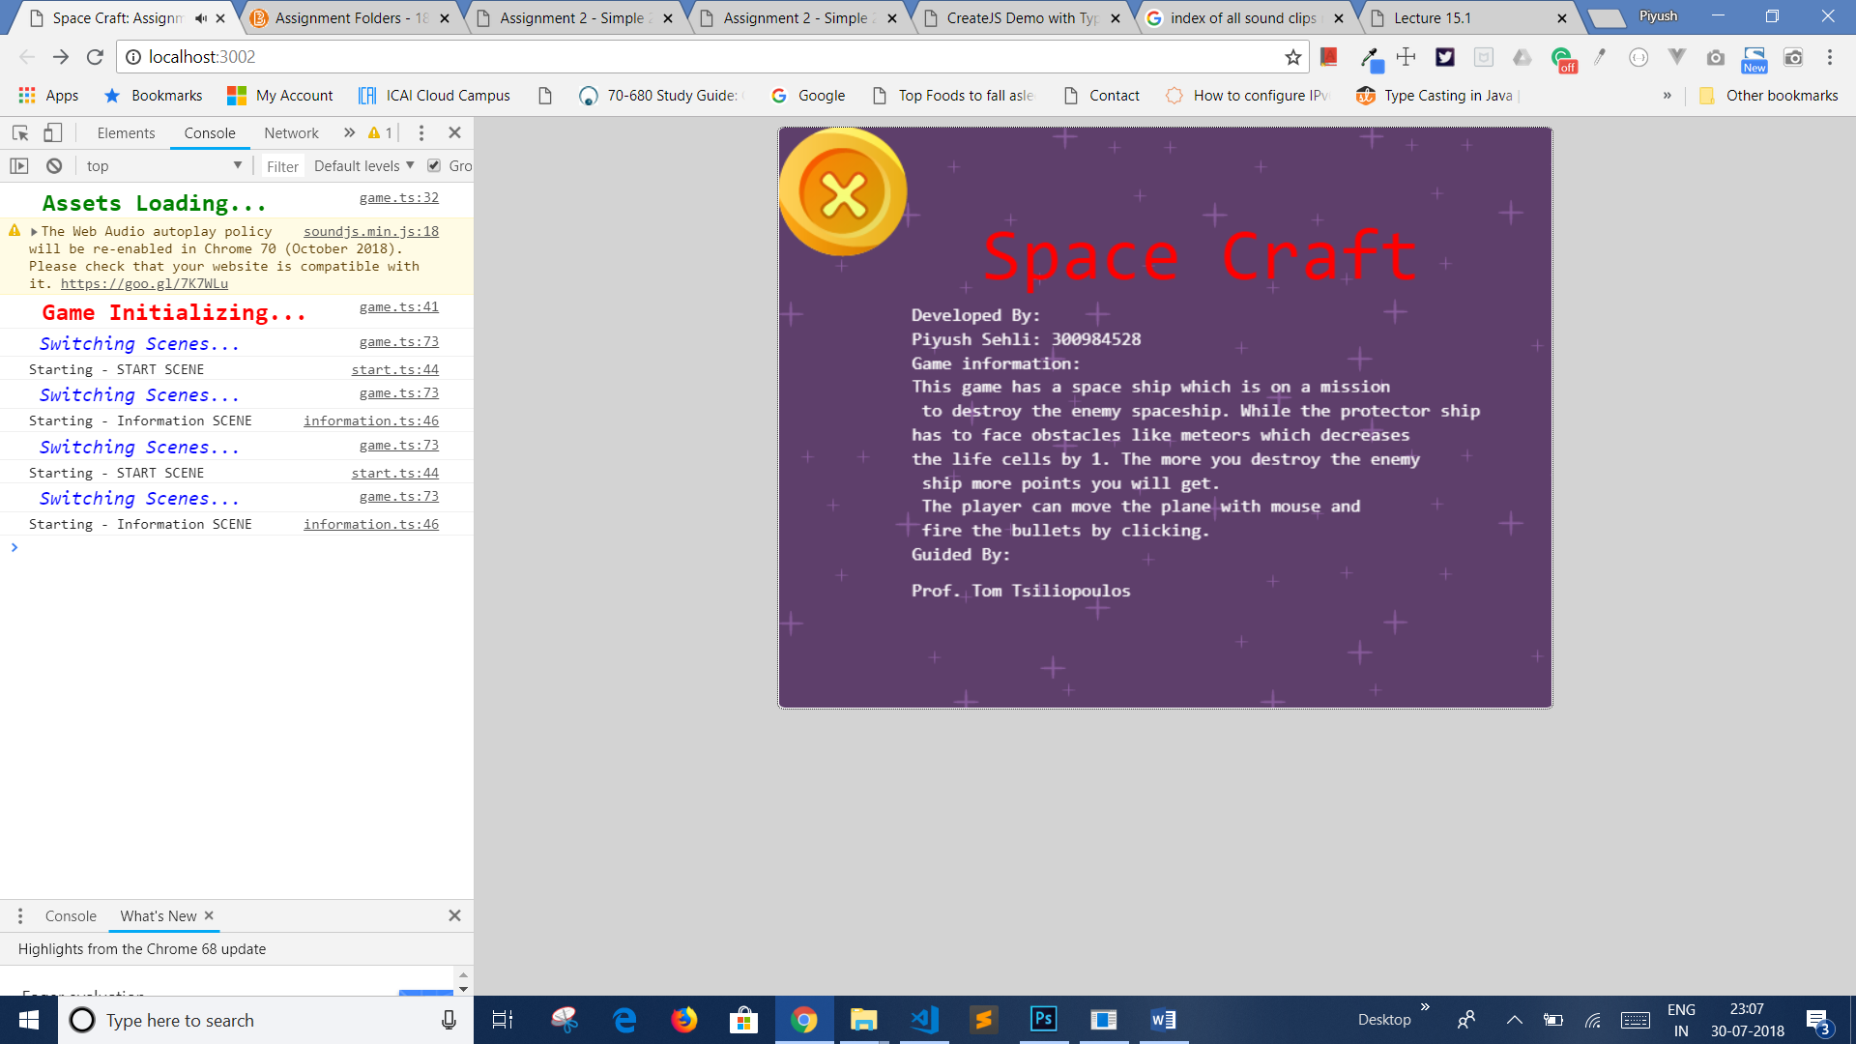

**End Screen**

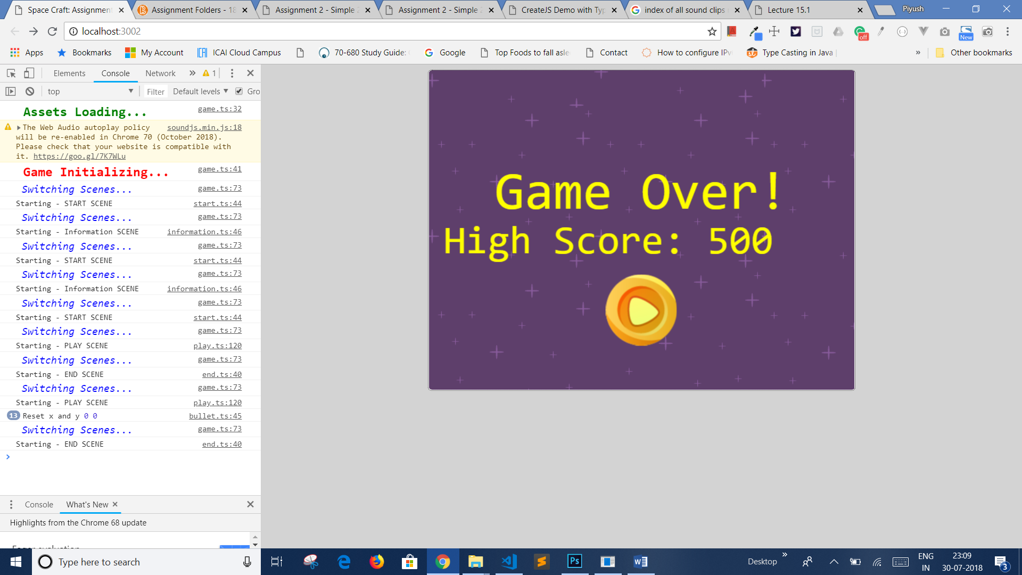

## Controls

*(Which keys does your game use? Does it use the mouse or a joystick?)*

This game uses mouse for moving the player’s ship horizontally. Moreover, it uses mouse click to shoot the enemy’s ship.

## Interface Sketch

*(What does the game interface look like? Provide a screen shot or sketch)*

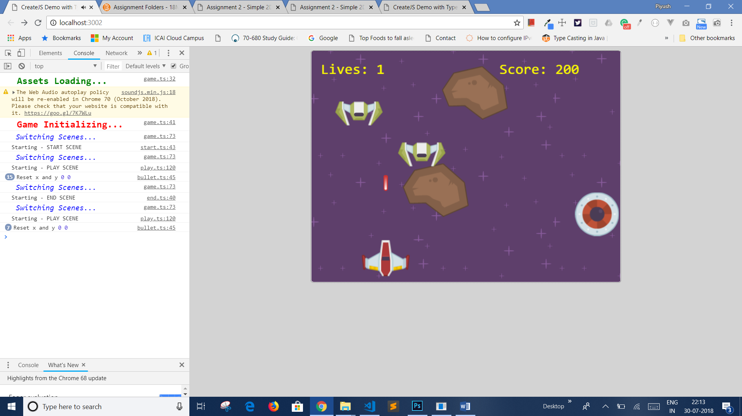

## Menu and Screen Descriptions

*(Include additional screen shots and accompanying descriptions for any menus and additional screen)*

***Play:*** *Click this button to play the game.*

***Information:*** *Click this button to see the information related to game.*

***Exit:*** *To exit the game.*

***Resume:*** *To resume the game at end screen.*

## Game World

*(Describe Your Game Environment)*

The game has four scenes in total such as Start Scene, Play Scene, Information Scene and End Scene.

* **Start Scene:** This scene contains three menu options: Play, Information and Exit. The play option will exchange the scene to play scene in order to progress the game. Whereas the information option will open an information screen to provide the details about the game.
* **Play Scene:** This scene will let the user to play the real game with different mechanics and controls. This scene contains characters like player’s ship, enemy’s ship, meteor, bullets and UFO. Player’s ship is privileged with powers like shooting a bullet to destroy enemy’s ship. Moreover, player’s ship gains points by hovering over round UFO. However, meteor and enemy ship collision with player’s ship can deduct the life chances of player.
* **End Scene:** The end scene shows the scores as well as option to restart the game again.
* **Information Scene:** This scene contains details regarding the game like developer’s name and description about the game.

**That is all about the game environment of Space Craft.**

## Levels

*(Describe Each of your game levels)*

**Easy:** Initially, the game is easy with few hurdles.

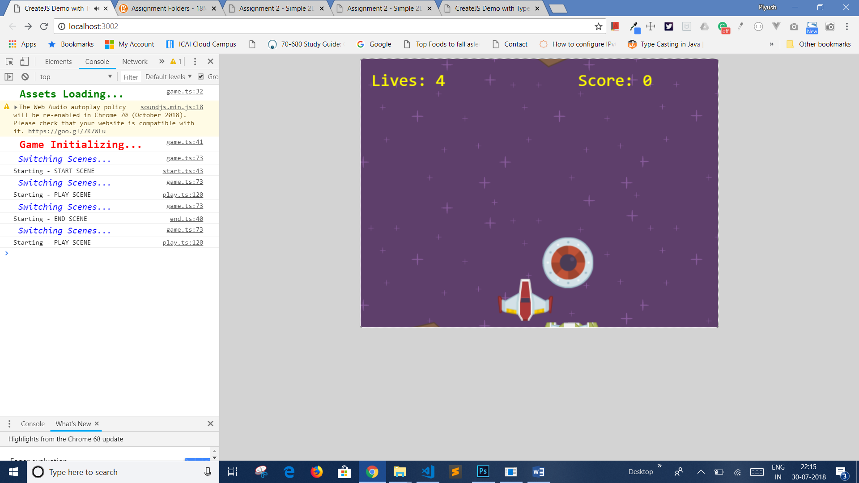

**Medium:** Under this level, there are meteor and enemy’s ships attacking player’s ship.

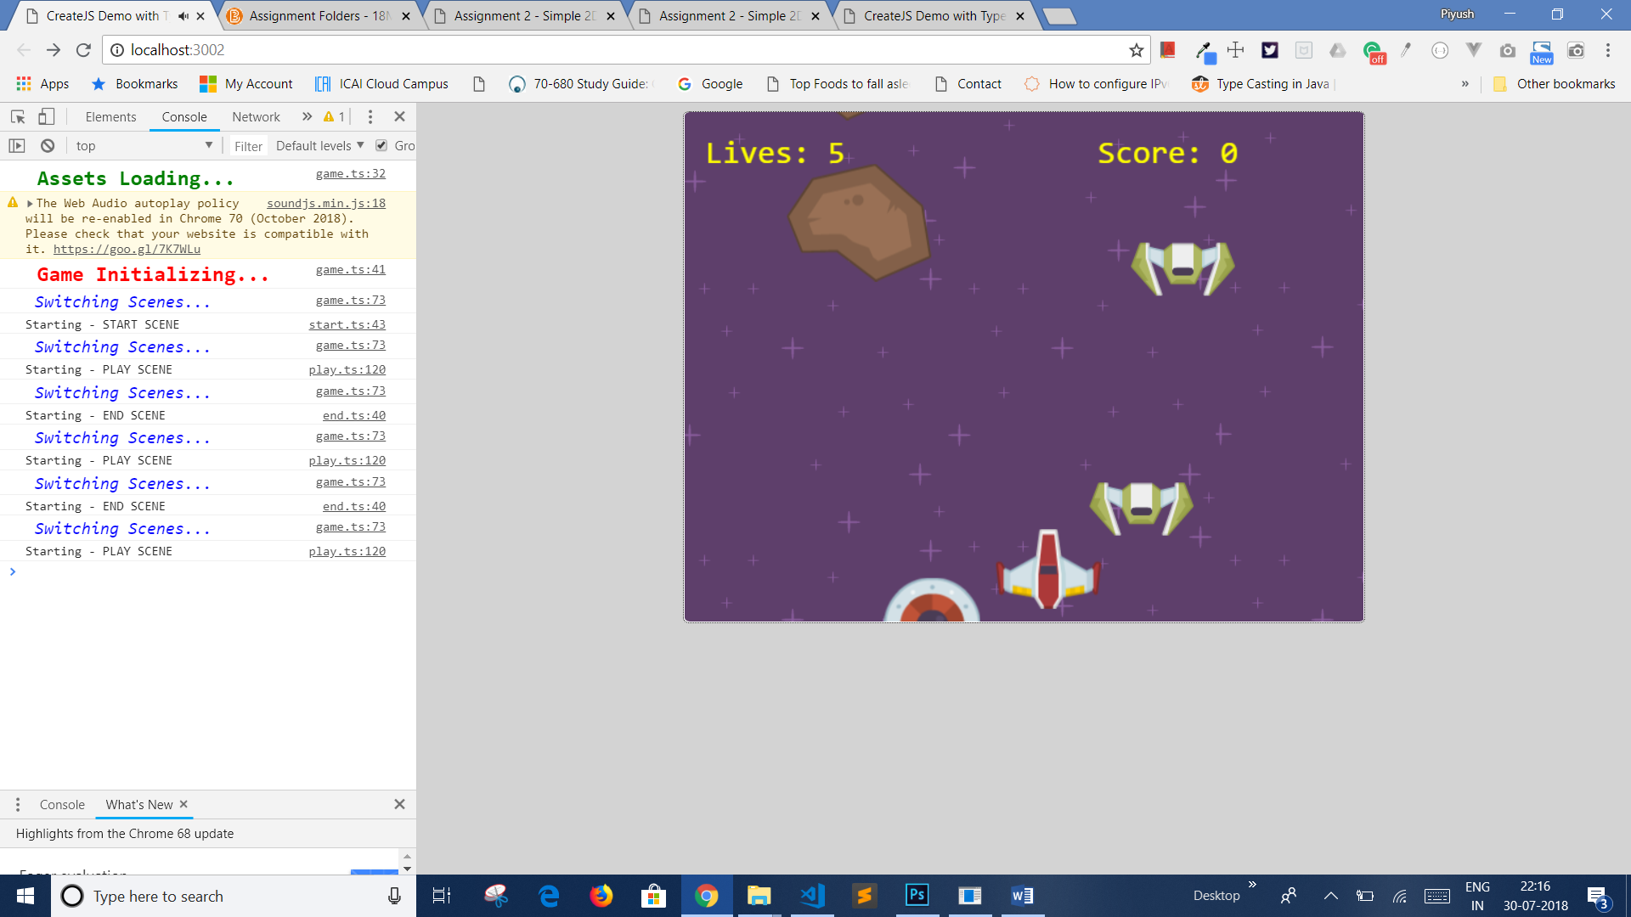

**Difficult:** The meteor and enemy’s ship will get double in number and player’s ship needs to move and shoot the enemy’s ships fast in order to survive in the game.

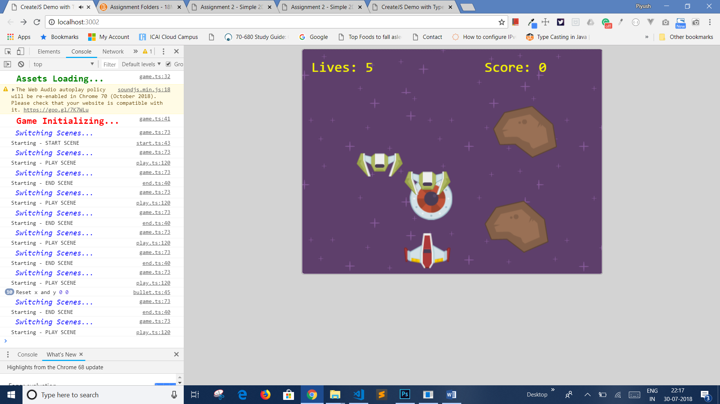

## Characters

***Player’s ship***

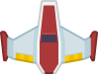

***Enemy’s Ship***

**

***Friendly UFO***

**

***Meteor***

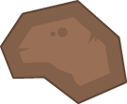

**Bullet**

**

## Non-player Characters

(Describe Any Computer controlled Allies and how they work)

There is only one allies character which are not controlled by user:

UFO: The player’s ship scores 100 points by only hovering over the UFO character.

## Enemies

*(Describe computer-generated enemies and boss monsters)*

**There are two main enemies of player’s ship:**

Enemy’s ships: Collision with this ship will result in losing the life count by 1. Where as, the user can prevent collision by shooting the bullet towards enemy’s ship.

Meteors: Meteor can result in losing 1 life chance in case of collision with player’s ship.

## Weapons

*(Describe any weapons available to the user)*

Bullets: The player’s ship can fire bullets which is linked to mouse click event. This weapon helps user to shoot the enemy’s ships.

## Abilities

The player’s ship has the ability of shooting bullets to destroy the enemy’s ship.

## Scoring

Score: 100 points for each shooting an enemy’s ship

Life: 1 life point deduction on each collision with enemy and meteor.

## Sound Index

*(Include an index of all your sound clips)*

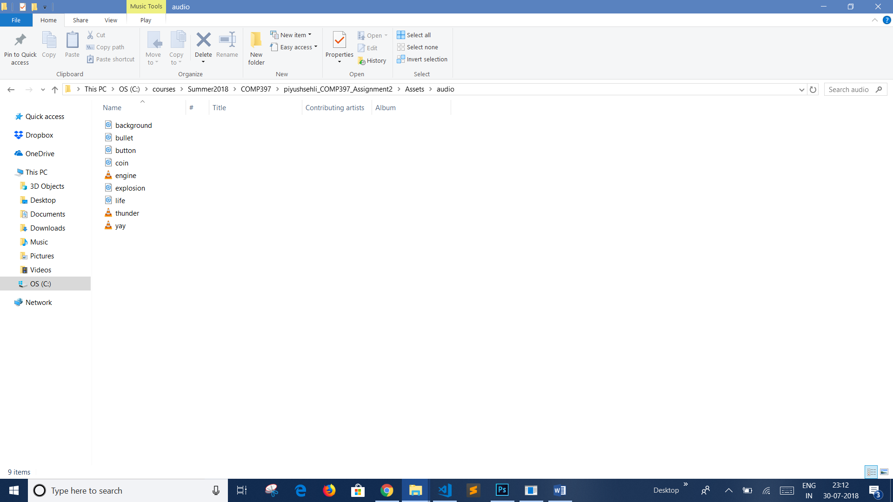

## Art / Multimedia Index

*(Include an index of all your graphic and video assets here)*

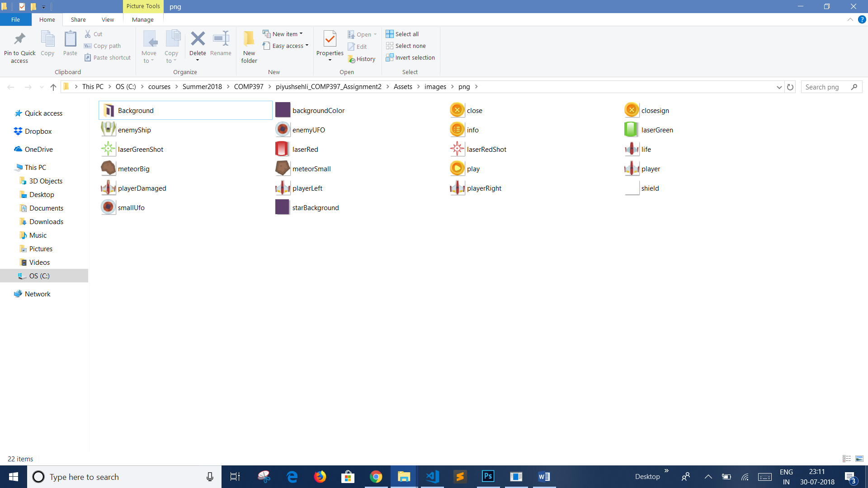

## Future Features

*(Include any future features that are planned to be implemented)*

*It might contain a boss in the end of each level.*