AICTE | IBM SkillsBuild
Data Analytics with AI Internship 2026

PROJECT REPORT
FlightPath to Loyalty:
Predictive Modeling and Driver Analysis of Airline Passenger Satisfaction
Airline Passenger Satisfaction Survey | 129,880 records | 24 attributes

Submitted by
Piyush
Internship Program
AICTE | IBM SkillsBuild Data Analytics with AI Internship 2026
Tools: Python • pandas • scikit-learn • matplotlib • seaborn • Streamlit

Table of Contents

Abstract / Executive Summary
Passenger satisfaction is closely tied to an airline’s repeat bookings and retention, yet operational measures such as punctuality alone do not explain why passengers move from dissatisfaction to loyalty. This project analyses 129,880 airline passenger survey records (24 attributes) to identify the touchpoints, passenger segments and operational conditions most strongly associated with satisfaction, and to build a classifier that predicts whether a passenger is Satisfied or Neutral/Dissatisfied.
The data was audited, cleaned and processed in a leakage-free scikit-learn pipeline (median imputation of 393 missing Arrival Delay values, one-hot encoding of four categorical variables, standard scaling of numeric variables). An 80/20 stratified split produced 103,904 training and 25,976 test observations. A Logistic Regression baseline and a Random Forest classifier (100 trees, maximum depth 16) were benchmarked.

Key results
- Class balance: 43.45% Satisfied (56,428) versus 56.55% Neutral/Dissatisfied (73,452).
- Model performance (test set): Random Forest reached 96.09% accuracy, 96.61% precision, 94.30% recall, 95.44% F1-score and 0.9934 ROC-AUC, against 87.71%, 87.16%, 84.11%, 85.61% and 0.9295 for Logistic Regression.
- Top drivers (Random Forest importance): Online Boarding (18.11%), In-flight Wifi Service (14.60%), Type of Travel – Personal (12.91%), Class – Economy (7.61%), In-flight Entertainment (6.49%) and Seat Comfort (4.89%).
- Rating thresholds: satisfaction with Online Boarding is 11.45%–13.78% at ratings 1–3 but 62.30% at rating 4 and 87.06% at rating 5; for In-flight Wifi it is 24.72%–32.82% at ratings 1–3, 60.08% at rating 4 and 99.02% at rating 5.
- Segment gaps: 69.44% of Business-class passengers are satisfied versus 18.77% in Economy. Returning Business travellers are the most satisfied segment (70.62%) and returning Personal travellers the least (10.10%).
- Delays: the share of dissatisfied passengers rises from 54.06% on on-time departures to 64.15% for delays of 61–180 minutes and then plateaus (64.11% above 180 minutes).
Based on these findings the report recommends modernising digital boarding, improving in-flight connectivity, improving Economy-cabin comfort, and adopting an automated service-recovery rule driven by predicted dissatisfaction risk. All findings are statistical associations from observational survey data and should be validated (for example through A/B testing) before large-scale rollout.
Keywords: airline passenger satisfaction, customer experience, classification, Random Forest, Logistic Regression, feature importance, driver analysis.

1. Problem Statement & Objectives

1.1 Problem Statement
Airline profitability and passenger retention depend on the end-to-end travel experience. Airlines routinely track punctuality and operational statistics, but understanding which combination of passenger characteristics, service touchpoints and delays tips a passenger from dissatisfaction to satisfaction requires empirical analysis. The project addresses two questions:
- Diagnostic analytics: Which passenger demographics, travel classes, journey touchpoints (for example online boarding, in-flight Wifi, seat comfort, leg room) and flight delays are most strongly associated with passenger dissatisfaction?
- Predictive modelling: Can a robust binary classifier determine whether a passenger is Satisfied (y = 1) or Neutral/Dissatisfied (y = 0), so that airlines can intervene proactively before silent churn occurs?

1.2 Objectives
- Perform a data-quality audit and cleaning, including missing values, duplicates and the “0 = not applicable” rating convention, using a pipeline that avoids data leakage.
- Carry out exploratory data analysis (EDA) relating demographics, travel class, touchpoint ratings, delays and satisfaction.
- Train and evaluate Logistic Regression and Random Forest classifiers on an 80/20 stratified split.
- Quantify feature importance to identify and rank the drivers of satisfaction.
- Translate findings into prescriptive business recommendations, and deliver the work as a reproducible notebook, saved models and an interactive Streamlit dashboard.

1.3 Project Deliverables
The project folder contains the executed Jupyter notebook (Piyush_FlightPath_to_Loyalty.ipynb), the raw dataset and data dictionary, nine figures, two serialised model pipelines (Random Forest and Logistic Regression, .joblib), a README, a requirements file and a Streamlit application (app.py). The dashboard has six modules: Executive KPI Dashboard, Exploratory Data Analysis, Machine Learning Diagnostics, Feature Driver Analysis, Real-Time Risk Simulator and Prescriptive Business Roadmap.

2. Dataset Description
The analysis uses the Airline Passenger Satisfaction survey dataset (Kaggle: teejmahal20/airline-passenger-satisfaction), stored as airline_passenger_satisfaction.csv. It contains 129,880 observations and 24 columns, with no exact duplicate rows and 129,880 unique passenger IDs (one per row). The column definitions are provided in data_dictionary.csv.
Table 1: Attribute groups in the dataset
Category | Variables
Identifier | ID (surrogate key; excluded from predictors)
Demographic & flight profile | Gender, Age, Customer Type (First-time / Returning), Type of Travel (Business / Personal), Class (Business / Economy / Economy Plus), Flight Distance
Operational metrics | Departure Delay (minutes), Arrival Delay (minutes)
Service ratings (14) | Departure and Arrival Time Convenience, Ease of Online Booking, Check-in Service, Online Boarding, Gate Location, On-board Service, Seat Comfort, Leg Room Service, Cleanliness, Food and Drink, In-flight Service, In-flight Wifi Service, In-flight Entertainment, Baggage Handling
Target | Satisfaction (Satisfied / Neutral or Dissatisfied)

The 14 service ratings use a 1 (lowest) to 5 (highest) scale, where 0 means “not applicable” according to the data dictionary.

2.1 Target Variable
Satisfaction is binary: Satisfied (56,428 passengers; 43.45%) and Neutral or Dissatisfied (73,452 passengers; 56.55%). The classes are moderately imbalanced, so a stratified split was used to preserve this ratio in both training and test data.

2.2 Sample Composition and Numeric Summary
Table 2: Composition of the passenger sample
Variable | Category | Passengers | Share
Class | Business | 62,160 | 47.9%
 | Economy | 58,309 | 44.9%
 | Economy Plus | 9,411 | 7.2%
Type of Travel | Business | 89,693 | 69.1%
 | Personal | 40,187 | 30.9%
Customer Type | Returning | 106,100 | 81.7%
 | First-time | 23,780 | 18.3%
Gender | Female | 65,899 | 50.7%
 | Male | 63,981 | 49.3%

Table 3: Summary statistics of numeric variables
Variable | Mean | Median | Min | Max
Age (years) | 39.43 | 40 | 7 | 85
Flight Distance (miles) | 1,190.32 | 844 | 31 | 4,983
Departure Delay (min) | 14.71 | 0 | 0 | 1,592
Arrival Delay (min) | 15.09 | 0 | 0 | 1,584

Both delay variables are strongly right-skewed: the median delay is zero minutes, whereas the maximum values exceed 1,500 minutes. Arrival Delay statistics are computed on the 129,487 non-missing records.

3. Data Cleaning & Preprocessing

3.1 Data Quality Audit
- Shape and duplicates: 129,880 rows × 24 columns; 0 exact duplicate rows; all passenger IDs unique.
- Missing values: only Arrival Delay has missing values – 393 records (0.30%).
- Data types: 18 integer columns (including ID and the 14 ratings), 1 float column (Arrival Delay) and 5 text columns (four categorical variables and the target).
- “0 = Not Applicable” ratings: the audit found zero-coded responses concentrated in a few touchpoints (Table 4).
Table 4: Zero-coded (“not applicable”) ratings by service (selected features)
Service rating | Zero count | Share of records
Departure and Arrival Time Convenience | 6,681 | 5.14%
Ease of Online Booking | 5,682 | 4.37%
In-flight Wifi Service | 3,916 | 3.02%
Online Boarding | 3,080 | 2.37%
Leg Room Service | 598 | 0.46%
Food and Drink | 132 | 0.10%
All other rating columns | 0 – 18 each | ≤ 0.01%

3.2 Cleaning and Transformation Steps
- Target encoding: Satisfaction mapped to 1 (Satisfied) and 0 (Neutral or Dissatisfied).
- Identifier exclusion: ID was dropped from the predictor matrix to prevent memorisation of a row key.
- Missing-value imputation: Arrival Delay was imputed with the median inside the pipeline, so the median is learned from training data only (no leakage into the test set).
- Extreme delays retained: valid long delays (up to 1,592 minutes) were preserved rather than deleted.
- Categorical encoding: Gender, Customer Type, Type of Travel and Class were one-hot encoded (drop-first, unknown categories ignored), with most-frequent imputation as a safeguard.
- Scaling: the four continuous variables (Age, Flight Distance, Departure Delay, Arrival Delay) and the 14 rating variables were standardised with StandardScaler.
All steps were combined in a single scikit-learn ColumnTransformer and wrapped in a Pipeline with the classifier, which ensures that imputation, encoding and scaling are fitted on training data only. The resulting model input has 23 features: 18 numeric plus 5 one-hot indicator columns (Gender_Male, Customer Type_Returning, Type of Travel_Personal, Class_Economy, Class_Economy Plus).
Treatment of zero ratings. In the EDA, zero-coded responses were excluded when computing satisfaction rates across rating levels 1–5 (Figure 4). In the model pipeline, ratings were kept as supplied (including 0) and standardised, which allows tree-based models to separate the “not applicable” level from genuine ratings. The notebook notes that 3,906 of the 3,916 passengers who gave In-flight Wifi Service a rating of 0 are satisfied, so the 0 level carries a distinct pattern of its own.

4. Exploratory Data Analysis
Six visualisations examine how satisfaction varies across passenger groups, service ratings and delays. Percentages quoted below are the exact values reported in the notebook and README and were re-checked against the raw dataset. All patterns are statistical associations, not proof of causation.

4.1 Overall Satisfaction
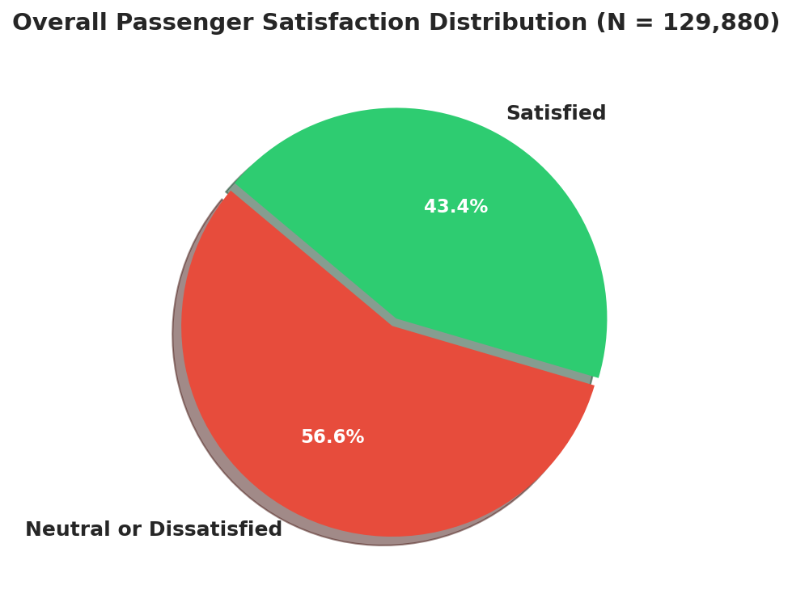
Figure 1: Overall passenger satisfaction distribution (N = 129,880).
The chart labels are rounded to one decimal place; exact values are 43.45% and 56.55%.
Of the 129,880 passengers, 56.55% (73,452) are neutral or dissatisfied and 43.45% (56,428) are satisfied. More than half of the passenger base therefore experiences some form of service friction, which indicates substantial retention risk.

4.2 Satisfaction by Travel Class
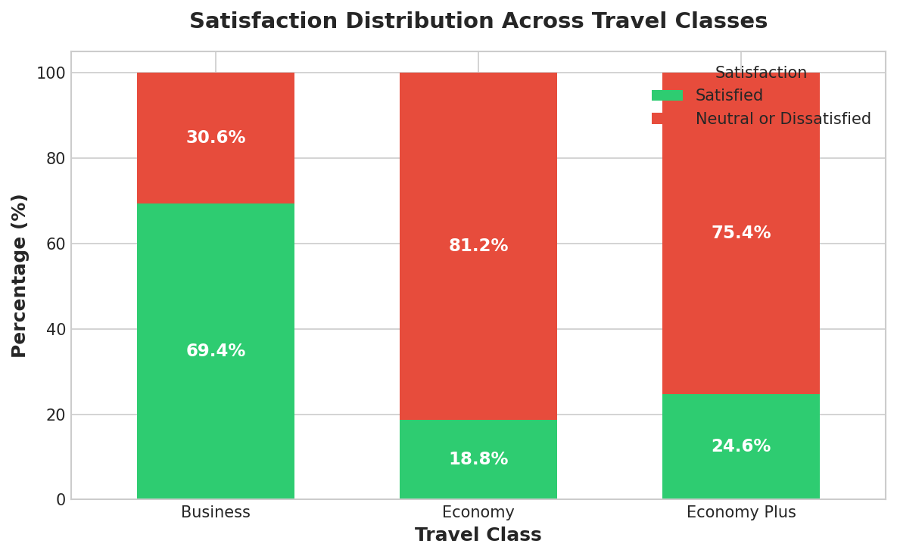
Figure 2: Satisfaction distribution across travel classes.
Travel class shows a stark association with satisfaction. Business passengers report a 69.44% satisfaction rate (30.56% dissatisfied), compared with only 18.77% in Economy (81.23% dissatisfied) and 24.64% in Economy Plus (75.36% dissatisfied). Over 81% of Economy travellers are neutral or dissatisfied. Since Economy and Economy Plus together account for over half of all passengers (Table 2), this gap has a large effect on overall satisfaction.

4.3 Purpose of Travel and Customer Type
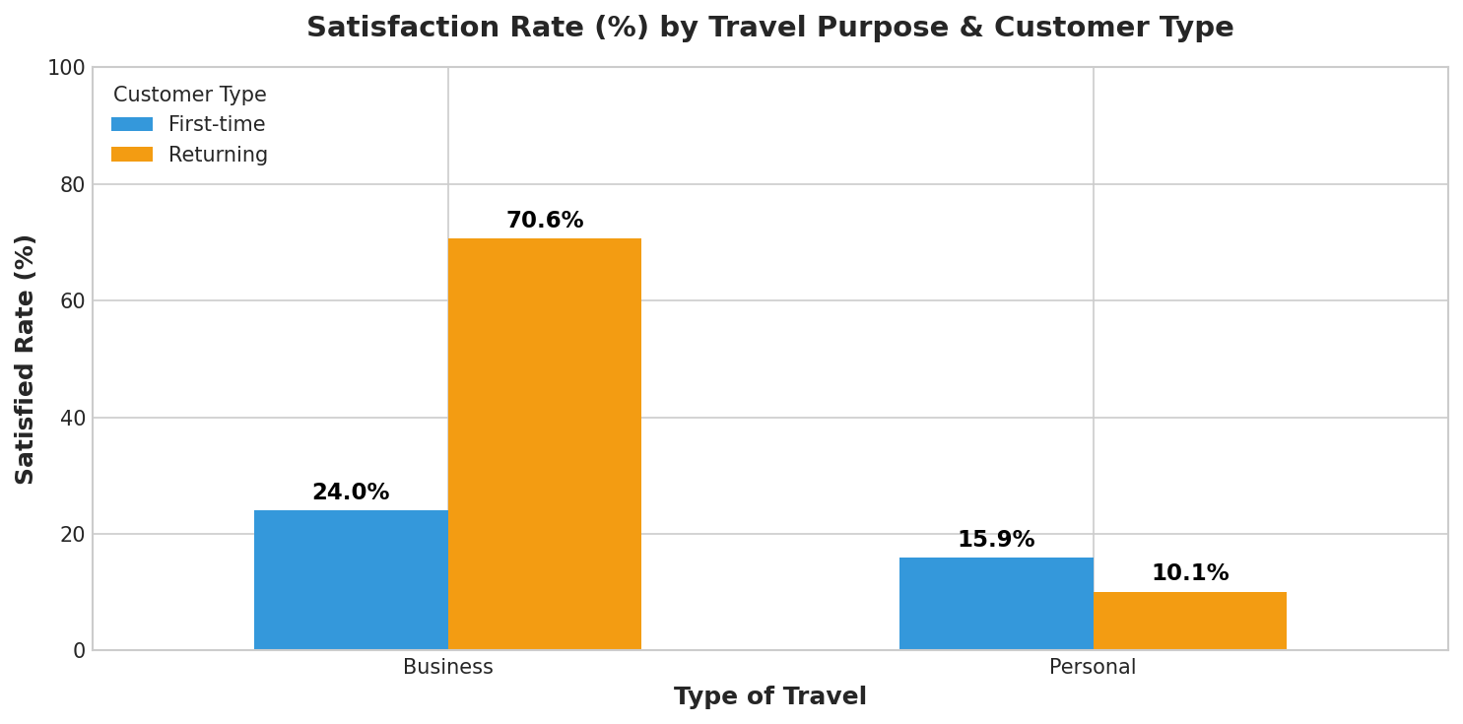
Figure 3: Satisfaction rate (%) by travel purpose and customer type.
Table 5: Satisfaction by Purpose of Travel × Customer Type
Segment | Satisfied | Dissatisfied | Passengers
Business travel × Returning | 70.62% | 29.38% | 66,114
Business travel × First-time | 24.04% | 75.96% | 23,579
Personal travel × First-time | 15.92% | 84.08% | 201
Personal travel × Returning | 10.10% | 89.90% | 39,986

Cross-tabulating purpose of travel with customer type shows exact cohort rates. Returning Business travellers form the highest-satisfaction segment (70.62% satisfied), whereas first-time Business travellers reach only 24.04%. Personal travellers are far less satisfied: 15.92% of first-time and 10.10% of returning Personal travellers are satisfied, the latter being the lowest-satisfaction segment. The returning-customer advantage therefore exists only within Business travel. The passenger counts in Table 5 are computed from the dataset; note that the Personal × First-time segment contains only 201 passengers, so its rate is based on a much smaller sample than the other three. The notebook links the low Personal-travel rates to leisure flyers, who often travel in Economy, experiencing friction across multiple touchpoints.

4.4 Service Touchpoint Rating Curves
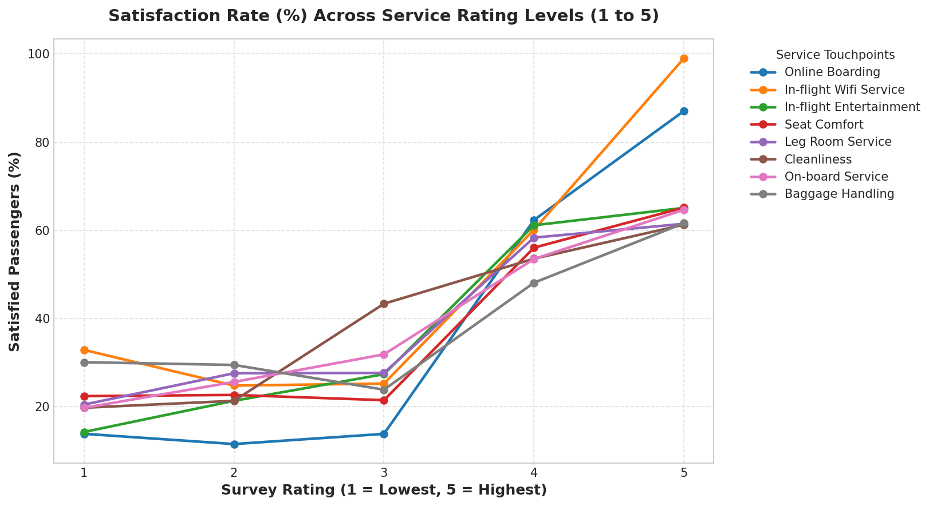
Figure 4: Satisfaction rate (%) across service rating levels 1 to 5 for eight touchpoints.
The curves show steep, non-linear threshold dynamics: satisfaction stays low across ratings 1–3 and jumps at ratings 4 and 5. Table 6 gives the exact rates for the two strongest touchpoints (zero-coded “not applicable” responses excluded).
Table 6: Satisfaction rate by rating level for the two leading digital touchpoints
Rating | Online Boarding – Satisfied | Online Boarding – Dissatisfied | In-flight Wifi – Satisfied | In-flight Wifi – Dissatisfied
1 | 13.78% | 86.22% | 32.82% | 67.18%
2 | 11.45% | 88.55% | 24.72% | 75.28%
3 | 13.76% | 86.24% | 25.18% | 74.82%
4 | 62.30% | 37.70% | 60.08% | 39.92%
5 | 87.06% | 12.94% | 99.02% | 0.98%

- Online Boarding: satisfaction is only 11.45%–13.78% at ratings 1–3, then rises to 62.30% at rating 4 and 87.06% at rating 5.
- In-flight Wifi Service: satisfaction is 24.72%–32.82% at ratings 1–3 (67.18%–75.28% dissatisfied), then 60.08% at rating 4 and 99.02% at rating 5 – the steepest curve in the chart.
- The other touchpoints in Figure 4 (In-flight Entertainment, Seat Comfort, Leg Room Service, Cleanliness, On-board Service and Baggage Handling) also show lower satisfaction at ratings 1–3 than at 4–5, but with a less pronounced jump than Online Boarding and Wifi.
Digital and connectivity touchpoints therefore act as make-or-break differentiators. As a side note from the notebook, rating 0 (“not applicable”) behaves differently: 3,906 of the 3,916 passengers with a Wifi rating of 0 are satisfied.

4.5 Impact of Departure Delay
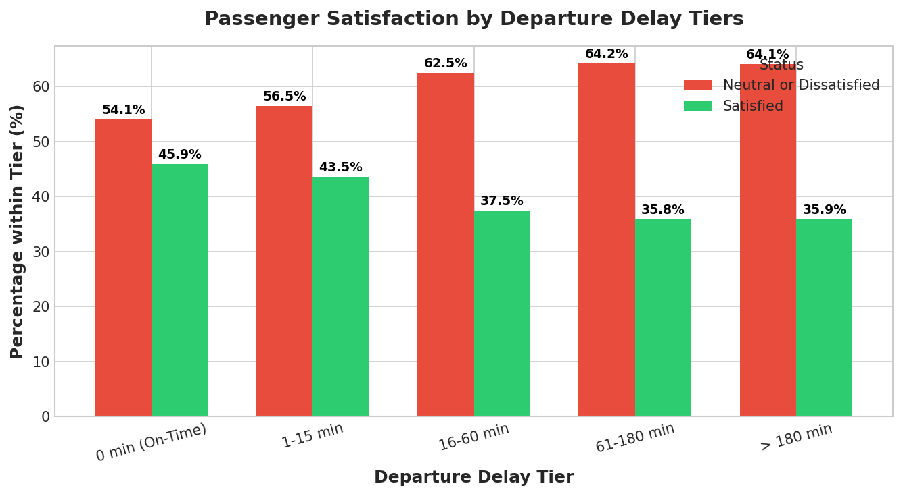
Figure 5: Passenger satisfaction by departure delay tier.
Table 7: Satisfaction by departure delay tier
Departure delay | Dissatisfied | Satisfied | Passengers
0 min (on-time) | 54.06% | 45.94% | 73,356
1–15 min | 56.45% | 43.55% | 27,787
16–60 min | 62.50% | 37.50% | 19,762
61–180 min | 64.15% | 35.85% | 7,685
> 180 min | 64.11% | 35.89% | 1,290

Dissatisfaction increases with delay length, but not dramatically. On-time departures already show 54.06% neutral/dissatisfied passengers, which indicates that core touchpoints (boarding, seats, Wifi) account for a large share of baseline dissatisfaction even without delays. The share rises to 56.45% for 1–15 minute delays and 62.50% for 16–60 minutes, reaches 64.15% for 61–180 minutes and then plateaus (64.11% above 180 minutes). Punctuality therefore matters, but it explains only part of the picture. Passenger counts per tier are computed from the dataset; only 1,290 passengers experienced delays above 180 minutes.

4.6 Age Profile
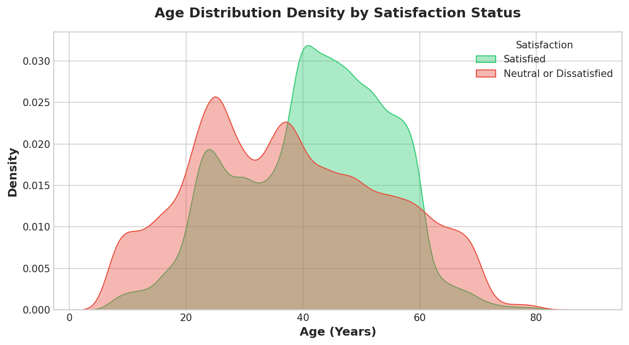
Figure 6: Age density by satisfaction status.
The notebook’s interpretation is that passengers aged 40 to 60 show the highest concentration of satisfied passengers (frequent business travellers), whereas young adults (18 to 32) are disproportionately dissatisfied. Satisfaction rates computed from the dataset are consistent with this: 57.63% of passengers aged 40–60 (55,763 passengers) are satisfied, compared with 35.95% of those aged 18–32 (34,968 passengers). The youngest (17 and under; 16.73%) and oldest (61 and over; 20.82%) groups show the lowest satisfaction rates.

5. Machine Learning Methodology

5.1 Problem Formulation
The task is supervised binary classification: predict Satisfaction (1 = Satisfied, 0 = Neutral or Dissatisfied) from 22 input variables (all columns except ID and the target). The positive class is “Satisfied”.

5.2 Train/Test Split
Table 8: Stratified 80/20 split (random_state = 42)
Partition | Observations | Share | Satisfied | Neutral/Dissatisfied
Training set | 103,904 | 80.0% | 43.45% | 56.55%
Test set | 25,976 | 20.0% | 43.45% | 56.55%

Stratification kept the class ratio identical in both partitions. The test set was used only for evaluation.

5.3 Models
Table 9: Models benchmarked
Model | Role | Configuration
Logistic Regression | Linear baseline | L2 regularisation, L-BFGS solver, max_iter = 1000, random_state = 42
Random Forest Classifier | Non-linear ensemble (champion) | 100 estimators, max_depth = 16, random_state = 42, parallelised (n_jobs = -1)

Both models share the same preprocessing ColumnTransformer inside a scikit-learn Pipeline. Logistic Regression provides an interpretable linear benchmark, while the Random Forest captures non-linear effects and interactions between ratings, travel purpose and cabin class. The environment requires Python 3.10+ and the packages in requirements.txt (pandas ≥ 2.0.0, numpy ≥ 1.24.0, scikit-learn ≥ 1.4.0, matplotlib ≥ 3.7.0, seaborn ≥ 0.12.0, streamlit ≥ 1.28.0, joblib ≥ 1.3.0, scipy ≥ 1.10.0). The fitted pipelines were saved with joblib (models/satisfaction_lr_model.joblib and models/satisfaction_rf_model.joblib).

5.4 Evaluation Metrics
Models were compared on the held-out test set using Accuracy, Precision, Recall, F1-score and ROC-AUC, complemented by normalised confusion matrices, ROC curves and Precision–Recall curves. Feature importance for the Random Forest was measured with mean decrease in impurity (MDI / Gini importance).

6. Model Evaluation & Results

6.1 Performance Comparison
Table 10: Test-set performance of the two models
Model | Accuracy | Precision | Recall | F1-Score | ROC-AUC
Logistic Regression (Baseline) | 87.71% | 87.16% | 84.11% | 85.61% | 0.9295
Random Forest (Champion) | 96.09% | 96.61% | 94.30% | 95.44% | 0.9934
Improvement (RF – LR) | +8.38 pts | +9.45 pts | +10.19 pts | +9.83 pts | +0.0639

The Random Forest outperforms the baseline on every metric. Accuracy improves by 8.38 percentage points, and recall – the share of truly satisfied passengers correctly identified – improves by 10.19 points. The ROC-AUC of 0.9934 indicates near-perfect ranking of satisfied versus non-satisfied passengers on the test set.

6.2 Confusion Matrices
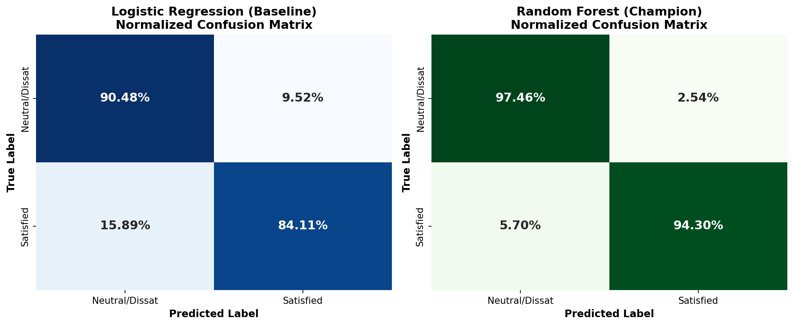
Figure 7: Normalised confusion matrices for Logistic Regression (left) and Random Forest (right).
Table 11: Normalised confusion-matrix rates (rows = true class)
Model | True Neutral/Dissatisfied → predicted correctly | True Neutral/Dissatisfied → predicted Satisfied | True Satisfied → predicted Neutral/Dissatisfied | True Satisfied → predicted correctly
Logistic Regression | 90.48% | 9.52% | 15.89% | 84.11%
Random Forest | 97.46% | 2.54% | 5.70% | 94.30%

The Random Forest correctly recognises 97.46% of neutral/dissatisfied passengers and 94.30% of satisfied passengers. Compared with the baseline, it reduces the rate of dissatisfied passengers wrongly predicted as satisfied from 9.52% to 2.54%, and the rate of satisfied passengers wrongly predicted as dissatisfied from 15.89% to 5.70%.
Error trade-off. The project treats predicting “Satisfied” for a passenger who is actually dissatisfied (false positive) as the more costly error, because the passenger may leave silently without any service-recovery action. The opposite error (false negative) is considered cheaper, as it only results in an unnecessary courtesy gesture. The Random Forest’s low false-positive rate (2.54%) is therefore particularly valuable for this use case.

6.3 ROC and Precision–Recall Curves
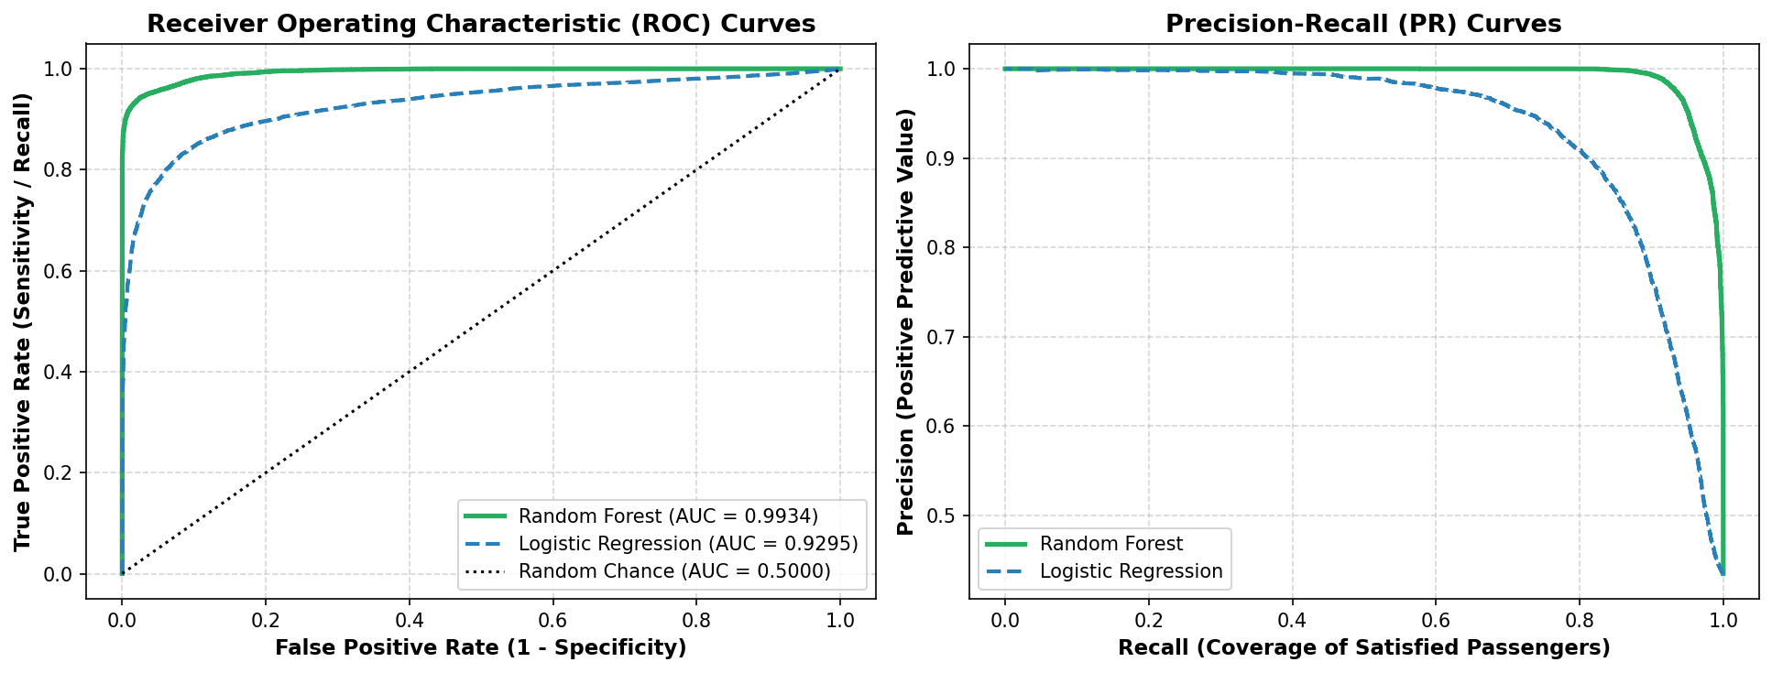
Figure 8: ROC curves (left) and Precision–Recall curves (right) for both models.
The Random Forest ROC curve (AUC = 0.9934) hugs the top-left corner, while the Logistic Regression curve (AUC = 0.9295) lies clearly below it; both are far above the random-chance diagonal (AUC = 0.5). In the Precision–Recall plot, the Random Forest maintains precision close to 1.0 up to a recall of roughly 0.9, whereas the Logistic Regression precision starts to fall at much lower recall. The gap between the models shows that non-linear interactions between features carry substantial predictive information beyond a linear model.
Champion model. Random Forest was selected as the champion model and used for driver analysis and the Streamlit risk simulator.

7. Feature Importance / Driver Analysis
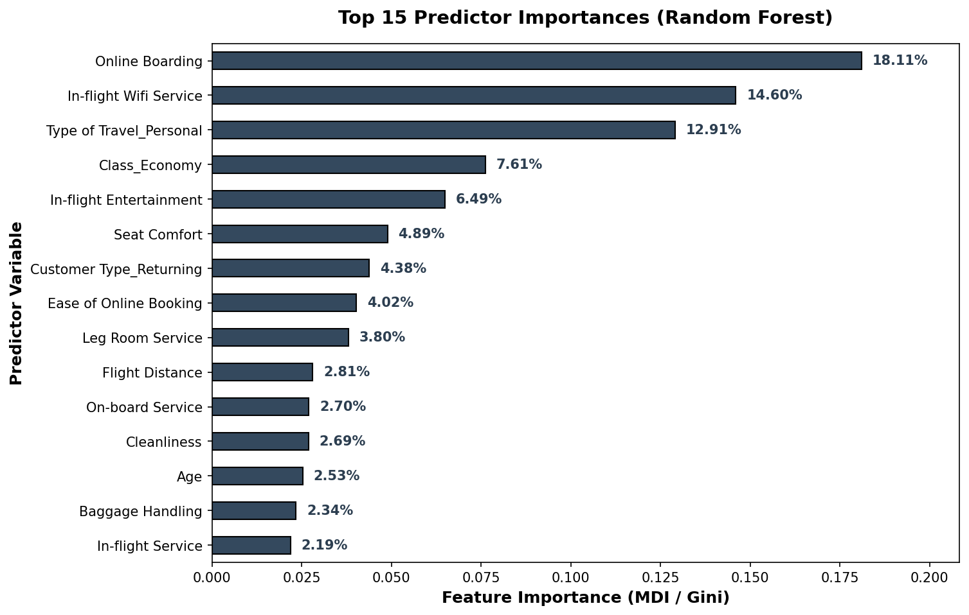
Figure 9: Top 15 predictor importances from the Random Forest (MDI / Gini).
Table 12: Top 15 Random Forest feature importances
Rank | Predictor | Importance | Rank | Predictor | Importance
1 | Online Boarding | 18.11% | 9 | Leg Room Service | 3.80%
2 | In-flight Wifi Service | 14.60% | 10 | Flight Distance | 2.81%
3 | Type of Travel – Personal | 12.91% | 11 | On-board Service | 2.70%
4 | Class – Economy | 7.61% | 12 | Cleanliness | 2.69%
5 | In-flight Entertainment | 6.49% | 13 | Age | 2.53%
6 | Seat Comfort | 4.89% | 14 | Baggage Handling | 2.34%
7 | Customer Type – Returning | 4.38% | 15 | In-flight Service | 2.19%
8 | Ease of Online Booking | 4.02%

7.1 Interpretation of the Driver Hierarchy
- Online Boarding (18.11%) is the single most important predictor. Friction in mobile check-in, seat assignment or gate boarding appears to shape sentiment early in the journey; satisfaction is only 11.45%–13.78% at ratings 1–3 versus 87.06% at rating 5.
- In-flight Wifi Service (14.60%) is the second strongest predictor and the strongest in-flight differentiator: satisfaction is 24.72%–32.82% at ratings 1–3 and 99.02% at rating 5. Weak Wifi ratings severely penalise satisfaction even when physical comfort is acceptable.
- Type of Travel – Personal (12.91%) and Class – Economy (7.61%) are the most influential passenger-profile variables. The notebook notes that leisure and Economy travellers face the lowest baseline satisfaction; Economy passengers are 18.77% satisfied, and returning Personal travellers only 10.10%.
- In-flight Entertainment (6.49%) and Seat Comfort (4.89%) are the main physical and entertainment factors, followed by Customer Type – Returning (4.38%), Ease of Online Booking (4.02%) and Leg Room Service (3.80%).
- Operational and demographic variables such as Flight Distance (2.81%) and Age (2.53%) contribute less individually; Departure and Arrival Delay do not appear among the top 15 predictors, which is consistent with the modest delay effect seen in Section 4.5.
Importance values indicate how much each variable contributes to the model’s predictions, not the direction or causal size of its effect. Direction is better read from the EDA: higher online-boarding, Wifi and entertainment ratings, Business class and Business travel all coincide with higher satisfaction.

8. Business Recommendations
The recommendations below follow from the driver ranking and EDA findings, in priority order.
Table 13: Prioritised recommendations
Priority | Recommendation | Evidence from the project | Proposed action
1 | Digital gate & boarding modernisation | Online Boarding is the #1 driver (18.11%); satisfaction 11.45%–13.78% at ratings 1–3 vs 87.06% at rating 5 | Overhaul mobile-app boarding flows, automated wallet/boarding-pass generation, automated seat reallocation and biometric fast-track boarding at hub gates
2 | Tiered in-flight connectivity | Wifi is the #2 driver (14.60%); 67.18%–75.28% of passengers rating Wifi 1–3 are dissatisfied; 99.02% satisfied at rating 5 | Free baseline messaging (e.g. WhatsApp, iMessage) for all passengers; high-speed streaming/browsing packages for loyalty members and business travellers
3 | Economy cabin ergonomics & comfort | Economy: 81.23% dissatisfied; Economy class (7.61%), Seat Comfort (4.89%) and Leg Room (3.80%) are among the top drivers | Optimise ergonomic seat padding, quick-turn cabin cleanliness, and bundle entertainment access with personal devices
4 | Automated service recovery | Random Forest: 0.9934 ROC-AUC; dissatisfaction 62.50%–64.15% for delays above 15 minutes | Deploy the model at check-in and landing and apply the decision rule below

Decision rule for service recovery
If a passenger has a predicted dissatisfaction risk above 60%, or experiences a departure delay above 30 minutes combined with a Wifi/boarding rating of 2 or lower, the airline’s CRM automatically triggers an immediate mobile compensation gesture, such as a lounge pass, 1,000 bonus loyalty miles or a meal voucher. The Streamlit “Real-Time Risk Simulator” module demonstrates how a passenger profile is scored.

Additional targeting insights
- First-time Business travellers are satisfied at only 24.04% versus 70.62% for returning Business travellers, so the first-trip experience deserves attention. Returning Personal travellers (10.10%) are the least satisfied segment.
- Young adults (18–32) and passengers aged 61 and over show lower satisfaction (35.95% and 20.82%) than passengers aged 40–60 (57.63%), suggesting segment-specific service design.
- These recommendations are hypotheses from observational data; pilot them through A/B tests before fleet-wide rollout, and retrain the model periodically (the project suggests quarterly) to detect drift in passenger preferences.

9. Limitations
- Correlation, not causation: the data are observational survey responses; the drivers identified are statistical associations, and interventions should be validated experimentally.
- Single dataset and split: results come from one public survey dataset and one 80/20 stratified split (random_state = 42). The notebook does not report cross-validation or hyperparameter search, so the stability of the 96.09% accuracy across other splits or airlines is not established. The dataset documentation does not state the airline or survey period.
- Ratings and satisfaction share the same survey: the model uses post-flight ratings, which are collected together with the target. It therefore classifies satisfaction from already-reported experience rather than forecasting it before the flight; using it “at check-in” as proposed would require ratings or proxies that are available at that time.
- Importance measure: Random Forest MDI importance shows the contribution to prediction, not the direction or size of an effect, and it can be shared between correlated variables (for example Personal travel and Economy class). One-hot categories are also reported separately.
- Small segment: the Personal × First-time cohort has only 201 passengers, so its 15.92% satisfaction rate is less reliable than the rates for the other three travel-purpose × customer-type segments.
- Zero-coded ratings: “not applicable” responses (0) were retained as numeric values in the models rather than recoded as missing; alternative treatments were not compared. Because 3,906 of the 3,916 passengers with a Wifi rating of 0 are satisfied, this level is highly informative for the model in its own right.
- Untuned thresholds: the decision rule (risk above 60%, delay above 30 minutes, rating of 2 or lower) is a proposed operating policy; the notebook does not optimise these cut-offs or quantify their financial return.
- Class imbalance and error costs: the 56.55%/43.45% split is moderate, and the higher cost of false positives is a business assumption; the notebook uses the default classification threshold.
- Deployment scope: the Streamlit dashboard is a demonstration; live data integration, monitoring and fairness review were not part of the project.

10. Conclusion
This project analysed 129,880 airline passenger survey records to understand and predict satisfaction. Only 43.45% (56,428) of passengers are satisfied, and satisfaction varies sharply by cabin class and travel purpose: Business-class passengers are satisfied at 69.44% versus 18.77% in Economy, and returning Business travellers (70.62%) are far more satisfied than returning Personal travellers (10.10%). Satisfaction rises steeply only when service ratings reach 4 or 5 – Online Boarding from 13.76% at rating 3 to 62.30% at rating 4, and In-flight Wifi from 25.18% to 60.08% – while departure delays are associated with a moderate increase in dissatisfaction (from 54.06% on time to 64.15% for 61–180 minute delays, then a plateau).
A leakage-free pipeline and a Random Forest classifier delivered 96.09% accuracy, 96.61% precision, 94.30% recall, a 95.44% F1-score and a 0.9934 ROC-AUC on 25,976 unseen passengers, substantially outperforming the Logistic Regression baseline (87.71% accuracy, 0.9295 ROC-AUC). The driver analysis ranks Online Boarding, In-flight Wifi, Personal travel, Economy class, In-flight Entertainment and Seat Comfort as the most influential predictors.
These results support four actions: modernise digital boarding, improve in-flight connectivity, enhance Economy-cabin comfort and introduce automated, model-driven service recovery. Together with the notebook, saved models and Streamlit dashboard, the project provides a reproducible analytical foundation that airline teams can validate through A/B testing and extend with cross-validation, threshold tuning and additional data.

11. References
[1] Airline Passenger Satisfaction dataset (teejmahal20). Kaggle. https://www.kaggle.com/datasets/teejmahal20/airline-passenger-satisfaction
[2] Breiman, L. (2001). Random Forests. Machine Learning, 45(1), 5–32.
[3] Pedregosa, F., et al. (2011). Scikit-learn: Machine Learning in Python. Journal of Machine Learning Research, 12, 2825–2830.
[4] McKinney, W. (2010). Data Structures for Statistical Computing in Python. Proceedings of the 9th Python in Science Conference, 51–56.
[5] Harris, C. R., et al. (2020). Array programming with NumPy. Nature, 585, 357–362.
[6] Hunter, J. D. (2007). Matplotlib: A 2D Graphics Environment. Computing in Science & Engineering, 9(3), 90–95.
[7] Waskom, M. L. (2021). seaborn: statistical data visualization. Journal of Open Source Software, 6(60), 3021.
[8] Streamlit Inc. Streamlit documentation. https://streamlit.io/
[9] IBM SkillsBuild. https://skillsbuild.org/
[10] Project files: Piyush_FlightPath_to_Loyalty.ipynb, README.md, requirements.txt, data_dictionary.csv, app.py and figures/ (Airline_Passenger_Satisfaction_Project).

