1.what is sdlc?

•SDLC is a structure imposed on the development of a software product that defines the process for planning, implementation, testing, documentation, deployment, and ongoing maintenance and support.

**2.what is software testing?**

Software Testing is a process used to identify the correctness, • Completeness, and quality of developed computer software.

**3.what is agile methodology?**

process models with focus on process adaptability and customer satisfaction by rapid delivery of working software product.

Agile SDLC model is a combination of iterative and incremental

**4.what is srs?**

• A software requirements specification is a complete description of the behavior of the system to be developed.

**5.what is oops?**

Oops is object oriented programming system.black box testing,function testing.

**6.write basic concept of oops.  
There are four fundamental concept of object-oriented programming.  
1.inheritance  
2.encapsulation  
3.polymorphism  
4.data abstraction.**

**7.What is object?**  
instance of an class   
to create an memory of an class  
to access the whole properties of an class except privet.

**8.What is class ?** class is an collection of data member (variable) and member function (process,method) with its behaviors.

**9.What is encapsulation?**data hiding:wrapping up of data into single unit private your data member or member function.

**10.What is inheritance**properties of parent class extends into child class.main perpose is re usablity,extansiblity.  
There are mainly 5 types.  
1.single  
2.multilevel  
3.hirechical  
4.multiple:java does not support  
5.hybrid:java does not support. **11.What is poly morph ism?**Ability to tack one name having different forms.  
Many forms or multiple forms  
there are mainly 2 types  
1.compile time(method overloading)  
2.run time (method overriding)

**•**

**12.Write SDLC phases with basic introduction.**Sdlc have 6 phases.  
Requirement,analysis,design,implementation,testing,maintenance.  
  
1.Requirement:Features,Usage scenarios Although requirements may be documented in written form, they may Be incomplete, unambiguous, or even incorrect.**•**Requirements will Change.  
Build constant feedback into the project plan •   
Plan for change  
  
2.analysis:  
The analysis phase defines the requirements of the system, independent of how these requirements will be accomplished.  
The deliverable result at the end of this phase is a requirement document.  
  
3.design phase:  
Design Architecture Document • I  
implementation Plan•   
The Design team can now expand upon the information established in the requirement document.  
  
4.Implementation Phase:In the implementation phase, the team builds the components either document from the design phase and the requirement document from the analysis phase, the team should build exactly what has been requested, though there is still room for innovation and flexibility.   
  
5.TestingPhase:Simply stated, quality is very important. Many companies have not learned that quality is important and deliver more claimed functionality but at a lower quality level.  
 It is more easier to explain to customer why testing is important.  
A customer satisfied with the in testing, and is the process of enhancing and optimizing deployed software as well as fixing defects.  
  
Maintenance :is the process of changing a system after it has been deployed.  
They have 3 types .  
corrective,adaptive,perspective maintenance. **13. Explain Phases of the waterfall model.**The waterfall is unrealistic for many reason especially requirement must be frozen to early in the life product.  
  
Pros:simple and easy to understand and use.  
Easy to manage due to the rigidity of the model.  
Works well for smaller project where requirement are very well understood.  
Clear defined stages.  
Well understood milestone.  
  
Cons:  
high amount of risk and uncertainty.  
It has no feed back.  
It has no parallelism.  
No experiments.  
60% efforts maintenance  
.  
 **14. Write phases of spiral model:**spiral model has a 4 phases :planning,risk analysis,engineering,customer evolution.  
  
planning :determination of objectives,alternatives and constraint.

Risk analysis:analysis of alternatives and resolution of risk.ge

Engineering:development of the next level product.  
customer evolution:assessment of the result of engineering.  
 **•   
15.Write agile manifesto principles.**

Our highest priority is to satisfy the customer through early and continuous delivery of valuable software.  
  
Deliver working software frequently,from a couple of weeks to a couple of month,with a preference for a shorter timescale.  
  
Buisness people and developers must work together daily thought the project.  
Working software is the primary measure of progress. **16.Explain working methodology of agile model and also write pros and cons.**Agile SDLC model is a combination of iterative and incremental process models with focus on process adaptability and customer satisfaction by rapid delivery of working software product.   
 Agile Methods break the product into small incremental builds.   
  
These builds are provided in iterations. • Each iteration typically lasts from about one to three weeks.Pros:  
Is a very realistic approach to software development   
Promotes team work and cross training•  
Functionality can be developed rapidly and demonstrated.  
Resource requirements are minimum.Suitable for fixed or changing requirement **cons:**Not suitable for handling complex dependencies. •  
More risk of sustainability, maintainability and extensibility  
  
17**.Draw Use case on online bill payment system (paytm)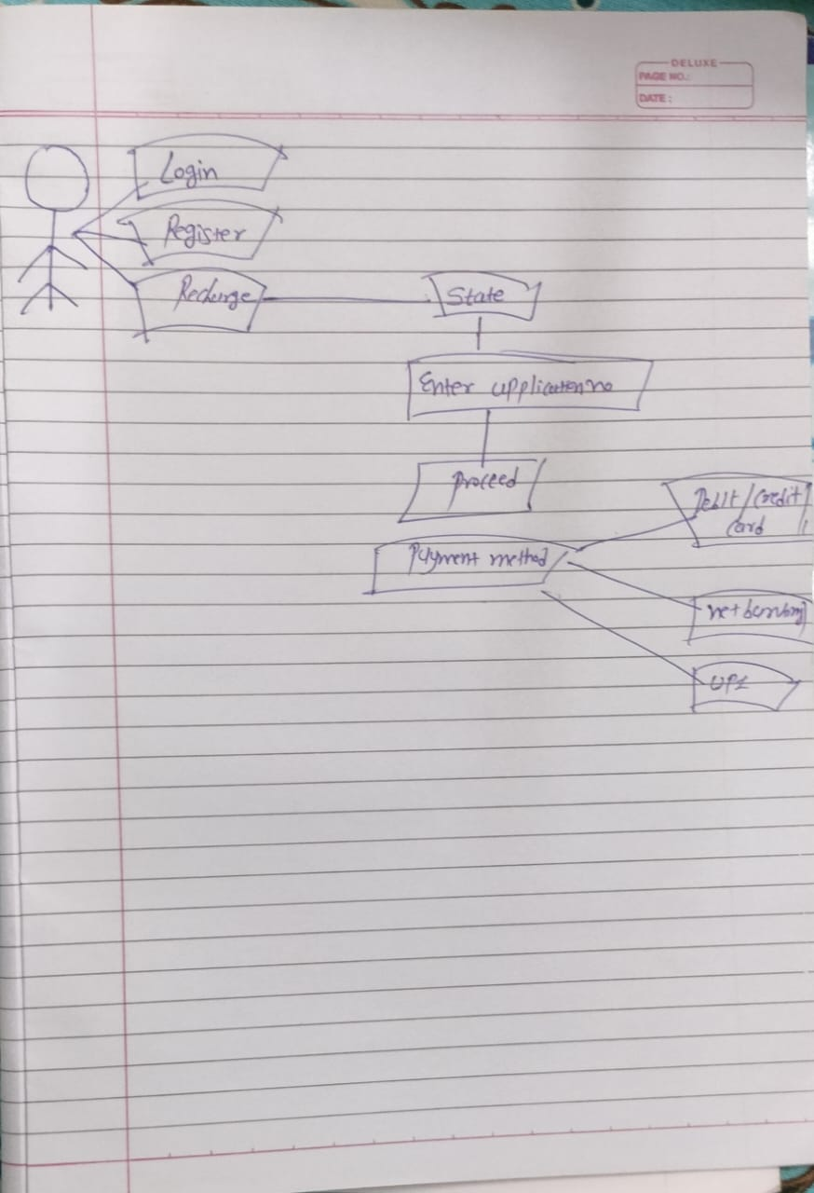 g •   
  
  
  
  
  
  
  
  
  
  
  
  
  
  
  
18.Draw Use case on Online book shopping.**

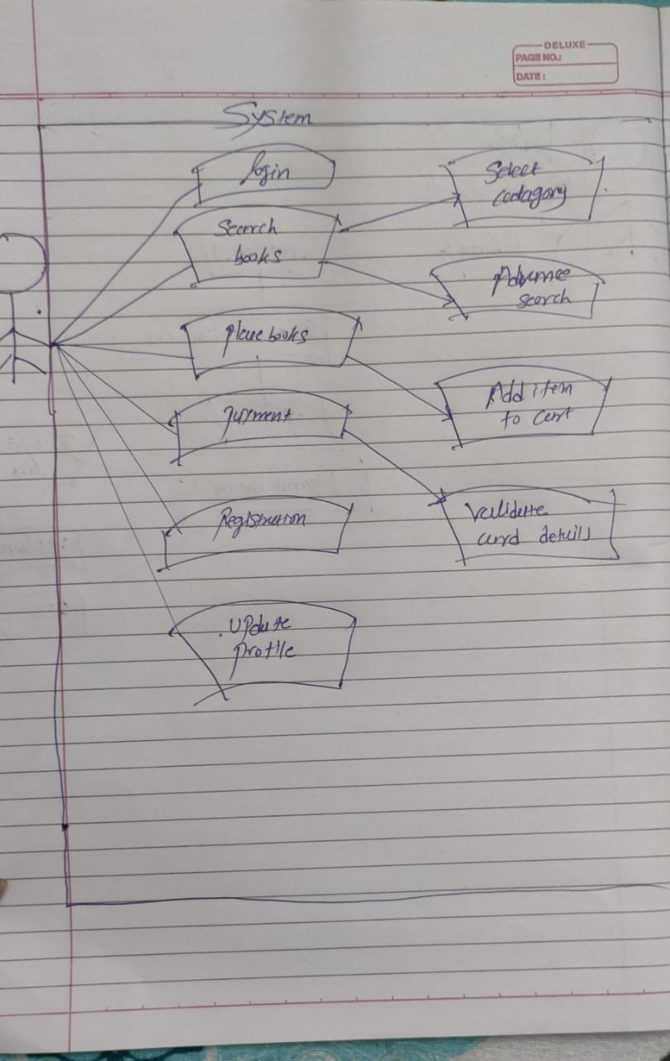

**19.draw use case on shopping product using cod.**

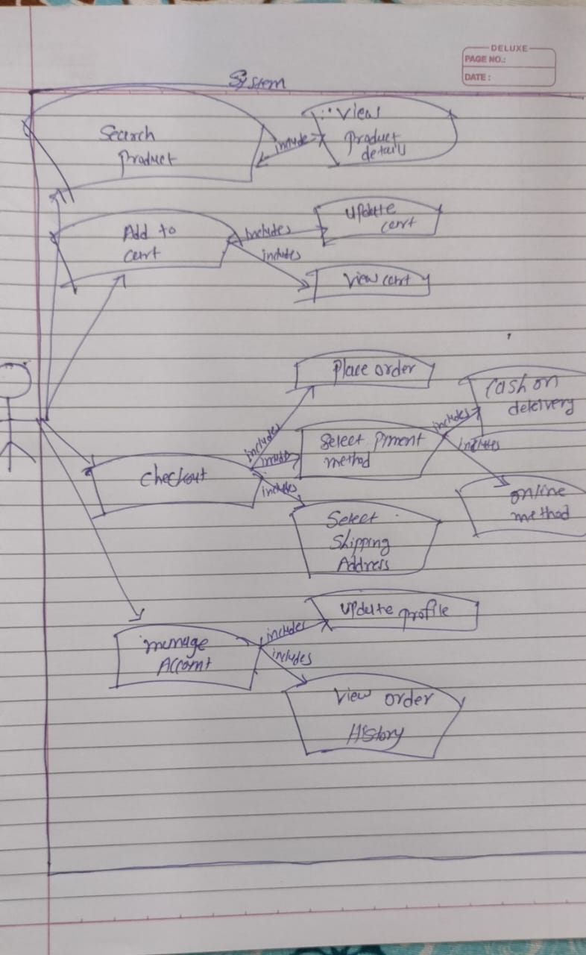

**20.draw use case on online shopping product using payment gateway.  
  
  
  
  
  
  
  
  
  
  
