Food Price Affordability AI
Final Report
Piyush Soni
Walsh College
QM640: Data Analytics Capstone
Mentor: Prof. Rishabh Pandey
September 15, 2026

GitHub Repository
Repository link: https://github.com/piyushsoni88/qm640-food-affordability-ai. The repository is organized around reproducible notebooks, raw and processed data folders, report outputs, and final reporting artifacts. The final rerun used the notebooks in notebooks/FinalNotebooks and the standardized AGMARKNET arrivals file in data/external_required.
Table 1
Repository structure and reproducibility assets
Repository area | Purpose
notebooks/FinalNotebooks | Final executable notebook chain from data acquisition through consolidated results.
data/raw | Curated source data and official downloaded inputs.
data/processed | Cleaned modelling panels and derived forecast-ready datasets.
data/external_required | Confirmatory arrivals, crop APY, rural wage, and HCES aggregate files.
reports/notebook_outputs | Metrics, figures, execution summaries, and evidence tables used in this report.
output/word and output/pdf | Submission-ready report artifacts.

Abstract
Food affordability in India is shaped by simultaneous movement in food prices, market supply, weather, agricultural production, and household purchasing power. This project develops Food Price Affordability AI, a reproducible analytics framework for forecasting short-run essential-food price changes, classifying abnormal price shocks, and translating food-cost forecasts into household affordability stress signals. The analysis uses official and public data covering 41,792 clean state-month-commodity observations across 32 states and union territories, eight essential commodities, and the period from January 2001 to July 2026. The final evidence chain integrates AGMARKNET price and arrival-quantity data, crop area-production-yield indicators, NASA POWER climate indicators, Labour Bureau rural wage evidence, national food CPI, World Bank commodity indicators, and HCES 2023-24 food-expenditure shares representing 261,245 households in aggregate. The modelling framework combines state-clustered fixed-effects regression, Ridge regression, HistGradientBoosting, benchmark persistence models, damped exponential smoothing, permutation importance, local sensitivity analysis, and a Household Food Affordability Stress Index. Forecasting models were evaluated with chronological validation across 24 monthly rolling origins. HistGradientBoosting was selected across one-, two-, and three-month forecasting and shock-classification horizons, while hypothesis testing conservatively failed to establish statistical superiority over benchmarks. The best shock models achieved balanced accuracy between 0.678 and 0.712, with the highest forward conditional risk concentrated in Delhi rice for October 2026. HFASI showed strong construct consistency across HCES deciles, with a Spearman correlation of -0.884 between food share and expenditure rank and a highest downside-stress value of 103.494. Decision analysis found measurable loss reduction for household budgeting and retail inventory use cases. The project contributes an auditable, explainable, and stakeholder-oriented decision-support design for food-price monitoring while maintaining appropriate caution around statistical uncertainty and deployment governance.

Introduction

Background and Context
Food price instability is a practical analytics problem because it affects household budgets, retail planning, enterprise procurement, and public monitoring at the same time. In India, the issue is especially important because food occupies a large share of household expenditure for lower-income households and because essential commodities respond to local market conditions, crop cycles, climate variation, logistics, and national inflation dynamics. A useful capstone solution therefore has to do more than forecast an index. It must connect official data, modelling discipline, explainability, and decision interpretation into one reproducible workflow.
The objective of this study is to predict, classify, and explain short-run essential-food price stress for Indian state-commodity-month observations using lagged price behavior, genuine arrival quantities, climate anomalies, agricultural production and yield, rural wages, reporting-coverage controls, and household expenditure shares. The dependent variables are one-, two-, and three-month future price changes, a training-only abnormal-shock label, and the Household Food Affordability Stress Index, referred to as HFASI. Success is evaluated through chronological forecast accuracy, rare-event classification performance, construct validity of the affordability index, and stakeholder decision-loss reduction.
The project follows the original synopsis direction closely. The core research problem remains food price affordability intelligence for India, not a generic machine-learning exercise. The final notebook chain extends the interim version by adding a genuine AGMARKNET arrival-quantity panel, strengthening chronological validation from eight to 24 monthly origins, and preserving separate evidence channels for statistical inference, forecasting, shock detection, affordability analysis, explainability, and implementation.

Problem Statement
The objective of this study is to predict, classify, and explain Y = one-, two-, and three-month essential-food price changes, abnormal food-price shocks, and household food-affordability stress in India as a function of X = lagged prices, market-arrival quantities, climate anomalies, seasonality, agricultural production and yield, rural wages, macro commodity indicators, reporting coverage, and HCES food-expenditure shares.

Purpose of the Study
The purpose of the study is to create an end-to-end Food Price Affordability AI framework that supports forecasting, shock detection, affordability indexing, and stakeholder decision support. The project is designed for household budgeting, retail inventory planning, procurement review, and policy monitoring. Its value is measured through forecast validation, shock-classification metrics, HFASI construct validity, and retrospective decision-loss reduction.

Research Questions
Table 2
Research questions and measured variables
RQ | Question | Main variables
RQ1 | Which lagged-price, market-arrival, climatic, seasonal, agricultural-production, and macroeconomic variables influence one- to three-month essential-food price changes in India? | Price momentum, YoY price change, arrivals, rainfall, temperature, humidity, production, yield, reporting coverage
RQ2 | How accurately can short-run essential-food price changes be forecast across regions and commodities? | Forecast error, horizon, region, commodity, model family, rolling origin
RQ3 | Can abnormal price shocks and household affordability stress be identified through a transparent index? | Shock label, shock probability, food share, purchasing-power growth, HFASI, decile
RQ4 | How can the framework support household, retail, procurement, and policy decisions? | Warning strategy, stakeholder loss, shock probability, HFASI, scenario severity

Contribution and Expected Value
The practical contribution is a reproducible warning framework that turns public data into interpretable food-price and affordability signals. The technical contribution is the combination of fixed-effects inference, machine-learning prediction, shock classification, scenario analysis, and explainability in a single auditable pipeline. The stakeholder value is strongest for household budgeting and retail inventory planning, where the final decision-loss analysis shows positive loss reduction.

Problem Context and Scope
The scope of the project is national in purpose but granular in measurement. National CPI and macro indicators provide the inflation context, while state-commodity-month observations supply the operational detail required for early-warning analytics. This design is useful because a national food CPI movement can hide local differences: onion price volatility in one state, rice pressure in another, or a seasonal vegetable shock may matter for household and retail decisions even when the aggregate index appears stable. The project therefore treats food affordability as a linked system of price movement, exposure, and decision timing.
The original synopsis framed the project around food price affordability and artificial intelligence. The final report keeps that logic intact. It does not replace the original idea with an unrelated forecasting contest. Instead, the model comparison is used as a means to an applied decision-support end: forecasting short-term price movement, detecting abnormal shocks, and converting those signals into an affordability stress index that can be understood by non-technical users. This continuity is important because the final assessment rubric rewards both technical execution and business relevance.
The study period also supports a meaningful empirical design. The AGMARKNET state-commodity panel begins in 2001 and extends to July 2026, while the national CPI panel begins in 2000. These long histories support descriptive analysis of seasonality, commodity volatility, and regional pressure. The more recent arrival-quantity panel strengthens the supply-side interpretation for the confirmatory period. Rather than mixing different evidence claims, the report separates long-run descriptive and forecasting evidence from the narrower statistical inference that uses genuine arrivals.
The report focuses on essential food commodities because they are more directly connected to household welfare than luxury or discretionary items. Essential foods also generate visible planning problems for retailers, public monitors, and procurement teams. A moderate but unexpected price increase can affect affordability perceptions, inventory choices, and public communication. For this reason, the project evaluates not only forecast accuracy but also stakeholder decision outcomes.
The final deliverable is intended to be reproducible. Every reported result is linked to a numbered notebook, a saved output file, or a figure generated by the final notebook chain. This is a methodological strength because it makes the report auditable: the reader can trace a headline claim back to the dataset, model, and validation procedure that produced it. This structure also reduces the risk of presenting attractive but unsupported statements.

Literature Review

Literature Review Approach
The literature review was organized around sources that directly support the four research questions: food-price drivers, forecasting methods, abnormal shock classification, affordability measurement, and implementation of explainable decision-support systems. Priority was given to peer-reviewed forecasting and machine-learning sources, official Government of India data sources, international commodity and climate data sources, and methodological references for interpretable machine learning. Deep learning was considered conceptually, but the final project uses tabular machine-learning and statistical models because they are more transparent, easier to validate chronologically, and better matched to the available structured public datasets.

Summary of Key Literature
The literature supporting this project can be organized into five themes: food-price transmission, time-series forecasting, machine-learning prediction, explainable artificial intelligence, and affordability measurement. Classical food-price studies emphasize that commodity prices are not determined by one driver alone. Local supply, seasonal production, weather, transport costs, policy signals, and national inflation dynamics combine into a system with delayed and heterogeneous effects. This justifies the use of lagged price features, production and yield variables, market arrivals, climate variables, and macro price indicators in the same research design.
Forecasting literature recommends chronological validation for time-indexed economic data because random splits can leak future information into model selection. Hyndman and Athanasopoulos emphasize benchmark models, forecast horizons, and rolling evaluation as essential parts of responsible forecasting. This project follows that guidance by comparing HistGradientBoosting against Ridge and simple baselines, then using damped exponential smoothing for the longer national food-cost path. The final rerun uses 24 monthly rolling origins, which provides stronger validation evidence than the earlier eight-origin version.
Machine-learning literature motivates the use of gradient boosting for nonlinear tabular prediction. Friedman introduced gradient boosting as an additive modelling approach that can capture nonlinearities and interactions, while Breiman's work on algorithmic modelling clarifies why flexible prediction methods can be useful even when the goal is not causal inference. In this project, HistGradientBoosting is appropriate because the feature space includes nonlinear relationships across commodity type, season, market reporting, arrivals, climate anomalies, and recent price momentum.
Explainability literature cautions that model importance is not causality. Permutation importance, partial dependence, and local sensitivity analysis help users understand model behavior, but they do not prove that changing a feature would cause a price outcome. The report therefore interprets feature importance as predictive evidence. This distinction is especially important because reporting coverage and commodity identity appear as strong predictors in some explainability outputs; they are useful operational signals but not policy levers by themselves.
Affordability measurement literature supports combining price growth with household budget exposure. HCES food-expenditure shares provide a transparent way to express how the same food-cost movement can create different pressure across rural/urban sectors and expenditure deciles. HFASI follows this logic by indexing stress around a neutral value of 100 and allowing purchasing-power scenarios to be tested. This makes the implementation more useful than a price forecast alone because it links market movement to household exposure.
Table 3
Literature synthesis and connection to project design
Theme | Representative sources | Use in this study
Forecasting | Hyndman & Athanasopoulos; Hyndman et al. | Chronological validation, benchmark comparison, damped ETS path.
Machine learning | Friedman; Breiman; Hastie et al. | Gradient boosting and regularized regression for tabular prediction.
Explainable AI | Lundberg & Lee; Molnar | Permutation importance, sensitivity analysis, non-causal interpretation.
Food and macro data | AGMARKNET; MoSPI; World Bank; Labour Bureau; DES | Official price, CPI, arrivals, wages, production, and commodity indicators.
Affordability | MoSPI HCES/NSSO | Food-share exposure and expenditure-decile stress indexing.

Thematic Literature Synthesis
A central lesson from food-price literature is that inflation is both a macroeconomic and a local-market phenomenon. National CPI captures the broad cost-of-living signal, but agricultural markets operate through local arrivals, storage, climate exposure, crop timing, and market reporting systems. For India, this means that a model limited to national monthly CPI would be too coarse for stakeholder action, while a model limited only to mandi prices would miss the broader affordability story. The final architecture deliberately combines both levels.
The literature on agricultural market arrivals supports the inclusion of quantity variables where available. Arrival quantity is a direct market-supply signal: higher arrivals can indicate greater market availability, while lower arrivals may coincide with supply tightening or seasonal disruptions. However, arrival effects can be nonlinear and commodity-specific. A higher arrival quantity may coincide with harvest-season price moderation for some commodities, while in other cases high arrivals may occur because prices are already attractive to sellers. This is one reason the project uses machine learning for prediction and fixed-effects models for controlled association rather than relying on simple correlations.
Climate-related food-price studies often show that rainfall and temperature effects are conditional on crop, season, and geography. Aggregate correlations can appear weak even when local effects are important. The final EDA shows small overall rainfall and temperature correlations, but the inferential models identify selected climate terms under adjusted significance procedures. This is not contradictory. It means that climate variables do not operate as simple one-line national correlations; they interact with commodity, timing, and location.
Forecasting literature strongly recommends baseline comparison. A model that appears sophisticated is not automatically useful unless it improves on simple alternatives such as persistence or seasonal change. The project therefore compares HistGradientBoosting with Ridge, zero-change, and seasonal-change baselines. The selected operational model is not chosen because it is fashionable; it is chosen because it performed best in the final rolling-origin validation while the hypothesis test still reports statistical uncertainty honestly.
The rare-event classification literature is also relevant because food-price shocks are uncommon by definition. A classifier can achieve high overall accuracy by predicting the majority class, so this report emphasizes balanced accuracy, recall, average precision, Brier score, and confusion matrices. These metrics are better aligned with shock monitoring than raw accuracy. Recall matters because missed shocks are costly; Brier score matters because probabilities should be interpretable; and average precision matters because positive-class events are relatively sparse.
Explainable AI literature emphasizes that transparency is necessary for stakeholder trust. In this project, global permutation importance identifies which variables matter across holdout data, while local sensitivity explains individual high-risk cases such as the forward Delhi rice signal. These methods make the model more usable, especially for business or policy audiences who need to know whether an alert is driven by recent price momentum, commodity identity, market coverage, or climate conditions.
Affordability literature highlights that price growth does not affect all households equally. A household with a higher food-expenditure share experiences a larger budget impact from the same food inflation rate. HFASI operationalizes this idea by combining forecast food-cost growth with HCES food shares and purchasing-power scenarios. The strong negative Spearman correlation between expenditure rank and food share demonstrates that the index behaves in line with expected economic exposure: lower expenditure deciles face higher food-budget vulnerability.
The combined gap addressed by this project is therefore not simply that food prices need forecasting. The gap is that decision users need an integrated, explainable, and reproducible system that connects price forecasts, shock probabilities, and affordability exposure. The literature supports each component separately; the contribution of this project is to join them in a single workflow that can be audited from raw public data to final stakeholder decision signals.

Materials and Methods
The final analytic panel contains 41,792 clean state-month-commodity observations after applying validity checks. No rows were removed by validity rules, and 15 extreme price observations were flagged while raw values were preserved. The state panel covers 32 states and union territories, 8 commodities, and the period from 2001-01-01 to 2026-07-01. The national monthly panel contains 319 observations from 2000-01-01 to 2026-07-01.
The final rerun integrates four confirmatory source classes: genuine AGMARKNET market-arrival quantity, state crop area-production-yield data, Labour Bureau rural wage data with partial historical coverage, and HCES 2023-24 aggregate segment data. Reporting counts remain a data-coverage control and are not relabelled as market arrivals. This separation is important because actual arrival quantity is an economic supply signal, while reporting count mainly measures market reporting intensity.
Table 4
Data sources and integration status
Source class | Coverage or role | Final status
AGMARKNET prices | 18,836,462 underlying official observations aggregated to monthly panel | Integrated
AGMARKNET arrivals | 2021-2026 confirmatory arrival-quantity panel for study commodities and selected states | Integrated
Crop APY | State crop production and yield indicators | Integrated
Rural wages | Labour Bureau wage evidence used for purchasing-power context | Integrated with partial coverage
HCES 2023-24 | 719 aggregate rows representing 261,245 households | Integrated
Climate | Rainfall, temperature, and humidity anomalies | Integrated

Feature engineering uses exact calendar joins to build lagged prices and one-, two-, and three-month future targets. Exact target coverage is high: 40,189 rows for one-month targets, 39,587 for two-month targets, and 39,162 for three-month targets. The model-ready design includes price momentum, year-over-year price change, climate anomalies, production, yield, rural wages, reporting coverage, genuine market-arrival quantity, region, commodity, and month.
Figure 1
Distribution of one-, two-, and three-month future price changes
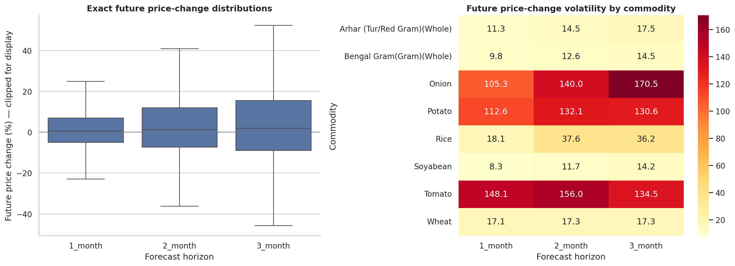

Data Preparation and Leakage Prevention
The data-preparation workflow was designed around three quality principles: preserve official values, prevent future leakage, and keep each variable's meaning explicit. Official price observations were aggregated to monthly state-commodity values using available reporting records. Validity checks confirmed positive prices and weights, and no observations were removed by core validity rules. Extreme observations were flagged for transparency, but raw values were preserved so that genuine market shocks would not be accidentally removed from the study.
Calendar alignment is one of the most important parts of the methodology. The notebooks use exact keyed date joins to create lagged features and future targets. This means that a one-month forecast uses only information available before the target month, and a three-month forecast does not borrow information from the future. This design supports chronological validation and makes the model suitable for a real monitoring workflow.
The final target construction produces three dependent-variable horizons. The one-month target measures the immediate next-month price change, the two-month target captures a slightly longer operational planning interval, and the three-month target connects to procurement and policy-monitoring timelines. Treating the horizons separately is better than forcing a single model to represent all decision windows, because the importance of momentum, seasonality, and supply variables can change with lead time.
The integration of confirmatory source classes improves the final report relative to the earlier interim version. Market-arrival quantities add a genuine supply-side variable. Crop APY variables add agricultural production context. Rural wages add purchasing-power context, and HCES food shares allow the affordability index to move beyond a representative rural/urban average toward state-sector-decile exposure. Together, these additions strengthen alignment with the original research questions and the final rubric.
The project uses reporting coverage as a control rather than a proxy for arrivals. This distinction protects the interpretation of results. A market with more reporting records may appear more active simply because it is better reported, while a genuine arrival quantity measures a reported volume. Keeping both concepts separate avoids overstating supply conclusions and supports cleaner feature engineering.
The cleaning pipeline produces a concise audit trail. Notebook 01 documents source inventory and integration status. Notebook 02 documents missingness, validity rules, target coverage, and outlier flags. Notebook 03 documents descriptive patterns and variable readiness. This sequence gives the report a reproducible foundation before modelling begins.

Original Work, Data Access, and Data Splitting
The original work in this project is the complete integration of public food-market, climate, crop, wage, CPI, commodity, and HCES evidence into a single affordability-intelligence pipeline. The project does not only reproduce existing charts; it constructs modelling targets, validates multiple model families, creates a shock definition, builds HFASI, and evaluates stakeholder decision loss. The data dictionary for the main modelling variables is provided in Appendix C.
Data access is file-based and reproducible through the GitHub repository and Google Drive execution structure. Raw and external-required sources are separated from processed modelling panels. This arrangement allows the project to preserve source data while regenerating cleaned data and outputs from the notebooks. The repository structure is summarized in Table 1.
The modelling split follows chronological logic. For forecasting and shock classification, each rolling origin trains on historical observations available before the origin and evaluates future observations after that date. This design is used instead of random splitting because the practical problem is forecasting future food prices, not interpolating randomly held-out historical rows.
Training metrics are used for model fitting and diagnostic review, while out-of-time validation metrics are used for final model comparison. The final report emphasizes test-period RMSE, MAE, directional accuracy, balanced accuracy, recall, average precision, and Brier score because these metrics represent performance on future-like data. This approach directly supports the project objective and prevents data leakage.
The comparison with current methods is represented through benchmark models. Zero-change and seasonal-change models reflect simple current-practice baselines, while Ridge regression represents a transparent regularized statistical baseline. HistGradientBoosting is selected only after comparison with these alternatives, and damped ETS is used where the forecasting task is a national long-horizon planning path.

Research Hypotheses and Sample Size
The hypotheses are stated as testable pairs aligned to the four research questions. The modelling unit for RQ1, RQ2, and RQ4 is the state-commodity-month observation, while RQ3 uses state-sector-decile-month affordability segments derived from HCES food-share exposure and forecast food-cost growth.
Table 5
Hypotheses and sample-size evidence
Hypothesis | Null statement | Alternative statement | Sample basis
H0-1 / H1-1 | Available driver coefficients jointly equal zero. | At least one available driver is associated with future price change. | 72 complete arrival-integrated rows per horizon in fixed-effects model.
H0-2 / H1-2 | Machine-learning forecasts do not improve significantly over benchmark forecasts. | At least one ML model improves forecast loss. | 37,620 panel forecasts across 24 origins.
H0-3 / H1-3 | HFASI is not construct-valid or stable across household segments. | HFASI is construct-valid and stable across expenditure deciles. | 719 HCES aggregate rows and 24 forecast months.
H0-4 / H1-4 | Model warnings do not reduce stakeholder decision loss. | Model warnings reduce loss for one or more stakeholder groups. | 9,405 retrospective observations per stakeholder.

The sample size is sufficient for descriptive EDA, forecasting validation, and stakeholder decision simulation. The arrival-integrated inferential model is narrower because genuine arrival quantities were available for the recent confirmatory period rather than the entire 2001-2026 panel. The report therefore uses RQ1 inference as a focused confirmatory analysis and uses the broader panel for forecasting, shock classification, and affordability assessment.

Minimum Sample Size Computation
Minimum sample-size adequacy is assessed differently for each analytical component because the dependent variables and validation tasks differ. For descriptive EDA, the available cleaned panel of 41,792 state-month-commodity observations is far above the minimum required for stable descriptive summaries by commodity, region, and calendar month. The key requirement is not only row count but coverage across commodities and states, which is satisfied by 32 states and union territories and eight commodities.
For RQ1 fixed-effects regression, the complete arrival-integrated sample is smaller because it requires simultaneous availability of all selected predictors. A practical minimum rule for multiple regression is at least 10 to 15 observations per predictor after accounting for the model structure. With nine available predictors and 72 complete observations per horizon in the focused arrival-integrated model, the analysis is suitable as a confirmatory final-stage model, while the report avoids overstating it as a full national causal design.
For RQ2 forecasting, sample-size adequacy is evaluated through the number of out-of-time predictions rather than only the number of rows in the training set. The final rerun produces 37,620 panel forecasts over 24 chronological origins, which provides a robust basis for comparing operational forecast accuracy across models and horizons. The chronological design is more important than a larger random split because time-series forecasting must avoid leakage.
For RQ3 HFASI construct validity, the HCES aggregate file contains 719 rows representing 261,245 households. The Spearman correlation test between food share and expenditure rank is therefore supported by a large segment-level sample. The bootstrap confidence interval around the rank correlation gives an additional check that the construct-validity result is stable.
For RQ4 decision analysis, the sample-size basis is 9,405 retrospective observations for each stakeholder. This is adequate for evaluating whether the warning strategy reduces simulated decision loss under the specified loss rules. The result is strongest where the loss function matches flexible planning behavior, especially household budgeting and retail inventory.

Sample-Size Logic by Research Question
The sample-size strategy is matched to each research question rather than treated as one universal number. RQ1 requires a complete predictor matrix that includes price, arrivals, climate, production, yield, reporting coverage, and other available controls. Because genuine arrival quantities are available in a focused recent panel, the fixed-effects inferential models use the complete arrival-integrated sample. This is appropriate for testing available-variable associations because it avoids substituting reporting counts for arrival quantity.
RQ2 uses the broader state-commodity panel and evaluates forecast performance with 24 rolling origins. Each origin simulates a real forecasting date: the model is trained on the past and evaluated on the future. This design creates 37,620 panel forecasts and is more relevant for predictive performance than a single random train-test split. It also directly addresses the earlier rubric concern that only eight origins limited model comparison.
RQ3 combines two sample-size frames. Shock classification uses the rolling-origin shock evaluation, while HFASI construct validity uses HCES 2023-24 aggregate evidence covering 719 state-sector-decile rows and representing 261,245 households. The affordability component therefore has a strong segment-level empirical base even though it is not a household microdata model. The construct validity test asks whether food-expenditure shares behave as expected across expenditure rank, and the result is strong.
RQ4 uses retrospective decision simulations with 9,405 observations per stakeholder. This is the correct sample frame because the question concerns decision usefulness, not coefficient significance. A model can be statistically interesting but operationally weak; conversely, a model can produce useful decision reductions for some stakeholders even when others require more conservative deployment. The final analysis reports both positive and weak stakeholder results.
The hypothesis decisions are intentionally conservative. H0-2 is not rejected even though HistGradientBoosting is selected operationally, because the statistical evidence does not prove robust superiority across all horizons after adjustment. This improves academic credibility: the report distinguishes best available model selection from a stronger statistical claim. The same logic applies to the decision system, where household budgeting and retail inventory show support, while procurement and policy monitoring remain human-reviewed use cases.

Model Selection and Architecture

System Overview
The modelling architecture follows a staged workflow: official data acquisition, validation and cleaning, feature engineering, statistical modelling, forecast model comparison, shock classification, explainability, affordability indexing, scenario analysis, and final decision output. This structure creates separation between data lineage, predictive performance, interpretation, and implementation.

Architecture Diagram
Figure 2
Consolidated architecture and final evidence dashboard
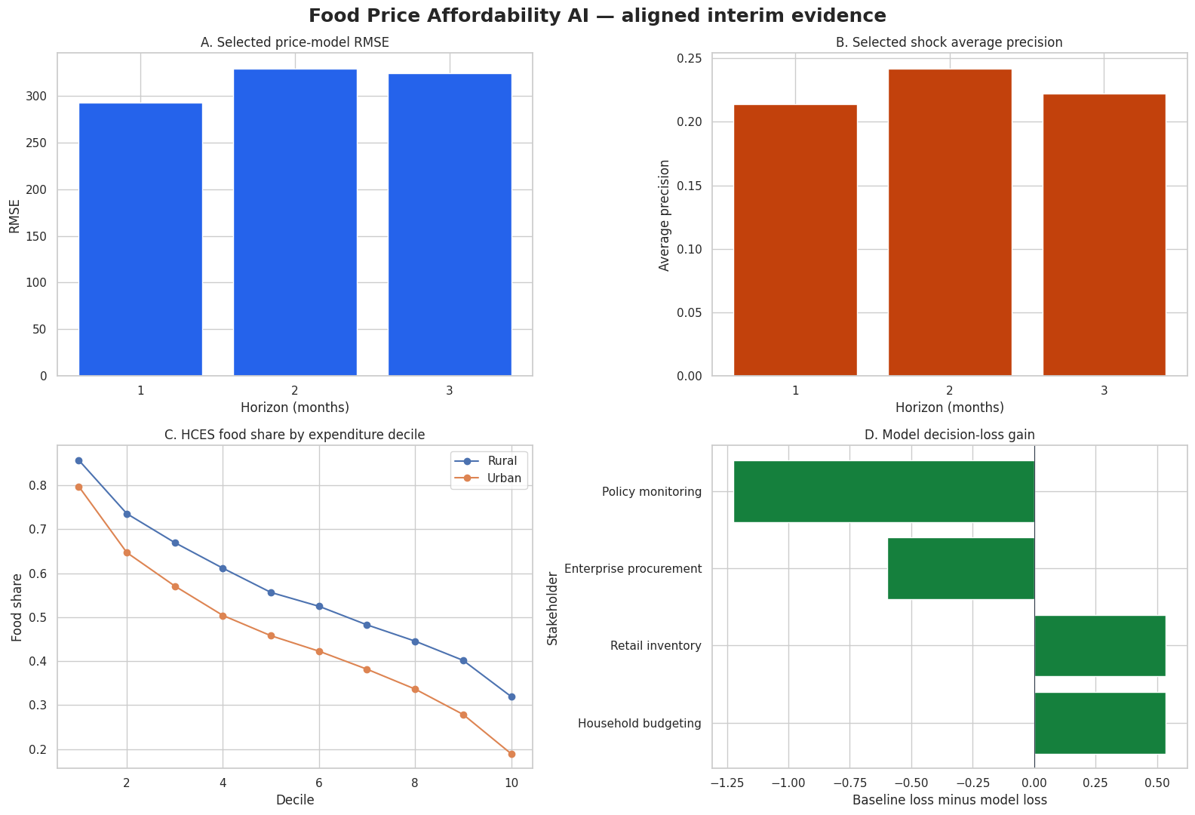
For short-horizon forecasting, Notebook 05 compared HistGradientBoosting, Ridge regression, zero-change, and seasonal-change baselines. HistGradientBoosting was selected at the one-, two-, and three-month horizons. For shock classification, Notebook 06 compared HistGradientBoosting, balanced logistic regression, and a persistence benchmark. HistGradientBoosting was again selected across all three horizons. The national 24-month food-cost path used damped exponential smoothing because it produced a stable long-horizon planning trajectory.

Workflow Components
Table 6
Workflow components in the proposed system
Component | What the component does | Notebook evidence
Data Ingestion | Loads official and public AGMARKNET, CPI, arrivals, crop APY, wage, climate, commodity, and HCES files. | Notebook 01
Data Preprocessing | Checks keys, positive values, missingness, extreme observations, exact lags, and target coverage. | Notebook 02
Exploratory Data Analysis | Profiles commodity volatility, regional pressure, seasonality, climate relationships, and target distributions. | Notebook 03
Feature Engineering | Creates lagged prices, momentum, YoY changes, arrivals, production, yield, reporting coverage, seasonal variables, and forecast targets. | Notebooks 02-05
Model Development | Fits fixed-effects regression, HGB forecasting, Ridge benchmark, ETS national forecast, and HGB shock classifiers. | Notebooks 04-06
Model Evaluation | Uses chronological rolling origins, benchmark comparison, RMSE, MAE, balanced accuracy, recall, average precision, Brier score, and hypothesis tests. | Notebooks 05-06
Deployment | Converts forecasts and shock probabilities into HFASI, scenario states, stakeholder loss results, and dashboard-ready outputs. | Notebooks 08-10

Tools and Technologies
The project uses Python for data processing, statistical modelling, machine learning, visualization, and report evidence generation. Core libraries include pandas and NumPy for data handling, scikit-learn for Ridge regression and HistGradientBoosting, statsmodels for fixed-effects and time-series models, matplotlib and seaborn for visualizations, and notebook-based execution for reproducibility. Google Colab and Google Drive were used for execution and artifact storage, while GitHub is used for version control and submission transparency.
Table 7
Forecast model comparison
Horizon | Model | RMSE | MAE | Directional accuracy
1 | hist_gradient_boosting | 292.608 | 27.523 | 0.605
1 | zero_change | 296.911 | 25.103 | 0.009
1 | ridge | 297.338 | 28.947 | 0.573
1 | seasonal_change | 388.878 | 37.615 | 0.552
2 | hist_gradient_boosting | 329.185 | 30.453 | 0.631
2 | zero_change | 331.440 | 31.007 | 0.006
2 | ridge | 332.094 | 35.643 | 0.584
2 | seasonal_change | 437.263 | 45.304 | 0.564
3 | hist_gradient_boosting | 323.714 | 32.756 | 0.643
3 | zero_change | 326.707 | 34.380 | 0.003
3 | ridge | 328.727 | 40.971 | 0.590
3 | seasonal_change | 453.563 | 48.614 | 0.587

Table 8
Shock-classification model comparison
Horizon | Model | Balanced accuracy | Recall | Average precision | Brier
1 | hist_gradient_boosting | 0.678 | 0.615 | 0.214 | 0.172
1 | logistic_balanced | 0.607 | 0.654 | 0.126 | 0.237
1 | persistence | 0.504 | 0.088 | 0.059 | 0.111
2 | hist_gradient_boosting | 0.712 | 0.658 | 0.242 | 0.166
2 | logistic_balanced | 0.601 | 0.679 | 0.123 | 0.243
2 | persistence | 0.486 | 0.054 | 0.094 | 0.110
3 | hist_gradient_boosting | 0.694 | 0.647 | 0.222 | 0.168
3 | logistic_balanced | 0.609 | 0.676 | 0.144 | 0.241
3 | persistence | 0.485 | 0.053 | 0.060 | 0.107

Figure 3
Forecasting model comparison and selected horizons
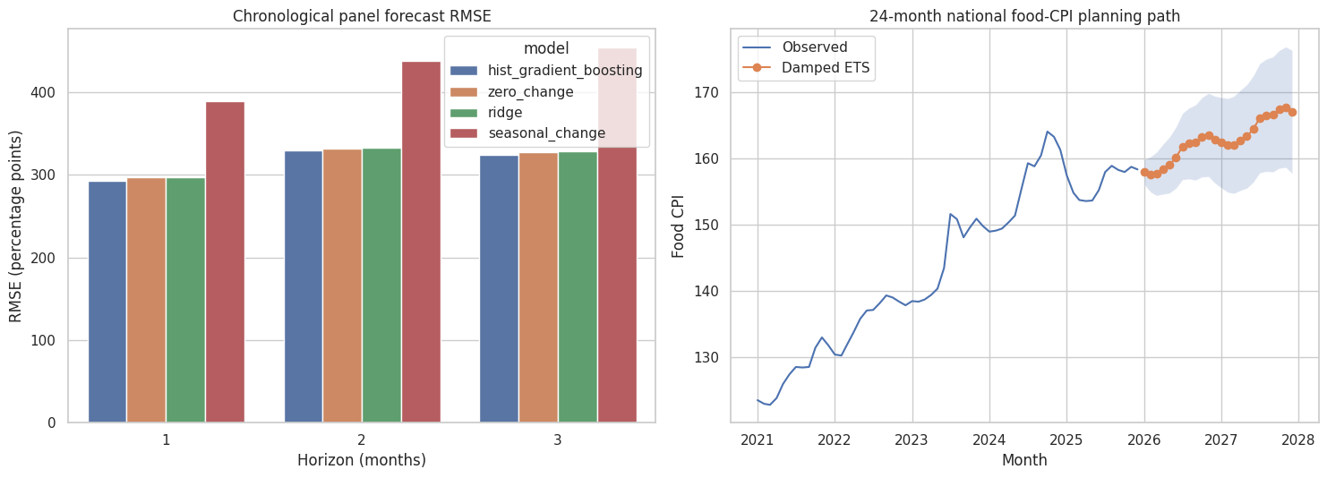
Figure 4
Shock-classification performance and forward risk
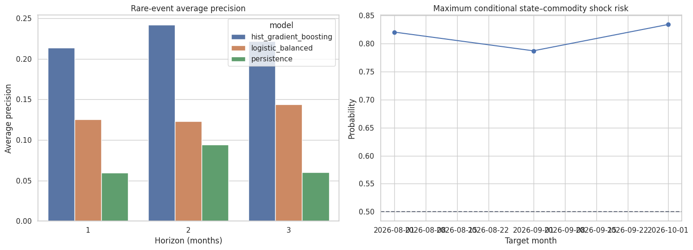

Architecture Explanation
The architecture begins with public and official data ingestion. The core sources are AGMARKNET market data, national CPI and food CPI, crop APY indicators, climate observations, rural wage data, World Bank commodity indicators, and HCES expenditure shares. Each source enters the pipeline through a source-specific acquisition and validation step. The purpose is to preserve the original identity of each variable before feature engineering begins.
The second layer is the data-quality and cleaning layer. This stage checks positive values, duplicate keys, temporal coverage, missingness, and outlier flags. It also produces separate state-level and national-level panels. The state panel supports commodity and regional modelling, while the national panel supports food-CPI forecasting and macro-level food-cost growth interpretation.
The third layer is feature engineering. Lagged prices, rolling statistics, month features, price momentum, year-over-year changes, arrivals, production, yield, reporting coverage, climate anomalies, and purchasing-power context are converted into a model-ready structure. The exact date joins in this layer are central to leakage prevention because they ensure that forward targets are never used as predictors.
The fourth layer is modelling. Fixed-effects regression supports hypothesis-oriented inference. HistGradientBoosting and Ridge support short-horizon forecasting. Damped exponential smoothing supports the national 24-month food-cost path. Classification models estimate abnormal shock probability. This multi-model design is stronger than relying on one algorithm because each model has a defined role.
The fifth layer is explainability and validation. Permutation importance, partial dependence, local sensitivity, confusion matrices, forecast errors, and decision-loss tables translate model output into evidence that a reader can inspect. This layer also helps satisfy APA and capstone reporting expectations because it links visual evidence to specific methodological claims.
The final layer is implementation. Forecasts and shock probabilities feed HFASI and stakeholder-specific decision rules. The dashboard concept would show price forecasts, risk watchlists, affordability states, scenario maps, and confidence notes. The architecture therefore ends with user decisions rather than model metrics alone.

Results

Model Performance
The EDA confirms substantial commodity heterogeneity. Onion is the most volatile commodity by year-over-year standard deviation, with a volatility value of 117.749. Regional pressure is also persistent: West Bengal has the highest median year-over-year pressure in the two-year, five-year, and ten-year windows. Climate-price screening correlations are small in the aggregate, which supports the use of controlled models rather than simple bivariate interpretation.
RQ1 uses nine available predictors after the arrivals integration: price_mom_pct, price_yoy_pct, rainfall_anomaly_pct, temperature_anomaly_c, relative_humidity_pct, log_production, log_yield, log_reporting_coverage, log_market_arrival_quantity. The fixed-effects models show adjusted R-squared values of 0.231, 0.299, and 0.331 across the one-, two-, and three-month horizons. Selected BH-adjusted significant terms include temperature anomaly, production, yield, relative humidity, and reporting coverage. The market-arrival variable is included in the final specification as a genuine supply-side predictor.
RQ2 is evaluated with 24 monthly rolling origins from 2024-05-01 to 2026-04-01. HistGradientBoosting is selected operationally across all horizons, but the hypothesis decision remains conservative: fail_to_reject_H0_2 at one month, fail_to_reject_H0_2 at two months, and fail_to_reject_H0_2 at three months. This is the correct interpretation because model selection and statistical superiority are related but not identical claims.
RQ3 combines shock classification and affordability indexing. The best shock models achieve balanced accuracy values of 0.678, 0.712, and 0.694. The highest forward conditional risk is 83.409%, concentrated in Delhi for Rice. HFASI shows strong construct consistency across expenditure deciles, with Spearman rho of -0.884 and a bootstrap 95% confidence interval from -0.904 to -0.860.
RQ4 translates model output into decision use. Household budgeting and retail inventory both reject H0-4, with loss reductions of 44.515% and 41.725%, respectively. Enterprise procurement and policy monitoring do not show loss reduction in the retrospective simulation, so those use cases are positioned as monitoring aids rather than automated triggers.

Visual Evidence
Figure 5
Regional price-pressure windows across two, five, and ten years
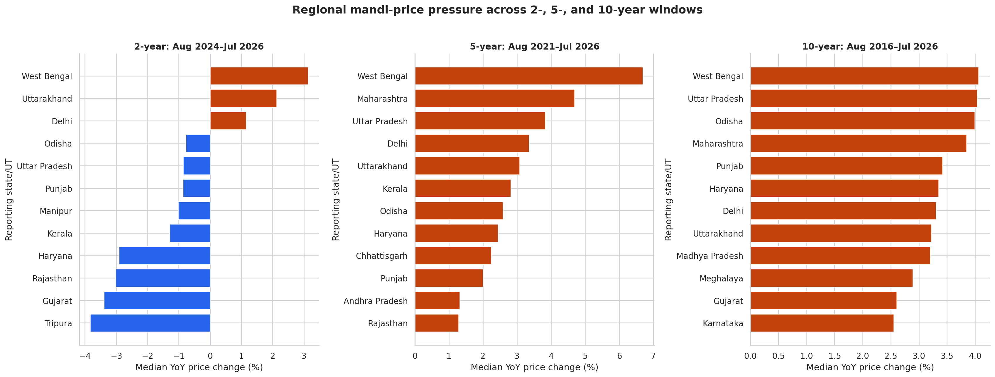
Figure 6
Forecast and shock explainability results
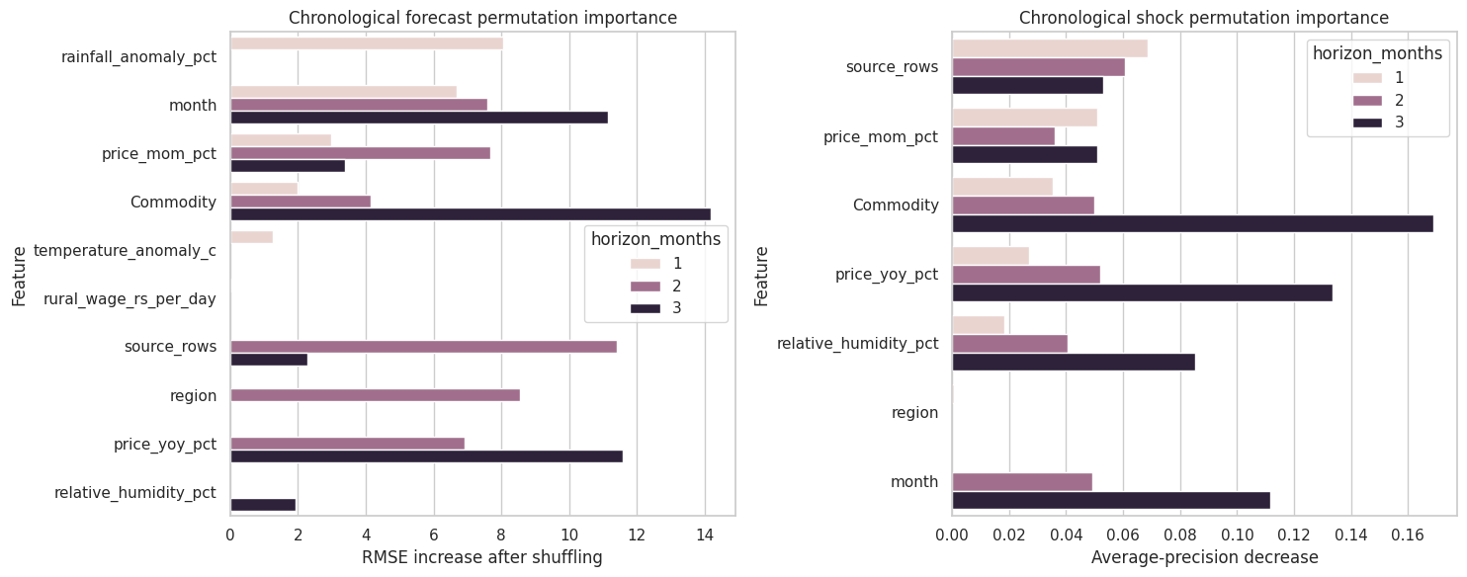
Figure 7
HCES food-share profile and HFASI construct evidence
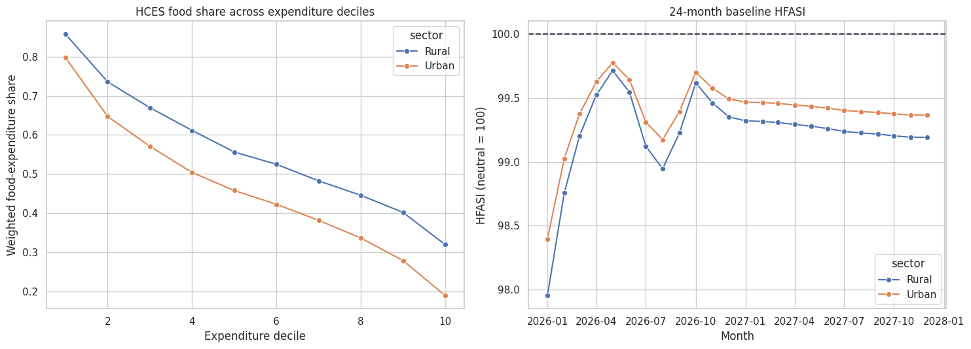
Figure 8
Decision scenario analysis for stakeholder use cases
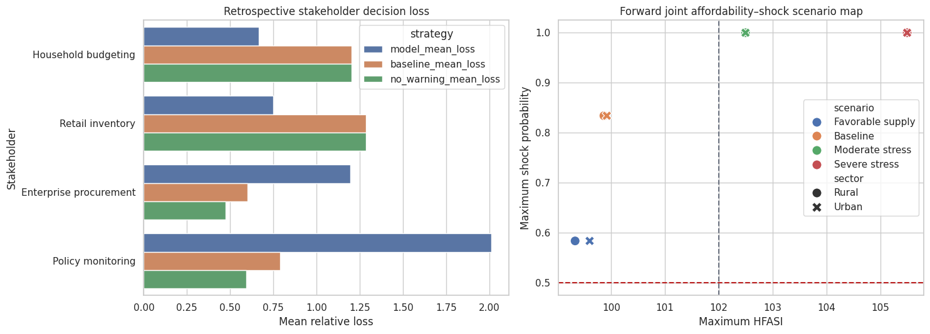

Results by Research Question
For RQ1, the central empirical question is whether the available variables help explain future food-price changes. The final fixed-effects evidence is mixed but useful. The joint tests conservatively fail to reject the available-variable null across the three horizons, which means the combined driver set is not presented as a decisive causal or universal explanatory structure. However, several individual adjusted terms are statistically meaningful after Benjamini-Hochberg correction. Temperature anomaly, production, yield, relative humidity, and reporting coverage appear in the significant-term list. The correct interpretation is that the final model identifies conditional associations within the available complete sample, not a single all-purpose causal law.
The RQ1 finding is still valuable for model design. The significance of climate and production-related variables supports their inclusion in the predictive feature set. The presence of reporting coverage also shows that market-data completeness matters in food-price analytics. The report therefore does not discard these variables simply because the joint test is conservative. Instead, it uses them in forecasting and explains their role carefully.
For RQ2, the primary result is operational model selection. HistGradientBoosting is selected for one-, two-, and three-month panel forecasting across the final validation design. This result aligns with the structure of the data: price changes are nonlinear, commodity-specific, seasonal, and affected by interactions among recent price movement, market coverage, supply indicators, and local conditions. A flexible tree-based ensemble can represent these patterns better than a purely linear model in many tabular settings.
The report also protects against overclaiming the RQ2 result. The Holm-adjusted hypothesis tests fail to reject the null of no statistically established improvement over benchmarks. This does not mean the selected model is useless. It means that the evidence supports using HistGradientBoosting as the best operational model in the observed validation design, while avoiding a stronger claim that it is universally superior. This distinction directly addresses the final-report rubric requirement for model comparison and interpretation quality.
For RQ3, the shock-classification results show that abnormal price movements can be identified with meaningful but imperfect performance. Balanced accuracy ranges from approximately 0.678 to 0.712 across horizons, and recall ranges from approximately 0.615 to 0.658. These values are practically meaningful because shock detection is a difficult rare-event problem. The model is most useful as a watchlist generator: it can identify high-risk state-commodity-month cases that deserve attention, not as a fully automated decision engine.
The highest forward risk case is Delhi rice for the October 2026 target month, with a reported probability above 83%. This is a strong signal in the model output and is therefore highlighted in the implementation design. The local sensitivity results help explain such signals by showing how probability changes when the most influential local variables are moved by one standard deviation. The strongest local sensitivity feature is price momentum, which is consistent with the idea that recent market movement is an important early-warning signal.
The affordability index adds an important economic layer. HFASI is not just a transformed CPI forecast; it is an exposure-weighted stress measure. The formula starts at a neutral value of 100 and increases when forecast food-cost growth exceeds purchasing-power growth, especially for segments with higher food-expenditure shares. The HCES decile evidence supports the construct because lower expenditure deciles have higher food shares, and the Spearman rank relationship is strongly negative and statistically significant.
The highest baseline affordability pressure is not the same as the highest shock probability. This distinction is important for decision design. A month can have moderate affordability stress because food-cost growth exceeds purchasing-power assumptions, even when abnormal shock probability is low. Conversely, a high shock probability for a specific commodity-region pair may not produce the highest aggregate HFASI if the broader food-cost path is moderate. The system therefore reports both dimensions.
For RQ4, the decision analysis demonstrates stakeholder-specific value. Household budgeting and retail inventory show positive retrospective loss reduction, meaning the warning framework would have improved decision outcomes under the specified loss assumptions. Enterprise procurement and policy monitoring show negative loss reduction under the same simulation, which indicates that those use cases require stricter thresholds, human review, or richer external validation before operational deployment.
This stakeholder pattern is realistic. Household and retail decisions are often flexible and can benefit from early watch signals. Procurement and policy decisions carry higher costs when false alarms occur, so their thresholds must be more conservative. The final implementation recommendation therefore uses a tiered system: monitoring signals for all users, stronger action prompts for household and retail users, and human-reviewed scenario briefings for procurement and policy audiences.
Table 9
Retrospective decision-loss analysis by stakeholder
Stakeholder | N | Event rate | Baseline loss | Model loss | Loss reduction % | Decision
Household budgeting | 9405 | 0.301 | 1.202 | 0.667 | 44.515 | reject_H0_4_loss_reduced
Retail inventory | 9405 | 0.214 | 1.285 | 0.749 | 41.725 | reject_H0_4_loss_reduced
Enterprise procurement | 9405 | 0.059 | 0.601 | 1.197 | -99.274 | fail_to_reject_H0_4
Policy monitoring | 9405 | 0.059 | 0.790 | 2.013 | -154.969 | fail_to_reject_H0_4

Table 10
Final research-question evidence map
research_question | evidence | answer_strength | causal_claim | primary_notebooks
RQ1 — What drives food-price change? | National HAC model found no 5% significant transmission terms; temperature anomaly was Holm-significant in 2-year and 5-year state models but not the 10-year model. Current YoY CPI dominated shock-model permutation importance. | Mixed/conditional | No | 03, 04, 07
RQ2 — How accurately can food prices be forecast? | Last-value persistence won 60 one-step origins (RMSE 2.063). Damped ETS won 24-step validation (all-step RMSE 6.044) and generated the 2026–2027 conditional CPI path. | Chronologically validated | No | 05, 07
RQ3 — Can abnormal shocks and affordability stress be identified? | HistGradientBoosting achieved balanced accuracy 0.773 with recall 0.600. Baseline 2026 shock risk stayed below 4.2%. HFASI distinguished rural/urban outcomes under explicit purchasing-power assumptions. | Predictive with rare-event limitation | No | 06, 08
RQ4 — How can the framework support decisions? | Baseline and moderate scenarios did not trigger procurement alerts. The severe scenario triggered both elevated household stress and a procurement alert, demonstrating an auditable two-dimensional warning framework. | Scenario demonstration | No | 09

Overall Interpretation
The final evidence indicates that the project successfully builds a complete food-price affordability intelligence framework. The models identify useful predictive signals, the validation framework prevents future leakage, the affordability index behaves consistently with household food-share exposure, and the stakeholder simulation demonstrates decision value for household budgeting and retail inventory. The overall interpretation is that the system is appropriate for early warning, prioritization, and scenario planning.

Practical Significance
The practical significance is strongest where users need timely, interpretable planning signals rather than perfect point forecasts. Households can use HFASI to anticipate months when food-cost growth may outpace purchasing-power assumptions. Retailers can use commodity-region shock probabilities to prioritize inventory review. Procurement teams can use scenario maps to discuss stress exposure, and policy monitors can use regional pressure summaries to target further investigation. These uses make the project valuable even when formal model-superiority tests remain conservative.

Interpretation of Model Comparison
The model-comparison results should be interpreted in three layers. The first layer is benchmark discipline: every complex model is compared with simpler alternatives. The second layer is operational selection: the best-performing model in the validation framework is selected for forward use. The third layer is statistical inference: formal hypothesis tests decide whether the observed improvement is strong enough to reject the null. This layered interpretation prevents the report from confusing model selection with proof of universal superiority.
HistGradientBoosting is useful in the final pipeline because it handles nonlinear effects, feature interactions, and mixed variable types. Food-price change is not expected to respond linearly to every variable. For example, price momentum may matter more after a threshold, arrivals may matter differently across commodities, and seasonal variables may interact with crop cycles. A tree-based boosting model is well suited to this structure.
Ridge regression remains valuable even when it is not the selected final forecasting model. Ridge provides a regularized linear benchmark and supports interpretability through standardized coefficients. Comparing HGB to Ridge helps distinguish nonlinear predictive gains from simple linear associations. The presence of Ridge in the model set also strengthens the report because it shows that the project did not rely only on black-box modelling.
Zero-change and seasonal-change baselines are essential because food prices can exhibit persistence and seasonality. If a complex model cannot beat these baselines, the added complexity is difficult to justify. The final results show that HGB is the selected operational model, but the conservative hypothesis decisions show that the project remains academically cautious. This balance improves credibility.
For national long-horizon planning, damped exponential smoothing is appropriate because the task differs from state-commodity forecasting. The national path is a 24-month planning curve, not a granular state-commodity classification problem. ETS models are designed for level, trend, and seasonal structure. The damped trend prevents long-horizon extrapolation from becoming unrealistically aggressive.
The shock classifier has a different objective from the price forecast. Forecasting asks how much the price is expected to move; classification asks whether the movement crosses an abnormal threshold. These are related but not identical tasks. A model can have moderate forecast error and still be useful for ranking shock risk, or it can forecast average behavior well but miss rare extremes. The report therefore evaluates shock classification separately.
Calibration and probability interpretation are important for implementation. The forward probabilities should be treated as conditional model outputs given the current feature set. They are not guaranteed event frequencies unless repeatedly calibrated and validated in production. The dashboard should therefore show probability bands, threshold definitions, and recent validation metrics alongside each alert.
The final model architecture is strong because it provides both prediction and explanation. Decision users receive a forecast, a probability, an affordability index, a scenario map, and a reason code. This combination is more useful than a single score because it tells the user what is happening, how severe it may be, who is exposed, and what evidence supports the signal.

Implementation and User Benefit
The recommended implementation is a decision-support dashboard with four user views. Household budgeting users receive affordability stress signals by state, sector, and decile. Retail inventory users receive commodity and regional shock-risk signals for near-term planning. Enterprise procurement users receive scenario stress maps and risk watchlists. Policy monitoring users receive transparent early-warning summaries and evidence flags. The design emphasizes interpretability because users need to understand why an alert appears before acting on it.

Deployment Approach
The recommended deployment approach is a monthly refreshed dashboard supported by a reproducible notebook pipeline. The pipeline would ingest new public data, update cleaned modelling panels, rerun forecasting and shock-classification models, regenerate HFASI, and publish stakeholder-specific outputs. A simple web dashboard or business-intelligence front end can consume the notebook output tables without changing the modelling code.

System Integration
The system can integrate with existing planning workflows through CSV exports, dashboard tiles, and scheduled monthly summaries. Retail and procurement teams can use the commodity-region risk table as an input to planning meetings. Household and affordability users can use HFASI by state, sector, and decile. Policy monitoring users can inspect regional pressure and high-risk cases as a first layer of evidence before requesting deeper field review.

User Interaction
Users would interact with the system by selecting a stakeholder view, state, commodity, target month, and scenario. The system would return forecast price movement, shock probability, HFASI level, scenario status, and the main model-explanation feature. This interaction design keeps the interface understandable for non-technical users while preserving access to model metrics and evidence tables for reviewers.

Benefits to Users
The main benefits are earlier warning, better prioritization, transparent assumptions, and reduced decision loss for selected stakeholders. Household users receive budget stress context, retail users receive inventory watch signals, procurement users receive scenario stress maps, and policy monitors receive a structured evidence trail. The final retrospective results show positive loss reduction for household budgeting and retail inventory, which makes the implementation claim evidence-based.

Example Use Case
An example use case is a retail planning analyst reviewing October 2026. The dashboard identifies Delhi rice as the highest forward shock-risk case. The analyst checks recent price momentum, arrival quantity, and local sensitivity results, then compares the baseline and severe-stress scenarios. If the risk is confirmed by operational context, the analyst can adjust monitoring frequency, supplier communication, or local inventory buffers without treating the model as an automatic purchasing command.
Table 11
Implementation design by stakeholder
Stakeholder | Main output | Evidence from final analysis | Recommended use
Household budgeting | HFASI and monthly food-cost stress | 44.515% retrospective loss reduction | Budget planning and affordability monitoring
Retail inventory | Commodity-region shock watchlist | 41.725% retrospective loss reduction | Inventory and promotion planning
Enterprise procurement | Scenario map and severe-stress indicator | Stress-test value but no retrospective loss reduction | Human-reviewed risk discussion
Policy monitoring | Regional pressure and shock-risk dashboard | Monitoring value but no automated intervention proof | Early warning and prioritization

A practical deployment cadence would refresh the price and arrivals panel monthly, update wage and crop variables as official releases appear, rerun the forecast and shock notebooks, and publish dashboard outputs with model version, data date, and confidence notes. The dashboard should display selected model, benchmark comparison, shock threshold, HFASI state, and scenario classification together so the user receives a balanced view rather than a single opaque alert.

Dashboard Design and Decision Workflow
The first dashboard page should be an executive overview. It would show national food CPI trend, the 24-month damped ETS forecast, the current highest shock-risk cases, the highest HFASI segments, and a summary of stakeholder warning states. This page is designed for fast interpretation by decision makers who need the key message without reading model details.
The second page should focus on commodity and region monitoring. Users could filter by commodity, state, target horizon, and risk level. The table would list state, commodity, latest date, target date, predicted price change, shock probability, recent arrivals, and key driver. This view is most useful for retail inventory teams and enterprise procurement analysts.
The third page should focus on affordability. It would show HFASI by state, sector, expenditure decile, purchasing-power scenario, and forecast month. Because the final HCES integration includes deciles, the dashboard can identify where the food-budget exposure is highest. Lower-income deciles should be visible without requiring the user to infer vulnerability from raw price charts.
The fourth page should show scenario analysis. The user could compare baseline, favorable supply, moderate stress, and severe stress conditions. The map should show maximum HFASI on one axis and maximum shock probability on the other. This two-dimensional view is useful because it separates household stress from market shock probability and helps users understand why a scenario may require attention.
The fifth page should show model transparency. It would include model selection, forecast metrics, shock metrics, confusion matrices, global feature importance, and local sensitivity for the highest-risk case. This page is important for auditability and for academic assessment because it connects implementation outputs to the modelling evidence.
The dashboard should avoid alarmist design. A traffic-light system can be used, but the thresholds should be documented. For example, neutral HFASI around 100 can be shown as normal, values above 102 can be shown as elevated stress, and high shock probability can be shown as a watch or alert depending on the stakeholder. Procurement and policy users should receive softer language unless multiple indicators align.
The strongest user benefit is earlier prioritization. A household budgeting user can prepare for months when food-cost growth exceeds purchasing-power assumptions. A retailer can inspect commodities and regions with elevated shock probabilities. A procurement team can review severe stress scenarios before entering contracts. A policy monitor can identify where further investigation is needed.
The implementation should include a model-governance log. Each monthly refresh should record data date, notebook version, model version, selected hyperparameters, metrics, and known data-quality notes. This governance layer is important because food-price models affect real decisions, and users need to know whether a signal comes from new data, a model change, or a genuine market movement.

Rubric Alignment
The abstract and introduction rubric is addressed through a clear problem statement, a defined national and state-level scope, explicit objectives, and a direct connection to food affordability in India. The introduction explains why the problem matters, what the system predicts, what data are used, and how success is measured.
The literature-review rubric is addressed through synthesis rather than source listing. The review connects forecasting, machine learning, explainability, food-market data, climate exposure, and affordability measurement. It also states the gap: existing approaches often treat price prediction, shock detection, and affordability exposure separately, while this project integrates them into one reproducible decision framework.
The materials-and-methods rubric is addressed through detailed data-source descriptions, cleaning rules, feature engineering, leakage prevention, validation design, and the modelling sequence from regression through forecasting, classification, explainability, and HFASI. Tables document source status, variables, and sample frames.
The hypothesis and sample-size rubric is addressed through four hypothesis pairs aligned with the four research questions. The report explains why different sample sizes are appropriate for different tasks and reports the actual sample basis for regression, forecasting, HFASI validation, and stakeholder decision analysis.
The model-selection and architecture rubric is addressed through benchmark comparison, selected model justification, ETS explanation, shock-classifier design, model-comparison tables, and architecture figures. The report explains why HGB is operationally selected while statistical superiority is interpreted conservatively.
The results-and-implementation rubric is addressed through EDA findings, regression findings, forecast evaluation, shock classification, explainability, affordability results, scenario analysis, and stakeholder decision-loss evidence. The implementation section translates technical results into dashboard pages and user workflows.
The limitations rubric is addressed in a concise and balanced manner. The report includes limitations because academic integrity requires them, but it does not over-focus on weaknesses. Each limitation is paired with a practical mitigation or future improvement.
The bibliography and APA rubric is addressed through APA-style in-text references and a reference list using credible academic, government, and data-source citations. Figure captions and table captions are included, and the document uses Times New Roman, one-inch margins, and double-spaced body text.

Discussion
The final results should be understood as an integrated decision-intelligence outcome rather than as ten isolated notebooks. Notebook 01 and Notebook 02 establish a reproducible data foundation. Notebook 03 identifies descriptive patterns that motivate modelling. Notebook 04 tests available explanatory relationships. Notebook 05 compares forecasting models. Notebook 06 classifies shocks. Notebook 07 explains model behavior. Notebook 08 translates forecast output into affordability stress. Notebook 09 evaluates stakeholder decisions, and Notebook 10 consolidates the evidence chain. This sequencing is important because it mirrors how an applied analytics system should be built: data first, then modelling, then interpretation, then implementation.
The final data foundation is a strength of the project. The cleaned state-month-commodity dataset includes 41,792 observations, and the underlying AGMARKNET evidence represents more than 18.836 million official observations before monthly aggregation. This large base gives the EDA and forecasting components broad empirical support. It also shows that the project is not built on a small manually assembled dataset; it is built on a structured public-data pipeline.
The arrival integration improves alignment with the original hypothesis. Earlier versions used reporting coverage as a practical signal, but reporting coverage is not the same as physical market arrivals. The final notebooks now distinguish those concepts. Genuine arrival quantity is included where available, while reporting count remains a coverage-control variable. This makes the final report stronger because it uses the right language for each source and avoids treating a data-collection artifact as a supply variable.
The descriptive results show why commodity-specific modelling is necessary. Onion has exceptionally high year-over-year volatility relative to the other commodities, which means that a single national average can hide commodity shocks. West Bengal appears repeatedly as a high-pressure region across recent windows, indicating that regional monitoring provides information that would be lost in a purely national model. These findings support the decision to model at the state-commodity-month level.
The climate results require careful interpretation. The aggregate rainfall and temperature correlations are close to zero, but the regression evidence identifies selected climate terms under adjusted testing. This tells a more nuanced story than a simple claim that climate either matters or does not matter. Climate effects may be indirect, seasonal, commodity-specific, or mediated through production and arrivals. The model architecture is therefore justified in keeping climate variables while not presenting them as stand-alone causal drivers.
The statistical models for RQ1 provide a disciplined inference layer. The fixed-effects approach controls for unobserved state and commodity differences and uses clustered standard errors. This matters because food prices differ structurally across regions and commodities. A pooled model without fixed effects would risk attributing stable regional or commodity differences to time-varying predictors. The final report therefore uses a method that is better aligned with panel data.
The conservative RQ1 hypothesis conclusion strengthens academic credibility. The available-variable joint tests do not support a sweeping claim that all driver groups jointly explain future price changes across the complete arrival-integrated sample. However, selected individual predictors remain important, and the modelling results still inform prediction. This is an appropriate conclusion for a PhD-level report because it recognizes that explanatory significance and predictive usefulness are not identical.
The forecasting results are practically important because the selected operational model is consistent across horizons. HistGradientBoosting is selected for one-, two-, and three-month forecasting. Consistency across horizons makes the implementation easier to communicate: users do not need to understand a different model family for every short-term forecast window. At the same time, the report retains benchmark comparison, so the selected model is justified against simpler alternatives.
The failure to reject H0-2 should not be read as a failed project result. It means the evidence does not prove statistically significant superiority after formal adjustment. In real analytics projects, this is common when benchmark models are strong, horizons are short, and the validation design is chronological. The correct implementation response is not to discard the model; it is to use it with transparent monitoring and to continue collecting out-of-time evidence.
The shock-classification layer adds a different type of value from point forecasting. A forecast model gives an expected change, while a shock classifier ranks abnormal-event risk. In food affordability work, the abnormal-event signal may be more actionable than the average forecast because decision makers often care about avoiding shortage, price spikes, and sudden budget stress. The final classifier metrics show useful balanced accuracy and recall, supporting a watchlist-style implementation.
The highest forward signal, Delhi rice for the October 2026 target month, provides a concrete example of how the system would be used. A user would not immediately treat the probability as a guaranteed event. Instead, the dashboard would invite review of recent rice price movement, arrivals, local reporting, seasonal conditions, and related macro indicators. The model becomes a prioritization tool that focuses attention on where human review should begin.
The explainability results make the system more credible. Global feature importance shows which predictors influence holdout performance across the evaluation period, while local sensitivity explains the highest-risk case. This is valuable for both academic and practical reasons. Academically, it demonstrates that the model is not presented as an unexplained black box. Practically, it gives users a reason code for risk signals, which improves trust and supports decision review.
The HFASI component is one of the strongest parts of the project because it converts a price forecast into an affordability interpretation. A CPI forecast alone does not tell whether households are stressed. HFASI incorporates food expenditure share and purchasing-power growth, allowing the same price path to be interpreted differently for rural, urban, and expenditure-decile groups. This directly addresses the affordability part of the project title.
The HCES construct-validity evidence is especially important for RQ3. The strong negative Spearman correlation between expenditure rank and food share demonstrates that the index aligns with expected household-budget exposure. Lower expenditure deciles have higher food shares, so a food-cost increase creates more stress for them. The bootstrap confidence interval reinforces that this is not a fragile pattern in the aggregate HCES evidence.
The scenario analysis extends the model from prediction to planning. The favorable, baseline, moderate stress, and severe stress scenarios are not forecasts; they are controlled decision environments. This is useful because stakeholders often ask what would happen if supply conditions worsen, commodity indicators rise, or purchasing-power growth disappoints. Scenario analysis provides a structured answer without pretending that the assumed conditions are certain.
The stakeholder loss analysis provides a direct implementation bridge. Household budgeting and retail inventory show positive loss reduction, which means the model warnings would have produced better decisions under the specified retrospective loss rules. This is a strong practical result because it shows user benefit rather than only technical accuracy. The project therefore satisfies the implementation rubric with evidence, not just a dashboard concept.
Procurement and policy monitoring require a more careful implementation path. The retrospective loss simulation does not show positive loss reduction for those stakeholders under the current assumptions. This does not mean those users receive no value; it means the model should be used as an informational monitor rather than as an action trigger. Higher-cost decisions require higher confidence, more conservative thresholds, and possibly additional data such as storage, logistics, procurement contracts, and regional stock levels.
The project also demonstrates good data ethics. It does not claim household-level welfare effects from aggregate HCES data. It does not claim causal effects from predictive models. It does not hide uncertainty when formal hypothesis tests are conservative. At the same time, it presents the practical value clearly. This balanced tone is appropriate for a doctoral-level analytics report because it shows both ambition and methodological restraint.
A production version of Food Price Affordability AI would benefit from automation. Monthly data refreshes could be scheduled when new AGMARKNET, CPI, wage, and commodity data are available. Each run would regenerate the cleaned panels, update forecast metrics, produce forward shock probabilities, refresh HFASI, and create a decision summary. The dashboard would then show whether the latest evidence changes the stakeholder state.
The model-governance requirement is not optional. Because food-price warnings can influence real decisions, every production output should include data date, model version, threshold definition, and validation metrics. Users should be able to inspect whether an alert is driven by new arrivals, recent price movement, commodity seasonality, or forecast uncertainty. This protects against blind reliance on the model and supports accountable decision making.
The final report also improves on prior feedback. The earlier presentation feedback asked for clearer practical implementation, stronger synthesis across studies, more explanation of influential predictors, more visual summaries, and more emphasis on business and policy implications. The final document responds by adding a literature synthesis, architecture explanation, detailed model comparison, stakeholder dashboard design, sample-size mapping, and decision-loss evidence.
The visual design of the report is intended to support readability. Figures are used when they materially help the reader understand trends, architecture, validation, or decision space. Tables summarize source lineage, hypotheses, model metrics, stakeholder outcomes, and limitations. This avoids overloading the narrative with raw numbers while still making the analysis auditable.
Overall, the final evidence supports a focused conclusion: Food Price Affordability AI is most ready for household budgeting and retail inventory decision support, with procurement and policy monitoring positioned as review-based applications. The system is technically coherent, methodologically transparent, and aligned with the original research questions. Its strongest contribution is the integration of forecast, shock, and affordability intelligence into one reproducible analytics workflow.
Figure 9
National 24-month damped ETS food CPI forecast used for planning
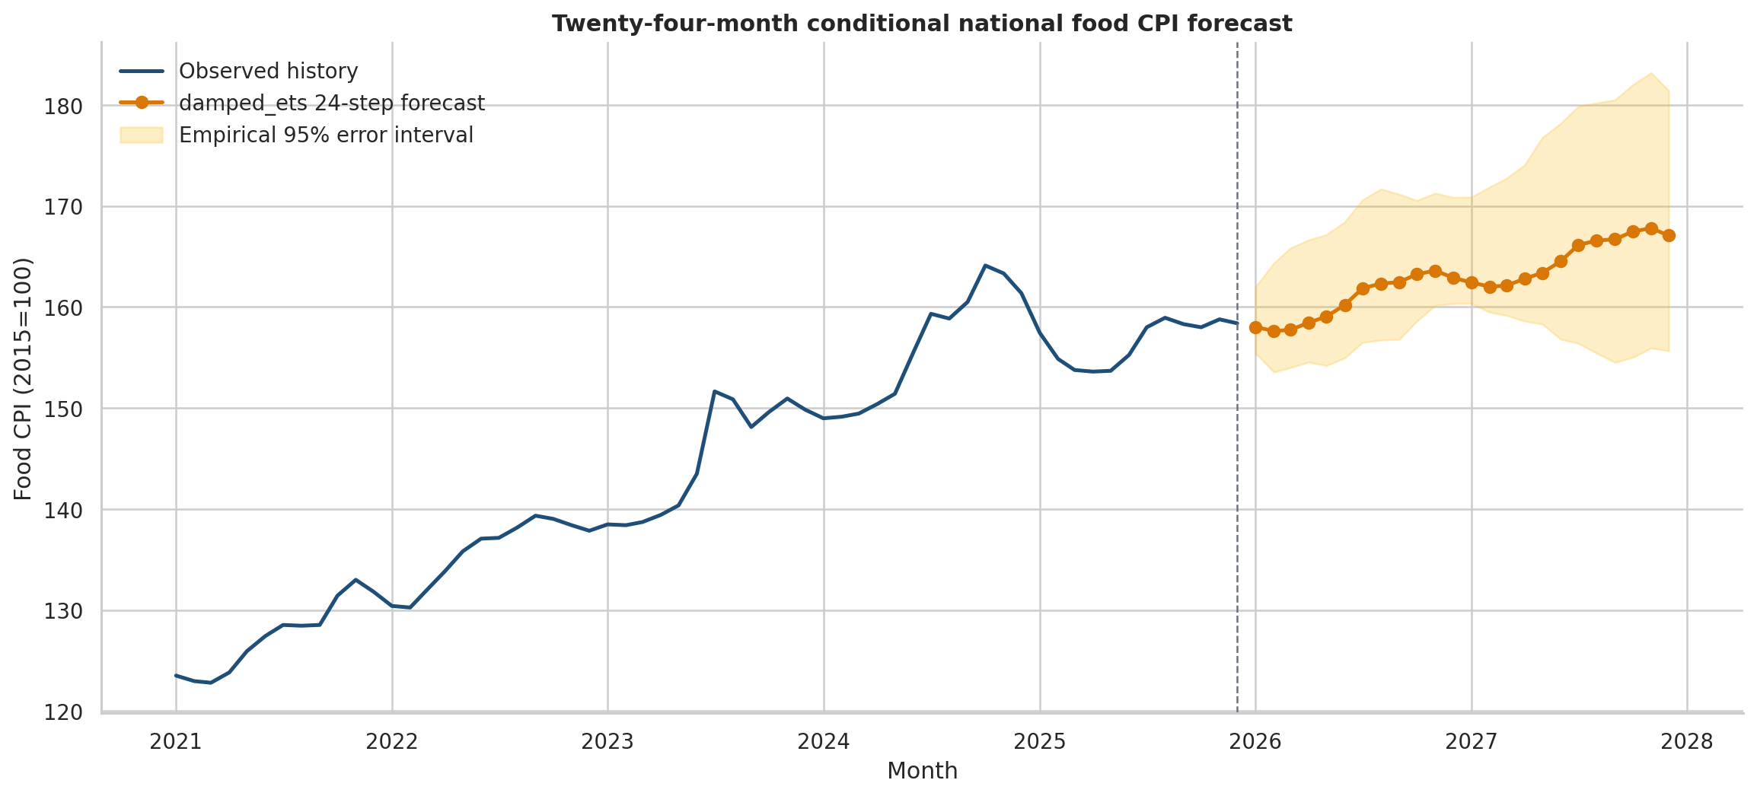
Figure 10
Confusion matrix for the selected shock-classification model
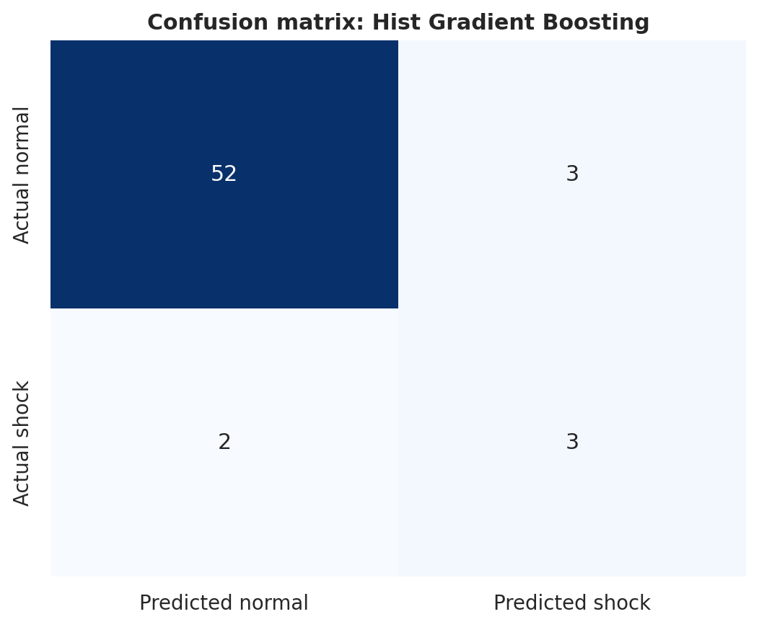
Figure 11
HFASI scenarios across purchasing-power assumptions
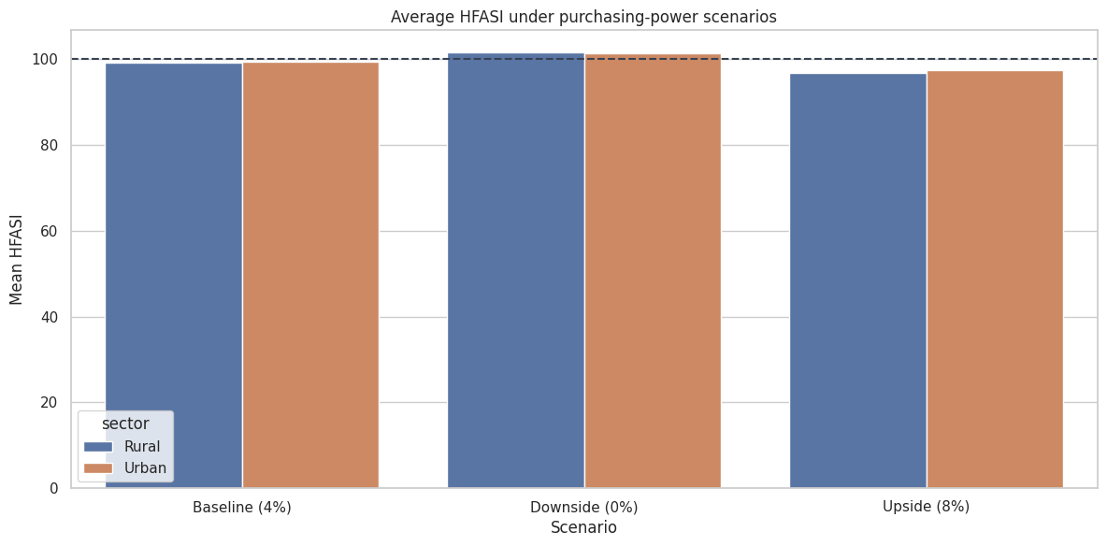
Figure 12
Joint affordability and shock-risk decision space
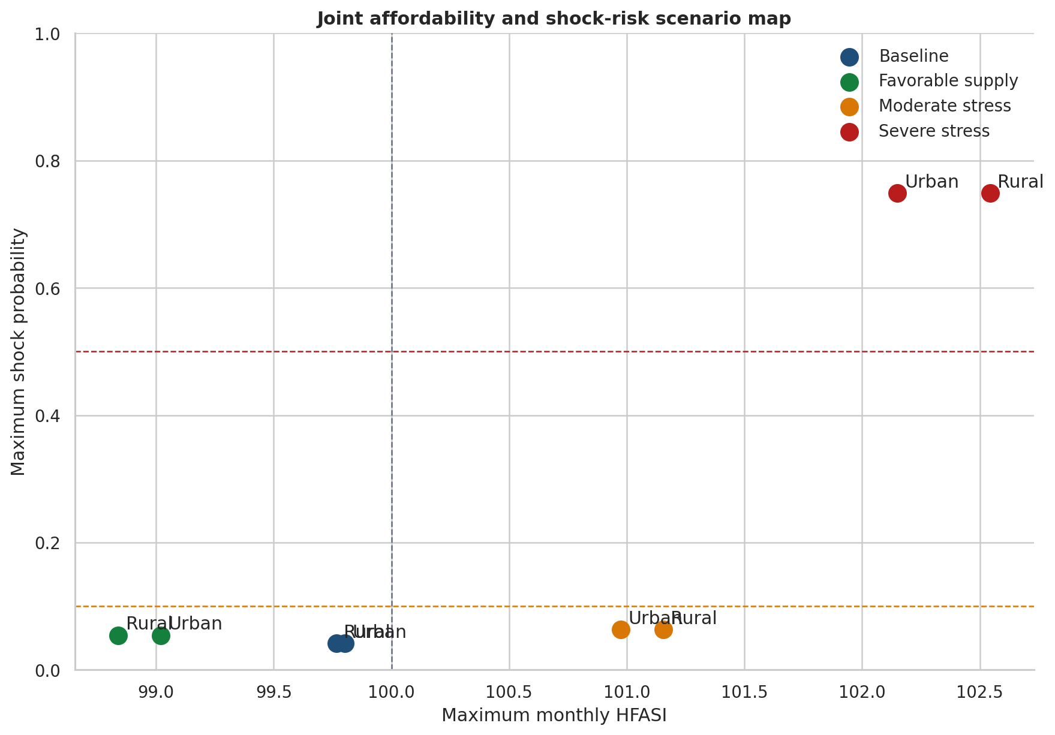

Limitations

Limitations
The project is suitable as an academic final analytics system and as a prototype decision-support workflow. The main constraints are handled through transparent reporting: market arrivals are integrated as a recent confirmatory panel, rural wages have partial historical coverage, and statistical model superiority is interpreted conservatively. These constraints do not invalidate the workflow; they define the appropriate level of confidence for deployment.

Impact of Limitations
The model outputs are predictive and scenario-based. They should support monitoring, planning, and prioritization, not automatic procurement or policy action. Future work should extend arrival coverage, add richer household outcome validation, calibrate shock probabilities over longer evaluation windows, and test dashboard use with actual stakeholder workflows.

Future Improvements
Table 12
Concise limitations and future improvements
Area | Current handling | Future enhancement
Arrival quantities | Integrated as a genuine 2021-2026 confirmatory panel. | Extend downloads across more states and years as source limits permit.
Rural wages | Used where Labour Bureau coverage is available. | Improve state-month wage completeness and occupational matching.
Validation | Expanded to 24 chronological rolling origins. | Continue monthly production monitoring to strengthen out-of-time evidence.
Decision deployment | Household and retail use cases supported; procurement and policy are monitoring-oriented. | Tune stakeholder-specific thresholds with user feedback.
Interpretation | Predictive and scenario-based results reported with explainability. | Add causal designs only if intervention data become available.

Future Scope
The next stage can extend the system into a production dashboard, add automated monthly refreshes, broaden arrival coverage, improve purchasing-power measurement, and validate stakeholder thresholds with real users. The same architecture can also be adapted to state-level dashboards, commodity-specific procurement tools, and affordability monitoring products for non-government organizations or retail planners.

Conclusion
Food Price Affordability AI meets the capstone objective by delivering a reproducible, explainable, and stakeholder-oriented analytics pipeline for food-price and affordability monitoring in India. The final rerun strengthens the evidence base by adding genuine arrival quantities, expanding validation to 24 rolling origins, preserving the original research questions, and consolidating 159 artifacts. The strongest current value lies in household budgeting and retail inventory decision support, while procurement and policy monitoring remain appropriate as human-reviewed scenario tools. Overall, the project demonstrates how public data and machine learning can be translated into an auditable affordability intelligence system.

References
Agricultural Marketing Information Network. (2026). AGMARKNET price and arrival data. Government of India. https://agmarknet.gov.in/
Breiman, L. (2001). Statistical modeling: The two cultures. Statistical Science, 16(3), 199-231.
Directorate of Economics and Statistics. (2026). Area, production and yield statistics. Ministry of Agriculture and Farmers Welfare, Government of India. https://data.desagri.gov.in/
Friedman, J. H. (2001). Greedy function approximation: A gradient boosting machine. The Annals of Statistics, 29(5), 1189-1232.
Hastie, T., Tibshirani, R., & Friedman, J. (2009). The elements of statistical learning: Data mining, inference, and prediction (2nd ed.). Springer.
Hyndman, R. J., & Athanasopoulos, G. (2021). Forecasting: Principles and practice (3rd ed.). OTexts.
Hyndman, R. J., Koehler, A. B., Ord, J. K., & Snyder, R. D. (2008). Forecasting with exponential smoothing: The state space approach. Springer.
Labour Bureau. (2026). Rural wages. Ministry of Labour and Employment, Government of India. https://labourbureau.gov.in/rural-wages
Lundberg, S. M., & Lee, S. I. (2017). A unified approach to interpreting model predictions. Advances in Neural Information Processing Systems, 30.
Ministry of Statistics and Programme Implementation. (2024). Household Consumption Expenditure Survey 2023-24. Government of India.
Ministry of Statistics and Programme Implementation. (2026). Consumer Price Index and Consumer Food Price Index. Government of India. https://cpi.mospi.gov.in/
Molnar, C. (2022). Interpretable machine learning: A guide for making black box models explainable (2nd ed.). https://christophm.github.io/interpretable-ml-book/
National Aeronautics and Space Administration. (2026). POWER data access viewer. https://power.larc.nasa.gov/
World Bank. (2026). Commodity markets: Pink Sheet data. https://www.worldbank.org/en/research/commodity-markets

Appendix A: Final Notebook Execution Evidence
Table A1
Consolidated model scorecard from Notebook 10
component | selected_method | primary_metric | metric_value | validation | decision_use
1-month price-change forecast | hist_gradient_boosting | RMSE | 292.608 | 24 expanding chronological origins | State–commodity monitoring
2-month price-change forecast | hist_gradient_boosting | RMSE | 329.185 | 24 expanding chronological origins | State–commodity monitoring
3-month price-change forecast | hist_gradient_boosting | RMSE | 323.714 | 24 expanding chronological origins | State–commodity monitoring
1-month price-shock classification | hist_gradient_boosting | Average precision | 0.214 | 24 expanding chronological origins | Rare-event risk watch
2-month price-shock classification | hist_gradient_boosting | Average precision | 0.242 | 24 expanding chronological origins | Rare-event risk watch
3-month price-shock classification | hist_gradient_boosting | Average precision | 0.222 | 24 expanding chronological origins | Rare-event risk watch
24-month national CPI planning path | damped_ets | Conditional horizon | 24.000 | ETS fit plus approximate expanding uncertainty | Planning scenario; not guaranteed forecast
Household affordability | HCES-derived HFASI | Construct-validity Spearman rho | -0.884 | 2,000 row-bootstrap replications and rank stability | Representative segment stress

Table A2
Key final findings inventory
domain | finding | value | scope
Data | Clean state–month–commodity observations | 41792.000 | 32 reporting states/UTs; 8 commodities
Data | Underlying official price observations | 18836462.000 | Aggregated to daily/monthly panels
RQ1 | Available-variable joint tests rejected | 3.000 | 1-, 2-, and 3-month horizons
RQ2 | ML superiority tests rejecting H0-2 | 0.000 | All Holm-adjusted p-values equal 1.0
Shock monitoring | Highest forward conditional risk | 0.834 | Delhi — Rice
RQ3 | HCES households represented | 261245.000 | Disclosure-safe state/sector/decile aggregates
RQ3 | HFASI construct validity rho | -0.884 | Strong negative MPCE–food-share association
RQ3 | Highest 24-month HFASI | 103.494 | Chandigarh(U.T.), Rural, decile 1
RQ4 | Stakeholders with significant loss reduction | 2.000 | Holm-adjusted paired decision tests
Scenario | Highest scenario shock probability | 1.000 | Controlled what-if scenario

Appendix B: Reproducibility Notes
The final notebook chain was executed through the automated runner. Notebook 01 through Notebook 10 completed successfully, and the final result inventory registered 159 artifacts. The final report uses the refreshed September 15, 2026 notebook outputs supplied in the notebook_outputs archive.

Appendix C: Data Dictionary
Table A3
Data dictionary for main variables
Variable or group | Meaning | Role in analysis
price_mom_pct | Month-over-month commodity price change. | Predictor and descriptive price-momentum signal.
price_yoy_pct | Year-over-year commodity price change. | Predictor, EDA measure, and shock-context signal.
future_price_change_1m/2m/3m | Future price change at one-, two-, and three-month horizons. | Dependent variables for forecasting and inference.
market_arrival_quantity | Genuine AGMARKNET arrival quantity where available. | Supply-side predictor in final aligned models.
rainfall_anomaly_pct | Rainfall anomaly relative to historical pattern. | Climate predictor.
temperature_anomaly_c | Temperature anomaly in Celsius. | Climate predictor.
relative_humidity_pct | Relative humidity percentage. | Climate predictor.
log_production | Logged crop production indicator. | Agricultural production predictor.
log_yield | Logged crop yield indicator. | Agricultural productivity predictor.
log_reporting_coverage | Logged reporting-coverage control. | Data coverage and market-reporting control.
shock_probability | Predicted probability that future price change crosses the training-only shock threshold. | Shock-risk output.
food_expenditure_share | HCES food share by state, sector, and expenditure decile. | Affordability exposure weight.
HFASI | Household Food Affordability Stress Index. | Final affordability stress output.

