Data Analytics Capstone
Forecasting Essential Food Price Shocks and Household Affordability Stress in India
An Explainable AI Decision-Intelligence Framework Using Public Market, Agricultural, Climatic, and Economic Data
Interim Report
Piyush Soni
Walsh College
QM640: Data Analytics Capstone
Mentor: Prof. Rishabh Pandey
Summer 2026 Term
July 28, 2026

GitHub Repository and Project Status
The public repository containing the permitted data, acquisition and analysis code, notebooks, documentation, and report materials is: https://github.com/piyushsoni88/qm640-food-affordability-ai
Curated data: https://github.com/piyushsoni88/qm640-food-affordability-ai/tree/main/data/curated - compressed evaluator-accessible analytical source files
Data dictionary: https://github.com/piyushsoni88/qm640-food-affordability-ai/blob/main/data/data_dictionary.csv - variable definitions and transformations
Source manifest: https://github.com/piyushsoni88/qm640-food-affordability-ai/blob/main/data/source_manifest.csv - source URLs, provenance, and coverage
Executed workflow: https://github.com/piyushsoni88/qm640-food-affordability-ai/tree/main/notebooks - ten Colab-compatible notebooks from acquisition through consolidation
Reusable scripts: https://github.com/piyushsoni88/qm640-food-affordability-ai/tree/main/scripts - parameterized collection, transformation, and report builders
Report outputs: https://github.com/piyushsoni88/qm640-food-affordability-ai/tree/main/reports - figures, tables, model cards, and Word report

Interim Project Status (Progress Snapshot)
Completed: public-data acquisition, lineage controls, cleaning, exploratory analysis, statistical modeling, forecasting, shock classification, explainability, affordability indexing, stress scenarios, and final evidence consolidation.
Completed: 10 sequential notebooks executed successfully; Notebook 10 verified nine upstream summaries and inventoried 98 report artifacts.
In progress: final narrative packaging and synchronized GitHub publication of the executed notebooks and report.
Pending for the final study: licensed HCES microdata extraction, independent household-level validation, broader decision-loss backtesting, and monitored deployment testing.
Table 1
Interim analytical snapshot
Evidence layer | Verified result | Coverage / interpretation
Curated analytical rows | 1,494,745 | Permitted compressed files across official and multilateral sources
AGMARKNET aggregate | 969,377 rows | Represents 18,836,462 underlying official price observations
Clean state panel | 41,792 rows | 32 reporting states/UTs; 8 commodities; 2001-2026 YTD
National panel | 319 months | January 2000-July 2026; food CPI observed through December 2025
Note. Large or restricted raw archives remain local and are recreated through documented scripts; no credentials or unauthorized microdata are committed.

Introduction

Background and Context
Food-price volatility is simultaneously a household-welfare problem, a procurement risk, and a policy-monitoring challenge. Rice, wheat, onion, potato, tomato, pulses, edible oil, and sugar differ in production cycles, storability, market concentration, and transport exposure. Their prices can respond to crop losses, market-arrival contractions, fuel costs, trade restrictions, festival demand, and storage constraints. When signals are detected only after retail prices rise, households lose purchasing power and food-sector enterprises face margin compression, stock-outs, or emergency purchases.
The welfare effect is unequal because food absorbs a larger share of household expenditure in rural and lower-income settings. The Household Consumption Expenditure Survey (HCES) 2022-2023 reports food shares of approximately 46.3% of rural Monthly Per Capita Consumption Expenditure and 39.1% of urban expenditure (Ministry of Statistics and Programme Implementation [MOSPI], 2024). A useful system must therefore do more than forecast an index: it must disclose uncertainty, explain predictive signals, and translate expected cost pressure into a segment-sensitive affordability measure.
India offers rich but fragmented public data. AGMARKNET provides official mandi observations; FAOSTAT supplies standardized agricultural and price series; NASA POWER provides reproducible climate histories; and the World Bank Pink Sheet provides monthly global commodity and energy benchmarks. Combining these sources supports a longitudinal state-commodity panel and a national forecasting panel, while also introducing differences in frequency, units, reporting completeness, and release timing that require explicit lineage and quality controls.

Problem Statement
Indian households and food-sector enterprises face recurring uncertainty because essential-food prices are volatile, geographically uneven, and shaped by interacting climatic, seasonal, agricultural, market, and macroeconomic forces. Although relevant public data exist, they are commonly used for retrospective monitoring in separate systems. The operational gap is an integrated and explainable early-warning workflow that compares transparent baselines with machine learning, quantifies uncertainty, detects abnormal inflation risk, and converts forecast food-cost pressure into an interpretable affordability measure.

Purpose of the Study
This quantitative longitudinal study develops and validates a reproducible decision-intelligence framework for essential-food price risk and household affordability stress in India. The original four-part design is retained without redefinition: explain future commodity-price changes, compare statistical and machine-learning forecasts, validate HFASI across household segments, and test whether model-driven warnings improve decisions. The national food CPI, aggregate rural/urban HFASI, and scenario outputs reported here are interim operational evidence within that design, not substitutes for the originally proposed commodity-region, household-validity, and decision-loss tests. Chronological validation prevents look-ahead bias, while explainability and uncertainty reporting prevent black-box overstatement.

Scope and Objectives
The confirmatory scope remains the eight-commodity, commodity-region-month design proposed in the synopsis, with one-, two-, and three-month price and shock horizons and household-segment affordability validation. The implemented interim panel expands coverage to all available reporting states and union territories: 41,792 cleaned state-month-commodity observations from January 2001 through July 2026. A 319-row national monthly panel from January 2000 through July 2026 supplies an additional benchmark, with food CPI observed through December 2025. The interim two-, five-, and ten-year analyses, one-step and 24-step national forecasts, and 2026 scenarios supplement rather than replace the original confirmatory solution.

Research Question 1 (RQ1)
Which lagged-price, market-arrival, climatic, seasonal, agricultural-production, and macroeconomic variables significantly influence one- to three-month essential-food price changes in India?

Research Question 2 (RQ2)
Do machine-learning and ensemble models predict essential-food prices and price shocks more accurately than conventional statistical forecasting models?

Research Question 3 (RQ3)
How can forecasted commodity-price changes be translated into a statistically reliable, interpretable, and stable Household Food Affordability Stress Index across rural, urban, and expenditure segments?

Research Question 4 (RQ4)
How effectively can the proposed early-warning framework support household budgeting, retail inventory, enterprise procurement, and policy-monitoring decisions under alternative supply and price scenarios?

Original Hypotheses and Variables (Retained)

RQ1 Driver Hypothesis
Dependent variable: one-, two-, or three-month future essential-food price change. Primary independent variables: lagged commodity price, market arrivals, rainfall anomaly, crop production/yield, fuel or logistics cost, and wage or macroeconomic growth; commodity, region, season, trend, market structure, and data-quality indicators are controls. H0-1: after controls, the joint coefficients of the pre-specified predictors equal zero. H1-1: at least one pre-specified predictor has a nonzero association with future essential-food price change.

RQ2 Forecast-Accuracy Hypothesis
Outcome variables: out-of-sample MAE, RMSE, MASE, shock-classification loss, and the paired loss differential. Comparison variables: model family, statistical baseline, forecast horizon, commodity/region, and forecast origin. H0-2: the expected loss of the best machine-learning or ensemble model is equal to or greater than that of the best statistical baseline. H1-2: at least one machine-learning or ensemble model has lower expected loss under chronological validation.

RQ3 HFASI-Validity Hypothesis
Outcome variables: HFASI, independently observed real food-cost pressure, criterion-validity correlation, and household-segment rank stability. Component and grouping variables: forecast commodity-price growth, food-expenditure share, nominal wage/income growth, rural/urban status, expenditure fractile, and reference window. H0-3: HFASI has zero or negative association with observed pressure and unstable segment rankings. H1-3: HFASI has a positive association with observed pressure and stable rankings under reasonable weights and normalization choices.

RQ4 Decision-Value Hypothesis
Outcome variables: household-budget loss, inventory or procurement loss, alert precision/recall, and paired decision-loss improvement. Decision variables: model alert or shock probability, HFASI level, warning lead time, scenario severity, and strategy type (model-driven, no-warning, or seasonal-naive). H0-4: model-driven alerts do not reduce retrospective decision loss. H1-4: model-driven alerts produce a positive reduction in paired retrospective decision loss.
Note. Interim-status rule: available notebook outputs may provide partial evidence for a hypothesis, but they do not redefine its variables, population, horizon, or planned confirmatory test.

Measurable Objectives
Create an auditable public-data pipeline with source manifests, data dictionary, quality flags, exact calendar lags, and reproducible Colab notebooks.
Compare persistence, seasonal-naive, regularized regression, tree ensembles, and damped exponential smoothing with expanding chronological validation.
Evaluate rare-event classification using balanced accuracy, precision, recall, specificity, F1, ROC-AUC, average precision, Brier score, and a confusion matrix.
Construct HFASI with published rural/urban food shares, explicit purchasing-power assumptions, forecast uncertainty, and sensitivity analysis.
Demonstrate an evidence-bounded decision framework without converting predictive associations into causal claims or automatic policy triggers.

Literature Survey

Literature Review Approach
Sources were selected from peer-reviewed journals, conference proceedings, systematic reviews, and official statistical publications using combinations of agricultural price forecasting, food inflation, price shock, explainable machine learning, forecast evaluation, household affordability, and India. Inclusion required direct relevance to at least one research question, a described method, and a traceable publication. Studies relying on random train-test splits were retained as domain context but not treated as temporal-validation benchmarks.
Table 2
Literature relevance matrix
Source | Domain / context | Method | Key finding and project relevance
Akter & Basher (2014) | Household welfare | Shock/welfare analysis | Food and income shocks reduce welfare; supports RQ3 segment sensitivity.
Cattaneo et al. (2023) | Diet affordability | Policy synthesis | Links price shocks to diet affordability and mitigation; supports RQ3/RQ4.
Hyndman & Koehler (2006) | Forecast evaluation | Metric analysis | Clarifies scale-dependent and scaled errors; supports RQ2 metrics.
Makridakis et al. (2018) | Forecast comparison | Empirical review | Warns that complex ML does not always beat statistical baselines; supports RQ2.
Jain et al. (2020) | Crop-price forecasting | Quality-aware framework | Makes data quality part of forecasting design; supports RQ1/RQ2.
Madaan et al. (2019) | Indian commodities | Forecasting/anomaly detection | Shows value of joint forecast and anomaly workflows; supports RQ2/RQ3.
Ma et al. (2019) | Indian produce prices | Interpretable collaborative filtering | Demonstrates farmer-facing interpretable price predictions; supports RQ2/RQ4.
Bhardwaj et al. (2023) | Agricultural forecasting | Deep learning | Shows nonlinear predictive capacity but reinforces sample-size needs; supports RQ2.
Lundberg & Lee (2017) | Model interpretation | SHAP theory | Provides a framework for local/global predictive explanation; supports RQ1.
Theofilou et al. (2025) | Staple-crop forecasting | Systematic review | Identifies gaps in external variables, interpretability, and validation; supports all RQs.

Thematic Synthesis
First, the forecasting literature favors strong baselines and time-aware evaluation. Hyndman and Koehler (2006) show that error measures answer different questions, while Makridakis et al. (2018) caution that algorithmic complexity is not synonymous with accuracy. This evidence directly motivated separate one-step and 24-step backtests, expanding rather than shuffled validation, and the requirement that a complex model beat naive persistence before promotion.
Second, agricultural forecasting depends on data quality and context. Jain et al. (2020) emphasize quality-aware time-series design, and Madaan et al. (2019) connect price prediction with anomaly detection in India. Ma et al. (2019) demonstrate the value of interpretable outputs for marginal users, whereas Bhardwaj et al. (2023) illustrates the capacity and data demands of deep learning. The present project therefore retains missingness and coverage indicators, avoids price interpolation, and limits model complexity to what chronological evidence supports.
Third, price shocks become decision relevant only when translated into exposure. Akter and Basher (2014) and Cattaneo et al. (2023) show that food and income shocks affect welfare through household budget shares and purchasing power. This supports HFASI as a formative scenario index rather than a generic price score. It also supports separate rural and urban weights and requires purchasing-power assumptions to accompany every reported value.
Finally, explainability must be interpreted carefully. Lundberg and Lee (2017) formalize additive model explanations, but feature attribution describes the fitted model rather than causal intervention effects. The systematic review by Theofilou et al. (2025) similarly identifies validation and interpretability gaps. Accordingly, this study uses out-of-sample permutation importance, partial dependence, local sensitivity, and explicit causal-language restrictions.

Literature-to-Design Decisions
Use last-value and seasonal-naive forecasts as mandatory baselines.
Use expanding-window validation and horizon-specific error reporting.
Preserve raw outliers and reporting gaps; distinguish data quality from price movement.
Evaluate rare shocks with recall, average precision, calibration, and confusion counts.
Report affordability and scenario assumptions alongside point predictions.

Data Description

Data Sources and Access
The study integrates openly accessible government and multilateral data. The largest source is the AGMARKNET historical market-price layer, stored as a compressed daily-state aggregate representing 18,836,462 underlying official observations. The original source plan is retained: AGMARKNET/e-NAM for prices and arrivals, MOSPI for CPI/CFPI and HCES, IMD for official rainfall, agricultural agencies for production and yield, and the Labour Bureau for rural wages. NASA POWER, FAOSTAT, and the World Bank Pink Sheet provide reproducible interim climate, production-price, international commodity, and energy variables where the planned official series are incomplete. Each file is identified in the source manifest with URL, coverage, extraction metadata, and derived-file path.
Table 3
Principal data sources and analytical roles
Source | Variables / coverage | Analytical role | Access
AGMARKNET / OGD India | Daily min, max, modal price; market and commodity; 2000-2026 YTD | State-commodity wholesale-price backbone | data.gov.in / AGMARKNET
NASA POWER | Daily and monthly rainfall, temperature, humidity; all states/UTs | Climate level and anomaly features | power.larc.nasa.gov
World Bank Pink Sheet | Monthly wheat, rice, oils, sugar, crude oil | International commodity and energy controls | worldbank.org/commodities
FAOSTAT | Food CPI, producer prices, crop production | Benchmark and annual supply indicators | fao.org/faostat
MOSPI HCES 2022-23 | Rural/urban expenditure and food shares | HFASI representative segment weights | mospi.gov.in

Dataset Overview
Attribute | Verified value
State analytical records | 41,792 cleaned state-month-commodity rows
State/UT reporting coverage | 32 price-reporting regions; climate matching 100%
Commodities | 8 essential commodities
National records | 319 monthly rows; 312 with food CPI
Time period | State: Jan. 2001-Jul. 2026; national: Jan. 2000-Jul. 2026
Units of analysis | State-commodity-month and national month
Targets | Food CPI level; exact YoY/MoM change; next-month shock label; HFASI
Note. National food CPI is available through December 2025. January 2026 uses observed December 2025 predictors; later 2026 risks use conditional forecast inputs.

Data Dictionary (Mandatory)
Table 4
Core analytical data dictionary
Variable | Definition | Type / unit | Missing-value handling | Role
date | Monthly observation or forecast-origin date | Date (YYYY-MM) | Reject unparseable dates | Panel key
region / commodity | Reporting state/UT and standardized food item | Categorical | Preserve explicit missing/unknown labels | Keys / controls
modal_price | Representative official mandi price | INR/quintal | No interpolation; retain gaps | Target / predictor
food_cpi_2015_100 | National food CPI index | Index, 2015=100 | Retain source missingness | Forecast target
rainfall / temperature anomaly | Deviation from month-specific climate normal | % / degrees C | No zero-fill in observed data | Predictors
lag and rolling features | Exact calendar lags and prior-window statistics | Continuous | Available only when keyed history exists | Predictors
shock_next | Next-month YoY food CPI at/above training 75th percentile | Binary | Created only with observed target | Classification target
HFASI | 100 + food share x (food-cost growth - purchasing-power growth) | Baseline-100 index | Scenario assumptions required | Decision output

GitHub Data Availability Statement
Evaluator-accessible curated datasets are committed under data/curated, including the compressed AGMARKNET daily-state aggregate, state and national affordability panels, NASA climate panels, FAOSTAT extracts, and World Bank monthly indicators. The data dictionary and source manifest are stored at the root of data/. Raw bulk archives and credential-protected sources are excluded under the repository storage policy; retrieval scripts and checksums provide reproducibility without exposing credentials or violating source terms.

Repository Evidence
The complete folder tree and notebook-to-output map appear in Appendix A. The repository README provides execution order, source policy, and environment instructions. Open README
Raw data path: data/raw/ (local-only bulk or credential-dependent archives; retrieval code committed).
Curated/processed evaluator data: data/curated/.
Code and notebooks: scripts/ and notebooks/.
Figures, tables, and model cards: reports/.

Analysis

Data Cleaning
Notebook 02 applied schema checks, date normalization, controlled region and commodity labels, numeric coercion, unit/range validation, duplicate-key audits, and exact calendar-lag construction. No price observation was interpolated. The validity rules removed zero rows from the 41,792-row state panel; 15 extreme-price rows (0.036%) were flagged while their raw values were preserved. Exact one-month lags were available for 40,189 rows and exact 12-month lags for 37,090 rows. Climate anomalies were calculated for 41,790 rows after deduplicating repeated state-month climate values across commodities.
Table 5
Data cleaning log
Issue | Variables affected | Detection | Treatment | Rationale
Missing prices | Modal-price measures | Null and coverage profiles | Retained; no interpolation | Avoid invented official prices
Extreme prices | State commodity prices | Robust tail rules | Flagged 15; raw values preserved | Possible genuine shocks
Duplicates | State-commodity-month keys | Exact key audit | Deterministic aggregation/check | Prevent duplicated weight
Calendar gaps | Lagged features | Keyed date joins | Lag missing unless exact month exists | Prevent false row-offset lags
Climate repetition | State-month climate | State-month deduplication | One climate value per state-month | Avoid commodity-count weighting

Exploratory Data Analysis Results
The national series rises over the long run but contains distinct inflation surges and reversals. Onion has the highest commodity-level YoY volatility (standard deviation 117.75 percentage points), consistent with perishability and episodic supply disruption. Regional pressure rankings are stable in direction but differ in magnitude: West Bengal records the highest eligible median YoY pressure in the two-year (3.13%), five-year (6.70%), and ten-year (4.06%) windows. Raw rainfall-price and temperature-price correlations are near zero, indicating that contemporaneous bivariate relationships are insufficient for causal interpretation.
Figure 1
National food CPI and official market-price index
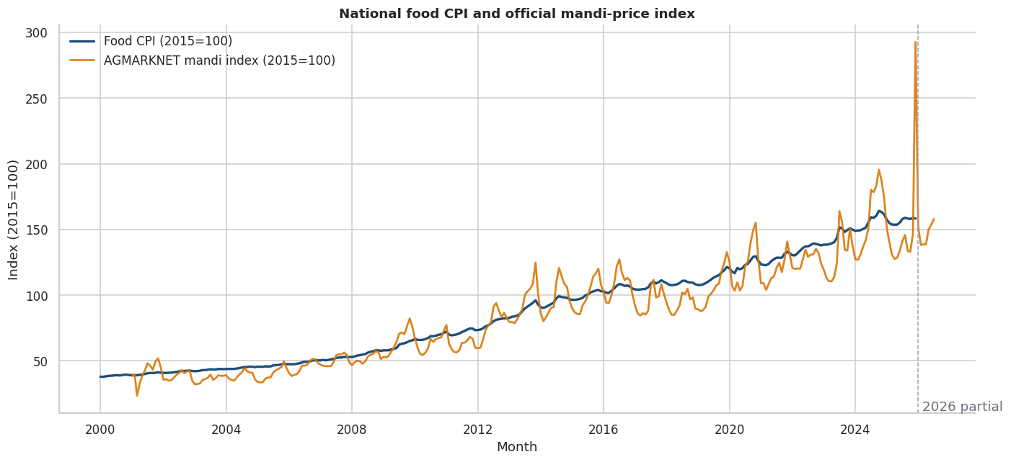
Note. The national CPI trend is smoother than the volatile official mandi-price aggregate. Both series are indexed for comparison; the chart does not imply one causes the other.

EDA Interpretation and Modelling Design
Figure 2
Regional median price pressure across two-, five-, and ten-year windows
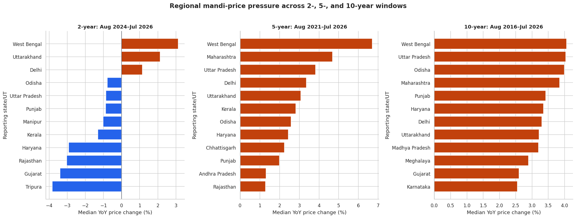
Note. Only regions meeting the coverage rule are ranked. The repeated West Bengal result is descriptive and may reflect commodity mix, reporting, market structure, or common shocks.
Table 6
EDA insight summary
Reference | What it shows | Key insight | RQ / decision relevance
Figure 1 | National CPI and mandi trend | CPI is smoother; mandi prices show large commodity shocks | RQ1/RQ2: use separate targets and robust validation
Figure 2 | Regional window rankings | Pressure is persistent but horizon-sensitive | RQ1/RQ4: avoid one-window policy rankings
Coverage audit | Reporting regions over time | Panel is unbalanced | All RQs: retain coverage controls
Climate scatterplots | Raw anomalies versus price change | Near-zero bivariate correlation | RQ1: require controlled lag models

Choice of Models With Justification
The original solution architecture is retained. RQ1 uses cluster-robust driver models for one- to three-month commodity-region price change. RQ2 compares seasonal-naive, exponential smoothing, ARIMA/SARIMA, regularized regression, Random Forest, gradient boosting, and only data-justified neural alternatives under rolling-origin validation. RQ3 constructs and validates HFASI against independently observed real food-cost pressure and segment rankings. RQ4 backtests paired household-budget, inventory, and procurement decision loss against no-warning and seasonal-naive strategies. The completed interim notebooks implement a verified subset: HAC and state fixed-effects models; naive, Ridge ARX, Random Forest, histogram gradient boosting, and damped ETS forecasts; weighted shock classification; a baseline-100 HFASI prototype; and controlled scenarios. These interim methods provide evidence and pipeline validation but do not change the original confirmatory solutions.

Features, Evaluation Metrics, and Preliminary Performance

Features Included and Feature Engineering
Table 7
Feature set and usage
Feature family | Original / engineered | Reason | Used in
Food CPI lags 1,2,3,6,12 | Engineered exact lags | Persistence, seasonality, autoregression | Ridge ARX and ML forecasts
Rolling mean/std. | Engineered from prior CPI | Local level and volatility | Forecast models
Mandi index / YoY | Original + engineered | Wholesale pressure signal | Regression, forecast, shock
Market arrivals | Planned original + lags | Supply entering the market | Final RQ1/RQ2 confirmation
Production and yield | Planned annual/crop-season alignment | Underlying supply capacity | Final RQ1 confirmation
Wage/income growth | Planned official lagged series | Household purchasing power | Final RQ3 validation
World wheat and crude | Original + YoY change | Global food and transport context | Regression, forecast, shock
Rainfall/temperature anomaly | Engineered climate normal deviation | Weather stress | State regression and shock
Month sine/cosine and trend | Engineered | Seasonality and long-run change | Forecast and shock

Evaluation Metrics (Formulae and Calculations)
Table 8
Evaluation metrics and formulae
Metric | Formula | Interpretation | Used for
MAE | mean(|y - yhat|) | Typical absolute index-point error | Forecasting
RMSE | sqrt(mean((y - yhat)^2)) | Penalizes large misses | Forecasting
MAPE | 100 mean(|(y-yhat)/y|) | Scale-free percentage error | Forecasting
Precision | TP/(TP+FP) | Share of alerts that are shocks | Classification
Recall | TP/(TP+FN) | Share of shocks detected | Classification
Balanced accuracy | (Recall + Specificity)/2 | Balances rare shock and normal classes | Classification
Brier score | mean((p-o)^2) | Probability accuracy; lower is better | Classification
Prototype HFASI | 100 + w_food(g_food-g_power) | Interim neutral-at-100 stress score | Scenario prototype
Spearman rho | rank correlation(HFASI, observed pressure) | Original criterion-validity test | Final RQ3
Decision-loss gain | loss_baseline - loss_model | Positive values favor model warnings | Final RQ4
The selected shock model produced TP=3, TN=52, FP=3, and FN=2. Therefore, precision=3/(3+3)=0.500, recall=3/(3+2)=0.600, specificity=52/(52+3)=0.945, and balanced accuracy=(0.600+0.945)/2=0.773. For the May 2026 rural downside scenario, the interim prototype score is 100+0.463(3.494-0)=101.618. This prototype will not be treated as confirmatory HFASI validity evidence until it is normalized and tested against observed household pressure as specified in H0-3/H1-3.

Preliminary Results

Preliminary Model Performance
Table 9
Preliminary model performance comparison
Task / model | Validation | Primary result | Secondary result | Key takeaway
One-step naive last | 60 rolling origins | RMSE 2.063 | MAE 1.530; MAPE 1.071% | Best one-step model
One-step Ridge ARX | 60 rolling origins | RMSE 2.572 | 24.69% worse than naive | Complexity did not improve accuracy
24-step damped ETS | 24 origins x 24 horizons | All-step RMSE 6.044 | H24 RMSE 8.391 | Best long-horizon path
HistGradientBoosting shock | 60 rolling origins | Balanced accuracy 0.773 | Recall 0.600; Brier 0.0758 | Best rare-event balance

RQ1 Preliminary Findings
The national full model has adjusted R-squared=.870 and residual RMSE=1.243, but none of the five available interim transmission terms is significant at 5%. State fixed-effects models identify a positive lagged temperature-anomaly association in the two-year (coefficient 4.99, Holm-adjusted p<.001) and five-year (4.28, Holm-adjusted p<.001) windows, but not the ten-year window. Rainfall terms are not significant after Holm adjustment. These are partial tests of H0-1 because the current model does not yet contain the complete pre-specified market-arrival, production/yield, wage, logistics, and one- to three-month commodity-region variable set. H0-1 is therefore not finally adjudicated.

RQ2 Preliminary Findings
Last-value persistence wins the national one-step comparison, whereas damped ETS wins the national 24-step backtest. The available interim evidence therefore fails to support H1-2 for the national benchmark; machine learning did not outperform the best transparent baseline. Ridge permutation importance is highest for the 12-month CPI lag (mean RMSE degradation 1.01), followed by the one-month lag and mandi index. The shock-classification comparison provides complementary RQ2 evidence: HistGradientBoosting attains balanced accuracy 0.773, precision 0.500, and recall 0.600. The original H0-2/H1-2 decision remains subject to the planned one-, two-, and three-month commodity-region forecast-loss comparisons.
Figure 3
Twenty-four-month conditional national food CPI forecast
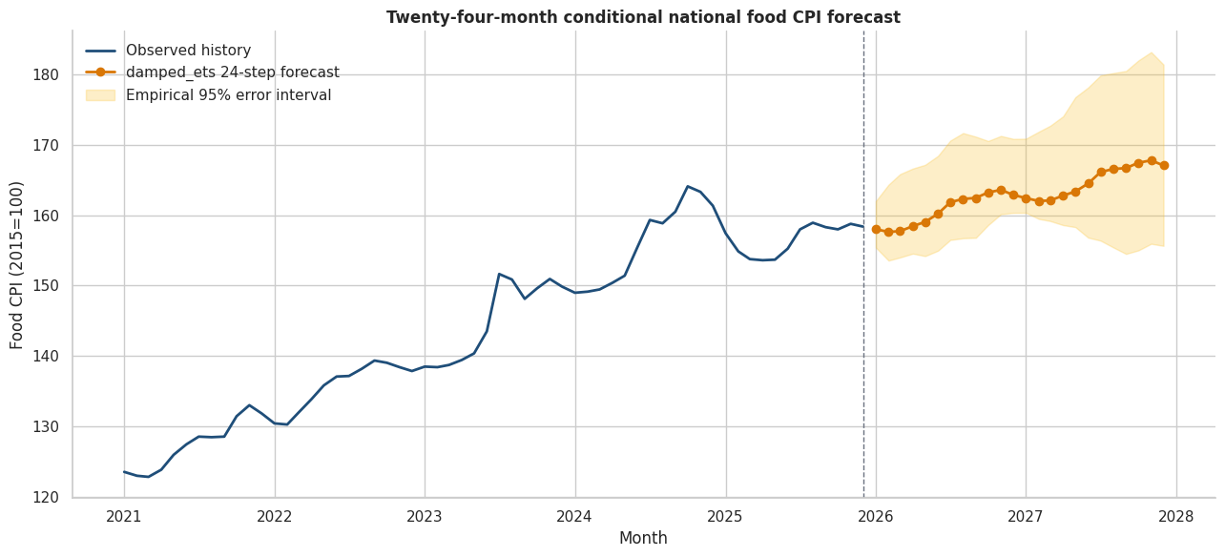
Note. The damped ETS point path is selected by 24-step backtesting. Empirical intervals use matching historical horizons and are approximate because only 24 origins are available.

Preliminary Findings by Research Question (Continued)

RQ3 Preliminary Findings
The current HFASI prototype operationalizes four original components: forecast food-cost growth, food-expenditure share, purchasing-power growth, and household segment. It uses published food shares of 0.463 rural and 0.391 urban. With 4% purchasing-power growth, the highest baseline prototype score is 99.80; with 0% growth, all 12 months show mild stress, with rural mean 101.20 versus 101.01 urban. Forecast uncertainty crosses the neutral reference in multiple months.
This is prototype evidence only. H0-3/H1-3 require independently observed real food-cost pressure, expenditure-fractile groups, survey-weighted household exposure, Spearman criterion validity, and rank-stability sensitivity. Because HCES microdata and wage/income variables are not yet integrated, the report does not claim that H1-3 has been confirmed. The final solution remains the statistically validated, segment-sensitive HFASI specified in the original synopsis.

RQ4 Preliminary Findings
The interim decision layer combines prototype HFASI with shock probability. The shock threshold is the initial-training 75th percentile of next-month YoY food inflation (8.591%); only five shocks occur among 60 evaluation months. Baseline and favorable-supply scenarios remain normal, moderate stress produces a household-budget watch, and severe stress produces elevated household stress and a procurement alert: rural prototype HFASI reaches 102.54 and maximum shock probability reaches 74.88%. This demonstrates the planned warning architecture but does not test H0-4/H1-4. The original solution requires paired retrospective household-budget, inventory, and procurement loss against no-warning and seasonal-naive strategies.
Figure 4
Conditional shock probability under alternative 2026 scenarios
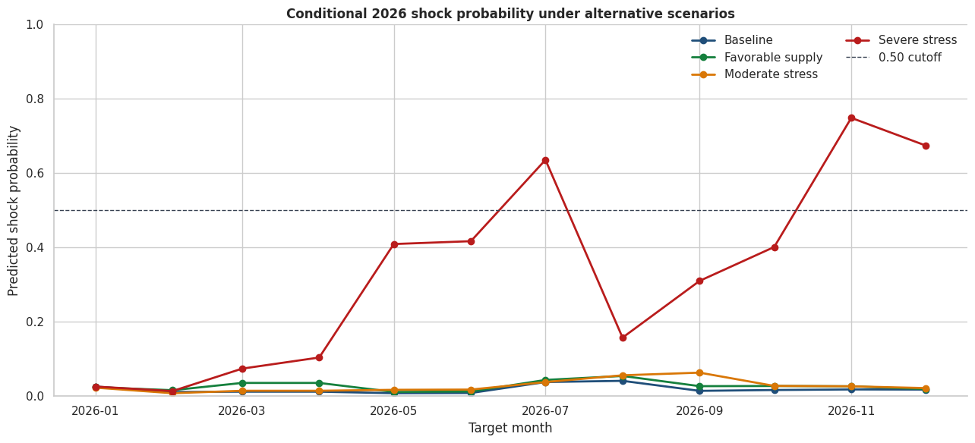
Note. The severe scenario is a controlled stress test, not a forecast. The favorable scenario's slightly higher mean probability than baseline reflects nonlinear model sensitivity and must not be given a causal interpretation.

Interim Limitations and Risks
Household representation is the principal scope limitation. HFASI uses published aggregate rural and urban food shares because the HCES microdata were not supplied. It cannot support household-level, expenditure-quantile, or causal welfare inference. The affordability results are representative scenarios whose purchasing-power assumptions must remain visible.
Rare-event uncertainty is also material. The 60-month shock evaluation contains only five shocks, so recall, precision, and probability estimates have high sampling uncertainty. The classifier is useful as a risk watch but not as an automatic policy trigger. The favorable scenario's slightly higher mean risk than baseline further demonstrates nonlinear model sensitivity.
The AGMARKNET panel is unbalanced, coverage changes can resemble price changes, and the state regressions can contain omitted variables, common trends, or release-timing mismatches. Climate associations are horizon-dependent and not causal. Long-horizon intervals use only 24 historical forecast origins. These issues are mitigated through coverage indicators, exact calendar joins, raw-value preservation, cluster/HAC uncertainty, chronological validation, sensitivity analysis, and explicit interpretation constraints.

Next Steps for the Final Report
Obtain authorized HCES 2022-23/2023-24 microdata, apply survey weights, and validate HFASI across expenditure fractiles without publishing restricted raw records.
Complete the original one-, two-, and three-month commodity-region forecasts and paired ML-versus-statistical loss comparison for H0-2/H1-2.
Integrate release-date-safe market arrivals, crop production/yield, wage/income, logistics, and policy-event variables for the complete H0-1/H1-1 joint test.
Validate HFASI against independently observed real food-cost pressure using Spearman correlation, bootstrap confidence intervals, known-groups comparisons, and rank stability.
Backtest household-budget, inventory, and procurement losses against no-warning and seasonal-naive decision rules for H0-4/H1-4.
Expand rare-shock evaluation as new observed months become available and calibrate alert thresholds to asymmetric decision costs.
Complete model cards, environment lock files, automated tests, and monitored drift/coverage checks before deployment.

Interim Conclusion
The interim evidence supports an integrated but deliberately conservative framework. Strong baselines remain essential; predictive drivers are not causal; affordability conclusions depend on household exposure and purchasing power; and severe scenarios can jointly trigger household and procurement warnings. The completed pipeline is reproducible, explainable, and suitable for final validation, while its limitations are sufficiently material to prevent overstatement.

Bibliography
Akter, S., & Basher, S. A. (2014). The impacts of food price and income shocks on household food security and economic well-being: Evidence from rural Bangladesh. Global Environmental Change, 25, 150-162. https://doi.org/10.1016/j.gloenvcha.2014.02.003
Bhardwaj, M. R., Pawar, J., Bhat, A., Deepanshu, Enaganti, I., Sagar, K., & Narahari, Y. (2023). An innovative deep learning based approach for accurate agricultural crop price prediction. In 2023 IEEE 19th International Conference on Automation Science and Engineering. https://doi.org/10.1109/CASE56687.2023.10260494
Cattaneo, A., Sadiddin, A., Vaz, S., Conti, V., Holleman, C., Sanchez, M. V., & Torero, M. (2023). Ensuring affordability of diets in the face of shocks. Food Policy, 117, 102470. https://doi.org/10.1016/j.foodpol.2023.102470
Hyndman, R. J., & Koehler, A. B. (2006). Another look at measures of forecast accuracy. International Journal of Forecasting, 22(4), 679-688. https://doi.org/10.1016/j.ijforecast.2006.03.001
Jain, A., Marvaniya, S., Godbole, S., & Munigala, V. (2020). A framework for crop price forecasting in emerging economies by analyzing the quality of time-series data. arXiv. https://doi.org/10.48550/arXiv.2009.04171
Lundberg, S. M., & Lee, S.-I. (2017). A unified approach to interpreting model predictions. Advances in Neural Information Processing Systems, 30, 4765-4774.
Ma, W., Nowocin, K., Marathe, N., & Chen, G. H. (2019). An interpretable produce price forecasting system for small and marginal farmers in India using collaborative filtering and adaptive nearest neighbors. Proceedings of the Tenth International Conference on Information and Communication Technologies and Development, Article 6, 1-11. https://doi.org/10.1145/3287098.3287100
Madaan, L., Sharma, A., Khandelwal, P., Goel, S., Singla, P., & Seth, A. (2019). Price forecasting and anomaly detection for agricultural commodities in India. Proceedings of the 2nd ACM SIGCAS Conference on Computing and Sustainable Societies. https://doi.org/10.1145/3314344.3332488
Makridakis, S., Spiliotis, E., & Assimakopoulos, V. (2018). Statistical and machine learning forecasting methods: Concerns and ways forward. PLOS ONE, 13(3), e0194889. https://doi.org/10.1371/journal.pone.0194889
Ministry of Statistics and Programme Implementation. (2024). Survey on Household Consumption Expenditure: 2022-23 (NSS Report No. 591). Government of India. https://mospi.gov.in/sites/default/files/publication_reports/Report_591_HCES_2022-23New.pdf
Open Government Data Platform India. (2026). Current daily price of various commodities from various markets (Mandi). https://www.data.gov.in/catalog/current-daily-price-various-commodities-various-markets-mandi
Theofilou, A., Arvanitakis, G., & Tzouramani, I. (2025). Predicting prices of staple crops using machine learning: A systematic review of studies on wheat, corn, and rice. Sustainability, 17(12), 5456. https://doi.org/10.3390/su17125456
World Bank. (2026). Commodity markets (Pink Sheet) data. https://www.worldbank.org/en/research/commodity-markets
National Aeronautics and Space Administration. (2026). POWER Data Access Viewer. https://power.larc.nasa.gov/

Appendix A

GitHub Repository Structure and Reproducibility Map
The repository structure below is referenced in the GitHub availability statement and maps evaluator actions to stable public paths.
qm640-food-affordability-ai/
|-- README.md
|-- config/ # versioned settings and source profiles
|-- data/
| |-- curated/ # evaluator-accessible compressed datasets
| |-- raw/ # local-only bulk or credential-dependent data
| |-- data_dictionary.csv
| `-- source_manifest.csv
|-- notebooks/
| |-- 01_data_acquisition.ipynb
| |-- 02_data_quality_and_cleaning.ipynb
| |-- 03_exploratory_analysis.ipynb
| |-- 04_statistical_analysis.ipynb
| |-- 05_forecasting_models.ipynb
| |-- 06_shock_classification.ipynb
| |-- 07_explainability.ipynb
| |-- 08_affordability_index.ipynb
| |-- 09_scenario_analysis.ipynb
| `-- 10_final_results.ipynb
|-- scripts/ # collection, build, validation, report code
|-- src/ # reusable Python package
|-- tests/ # automated quality and pipeline tests
`-- reports/ # figures, tables, model cards, final report
Table 10
Notebook purpose and primary verified output
Notebook | Purpose | Primary output
01 | Acquisition and panel construction | 14 curated files; 1,494,745 rows
02 | Quality and cleaning | 41,792 clean state rows; no price interpolation
03 | EDA | 2/5/10-year pressure, volatility, coverage
04 | Statistical analysis | HAC national and fixed-effects state results
05 | Forecasting | Naive one-step; damped ETS 24-step path
06 | Shock classification | HGB metrics and 2026 monthly risk
07 | Explainability | Permutation, partial dependence, local sensitivity
08 | HFASI | Rural/urban scenario and uncertainty tables
09 | Scenario decisions | Baseline through severe stress signals
10 | Consolidation | RQ map, dashboard, limitations, 98-artifact inventory

Appendix B

Extended Formulae, Assumptions, and Result Checks
Table 11
Formulae and actual interim calculations
Measure | Formula | Verified calculation
MAE | (1/n) SUM |y_t - yhat_t| | Naive one-step MAE = 1.5295
RMSE | sqrt[(1/n) SUM (y_t-yhat_t)^2] | Naive one-step RMSE = 2.0628
MAPE | (100/n) SUM |(y_t-yhat_t)/y_t| | Naive MAPE = 1.0712%
Precision | TP/(TP+FP) | 3/(3+3) = 0.500
Recall | TP/(TP+FN) | 3/(3+2) = 0.600
Specificity | TN/(TN+FP) | 52/(52+3) = 0.945
Balanced accuracy | (Recall+Specificity)/2 | (0.600+0.945)/2 = 0.773
Brier | (1/n) SUM (p_t-o_t)^2 | Selected classifier = 0.0758
HFASI | 100+w_food(g_food-g_power) | Rural May downside = 101.618

Conditional 2026 Assumptions
January shock risk uses observed December 2025 inputs.
February-December shock risks use the Notebook 05 CPI path.
External price levels are held at December 2025 values.
Future climate anomalies are set to seasonal normal in the baseline.
HFASI purchasing-power scenarios are 0%, 4%, and 8%; they are assumptions, not income forecasts.

Stress-Scenario Overlays
Scenario | Food-cost overlay | Mandi / wheat / crude | Rain / temperature
Baseline | 0 pp | 0 / 0 / 0 pp | 0 pp / 0 C
Favorable supply | -2 pp | -5 / -5 / -10 pp | +10 pp / -0.5 C
Moderate stress | +3 pp | +10 / +10 / +15 pp | -15 pp / +1.5 C
Severe stress | +6 pp | +20 / +20 / +30 pp | -30 pp / +3.0 C
Note. Scenario changes are controlled feature perturbations. They are not probabilistic forecasts or estimated causal effects.

Appendix C

Consolidated Results Dashboard and Artifact Evidence
Figure C1 consolidates the principal forecast, baseline risk, affordability, and scenario decision outputs. It is generated by Notebook 10 and is referenced in the preliminary-results discussion.
Figure 5
Food Price Affordability AI consolidated interim results
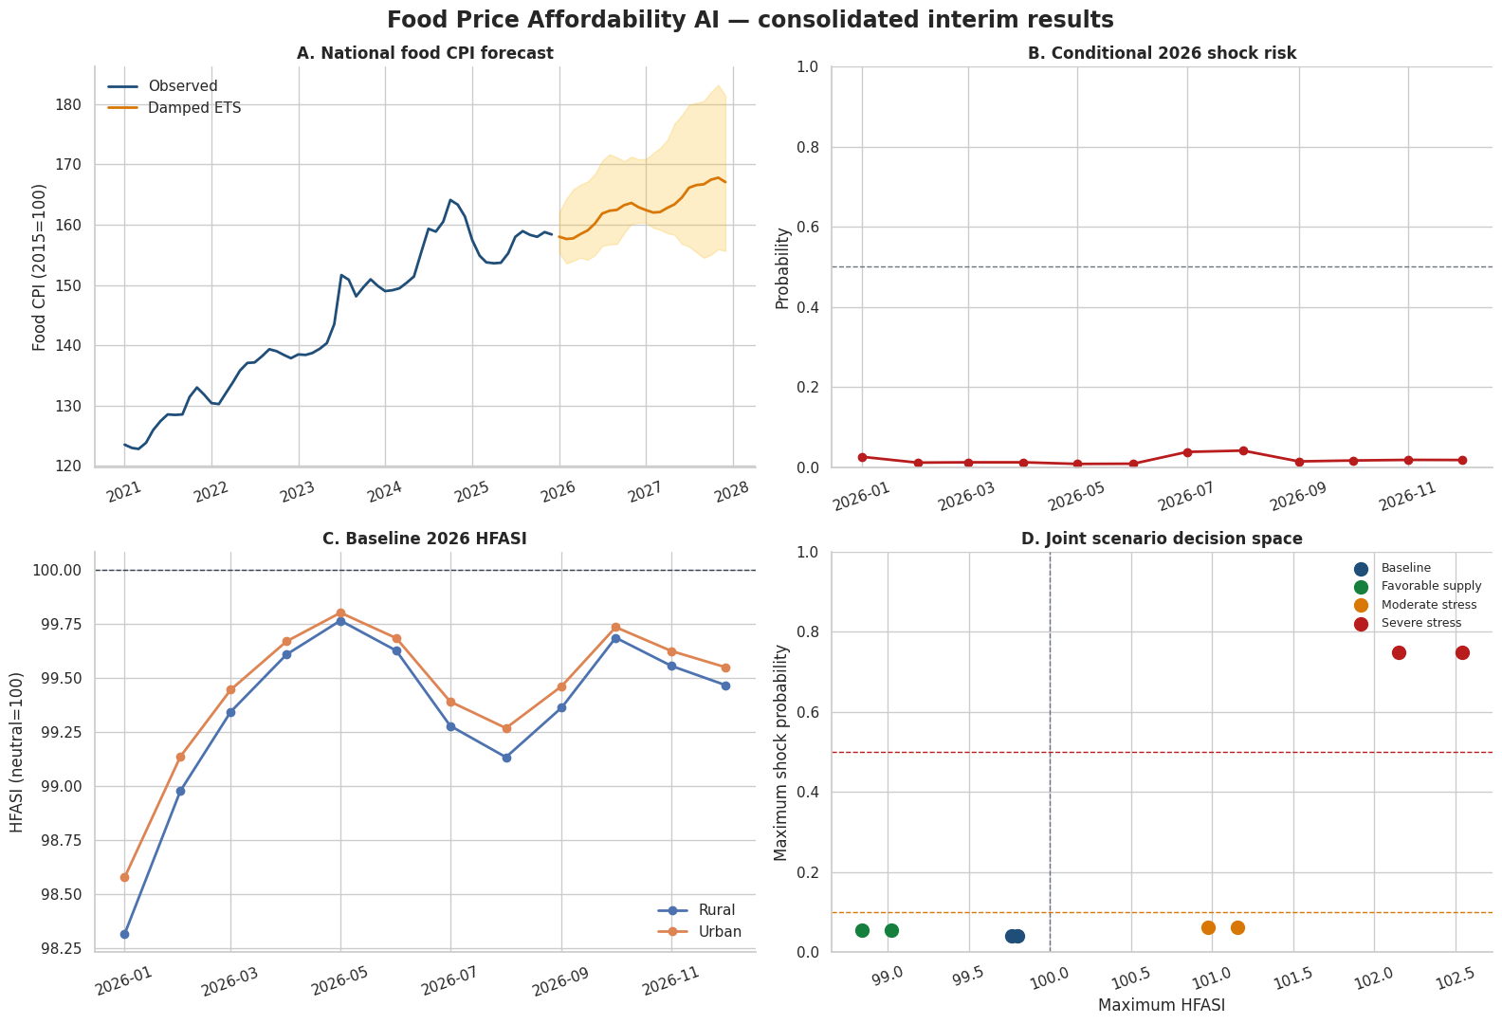
Note. Panels show the 24-month damped ETS path, baseline 2026 shock risk, baseline rural/urban HFASI, and the joint scenario decision space. All panels are conditional and non-causal.

Verified Final Evidence
Notebooks 01-09 completed and verified by Notebook 10.
Four research questions mapped to evidence and interpretation strength.
Eleven key findings and six material limitations consolidated.
Ninety-eight report artifacts inventoried with file size and SHA-256 hash.
No missing prices interpolated; raw extreme values preserved with flags.
Report numbers are transcribed from execution summaries, not manually recalculated.

