Data Analytics Capstone
Forecasting Essential Food Price Shocks and Household Affordability Stress in India
An Explainable AI Decision-Intelligence Framework Using Public Market, Agricultural, Climatic, and Economic Data
Interim Report
Piyush Soni
Walsh College
QM640: Data Analytics Capstone
Mentor: Prof. Rishabh Pandey
Summer 2026 Term
July 30, 2026

GitHub Repository and Project Status

GitHub Data Availability Statement
Public repository: https://github.com/piyushsoni88/qm640-food-affordability-ai
Curated analytical data: https://github.com/piyushsoni88/qm640-food-affordability-ai/tree/main/data/curated - compressed price, climate, macroeconomic, and national/state panels
Confirmatory supplements: https://github.com/piyushsoni88/qm640-food-affordability-ai/tree/main/data/external_required - DES crop APY, Labour Bureau wages, and HCES 2023-24 segment aggregates
Data dictionary: https://github.com/piyushsoni88/qm640-food-affordability-ai/blob/main/data/data_dictionary.csv - field definitions, analytical roles, transformations, and handling rules
Aligned notebooks: https://github.com/piyushsoni88/qm640-food-affordability-ai/tree/main/notebooks - ten Colab-compatible notebooks from acquisition through final consolidation
Notebook evidence: https://github.com/piyushsoni88/qm640-food-affordability-ai/tree/main/reports/notebook_outputs - execution summaries, model metrics, tables, figures, and checks
Table 1
Verified analytical coverage
Layer | Verified quantity | Coverage / qualification
Curated analytical files | 1,494,745 rows | 14 files audited
AGMARKNET daily aggregate | 969,377 rows | Represents 18,836,462 official records
State-month-commodity panel | 41,792 rows | 32 states/UTs; 8 commodities; 2001-Jul 2026
National monthly panel | 319 rows | 2000-Jul 2026; CPI observed through Dec 2025
Note. Permitted compressed data are public in the repository. Bulk/restricted raw archives are represented by official retrieval scripts, manifests, and checksums; credentials are excluded. Appendix A maps the full repository and notebook evidence chain.

Introduction

Executive Summary
This interim report continues the approved synopsis without changing its four research questions, hypothesis pairs, 1-3 month horizons, or decision stakeholders. Ten aligned notebooks now form a complete evidence chain from public-data acquisition to statistical tests, forecasts, explainability, affordability measurement, and retrospective decision analysis. Notebook 10 verified nine upstream summaries, mapped all four hypotheses, inventoried 155 artifacts, and confirmed report readiness.
The cleaned state panel contains 41,792 commodity-region-month observations. Available-variable panel models reject H0-1 at all three horizons, although the full original driver hypothesis remains partially unresolved because genuine market-arrival quantity is missing. HistGradientBoosting is selected for all forecast horizons, but its loss advantage over conventional baselines is not statistically significant; H0-2 is therefore not rejected. Commodity-specific shock classification achieves balanced accuracy of 0.714, 0.760, and 0.712 at one, two, and three months.
HFASI uses HCES 2023-24 disclosure-safe aggregates covering 36 states/UTs, rural and urban sectors, ten expenditure deciles, and 261,245 sampled households. Its food-share construct is strongly ordered by MPCE (Spearman rho=-.884; 95% bootstrap CI [-.904, -.860]) and perfectly rank-stable across the 24 forecast months, providing provisional support for H1-3. Retrospective warnings reduce loss for household budgeting and retail inventory, but not for enterprise procurement or policy monitoring; RQ4 receives partial support.

Background, Problem, Purpose, and Progress

Background and Context
Essential-food price volatility is simultaneously a household-welfare problem, a procurement risk, and a policy-monitoring challenge. Rice, wheat, onion, potato, tomato, pulses, edible oil, and sugar differ in production cycles, storability, transport exposure, and seasonal supply. Price increases therefore emerge from interacting market, climatic, agricultural, logistical, and macroeconomic signals rather than a single stable driver (Madaan et al., 2019; Theofilou et al., 2025).

Problem Statement and Purpose
India has rich but fragmented public data, while many operational decisions remain retrospective. The study addresses the absence of an integrated, explainable, and validated early-warning workflow that predicts one- to three-month price changes and shocks, discloses uncertainty, measures household affordability pressure, and tests decision value. The work is predictive and associational; it does not claim causal intervention effects.

Interim Project Status (Progress Snapshot)
Status | Completed or planned work
Completed | Acquisition, lineage audit, cleaning, exact targets, EDA, RQ1 inference, RQ2 forecasting, shock classification, explainability, HFASI, stakeholder-loss analysis, and consolidated evidence.
Integrated | DES state crop area/production/yield; HCES 2023-24 aggregates; Labour Bureau rural wages with partial panel coverage.
Open gap | Genuine market-arrival quantity. Reporting-row counts remain quality/coverage indicators and are never relabelled as arrivals.
Final-stage work | Broader release-date-safe arrivals, wage coverage, geographic robustness, probability calibration, stakeholder cost tuning, and monitored deployment.

Scope, Objectives, and Research Questions
The primary unit is the commodity-region-month. The confirmatory outcomes are one-, two-, and three-month future price changes and commodity-specific abnormal upward shocks. The current panel includes 32 reporting states/UTs and eight essential commodities from 2001 through July 2026; 2026 is explicitly year-to-date. A national monthly benchmark and 24-month conditional CPI path supplement, but do not replace, the original commodity-region design.

Research Questions
Research Question 1 (RQ1). Which lagged-price, market-arrival, climatic, seasonal, agricultural-production, and macroeconomic variables significantly influence one- to three-month essential-food price changes in India?
Research Question 2 (RQ2). Do machine-learning and ensemble models predict essential-food prices and price shocks more accurately than conventional statistical forecasting models?
Research Question 3 (RQ3). How can forecasted commodity-price changes be translated into a statistically reliable, interpretable, and stable Household Food Affordability Stress Index across rural, urban, and expenditure segments?
Research Question 4 (RQ4). How effectively can the proposed early-warning framework support household budgeting, retail inventory, enterprise procurement, and policy-monitoring decisions under alternative supply and price scenarios?

Measurable Objectives
Estimate driver direction, magnitude, uncertainty, and horizon stability.
Compare ML with transparent statistical baselines using chronological out-of-sample loss.
Validate HFASI construct ordering and segment-rank stability.
Test whether model warnings reduce stakeholder-specific retrospective loss.

Hypotheses and Conceptual Framework
Table 2
Original hypothesis pairs and current decision status
RQ | Null and alternative logic retained from the synopsis | Aligned interim decision
RQ1 | H0-1: joint pre-specified driver coefficients equal zero. H1-1: at least one coefficient is nonzero after controls. | Reject available-variable H0-1 at 1-3 months; full H0-1 partially unresolved because arrivals are missing.
RQ2 | H0-2: best ML/ensemble expected loss is >= best statistical baseline. H1-2: at least one ML/ensemble has lower loss. | Fail to reject H0-2 at all horizons; Holm-adjusted p=1.000.
RQ3 | H0-3: HFASI lacks construct association and stable segment ranks. H1-3: association and ranks are valid and stable. | Provisionally reject H0-3; rho=-.884 and monthly rank stability=1.000.
RQ4 | H0-4: warnings do not reduce decision loss. H1-4: paired retrospective loss is reduced. | Partial support: household and retail improve; procurement and policy do not.
Figure 1
Synopsis-aligned analytical and decision framework
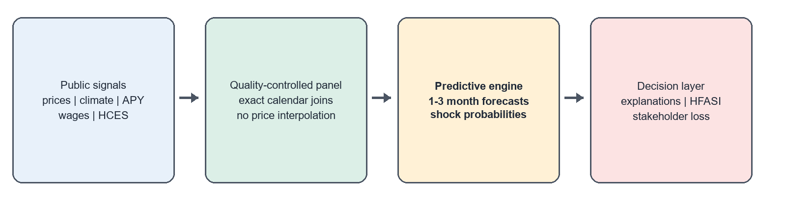
Note. Observable public signals flow through quality controls into predictive outputs, explanations, HFASI, and stakeholder-specific decisions. Predictive explanations are not causal effects.

Literature Survey
Sources were selected using agricultural-price forecasting, food inflation, price shock, explainable AI, household affordability, and chronological validation. Inclusion required a traceable scholarly or official source, a described method, and direct relevance to at least one research question. The synthesis supports strong baselines, time-ordered evaluation, explicit rare-event metrics, transparent explanation, and separate welfare validation.
Table 3
Literature relevance matrix (minimum ten sources)
Source | Method / context | Principal contribution to this study
Akter & Basher (2014) | Food-price shocks and welfare | Supports unequal household exposure and RQ3 validation.
Cattaneo et al. (2023) | Diet-affordability synthesis | Connects shocks, affordability, and mitigation decisions.
Hyndman & Koehler (2006) | Forecast-error measures | Supports MAE/RMSE/scaled-error selection.
Makridakis et al. (2018) | Statistical vs. ML evidence | Requires strong baselines; complexity is not presumed superior.
Jain et al. (2020) | Quality-aware crop forecasting | Supports reporting-coverage and lineage features.
Ma et al. (2019) | Interpretable India price forecasts | Supports localized forecasts and user-facing explanations.
Madaan et al. (2019) | India forecasts and anomalies | Supports joint regression/classification design.
Lundberg & Lee (2017) | Model explanation | Motivates local/global sensitivity with non-causal caveats.
Malesios et al. (2020) | Food-price change points | Supports explicit shock definitions and structural awareness.
Theofilou et al. (2025) | Systematic review | Identifies generalizability, validation, and exogenous-data gaps.
Note. The complete APA-style bibliography also includes official MOSPI, OGD India, NASA POWER, Labour Bureau, and World Bank data sources.

Data Description, Sources, and Access

Dataset Overview
Notebook 01 audited 14 curated files and 1,494,745 analytical rows. The 969,377-row AGMARKNET daily state aggregate represents 18,836,462 underlying official observations. Monthly aggregation yields 41,792 state-commodity records. The model panel is unbalanced because official market reporting varies by state, commodity, and month; coverage indicators are retained to distinguish information availability from supply.
Table 4
Data sources and analytical roles
Source | Variables / coverage | Role and repository access
AGMARKNET / OGD | Prices, state, commodity, reporting counts; 2001-Jul 2026 | Price backbone; data/curated
NASA POWER | Rainfall, temperature, humidity; 2000-Jul 2026 | Climate predictors; representative administrative-capital points
DES agriculture | State-crop area, production, yield | Supply-side predictors; data/external_required
Labour Bureau | Rural wage series | Purchasing-power predictor; integrated with partial match coverage
HCES 2023-24 | MPCE, food shares, sector, decile; 261,245 sampled households | Disclosure-safe segment aggregates; HFASI validation
MOSPI / FAOSTAT | CPI/food CPI and long-run production-price indices | National benchmark and macro controls
World Bank | Wheat, edible oils, crude oil and related prices | External food/energy controls
Repository metadata | Manifest, checksums, dictionary, quality summaries | Lineage and evaluator reproducibility
Note. Genuine arrivals remain missing. The variable source_rows is a reporting-coverage measure, not market-arrival quantity. Climate values are point-based representatives, not area-weighted state means.

Data Cleaning, Features, and Evaluation

Data Cleaning
Table 5
Cleaning and integration log
Issue | Detection / treatment | Verified result
Validity and duplicates | Key/range rules; exact region-commodity-month keys | 0 rows removed; 41,792 retained
Extreme prices | Robust flags; preserve plausible shocks | 15 rows flagged (0.0359%); raw values preserved
Missing prices | No synthetic price interpolation | Observed values only
Calendar lags/targets | Exact keyed date joins | 1m 40,189; 2m 39,587; 3m 39,162 targets
Confirmatory sources | Canonical state/commodity/date harmonization | APY integrated; wages partial; HCES aggregates available

Features Included and Feature Engineering
Predictors include current monthly and annual price change, rainfall anomaly, temperature anomaly, relative humidity, log production, log yield, reporting coverage, calendar seasonality, commodity and region, and partial wage features. Models use only information available at the forecast origin. Forecast evaluation uses RMSE/MAE and paired chronological loss; shock evaluation uses balanced accuracy, recall, average precision, and Brier score. RQ1 uses cluster-robust inference with Benjamini-Hochberg false-discovery control. Appendix B provides the expanded dictionary and Appendix C supplies formulae and hypothesis traceability.

Evaluation Metrics (Include Formulae and Calculations)
Metric | Formula / interpretation
RMSE | sqrt(mean((actual - forecast)^2)); penalizes large misses
Balanced accuracy | (recall + specificity)/2; robust to rare shocks
Average precision | Precision-recall summary under class imbalance
HFASI | 100 + food share x (forecast food-cost growth - purchasing-power growth)

Exploratory Data Analysis
EDA covered all 41,792 state rows and 319 national months. Onion has the largest year-over-year price-change standard deviation (117.75), confirming that pooled averages conceal commodity-specific risk. West Bengal has the highest median price pressure in each recent window: 3.13% over two years, 6.70% over five years, and 4.06% over ten years. The window comparison prevents a short recent period from being mistaken for a stable long-run ranking.
Table 6
EDA insight summary
Evidence | Result | Interpretation / decision
Commodity volatility | Onion; YoY SD 117.75 | Retain commodity effects and shock-specific metrics.
2-year regional pressure | West Bengal; median 3.13% | Near-term monitoring priority.
5-year regional pressure | West Bengal; median 6.70% | Persistent medium-term pressure.
10-year regional pressure | West Bengal; median 4.06% | Long-run comparison remains elevated.
Exploratory inflation threshold | 8.027%; 75 high-inflation months | Descriptive only; classifier uses training-only commodity thresholds.
Climate-price correlations | Rain -.0025; temperature -.0040 | Near-zero unconditional correlation does not preclude conditional/nonlinear effects.
Latest food CPI | 158.388 in Dec 2025 | Observed endpoint for national forecasting.
All EDA associations are descriptive, not causal. The unbalanced reporting panel, point-based climate coverage, and partial 2026 observations are retained as visible qualifications. Figures and detailed commodity/window outputs are available in the Notebook 03 evidence folder.

Preliminary Results: RQ1 Statistical Driver Analysis
Fixed-effects panel models estimate future price change at one, two, and three months using eight available predictor groups and commodity, region, season, and time controls. Model samples contain 3,798, 3,783, and 3,777 observations across 25 states/UTs. R-squared is .247, .249, and .266, while RMSE increases from 16.35 to 37.48 percentage points as the horizon lengthens.
Table 7
BH-significant standardized available-variable terms
h | Positive terms | Negative term | Joint decision
1 | MoM price +23.49; temperature +1.65; humidity +2.22 | YoY price -4.22 | Reject available-variable H0-1
2 | MoM price +26.04; temperature +1.92; humidity +2.37 | YoY price -9.17 | Reject available-variable H0-1
3 | MoM price +21.40; temperature +1.99; reporting coverage +2.73 | YoY price -13.20 | Reject available-variable H0-1
The positive current MoM term and negative YoY term indicate short-run momentum combined with longer-run mean-reversion or base effects. Temperature remains significant across horizons, while humidity is significant at one and two months. Reporting coverage at three months is a measurement result and must not be interpreted as supply. Three partial wage models were estimated, but low integration coverage limits their confirmatory weight.
RQ1 decision: Reject the available-variable H0-1 at all horizons; do not claim the full original H0-1 is settled.
Note. Coefficients are conditional associations, not causal effects. Genuine market-arrival quantity is required before the full pre-specified driver hypothesis can be adjudicated.

RQ2: Forecasting and Shock Classification

Choice of Models With Justification
Eight expanding chronological origins from May 2024 through February 2026 compare HistGradientBoosting, Ridge, zero-change, and seasonal-change forecasts. HistGradientBoosting is selected at all three horizons across 12,540 evaluated panel forecasts. However, paired loss differences do not establish statistically meaningful superiority over the best baseline: Holm-adjusted p=1.000 for every horizon. H0-2 is therefore not rejected. A damped ETS model supplies a supplementary 24-month national CPI planning path for January 2026 through December 2027.
Table 8
Selected commodity-shock classifier performance
h | BA | TPR | Avg. precision | BS | Shocks
1 | .714 | .630 | .331 | .150 | 73
2 | .760 | .773 | .311 | .169 | 66
3 | .712 | .717 | .259 | .183 | 60
Figure 2
Chronological shock-classification balanced accuracy
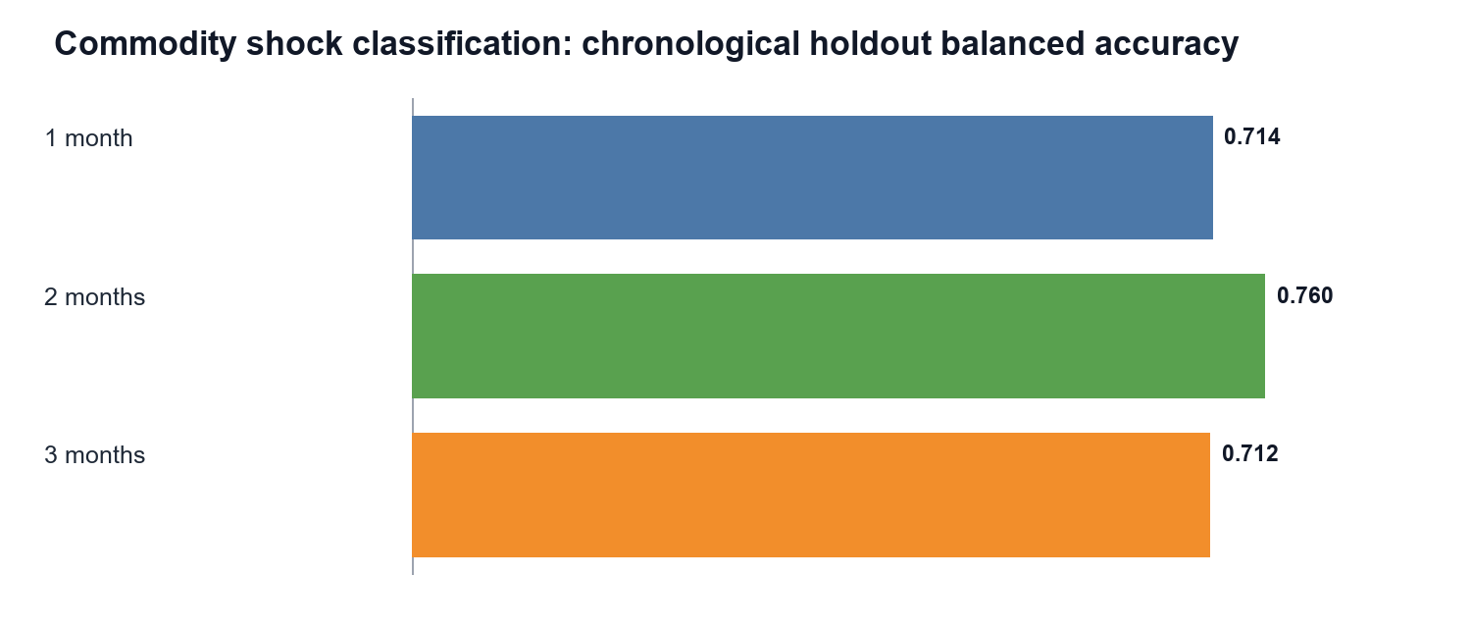
The highest forward conditional risk is 0.820 for Delhi-Rice at the three-month horizon (target October 2026). This is a model-based risk watch, not an observed future event or automatic policy trigger. The 90th-percentile shock threshold is computed from training data only, preventing leakage.

Explainability and RQ3: Household Affordability

Explainability
Chronological holdout permutation importance identifies rainfall anomaly as the leading one-month forecast feature, reporting coverage (source_rows) at two months, and commodity identity at three months. Shock importance is led by reporting coverage at one and two months and commodity at three months. In the highest-risk Delhi-Rice case, the leading local sensitivity is current MoM price change; a one-standard-deviation central perturbation changes probability by -0.238. These results describe fitted-model usage and measurement sensitivity, not causal attribution.

HFASI Construction and Validation
HFASI = 100 + HCES food share x (forecast food-cost growth - purchasing-power growth). Notebook 08 uses 719 disclosure-safe HCES 2023-24 aggregate rows representing 261,245 sampled households across 36 states/UTs, rural/urban sectors, and expenditure deciles 1-10. It does not use or expose household microdata.
Table 9
HFASI construct-validity and stability evidence
Test / output | Verified result | Interpretation
MPCE-food-share ordering | Spearman rho=-.884; p<.001 | Higher MPCE is strongly associated with lower food share, as theory expects.
Bootstrap interval | 95% CI [-.904, -.860] | Strong ordering is robust to resampling.
Rank stability | Mean/minimum=1.000 | Segment ordering is unchanged across 24 forecast months.
Highest baseline construct | 103.494; Chandigarh(U.T.), rural, decile 1, May 2026, downside | Stress concentrates in high-food-share, low-decile segments.
RQ3 decision: Provisionally reject H0-3; HFASI is construct-valid and rank-stable within the aggregate segment design.
Note. HFASI is a scenario-based segment index, not a household welfare threshold, causal effect, or claim about every sampled household.

RQ4: Decision Value and Scenario Analysis
Notebook 09 evaluates 3,135 retrospective observations for each of four stakeholders. Model warnings reduce loss by 48.38% for household budgeting and 45.71% for retail inventory, so H0-4 is rejected for these uses. They increase loss for enterprise procurement (-112.37%) and policy monitoring (-174.21%); H0-4 is not rejected for those uses. The overall conclusion is partial support, not universal decision superiority.
Table 10
Stakeholder decision-loss results
Stakeholder | Loss reduction | Hypothesis decision | Operational interpretation
Household budgeting | +48.38% | Reject H0-4 | Warnings improve budget-timing decisions.
Retail inventory | +45.71% | Reject H0-4 | Warnings improve replenishment decisions.
Enterprise procurement | -112.37% | Fail to reject H0-4 | Current threshold/cost rule is unsuitable.
Policy monitoring | -174.21% | Fail to reject H0-4 | Current warning rule over-penalizes policy decisions.
Figure 3
Retrospective decision-loss reduction by stakeholder
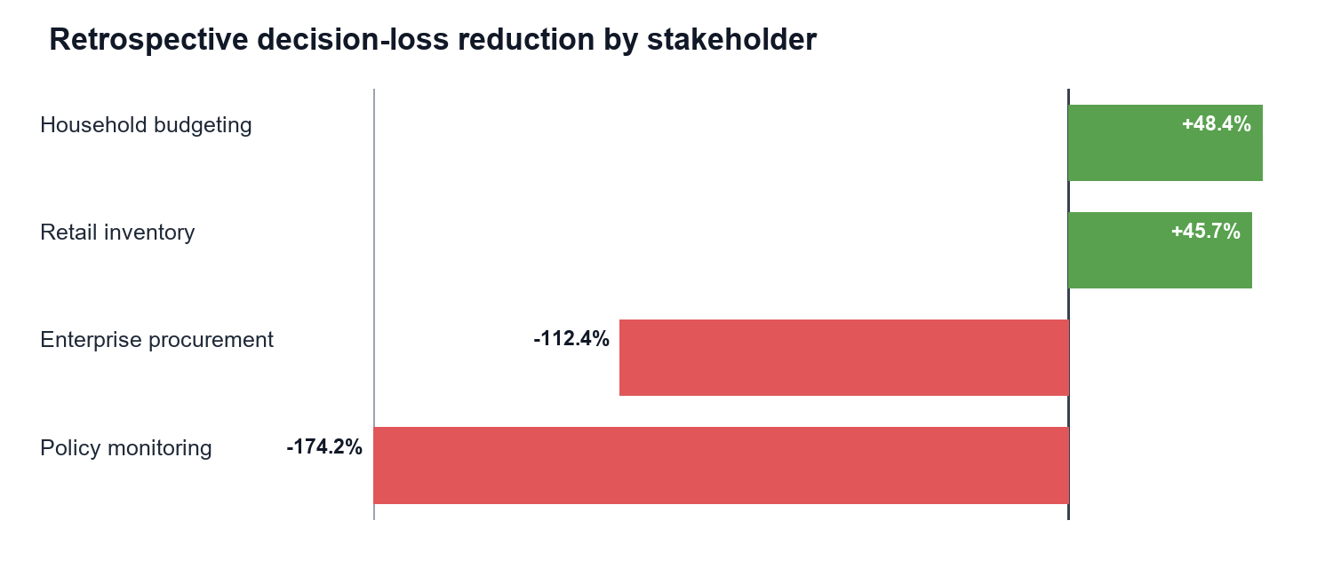
Controlled favorable, baseline, moderate, and severe scenarios test the joint HFASI-risk decision space. The severe stress overlay reaches HFASI 105.494 and a clipped modeled shock probability of 1.000. These are deterministic stress tests, not forecasts; the clipped probability signals extrapolation and reinforces the need for calibration and human review.

Limitations, Ethics, Next Steps, and Conclusion

Interim Limitations and Risks
Genuine market-arrival quantity is missing; reporting coverage must not substitute for supply.
Rural-wage integration is partial, limiting purchasing-power inference in the panel models.
The official market panel is unbalanced; coverage changes can resemble price changes.
Climate features are representative point locations, not area-weighted state averages.
Only eight chronological forecast origins are available in the aligned panel evaluation.
HCES inputs are disclosure-safe aggregates; HFASI is not a household-level causal welfare estimate.
Explainability, fixed-effects estimates, and stress scenarios are predictive/associational, not causal.

Next Steps for the Final Report
Acquire release-date-safe arrivals and broaden state-month rural-wage coverage.
Expand rolling origins, perform geographic/commodity robustness tests, and calibrate probabilities.
Tune stakeholder-specific asymmetric cost rules, especially procurement and policy thresholds.
Add area-weighted climate summaries and independent affordability criterion measures.

Interim Conclusion
The aligned evidence chain preserves the synopsis and provides a defensible interim answer to every RQ: available drivers matter, ML has not yet beaten baselines significantly, HFASI is provisionally valid and stable, and warning value is stakeholder-specific. The public repository, appendices, and notebook evidence make each conclusion auditable while retaining the qualifications required for the final report.

Bibliography
Akter, S., & Basher, S. A. (2014). The impacts of food price and income shocks on household food security and economic well-being: Evidence from rural Bangladesh. Global Environmental Change, 25, 150-162. https://doi.org/10.1016/j.gloenvcha.2014.02.003
Bhardwaj, M. R., Pawar, J., Bhat, A., et al. (2023). An innovative deep learning based approach for accurate agricultural crop price prediction. 2023 IEEE International Conference on Automation Science and Engineering. https://doi.org/10.1109/CASE56687.2023.10260494
Cattaneo, A., Sadiddin, A., Vaz, S., et al. (2023). Ensuring affordability of diets in the face of shocks. Food Policy, 117, 102470. https://doi.org/10.1016/j.foodpol.2023.102470
Hyndman, R. J., & Koehler, A. B. (2006). Another look at measures of forecast accuracy. International Journal of Forecasting, 22(4), 679-688. https://doi.org/10.1016/j.ijforecast.2006.03.001
Jain, A., Marvaniya, S., Godbole, S., & Munigala, V. (2020). A framework for crop price forecasting in emerging economies by analyzing the quality of time-series data. arXiv. https://doi.org/10.48550/arXiv.2009.04171
Lundberg, S. M., & Lee, S.-I. (2017). A unified approach to interpreting model predictions. Advances in Neural Information Processing Systems, 30, 4765-4774.
Ma, W., Nowocin, K., Marathe, N., & Chen, G. H. (2019). An interpretable produce price forecasting system for small and marginal farmers in India. Proceedings of ICTD, Article 6, 1-11. https://doi.org/10.1145/3287098.3287100
Madaan, L., Sharma, A., Khandelwal, P., Goel, S., Singla, P., & Seth, A. (2019). Price forecasting and anomaly detection for agricultural commodities in India. COMPASS. https://doi.org/10.1145/3314344.3332488

Bibliography (Continued)
Makridakis, S., Spiliotis, E., & Assimakopoulos, V. (2018). Statistical and machine learning forecasting methods: Concerns and ways forward. PLOS ONE, 13(3), e0194889. https://doi.org/10.1371/journal.pone.0194889
Malesios, C., Jones, N., & Jones, A. (2020). A change-point analysis of food price shocks. Climate Risk Management, 27, 100208. https://doi.org/10.1016/j.crm.2019.100208
Ministry of Statistics and Programme Implementation. (2025). Household Consumption Expenditure Survey: 2023-24. Government of India.
Open Government Data Platform India. (2026). Current daily price of various commodities from various markets (Mandi). https://www.data.gov.in/catalog/current-daily-price-various-commodities-various-markets-mandi
Theofilou, A., Arvanitakis, G., & Tzouramani, I. (2025). Predicting prices of staple crops using machine learning: A systematic review. Sustainability, 17(12), 5456. https://doi.org/10.3390/su17125456
National Aeronautics and Space Administration. (2026). POWER Data Access Viewer. https://power.larc.nasa.gov/
World Bank. (2026). Commodity markets (Pink Sheet) data. https://www.worldbank.org/en/research/commodity-markets
Note. All official web sources were used through the repository's source manifest and retrieval notebooks. Access and coverage limitations are recorded with the corresponding files.

Appendix A

GitHub Repository Structure and Reproducibility Map
The repository tree below is referenced in the main report and maps evaluator actions to stable public paths.
qm640-food-affordability-ai/
|-- README.md
|-- data/
| |-- curated/ # compressed analytical source panels
| |-- external_required/ # APY, wages, HCES segment aggregates
| |-- data_dictionary.csv
| `-- source_manifest.csv
|-- notebooks/
| |-- 01_data_acquisition_synopsis_aligned.ipynb
| |-- 02_data_quality_and_cleaning_synopsis_aligned.ipynb
| |-- 03_exploratory_analysis_synopsis_aligned.ipynb
| |-- 04_statistical_analysis_synopsis_aligned.ipynb
| |-- 05_forecasting_models_synopsis_aligned.ipynb
| |-- 06_shock_classification_synopsis_aligned.ipynb
| |-- 07_explainability_synopsis_aligned.ipynb
| |-- 08_affordability_index_synopsis_aligned.ipynb
| |-- 09_decision_scenario_analysis_synopsis_aligned.ipynb
| `-- 10_final_results_synopsis_aligned.ipynb
|-- reports/notebook_outputs/ # figures, metrics, summaries, checks
|-- scripts/ # reusable collection/report utilities
|-- src/ # reusable Python package
`-- tests/ # pipeline and quality checks

Appendix A (Continued)
Table 11
Notebook-to-evidence map
NB | Primary purpose | Verified output
01 | Acquisition and source audit | 1,494,745 curated rows; remaining gaps identified
02 | Cleaning and integration | 41,792 rows; 1-3 month exact targets
03 | EDA | Volatility, 2/5/10-year pressure, coverage
04 | RQ1 inference | Three fixed-effects models; BH-controlled terms
05 | RQ2 forecasting | 12,540 forecasts; H0-2 decisions
06 | Shock classification | Three horizon-specific HGB classifiers
07 | Explainability | Permutation and local sensitivity evidence
08 | RQ3 HFASI | 719 HCES aggregates; validity and stability
09 | RQ4 decision value | Four stakeholders; four stress scenarios
10 | Consolidation | 155 artifacts; RQ/hypothesis traceability

Appendix B

Expanded Data Dictionary
Table 12
Core variables, types, and analytical roles
Variable / group | Type / unit | Role | Definition and treatment
date, Region, Commodity | Temporal / categorical | Panel keys | Month, state/UT, and essential-food commodity; standardized aliases.
modal_price, price_mom_pct, price_yoy_pct | Numeric; INR/unit and % | Target/predictors | Observed market price and backward-looking changes; no price interpolation.
future_price_change_1m/2m/3m | Numeric; % | Dependent variables | Exact calendar forward change at 1, 2, or 3 months.
shock_1m/2m/3m | Binary | Classification targets | Future change >= training-only commodity-specific 90th percentile.
rainfall_anomaly_pct | Numeric; % | Climate predictor | Departure from seasonal climatology at representative state point.
temperature_anomaly_c | Numeric; C | Climate predictor | Temperature departure from climatology.
relative_humidity_pct | Numeric; % | Climate predictor | Monthly mean relative humidity.
production, yield | Numeric; tonnes / yield unit | Supply predictors | DES state-crop annual values aligned to commodity and marketing period.
source_rows | Count/log | Quality control | Contributing official reporting rows; never treated as market arrivals.
rural_wage | Numeric | Macro/HFASI input | Labour Bureau wage measure; partial match coverage retained.
food_share, MPCE, decile, sector | 0-1 / INR / category | HFASI inputs/groups | HCES 2023-24 disclosure-safe segment aggregates.
HFASI | Index centered at 100 | Affordability output | Food share weighted gap between forecast food-cost and purchasing-power growth.

Appendix C

Formulae, Hypothesis Traceability, and Decision Rules
Table 13
Evaluation formulae and aligned use
Measure | Formula | Use
RMSE | sqrt[(1/n) SUM(y-yhat)^2] | Panel forecast loss and model selection
Balanced accuracy | (TPR+TNR)/2 | Rare-shock classification
Recall | TP/(TP+FN) | Missed-shock sensitivity
Average precision | Area under precision-recall curve | Rare-event ranking quality
Brier score | (1/n) SUM(p-o)^2 | Probability accuracy
Spearman rho | Correlation of ranked MPCE and food share | HFASI construct validity
Loss reduction | 100 x (baseline loss-model loss)/baseline loss | Stakeholder decision value
HFASI | 100+w_food(g_food-g_power) | Segment affordability stress
Table 14
Research-question evidence chain
RQ | Primary test/output | Decision | Qualification
RQ1 | Cluster-robust FE; BH FDR | Available H0 rejected at 1-3m | Full H0 awaits arrivals
RQ2 | Chronological paired forecast loss | H0 not rejected at 1-3m | Only eight aligned origins
RQ3 | Spearman + bootstrap + rank stability | Provisional H0 rejection | Aggregate segment construct
RQ4 | Paired retrospective stakeholder loss | Partial support | Cost rules are stakeholder-specific

Appendix D

Limitations Register, Next-Stage Work, and Report Checklist
Table 15
Material limitations and mitigation
Limitation | Impact | Mitigation / next stage
Market arrivals missing | Full RQ1 hypothesis unresolved | Acquire official quantity with unit/date lineage.
Partial rural wages | Weak purchasing-power panel coverage | Expand release-safe Labour Bureau harmonization.
Unbalanced reporting | Coverage can mimic price change | Retain source_rows controls and balanced sensitivity samples.
Point climate locations | State climate exposure measured imperfectly | Build area-weighted gridded state summaries.
Eight forecast origins | Forecast-loss inference has low power | Extend chronological backtest as releases accrue.
Aggregate HCES | No household-level inference | Retain disclosure-safe segment language; use authorized microdata if approved.
Nonlinear scenario extremes | Probability clips at 1.0 | Treat as stress test; calibrate/extrapolation-check before use.
Stakeholder loss asymmetry | Warnings harm procurement/policy under current rules | Tune threshold and costs separately for each stakeholder.
Associational evidence | No causal intervention claim | Use causal methods only in a separately identified design.

Final-Report Checklist
Original title, four RQs, and four hypothesis pairs preserved.
All mandatory template sections, GitHub links, data dictionary, cleaning log, metrics, preliminary results, limitations, next steps, bibliography, and appendices included.
All key numbers transcribed from the aligned execution summaries; no causal overstatement.
Main narrative is deliberately page-controlled; appendices hold extended evidence.

