DESKTOP BASED MEETING SCHEDULER

Class Diagram
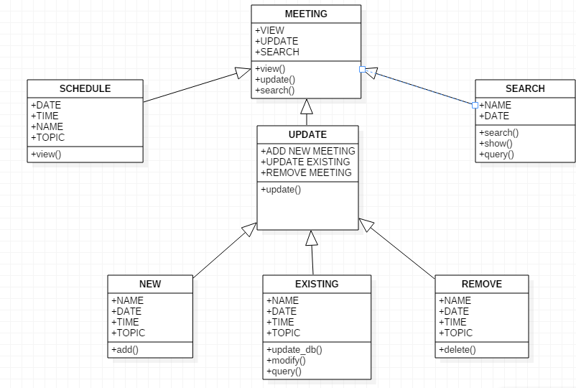
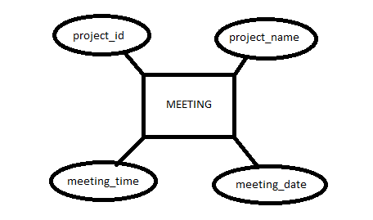
ER Diagram

- MainMenu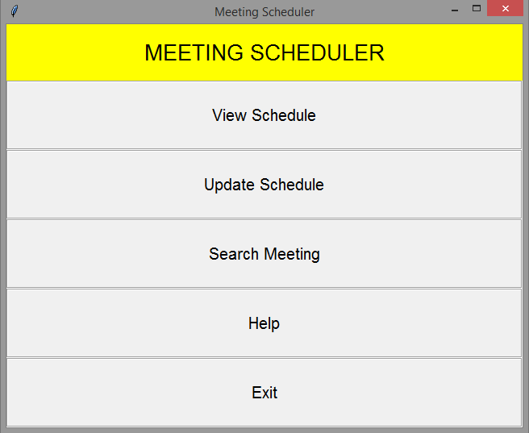

- This shows a GUI Window which gives access to 3 main modules of the application.
- These Modules are:-
    - View Schedule
    - Update Schedule
    - Search Schedule

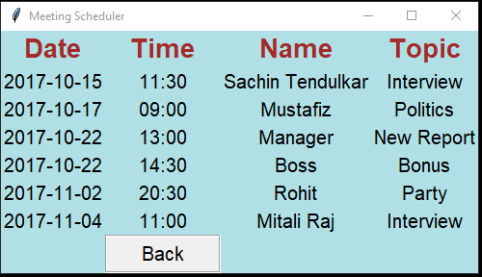
  - View Schedule

- This module contains a new window that shows all the meetings scheduled by the user.
- In this module the view function fetches the data from the database in sorted order with respect to date and time.

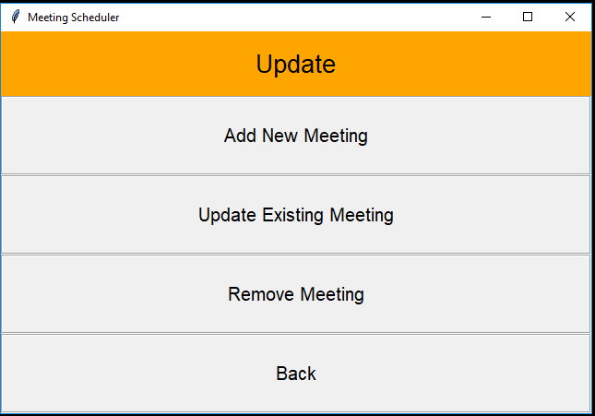
  - Update Schedule

- This module contains 3 sub-modules.
- These sub-modules are:
- Add New Meeting
- Update Existing Meeting
- Remove Meeting

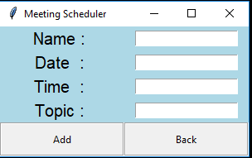
    - Add New Meeting

- In this sub-module we can add a new meeting to the database
- It contains 4 fields to provide the information i.e., name, date, time and topic.
- It contains 2 buttons i.e., add and back.
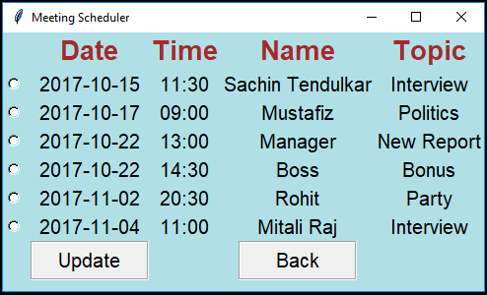
    - Update Existing Meeting

- This sub-module contains radio buttons to select the meeting that needs to be updated.
- By selecting the desired choice and on pressing the update button a new window will open which will contain all the fields where the user can update the existing meeting.
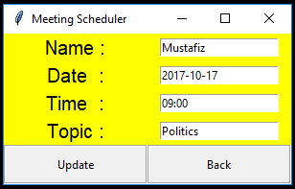

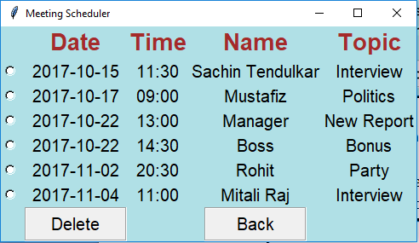
    - Remove Meeting

- This sub-module contains the list of all meetings which the user can remove by selecting the desired choice.
- And it contains 2 buttons i.e., delete and back.
- Only one meeting can be removed at a time after which the window refreshes with the updated list automatically.

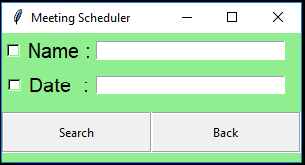
  - Search Meeting Schedule

- This module is used to search a meeting.
- It contains two fields date and name which can be selected to search a particular meeting.
- For example: -
  - Here the Name field is checked and the search query is “Rohit” which gives the following result.
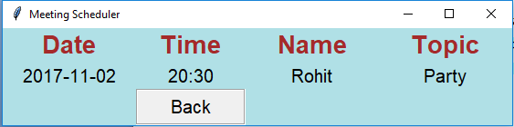

Responsibilities :-

- Piyush Swain :
GUI
Add and Remove Modules
- Saurav Kumar :
DataBase
Update Module
- Ashirbad Subudhi :
Search Module
Documentation
- Rohit Patnaik :
View Module
Documentation

