FERABEE LIQUOR PRIVATE LIMITED
MASTER PROJECT REPORT & COMPREHENSIVE RESEARCH BLUEPRINT
Brand: FERABEE LIQUOR — The Royal Bee | 100% Detailed Execution Plan
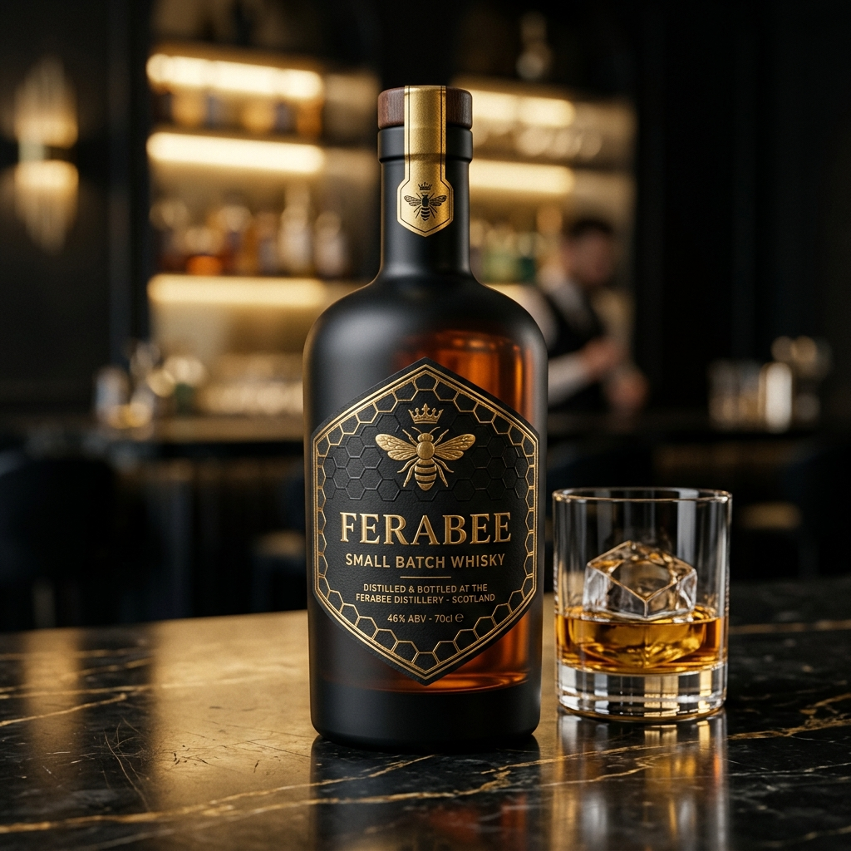
Concept Render: FeraBee Small Batch Whisky
★ EXECUTIVE SUMMARY
FeraBee Liquor Pvt Ltd is launching a premium 6-to-8 product alcobev portfolio paired with an exclusive chain of 367 '100-Cover FeraBee Bee Lounges' across Maharashtra (355 Talukas) and Goa (12 Talukas) under a Company Owned Franchise Operated (COFO) model. Direct consumption through franchise outlets guarantees 2,09,190 cases/year of stock liquidation, eliminating traditional wine shop retail dependency.
1. Executive Summary & Corporate Structure
FeraBee Liquor Private Limited represents a high-growth corporate model in the Indian spirits and hospitality franchise ecosystem. By securing manufacturing and bottling agreements out of Goa, the company benefits from a 30% to 40% excise tax advantage compared to surrounding states.
- Legal Corporate Name: FERABEE LIQUOR PRIVATE LIMITED
- Authorised Capital: ₹10,00,00,000 (₹10 Crore) | Paid-Up: ₹50,00,000 (₹50 Lakh)
- Promoter Shareholding: 51% : 49% split between Founding Promoters
- Final Selected Brand Logo: Option 1 Hive — Round Emblem, Honeycomb Texture, Hexagonal Crest, 3D Gold Bee, Laurel Wreath in Black & Gold Foil
- Official Brand Identity: 'The Royal Bee — Gold on Black / Premium Spirits - Crisp & Refined'
- Core Brand Numerology: FERABEE = 23 = 5 (Signifying rapid expansion, energy & prosperity)
2. Product Portfolio & Technical Specifications
The FeraBee product lineup comprises core SKUs across Spirits, Craft Beer, and Wine, formulated at 42.8% v/v IMFL standard strength with custom luxury packaging:
Product Category | Packaging / Volume | Blend / Alcohol Spec | MH MRP (₹) | Goa MRP (₹)
FeraBee Whisky | 750ml Custom Black Glass | 42.8% v/v Grain & Malt blend, Honey Finish | ₹1,850 | ₹1,350
FeraBee Vodka | 750ml Clear Glass | 42.8% v/v Triple-Distilled, Charcoal Filtered | ₹1,650 | ₹1,150
FeraBee Gin | 750ml Clear Glass | 42.8% v/v Artisanal Botanical Blend | ₹1,950 | ₹1,450
FeraBee Rum | 750ml Glass Bottle | 42.8% v/v Premium Dark Molasses Rum | ₹1,550 | ₹1,050
FeraBee Beer | 650ml Bottle & 500ml Can | 5.0% / 4.8% alc/vol Premium Crisp Lager | ₹220 | ₹140
FeraBee Wine | 750ml Glass Bottle | 12.0% alc/vol Sparkling Red & White | ₹1,250 | ₹850

3. The 100-Cover 'FeraBee Bee Lounge' Concept & Interior Design
Each FeraBee franchise outlet operates as a high-density, social dining destination designed to offer maximum visual appeal and customer throughput:
- Store Footprint: 2,500 – 3,000 sq. ft. efficient layout (50 ft × 50 ft optimal configuration).
- Seating Capacity: 100 Covers Total (60 Indoor seats with 12 Hexagonal tables + 40 Outdoor Patio covers).
- Interior Aesthetic: Black Marble flooring, Gold Trim, Honey Drip Bar Counter, Gold Hexagonal LED Ceiling, and a 3D Gold Bee Feature Wall.
- Territory Rights: Exclusive territorial protection of 1 Outlet per Taluka (15km radius exclusivity).
4. Franchise Unit Economics & The Unlimited Package
The commercial catalyst of the FeraBee Bee Lounge chain is the Unlimited Food + Spirits Package, structured legally as 'Unlimited Food + Complimentary FeraBee Tasting':
Tier Package | Timing / Hours | Inclusions / Offerings | Unit Cost | Net Profit / Guest
SILVER HIVE (₹999) | Mon-Thu Lunch (12-5pm) | Unlimited Beer + Vodka/Rum (max 6 pegs) + Veg Food | ₹380 | ₹619 (62% Margin)
GOLD BEE (₹1,499) | Daily Dinner (7-11:30pm) | Unlimited Whisky/Vodka/Gin/Rum/Beer + 7 Starters + Main + Dessert | ₹580 | ₹919 (61% Margin)
PLATINUM ROYAL (₹1,999) | Weekends & Peak | All 6 Spirits incl. Sparkling Wine + Seafood + Live BBQ | ₹780 | ₹1,219 (61% Margin)

Franchise Outlet Monthly Profit & Loss Statement
P&L Item Category | Monthly Amount (₹) | Operational Commentary
Unlimited Package Sales | ₹40,92,270 | 105 guests/day @ ₹1,499 x 26 operating days
A La Carte Food & Drinks | ₹9,94,500 | 45 guests/day @ ₹850 x 26 operating days
TOTAL MONTHLY REVENUE | ₹50,86,770 | Gross Turnover per outlet
Gross Profit (61% Margin) | ₹31,00,000 | Net margin after food & liquor COGS
Less: Monthly Opex | ₹6,44,000 | Rent (₹1L), Staff 14 salaries (₹2.2L), Power, Royalty 6%, Mktg 3%
NET PROFIT PER BAR (MONTHLY) | ₹24,50,000 | Net profit accruing to Franchisee
NET PROFIT PER BAR (ANNUAL) | ₹2,94,00,000 | Annualized Net Earnings
FRANCHISE PAYBACK PERIOD | 4.7 MONTHS | Payback on ₹1.15 Cr Maharashtra Capex

5. High-Yield Taluka Selection & Phase 1 Rollout Strategy
To maximize initial cash flow and prove unit economics within the first 6 months, FeraBee will execute a targeted rollout focusing on High-Density, High-Disposable-Income Talukas:
Target Region | Key Talukas / Locations Included | Outlet Count
Goa State (100% Coverage) | Tiswadi (Panjim), Bardez (Mapusa/Anjuna/Baga), Salcete (Margao), Mormugao, Ponda, Pernem | 12 Outlets
Pune District Cluster | Haveli (Vimannagar/Kharadi), Pune City (FC Rd/JM Rd), Maval (Hinjawadi/Wakad), Mulshi (Baner) | 8 Outlets
Mumbai & Thane Belt | Mumbai City, Salsette (Andheri/Bandra/Borivali), Thane (Ghodbunder/Majiwada), Navi Mumbai | 12 Outlets
Western MH & Konkan | Nashik (College Rd), Chhatrapati Sambhajinagar, Kolhapur Karveer, Satara, Sangli, Solapur | 10 Outlets
Vidarbha Region | Nagpur Urban (Dharampeth/Sadar), Nagpur Rural, Chandrapur, Amravati | 8 Outlets

6. State Excise, Inter-State Transit & Legal Compliance
Inter-state movement of liquor between Goa (Manufacturing base) and Maharashtra (Primary consumption market) requires rigorous compliance with state excise tariffs and transit permit laws:
Transit Stage | Statutory Procedure & Regulatory Compliance
1. Distillery Clearance | Bottling permit issued via Goa Excise Portal (GEMS). Payment of Goa Export Duty (~₹10-15/case).
2. Transit Pass (TP) | Application for Inter-State Transport Pass (Pass-2). GPS-tracked bonded truck dispatch from Goa facility.
3. Maharashtra Border Entry | Import Pass verification at Maharashtra State Border Checkposts (Banda/Insuli). Duty payment.
4. Bonded Wholesale Storage | Stock deposited in State-approved FL-1 Wholesale Bonded Warehouse before distribution to FeraBee bars.

7. Manufacturing Lease & Raw Material Supply Chain
Initial production leverages third-party lease bottling agreements in Goa (Verna/Ponda Industrial Estates) with excess capacity of 25,000 cases/month at a processing cost of ₹45–60 per case:
Ingredient / Material | Technical Sourcing Specification
Grain Neutral Spirit (ENA) | 96.5% Extra Neutral Alcohol derived from grain, sulfur-free (Sourced from MH/Karnataka)
Scotch Malt Concentrate | Imported 18-Year Highland Single Malt Concentrate (Imported via Custom Bonded Warehouse)
Botanical Extracts (Gin) | Juniper berries, coriander seeds, Goan cardamom, lemon peel extracts via vapor infusion
Craft Beer Brewing Stock | Premium 2-row Pilsner malt, Caramel malt, Cascade hops, and ale yeast for Amber Ale

8. Store Operations, Technology Stack & Anti-Theft SOPs
To prevent stock leakage, unauthorized pouring, or food waste, each FeraBee Bee Lounge implements an integrated operational tech stack:
- RFID Wristband POS: Issued at reception upon cover payment. Tracks package entry time, table number, and drinks consumed.
- Optic Auto-Pourers: Hard spirits dispensed via electronic 60ml optic pourers linked via Bluetooth/Wi-Fi directly to POS billing.
- Portion Control SOP: Starters pre-batched and portion-controlled (120g/portion) to maintain exact 61% gross profit margin.
- Cloud CCTV Surveillance: 16-camera HD Cloud AI surveillance covering Bar Counter, Kitchen Pass, and Cashier for 24/7 audit.
9. Investment Ask, Cap Table, & Investor Term Sheet
The capital structure combines founders equity, bank cash credit limits, and an equity raise to fund national expansion:
Capital Source | Amount (₹) | Structure & Terms
Founders Paid-Up Equity | ₹50,00,000 | Equity Shares (51% : 49%)
Bank Cash Credit (CC) / Loan | ₹3,50,00,000 | Secured Working Capital Facility
External Investor Equity Raise | ₹18,00,00,000 | Preferred Equity (25.0% Stake)
TOTAL CAPITALIZATION | ₹22,00,00,000 | Total Operational Runway

★ INVESTOR RETURN HIGHLIGHT
At Year 3, based on a conservative 10.0x EBITDA multiple on projected ₹78.0 Crore EBITDA, FeraBee Liquor Private Limited will achieve an Enterprise Valuation of ₹780.0 Crore. The investor's 25% equity stake will be valued at ₹195.0 Crore, representing an estimated 10.8X Return on Investment (ROI) over 36 months.

