FERABEE
L I Q U O R
━━━━━━━━━━━━━━━━━━━━━━━
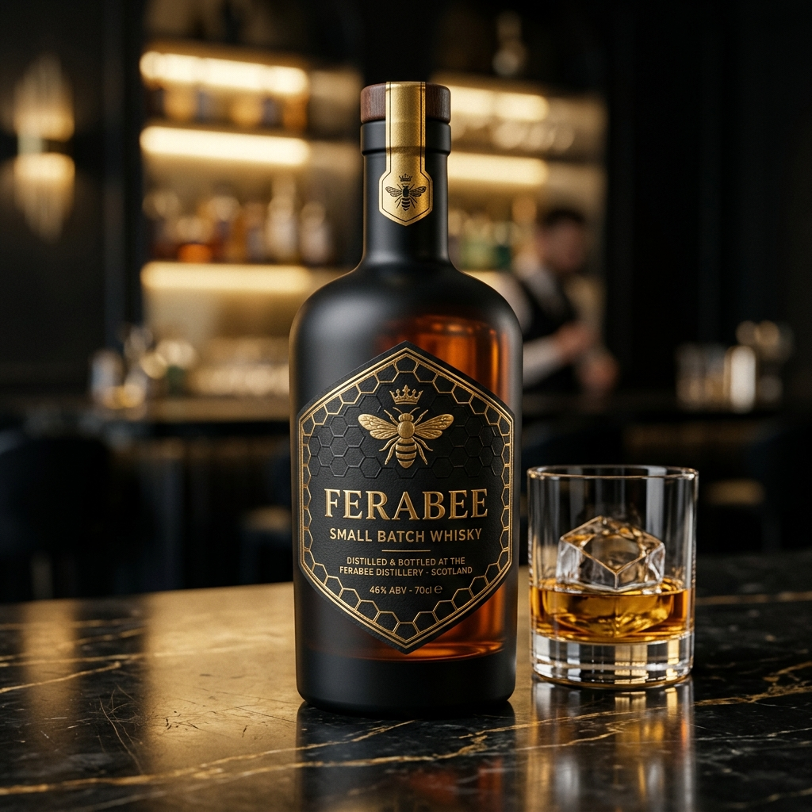
INVESTOR PITCH DECK
Series A — ₹18.0 Crore for 25% Equity
August 2026 | Confidential

THE PROBLEM

Why India's ₹5,200 Crore Premium Alcobev Market is Broken
◉ Death by Distribution: Over 60% of brand margins are lost to middlemen — wholesalers, wine shops, retail bars.
◉ Archaic Pricing: Outdated 1-by-1 peg pricing models alienate Gen Z and Millennial consumers who seek experiential dining.
◉ Regulatory Maze: State excise complexity creates opaque supply chains, making tracking and compliance nearly impossible for emerging brands.
◉ Zero Incumbents: India has zero nationally scaled 'brand-owned lounge chains' in the premium spirits segment. The whitespace is massive.

THE FERABEE SOLUTION

Vertically Integrated: Manufacture → Distribute → Serve → Profit
◉ Own the Product: Manufacture proprietary premium spirits (Whisky, Vodka, Gin, Rum, Beer) with luxury 'Gold on Black' packaging.
◉ Own the Distribution: Deploy 367 'FeraBee Bee Lounges' — branded, Instagrammable, 100-cover premium dining destinations.
◉ Own the Experience: Pre-Paid 'Curated Flights' Token System delivering extreme perceived value at guaranteed 50%+ gross margins.
◉ Own the Brand: Franchise Owned Company Operated (FOCO) — franchisees invest capex, FeraBee controls operations & quality.

MARKET OPPORTUNITY

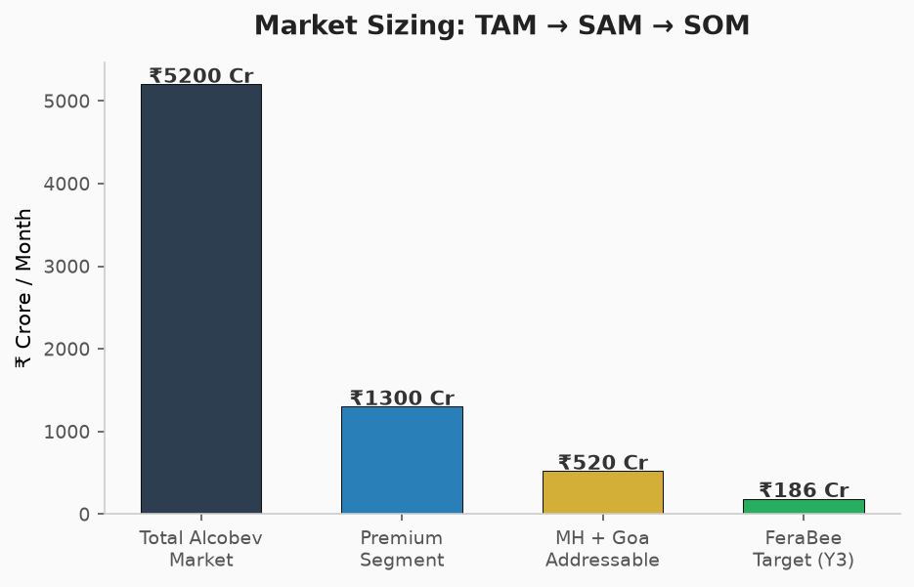
TAM → SAM → SOM Funnel

◉ Indian Alcobev market: $52 Billion (2025), growing at 12% CAGR.
◉ Premium segment (where FeraBee competes): Growing at 18% CAGR — fastest sub-segment.
◉ Maharashtra alone contributes 25% of national spirits consumption. 355 Talukas = massive whitespace.

THE PRODUCT PORTFOLIO

6 Core SKUs — 42.8% v/v Premium IMFL Standard
Product | Specification | Packaging | Target MRP (MH)
FeraBee Whisky | Grain & Malt, Honey Finish | 750ml Custom Black Glass | ₹2,200
FeraBee Vodka | Triple-Distilled, Charcoal | 750ml Clear Glass | ₹1,900
FeraBee Gin | Artisanal Botanical Blend | 750ml Clear Glass | ₹2,400
FeraBee Rum | Premium Dark Molasses | 750ml Glass Bottle | ₹1,700
FeraBee Beer | 5.0% Premium Crisp Lager | 650ml Bottle / 500ml Can | ₹250
FeraBee Wine | 12.0% Sparkling | 750ml Glass Bottle | ₹1,500

UNIT ECONOMICS — PER OUTLET

Conservative, Legally Compliant Projections Using Token System
Tier | Price | Inclusions | Gross Margin
Silver Hive | ₹999 | Unlimited Food + 4 Beer/Vodka Tokens | 55%
Gold Bee | ₹1,499 | Unlimited Food + 6 Spirit Tokens | 52%
Platinum Royal | ₹1,999 | Unlimited Food + 8 All-Spirit Tokens + BBQ | 50%

₹5.0L – ₹8.0L
Revised Monthly Net Profit per Outlet

18–24 MONTHS
Revised Franchise Payback Period

COMPETITIVE LANDSCAPE

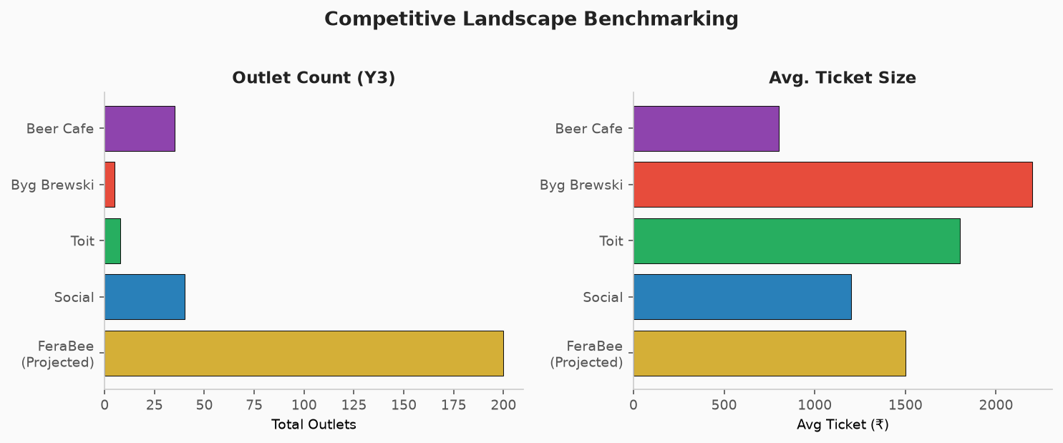
FeraBee vs. Key Competitors: Scale & Ticket Size

3-YEAR GROWTH ROADMAP

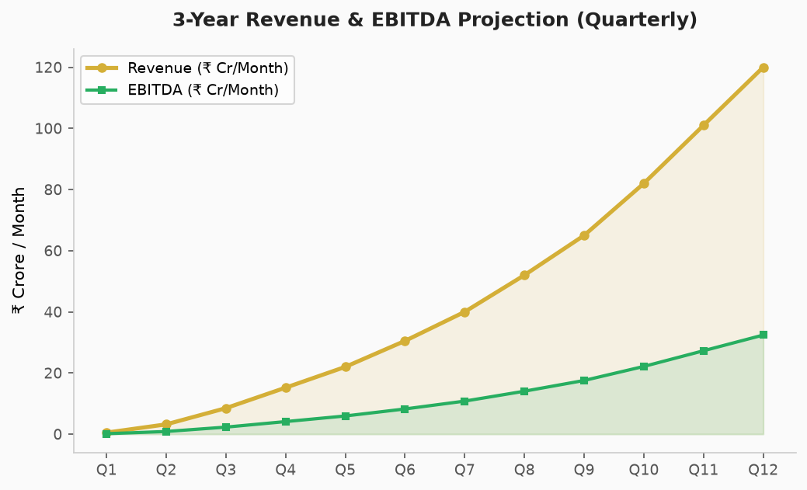
Quarterly Revenue & EBITDA Trajectory

Phase | Timeline | Region | Outlets
Pilot COCO | M1–M3 | Mumbai (Andheri, BKC, Powai) | 3
Phase 1 FOCO | M4–M6 | Mumbai-Thane-Navi Mumbai | 20
Phase 2 | M7–M12 | Pune, Nashik, Nagpur | 60
Phase 3 | M13–M24 | Deep Maharashtra + Goa | 200
Phase 4 | M25–M36 | Full 367 Taluka Coverage | 367

THE INVESTMENT ASK

₹18.0 Crore for 25.0% Equity Stake
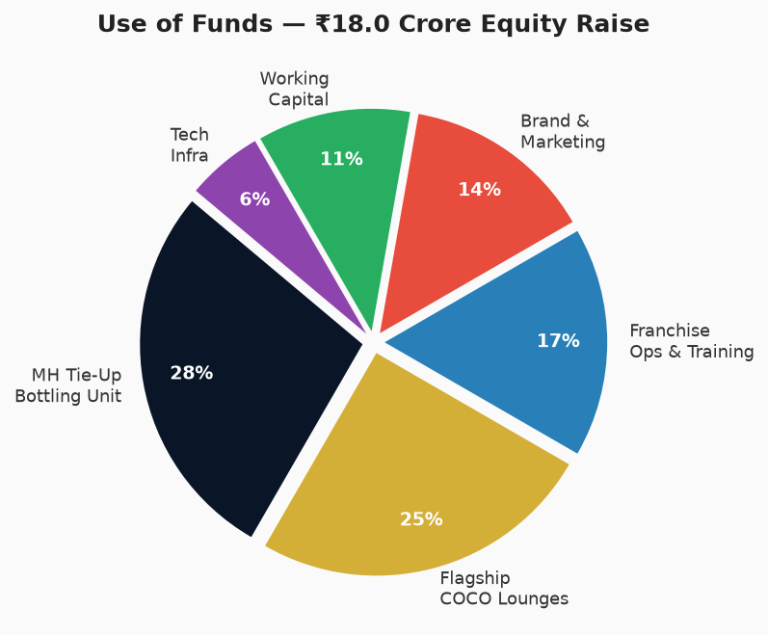
Allocation of ₹18 Crore Equity Raise

Capital Source | Amount | Terms
Founders' Equity | ₹50 Lakh | 51:49 Equity
Bank CC Facility | ₹3.5 Crore | Secured Working Capital
External Equity Raise | ₹18.0 Crore | 25% Preferred Equity
TOTAL | ₹22.0 Crore | Full Operational Runway

EXIT & RETURNS

Conservative, Legally Defensible Valuation
Metric | Projection
Year 3 Outlet Count | 200–250 (Realistic Licensing)
Year 3 EBITDA | ₹24–₹36 Crore
EBITDA Multiple | 8.0x (Conservative)
Enterprise Valuation | ₹192–₹288 Crore
Investor 25% Stake Value | ₹48–₹72 Crore
Investor ROI | 2.7x – 4.0x
IRR (Estimated) | 45–60%

2.7x – 4.0x ROI
Projected Investor Return (36 Months)

JOIN THE HIVE.
Let's Redefine India's Premium Spirits Industry.
━━━━━━━━━━━━━━━━━━━━━━━
FERABEE LIQUOR PRIVATE LIMITED
Corporate Office: Goa & Mumbai, India
Email: invest@ferabee.com | Web: www.ferabee.com
Confidential — For Authorized Investors Only

