FERABEE LIQUOR
PRODUCT MIX & PORTFOLIO STRATEGY

PORTFOLIO OVERVIEW

The FeraBee product portfolio is engineered to cover the entire spectrum of premium consumption occasions within the Bee Lounges. By maintaining a highly focused 6-SKU lineup, the brand optimizes supply chain efficiency, reduces custom glass mold costs, and perfectly aligns with the 'Curated Token' package structure.
The overarching aesthetic across all SKUs is 'Gold on Black / The Royal Bee', emphasizing luxury, exclusivity, and high visual appeal (Instagrammability) for the Gen Z and Millennial demographics.
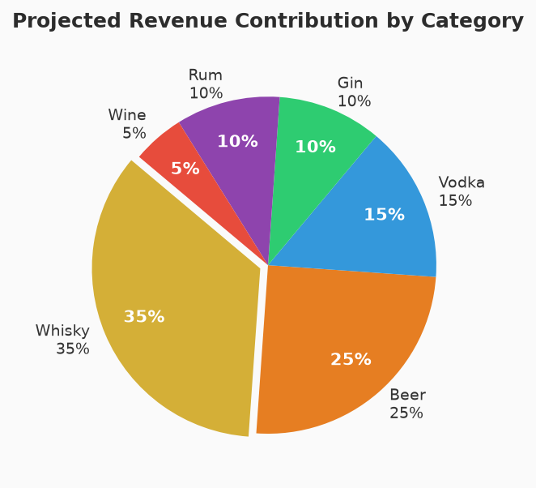

THE PRODUCT LINE

FERABEE RESERVE WHISKY
Category: Premium Blended Whisky | Strength: 42.8% v/v
Tasting Notes: Rich grain and malt blend with a distinct, smooth honey finish. Warm amber color with notes of vanilla and oak.
Target Demographic: Core demographic (25-45). Primary driver for Gold and Platinum packages. Preferred spirit for corporate and evening dining.

FERABEE PURE VODKA
Category: Premium Vodka | Strength: 42.8% v/v
Tasting Notes: Triple-distilled, charcoal-filtered for absolute clarity and a crisp, neutral palate. Exceptionally smooth mouthfeel.
Target Demographic: High-energy youth demographic (21-30). Foundation for all lounge cocktails and high-volume mixer consumption.

FERABEE BOTANICAL GIN
Category: Craft Gin | Strength: 42.8% v/v
Tasting Notes: Vapor-infused with juniper berries, Goan cardamom, coriander seeds, and fresh lemon peel. Floral and zesty.
Target Demographic: Millennial and female demographic. Growing rapidly as a daytime and early evening lifestyle choice.

FERABEE DARK RUM
Category: Premium Dark Rum | Strength: 42.8% v/v
Tasting Notes: Deep, molasses-based dark rum matured with hints of caramel, spice, and tropical sweetness.
Target Demographic: Dedicated regional consumers and cocktail base for tropical/tiki style lounge offerings.

FERABEE CRISP LAGER
Category: Craft Beer | Strength: 5.0% ABV
Tasting Notes: Premium 2-row Pilsner malt and Cascade hops. Light, crisp, refreshing with a clean finish.
Target Demographic: High-volume daytime/lunch consumers (Silver Hive package). Crucial entry point for the 21-24 age demographic.

FERABEE SPARKLING
Category: Sparkling Wine | Strength: 12.0% ABV
Tasting Notes: Light, effervescent, with notes of green apple and citrus. Available in Brut and Rose variants.
Target Demographic: Celebratory occasions, brunches, and the premium female demographic. Included in Platinum Royal packages.

MARGIN & PRICING ARCHITECTURE

A core advantage of the vertically integrated FOCO model is the extraction of wholesale and retail margins directly at the point of consumption. The table below outlines the A La Carte pricing strategy compared to the estimated Cost of Goods Sold (COGS), assuming local Maharashtra manufacturing to bypass import friction.
SKU | Volume | Est. COGS (₹) | A La Carte Price (₹) | Gross Margin
Reserve Whisky | 60ml Peg | ₹35 | ₹180 | 80.5%
Pure Vodka | 60ml Peg | ₹22 | ₹150 | 85.3%
Botanical Gin | 60ml Peg | ₹30 | ₹170 | 82.3%
Dark Rum | 60ml Peg | ₹25 | ₹140 | 82.1%
Crisp Lager | 500ml Can | ₹55 | ₹180 | 69.4%
Sparkling Wine | 150ml Glass | ₹90 | ₹250 | 64.0%

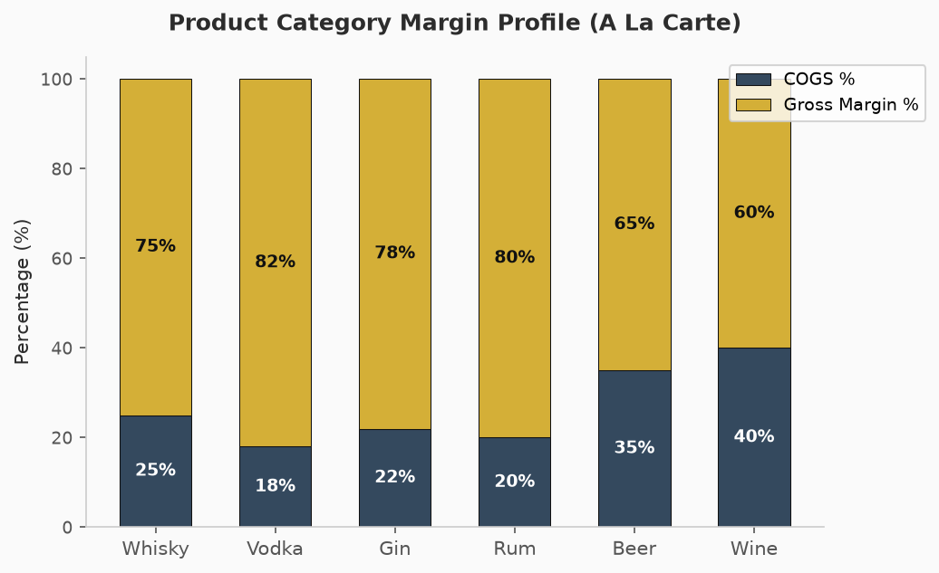

┃ PRODUCT MIX SYNERGY WITHIN THE TOKEN PACKAGES
The profitability of the FeraBee Lounges relies on the blended margin of the Pre-Paid Token Packages. By mixing high-margin white spirits (Vodka/Gin) with volume drivers (Beer) and premium perceived value items (Whisky), the blended beverage COGS is tightly controlled at approximately 20-25% across all tiers.

