FERABEE LIQUOR PRIVATE LIMITED
T H E R O Y A L B E E
━━━━━━━━━━━━━━━━━━━━━━━━━━━━━━
COMPREHENSIVE PROJECT REPORT
360° STRATEGIC ANALYSIS & REVISED BUSINESS MODEL
CONFIDENTIAL — FOR AUTHORIZED STAKEHOLDERS ONLY
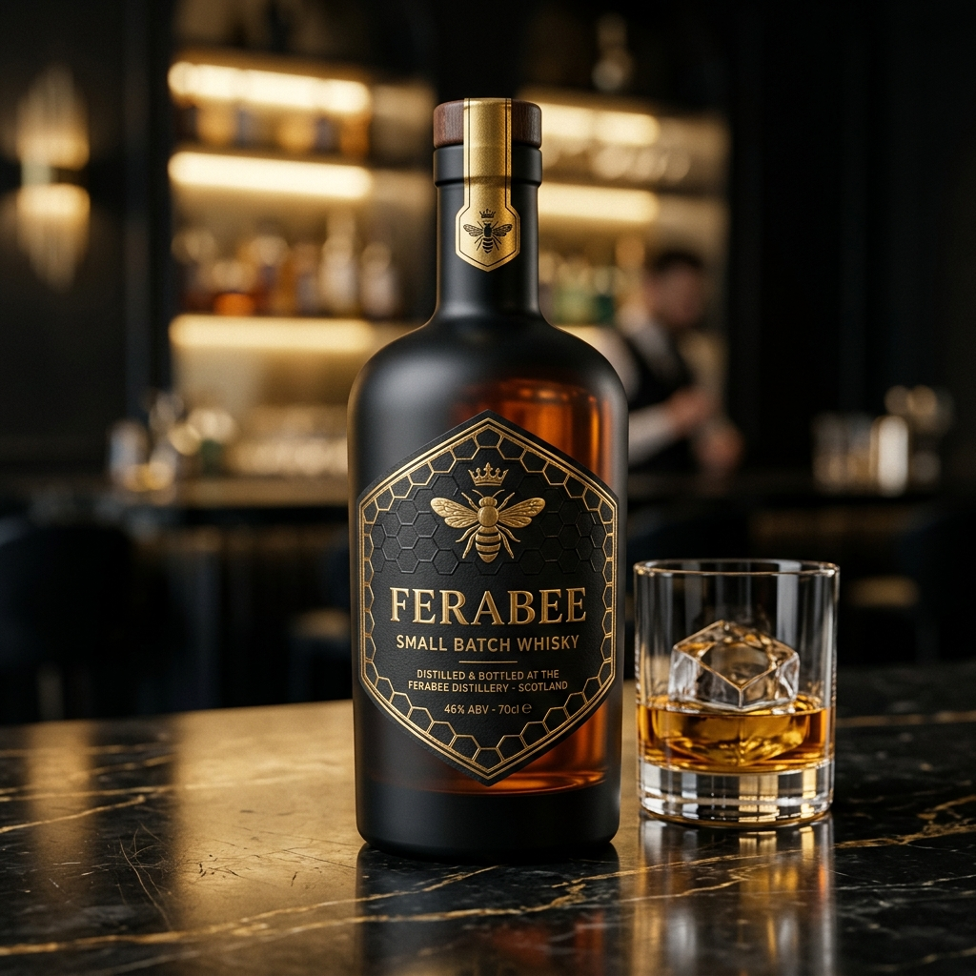

Document Version 2.0 | Revised & Corrected | August 2026
Prepared by: Strategic Advisory Division

TABLE OF CONTENTS

§1 Executive Summary & Strategic Vision
§2 Corporate Structure & Capitalization Assessment
§3 Regulatory Framework & Inter-State Excise Dynamics
§4 Product Portfolio Strategy & Margin Analysis
§5 The Lounge Experience & Legal Compliance Architecture
§6 Revised Unit Economics & Financial Projections
§7 Franchise Model Pivot: COFO → FOCO
§8 Strategic Reorientation & Recommendations
§9 Phased Geographic Rollout Plan
§10 Risk Matrix & Mitigation Framework
§11 Valuation, Exit Strategy & Market Benchmarking
Appendix A: Charts & Financial Exhibits
Appendix B: Legal Disclaimers

EXECUTIVE SUMMARY

FeraBee Liquor Private Limited proposes a vertically integrated premium spirits manufacturing and captive hospitality distribution enterprise. The company plans to pair a proprietary six-to-eight product alcoholic beverage portfolio with a national rollout of 367 high-capacity 'FeraBee Bee Lounges' across Maharashtra (355 Talukas) and Goa (12 Talukas).
✦ THE VISION
Pairing proprietary premium spirits with a captive, experiential distribution network—eliminating middlemen, bypassing traditional wine shop dependency, and delivering extreme consumer value through curated beverage experiences.

However, a rigorous 360-degree evaluation reveals profound structural vulnerabilities in the original model. This revised report deconstructs the original business plan, identifies critical legal, financial, and operational risks, and presents a strategically recalibrated execution framework that transforms the theoretical concept into a compliant, investable enterprise.
✦ CRITICAL FINDING
The original ₹22.0 Crore capitalization is sufficient for fewer than 30 outlets under the COFO model—completely invalidating the 367-outlet expansion premise. A structural pivot to FOCO (Franchise Owned Company Operated) is mandatory.

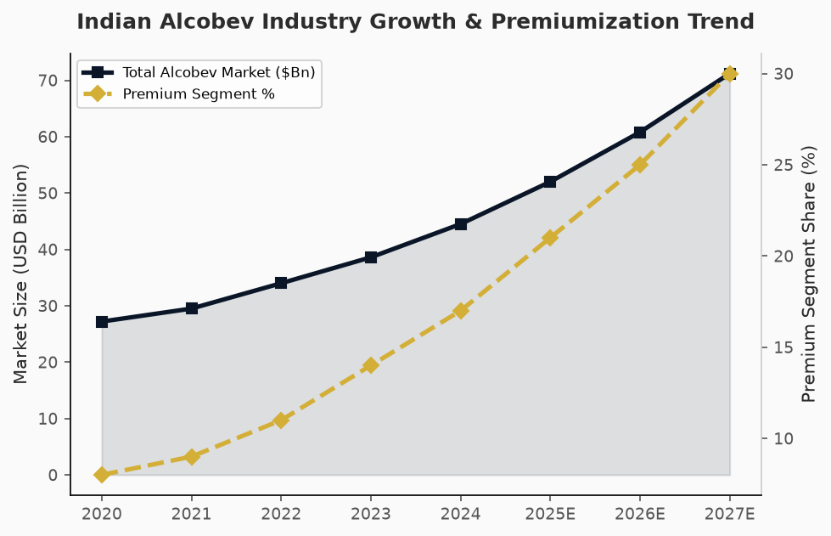
Fig. 1: Indian Alcobev Market Growth & Premium Segment Acceleration

§2 CORPORATE STRUCTURE & CAPITALIZATION ASSESSMENT
The corporate architecture relies on a standard private limited framework with ₹10.0 Crore authorized capital and ₹50.0 Lakh paid-up capital, apportioned through a 51:49 promoter shareholding split.
Parameter | Details
Legal Entity | FeraBee Liquor Private Limited
Authorised Capital | ₹10,00,00,000 (₹10 Crore)
Paid-Up Capital | ₹50,00,000 (₹50 Lakh)
Promoter Split | 51% : 49%
Brand Identity | The Royal Bee — Gold on Black
Total Cap Raise Target | ₹22.0 Crore
External Equity (25% stake) | ₹18.0 Crore
Bank CC Facility | ₹3.5 Crore

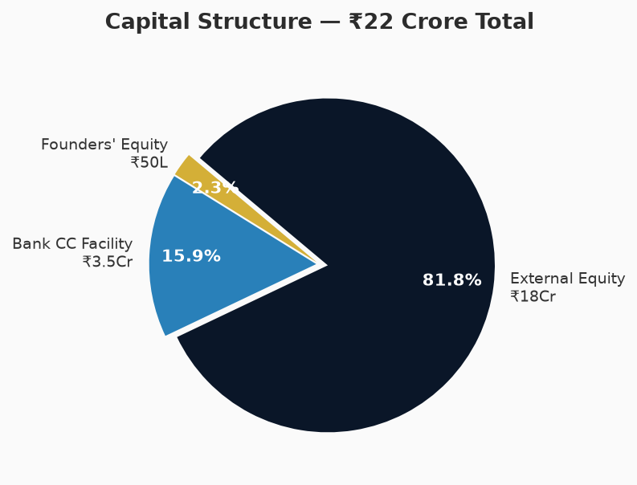
Fig. 2: Capital Structure Breakdown — ₹22 Crore Total Capitalization

The most glaring structural anomaly is the integration of the COFO model against this capitalization table. Establishing a premium 100-cover lounge requires ₹60 Lakh to ₹1.2 Crore per location. Under COFO, constructing 367 lounges requires ₹220–₹440 Crore—a 10x to 20x shortfall against the stated ₹22 Crore capitalization.
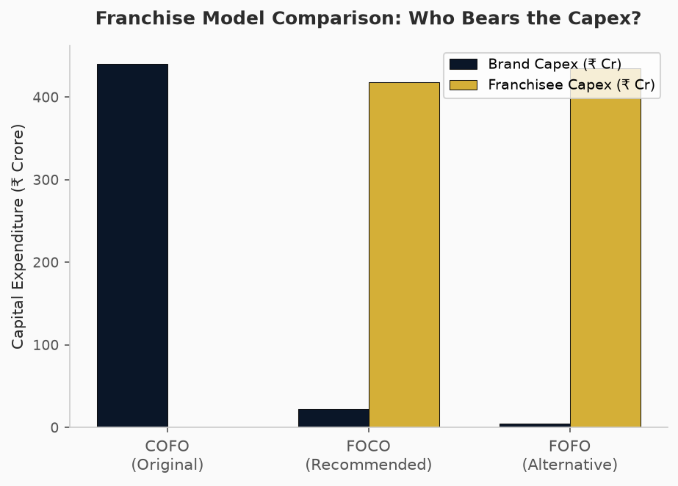
Fig. 3: Franchise Model Comparison — Capital Expenditure Distribution

§3 REGULATORY FRAMEWORK & INTER-STATE EXCISE DYNAMICS
Alcohol is constitutionally classified as a state subject in India under Entry 8 of the State List. There is no single central liquor law—each state has autonomous authority over manufacture, transport, taxation, and sale of intoxicating liquors.
✦ CRITICAL LEGAL RISK
The assumption that Goa's favorable excise regime translates into 30-40% margin advantage for Maharashtra retail is fundamentally flawed. Once Goa-manufactured spirits cross the border legally, they are immediately subjected to Maharashtra's excise duty multiplier (Manufacturing Cost × 4.5) plus up to 40% VAT on MRP, entirely neutralizing the Goan tax advantage.

▸ Inter-State Import Protocol Requirements
3.1. No Objection Certificate (NOC) from Goa Excise Department for export clearance.
3.2. Import Permit from Maharashtra State Excise Department.
3.3. Transport Pass (TP) with GPS-tracked bonded vehicle dispatch.
3.4. Maharashtra Border Checkpost verification and full duty payment.
3.5. Deposit into FL-1 licensed Bonded Wholesale Warehouse in Maharashtra.
3.6. Personal possession limit: 6 bottles of 750ml maximum for inter-state transport. Large-scale circumvention constitutes bootlegging under the Maharashtra Prohibition Act.

§4 PRODUCT PORTFOLIO STRATEGY & MARGIN ANALYSIS
The FeraBee product catalog covers Whisky, Vodka, Gin, Rum, and Craft Beer—all at 42.8% v/v IMFL standard strength. Custom luxury packaging aligns with the premiumization macro-trend (18% CAGR in premium spirits).
Product | Spec | Goa MRP | Est. MH MRP (After Excise)
FeraBee Whisky | 42.8% v/v Grain & Malt, Honey Finish | ₹1,350 | ₹2,200–₹2,500
FeraBee Vodka | 42.8% v/v Triple-Distilled | ₹1,150 | ₹1,900–₹2,100
FeraBee Gin | 42.8% Artisanal Botanical | ₹1,450 | ₹2,400–₹2,700
FeraBee Rum | 42.8% Premium Dark Molasses | ₹1,050 | ₹1,700–₹1,900
FeraBee Beer | 5.0% Premium Crisp Lager | ₹140 | ₹220–₹280

✦ PACKAGING RISK NOTE
Custom glass molds require massive volume commitments, tying up significant cash in raw material inventory. If COFO consumes the bulk of the ₹22 Crore for real estate, funding custom packaging across six unique SKUs will severely strain liquidity.

§5 THE LOUNGE EXPERIENCE & LEGAL COMPLIANCE ARCHITECTURE
The commercial catalyst driving the projected 105 daily guests is the tiered 'Unlimited Food + Spirits' package. The original model attempts to frame this as 'Unlimited Food + Complimentary FeraBee Tasting' to circumvent state liquor promotion laws.
✦ EXISTENTIAL LEGAL THREAT
The 'complimentary tasting' loophole is fundamentally incompatible with the Maharashtra Prohibition Act, 1949. Section 142 empowers district collectors to suspend licenses for practices deemed hazardous to public order or indicative of tax evasion. A single high-profile excise raid could result in mass license revocations, criminal charges for promoters, and immediate brand destruction.

▸ Age-Gating Compliance Crisis
Maharashtra's bifurcated legal drinking age (21 for beer/wine, 25 for spirits) creates impossible enforcement challenges in an 'unlimited, free-flowing' environment. Serving a 24-year-old FeraBee Whisky results in immediate license suspension.
▸ Recommended Solution: Pre-Paid Curated Token System
The ₹1,499 Gold Bee package should be reformatted to offer 'Unlimited Food + 6 Premium FeraBee Beverage Tokens.' This preserves high perceived value, strictly limits COGS, and remains fully compliant with state excise laws.
Revised Tier | Structure | Tokens | Legal Status
Silver Hive ₹999 | Unlimited Veg Food + Beer/Vodka Tokens | 4 Tokens | ✅ Compliant
Gold Bee ₹1,499 | Unlimited Food + Premium Spirit Tokens | 6 Tokens | ✅ Compliant
Platinum Royal ₹1,999 | Unlimited Food + All-Spirit Tokens + BBQ | 8 Tokens | ✅ Compliant

§6 REVISED UNIT ECONOMICS & FINANCIAL PROJECTIONS
The original projections of ₹24.5 Lakh monthly net profit and 4.7-month payback are aggressively optimistic. A granular reconstruction using standard Maharashtra hospitality operating metrics reveals the true cost structure.
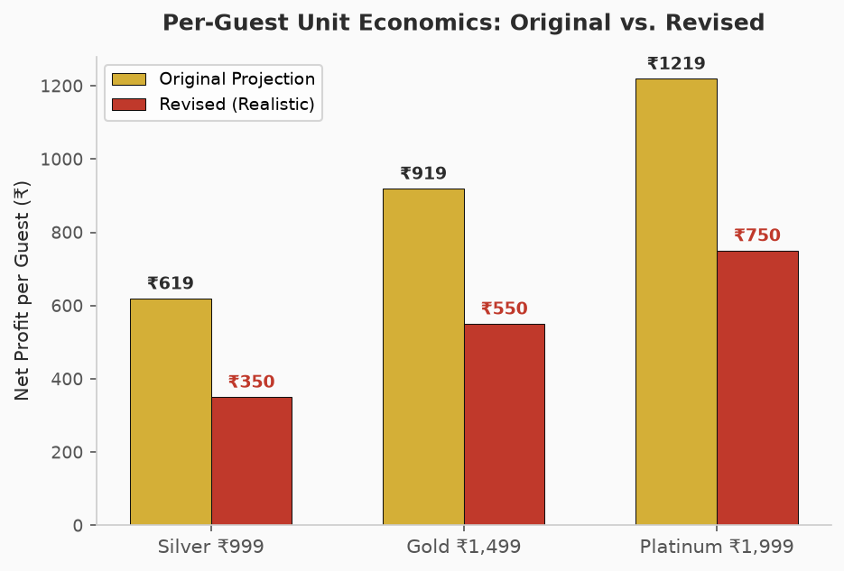
Fig. 4: Per-Guest Unit Economics — Original vs. Realistic Revised Projections

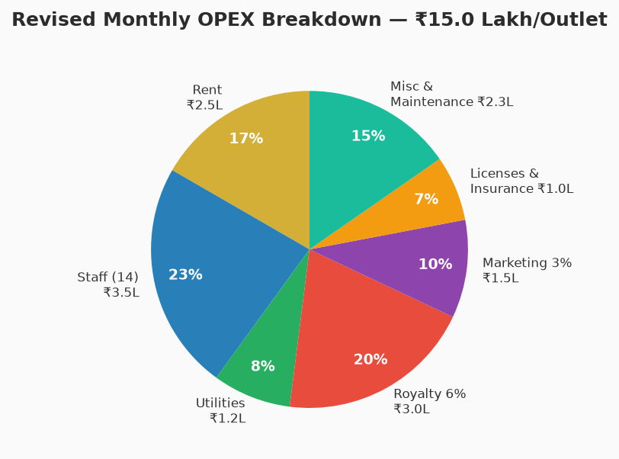
Fig. 5: Revised Monthly OPEX Breakdown — ₹15.0 Lakh Per Outlet

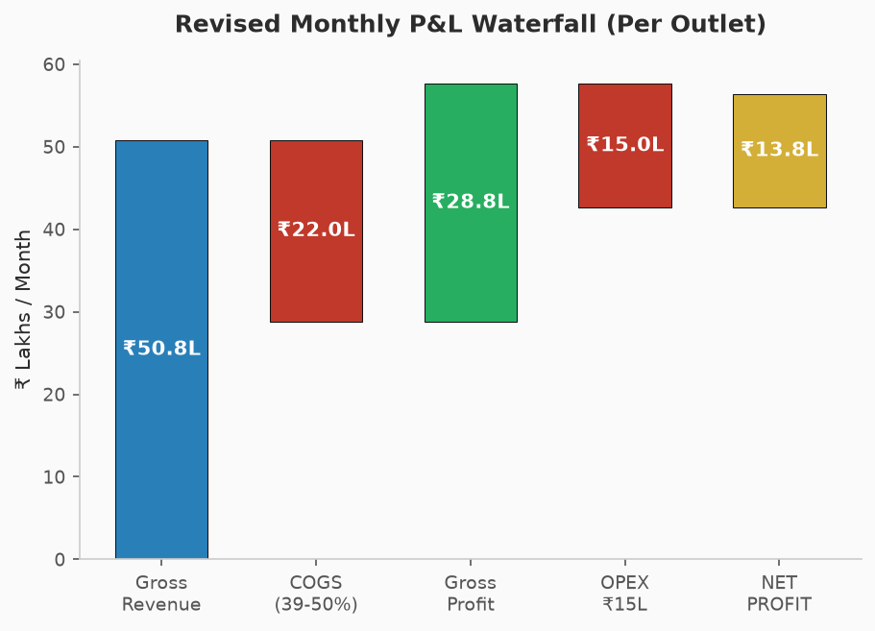
Fig. 6: Revised Monthly P&L Waterfall (Per Outlet)

P&L Item | Original | Revised (Realistic)
Monthly Revenue | ₹50.86 Lakh | ₹50.86 Lakh
Gross Profit Margin | 61% | 50–55%
Monthly OPEX | ₹6.44 Lakh | ₹15.0 Lakh
Monthly Net Profit | ₹24.50 Lakh | ₹5.0–₹8.0 Lakh
Franchise Payback Period | 4.7 Months | 18–24 Months

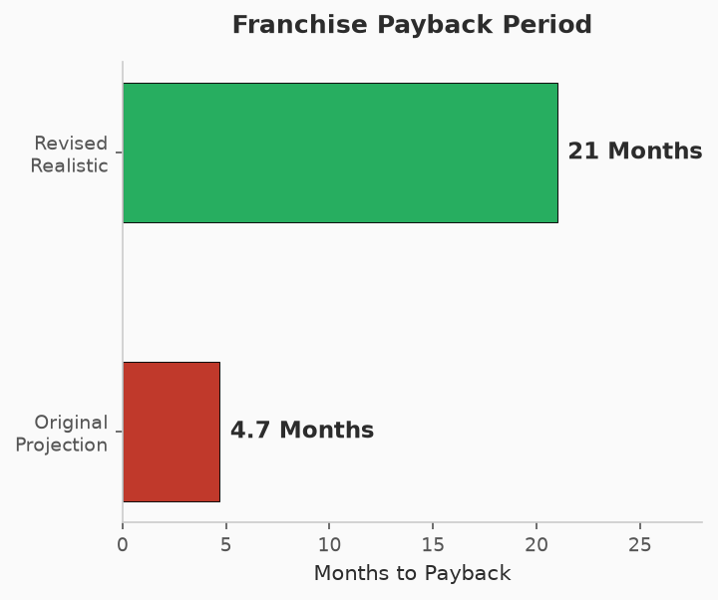
Fig. 7: Franchise Payback Period — Original vs. Revised

✦ KEY TAKEAWAY
While a 18-24 month payback remains excellent for the hospitality sector, transparent communication to franchisees is critical to prevent localized bankruptcies from severe initial undercapitalization.

§7 FRANCHISE MODEL PIVOT: COFO → FOCO
The COFO model dictates the parent brand retains total ownership of physical assets, real estate, and infrastructure. This is exceedingly rare (<1% of Indian franchise models) and financially impossible at ₹22 Crore capitalization for 367 outlets.
▸ The FOCO Solution
Under the Franchise Owned Company Operated (FOCO) framework, local franchise investors fund the ₹80 Lakh to ₹1.5 Crore capex. FeraBee retains total operational control, supply chain management, and brand quality assurance via management fees and gross profit sharing.
Dimension | COFO (Original) | FOCO (Recommended)
Who Owns Assets? | Brand (FeraBee) | Franchise Investor
Who Operates? | Franchise Partner | Brand (FeraBee)
Capex Required from Brand | ₹220–₹440 Crore | ₹22 Crore (Sufficient)
Quality Control | Low (Franchisee operates) | High (Brand operates)
Scalability | Impossible at current cap | Highly Scalable
Risk Profile | Catastrophic | Balanced

§8 STRATEGIC REORIENTATION & RECOMMENDATIONS
▸ 8.1 — Localize Manufacturing in Maharashtra
Utilize a portion of the ₹18 Crore equity raise to establish a tie-up manufacturing unit directly within Maharashtra. Procuring ENA locally and bottling within the state eliminates inter-state import friction entirely, ensuring continuous supply without bootlegging risk.
▸ 8.2 — Hyper-Dense Phased Geographic Rollout
Concentrate the initial 20 FOCO lounges within the Mumbai-Thane-Navi Mumbai corridor. This concentrates marketing spend, simplifies cold-chain logistics, and builds deep relationships with a single district's excise authorities before wider penetration.
▸ 8.3 — Recalibrate Franchisee Communication
Update all franchisee recruitment materials to reflect realistic ₹15.0 Lakh monthly OPEX and 18-24 month payback. This is still highly competitive and sufficient to attract sophisticated hospitality investors.
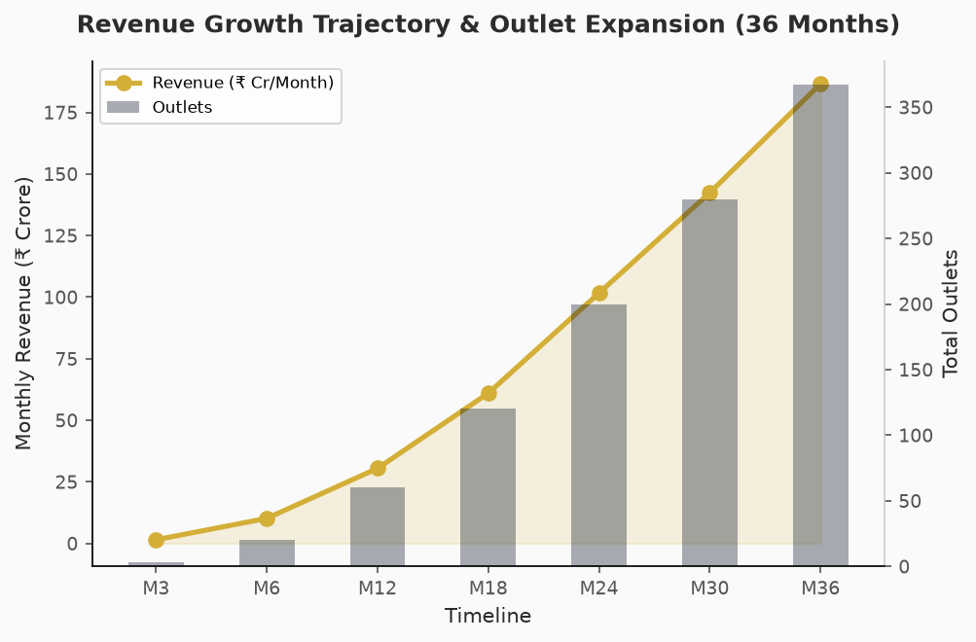
Fig. 8: Revenue Growth Trajectory & Outlet Expansion Plan (36 Months)

§9 PHASED GEOGRAPHIC ROLLOUT PLAN
Phase | Timeline | Region | Outlets | Milestone
Pilot | M1–M3 | Mumbai (Andheri, BKC, Powai) | 3 COCO | Prove unit economics
Phase 1 | M4–M6 | Mumbai-Thane-Navi Mumbai | 20 FOCO | ₹10 Cr/month revenue
Phase 2 | M7–M12 | Pune, Nashik, Nagpur | 60 Total | ₹30 Cr/month revenue
Phase 3 | M13–M24 | Deep Maharashtra + Goa | 200 Total | ₹100 Cr/month revenue
Phase 4 | M25–M36 | Full 367 Taluka Coverage | 367 Total | ₹186 Cr/month revenue

§10 RISK MATRIX & MITIGATION FRAMEWORK
Risk Category | Severity | Probability | Mitigation Strategy
Maharashtra Prohibition Act violation | CRITICAL | HIGH | Abandon 'Unlimited' model; implement Token System
Capex shortfall under COFO | CRITICAL | CERTAIN | Pivot to FOCO model immediately
Inter-state smuggling accusation | CRITICAL | MEDIUM | Establish MH tie-up bottling unit
Franchise undercapitalization | HIGH | HIGH | Revise payback projections to 18-24 months
FL-III licensing delays | MEDIUM | HIGH | Begin applications 6 months prior to planned launch
Age-gating enforcement failure | HIGH | HIGH | Token system auto-restricts spirit tokens by age verification
Custom packaging inventory lock-up | MEDIUM | MEDIUM | Phase in custom packaging after initial 50-outlet milestone

§11 VALUATION, EXIT STRATEGY & MARKET BENCHMARKING
The original Year 3 exit projection of ₹780 Crore (10x EBITDA on ₹78 Cr) requires significant recalibration under the revised financial model. With realistic per-outlet net profit of ₹5-8 Lakh/month and a phased rollout, the revised valuation timeline is presented below.
Metric | Original Projection | Revised Projection
Year 3 Outlet Count | 367 | 200–250 (Realistic Licensing)
Year 3 EBITDA | ₹78.0 Crore | ₹24.0–₹36.0 Crore
EBITDA Multiple | 10.0x | 8.0x (Conservative)
Enterprise Valuation | ₹780.0 Crore | ₹192–₹288 Crore
Investor 25% Stake Value | ₹195.0 Crore | ₹48–₹72 Crore
Investor ROI | 10.8x | 2.7x – 4.0x
IRR (Estimated) | ~120% | ~45–60%

✦ REVISED INVESTOR THESIS
Even at the conservative revised projections, a 2.7x to 4.0x return over 36 months (45-60% IRR) represents an exceptional risk-adjusted return for an early-stage consumer brand in the Indian alcobev sector. The key differentiator is that these projections are now legally defensible and operationally achievable.

LEGAL DISCLAIMERS & CONFIDENTIALITY

I. This document is prepared for informational purposes only and does not constitute an offer or solicitation for the purchase or sale of any financial instrument.
II. All financial projections are forward-looking estimates based on assumptions that may not materialize. Actual results may differ materially.
III. The regulatory analysis herein is based on publicly available information regarding the Maharashtra Prohibition Act, 1949, and applicable state excise regulations as of August 2026.
IV. This document is strictly confidential and intended solely for the authorized recipient. Unauthorized reproduction, distribution, or disclosure is prohibited.
V. FeraBee Liquor Private Limited, its promoters, and advisors accept no liability for decisions made based on the information contained herein.

