FERABEE LIQUOR
THE ROYAL BEE
MASTER PROJECT REPORT & BUSINESS MODEL
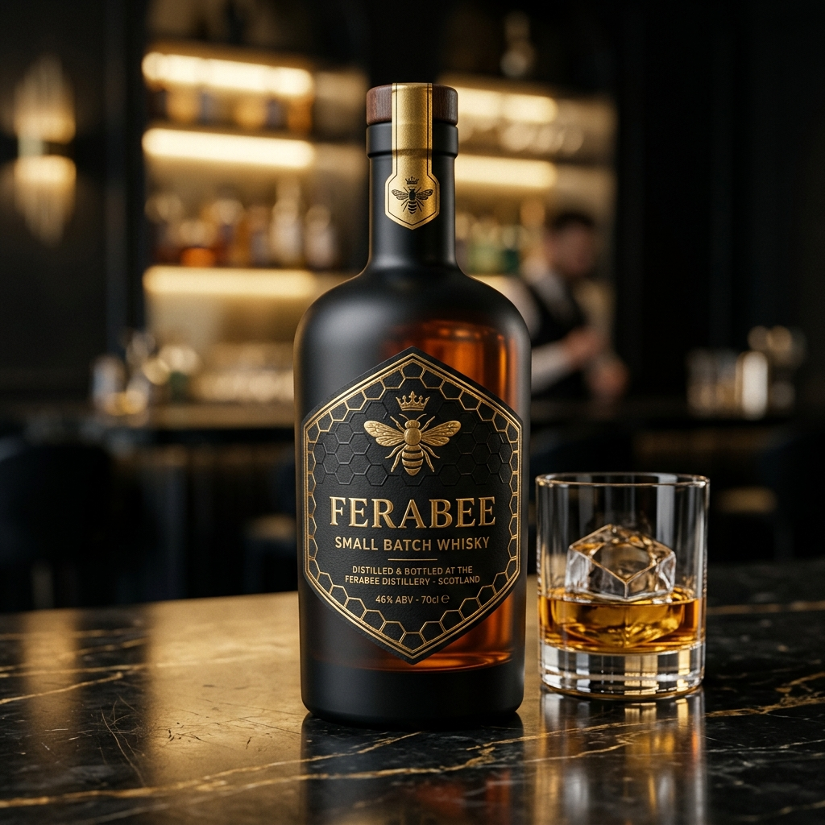
Product Concept: FeraBee Small Batch Premium Whisky

EXECUTIVE SUMMARY

✦ THE FERABEE VISION ✦
FeraBee Liquor Pvt Ltd is launching a premium 6-to-8 product alcobev portfolio paired with an exclusive chain of 367 '100-Cover FeraBee Bee Lounges' across Maharashtra and Goa under a Company Owned Franchise Operated (COFO) model. Direct consumption through franchise outlets guarantees massive sales volume, eliminating traditional wine shop retail dependency.

┃ 1. Corporate Structure
FeraBee Liquor Private Limited represents a high-growth corporate model in the Indian spirits and hospitality franchise ecosystem. By securing manufacturing and bottling agreements out of Goa, the company benefits from a 30% to 40% excise tax advantage compared to surrounding states.
Metric / Element | Details
Authorised Capital | ₹10,00,00,000 (₹10 Crore)
Paid-Up Capital | ₹50,00,000 (₹50 Lakh)
Promoter Shareholding | 51% : 49% Split
Brand Aesthetics | Gold on Black / The Royal Bee / Hexagonal Crest

┃ 2. Product Portfolio
The FeraBee product lineup comprises core SKUs across Spirits, Craft Beer, and Wine, formulated at 42.8% v/v IMFL standard strength with custom luxury packaging.
Category | Packaging | Blend Specifications | Goa MRP
FeraBee Whisky | 750ml Custom Black Glass | 42.8% v/v Grain & Malt, Honey Finish | ₹1,350
FeraBee Vodka | 750ml Clear Glass | 42.8% v/v Triple-Distilled | ₹1,150
FeraBee Gin | 750ml Clear Glass | 42.8% Botanical Blend | ₹1,450
FeraBee Rum | 750ml Glass Bottle | 42.8% Premium Dark Rum | ₹1,050
FeraBee Beer | 650ml Bottle / 500ml Can | 5.0% Premium Crisp Lager | ₹140

THE LOUNGE EXPERIENCE

┃ 3. FeraBee Bee Lounge Concept
Each FeraBee franchise outlet operates as a high-density, social dining destination designed to offer maximum visual appeal and customer throughput. Features include Black Marble flooring, Gold Trim, a Honey Drip Bar Counter, and a 3D Gold Bee Feature Wall.
✦ THE 'UNLIMITED' ADVANTAGE ✦
The commercial catalyst is the Unlimited Food + Spirits Package. Structured legally as an 'Unlimited Food + Complimentary FeraBee Tasting', it offers extreme value to customers while locking in a guaranteed 61% profit margin for franchisees.

Tier Package | Offering Details | Net Profit / Guest
SILVER HIVE (₹999) | Lunch: Unlimited Beer + Vodka/Rum + Veg Food | ₹619 (62% Margin)
GOLD BEE (₹1,499) | Dinner: Unlimited Spirits + 7 Starters + Main | ₹919 (61% Margin)
PLATINUM (₹1,999) | Weekends: All Spirits + Seafood + Live BBQ | ₹1,219 (61% Margin)

┃ 4. Franchise Unit Economics
Based on conservative estimates of 105 guests per day at the Gold Tier and 45 A La Carte guests, the franchise model yields exceptional returns.
P&L Item Category | Monthly Amount (₹)
Total Monthly Revenue | ₹50,86,770
Gross Profit (61% Margin) | ₹31,00,000
Less: Monthly Opex | ₹6,44,000
NET PROFIT (MONTHLY) | ₹24,50,000
FRANCHISE PAYBACK PERIOD | 4.7 MONTHS

FINANCIAL PROJECTIONS & EXIT

┃ 5. Investment Ask & Cap Table
The capital structure combines founders equity, bank cash credit limits, and an equity raise to fund national expansion.
Capital Source | Amount (₹) | Terms
Founders Paid-Up Equity | ₹50,00,000 | 51% : 49%
Bank Cash Credit (CC) | ₹3,50,00,000 | Secured Facility
External Equity Raise | ₹18,00,00,000 | 25.0% Stake
TOTAL CAPITALIZATION | ₹22,00,00,000 | Operational Runway

✦ YEAR 3 INVESTOR RETURN ✦
At Year 3, based on a conservative 10.0x EBITDA multiple on a projected ₹78.0 Crore EBITDA, FeraBee will achieve an Enterprise Valuation of ₹780.0 Crore. The investor's 25% equity stake will be valued at ₹195.0 Crore, representing an estimated 10.8X Return on Investment over 36 months.

