UML Diagram
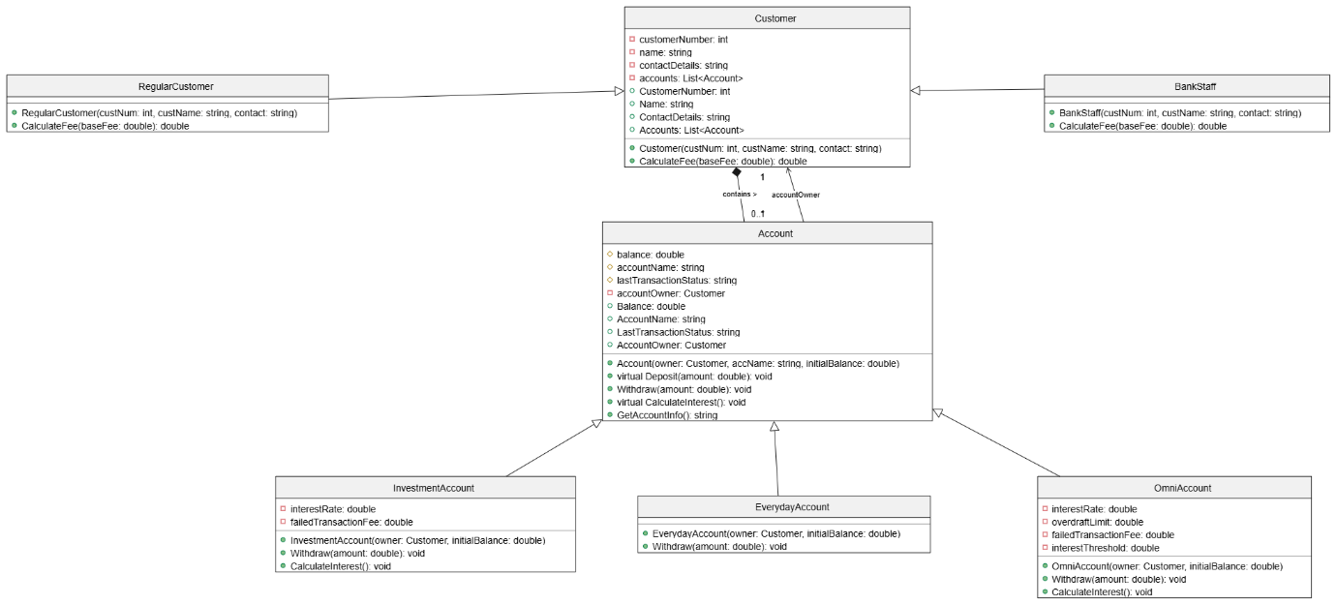

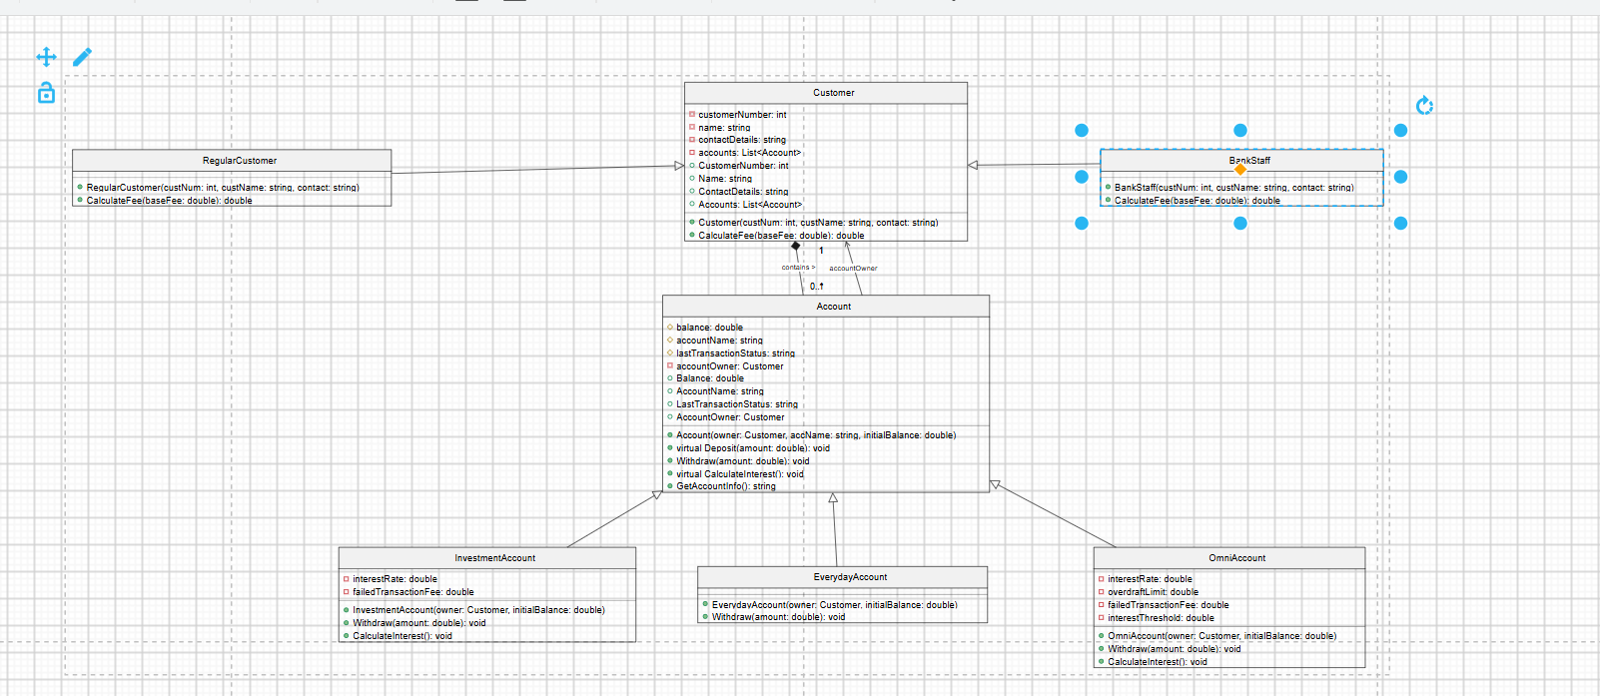

Justification
Core Object-Oriented Programming (OOP) principles mentioned are Inheritance, Composition which forms a robust and logical banking model in the system architecture.
Account and Customer are abstract base classes that are supported by the inheritance and polymorphism. By not making it possible to instantiate generic, undefinable accounts and/or customers, this allows only concrete types (e.g. OmniAccount or BankStaff) to be represented in the system. The Account class implements a virtual Deposit method since all deposits are treated the same way and contains attributes that can be shared by all types of accounts (e.g., Balance). On the other hand, the abstract Withdraw method is indicated. With this design pattern, the child classes (EverydayAccount, InvestmentAccount and OmniAccount) must explicitly override the transaction logic that handles overdraft limits and penalties for transactions that fail for each new type of account. Likewise, the Customer hierarchy exploits polymorphism by using an abstract method, ComputeFee. This enables the RegularCustomer to pay a full fee and BankStaff will automatically credit a 50% of the fee.
Architecture supports the banking scenario via a strong Composition relationship that also makes use of a Customer entity having a set of Account objects (List<Account>)). This securely wraps the accounts inside the customer's profile, just like in real life, the person does not live without a bank account. In addition, there is a one-to-one relationship, in which every child Account has a reference to its corresponding Customer owner, and vice versa. It's a structural decision that is important for fee processing because an InvestmentAccount or OmniAccount will register a withdrawn amount which has failed when the withdrawal has been made, immediately pinching off the accountOwner.CalculateFee(). This gives the exact penalty depending on the user's particular role, and maintains the cleanliness of the classes because the conditional specification is not hardcoded in the classes themselves.

Task 03
User flow diagram
