

S.B. JAIN INSTITUTE OF TECHNOLOGY MANAGEMENT & RESEARCH, NAGPUR

Practical 1
Prelab

Aim: Installation of Linux Operating System.

Name: Piyush Thorve
USN: CM25D002
Semester / Year: IV / II
Academic Session: 2025-26
Date of Performance:
Date of Submission:

- Aim: Installation of Linux Operating System.

- Objectives:
  - Understand the system requirements and compatibility for Linux OS installation.
  - Learn the step-by-step process to install and configure a Linux distribution.
  - Verify the installation and explore basic Linux commands for system setup.

❖ Requirements: 
- A bootable USB drive or DVD with the desired Linux distribution (e.g., Ubuntu, Fedora, Debian).
- A computer system with minimum hardware requirements: 2 GB RAM, 20 GB free disk space, and a compatible processor.
- Internet connection (optional, for updates during installation).
- Software for creating a bootable USB, like Rufus or Etcher (if needed).
- Basic knowledge of BIOS/UEFI settings for boot sequence configuration.

**IN THIS PRACTICAL WE’LL BE INSTALLING UBUNTU**

❖ Prerequisite: 
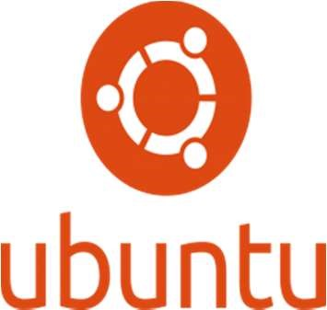
Linux is an open-source operating system widely used for personal, professional, and server environments. Its flexibility, security, and community-driven development make it a popular choice for users. The installation of a Linux OS involves creating a bootable medium, setting up the system to boot from the medium, and following the installation wizard to partition the disk and configure system settings. Common distributions like Ubuntu, Fedora, and Debian offer user-friendly interfaces for easy installation. The process may include creating swap space, selecting a file system like ext4, and setting up user accounts. Post-installation
tasks involve updating the system, installing necessary drivers, and customizing the environment. Understanding the installation process ensures better control over system performance and resource allocation, making Linux a powerful tool for both beginners and advanced users.

Steps to Make a Pendrive Bootable Using Rufus:

- Download and Open Rufus: Download Rufus from its official website, install it, and launch the application.
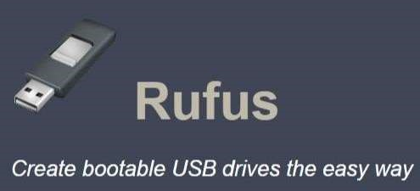
- Insert Pendrive and Select ISO: Connect the USB pendrive to your system. In Rufus, select your pendrive under "Device" and click "SELECT" to choose the Linux ISO file.
- Set Partition Scheme and File System: Choose "GPT" for UEFI or "MBR" for BIOS under "Partition scheme," and ensure the file system is set to "FAT32."
- Start the Process: Click "START," confirm the warning about data deletion, and wait for Rufus to create the bootable USB. Once done, eject the pendrive safely.

❖ Theory: 
An operating system (OS) is system software that acts as an interface between computer hardware and the user. It manages hardware resources and provides essential services for executing application software. The OS is a vital component of a computer system, enabling users to interact with the system in a structured and efficient manner.

Functions of an Operating System:

- Process Management: Handles the execution of multiple processes, ensuring smooth multitasking and optimal CPU usage.
- Memory Management: Allocates and manages system memory, ensuring that each program gets the required memory without interfering with others.
- File System Management: Organizes and manages data storage, allowing users to store, retrieve, and manipulate files.
- Device Management: Coordinates and controls input/output devices such as keyboards, printers, and disk drives.
- Security and Access Control: Protects data and system integrity by implementing user authentication and access restrictions.

Types of Operating Systems:

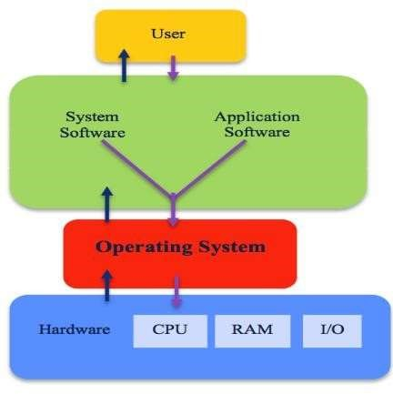
- Batch OS: Executes tasks in batches without direct user interaction.
- Time-Sharing OS: Allows multiple users to share system resources simultaneously.
- Distributed OS: Manages a group of independent computers and makes them appear as a single system.
- Real-Time OS: Designed for time-critical tasks where responses are needed within strict deadlines.
- Mobile OS: Specialized for mobile devices, such as Android and iOS.

Operating systems like Windows, Linux, and macOS are widely used across various platforms, each catering to specific user needs. Linux, for example, is known for its open-source nature and flexibility, while Windows provides a user-friendly interface for personal and professional use.

In summary, an operating system is the backbone of computer functionality, ensuring efficient resource management, user interaction, and system reliability. It continues to evolve, adapting to technological advancements and diverse user requirements.

❖ Steps to Install Linux Operating System: 
1. Prepare Bootable Media: Use a tool like Rufus to create a bootable USB drive or DVD with the Linux distribution ISO.


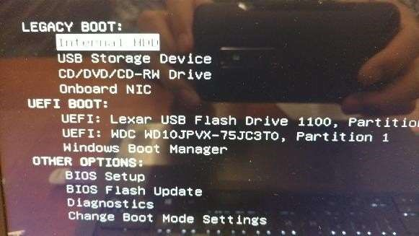


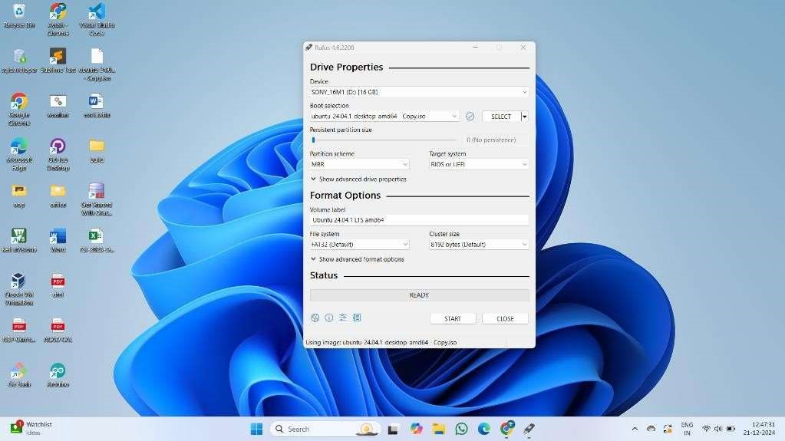
Configure BIOS/UEFI Settings
:
Restart your
computer and access the BIOS/UEFI settings
(
usually by pressing a key like F2, F10, or DEL
during boot). Set the boot priority to USB or
DVD.
2.

- Boot from Media: Insert the bootable USB or DVD and restart the computer. The system will boot into the Linux installer.
- Choose Installation Option: Select "Install Linux" or a similar option from the menu. Some distributions may allow you to try the OS before installation.
- Partition the Disk:
  - Select the partition scheme (automatic or manual).
  - Create required partitions (e.g., root /, swap, and optionally /home).
- Set Up User Details: Enter your username, password, and system name.
- Select Time Zone: Choose your location to configure the correct time and date settings.
- Begin Installation: Review the settings and click "Install." The process will take a few minutes to complete.

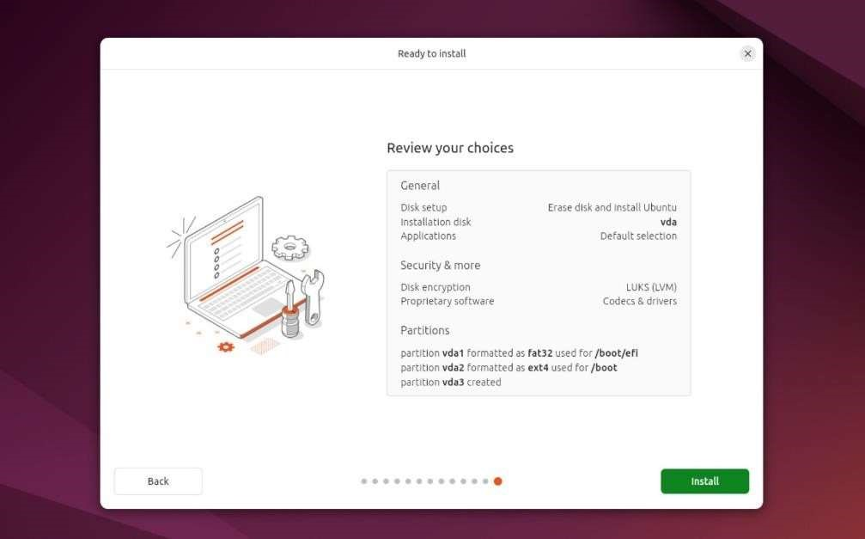

- Remove Bootable Media: Once installation is finished, remove the USB or DVD when prompted and restart the system.

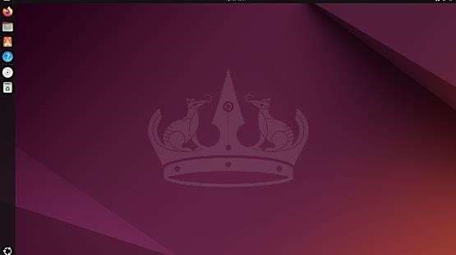

- Post-Installation Configuration: Log in to your new Linux system, update packages, and install additional software if needed.

Commands to update:

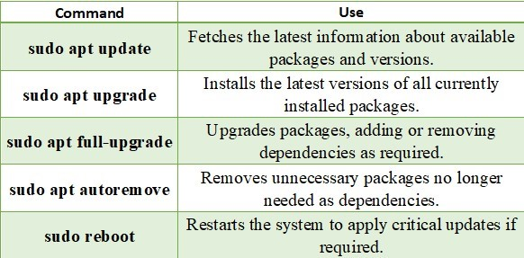
❖ Conclusion: The installation of the Linux operating system provides a hands-on understanding of system setup and configuration. It enables efficient utilization of resources and customization to suit user needs. Mastering this process builds a solid foundation for exploring advanced system administration tasks. 

❖ Discussion Questions: 
- Q: What is an operating system, and why is it important?
- Q: What is the purpose of creating a bootable USB, and how is it done?
- Q: Can you explain the difference between apt update and apt upgrade in Ubuntu?
- Q: Why is partitioning necessary during OS installation, and what are the common partitions used?
- Q: What steps should you follow after successfully installing a Linux OS?

❖ References: 
https://ubuntu.com/tutorials/install-ubuntu-desktop#1-overview https://youtu.be/wjbbl0TTMeo?si=32l6h8VbcmU-euD_
https://answers.microsoft.com/ https://rufus.ie/en/

Date: / /2026
Signature
Course Coordinator
B.Tech CSE(AIML)
Sem: 4 / 2025-26

