A
Project Report On

ALGORITHM HUB
INTERACTIVE ALGORITHM LEARNING AND VISUALIZATION PLATFORM

Designed By:
Mr. Piyush Uttam Sawant

Submitted To:

K.M.S.P. MANDAL’S

SANT RAWOOL MAHARAJ MAHAVIDYALAYA, KUDAL.
(NAAC Re-Accreditation “B+” Grade) In the partial fulfillment of

B.Sc. Computer Science (Sem V)
Under Guidance of:

Asst. Prof. Santosh Chougule (M.C.A.). Asst. Prof. Prakash Talankar (M.C.A.)

Through:

THE HEAD, DEPARTMENT OF COMPUTER SCIENCE,

S.R.M. COLLEGE, KUDAL.
UNIVERSITY OF MUMBAI PROJECT REPORT 2026 - 27

DECLARATION

To,
The Head,
Department of Computer Science,
S. R. M. College, Kudal.

Respected Sir/Madam,

I undersigned, hereby declare that the project on “Algorithm Hub – Interactive Algorithm Learning and Visualization Platform” is developed under the guidance of our project guide.

The findings, system designs, code implementations, and conclusions embodied in this report are based on the original work collected and developed by me. I am declaring that this is our original work. I have not copied any materials related to my project from unauthorized sources.

I do undersign that if my work is found to be copied or in violation of academic guidelines, then I am liable to punishment as per the university rule.

DATE:

PLACE: KUDAL.

(Mr. Piyush Uttam Sawant)


K.M.S.P. MANDAL’S
S SANT RAWOOL MAHARAJ MAHAVIDYALAYA,
KUDAL.

NAAC RE-ACCREDITATION “B+” GRADE

CERTIFICATE

This is to certify that Mr. Piyush Uttam Sawant having Exam

Seat Number: has satisfactorily carried out her project

work entitled.

Algorithm Hub

Interactive Algorithm Learning and Visualization Platform

As per the syllabus prescribed for B.Sc. Computer Science of Mumbai University, Mumbai.
It is also certified that this is her own work completed during the academic year 2026–27. The work done is satisfactory and is presented as per the specifications.

Project Guide External Examiner Head of Department

DATE:

ACKNOWLEDGEMENT

It is my great privilege and pleasure to present this final project report on “Algorithm Hub – Interactive Algorithm Learning and Visualization Platform”. I express my sincere thanks to all the respected professors, mentors, and peers who guided me throughout the conceptualization, implementation, and documentation phases of this project.

I express my heartfelt gratitude to our respected Principal and Head of the Department of Computer Science, S.R.M. College, Kudal, for providing state-of-the-art laboratory facilities, computing infrastructure, and encouragement.

I would like to extend my deepest appreciation to my Project Guide, Asst. Prof. Santosh Chougule and Asst. Prof. Prakash Talankar, who provided critical insights, technical mentorship, and patient assistance during the development of the neural try-on bridge, database schema design, and asynchronous server architectures.

And last but not least, I thank my parents, family, and classmates for their constant moral support and motivation.

Thank You.

( Mr. Piyush Uttam Sawant)

INDEX OF CONTENTS
Sr No | Chapter No. | Title | Page No.
1 | I | Acknowledgement | 4
2 | II | Synopsis of the Project | 6–9
 |  | 2.1 Problem Statement
 |  | 2.2 Objectives and Scope
 |  | 2.3 Process Description
3 | III | Main Report | 10–40
 |  | 3.1 Objectives and Scope of the Project
 |  | 3.2 Theoretical Background
 |  | 3.3 Survey of Literature and Research Analysis
 |  | 3.4 System Planning
 |  | 3.5 Hardware and Software Requirements
 |  | 3.6 Detailed Project Life Cycle (SDLC)
 |  | 3.7 Software Engineering Diagrams
 |  | 3.7.1 Data Flow Diagrams (DFD)
 |  | 3.7.2 Entity Relationship Diagram (ERD)
 |  | 3.7.3 Activity Diagram
 |  | 3.7.4 Class Diagram
 |  | 3.7.5 Object Diagram
 |  | 3.7.6 Use Case Diagram
 |  | 3.8 Input and Output Screen Design
 |  | 3.9 Methodology Used for Testing
 |  | 3.10 Test Cases and Test Reports
 |  | 3.11 Important Source Code of the Project
4 | IV | Annexure: Database Structure and Rules | 41–47
5 | V | Conclusion | 48–49
6 | VI | Future Enhancements | 50–53
7 | VII | References and Bibliography | 54–55

CHAPTER II:

SYNOPSIS OF THE PROJECT

Algorithm Hub

2.1Problem Statement

Algorithms are an essential part of computer science and software development. They provide step-by-step solutions to computational problems and are used in areas such as searching, sorting, data structures, graph processing, and problem-solving. However, many students find it difficult to understand algorithms through theoretical explanations alone.

Traditional learning methods often depend on textbooks, static diagrams, and classroom explanations. These methods may not clearly demonstrate how an algorithm executes, how data changes at each step, or how different algorithms compare in terms of performance. Beginners may also face difficulties selecting suitable algorithms, understanding their time and space complexity, and applying their knowledge to practical problems.

Learning algorithms requires both theoretical understanding and practical implementation. Without interactive demonstrations and sufficient practice opportunities, students may struggle to develop logical thinking and problem-solving skills.

To overcome these challenges, Algorithm Hub is developed as a web-based educational platform that helps students learn algorithms through explanations, interactive visualizations, and practice activities.

The system provides a centralized platform where users can explore algorithms, understand their working processes, observe execution steps through visualizations, and practice algorithm-related problems. The platform aims to make algorithm learning more interactive, understandable, and accessible.

The main purpose of this project is to support students and beginner programmers in developing a strong foundation in algorithms and improving their programming and problem-solving abilities.

2.2Objective And Scope
2.2.1Objectives
The main objectives of Algorithm Hub are:
- Interactive Algorithm Learning: To provide a user-friendly platform for learning algorithms through organized educational content.
- Algorithm Visualization: To demonstrate how algorithms execute through visual representations and step-by-step operations.
- Conceptual Understanding: To explain algorithm concepts and their working procedures in a simple and understandable manner.
- Algorithm Exploration: To organize algorithms into categories so users can explore relevant topics easily.
- Practical Problem-Solving: To provide a practice section where users can attempt algorithm-related programming problems.
- Beginner-Friendly Interface: To design an accessible interface suitable for students and users with different levels of programming knowledge.
- User Authentication: To provide registration and login functionality for accessing user-related features.
- Programming Practice: To encourage users to apply their theoretical knowledge through coding exercises and practical activities.
- Learning Progress Support: To provide a foundation for tracking learning activities and helping users identify areas for improvement, subject to the features implemented in the application.

- Improvement of Computational Thinking: To strengthen logical reasoning, analytical thinking, and programming skills through algorithm-based learning.

2.2.2Scope
Algorithm Hub is a web-based learning application primarily intended for computer science students, beginner programmers, and individuals who want to improve their understanding of algorithms.

The application provides algorithm-related learning content, visualization functionality, practice activities, and user authentication pages. Users can explore available algorithms, study their explanations, observe supported algorithm operations, and practice programming problems through the provided interface.

The project focuses on making algorithm concepts easier to understand by combining theoretical explanations with interactive learning features. It can be used for academic study, programming practice, revision, and preparation for technical assessments.
The application uses frontend technologies to present the learning interface and JavaScript functionality to support interactive features. Its backend uses Node.js and Express, with SQLite for data storage and authentication-related functionality.

The platform can be extended with additional algorithms, quizzes, personalized learning plans, progress tracking, performance comparisons, and further learning resources.
The accuracy and availability of learning results depend on the implemented algorithms, available educational content, and the functionality of the application. Users should also practise implementing algorithms independently to develop a deeper understanding of their operation and complexity.

2.3 Process Description
Algorithm Hub follows a structured process to help users explore, understand, visualize, and practise algorithms.

Step 1 – User Registration and Login
The user can create an account through the registration page or log in using existing credentials. The application provides authentication functionality to support access to user-related features.

Step 2 – Accessing the Home Page
After opening the application, the user accesses the home page, which introduces the platform and provides navigation to the available learning sections.

Step 3 – Exploring Algorithms
The user opens the algorithm section and explores the available algorithms and categories. The user selects an algorithm according to their learning requirements.

Step 4 – Understanding Algorithm Concepts
The selected algorithm's explanation page presents the available theoretical information, working procedure, and relevant examples. This helps the user understand the purpose and logic of the algorithm before attempting to visualize it.

Step 5 – Interactive Algorithm Visualization
The user opens the visualization section for a supported algorithm. The application demonstrates its operations through visual elements and execution steps, helping the user observe how the algorithm processes data.

Step 6 – Practising Algorithm Problems
The user accesses the practice section to work on programming problems and exercises. The application provides the available practice interface and coding-related resources to support practical learning.

Step 7 – Reviewing Learning Content
The user can revisit algorithm explanations, repeat visualizations, and attempt practice activities to reinforce their understanding and identify concepts that require additional study.

Step 8 – User Profile and Related Features
The application provides profile-related functionality for accessing available user information and related features. The exact information and learning records displayed depend on the implemented application functionality.

Step 9 – Continued Learning and Improvement
The user continues exploring algorithms, observing their execution, and solving practice problems. Repeated learning and practice help develop algorithmic thinking and improve programming skills.

Through this process, Algorithm Hub combines theoretical learning, visual demonstrations, and practical exercisesone web-based application. It aims to provide students with a more engaging and structured approach to learning algorithms.

CHAPTER III: MAIN REPORT

ALGORITHM HUB

3.1 Objectives and Scope of the Project

3.1.1 Objectives of the Project
Algorithm Hub is a web-based educational application designed to help students understand computer science algorithms through explanations, interactive visualizations, and programming practice. The project combines learning resources and practical activities in a single platform.
The main objectives of the project are:
- Simplified Algorithm Learning: To provide structured learning content that helps students understand algorithm concepts and their applications.
- Interactive Visualization: To demonstrate the execution of supported algorithms using visual elements and step-by-step operations.
- Algorithm Categorization: To organize algorithms into suitable categories so users can locate and study relevant topics easily.
- Detailed Explanations: To provide explanations of algorithm concepts and their working procedures.
- Programming Practice: To provide a practice section through which users can attempt coding problems and strengthen their implementation skills.
- User Authentication: To provide registration and login functionality for accessing user-related features.
- User-Friendly Interface: To develop a clear, responsive, and easy-to-navigate interface for students and beginner programmers.
- Practical Learning: To connect theoretical concepts with practical examples and interactive learning activities.
- Modular Development: To organize the application into separate frontend modules and backend services so that the system can be maintained and extended.
- Improved Problem-Solving Skills: To encourage logical thinking, computational reasoning, and independent programming practice.

3.1.2 Scope of the Project
Algorithm Hub is primarily intended for computer science students, beginner programmers, and learners who want to improve their knowledge of algorithms.
The project covers the following areas:
- A home page introducing the learning platform.
- An algorithm listing and categorization interface.
- Algorithm explanation pages.
- Interactive visualizers for supported algorithms.
- A programming practice interface.
- User registration and login functionality.
- Profile-related pages and user information features.
- Backend API functionality for supported application operations.
- Database storage using SQLite.
- Interactive JavaScript modules for algorithm-related functionality.

The frontend is developed using HTML, CSS, and JavaScript. The backend uses Node.js and Express, while SQLite supports the database functionality. Authentication-related dependencies include JSON Web Tokens (JWT) and bcryptjs.
The scope of the project can be expanded by adding more algorithms, quizzes, personalized learning plans, learning analytics, additional practice questions, and enhanced progress-tracking features.
The actual availability of each feature depends on its implementation in the submitted project.

3.2 Theoretical Background

3.2.1 Algorithms
An algorithm is a finite sequence of well-defined instructions used to solve a problem or complete a task. Algorithms form the foundation of programming and computer science.
Examples include sorting algorithms, searching algorithms, tree traversal algorithms, and graph traversal algorithms.
An algorithm generally has the following characteristics:
- Input: Data provided to the algorithm.
- Output: The result produced by the algorithm.
- Definiteness: Each instruction should be clearly defined.
- Finiteness: The algorithm should terminate after a finite number of steps.
- Effectiveness: Its operations should be practically executable.
Algorithm Hub helps learners study algorithms and observe the execution of supported operations.

3.2.2 Data Structures
A data structure is a method of organizing and storing data so that it can be accessed and processed efficiently.
Common data structures include:
- Arrays
- Linked lists
- Stacks and queues
- Trees
- Graphs
- Hash tables
Different algorithms use different data structures depending on the problem being solved. Visualization can help students understand how data is arranged and modified during execution.

3.2.3 Algorithm Visualization
Algorithm visualization represents the operations of an algorithm graphically. Instead of relying only on written explanations, learners can observe changes in data and the order of operations.For example, a sorting visualizer may show elements changing positions during sorting. A graph visualizer may represent vertices and edges while illustrating traversal.

Algorithm visualization can help learners understand execution sequences, intermediate states, and the relationship between algorithm steps.
In Algorithm Hub, JavaScript modules support the interactive functionality of the implemented visualizers.

3.2.4 Time and Space Complexity
Time complexity describes how an algorithm's execution requirements grow as the input size increases. Space complexity describes the additional memory requirements of an algorithm.
Big O notation is commonly used to express an upper-bound growth rate.
Complexity | Meaning | Example
O(1) | Constant growth | Accessing an array element by index
O(log n) | Logarithmic growth | Binary search on sorted data
O(n) | Linear growth | Sequential search
O(n log n) | Linearithmic growth | Merge sort
O(n²) | Quadratic growth | A simple nested-loop sorting method
The examples above are standard algorithm examples. The exact complexity of a particular implementation depends on its algorithm and assumptions.

3.2.5 Frontend Development
Frontend development involves the parts of a website that users see and interact with.
Algorithm Hub uses:
- HTML: Defines the structure of web pages.
- CSS: Controls layout, appearance, spacing, and responsive styling.
- JavaScript: Implements interactive behaviour, page functionality, and visualization logic.
The frontend provides navigation between learning pages, algorithm explanations, visualizers, practice interfaces, and authentication pages.

3.2.6 Backend Development
The backend handles server-side operations and communication between the frontend and the database.
Algorithm Hub uses Node.js as its JavaScript runtime and Express as its backend web framework.
The backend is responsible for supported API operations, including health checking and user-related functionality. The frontend communicates with the backend through HTTP requests.

3.2.7 Database ManagementA database stores information in an organized format so that it can be retrieved and updated when required

Algorithm Hub uses SQLite for database functionality. SQLite is a relational database engine that stores information in database tables and supports SQL queries.
The database supports the user-related operations implemented in the application. The exact tables and relationships should be documented from the database schema included in the final project version.

3.2.8 Authentication and Password Security
Authentication verifies the identity of a user before allowing access to protected functionality.
The project includes authentication-related backend functionality and uses JWT and bcryptjs dependencies.
- JWT: Supports token-based authentication.
- bcryptjs: Provides password-hashing functionality.
Passwords should be stored as hashes rather than plain text. Protected backend routes should verify authentication tokens before returning private information.

3.2.9 API Communication
An Application Programming Interface (API) allows different parts of an application to communicate.
In Algorithm Hub, the frontend sends HTTP requests to the Express backend. The backend processes supported requests and returns responses, commonly in JSON format.
The API design separates the user interface from server-side operations and helps make the application easier to maintain.

3.2.10 Code Execution and Practice Resources
The practice section supports coding-related learning activities. The project includes references to an external compiler service, such as Wandbox, or compiler links for relevant practice functionality.
External compiler availability depends on the service, network connectivity, supported programming languages, and the implementation used by the application.

3.3 Survey of Literature and Research Analysis

3.3.1 Introduction
Algorithm learning is an important part of computer science education. Students need to understand both the theoretical principles of algorithms and their practical execution.
Traditional learning methods use textbooks, lectures, pseudocode, and static diagrams. Although these methods explain algorithm concepts, they may not fully demonstrate the intermediate steps of an algorithm.Interactive educational tools can provide a more practical way to study algorithms by representing their operations visually.

3.3.2 Traditional Algorithm Learning
Traditional algorithm learning commonly involves classroom explanations, textbook examples, written exercises, and manual tracing.
Advantages:
- Builds theoretical understanding.
- Supports structured academic learning.
- Helps students learn algorithm notation and complexity.
Limitations:
- Manual tracing can be time-consuming.
- Static examples may not show every intermediate operation.
- Beginners may find complex data structures difficult to visualize.

3.3.3 Algorithm Visualization Tools
Algorithm visualization tools present algorithm operations through graphical representations and animations.
Advantages:
- Helps users observe execution steps.
- Supports practical understanding of data structures.
- Makes intermediate operations easier to follow.
Limitations:
- The usefulness of a visualizer depends on its accuracy.
- A visual demonstration alone may not explain every theoretical detail.
- Learners still need to practise implementation and complexity analysis.

3.3.4 Online Programming Practice Platforms
Online programming platforms allow learners to solve coding problems, test solutions, and improve programming skills.
Advantages:
- Provides practical problem-solving opportunities.
- Encourages independent learning.
- Helps users apply theoretical knowledge.
Limitations:
- Some platforms focus more on solving problems than explaining algorithm execution.
- Beginners may need additional explanations before attempting complex questions.
- External execution services may depend on network and service availability.

3.3.5 Research Analysis

The review of these learning approaches indicates that a useful educational platform should combine theoretical explanations, visual demonstrations, and practical exercises.
Algorithm Hub addresses this educational need by bringing algorithm exploration, explanations, visualizers, and practice functionality together in a web-based interface.
The project focuses on improving accessibility and making algorithm learning more interactive. Its effectiveness can be evaluated through functional testing, usability feedback, and observation of how successfully users complete learning activities.
This section is a qualitative analysis of common learning approaches, not the result of a formal survey or a controlled research experiment.

3.4 System Planning
System planning divides project development into manageable stages. It helps identify requirements, assign development activities, and organize implementation and testing.

3.4.1 Project Development Plan
Phase | Main Activities | Expected Deliverable
1. Requirement Analysis | Identify users, learning needs, and system requirements | Requirement specification
2. System Design | Plan application structure, pages, and backend communication | Design documents
3. Interface Development | Develop HTML pages, CSS styling, and navigation | Frontend interface
4. Algorithm Modules | Implement algorithm data, explanations, and visualizer functionality | Learning modules
5. Backend Development | Develop Express routes and supported API operations | Backend service
6. Database Integration | Configure SQLite and user-related data operations | Database integration
7. Authentication | Implement registration, login, and related token handling | Authentication functionality
8. Practice Integration | Develop practice interfaces and connect available compiler resources | Practice section
9. Testing | Test pages, API behaviour, validation, and integration | Test report
10. Documentation | Prepare diagrams, screenshots, source-code descriptions, and user instructions | Final project report

3.4.2 Gantt Chart 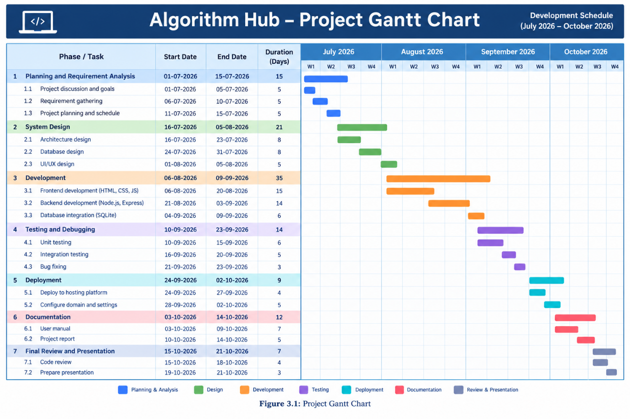

The Gantt chart should show the planned start date, end date, and duration of each project phase. Use the actual dates from your project work diary or development schedule.

3.5 Hardware and Software Requirements

3.5.1 Hardware Requirements
The following specifications are reasonable for developing and running the project locally. They are recommended specifications, not verified minimum requirements.
Component | Recommended Specification
Processor | Intel Core i3 or equivalent and above
RAM | 4 GB minimum; 8 GB recommended
Storage | At least 2 GB of available space for project files and dependencies
Operating System | Windows 10/11, Linux, or macOS
Display | Standard laptop or desktop display
Network | Internet connection for downloading dependencies and accessing external compiler resources

3.5.2 Software Requirements
Software / Technology | Purpose
HTML5 | Web page structure
CSS3 | Layout and interface styling
JavaScript | Frontend interaction and algorithm functionality
Node.js | Backend JavaScript runtime
Express.js | Backend server and API routes
SQLite | Relational database storage
JWT | Token-based authentication support
bcryptjs | Password-hashing functionality
Vite | Frontend development tooling, as configured in the project
Web Browser | Accessing and testing the application
Visual Studio Code or equivalent | Source-code editing
npm | Dependency management and package scripts
Wandbox or relevant compiler links | External coding practice support, where configured

3.6 Detailed Project Life Cycle (SDLC)
The Iterative and Incremental Software Development Life Cycle (SDLC) model is suitable for describing the development of Algorithm Hub. The application can be developed in stages, with each stage adding functionality and allowing earlier work to be tested.

Phase 1 – Requirement Analysis
The first phase identifies the learning difficulties faced by students and determines the application's main requirements.
The requirements include algorithm exploration, explanations, interactive visualization, practice functionality, user authentication, and backend communication.
Functional requirements describe what the application should do. Non-functional requirements describe qualities such as usability, maintainability, performance, and security.

Phase 2 – System Design
During this phase, the overall structure of the application is planned.
The design separates the frontend, backend, and database responsibilities. The frontend contains the web pages and JavaScript modules, the backend handles supported API requests, and SQLite provides database storage.
Navigation and page relationships are planned to provide a consistent learning experience.

Phase 3 – Implementation
The implementation phase converts the design into working application components.
The frontend uses HTML, CSS, and JavaScript. Algorithm-related functionality is organized into separate modules, including algorithm data, explanation logic, visualization functionality, and practice-related scripts.
The backend uses Node.js and Express to provide server-side routes. SQLite supports database operations, while authentication-related dependencies support user-account functionality.

Phase 4 – Integration
Integration connects the frontend, backend, and database.
The frontend sends requests to the backend for supported operations. The backend validates and processes these requests and performs relevant database operations.
Integration testing should verify that requests, responses, and database operations work correctly together.

Phase 5 – Testing
Testing is carried out to identify defects and confirm that the implemented features behave as expected.
The application should be tested for navigation, algorithm selection, visualization controls, registration, login, API responses, input validation, database operations, and practice functionality.
Both normal and invalid inputs should be tested.

Phase 6 – Deployment
Deployment makes the application available in its intended environment.
For local deployment, the frontend and backend are started using the project's configured development commands. The database must be configured correctly, and any required environment variables must be supplied.
For public deployment, the application should use production configuration, secure secrets, appropriate access controls, and a reliable hosting environment.
Note: Deployment to a public server should only be described as completed if it has actually been performed and verified.

Phase 7 – Maintenance
Maintenance includes correcting defects, updating dependencies, improving usability, adding new algorithms, and improving existing visualizations.
The modular structure allows individual parts of the application to be updated without unnecessarily changing unrelated functionality.

3.7 Software Engineering Diagrams
Software engineering diagrams explain the architecture, behaviour, data movement, and relationships of the application. Insert each diagram as a clear image and include its figure number and caption.

3.7.1 Data Flow Diagrams (DFD)
A Data Flow Diagram represents how information moves between external entities, processes, and data stores.

Level 0 – Context Diagram
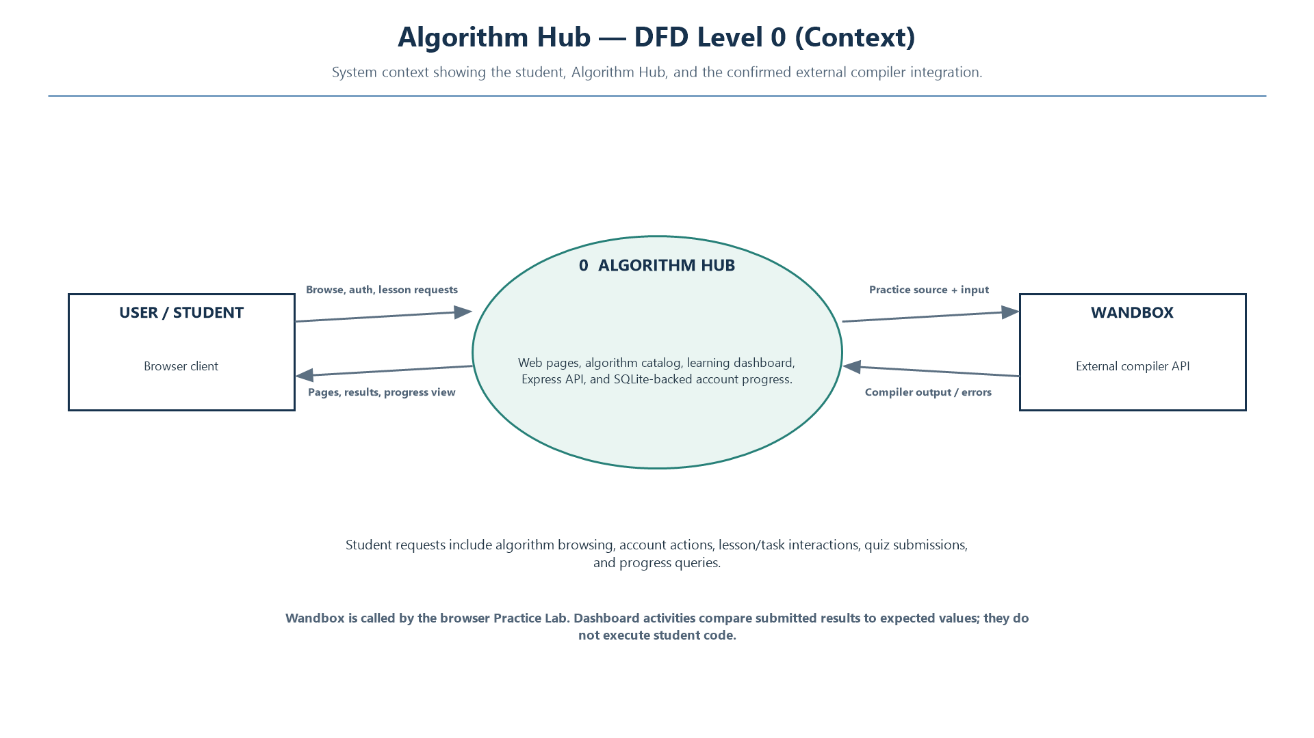

The context diagram should contain the following elements:
- External Entity: User
- System: Algorithm Hub
- External Service: Compiler service, where used by the practice functionality
- Data Flows: Requests to browse algorithms, authentication requests, practice interactions, and responses from the system
The user interacts with Algorithm Hub to access learning content and supported application features. If the practice implementation communicates with an external compiler, show that communication separately.

Level 1 – Data Flow Diagram
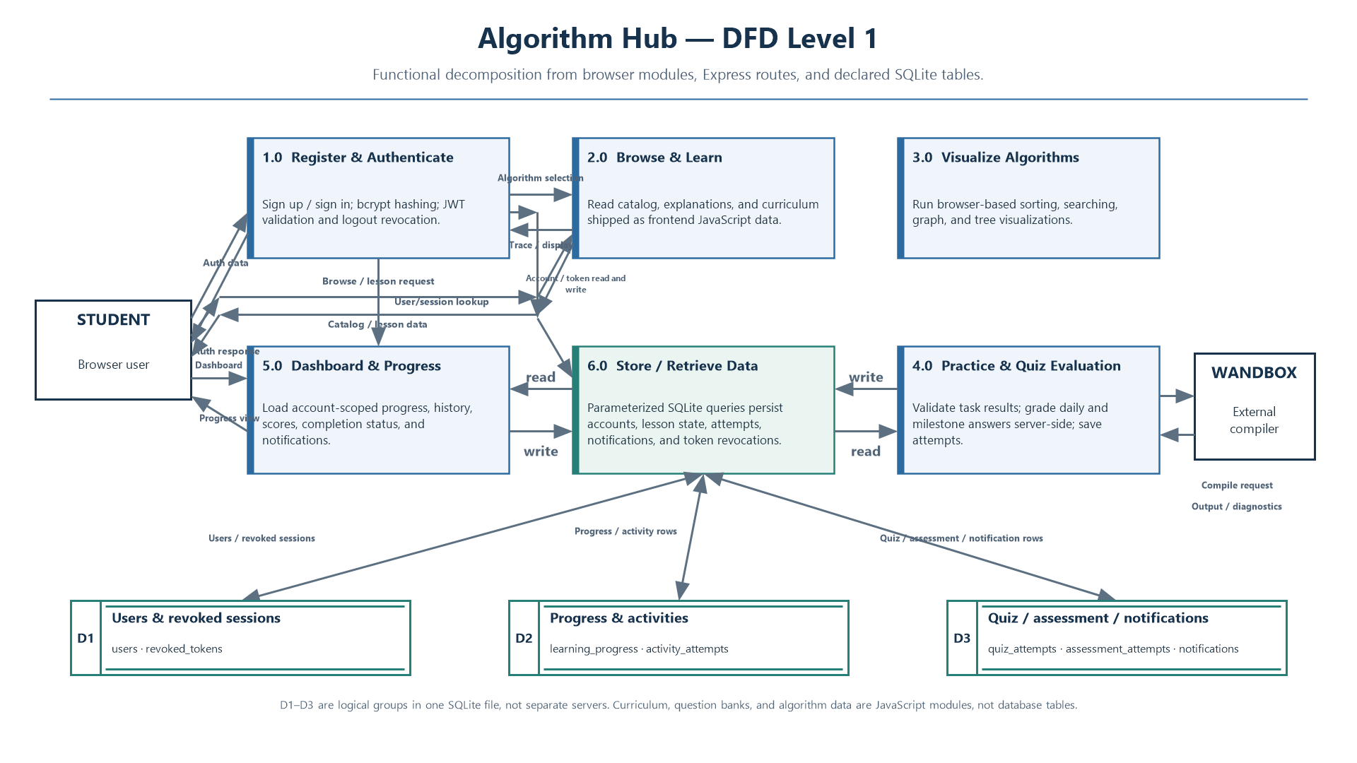

Recommended processes:
1.0 – Manage User Authentication
2.0 – Display and Explore Algorithms
3.0 – Explain Selected Algorithms
4.0 – Run Algorithm Visualizations
5.0 – Provide Practice Functionality
6.0 – Manage User-Related Data
The diagram should show the flow of information between these processes and the database. Include only the data stores and interactions supported by the actual implementation.

3.7.2 Entity Relationship Diagram (ERD)

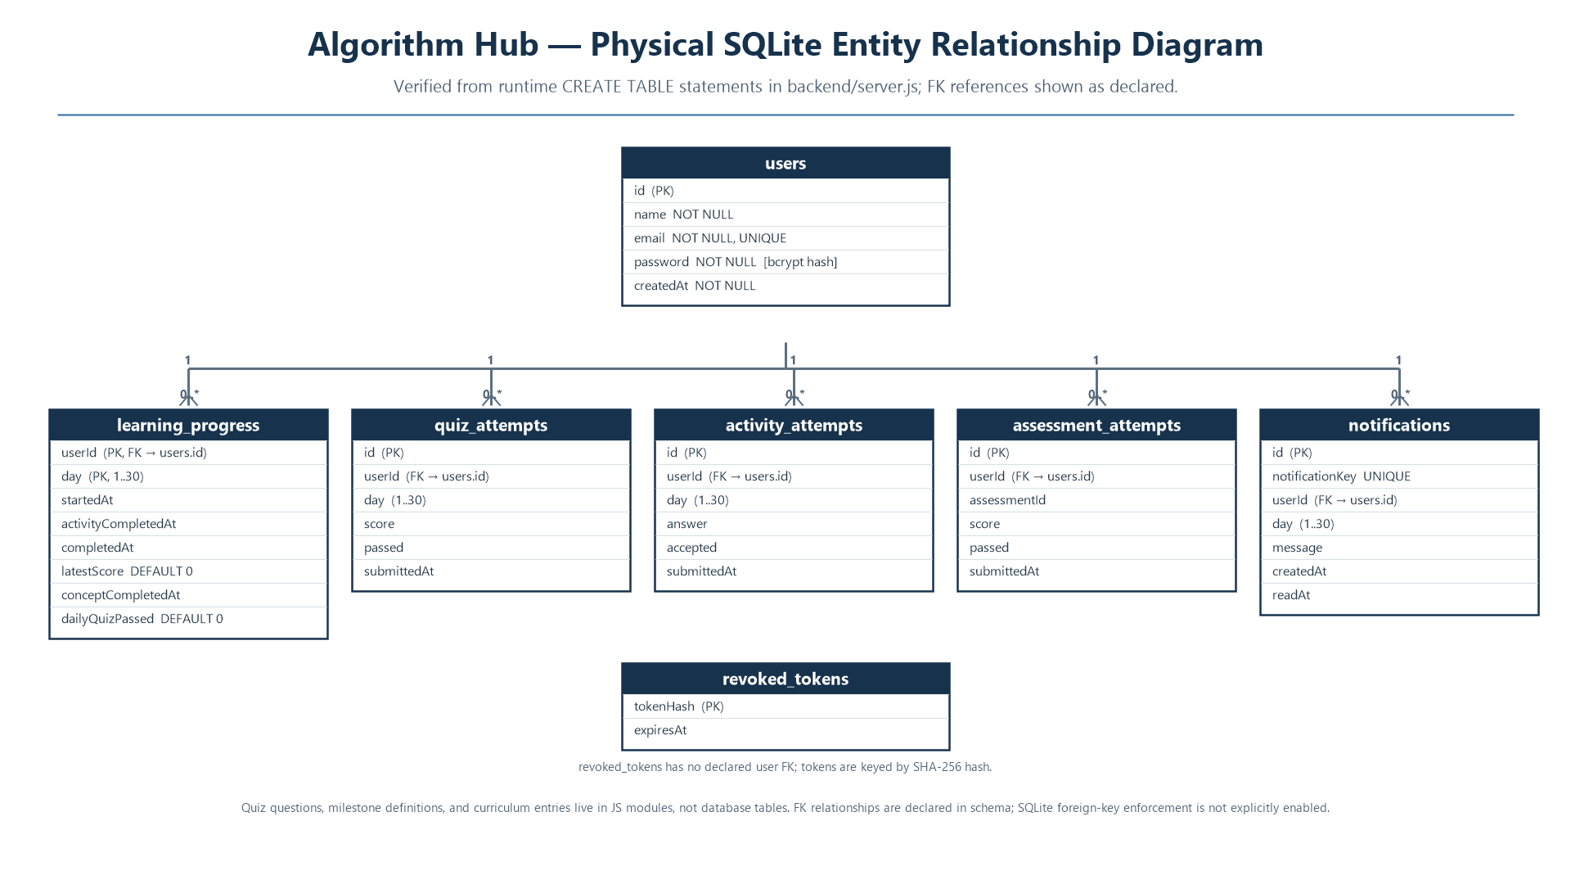
The ERD represents the database tables and their relationships.
The project uses SQLite, but the exact table names, attributes, primary keys, and foreign keys should be taken from the database initialization and query code in the submitted ZIP.
Use the following rules when preparing the ERD:
- Mark the primary key of every table.
- Mark foreign keys wherever they exist.
- Show one-to-many relationships where supported by the schema.
- Include only tables that actually exist in the project.
- Do not add hypothetical progress, quiz, or learning-history tables unless they are implemented.
The ERD should match the database used by the application rather than a proposed future design.

3.7.3 Activity Diagram

The activity diagram should represent the normal user learning workflow.Suggested flow:
Start → Open Application → Select a Learning Section → Browse Algorithms → Select an Algorithm → View Explanation → Open Visualizer → Interact with Supported Controls → Open Practice Section → Attempt an Exercise → End.
Registration and login can be shown as an optional branch where required by the selected feature.The diagram should show decision points where the user selects a different section or returns to the algorithm list

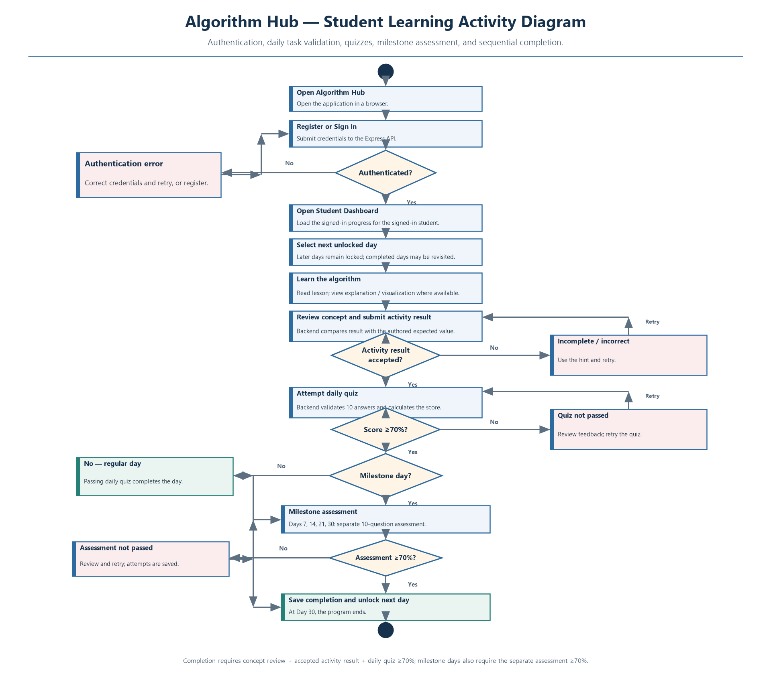

3.7.4 Class Diagram
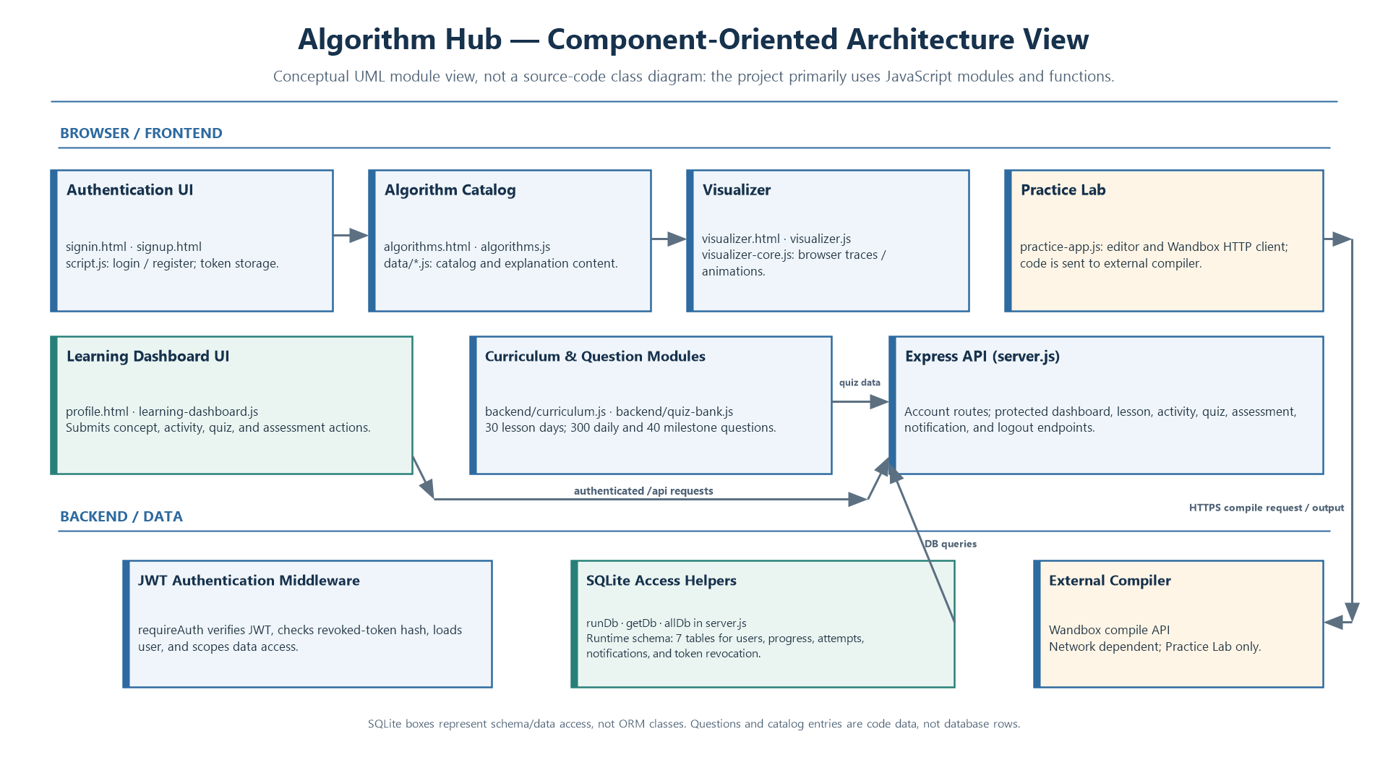

The class diagram represents the logical components of the system and their relationships.
Since the project is primarily implemented using JavaScript modules rather than a traditional object-oriented class hierarchy, the diagram should be presented as a logical component diagram using class-style boxes, unless the source code contains actual classes.
Possible logical components include:
- User Interface: Displays pages and accepts user interaction.
- Algorithm Module: Provides algorithm information and category data.
- Explanation Module: Displays the selected algorithm's educational content.
- Visualizer Module: Controls visualization-related behaviour.
- Practice Module: Supports coding practice functionality.
- API Server: Handles supported backend requests.
- Database: Stores data used by the application.
Connect components according to their actual dependencies. Do not represent every module as a literal JavaScript class if it is implemented as a function or module.
3.7.5 Object Diagram
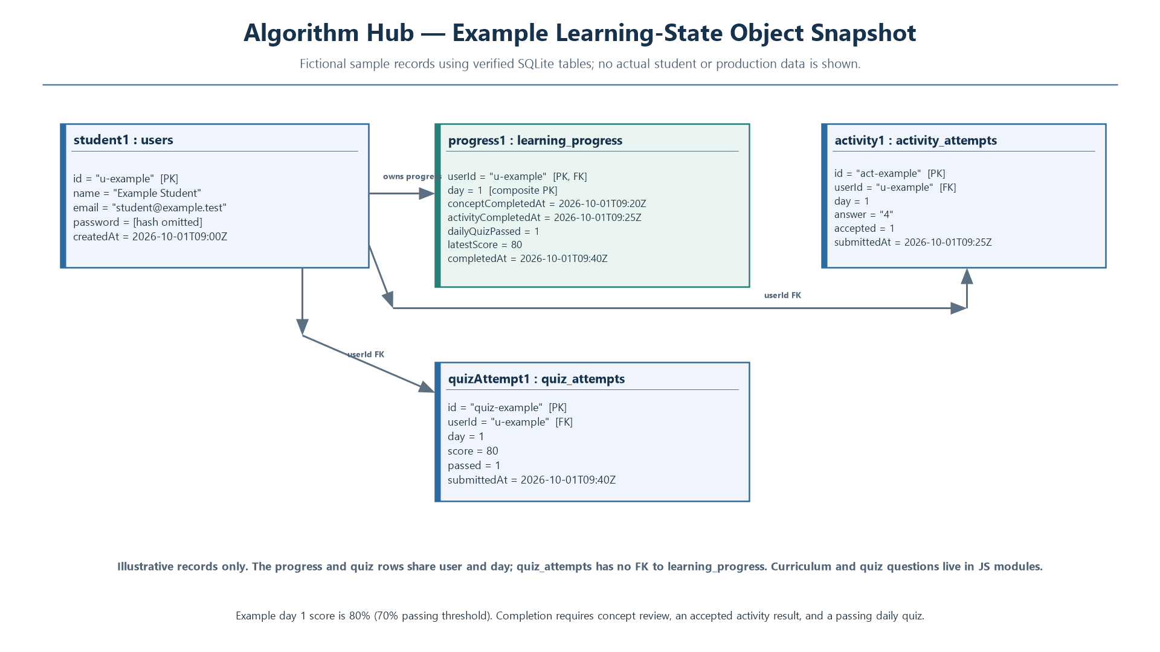

An object diagram presents an example snapshot of objects or component instances at a particular moment.For Algorithm Hub, it can illustrate a user session interacting with an algorithm page and a visualizer component.Example conceptual objects:
- userSession1
- algorithmPage1
- selectedAlgorithm1
- visualizerInstance1

The relationships should demonstrate how a selected algorithm is displayed and visualized. These are illustrative object instances; they should not be described as persistent database records unless the application actually stores them.
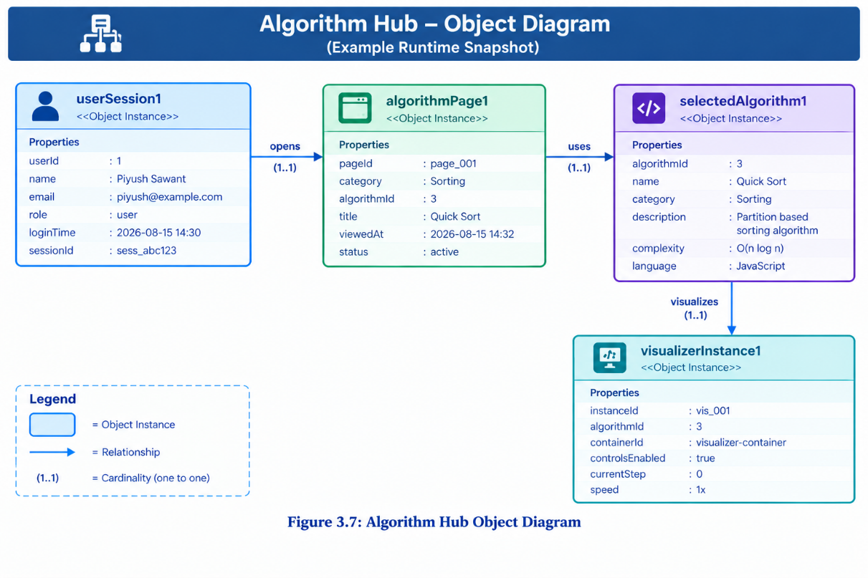

3.7.6 Use Case Diagram
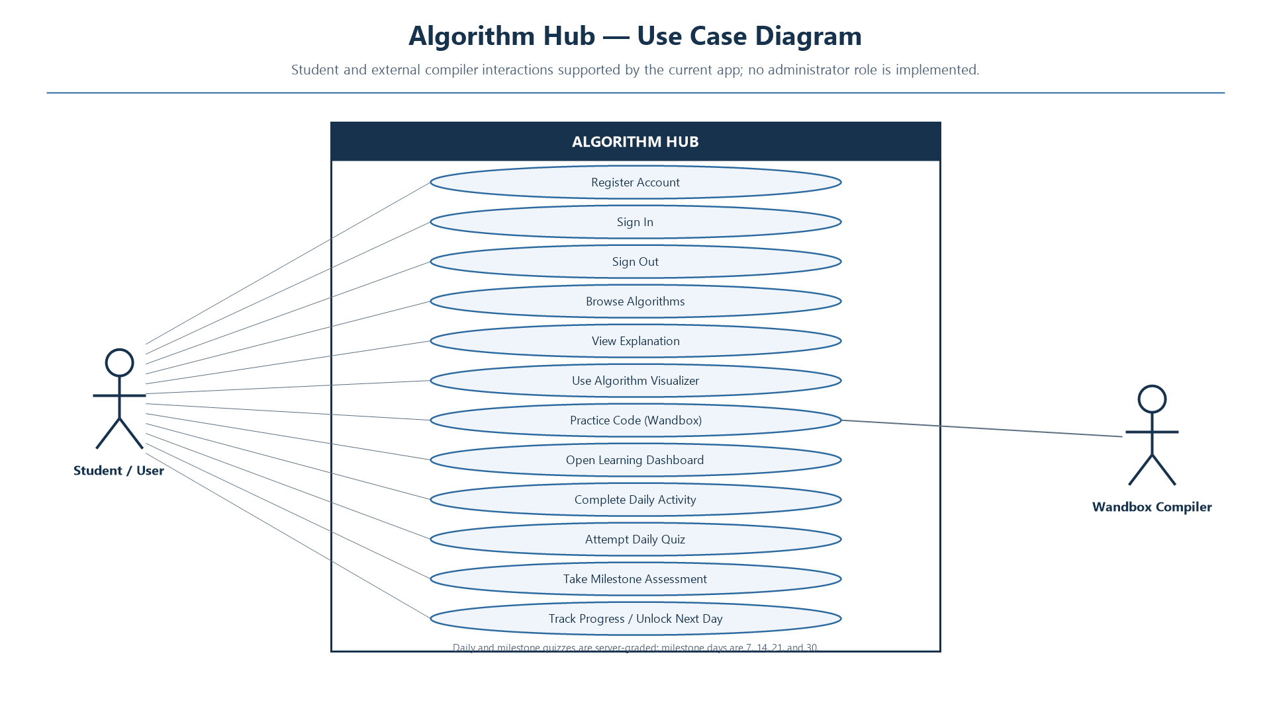

The primary actor is the User.
The use cases should include the features implemented in the application:
- Open Home Page
- Browse Algorithms
- Select an Algorithm
- View Algorithm Explanation
- Use Algorithm Visualizer
- Access Practice Section
- Register an Account
- Log In
- Access Profile-Related Features
An external compiler service may be shown as a supporting external system if the practice workflow uses it.
Connect each actor to the appropriate use cases. Do not include unimplemented use cases such as guaranteed progress analytics, quizzes, or automated learning plans unless they exist in the actual application.

3.8 Input and Output Screen Design
The screen-design section describes how users provide input and how the application displays information and results.
Insert screenshots from your actual running project in the positions below. Use readable images with figure captions and consistent sizing.

3.8.1 Home Page
[Insert Figure 3.9: Algorithm Hub Home Page Screenshot Here]
The home page introduces Algorithm Hub and provides navigation to the available learning sections. It acts as the starting point for users exploring the application.

3.8.2 Algorithm Listing Page
[Insert Figure 3.10: Algorithm Listing Page Screenshot Here]
The algorithm listing page allows users to browse available algorithms and select a topic for further learning. The page organizes the available content for easier navigation.

3.8.3 Algorithm Explanation Page
[Insert Figure 3.11: Algorithm Explanation Page Screenshot Here]
The explanation page presents educational information about the selected algorithm. Depending on the available content, it may include the algorithm's purpose, working procedure, examples, or complexity information.

3.8.4 Algorithm Visualizer Page
[Insert Figure 3.12: Algorithm Visualizer Screenshot Here]
The visualizer page provides the interactive representation of a supported algorithm. Users can interact with the available controls and observe the algorithm's operations.
Include an actual screenshot showing the algorithm, input or data area, visualization, and available controls.

3.8.5 Practice Page
[Insert Figure 3.13: Practice Page Screenshot Here]
The practice page provides access to programming exercises and related coding resources. Where configured, users can access external compiler services or relevant compiler links.

3.8.6 Registration Page
[Insert Figure 3.14: User Registration Page Screenshot Here]
The registration page allows a new user to submit the information required by the implemented account-creation form.

3.8.7 Login Page
[Insert Figure 3.15: User Login Page Screenshot Here]
The login page allows an existing user to submit credentials. The backend should validate the credentials before returning a successful authentication response.

3.8.8 Profile Page
[Insert Figure 3.16: User Profile Page Screenshot Here]
The profile page displays the user-related information and features actually supported by the project.

3.8.9 Output and Error Messages
[Insert Figure 3.17: Example Application Output or Validation Message Here]
This section can include a successful visualization, an algorithm result, a form-validation message, or an API error response. Use an actual screenshot from a test performed on the running application.

3.9 Methodology Used for Testing
Testing is performed to evaluate whether the application behaves according to its functional and non-functional requirements.
The following testing methods are suitable for Algorithm Hub.

3.9.1 Functional Testing
Functional testing checks whether the application's features operate according to their requirements.
Examples include navigation, algorithm selection, explanation display, visualization controls, registration, login, and practice-page access.

3.9.2 Input Validation Testing
Input validation testing checks how the application handles empty fields, invalid credentials, incomplete requests, and unexpected input.
Validation should be checked in both the frontend and backend wherever appropriate.

3.9.3 Integration Testing
Integration testing verifies communication between the frontend, Express backend, and SQLite database.
Where the practice section depends on an external compiler, its request and response behaviour should also be checked.

3.9.4 Database Testing
Database testing checks whether supported data operations work correctly. It includes verifying database initialization, record creation, retrieval, and error handling where those operations are implemented.

3.9.5 Authentication Testing
Authentication testing checks registration, valid login, invalid login, duplicate account handling, and the handling of protected routes or authentication tokens.

3.9.6 Usability Testing
Usability testing evaluates whether users can navigate the application, understand its content, operate visualizers, and access practice activities without unnecessary difficulty.

3.9.7 Compatibility Testing
Compatibility testing checks the application's appearance and functionality in supported web browsers and different screen sizes.

3.9.8 Error Handling Testing
Error handling testing checks the application's response to unavailable backend services, invalid requests, database failures, and unavailable external resources.

3.10 Test Cases and Test Reports
The following table provides a test-case template for the project. The expected results describe the intended behaviour; the actual results and status must be filled in after running each test.

Test ID | Test Case | Expected Result | Actual Result / Status
TC01 | Open the home page | Home page loads correctly | To be tested
TC02 | Open the algorithm listing | Available algorithms are displayed | To be tested
TC03 | Select an algorithm | Correct algorithm information opens | To be tested
TC04 | Open an explanation page | Relevant explanation is displayed | To be tested
TC05 | Open a supported visualizer | Visualizer loads without errors | To be tested
TC06 | Use visualizer controls | Supported operation behaves correctly | To be tested
TC07 | Navigate between learning sections | Navigation opens the correct page | To be tested
TC08 | Register with valid information | Account is created if all requirements are satisfied | To be tested
TC09 | Register using an existing account identifier | Duplicate account is rejected appropriately | To be tested
TC10 | Log in using valid credentials | Authentication succeeds | To be tested
TC11 | Log in using invalid credentials | Login is rejected with an appropriate message | To be tested
TC12 | Submit incomplete authentication input | Validation or error response is returned | To be tested
TC13 | Check backend health endpoint | Correct health response is returned | To be tested
TC14 | Verify database operations | Supported records can be stored and retrieved | To be tested
TC15 | Open the practice section | Practice interface loads correctly | To be tested
TC16 | Access an external compiler resource | Resource responds, or a suitable failure message is shown | To be tested
TC17 | Open the profile page | Available profile information is displayed correctly | To be tested
TC18 | Test invalid or unavailable API requests | Application handles the error appropriately | To be tested

3.10.1 Test Report
After executing the test cases, summarize the results using the following format:
Test Summary | Result
Total test cases | 18 planned cases
Passed | Fill in after testing
Failed | Fill in after testing
Blocked / Not executed | Fill in after testing
Overall status | Determine from actual test results
A test should be marked Passed only after the observed output matches the expected result. Attach relevant screenshots, error logs, or test evidence where available.

3.11 Important Source Code of the Project
This section documents important source-code files used in Algorithm Hub. The explanations below describe the known project structure; file paths should be checked against the final ZIP before submitting the report.

3.11.1 Frontend Structure
The frontend contains the HTML pages and JavaScript modules responsible for presenting content and implementing client-side functionality.
Important frontend files include:
File / Module | Purpose
index.html | Main entry or home page
algorithms.html | Algorithm listing interface
explanation.html | Algorithm explanation interface
visualizer.html | Algorithm visualization interface
practice.html | Programming practice interface
profile.html | Profile-related interface
signin.html | Login interface
signup.html | Registration interface
about.html | Project information page
script.js | General frontend behaviour
algorithms.js | Algorithm listing and related logic
visualizer.js | Visualizer interface behaviour
visualizer-core.js | Core visualization functionality
practice.js | Practice-page behaviour
practice-app.js | Practice application functionality
explanation.js | Explanation-page behaviour
Algorithm category data modules | Organized algorithm content
The exact responsibilities of individual files should be confirmed from their contents when preparing the final source-code appendix.

3.11.2 Algorithm Data Modules
The algorithm data modules organize the information used to present algorithms and their categories.
Their purpose is to keep learning content separate from general page structure and interaction logic. A modular arrangement can make it easier to maintain algorithm information and extend the application with additional content.
[Insert selected code screenshot: Algorithm category data module]

3.11.3 Algorithm Visualizer Modules
The visualizer-related modules implement the interface and core behaviour of supported visualizations.
- visualizer.js is associated with visualizer-page behaviour.
- visualizer-core.js contains core visualization functionality.
These modules should be documented with short code excerpts demonstrating the actual initialization, algorithm execution, state updates, or user-control handling present in the source.
[Insert selected code screenshot: Visualizer implementation]

3.11.4 Practice Modules
The practice modules support the coding-practice interface and related interactions.
The practice implementation includes references to external compiler functionality or compiler links. The final report should explain the exact execution workflow used by the submitted version, including any limitations imposed by the external service.
[Insert selected code screenshot: Practice functionality]

3.11.5 Backend Server
The backend is developed using Node.js and Express. Its server code defines API endpoints and handles the requests supported by the application.
The known API routes include:
- GET /api/health — backend health-check functionality.
- POST /api/register — registration functionality.
- POST /api/login — login functionality.
- GET /api/users — user-related endpoint.
The exact route implementation, request fields, response formats, and access controls must be checked against the submitted backend source code.
[Insert selected code screenshot: Express server and API routes]

3.11.6 Authentication and Password Handling
The project includes JWT and bcryptjs dependencies for authentication-related functionality.
Authentication code should be documented by showing the actual password-hashing or verification logic, token generation and validation, and any protected-route middleware present in the source.
Secrets used for token signing should be configured through secure environment variables rather than exposed in source code or committed configuration files.
[Insert selected code screenshot: Actual authentication implementation]

3.11.7 Database Integration
SQLite is used for database functionality. The database initialization and query code should be examined to identify the exact tables, fields, constraints, and relationships.
This section should include the actual database schema or selected queries used by the project. Do not insert an invented schema.
[Insert selected code screenshot: SQLite database initialization or query module]

3.11.8 Project Configuration
The project's package configuration identifies dependencies and scripts used to run or develop the application.
The final report should include the relevant parts of the actual package.json files, particularly the configured development commands and the dependencies required by the frontend and backend.
[Insert selected code screenshot: Relevant package configuration]

3.11.9 Source Code Presentation Guidelines
For the final submission:
- Include short, important source-code excerpts rather than every project file.
- Use the exact code from the final ZIP.
- Mention the actual file path above each excerpt.
- Explain the purpose of the code in two or three sentences.
- Use readable font sizes and consistent formatting.
- Avoid including API secrets, passwords, or private user data.
- Keep the complete source code available separately as part of the project submission if required by the college.

3.12 Summary
Algorithm Hub is a web-based algorithm-learning application that combines algorithm explanations, interactive visualizations, and programming practice. Its modular frontend, Express backend, and SQLite database provide the technical foundation for the implemented learning and user-related features.
The chapter describes the project's objectives, theoretical background, research analysis, development planning, requirements, SDLC, software engineering diagrams, screen designs, testing methodology, test-case structure, and important source-code components.
The final project report should be supported by actual application screenshots, verified database diagrams, source-code excerpts, and recorded test results. These materials demonstrate the implementation and help establish the correctness and completeness of the project.

CHAPTER IV: ANNEXURE

CHAPTER V: CONCLUSION

Conclusion

Algorithm Hub is a web-based learning platform developed to help students understand algorithms through organized learning content, visual demonstrations, and coding practice activities.

The project combines frontend and backend development, database management, and software engineering concepts to provide an interactive learning environment. It aims to make algorithm learning easier and more engaging than studying theoretical concepts alone.

The development of Algorithm Hub provides practical experience in designing and implementing a real-world web application. It also highlights the importance of software testing, input validation, error handling, and user-friendly design in developing a reliable application.

In conclusion, Algorithm Hub provides a useful foundation for interactive algorithm learning. With further improvements in visualization, practice activities, accessibility, and performance, the platform can become an even more effective learning resource for students.

CHAPTER VI: FUTURE ENHANCEMENT

Future Enhancements

The following features may be added in future versions of Algorithm Hub, depending on project requirements and available resources.

- More algorithm visualizations: Add additional sorting, searching, tree, graph, and dynamic programming visualizers.

- Step-by-step execution: Display each stage of an algorithm with clear explanations of how the data changes.

- Interactive coding practice: Allow students to write code and test it against predefined test cases.

- Progress tracking: Provide a personalized dashboard showing completed topics, practice activity, and learning progress.

- Quizzes and assessments: Add topic-wise quizzes with scores and feedback.

- Personalized learning plan: Recommend topics based on a learner’s current level and previous performance.

- AI-based learning assistant: Introduce a chatbot to explain algorithms and answer learning-related questions.

- Performance improvements: Optimize page loading, API response times, and database operations.

- Accessibility and responsive design: Improve usability on mobile devices and for learners with different accessibility needs.

- Deployment and maintenance: Deploy the application to a reliable hosting platform and maintain it through regular testing and updates.

CHAPTER VII
REFERENCES & BIBLIOGRAPH

References & Bibliography

Use the following references for the technologies and concepts relevant to Algorithm Hub.

1. MDN Web Docs. HTML: HyperText Markup Language.
https://developer.mozilla.org/en-US/docs/Web/HTML

2. MDN Web Docs. CSS: Cascading Style Sheets.
https://developer.mozilla.org/en-US/docs/Web/CSS

3. MDN Web Docs. JavaScript Guide.
https://developer.mozilla.org/en-US/docs/Web/JavaScript/Guide

4. Node.js Documentation. Node.js Documentation.
https://nodejs.org/docs/latest/api/

5. Express.js. Express Web Framework Documentation.
https://expressjs.com/

6. SQLite. SQLite Documentation.
https://www.sqlite.org/docs.html
7. OWASP Foundation. OWASP Top 10: Web Application Security Risks.
https://owasp.org/www-project-top-ten/

8. GitHub Docs. GitHub Documentation.
https://docs.github.com/

9. Sommerville, Ian. Software Engineering. Pearson.
Use the edition prescribed by your institution or available in your library.

10. Cormen, Thomas H., Charles E. Leiserson, Ronald L. Rivest, and Clifford Stein. Introduction to Algorithms. MIT Press.

11. Project Source Code and Development Notes. Algorithm Hub project files, configuration files, database seed scripts, and testing records used during project development.

