Final Capstone Report
Comprehensive Data Analysis: From Raw Data to Predictive Model
Dataset: Titanic Passenger Data
Consolidating Weeks 1-3: Data Cleaning • Visualization • Statistical Modeling
Tools: R (base R, ggplot2, caret, pROC, car)
Prepared by: Piyush Negi
Data Analyst Intern — Week 4 Final Submission

Table of Contents
1. Introduction
2. Methodology
3. Data Preparation and Cleaning (Week 1)
4. Data Visualization and Insight Communication (Week 2)
5. Statistical Analysis and Predictive Modeling (Week 3)
6. Results and Business Implications
7. Discussion
8. Conclusion: Lessons Learned, Challenges, and Future Directions

1. Introduction
This report consolidates four weeks of internship work into a single, cohesive data analysis project built around the Titanic passenger dataset — a publicly available dataset of 891 passengers aboard the RMS Titanic, recording demographic details, ticket information, and survival outcomes. The project was carried out end-to-end: raw data was cleaned and prepared (Week 1), explored visually to surface patterns (Week 2), and finally used to build and rigorously evaluate a statistical predictive model (Week 3). This Week 4 report brings all three stages together into one narrative, showing how a data-driven investigation progresses from a messy raw file to a validated, interpretable model, and draws out the practical insights and business-style implications that emerged along the way.
The guiding question throughout the project was simple to state but rich to investigate: what factors determined whether a Titanic passenger survived, and how well can those factors predict survival for an individual passenger? Answering this required cleaning genuinely messy real-world data, choosing appropriate visualizations to communicate patterns to a non-technical audience, and applying formal statistical hypothesis tests before committing to a predictive model — mirroring the workflow a data analyst would follow on virtually any real business dataset with a categorical outcome of interest (e.g. churn, default, conversion).
All work was carried out in R, using base R for foundational data manipulation and statistics, ggplot2 for visualization, and the caret/pROC/car packages for model training, evaluation, and diagnostics.

2. Methodology
The project followed a standard four-stage analytical pipeline, with each stage building directly on the output of the previous one:
- Stage 1 – Data Preparation: identify and treat missing values, detect and handle outliers, encode categorical variables, and engineer/normalize features, producing a fully clean, model-ready dataset.
- Stage 2 – Exploratory Visualization: use a range of chart types (bar, scatter, histogram, line, boxplot, stacked bar) to surface and communicate the relationships between passenger attributes and survival.
- Stage 3 – Statistical Analysis & Modeling: formally test the hypotheses suggested by the visualizations (t-tests, chi-square tests, correlation tests), then train and cross-validate a logistic regression classifier, and diagnose its performance and assumptions.
- Stage 4 – Synthesis & Reporting (this report): integrate the findings from all three stages into one narrative, connect the statistical results to practical implications, and reflect on lessons learned and future directions.
This staged approach mirrors the CRISP-DM-style workflow used broadly in industry (business understanding → data preparation → modeling → evaluation → deployment/reporting), and each stage's R code, outputs, and visuals are reproduced in the sections below with narrative explanation.

3. Data Preparation and Cleaning (Week 1)
The raw Titanic dataset (891 rows, 12 columns) contained missing values in three columns, a mix of numeric and categorical variables, and several extreme outliers in ticket fares — realistic messiness typical of real-world data.

3.1 Missing Value Diagnosis and Treatment
missing_pct <- round(100 * sapply(titanic, function(x) sum(is.na(x)|x==""))
/ nrow(titanic), 2)
Age: 19.87% missing | Cabin: 77.10% missing | Embarked: 0.22% missing
Each column was treated according to its missingness level rather than being uniformly dropped or imputed:
- Cabin (77% missing) → converted to a binary Cabin_Known indicator rather than deleted, preserving its signal as a proxy for class/cabin location.
- Embarked (2 rows missing) → imputed with the mode (most frequent port).
- Age (20% missing) → imputed with the median, stratified by Pclass and Sex for realism, with an Age_Imputed flag retained for traceability.

3.2 Outlier Detection and Treatment
The IQR method flagged 116 Fare outliers and 66 Age outliers. Rather than deleting these rows and losing genuine passenger records, Fare was winsorized (capped) at the 99th percentile.
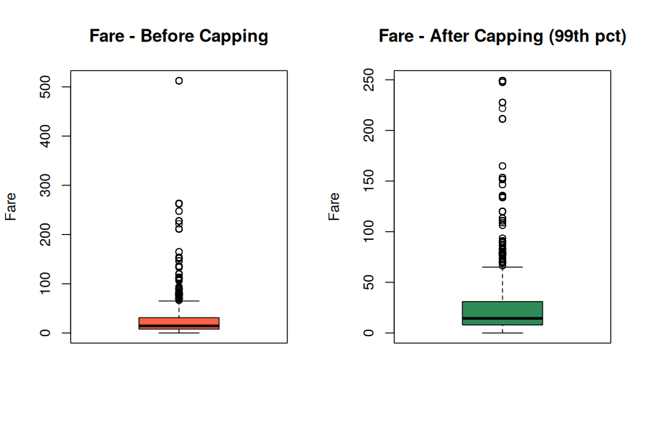
Figure 1. Fare distribution before and after capping extreme values at the 99th percentile.

3.3 Encoding and Feature Engineering
Categorical variables (Sex, Embarked) were numerically encoded (binary and one-hot respectively), and two engineered features — FamilySize and IsAlone — were derived from SibSp and Parch. Age and the capped Fare were then min-max normalized. The dataset grew from 12 raw columns to 20 fully-cleaned, model-ready columns with zero missing values.
titanic$FamilySize <- titanic$SibSp + titanic$Parch + 1
titanic$Age_Scaled <- min_max_scale(titanic$Age)
titanic$Fare_Scaled <- min_max_scale(titanic$Fare_Capped)

4. Data Visualization and Insight Communication (Week 2)
With a clean dataset in hand, six visualizations (built with ggplot2) were used to explore how passenger attributes related to survival, each chosen for the specific comparison it makes clearest.

4.1 Survival by Class and Sex
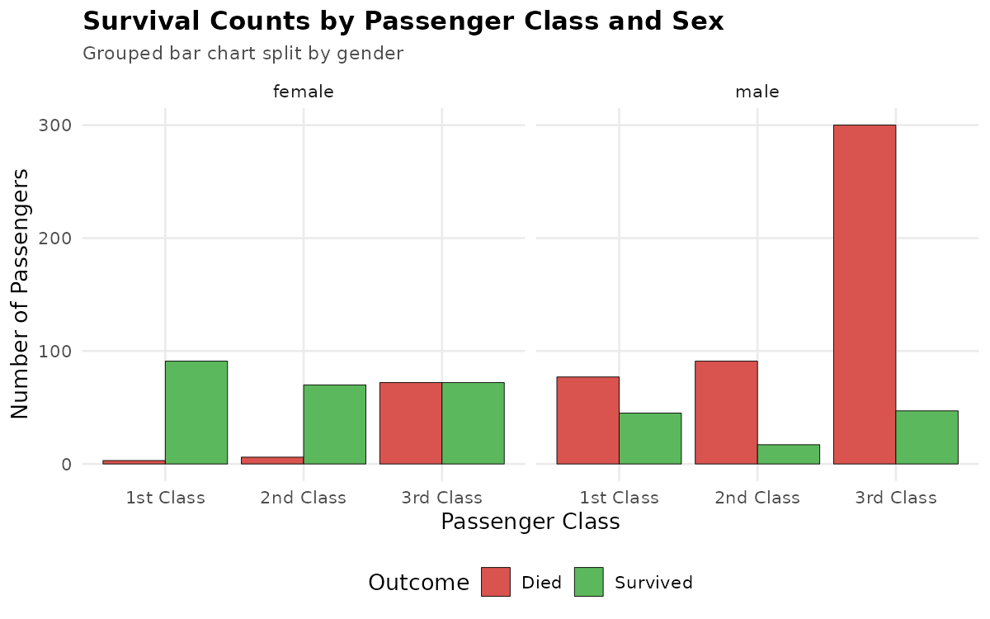
Figure 2. Survival counts by passenger class, faceted by sex.
This grouped, faceted bar chart makes the two biggest survival drivers visible in a single glance: women in 1st/2nd class survived overwhelmingly, while men in 3rd class died overwhelmingly — the single largest bar in the entire chart (over 300 deaths).

4.2 Age vs. Fare, Colored by Outcome
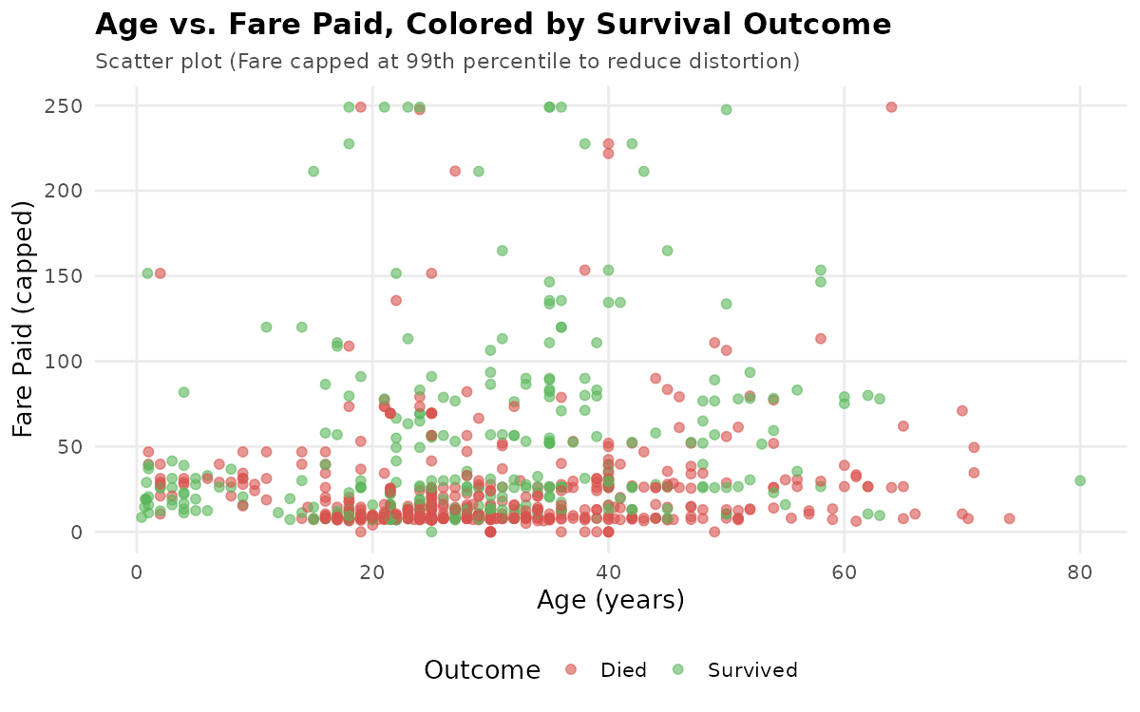
Figure 3. Age vs. fare paid, colored by survival outcome.
The scatter plot shows survivors (green) concentrated in the higher fare bands across nearly every age, while non-survivors (red) dominate the low-fare band — indicating fare (a proxy for class/cabin) mattered more to survival than age.

4.3 Survival Rate Trend by Age
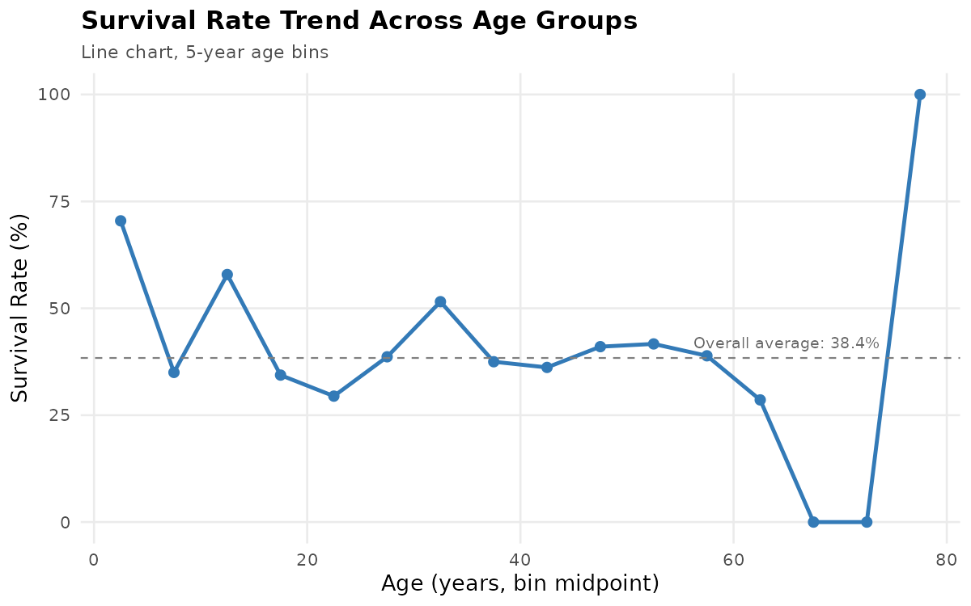
Figure 4. Survival rate (%) trend across 5-year age bins.
The line chart highlights a clear survival advantage for the youngest passengers (~70% for ages 0-5) against the 38.4% overall average, consistent with a 'children first' evacuation pattern, while the trend is noisier and closer to average through adulthood.

4.4 Fare by Class and Outcome
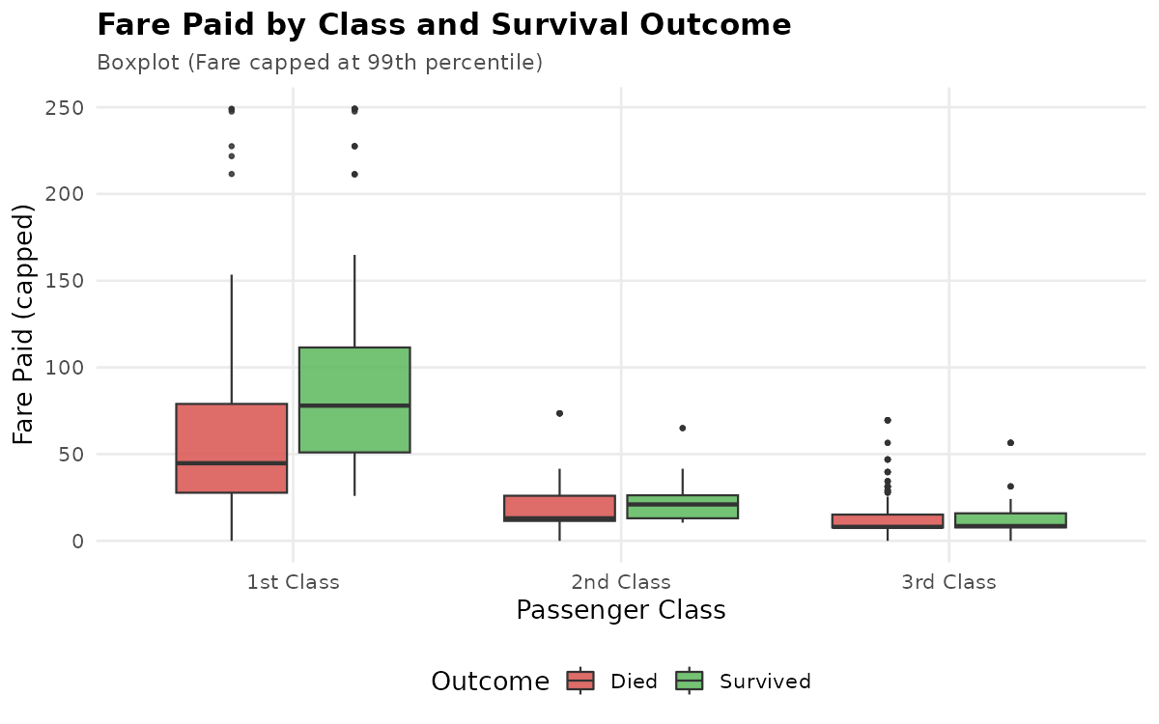
Figure 5. Fare distribution by class and survival outcome.
Within every class, survivors paid a visibly higher median fare than non-survivors — most pronounced in 1st class — suggesting fine-grained fare/cabin differences mattered even within the same nominal class.

5. Statistical Analysis and Predictive Modeling (Week 3)

5.1 Hypothesis Testing
Before modeling, the visual patterns from Week 2 were formally tested:
Test | Result | Conclusion
Welch t-test: Age by Survival | p = 0.082 | No significant difference
Welch t-test: Fare by Survival | p = 2.3e-13 | Highly significant (survivors paid ~2x more)
Chi-square: Sex vs Survival | p < 2.2e-16 | Highly significant
Chi-square: Pclass vs Survival | p < 2.2e-16 | Highly significant
Chi-square: Embarked vs Survival | p = 2.3e-06 | Significant

These tests confirmed statistically what the visualizations suggested: Sex, Pclass, and Fare are strongly associated with survival, while Age's effect is weak and not statistically significant on its own.

5.2 Logistic Regression Model
A logistic regression classifier was trained on an 80/20 stratified train/test split, using 10-fold cross-validation, to predict Survived from Pclass, Sex, Age, Fare, family size, embarkation port, and cabin status.
log_model <- train(Survived ~ Pclass + Sex_Encoded + Age + Fare_Capped +
FamilySize + Embarked_C + Embarked_Q + Cabin_Known,
data = train_data, method = "glm", family = "binomial",
trControl = trainControl(method = "cv", number = 10))

5.3 Model Performance
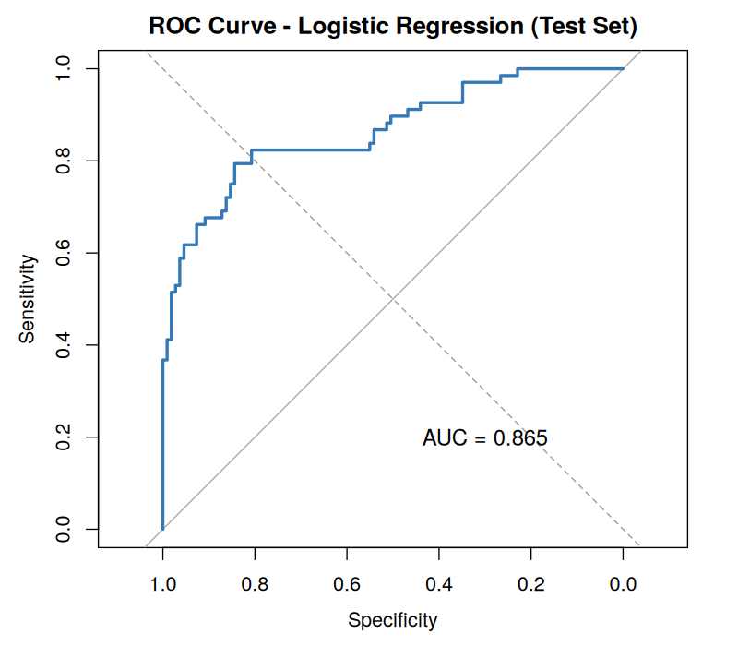
Figure 6. ROC curve on the held-out test set (AUC = 0.865).
Metric | Value
Test Accuracy | 82.5%
AUC (Test Set) | 0.865
Sensitivity (Survived) | 66.2%
Specificity (Died) | 92.7%

The model substantially outperforms the 61.6% no-information baseline, with Sex, Pclass, and Age emerging as the statistically significant predictors (all p < 0.01), while Fare and Embarked contributed no independent signal once Pclass was already in the model — confirming they act mainly as proxies for socio-economic class.
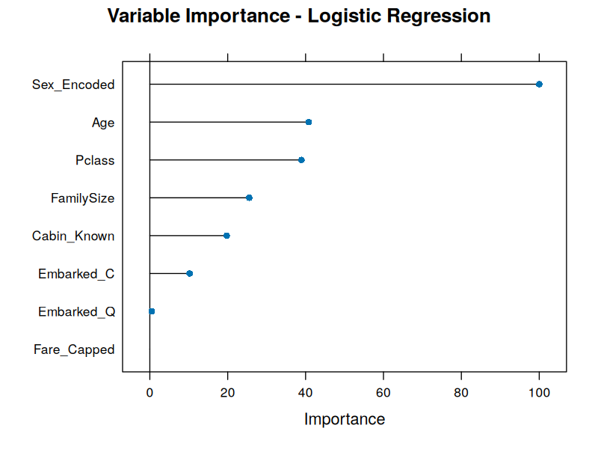
Figure 7. Variable importance ranked by absolute z-value.

6. Results and Business Implications
Synthesizing all three stages of analysis produces a consistent, well-supported picture:
- Demographic and socio-economic factors (sex, class) were the dominant determinants of survival, both visually and statistically, and both fed directly into a model that predicts survival with 82.5% accuracy and strong discriminative power (AUC 0.865).
- Secondary variables (Fare, Embarked) initially appeared meaningful in isolation but were shown, once combined with Pclass in a multivariate model, to be largely redundant proxies rather than independent drivers — an important reminder that univariate patterns can overstate a variable's real, independent contribution.
- Business framing: in any comparable business context (e.g. modeling customer churn or loan default), this workflow demonstrates why treating missing data and outliers with judgment (rather than blanket deletion) preserves sample size and signal, why exploratory visualization should precede formal testing to guide which hypotheses are worth testing, and why multivariate modeling is essential to separate genuinely independent risk factors from those that merely correlate with a more fundamental one (here, Pclass).
- Practically, a model like this — interpretable, with clear odds ratios — could support triage-style decision-making in an analogous business scenario (e.g. flagging high-risk customers or cases) where both accuracy and explainability to non-technical stakeholders matter.

7. Discussion
The statistical significance of Sex and Pclass, both in isolation (chi-square tests) and jointly (logistic regression coefficients with p < 0.001), gives strong confidence that these effects are real rather than artifacts of a small sample. The model's specificity (92.7%) considerably exceeding its sensitivity (66.2%) reveals an important pattern in its errors: it is conservative about predicting survival, meaning in a deployed setting it would systematically under-flag a subset of actual positive cases (survivors) — a trade-off that would need to be revisited depending on which type of error is costlier in a given application (e.g. a medical or safety context might weight false negatives far more heavily than false positives).
The diagnostic residual plots (Week 3, Section 4.4) also surfaced a small number of high-leverage passengers whose actual outcome ran against what their demographic profile would predict — for instance, high-fare passengers who died or low-fare passengers who survived. These cases are not simply noise to be ignored; in a real business setting they would be worth a manual review, since they often reveal a missing variable (in the Titanic's case, likely exact cabin deck or lifeboat assignment) that the current feature set doesn't capture.
Overall, the discussion reinforces a recurring theme across the four weeks: visual exploration, formal statistical testing, and multivariate modeling each catch different things — a pattern visible in a chart may or may not survive formal testing, and a variable significant on its own may or may not remain significant once a more fundamental variable is added to the model. Using all three together, as this project did, produces a much more reliable set of conclusions than any single method alone.

8. Conclusion: Lessons Learned, Challenges, and Future Directions

8.1 Lessons Learned
- Column-by-column, severity-aware treatment of missing data (indicator flags, stratified median imputation, mode imputation) preserved far more information than a blanket 'drop all rows with any NA' approach would have — going from 3 columns with missing values to zero missing values while keeping all 891 rows.
- Visualizing first, then testing, is a productive order: every pattern that looked strong visually (sex, class) was later confirmed statistically, which built justified confidence before committing modeling effort to those variables.
- A seemingly important variable in isolation (Fare) can turn out to be statistically redundant once combined with a more fundamental variable (Pclass) in a multivariate model — a reminder to always check variable importance in the full model, not just univariate tests.

8.2 Challenges Overcome
- Severely sparse columns (Cabin, 77% missing) required a judgment call between deletion and imputation; converting it to a binary indicator preserved useful signal without fabricating 77% of a column's values.
- Balancing outlier treatment against sample size: rather than deleting 116 Fare outlier rows (13% of the data), winsorization (capping) was used to control their influence while keeping every record.
- Interpreting the sensitivity/specificity imbalance required looking beyond a single accuracy number to understand the model's real-world error pattern before declaring it 'done'.

8.3 Potential Future Directions
- Extract passenger titles (Mr./Mrs./Miss/Master) from the Name field — a feature known to be a strong, more granular predictor than raw Sex/Age alone.
- Compare the logistic regression baseline against tree-based models (random forest, gradient boosting) that can capture non-linear effects and interactions, such as class × sex, without manual feature engineering.
- Tune the classification threshold or apply cost-sensitive learning to correct the sensitivity/specificity imbalance, depending on which error type matters more in a given use case.
- Expand cross-validation to repeated k-fold or bootstrap resampling to tighten the confidence intervals around performance metrics, given the relatively small 177-row test set used here.
Across four weeks, this project moved from a raw, imperfect CSV file to a fully validated, interpretable predictive model — demonstrating, on a single consistent dataset, the complete analytical workflow of a data analyst: clean and prepare data with judgment, explore and communicate patterns visually, formally test what those patterns suggest, and build and rigorously evaluate a model whose strengths, limitations, and next steps are clearly understood and documented.

