Week 3 Task
Statistical Analysis and Predictive Modeling using R
Dataset: Titanic Passenger Data (continued from Weeks 1-2)
Model: Logistic Regression Classification (caret, 10-fold CV)
Prepared by: Piyush Negi
Data Analyst Intern

1. Dataset Identification and Rationale
This task continues with the Titanic passenger dataset cleaned in Week 1 and visualized in Week 2 (titanic_cleaned.csv, 891 rows, zero missing values). The dataset is well suited to predictive modeling for several reasons:
- It has a clear, well-defined binary outcome variable — Survived — making it a natural fit for classification modeling.
- It contains a mix of strong predictors (Sex, Pclass) and weaker/noisier ones (Age, Fare, Embarked), which makes hypothesis testing and variable-importance analysis meaningful rather than trivial.
- At 891 rows it is small enough to train quickly and interpret fully, while still being large enough to support a legitimate train/test split and 10-fold cross-validation.
- Continuing the same dataset across all three weeks also demonstrates the complete analyst workflow — cleaning, then visual exploration, then formal statistical testing and modeling — on a single consistent case study.
The chosen modeling approach is binary logistic regression, since the target (Survived: Died / Survived) is categorical with two classes and logistic regression offers directly interpretable coefficients (as odds ratios), which is valuable for communicating findings to a non-technical stakeholder alongside the raw predictive performance.

2. Exploratory Statistical Analysis and Hypothesis Testing
Before modeling, a battery of statistical tests was run to formally verify the relationships that Weeks 1-2 suggested visually, and to check the distributional assumptions of the numeric variables.

2.1 Normality Testing (Shapiro-Wilk)
The Shapiro-Wilk test was used to check whether Age and Fare are normally distributed — relevant because many classical statistical tests assume normality.
shapiro.test(titanic$Age)
shapiro.test(titanic$Fare_Capped)
Age: W = 0.9655, p-value = 1.12e-13
Fare_Capped: W = 0.6013, p-value < 2.2e-16
Both p-values are far below 0.05, so the null hypothesis of normality is rejected for both variables. Age is only mildly non-normal (W close to 1), while Fare is strongly right-skewed (very low W), consistent with the histograms from Week 2. This justifies using the Welch t-test (robust to non-normality with large samples) rather than assuming a normal distribution, and supports the earlier decision to cap Fare outliers before modeling.

2.2 Hypothesis Test: Does Age differ between Survivors and Non-Survivors?
H0: mean Age is equal for survivors and non-survivors. H1: mean Age differs.
t.test(Age ~ Survived, data = titanic)
t = 1.7432, df = 675.11, p-value = 0.08175
95% CI: [-0.206, 3.464]
Mean (Died) = 29.74 Mean (Survived) = 28.11
With p = 0.082 (> 0.05), we fail to reject H0 at the 5% level — there is no statistically significant difference in mean age between the two groups. This confirms the Week 2 visual insight that age alone is a weak, borderline predictor of survival.

2.3 Hypothesis Test: Does Fare differ between Survivors and Non-Survivors?
H0: mean Fare is equal for survivors and non-survivors. H1: mean Fare differs.
t.test(Fare_Capped ~ Survived, data = titanic)
t = -7.5428, df = 487.38, p-value = 2.27e-13
95% CI: [-30.07, -17.64]
Mean (Died) = 22.07 Mean (Survived) = 45.93
The p-value is essentially zero, so we strongly reject H0: survivors paid, on average, more than double the fare of non-survivors (₤45.93 vs. ₤22.07). This is one of the strongest and most statistically confident findings in the analysis.

2.4 Chi-Square Tests of Independence (Categorical Predictors)
chisq.test(table(titanic$Sex, titanic$Survived))
chisq.test(table(titanic$Pclass, titanic$Survived))
chisq.test(table(titanic$Embarked, titanic$Survived))
Predictor vs. Survived | χ² statistic | df | p-value | Conclusion
Sex | 260.72 | 1 | < 2.2e-16 | Highly significant
Pclass | 102.89 | 2 | < 2.2e-16 | Highly significant
Embarked | 25.96 | 2 | 2.30e-06 | Significant

All three categorical variables show a statistically significant association with survival (all p < 0.001), confirming that Sex, Pclass, and Embarked are all legitimate candidate predictors — with Sex showing by far the largest chi-square statistic, i.e. the strongest association.

2.5 Correlation Test: Age vs. Fare
cor.test(titanic$Age, titanic$Fare_Capped)
t = 4.0241, df = 889, p-value = 6.21e-05
95% CI: [0.069, 0.198]
Sample correlation: r ≈ 0.13
Age and Fare are weakly but significantly positively correlated (r ≈ 0.13, p < 0.001) — older passengers tended to pay slightly higher fares, but the relationship is too weak to raise multicollinearity concerns for modeling (confirmed later via VIF).

3. Model Building

3.1 Train / Test Split
The cleaned dataset was split 80/20 into training and test sets using stratified sampling (caret::createDataPartition) to preserve the ~38% survival rate in both sets.
train_idx <- createDataPartition(model_data$Survived, p = 0.8, list = FALSE)
train_data <- model_data[train_idx, ]
test_data <- model_data[-train_idx, ]
Training rows: 714 | Testing rows: 177
Training class balance -> Died: 61.6%, Survived: 38.4%
Testing class balance -> Died: 61.6%, Survived: 38.4%

3.2 Logistic Regression with 10-Fold Cross-Validation
A binary logistic regression model was trained to predict Survived from Pclass, Sex_Encoded, Age, Fare_Capped, FamilySize, Embarked_C, Embarked_Q, and Cabin_Known. Ten-fold cross-validation was used on the training set to get a robust estimate of model performance before touching the held-out test set.
ctrl <- trainControl(method = "cv", number = 10, classProbs = TRUE,
summaryFunction = twoClassSummary)
log_model <- train(Survived ~ Pclass + Sex_Encoded + Age + Fare_Capped +
FamilySize + Embarked_C + Embarked_Q + Cabin_Known,
data = train_data, method = "glm", family = "binomial",
trControl = ctrl, metric = "ROC")
10-fold Cross-Validation Results:
ROC = 0.853 Sensitivity = 0.855 Specificity = 0.726
The cross-validated ROC (AUC) of 0.853 indicates strong discriminative ability well before evaluating on the untouched test set, and the sensitivity/specificity balance suggests the model is reasonably well calibrated rather than biased heavily toward one class.

3.3 Model Coefficients and Odds Ratios
summary(log_model$finalModel)
exp(coef(log_model$finalModel)) # odds ratios
Estimate Std.Error z value Pr(>|z|)
(Intercept) 4.7870 0.7259 6.60 4.3e-11 ***
Pclass -0.9642 0.2032 -4.75 2.1e-06 ***
Sex_Encoded -2.6776 0.2227 -12.02 < 2e-16 ***
Age -0.0454 0.0091 -4.97 6.8e-07 ***
Fare_Capped -0.0003 0.0034 -0.10 0.918
FamilySize -0.2379 0.0756 -3.15 0.00165 **
Embarked_C 0.3501 0.2650 1.32 0.186
Embarked_Q 0.0610 0.3766 0.16 0.871
Cabin_Known 0.8135 0.3312 2.46 0.01404 *
Odds Ratios:
Pclass=0.381 Sex_Encoded=0.069 Age=0.956 FamilySize=0.788 Cabin_Known=2.256
Interpreting the odds ratios: being male (Sex_Encoded = 1) multiplies the odds of survival by only 0.069 — i.e. men had roughly a 93% lower odds of survival than women, holding all else constant, making sex by far the strongest predictor. Each one-class increase in Pclass (e.g. 1st → 2nd) multiplies survival odds by 0.381 (a ~62% reduction), and each additional family member reduces survival odds by about 21%. Having a known cabin more than doubles the odds of survival (OR = 2.26), likely reflecting better cabin location. Fare and both Embarked dummies were not statistically significant once Pclass and Sex were already in the model — confirming the Week 2 suspicion that Fare and Embarked are largely proxies for class rather than independent effects.

4. Model Evaluation on the Held-Out Test Set

4.1 Confusion Matrix
test_pred <- predict(log_model, newdata = test_data)
confusionMatrix(test_pred, test_data$Survived, positive = "Survived")
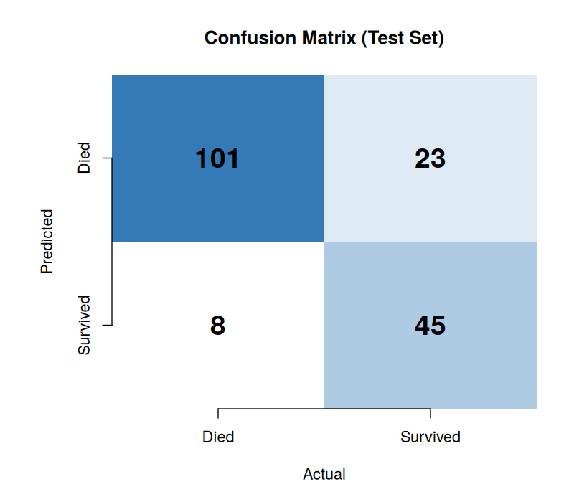
Figure 1. Confusion matrix on the 177-row held-out test set.
Metric | Value
Accuracy | 82.5% (95% CI: 76.1% - 87.8%)
Sensitivity (Recall, Survived) | 66.2%
Specificity (Died correctly identified) | 92.7%
Precision (Pos Pred Value) | 84.9%
Balanced Accuracy | 79.4%
Kappa | 0.614

The model correctly classified 146 of 177 test passengers (82.5% accuracy), a large improvement over the 61.6% no-information baseline of always predicting 'Died'. Specificity (92.7%) is notably higher than sensitivity (66.2%), meaning the model is better at correctly identifying passengers who died than those who survived — it misses roughly a third of actual survivors (23 false negatives) while making very few false-positive survival calls (8).

4.2 ROC Curve and AUC
roc_obj <- roc(test_data$Survived, test_probs, levels = c("Died","Survived"))
auc(roc_obj)
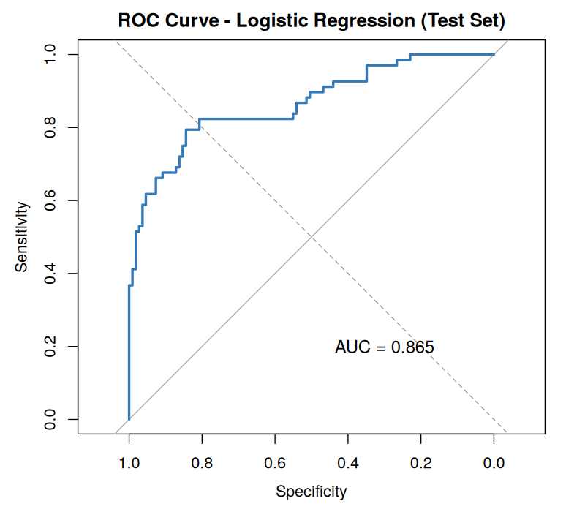
Figure 2. ROC curve for the logistic regression model on the test set (AUC = 0.865).
An AUC of 0.865 on the held-out test set (consistent with the 0.853 cross-validated estimate) indicates strong discriminative power — an 86.5% chance the model ranks a randomly chosen survivor higher than a randomly chosen non-survivor. This is a solid result for a model built on only 8 predictors with no interaction terms.

4.3 Variable Importance
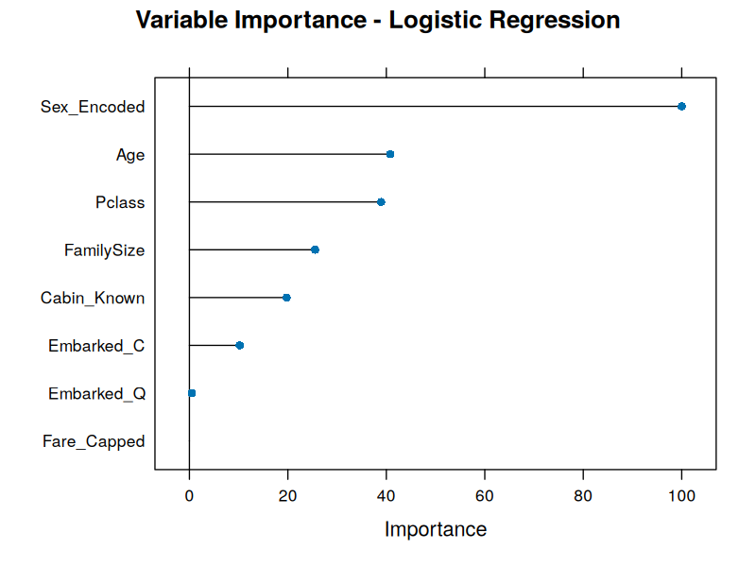
Figure 3. Variable importance ranked by absolute z-value from the logistic regression.
Sex is overwhelmingly the most important predictor, followed by Age, Pclass, and FamilySize. Fare_Capped contributes essentially nothing once the other variables are accounted for, reinforcing the earlier finding that it is redundant with Pclass.

4.4 Diagnostic Residual Plots
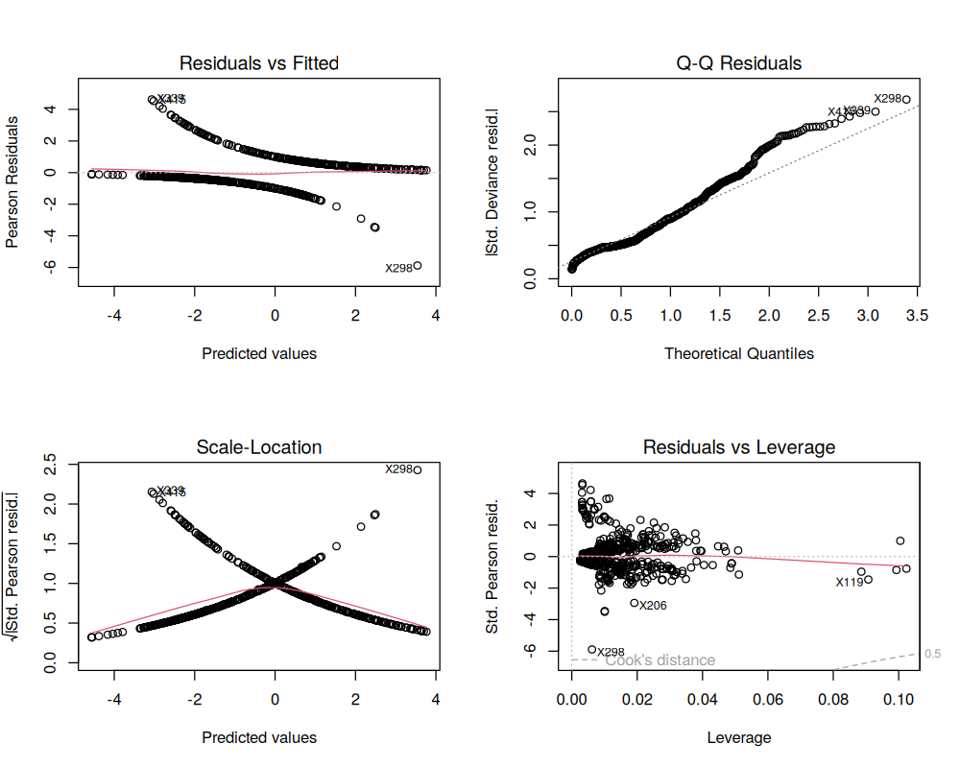
Figure 4. Standard GLM diagnostic plots: Residuals vs Fitted, Q-Q, Scale-Location, and Residuals vs Leverage.
The characteristic two-band pattern in the Residuals-vs-Fitted and Scale-Location plots is expected for a binary logistic regression (one band per outcome class) and is not itself a sign of a problem. The Q-Q plot shows some departure from the reference line in the upper tail, indicating a handful of poorly-fit observations (e.g. passenger row 298), which is consistent with a small number of high-leverage passengers whose actual outcome ran against what their profile would predict (for example, a high-fare passenger who died, or a low-fare passenger who survived). The Residuals-vs-Leverage plot shows no points crossing the Cook's distance threshold, so no single observation is unduly driving the model's coefficients.

4.5 Multicollinearity Check
car::vif(log_model$finalModel)
Pclass Sex_Encoded Age Fare_Capped FamilySize Embarked_C Embarked_Q Cabin_Known
2.91 1.22 1.44 1.81 1.37 1.09 1.11 2.02
All Variance Inflation Factors are comfortably below the common threshold of 5, so multicollinearity is not a concern for this model — each predictor is contributing largely independent information despite Pclass and Cabin_Known being correlated in principle.

5. Summary Interpretation and Potential Improvements

5.1 Model Performance Summary
- The logistic regression model achieves 82.5% test accuracy and an AUC of 0.865, both a substantial improvement over the 61.6% baseline of predicting the majority class.
- Sex, Pclass, and Age are statistically significant, meaningful predictors; Fare and Embarked add little once Pclass is included, confirming they act mainly as proxies for class.
- The model is noticeably more conservative about predicting survival than death (specificity 92.7% vs. sensitivity 66.2%), meaning in a real deployment it would under-flag some actual survivors.

5.2 Potential Improvements
- Address the sensitivity/specificity imbalance by adjusting the classification threshold below 0.5, or by using a cost-sensitive loss that penalizes false negatives more heavily, if correctly identifying survivors matters more than overall accuracy.
- Try more flexible models — random forest or gradient boosting — which can capture non-linear effects and interactions (e.g. class × sex) that a plain logistic regression cannot, and compare their AUC against this baseline.
- Engineer additional features, such as extracting passenger title (Mr./Mrs./Miss/Master) from the Name field, which is known from prior Titanic analyses to be a strong predictor of both age and survival.
- Investigate the small number of high-leverage misclassified passengers flagged in the diagnostic plots to check whether they represent genuine outliers or a missing predictor (e.g. crew status, exact cabin deck).
- With a larger dataset, repeat the 80/20 split multiple times (repeated cross-validation) to get a tighter confidence interval around the reported performance metrics, since the current test set of 177 rows produces a fairly wide 95% CI on accuracy (76.1%-87.8%).
Overall, this analysis demonstrates a complete, statistically grounded predictive modeling workflow — from hypothesis testing through cross-validated model training to full diagnostic evaluation — built on the same Titanic dataset cleaned in Week 1 and visualized in Week 2.

