# Simulation Program Usage Description

First downloading the python compiler, then double click the installation package. Install: first check the dialog box before Add Python 3.6 to PATH, then click Install Now. Click Close when installation is complete.

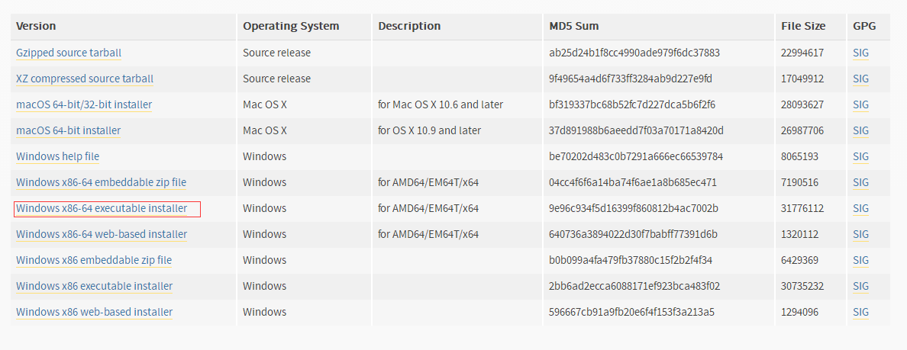

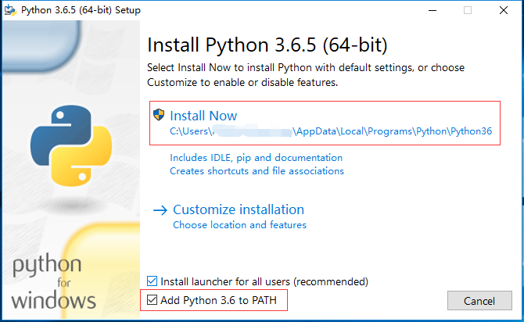

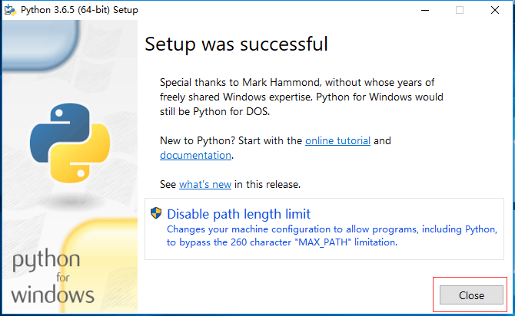

Then press “win+r” to open the command line, enter “pip install graphviz”, it will be installed successfully.

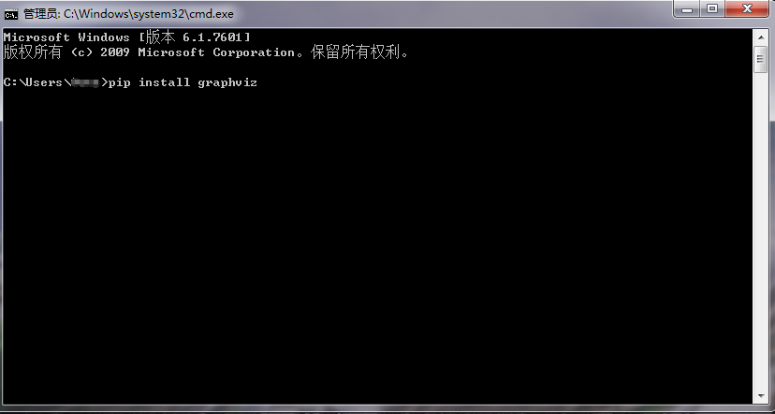 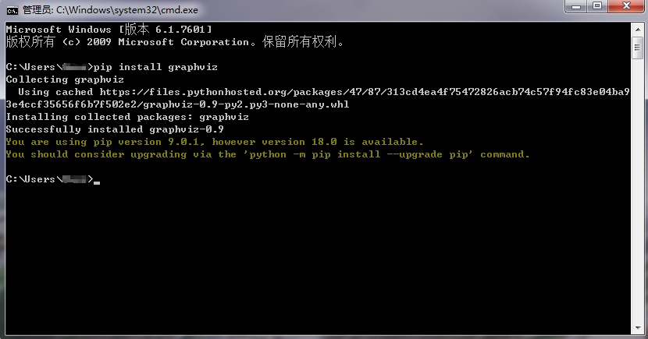

Next install the dependency library graphviz, first download the graphviz.msi file on the [website](dic://word/WEBSITE)( https://graphviz.gitlab.io/_pages/Download/Download_windows.html), double click the file into the installation, click next, write down the installation path, and check the everyone. Click Close after the installation is completed.

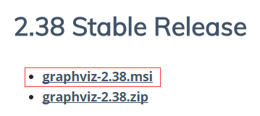

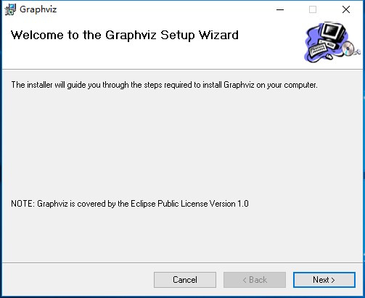

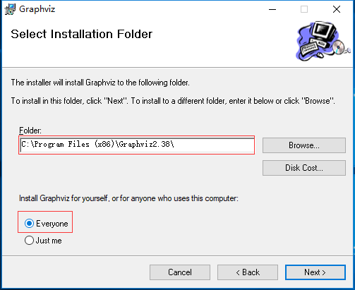

Next, configure the environment. find the bin file under the installation path of graphviz, and copy the file path. The right mouse button "this computer", select the properties, click the advanced system settings, click on the environment variable, click path and click the edit, add the just copied bin file path to path.





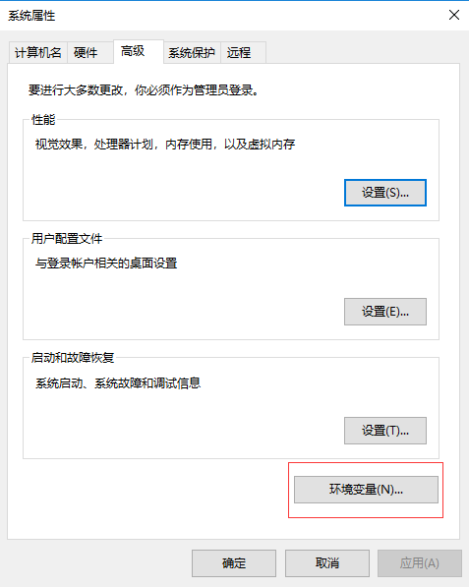

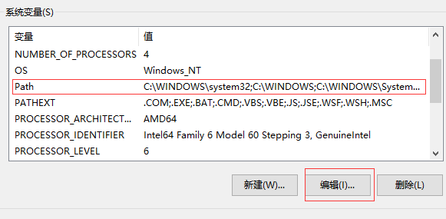

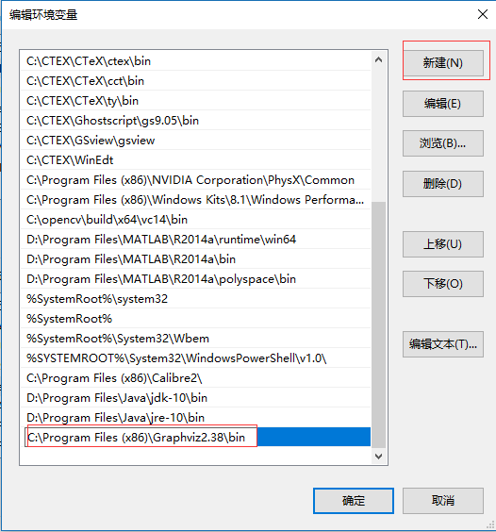

Finally, the program is opened as wordpad, and the name of the input file is assigned to the variable filename, the max step of the program can be set by yourself. Shut it down after saving, and then double click the program file to run.

