Table of Contents

2 References 4

3 Modifiers 4

3.1 d Flag 4

3.2 g Flag 4

3.3 i Flag 4

3.4 m Flag 4

3.5 s Flag 4

3.6 u Flag 4

3.7 y Flag 5

4 Groups and Ranges 5

4.1 OR Group - (x|y) 5

4.2 Specify Range [abcd] 5

4.3 Negated Range [^a-c] 5

4.4 Capturing Group 5

4.5 Capturing Group \nth 5

5 Meta characters 5

5.1 . 5

5.2 \w 6

5.3 \W 6

5.4 \d 6

5.5 \D 6

5.6 \s 6

5.7 \S 6

5.8 \ b 6

5.9 \B 7

5.10 \0 7

5.11 \n 7

5.12 \f 7

5.13 \r 7

5.14 \t 7

5.15 \v 7

5.16 \xxx 7

5.17 \xdd 7

5.18 \udddd 7

6 Quantifiers 8

6.1 N+ 8

6.1.1 N=john 8

6.1.2 N=\d 8

6.2 N* 8

6.2.1 digit + N=0 8

6.2.2 N=0 8

6.3 N? 9

6.3.1 N=u 9

6.4 N{X} 9

6.4.1 N = u {X = 3} 9

6.4.2 N = ou {X = 3} 10

6.5 N {X, Y} 10

6.5.1 N = ou {X = 3, Y= 6} 10

6.6 N{X,} 10

6.6.1 N = ou {X = 3, } 10

6.7 N$ 10

6.7.1 N$=is 11

6.8 ^N 11

6.8.1 ^N=is 11

6.9 ?=N 11

6.9.1 ?=N = all 11

6.9.2 ?!N =all 12

# References

* [RegExr: Learn, Build, & Test RegEx](https://regexr.com/)

# Modifiers

## d Flag

Expression match should contain the start and end string

## g Flag

Expression should be tested against all possible matches in a string

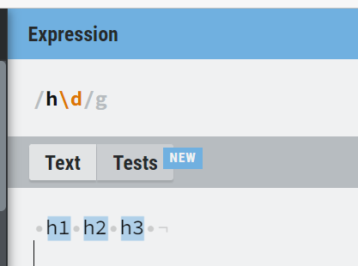

## i Flag

Do a case-insensitive search

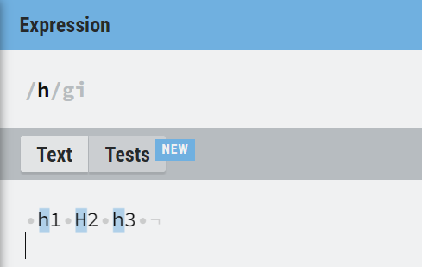

## m Flag

Multi-line search

## s Flag

Allows to match newline characters

## u Flag

Treat a pattern as a sequence of Unicode code points

## y Flag

Perform a "sticky" search that matches starting at the current position in the target string

# Groups and Ranges

## OR Group - (x|y)

Matches either "x" or "y"

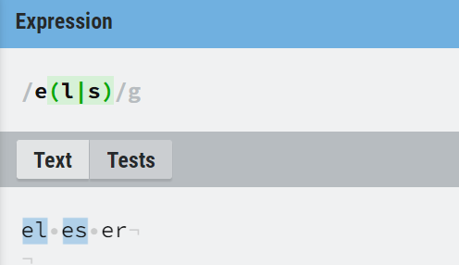

## Specify Range [abcd]

[abcd] is the same as [a-d]. They match the "b" in "brisket", and the "c" in "chop".

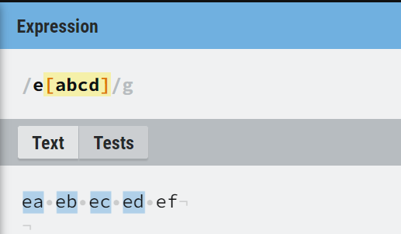

## Negated Range [^a-c]

[^a-c] They initially match "on" in "bacon" and "hop" in "chop" with global flag set

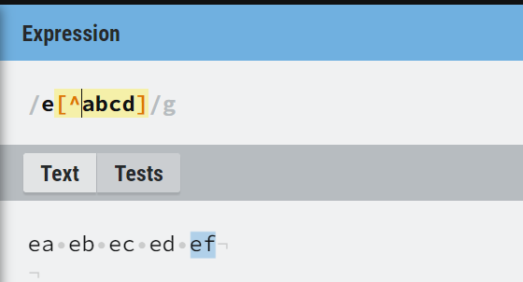

## Capturing Group

Matches x and remembers the match. (go)+ means go, gogo, gogogo and so on

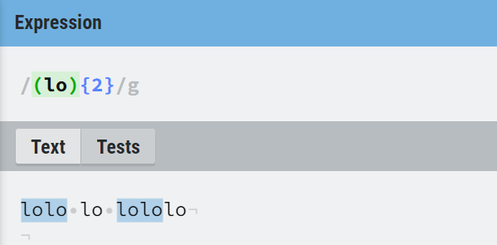

## Capturing Group \nth

Where "n" is a positive integer. \1 refers to the first capturing group in the regular expression. \2 will refer to the second capturing group and \n will refer to an nth capturing group

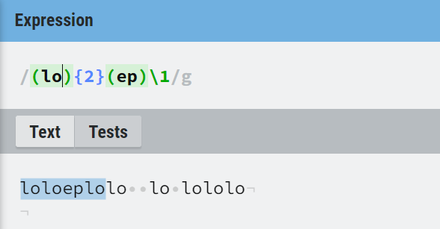

# Meta characters

## .

Find a single character, except newline or line terminator

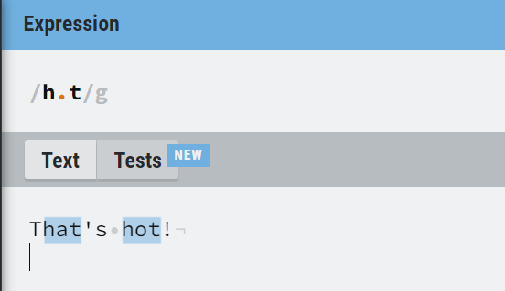

## \w

Find a word character. A word character is a character a-z, A-Z, 0-9, including _ (underscore)

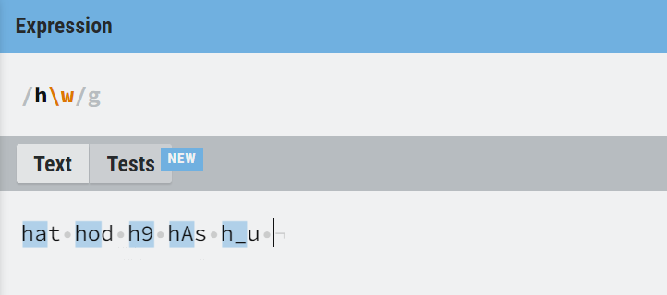

## \W

Find a non-word character

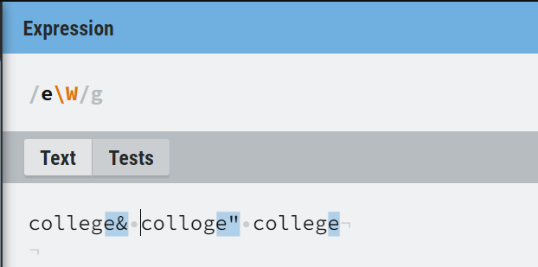

## \d

Find a digit

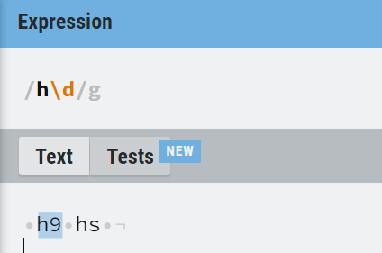

## \D

Find a non-digit character

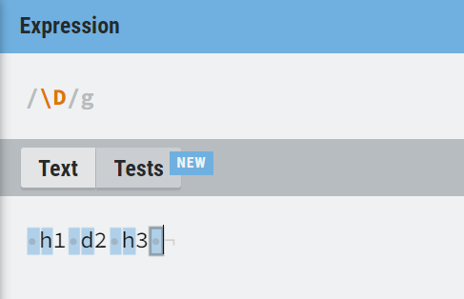

## \s

Find a whitespace character

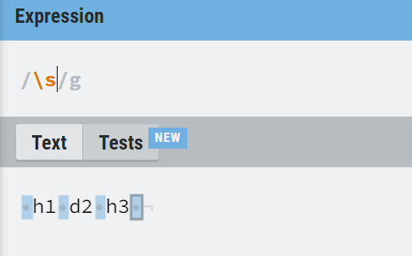

## \S

Find a non-whitespace character

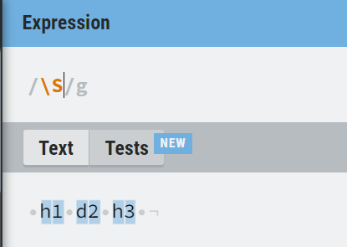

## \ b

Find a match at the beginning or end of a word

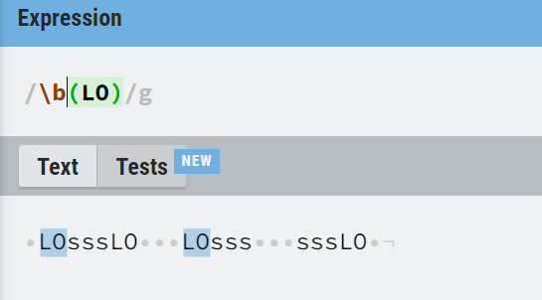

BEGINING of the WORD

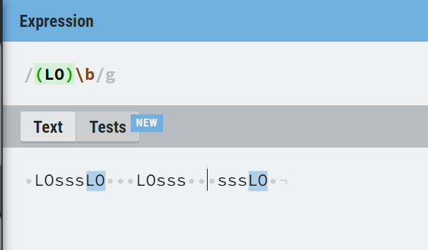

END of the WORD

## \B

Find a match, but not at the beginning or end of a word

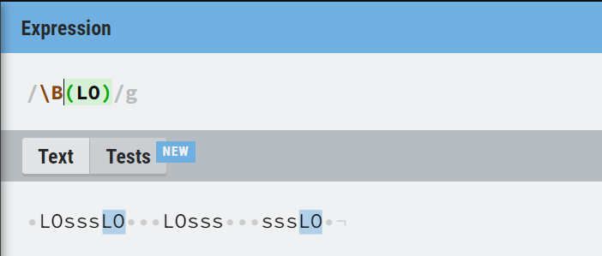

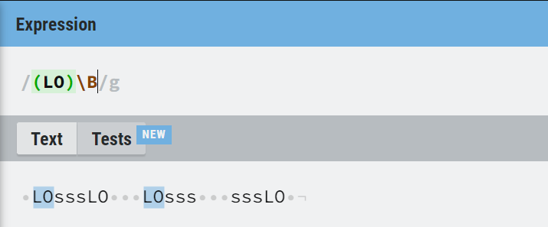

## \0

Find a NULL character

## **\n**

Find a new line character

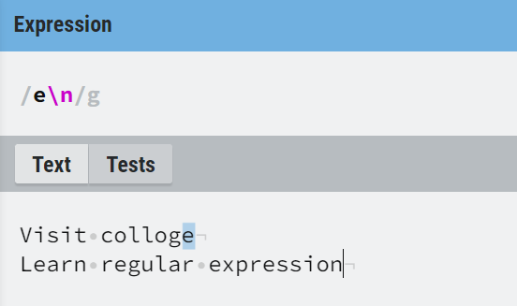

## **\f**

Find a form feed character

## **\r**

Find a carriage return character

## **\t**

Find a tab character

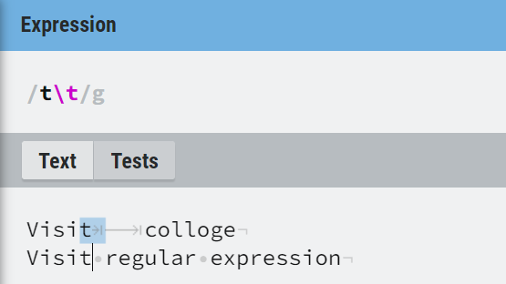

## **\v**

Find a vertical tab character

## **\xxx**

Find the character specified by an octal number xxx

## **\xdd**

Find the character specified by a hexadecimal number dd

## **\udddd**

Find the Unicode character specified by a hexadecimal number dddd

# Quantifiers

## N+

contains at **least one** N

### N=john

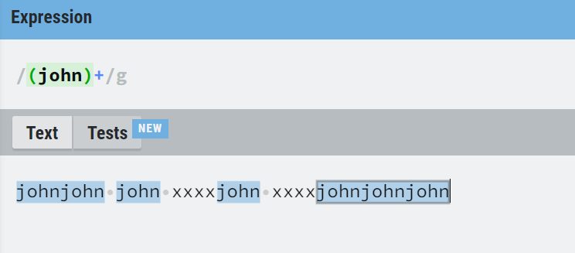

### N=\d

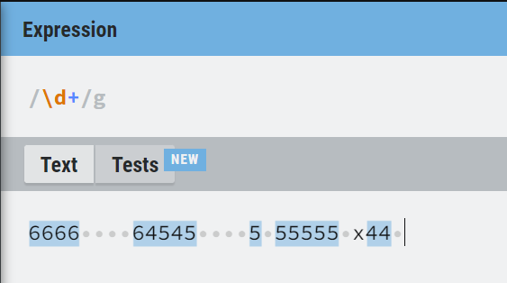

## N*

contains **zero or more occurrences** of N

### digit + N=0

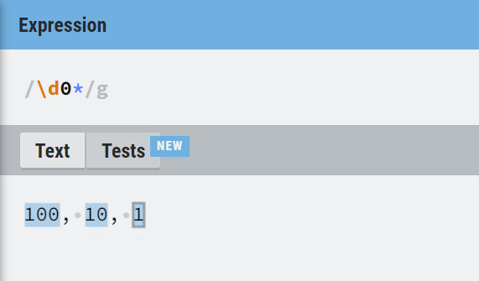

### N=0

Need something before N for zero occurrences

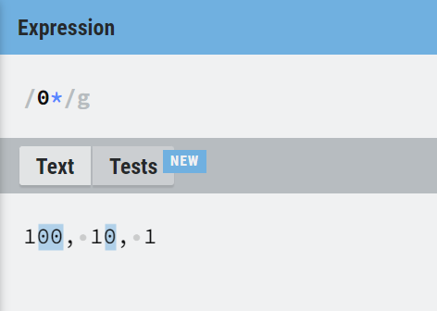

## N?

contains **zero or one occurrences**

### N=u

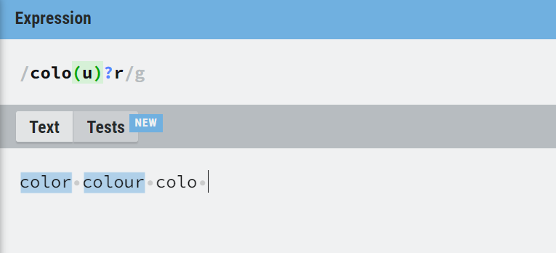

## N{X}

contains a **sequence of X** N's

### N = u {X = 3}

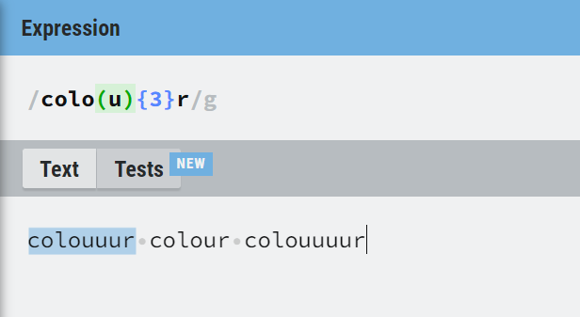

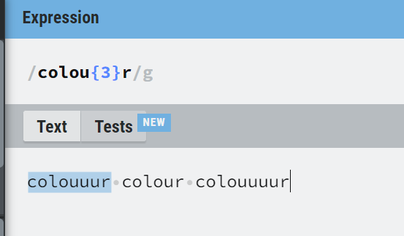

### N = ou {X = 3}

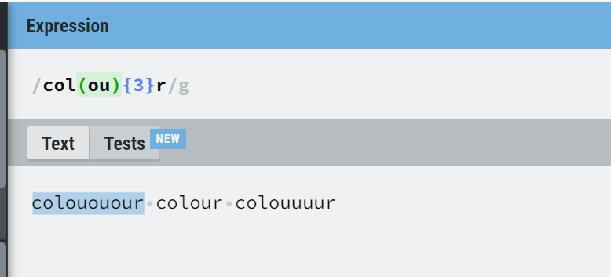

## N {X, Y}

contains a sequence **of X to Y** N's

### N = ou {X = 3, Y= 6}

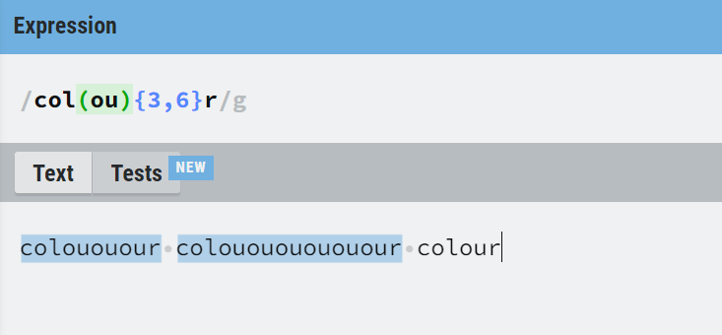

## N{X,}

contains a **sequence of at least X** N's

### N = ou {X = 3, }

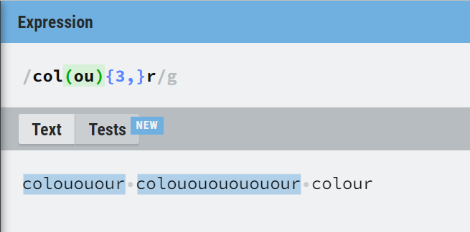

## N$

string with N at the **end** of it

### N$=is

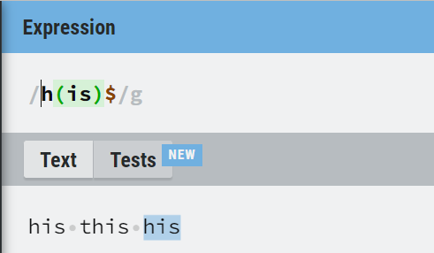

## ^N

string with N at the **beginning** of it

### ^N=is

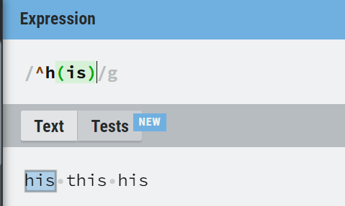

## ?=N

string that is **followed by a specific string** N

### ?=N = all

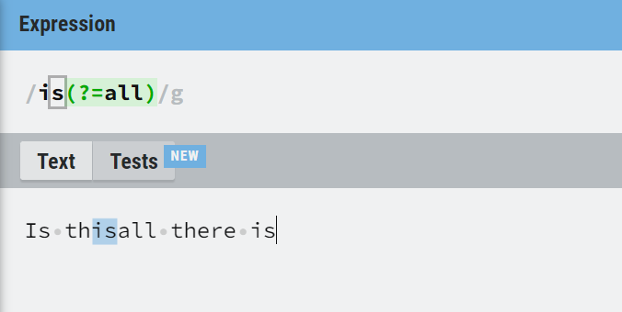

### ?!N =all

