Concept Document For:





All Work Copyright © 2014 by Angry Robot Studio

Written By:

Bryan Spahr

Shanon Mathai

Kylie Adkins

Jessica Candebat

Babak Shahian

Adrian Campos

Friday, February 28, 2014

**Recovery**

Game Genre: Survival Horror

Target Audience: Action and Adventure game players

Appeals to: Beginner through moderate gamers

Platform: PC

Player View: First person

Graphics Engine: Unity. (Direct3D)

**Recovery Key Concepts:**

**Story**

* Protagonist is John Hanks, an engineer, who crash-lands on a mysterious object in space.
* Protagonist wakes up after the crash, in a room filled with dead bodies, and is given supplies.
* The protagonist goal is to find a ship and leave this crazy building. However escaping is not a simple task. Enemies and various obstacles will get in his way.
* The protagonist will face enemy robots that are trying to kill him while he escapes.
* Type of Enemies:
  + Humanoid robot
  + Dog shaped robot
  + Wall crawling robot

**Game Play**

* Player must find supplies throughout the level. He has little resources, which make it difficult to beat the level.
* Frequent save points
* Player can use a flashlight to light up dark areas. However, his chances to be found by the enemy increase.
* Enemies engage the player at first sight and will continue to chase him until he is dead.
* Enemies have high HP and are difficult to kill. Each shot counts, especially with limited ammo.
* Player must find certain items to open doors and make it outside to his ship.
* Weird visual and sound effects occur throughout the game to build up player’s suspense.

**Player Actions**

* The player is given a gun, medkit, and a flashlight at the beginning of the game.
* There are only two types of attacks: attacks from guns and melee hits.
* Player can sprint in the game, however this only lasts a few seconds and they must catch their breath afterwards. In this state they move slow for 5-10 seconds, which can be dangerous.
* The player can also pick up items, however most of these cannot be equipped. They are used to solve puzzles, so that the player can continue further into the level. Ex: Player picks up key, and inserts it into a door.

**Game Flow**

* The game consists of two levels.
* Level 1:
  + Intro scene to the crash
  + Player picks up supplies
  + Player explores level, opening doors and defeating enemies
  + Player finds his ship and has to fight a swarm of enemies (mini boss)
* Level 2:
  + Protagonist discovers ship is missing core engine part
  + He has to explore a higher part of the building
  + Meets newer enemies
  + Finds Final Boss, the main antagonist who placed him inside this maze.

**Art style**

* Generally dark environment
* Metallic/Machine environment
* Ominous feel, sound adds to the suspenseful effects.

**Textural Description of Recovery:**

**Fictional story background**

In the year 2455, humanity began installing space stations to observe any dangerous activity that may harm the planet Earth. However, the Defense System AI went haywire at one of these stations, Station-0X22. It had determined that the space crew were a threat to humanity. The entire crew was slaughtered by a specialized combat robots. Soon, the United Earth Government decided to abandon Station-0X22. 100 years later, John Hanks, an aeronautical engineer, is traveling back from a conference in mars. During his return to earth, his ship’s autopilot system shuts down and he crashes into Station-0X22. John wakes up in a dark room and uses his flashlight to see. He discovers dead bodies all around him, screams and activates a dysfunctional combat robot. The robot attacks him and he blacks out. He wakes up and the robot has shut down. John realizes he is in a dangerous environment, and must escape in his ship. But with no survival or combat training, how will John survive this abandoned hell in space?

**Game Progression**

As the player goes through the station, he encounters obstacles that require him to explore and find other means of proceeding. As he progresses, he begins to have auditory and visual hallucinations which add to the suspenseful aspect of our game. Once he finds a new ship, he must find parts for it. This requires John to back into the station to search for engine parts. However, the DSAI will kill him at all costs.

**Mindset**

You are weak but not completely helpless. You need to gather resources while trying to avoid conflict with the robots where you can. Robots should be able to overpower you if you do not act quick enough, so conflict should generally be avoided (for the player’s benefit).

**Game play and player interaction example**

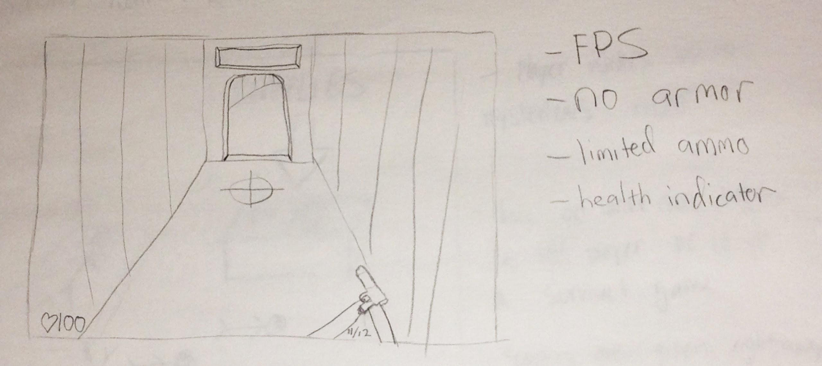

Recovery is played in first person mode. The user just sees the item John is holding, but not the actual character. The player can find ammo and medkits in order to increase his chance at survival. The player is able to pick up certain objects on the floor by pressing E. They do not go in his inventory, the item just floats in the air to simulate holding an item (think of amnesia). The levels do not have much light, so the player must use a flashlight (by pressing F) to help him see. At certain points of the game, the player’s screen will shake and they will begin to hear metallic noises. The game will include ambient noises and music to increase the anxiety of the players. The player encounters a low amount of enemies. However these enemies are very strong and will be able to kill the player.

**Roles**

|  |  |
| --- | --- |
| **Name** | **Positions** |
| Bryan Spahr | Team Lead, Developer, Sound Engineer |
| Adrian Campos | Developer, Level Designer |
| Shanon Mathai | Developer, Modeler, Animator |
| Jessica Candebat | Artist, Lead 3D models |
| Kylie Adkins | Artist, Lead concept art |
| Babak Shahian | Artist |