***Lecture* One**

***Section* 1.1 – *Polynomials and Factoring***

***Polynomials***

**Adding and Subtracting Polynomials**

**Properties of Real numbers**

For all real numbers *a*, *b*, and *c*:

 ***Commutative properties***



 ***Associative properties***



 ***Distributive properties***

***Add or subtract as indicated***

1. 







1. 





1. 





Multiply

1. 





1. 





1. 









Find 







Find 













Perform the indicated operations: 





Perform the indicated operations: 





Perform the indicated operations: 

 



***Factoring***

**Prime Factorization**

A process that allows us to write a composite number as a product of two or more prime numbers.

Tree

10

2 5 10 = 2 *x* 5

72 = 2. 36

= 2. 6. 6

= 2. 2. 3. 2. 3

= 23 32

**The Greatest Common Factor (GCF)**

The largest factor that two or more numbers (or terms) have in common

***Find GCF*** (18, 36)

18: 2. 9 36: 2. 18

2. 3. 3 2. 2. 3. 3

18: 2 32 → 1, 2, 3, 6, 9, **18**

36: 22 32 → 1, 2, 3, 4, 6, 9, 12, **18**, 36 GCF (18, 36) = 18 (is the greatest common factor)

***Find GCF*** (27, 45)

27 = 33

45 = 32 5

32 GCF (27, 45) = 9

***Find*** GCF (40, 56)

40 = 23 5

56 = 23 7

23 GCF (40, 56) = 8

***Find GCF*** (80, 60)

80 = 24 5

60 = 22 3 5

22 5 GCF (80, 60) = 20

***Factor out the greatest common factor***

|  |  |
| --- | --- |
| **12** | 2 . 2 . 3 |
| **18** | 2 . . 3 . 3 |
|  | 2 . 3 |

1. 



1. 



**Factoring Trinomial**

***Factor ***

|  |  |
| --- | --- |
| ***Product***  15 | ***Sum***  8 |
| 15 *x* 1 | 15 + 1 |
| 3 *x* 5 | 3 + 5 |



***Factor ***



**Special Factorization**











***Factor***

1. 





1. 

 *can’t be factored (in real number) it is prime.*

1. 



1. 





1. 





1. 



1. 







1. 







***Factor: ***



***Factor: ***



***Factor: ***





***Factor: ***









***Section* 1.2 – *Exponents***

**Integer Exponents**

*Definition of exponent*

 a appears as a factor n times

|  |  |
| --- | --- |
|  |  |
|  |  |
|  |  |
|  |  |

1. 



1. 



1. 



1. 



1. 



1. 



1. 



1. 





1. 







1. 







1. 







1. 











Calculations with exponents

1. 
2. 
3. 
4.  *is not a real number*

***Rational Exponents***



***Calculations with Exponents***

1.  











1.  







1.  







Simplify

1. 











1. 









1. 











Simplify

1. 





1. 



1. 







**Radicals**



1. 



1. 
2. 



1. 



**Properties**











Simplify

1. 







1. 





1. 







1. 





1. 





1. 







***Section* 1.3 − Fractions and Rationalization**

***Fraction* (*Basic*)**







1. 



1. 





Simplify: 





Simplify: 







If the denominators are the same ⇒ add the numerators



If the denominators are the same ⇒ subtract the numerators



If the denominators are not the same

⇒ Find Least Common Denominator (LCD) and convert so that the fractions have the same denominators

***LCD:*** is the smallest whole number that is a multiple of each

 LCD (8, 12)

8 = 23

12 = 22 3

23 3 = 24 LCD (8, 12) = 24











LCD (75, 50) 75 = 53

50 = 2 52

2 53 = 150 LCD (75, 50) = 150



















































** **

















***Find***:

1. 
2. 
3. 
4. 
5. 
6. 
7. 
8. 
9. 
10. 

**Operations with Fractions**

A rational expression is proper if the degree of numerator is less than the degree of denominator

A rational expression is improper if the degrees of numerator is greater than or equal the degree of denominator

















***Example***

Perform each indicated operation & simplify

1. 
2. 





***Example***

Perform each indicated operation & simplify

1.  





1.  





***Example***

Perform each indicated operation & simplify

1. 









1. 



***Example***

Perform each indicated operation & simplify



















**Rationalization Techniques**

1. If the denominator is , multiply by 
2. If the denominator is , multiply by 
3. If the denominator is , multiply by 



***Example***

Simplify by rationalizing the denominator

1. 



1. 



1. 







***Example***

Simplify 







***Example***

Simplify 



***Example***

Simplify 







***Example***

Simplify 







***Example***

Simplify 





***Example***

Rationalize the denominator or numerator

1.  



1.  







1. 











***Example***







***Example***

 









***Example***







***Exercises Section* 1.3 − Fractions and Rationalization**

1. Perform each indicated operation & simplify: 
2. Perform the operation and simplify: 
3. Perform the operation and simplify: 
4. Perform the operation and simplify: 
5. Simplify the fraction: 
6. Simplify: 
7. Simplify the expression: 
8. Simplify the expression: 
9. Simplify the expression: 
10. Simplify the expression: 
11. Simplify the expression: 
12. Simplify the expression: 

***Section* 1.4 − Equations and Application**

***Linear Equations***

A ***linear equation*** in one variable is an equation that is equivalent to one of the form 

**Equation-Solving Principles**

Addition Principle: If *a = b* is true ⇒ 

Multiplication Principle: If *a = b* is true ⇒ 

***Solve the following equations***

1. 





1. 





***Solve: ***







 *Divide both sides by 5*



**The Zero-Product Principle**:

If *ab* = 0. then *a* = 0 or *b* = 0.

***Solve ***

  


 

 

 

***Quadratic Formula***



***Solve  ***











 

 

 

***Solve ***















**Equations with Fractions**

|  |  |
| --- | --- |
| 10 | 2 5 |
| 15 | 3 5 |
| 20 | 2 2 5 |
| 5 | 5 |
|  | **2 2 3 5 = 60** |

***Solve ***











***Solve  ***

Conditions: 









***Solve  ***













 

 

Solution: 

***Slopes and Equations of Lines***

**Slope of a line** *(Definition)*

The slope of a line is defined as the vertical change (the *rise*) over the horizontal change (the *run*) as one travels along the line.



Find the slope of the line through each pair point

1. 







1. 





= 0

1. 



 Which is undefined → line is vertical.

**Equations of a Line**



This *linear equation* is called the *slope-intercept form* of the equation of a line.

***Point-Slope Form***



***Example***

Find the equation of the line through  with slope 

*Solution*

















***Example***

Find the equation of the line that passes through the point  and has slope 

*Solution*







 



**Parallel Lines** (//)

Two lines are parallel if and only if they have the same slope, or they are both vertical. 

***Example***

Find the equation of the line that passes through the point  and is parallel to the line 

*Solution*





















**Perpendicular Lines** (⊥)

Two lines are perpendicular if and only if the product of their slope is . 

***Example***

Find the slope of the line L perpendicular to the line having the equation 

*Solution*



 → Slope = 5

Slope of the line L = 

***Linear Functions and Applications***

**Linear Function**

A relationship *f* defined by



For real numbers *m* and *b*, is a ***linear function***

***Example***

*Let* ***. Find , , , and ***

*Solution*



















***Cost Analysis***

***Definition***

In a cost function of the form is the *linear cost function*

 Represents the marginal cost per item

 Fixed cost.

***Example***

The marginal cost to make x hatches of a prescription medication is $10 per batch, while the cost to produce 100 batches is $1500. Find the cost function , given that it is linear.

*Solution*

Since the cost function is linear 

The marginal cost = slope 











**Break-Even Analysis**







The number of units at which revenue just equals cost  is the ***break-even quantity***.

The corresponding ordered pair gives the ***break-even point***.

***Example***

A firm producing poultry feed finds that the total cost in dollars of producing and selling *x* units is given by



Management plans to charge $24 per unit for the feed.

1. How many units must be sold for the firm to break even?

The revenue: 



Break-even: 







1. What is the profit if 100 units of feed are sold?













1. How many units must be sold to produce a profit of $900?







***Exercises Section* 1.4 − Equations and Application**

1. Suppose that Greg, manager of a giant supermarket chain, has studied the supply and demand for watermelons. He has noticed that the demand increases as the price decreases. He has determined that the quantity (in thousands) demanded weekly q, and the price (in dollars) per watermelons, p, are related by the linear function.

 Demand function

1. Find the demand at a price of $5.25 per watermelon and at a price of $3.75 per watermelon.
2. Greg also noticed that the supply of watermelons decreased as the price decreased. Price p and supply q are related by the linear function

 Demand function

Find the supply at a price of $5.25 per watermelon and at a price of $3.00 per watermelon.

1. Use the algebra to find the equilibrium quantity for the watermelon in example 2
2. In Recent years, the percentage of the U.S. population age 18 and older who smoke has decreased at a roughly constant rate, from 23.3% in 2000 to 20.9% in 2004.
3. Find the equation describing this linear relationship.
4. One of the objectives of Healthy People 2010 (a campaign of the U.S. Department of Health and Human Services) is to reduce the percentage of U.S. adults to smoke to 12% or less by the year 2010. If this decline in smoking continues at the same rate, will they meet this objective
5. The number of African Americans earning doctorate degrees has risen at an approximately constant rate from 1987 to 2005. The linear equation , where x represents the number of years since 1987, can be used to estimate the annual number of African Americans earning doctorate degrees. Determine this number in 2006.

***Section* 1.5 – Limits and Asymptotes**

**Definition of the Limit of a Function**

If  becomes arbitrary close to a single number *L* as *x* approaches *c* from either side, then



Which is read as “the limit of  as *x* approaches *c* is *L.*”

**Limit of a Polynomial Function**

If  is a polynomial function and *c* is any real number, then



***Example***

Find the limit: 

*Solution*

 = 2*(1) + 4 = 6

***Example***

Find the limit: 

*Solution*







**Unbounded Behavior**

***Example***

Find the limit:

*Solution*





 (***Doesn’t exist***)









***Example***

Find the limit:

*Solution*







***Doesn’t exist***

**On-Sided limits**

***Example***

Find the limit: 

*Solution*



Find the limit: 



***Example***

Find: 

*Solution*





***Example***

Suppose and

Find 

*Solution*











***Example***

Find: 

*Solution*









**Vertical Asymptotes and Infinite Limits**

***Definition***

If  approaches infinity (±∞) as *x* approaches *c * from the right or from the left, then the line  is a vertical asymptote of the graph *f*.

***Example***

Find each limit.

1. 



1. 



**Finding Vertical Asymptotes (*Think Domain*)**

***Example***



*Solution*







***Example***

Find the vertical asymptote(s) of the graph of 

*Solution*







***Example***

Find the vertical asymptote(s) of the graph of 

*Solution*





Vertical Asymptote (VA): *x* = 3

Hole: *x* = -3 (***undefined***)

**Horizontal Asymptote**

***Definition***

If *f* is a function and and are real numbers, the statements

 *and* 

Denote limits at infinity. The lines and are ***horizontal asymptotes*** (***HA***) of the graph of *f*.

***Example***

Find the limit: 

*Solution*







***HA***: 

**Horizontal Asymptotes of Rational Functions**

Let  be a rational function.

1. If the degree of numerator is less than of denominator (*n* < *m*) ⇒ y = 0



1. If the degree of numerator is equal of denominator (*n* = *m*) ⇒



1. If the degree of numerator is greater than of denominator (*n* > *m*)⇒ No horizontal asymptote



***Example***

Find the vertical and horizontal asymptotes (if any) of

1. 

**VA**:

**HA**: 

1. 

No **VA**

**HA**: 

***Slant or Oblique Asymptotes***

When the degree of the numerator is one greater than the degree of the numerator, the graph has a slant or oblique asymptote. To find the slant asymptote, divide the fraction using long division. The quotient (not remainder) is the slant asymptote.







The slant asymptote is the line ***y = 3x - 6***

***Exercises Section* 1.5 – Limits and Asymptotes**

Find the limit:

1. 
2. 
3. 
4. 
5. 
6. 
7. 
8. 
9. 
10. 
11. 
12. 

Find the vertical and horizontal asymptotes (if any) of

1. 
2. 
3. 
4. 
5. 
6. 
7. 
8. 
9. 
10. 

***Section* 1.6 – Continuity and Rates of Change**

**Definition of Continuity**

Let *c* be a number in the interval (*a*, *b*), and let *f* be a function whose domain contains the interval (*a*, *b*). The function *f*  is continuous at the point *c* if the following conditions are true.

1. is defined
2. 
3. 

If *f*is continuous at every point in the interval (*a*, *b*), then it is continuous on an open interval (*a*, *b*)

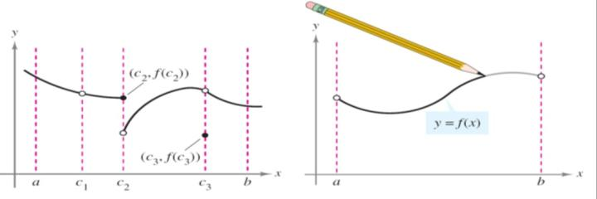

The Continuity of Polynomial & Rational functions:

1. A Polynomial function is continuous @ every real number
2. A rational function is continuous @ every point in its domain

**⇒ Continuous (-∞, *c*) and (*c*, ∞)

***Example***

Find all values of *x* where the following function is discontinuous



*Solution*









So  is discontinue at 

***Example***

1. 

Consists of all real number except *x* = 1.

Or

Continuous on (-∞, 1) and (1, ∞)

1. 

Continuous on (-∞, 2) and (2, ∞)

1. 

Continuous @ every real number

1. 

Continuous @ every real number

If *f*  is not continuous @ *x* = *c*⇒ function is said to have discontinuity @ *c*

⇒ This type of discontinuity falls into 2 categories:

1. Removable *ex*.  
2. Non-removable *ex*.  

***Definition*: Continuity on Close Interval**

Let *f*  be defined on a closed interval [*a, b*], if *f* is continuous on the open interval



***Example***

Discuss the continuity of 

*Solution*

*Domain*: *x* – 2 ≥ 0 ⇒ *x* ≥ 2



***Example***

Discuss the continuityof



*Solution*







*Slope and Rate of change*: Given 

**Definition of Average Rate of Change**

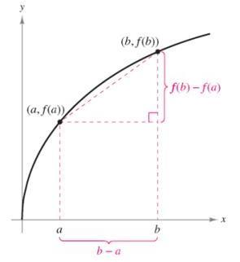

*Average Rate of Change* = 

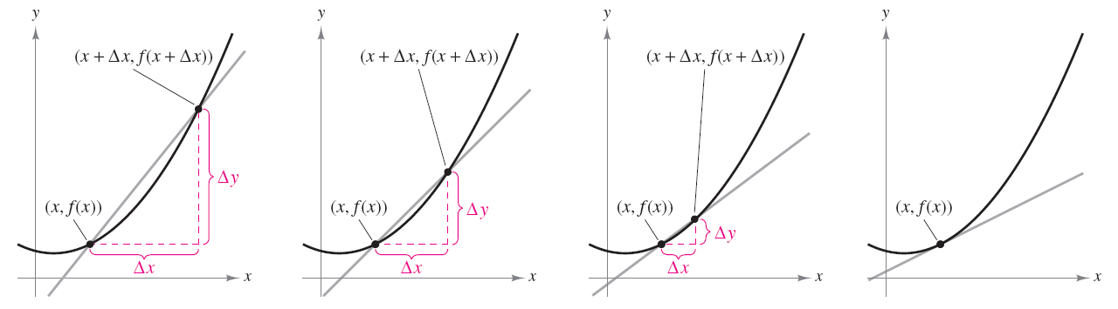

**Slope and limit process**

The secant line contains the points  and . Using the slope formula, the slope of the secant line is



If you allow  to become smaller, the secant line will change slope and become closer to the slope of the tangent line. If you were to allow to equal 0, the secant line becomes the tangent line. Of course you cannot allow  to equal 0, because the slope of the secant line would then be undefined. But you could let Δx approach 0. As  approaches 0, the secant line becomes the tangent line to the graph at the point . Thus the slope of the secant line becomes the slope of the tangent line at the point  is given by:

 *(Difference Quotient)*

As we know: 

***Example***

Cigarette consumption in the United Sates has been declining since reaching a peak around 1960. Per capita cigarette consumption since 1980 can be closely approximated by the function



Where *t* is the number of years since 1980. Find the average rate of change of per capita consumption from 1985 to 2005.

*Solution*











The average rate decreased at a rate of 76 cigarettes per year.

***Definition of Instantaneous rate of Change***



***Example***

The distance in feet of an object from a starting point is given by , where *t* is time in seconds.

1. Find the average velocity of the object from 2 sec to 4 sec.

The average velocity: 

  
 

1. Find the instantaneous velocity at 4 sec.













***Example***

Find the slope of the graph of  at the point (2, 4)

*Solution*



















***Exercises Section* 1.6 – Continuity and Rates of Change**

Determine whether  is continuous on the entire number line. Explain your reasoning.

1. 
2. 
3. Find the slope of the graph of 
4. Find the slope of the graph of 