***Lecture Three -* Graphs and the Derivative**

***Section* 3.1 – Increasing and Decreasing Functions**

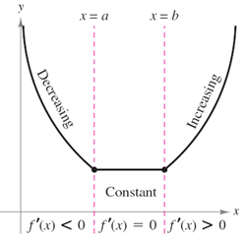

**Test for Increasing and Decreasing Functions**

Let *f* be differentiable on the interval (*a, b*)

1. If for all *x* in (*a, b*), then *f* is increasing on (*a, b*)
2. If for all *x* in (*a, b*), then *f* is decreasing on (*a, b*)
3. If for all *x* in (*a, b*), then *f* is constant on (*a, b*)

**Critical Numbers (*CN*)**

The critical numbers for a function  are those numbers in the domain of  for which  or  doesn’t exist. A critical point is a point whose *x*-coordinate is the critical number , and whose *y*-coordinate is 





 is a critical point.

If  undefined

***Example***

Find the open intervals on which the function  is increasing or decreasing

*Solution*



(*CN*)

|  |  |  |
| --- | --- | --- |
| -∞ -3 1 ∞ | | |
|  |  |  |
| ***Increasing*** | ***Decreasing*** | ***Increasing*** |

***Increasing***: (-∞, -3) and (1, ∞)

***Decreasing***: (-3, 1)

***Example***

Find the critical numbers and decide on which the function  is increasing or decreasing

*Solution*







 is the only critical number

|  |  |
| --- | --- |
| **-∞ 1 ∞** | |
| ***Decreasing*** | ***Increasing*** |

***Decreasing***: (-∞, 1)

***Increasing***: (1, ∞)

***Exercise Section* 3.1 – Increasing and Decreasing Functions**

Find the critical numbers and the open intervals on which the function is increasing or decreasing.

1. 
2. 
3. 
4. 
5. 
6. 
7. 
8. A county realty group estimates that the number of housing starts per year over the next three years will be



Where *r* is the mortgage rate (in percent).

1. Where is  increasing?
2. Where is  decreasing?
3. Suppose the total cost  to manufacture a quantity *x* of insecticide (in hundreds of liters) is given by . Where is  decreasing?
4. A manufacturer sells telephones with cost function  and revenue function . Determine the interval(s) on which the profit function is increasing.
5. The cost of a computer system increases with increased processor speeds. The cost *C* of a system as a function of processor speed is estimated as , where *x* is the processor speed in MHz. Determine the intervals where the cost function is decreasing.
6. The percent of concentration of a drug in the bloodstream *t* hours after the drug is administered is given by . On what time interval is the concentration of the drug increasing?
7. A probability function is defined by . Give the intervals where the function is increasing and decreasing.

***Section* 3.2 –Extrema and the First-Derivative Test**

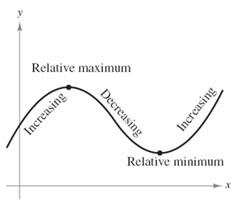

**First-Derivative Test for the Relative Extrema**

Let *f* be continuous on the interval (*a, b*) in which *x* is the only critical number. If *f* is differentiable on the interval (except possibly at *c*), then  can be classified as a relative minimum, a relative maximum, or neither, as shown

1. On the interval (*a, b*), If  is negative to the left of *x = c* and positive to the right of *x = c*, then  is a relative minimum (**RMIN**).
2. On the interval (*a, b*), If  is positive to the left of *x = c* and negative to the right of *x = c*, then is a relative maximum (**RMAX**).
3. On the interval (*a, b*), If  is positive on both sides of *x = c* or negative on both sides of *x = c*, thenis not a relative extremum of *f*.

***Example***

Find all relative Extrema as well as where the function is increasing and decreasing

*Solution*









|  |  |  |
| --- | --- | --- |
| **-∞ -1 1 ∞** | | |
| *> 0*  ***Increasing*** | *< 0*  ***Decreasing*** | *> 0*  ***Increasing*** |

**RMAX**: (-1, 5);

**RMIN**: (1, -3)

***Increasing****:*(-∞, -1) and (1, ∞);

***Decreasing****:* (-1, 1)

***Example***

Find all relative Extrema of and Find the open intervals on which is increasing or decreasing

*Solution*





 



 *Multiply both sides by*





***CN***:

 (0, 0) and (1, 2)

|  |  |  |
| --- | --- | --- |
| **-∞ 0 1 ∞** | | |
| < 0  ***Decreasing*** | ***Increasing*** | < 0  ***Decreasing*** |

**RMIN**: (0, 0)

**RMAX**: (1, 2)

***Decreasing****:*(-∞, 0) and (1, ∞)

***Increasing***: (0, 1)

***Example***

Find all relative Extrema as well as where the function is increasing and decreasing

*Solution*













 ***CN***: 

|  |  |  |
| --- | --- | --- |
| **-∞**   **∞** | | |
| ***Decreasing*** | ***Increasing*** | ***Decreasing*** |

**RMIN**: 

**RMAX**: 

***Decreasing****:* and 

***Increasing***: 

***Example***

A small company manufactures and sells bicycles. The production manager has determined that the cost and demand functions for bicycles per week are



Where *p* is the price per bicycle

1. Find the maximum weekly revenue
2. Find the maximum weekly profit
3. Find the price the company should charge to realize maximum profit.

*Solution*

1. Find the maximum weekly revenue







Maximum revenue = 









1. Find the maximum weekly profit















1. Find the price the company should charge to realize maximum profit.

If 

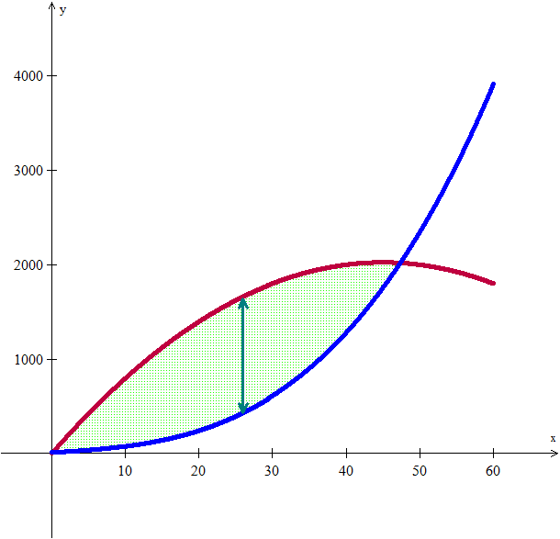

***Exercise Section* 3.2 – Extrema and the First-Derivative Test**

1. Find all relative extrema of the function 

Find all relative Extrema as well as where the function is increasing and decreasing

1. 
2. 
3. 
4. 
5. 
6. 
7. 
8. Coughing forces the trachea to contract, this in turn affects the velocity of the air through the trachea. The velocity of the air during coughing can be modeled by:  where *k* is a constant, R is the normal radius of the trachea (also a constant) and r is the radius of the trachea during coughing. What radius *r* will produce the maximum air velocity?
9. When a telephone wire is hung between two poles, the wire forms a U-shape curve called a Catenary. For instance, the function  models the shape of the telephone wire strung between two poles that are 60 *ft* apart (*x* & *y* are measured in *ft*). Show that the lowest point on the wire is midway between two poles. How much does the wire sag between the two poles?
10. The demand function for the product is modeled by where *p* is the price per unit in dollars and *x* is the number of units. What price will yield maximum revenue?
11. The annual revenue and cost functions for a manufacturer of grandfather clocks are approximately  and , where *x* denotes the number of clocks made. What is the maximum annual profit?
12. Find the number of units, *x*, that produces the maximum profit *P*, if  and 
13.  is an approximation to the total profit (in thousands of dollars) from the sale of *x* hundred thousand tires. Find the number of hundred thousands of tires that must be sold to maximize profit.
14.  is an approximation to the number of salmon swimming upstream to spawn, where *x* represents the water temperature in degrees Celsius. Find the temperature that produces the maximum number of salmon.

***Section* 3.3 – Absolute Extrema**

**Absolute Extrema**

Let *f* be defined on an interval *I* containing *c*.

1. **is an ***absolute minimum*** of *f* on *I* if ** for every *x* in *I*.
2. **is an ***absolute maximum*** of *f* on *I* if ** for every *x* in *I*.

The *absolute minimum* and *absolute maximum* values of a function on an interval are sometimes called the minimum and maximum of *f* on *I*.

***Example***

Find the minimum and maximum values of on the interval [0, 7].

*Solution*





→*y* = 16 - 32 + 10 = -6



***Absolute Maximum*** (0, 10)

***Absolute Minimum*** (4, -6)

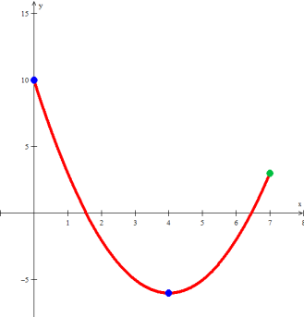

***Example***

Find the absolute extrema of on the interval .

*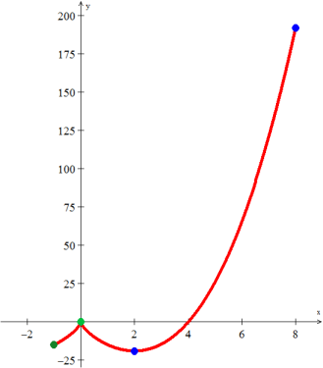Solution*











The derivative is undefined at

|  |  |
| --- | --- |
| *x* |  |
| -1 | -15 |
| 0 | 0 |
| 2 | -19.05 |
| 8 | 192 |

***Absolute Maximum*** (8, 192)

***Absolute Minimum*** (2, -19.05)

***Example***

Based on data from the U.S. Census Bureau, the number of people (in millions) in the US below poverty level between 1999 and 2006 can be approximated by the function



Where *t* is the number of years since March 1999. Based on this approximation,

In what year during this period did the number of people living below the poverty level reach its absolute maximum? What was the maximum number of people living below the poverty level during that period?

*Solution*





Based on the interval year from 1999 – 2006 ⇒

|  |  |
| --- | --- |
| *t* |  |
| 0 | 34.6 |
| 1.74 | 32 |
| 6.47 | **37.2** |
| 7 | 36.9 |

About 6.47 years after March 1999. And about 37.2 million people were below poverty level.

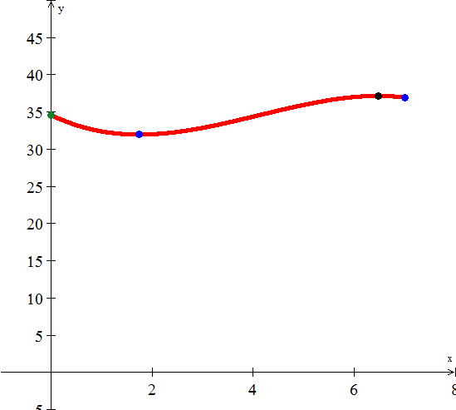

***Exercise Section* 3.3 – Absolute Extrema**

1. Find the absolute extrema of the function on the closed interval 
2. Find the absolute extrema of the function on the closed interval 
3. Find the absolute extrema of the function on the closed interval



1. Find the absolute extrema of the function on the closed interval 
2. Find the absolute extrema of the function on the closed interval 
3.  is an approximation to the total profit (in thousands of dollars) from the sale of *x* hundred thousand tires. Find the number of hundred thousands of tires that must be sold to maximize profit.
4.  is an approximation to the total profit (in thousands of dollars) from the sale of x hundred thousand tires. Find the number of hundred thousands of tires that must be sold to maximize profit.
5. Researchers have discovered that by controlling both the temperature and the relative humidity in a building, the growth of a certain fungus can be limited. The relationship between temperature and relative humidity, which limits growth, can be described by



where  is the relative humidity (in %) and *T* is the temperature (in °C). Find the temperature at which the relative humidity is minimized.

***Section* 3.4 - Concavity and the Second Derivative Test**

***Example***

Find the second derivative of 

*Solution*







**Velocity and acceleration**

***Example***

Suppose a car is moving in a straight line, with its position from a starting point (in feet) at time *t* (in seconds) given by



1. Find the velocity at any time *t*



1. Find the acceleration at any time *t*



1. Find the time intervals  when the car is going forward or backing up





The car is backing up first and forward 

1. Find the time intervals  when the car is speeding up or slowing down

 

|  |  |  |  |
| --- | --- | --- | --- |
| 0 | | | |
|  | − | − | + |
|  | − | + | + |
|  | + | − | − |

***Concavity***

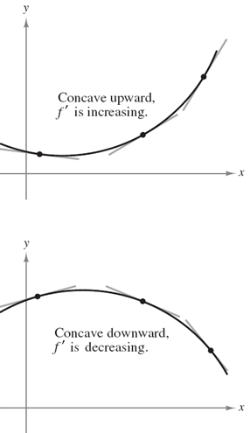***Definition***

Let *f* be differentiable on an open interval *I* . The graph of *f* is

1. **Concave *upward*** on I if is increasing on the interval.
2. **Concave *downward*** on I if is decreasing on the interval.

**Test for Concavity**

Let *f* be function whose second derivative exists on an open interval *I*.

1. If for all *x* in I, then *f*  is ***concave upward*** on I.
2. If  for all *x* in I, then *f* is ***concave downward*** on I.
3. Locate the *x* values @ which  or undefined
4. Use these test *x*-value to determine the test intervals
5. Test the sign of  in each interval

Find the second derivative of  and discuss the concavity of the graph



 for all *x*

*f* is concave downward for all *x*.

***Example***

Determine the intervals on which the graph of the function is concave upward or concave downward.



*Solution*





*Solve for x:*



|  |  |  |
| --- | --- | --- |
| -∞   ∞ | | |
| ***upward*** | ***downward*** | ***upward*** |

*f* is concave upward on 

*f* is concave downward on 

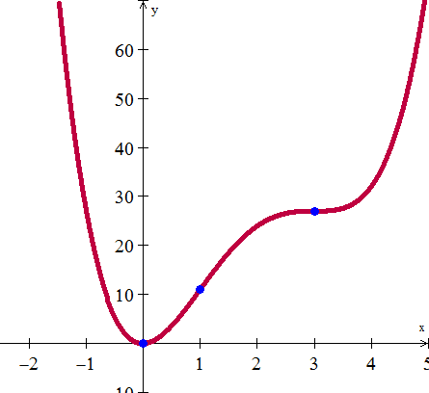

**Second-Derivative Test**

Let  and let  exist ()

1. If ⇒ is a relative Minimum
2. If ⇒ is a relative Maximum
3. If ⇒ Test fails → use  to determine Max, Min.

***Example***

Find all relative extrema for 

*Solution*







 Leads to relative maximum

 Leads to relative minimum

***RMAX***: 

***RMIN***: 

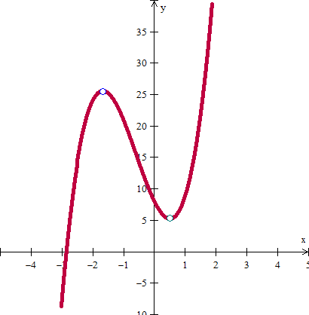

***Point of Inflection***

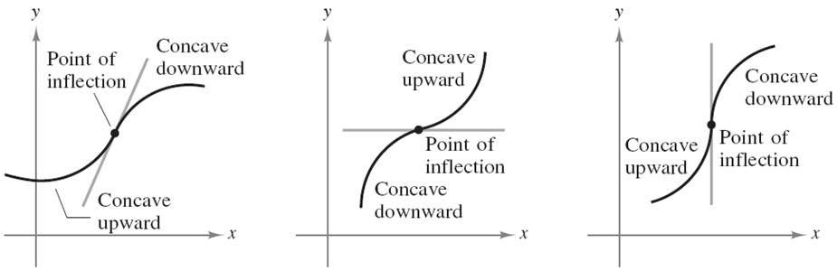

**Definition**

If the graph of a continuous function has a tangent line @ a point where its concavity changes from upward to downward (or down to upward) then the point is a point of inflection.

If  is a point of inflection of a graph of *f* ⇒ either  or undefined.

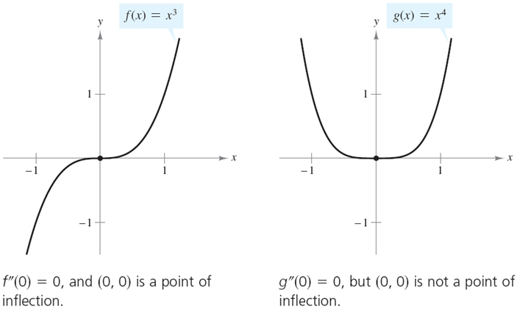

**Extended Applications: Diminishing Returns**

 

***Example***

Find the point of diminishing returns for the model below, where *R* is the revenue (in thousands of dollars) and *x* is the advertising cost (in thousands of dollars).



*Solution*







*x* = 150 (or $150,000) is a ***diminishing point***

An increased investment beyond this point is usually considered a poor use of capital

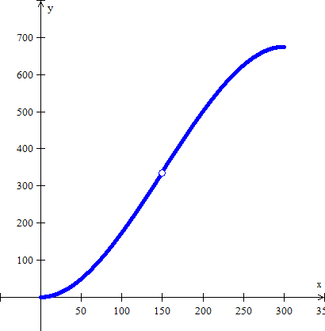

***Exercises Section* 3.4 - Concavity and the Second Derivative Test**

Determine the intervals on which the graph of the function is concave upward or concave downward.

1. 
2. 
3. 
4. Find the largest open interval where the function is concave upward 
5. Find the points of inflection. 
6. Find the second derivative of  and discuss the concavity of the graph
7. Find the extrema using the second derivative test
8. Discuss the concavity of the graph of f and find its points of inflection. 
9. Find all relative extrema of 
10. The revenue *R* generated from sales of a certain product is related to the amount *x* spent on advertising by



Where *x* and *R* are in thousands of dollars. Is there a point of diminishing returns for this function?

1. Find the point of diminishing returns (*x*, *y*) for the function



where represents revenue in thousands of dollars and *x* represents the amount spent on advertising in tens of thousands of dollars.

1. The population of a certain species of fish introduced into a lake is described by the logistic equation



where  is the population after *t* years. Find the point at which the growth rate of this population begins to decline.

***Section* 3.5 - Curve Sketching (*Summary*)**

***Example***

Given 

*Solution*









|  |  |  |  |  |
| --- | --- | --- | --- | --- |
|  |  |  |  |  |
| (-∞, -1) |  | − | + | Decreasing, Concave up |
| *x* = -1 | −32 | 0 | + | Relative Min |
| (-1, 1) |  | + | + | Increasing, Concave up |
| *x* = 1 | −16 | + | 0 | Point of Inflection |
| (1, 3) |  | + | − | Increasing, Concave down |
| *x* = 3 | 0 | 0 | − | Relative Max |
| (3, ∞) |  | − | − | Decreasing, Concave down |

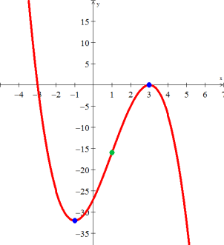

***Example***

Given 

*Solution*

*Vertical Asymptote*: 





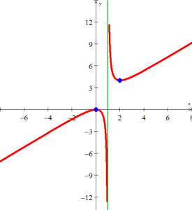 















|  |  |  |  |  |
| --- | --- | --- | --- | --- |
|  |  |  |  |  |
| (-∞, 0) |  | + | − | Increasing, Concave down |
| *x* = 0 | 0 | 0 | − | RMAX |
| (0, 1) |  | − | − | Decreasing, Concave down |
| *x* = 1 | *Undef.* | *Undef.* | *Undef.* | Vertical Asymptote |
| (1, 2) |  | − | + | Decreasing, Concave up |
| *x* = 2 | 4 | 0 | + | RMIN |
| (2, ∞) |  | + | + | Increasing, Concave up |

***Example***

Graph 

*Solution*

Domain: 











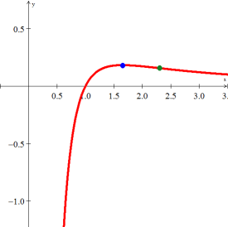 



















|  |  |  |
| --- | --- | --- |
| -∞ 1.65 2.3 ∞ | | |
| *Increasing* | ***Decreasing*** | ***Decreasing*** |
| ***Downward*** | ***Downward*** | ***Upward*** |

***Exercises Section* 3.5 - Curve Sketching**

Graph

1. 
2. 
3. 

***Section* 3.6 – Optimization**

**Maximization**

***Example***

Find two nonnegative numbers *x* and *y* for which , such that  is maximized.

*Solution*























The values that maximize  are 

***Reproduction***

Let

***S***: Number of adults present during the reproductive period.

***R***: Number of adults that return the next season to reproduce.

If , we can presumably harvest



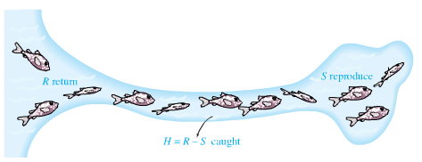

***Example***

Find the maximum sustainable harvest of the given function , where  is measured in thousands

*Solution*









 ***Cross-multiplication***











The maximum sustainable harvest is 12.980 *thousands*

**Optimization in Business and Economics**

To solve problems:

1. Identify all given quantities and all quantities to be determined.
2. Write a primary equation for the quantity that is to be maximized or minimized.
3. Reduce the primary equation to one having a single independent variable.
4. Determine the domain that the values for which the stated problem makes sense.
5. Determine the maximum or minimum value

***Average Cost Function***

To Study the effects of production levels on cost, economist use the average cost function , which is defined as



Where  is the total cost function and *x* the number of units produced.

***Example***

Find the production level that minimizes the average cost per unit for the cost function.

*Solution*













 



 



***Revenue***

Revenue primary equation is given by: , where *x* represent the number of units and *p* the price per unit.

***Example***

Find the price per unit that will maximize the monthly revenue for the business that sells 2000 units of a product per month at a price of $10 each. It can sell only 200 more items per month for each $0.25 reduction in price.

*Solution*

Given: ⇒ (2000, 10)







⇒ (2200, 9.75)

From the 2 points (2000, 10) and (2200, 9.75), Find an equation of a line.



































***Profit***

***P***rofit = ***R***evenue – ***C***ost



***Example***

Find the price that will maximize profit for the demand and cost functions .

*Solution*

































**Economic Lot Size**

Suppose that a company manufactures a constant number of units of a product per year and that the product can be manufactured in several batches of equal size throughout the year.

The number that should be manufactured in each batch in order to minimize the total cost is called the ***economic lot size***.

Let consider the variables:

***x*** = number of batches to be manufactured annually

***q*** = number units to order each time

***k*** = cost of storing one unit of the product for one year,

***f*** = fixed setup cost to manufacture the product,

***g*** = cost of manufacturing a single unit of the product,

***M*** = total number of units produced annually.

The production per batch is  units

Manufacturing cost per batch is: 

Total manufacturing cost is: 

The average inventory is one-half the production per batch:  units/yr.

The cost of storing 1 unit per year is given by *k*, therefore the total storage cost 

Total cost of producing *x* batches: 

To find the value of *x* to minimize : 







∴ The annual number of batches that minimizes total production costs is given by the formula



The number units to order each time are: 



***Example***

A company has an annual demand of 24,500 cans of automobile primer. The comptroller for the company says that it costs $2 to store one can of paint for 1 year and $500 to set up the plant for the production of the primer. Find the number of cans of primer that should be produced in each batch, as well as the number of batches per year, in order to minimize total production costs.

*Solution*

***Given***: 





 ***batches/yr.***

Each batch will consist of  cans of primer.

***Example***

A pharmacy has an annual need for 480 units of a certain antibiotic. It costs $3 to store one unit for one year. The fixed cost of placing an order amounts to $31. Find the number of units to order each time, and how many times a year the antibiotic should be ordered.

*Solution*

***Given***: 





 ***times/yr.***

***Definition of Price Elasticity of Demand***

Drop in price might result in a much greater demand

If  is differentiable function, then the price elastic of demand is given by

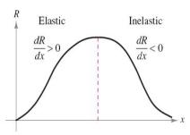 

Where  is the lowercase Greek letter ***eta***. For a given price,

* if ⇒ demand is elastic
* if ⇒ demand is inelastic
* if ⇒ demand is unit elastic

***Example***

Find the intervals on which the demand function , is elastic, inelastic, and of unit elastic

*Solution*

























 

 

 

 

 

 

 

 

 

 

 

, x = 144. So the demand is of unit elastic

, the demand is elastic

, the demand is inelastic

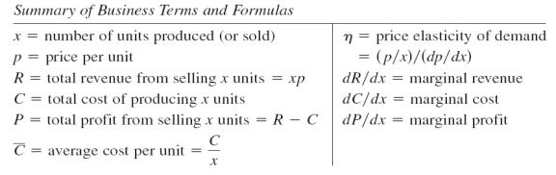

***Exercises*** ***Section* 3.6 – Optimization**

1. The product of two numbers is 72. Minimize the sum of the second number and twice the first number
2. Verify the function  has an absolute maximum when *x* = 6. What is the maximum volume?
3. A net enclosure for golf practice is open at one end. The volume of the enclosure is  cubic meters.
4. Find the dimensions that require the least amount of netting.
5. Find two numbers *x* and *y* such that their sum is 480 and  is maximized.
6. If the price charged for a candy bar is  cents, then x thousand candy bars will be sold in a certain city, where . How many candy bars must be sold to maximize revenue?
7. is an approximation to the number of salmon swimming upstream to spawn, where x represents the water temperature in degrees Celsius. Find the temperature that produces the maximum number of salmon.
8. A company wishes to manufacture a box with a volume of 52 cubic feet that is open on top and is twice as long as it is wide. Find the width of the box that can be produced using the minimum amount of material.
9. A rectangular field is to be enclosed on four sides with a fence. Fencing costs $3 per foot for two opposite sides, and $4 per foot for the other two sides. Find the dimensions of the field of area 730 square feet that would be the cheapest to enclose.
10. A page is to contain 30 square inches of print. The margins at the top and bottom of the page are 2 inches wide. The margins on the sides are 1 inch wide. What dimensions will minimize the amount of paper used?
11. Find the points of  that are closet to (0, 3)
12. A manufacturer wants to design an open box that has a square base and a surface area of 108 in2. What dimensions will produce a box with a maximum volume?
13. Suppose the spawner-recruit function for Idaho rabbits is , where S is measured in thousands of rabbits. Find  and the maximum sustainable harvest, .
14. A company wants to manufacture cylinder aluminum can with a volume 1000*cm*3. What should the radius and height of the can be to minimize the amount of aluminum used?
15. Find the maximum sustainable harvest of the given function , where S is measured in thousands.
16. A rectangular page will contain 54 in2 of print. The margins at the top and bottom of the page are 1.5 *inches* wide. The margins on each side are 1 *inch* wide. What should the dimensions of the page be to minimize the amount of paper used?
17. When a wholesaler sold a product at $40 per unit, sales were 300 units per week. After a price increase of $5, however, the average number of units sold dropped to 275 per week. Assuming that the demand function is linear, what price per unit will yield maximum total revenue?
18. Find the number of units that must be produced to maximize the revenue function. What is the maximum revenue?
19. A manufacturer has a steady demand for 14,112 cases of sugar. It costs $4 to store 1 case for 1 year, $36 in set up cost to produce each batch, and $25 to produce each case. Find the number of cases per batch that should be produced to minimize cost.
20. A restaurant has an annual for 920 bottles of California wine. It costs $2 to store 1 bottle for 1 year and it costs $4 to place a reorder. Find the optimum number of bottles per order.
21. Every year, Dan sells 213,696 cases of Cookie Mix. It costs $1 per year in electricity to store a case, plus he must pay annual warehouse fees of $4 per case for the maximum number of cases he will store. If it costs him $742 to set up a production run, plus $7 per case to manufacture a single case, how many production runs should he have each year to minimize his total costs.
22. A certain company produces potting soil and sells it in 50 lb. nags. Suppose that 100,000 bags are to be produced each year. It costs $6 per year to store a bag of potting soil, and it costs $3,000 to set up the facility to produce a batch of bags. Find the number of bags per batch that should be produced.
23. Find the approximate number of batches (to the nearest whole number) of an item that should be produced annually if 100,000 units are to be made. It costs $3 to store a unit for one year, and it costs $460 to setup the factory to produce each batch.
24. A bookstore has an annual demand for 67,000 copies of a best-selling book. It costs $0.40 to store one copy for one year and it costs $25 to place an order. Find the optimum number of copies per order
25. Find the approximate number of batches (to the nearest whole number of an item that should be produced annually if 170,000 units are to be made. It costs $3 to store a unit for one year, and it costs $520 to set up the factory to produce each batch.
26. The homeowner judges that an area of 800  for the garden is too small and decides to increase the area to 1.250 . What is the minimum cost of building a fence that will enclose a garden with an area of 1,250 ? What are the dimensions of this garden? Assume that the cost of fencing remains unchanged.



Since *x* and *y* represent distances, we know that  and .

1. An office supply company sells *x* permanent markers per year at $*p* per marker. The price-demand equation for these markers is . The total annual cost of manufacturing *x* permanent markers for the office supply company is.
2. What price should the company charge for the markers to maximize revenue?
3. What is the maximum revenue?
4. What is the company’s maximum profit?
5. What should the company charge for each marker, and how many markers should be produced?
6. The government decides to tax the company $2 for each marker produced. Taking into account this additional cost, how many markers should the company manufacture each week to maximize its weekly profit?
7. What is the maximum weekly profit?
8. How much should the company charge for the markers to realize the maximum weekly profit?
9. When a management training company prices its seminar on management techniques at $400 per person, 1,000 people will attend the seminar. The company estimates that for each $5 reduction in price, an additional 20 people will attend the seminar.
10. How much should the company charge for the seminar in order to maximize its revenue?
11. What is the maximum revenue?
12. After additional analysis, the management decides that its estimate of attendance was too high. Its new estimate is that only 10 additional people will attend the seminar for each $5 decrease in price. How much should the company charge for the seminar now in order to maximize revenue?
13. What is the new maximum revenue?
14. A multimedia company anticipates that there will be a demand for 20,000 copies of a certain DVD during the next year. It costs the company $0.50 to store a DVD for one year. Each time it must make additional DVDs, it costs $200 to set up the equipment. How many DVDs should the company make during each production run to minimize its total storage and setup costs?
15. A company manufactures and sells *x* digital cameras per week. The weekly price-demand and cost equations are, respectively:



1. What price should the company charge for the cameras, and how many cameras should be produced to maximize the weekly revenue? What is the maximum revenue?
2. What is the maximum weekly profit? How much should the company charge for the cameras, and how many cameras should be produced to realize the maximum weekly profit?
3. A company manufactures and sells *x* television sets per month. The monthly cost and price-demand equations are:



1. Find the maximum revenue.
2. Find the maximum profit, the production level that will realize the maximum profit, and the price the company should charge for each television set.
3. If the government decides to tax the company $5 for each set it produces, how many sets should the company manufacture each month to maximize the profit? What should the company charge for each set?
4. A university student center sells 1,600 cups of coffee per day at a price of $2.40.
5. A market survey shows that for every $0.05 reduction in price, 50 more cups of coffee will be sold. How much should be the student center charge for a cup of coffee in order to maximize revenue?
6. A different market survey shows that for every $0.10 reduction in the original $2.40 price, 60 more cups of coffee will be sold. Now how much should the student center charge for a cup of coffee in order to maximize revenue?
7. A 300-room hotel in Las Vegas is filled to capacity every night at $80 a room. For each $1 increase in rent, 3 fewer rooms are rented. If each rented room costs $10 to service per day, how much should be the management charge for each room to maximize gross profit? What is the maximum gross profit?
8. A commercial pear grower must decide on the optimum time to have fruit picked and sold. If the pears are picked now, they will bring 30¢ per pound, with each tree yielding an average of 60 pounds of salable pears. If the average yield per tree increases 6 pounds per tree per week for the next 4 weeks, but the price drops 2 ¢ per pound per week, when should the pears be picked to realize the maximum return per tree? What is the maximum return?
9. A pharmacy has a uniform annual demand for 200 bottles of a certain antibiotic. It costs $10 to store one bottle for one year and $40 to place an order. How many times during the year should the pharmacy order the antibiotic in order to minimize the total storage and reorder costs?
10. The cost per hour for fuel to run a train is  dollars, where *v* is the speed of the train in miles per hour. (Note that the cost goes up as the square of the speed.) Other costs, including labor are $300 per hour. How fast should the train travel on a 360-mile trip to minimize the total cost for the trip?
11. A parcel delivery service will deliver a package only if the length plus girth (distance around) does not exceed 108 inches.
12. Find the dimensions of a rectangular box with square ends that satisfies the delivery service’s restriction and has maximum volume. What is the maximum volume?
13. Find the dimensions (radius and height) of a cylinder container that meets the delivery service’s requirement and has maximum volume. What is the maximum volume?

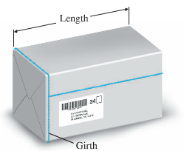

1. The owner of a retail lumber store wants to construct a fence an outdoor storage are adjacent to the store, using all of the store as part of one side of the area. Find the dimensions that will enclose the largest area if
2. 240 feet fencing material are used.
3. 400 feet fencing material are used.

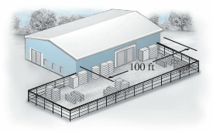

1. Some birds tend to avoid flights over large bodies of water during daylight hours. Suppose that an adult bird with this tendency is taken from its nesting area on the edge of a large lake to an island 5 miles offshore and is then release.
2. 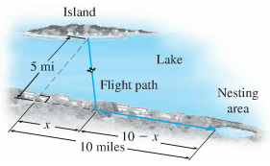If it takes only 1.4 times as much energy to fly over water as land, how far up the shore (*x*, in miles) should the bird head to minimize the total energy expended in returning to the nesting area?
3. If it takes only 1.1 times as much energy to fly over water as land, how far up the shore should the bird head to minimize the total energy expended in returning to the nesting area?
4. A large grocery chain found that, on average, a checker can recall *P*% of a given price list *x* hours after starting work, as given approximately by



At what time x does the checker recall a maximum percentage? What is the maximum?

***Section* 3.7 – Implicit Differentiation and Related Rates**

**Explicit and Implicit Functions**

 is called explicit form, the variable *y* is explicitly written as a function of *x*.

(***Example***: *y* = 3*x* - 5)

***Example***

Find  for the equation 

*Solution*







***Example***

Differentiate each expression with respect to *x*.

1. 

*Solution*



1. 

*Solution*







**Implicit Differentiation**

Consider an equation involving *x* and *y* in which *y* is a differentiable function of *x*. You can use the steps below to find .

1. Differentiate both sides of the equation with respect to *x*.
2. Write the result so that all terms involving  are on the left side of the equation and all other terms are on the right side of the equation.
3. Factor  out of terms if necessary.
4. Solve for .

***Example***

Find  for 

*Solution*















 *Divide every term by 2*



***Example***

Find the slope of the tangent line to the circle  at the point (3, -4)

*Solution*









Slope: 

***Example***

Find the equation of the tangent line to the circle  at the point (2, 4)

*Solution*





















***Example***

The demand function for a certain commodity is given by



Where *p* is the price in dollars and *q* is the demand in hundreds of units. Find the rate of change  of demand with respect to price when .

*Solution*

The rate of change is 











This means when the demand is 10,000 (100), demand is decreasing of the rate of 138.

***Example***

Suppose that *x* and *y* are both functions of *t*, which can be considered to represent time, and that *x* and *y* are related by the equation



Suppose further that when *x* = 2 and *y* = 3, then . Find the value of the  at that moment.

*Solution*











***Example***

A cone-shaped icicle is dripping from the roof. The radius of the icicle is decreasing at a rate of 0.2 cm per hour, while the length is increasing at a rate of 0.8 cm per hour. If the icicle is currently 4 cm in radius and 20 cm long, is the volume of the icicle increasing or decreasing and at what rate?

*Solution*

The volume of the cone is given by the formula: .



Given the values:







The volume is decreasing at a rate of 20 cm3 per hour.

***Exercises*** ***Section* 3.7 – Implicit Differentiation**

1. Find  for the equation 
2. Find : 
3. Find , 
4. Find :  and evaluate the derivative at the given point 
5. Find the slope of the tangent line to the circle  at the point (5, 1)
6. Find the rate of change of *x* with respect to *p*. 
7. The demand function for a product is given by. Find implicitly.