***Lecture Four* − Integration**

***Section* 4.1 – Antiderivatives, Substitution and General Power Rule**

***Antiderivatives***



**Definition of Antiderivative**

A Function *F* is an Antiderivative of a function *f* if for every *x* in the domain of *f*, it follows that



**Notation for Antiderivatives and indefinite integrals**

The notation



where *C* is an arbitrary constant, means that *F* is an Antiderivative of *f*.

That is  for all *x* in the domain of *f*.

 Indefinite integral

Antiderivative

Integrand

Integral sign



Differential

**Basic Integration Rules**











***Example***

Find each indefinite integral.

1. 
2. 
3. 

***Example***

Find indefinite integral. 

*Solution*







***Example***

Find each indefinite integral.

1. 







1. 







***Example***

Find each indefinite integral.

1. 



1. 





***Example***

Find the integral

*Solution*









***Particular Solutions***

In many applications of integrations, we are given enough information to determine a particular solution. To do this, we need to know the value of *F(x)* for one value of *x*. This information is called an initial condition.

***Example***

Find the general solution of , and find the particular solution that satisfies the initial condition *F*(1) = 8.

*Solution*

















***Example***

The marginal cost function for producing *x* units of a product is modeled by



It costs $40 to produce one unit. Find the cost of producing 200 units.

*Solution*





Cost $40 for one unit ⇒ C(*x* = 1) = 40



*K* = 12.01





***General Power Rule***

The Simple Power Rule is given by:



u3



du



**General Power Rule for Integration**

If *u* is a differentiable function of *x*, then



***Example***

Find the indefinite integral. 

*Solution*

Let 





***Example***

Find the indefinite integral. 

*Solution*













***Example***

Evaluate 

*Solution*

 







***Failure of the General Power Rule***

***Example***

Find 

*Solution*

 









***Example***

Find 

*Solution*





 ***Substitute for x and dx***











***Example***

The marginal propensity to consume income *x* can be modeled by 

Where Q represents the income consumed. Estimate the amount by a family of four whose income was $30,000.00, with initial condition of 19,999.

*Solution*



















***Exercises Section* 4.1 – Antiderivatives, Substitution and General Power Rule**

Find each indefinite integral.

1. 
2. 
3. 
4. 
5. 
6. 
7. 
8. 
9. 
10. 
11. 
12. 
13. 
14. 
15. 
16. 
17. 
18. 
19. 
20. 
21. 
22. 
23. 
24. 
25. 
26. Derive the position function if a ball is thrown upward with initial velocity of 32 ft per second from an initial height of 48 ft. When does the ball hit the ground? With what velocity does the ball hit the ground?
27. Suppose a publishing company has found that the marginal cost at a level of production of *x* thousand books is given by



And that the fixed cost (the cost before the first book can be produced) is a $25,000. Find the cost function .

1. If the marginal cost of producing x units of a commodity is given by



And the fixed cost is $2,000, find the cost function  and the cost of producing 20 units.

1. A satellite radio station is launching an aggressive advertising campaign in order to increase the number of daily listeners. The station currently has 27,000 daily listeners, and management expects the number of daily listeners, , to grow at the rate of



Listeners per day, where *t* is the number of days since the campaign began. How long should the campaign last if the station wants the number of daily listeners to grow to 41,000?

1. In 2007, U.S. consumption of renewable energy was 6.8 quadrillion Btu (or  Btu). Since the 1960s, consumption has been growing at a rate (in quadrillion Btu’s per year) given by



Where *t* is years after 1960. Find  and estimate U.S. consumption of renewable energy in 2020.

1. The graph of the marginal revenue function from the sale of *x* sports watches is given in the figure.
2. 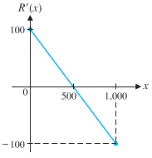Using the graph shown, describe the shape of the graph of the revenue function  as *x* increases from 0 to 1.000.
3. Find the equation of the marginal revenue function. (linear function)
4. Find the equation of the revenue function that satisfies . Graph the revenue function over the interval [0, 1,000]. Check the shape of the graph relative to the analysis in part (*a*).
5. Find the price-demand equation and determine the price when the demand is 700 units.
6. The rate of change of the monthly sales of a newly released football game is given by



Where *t* is the number of months since the game was released and  is the number of games sold each month. Find . When will monthly sales reach 20,000 games?

1. If the rate of labor is given by: 

And if the first 8 control units require 12,000 labor-hours, how many labor-hours, , will be required for the first *x* control units? The first 27 control units?

1. The area *A* of a healing wound changes at a rate given approximately by



Where *t* is time in days and . What will the area of the wound be in 10 days?

1. The marginal revenue (in thousands of dollars) from the sale of *x* gadgets is given by the following function 
2. Find the total revenue function if the revenue from 115 gadgets is $55,581.
3. How many gadgets must be sold for a revenue of at least $50,000.

***Section* 4.2 – Exponential and Logarithmic Integrals**

***Using the Exponential Rule***

Let *u* be a differentiable function of *x*

 *Simple Exponential Rule*



 *General Exponential Rule*

***Example***

Find each indefinite integral.

1. 



1. 

Let *u* = 5*x* → d*u* = 5d*x*





1. 





***Example***

Find indefinite integral 

*Solution*

Let *u* = 2*x* + 3 → d*u* = 2d*x*









***Using the Log Rule***

**Integrals of Logarithmic Functions**

Let *u* be a differentiable function of *x*.

 ***Simple Logarithmic Rule***



 ***General Logarithmic Rule***

***Example***

Find each indefinite integral.

1. 



1. 



1. 

Let 









***Example***

Find the indefinite integral.

*Solution*

Let 









***Exercise Section* 4.2 – Exponential and Logarithmic Integrals**

Find each indefinite integral.

1. 
2. 
3. 
4. 
5. 
6. 
7. 
8. 
9. 
10. 
11. 
12. 
13. 
14. 
15. 
16. 
17. 
18. 
19. 
20. Under certain conditions, the number of diseased cells *N*(*t*) at time *t* increases at a rate , where *A* is the rate of increase at time 0 (in cells per day) and *k* is a constant.
21. Suppose *A* = 60, and at 4 days, the cells are growing at a rate of 180 per day. Find a formula for the number of cells after *t* days, given that 200 cells are present at *t* = 0.
22. Use the answer from part (*a*) to find the number of cells present after 9 days.

***Section* 4.3 – Integration by Parts**

**Integration by Parts**



Let *u* and *v* be differentiable functions of *x*.



**Guidelines for integration by Parts**

1. Let *dv* be the most complicated portion of the integrand that fits a basic integration formula. Let *u* be the remaining factor.
2. Let *u* be the portion of the integrand whose derivative is a function simpler than *u*. Let *dv* be the remaining factor.

***Example***



*Solution*

Let: 











***Example***



*Solution*

Let: 









***Example***

Differentiate  to show that it is the Antiderivative of ln*x*.

*Solution*







**Integration by Parts Repeatedly**

***Example***



*Solution*

Let: 







Let: 









Let: 











***Exercises Section* 4.3 – Integration by Parts**

Find each integral

1. 
2. 
3. 
4. 
5. 
6. 
7. 

***Section* 4.4 – Area and the Fundamental Theorem of Calculus**

**Area and Definite Integrals**

**Definition of a Definite Integral**

Let *f* be nonnegative and continuous on the closed interval [*a, b*]. The area of the region bounded by the graph of *f*, the *x*-axis, and the lines *x* = *a* and *x* = *b* is denoted by

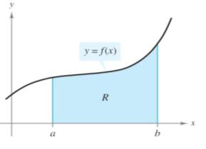



The expression  is called the definite integral from *a* to *b*, where *a* is the ***lower limit of integration*** and *b* is the ***upper limit of integration***.

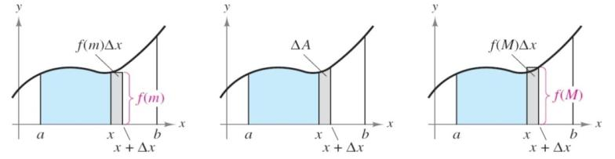

**The Fundamental Theorem of Calculus**

If *f* is nonnegative and continuous on the closed interval [*a, b*], then



Where *F* is any function such that for all *x* in [*a, b*].

**Guidelines for Using the Fundamental Theorems of Calculus**

1. The Fundamental Theorem of Calculus describes a way of evaluating a definite integral, not a procedure for finding anti-derivatives.
2. In applying the Fundamental Theorem, it is helpful to use the notation



1. The constant of integration C can be dropped because









**Properties of Definite Integrals**

Let *f* and *g* be continuous on the closed interval [*a*, *b*].











***Example***

Evaluate: 

*Solution*











***Example***

Find the area of the region bounded by the *x*-axis and the graph of 

*Solution*













***Example***

Evaluate: 

*Solution*















= 68

***Example***

Evaluate:

1. 

*Solution*









1. 

*Solution*







***Example***

Evaluate: 

*Solution*















***Marginal Analysis***

***Example***

The marginal profit for a product is modeled by 

1. Find the change in profit when sales increase from 100 to 101 units.
2. Find the change in profit when sales increase from 100 to 110 units.

*Solution*

1. 





= $14.18

1. 





≈ $141.79

***Average Value***

**Definition of the Average Value of a Definition**

If *f* is continuous on [*a, b*], then the average value of *f* on [*a, b*].

Average Value of *f* on [*a, b*] = 

***Example***

Find the average cost per unit over a two-year period if the cost per unit *c* of roller blades is given by

, for , where *t* is the time in months.

*Solution*

Average cost = 

0





***Even and Odd Function***

**Integration of Even and Odd Functions**

1. If *f* is an *even* function, then 
2. If *f* is an *odd* function, then 

***Example***

Evaluate each definite integral

1. 









1. 



***Annuity***

**Amount of an Annuity**

If ***c*** represents a continuous income function in dollars per year (where ***t*** is the time in years), ***r*** represents the interest rate compounded continuously and **T** represents the term of the annuity in years, then the amount of an annuity is

Amount of an annuity = 

***Example***

If you deposit $1000 in a savings account every year, paying 4% interest, how much will be in the account after 10 years?

*Solution*



Amount of an annuity = 







≈ $ 12,295.62

***Exercise Section* 4.4 – Area and the Fundamental Theorem of Calculus**

Evaluate each integral

1. 
2. 
3. 
4. 
5. 
6. 
7. 
8. 
9. 
10. 
11. 
12. 
13. 
14. A company manufactures *x* HDTVs per month. The monthly marginal profit (in dollars) is given by



The company is currently manufacturing 1,500 HDTVs per month, but is planning to increase production. Find the change in the monthly profit if monthly production is increased to 1,600 HDTVs.

1. An amusement company maintains records for each video game installed in an arcade. Suppose that  and  represent the total accumulated costs and revenues (in thousands of dollars), respectively, *t* years after a particular game has been installed. Suppose also that



The value of *t* for which  is called the ***useful life*** of the game.

1. Find the useful life of the game, to the nearest year.
2. Find the total profit accumulated during the useful life of the game.
3. The total cost (in dollars) of printing x dictionaries is 
4. Find the average cost per unit if 1,000 dictionaries are produced.
5. Find the average value of the cost function over the interval [0, 1,000}
6. Discuss the difference between parts (***a***) and (***b***)
7. If the rate of labor is , then approximately how many labor−hours will be required to assemble the 9th through the 27th.

***Section* 4.5 – Area between Two Curves**

**Area of a Region Bounded by Two Graphs**

If *f* and *g* are continuous on [*a, b*] and fro all *x* in the interval, then the area of the region bounded by the graphs of *f, g, x = a*, and *x = b* is given by



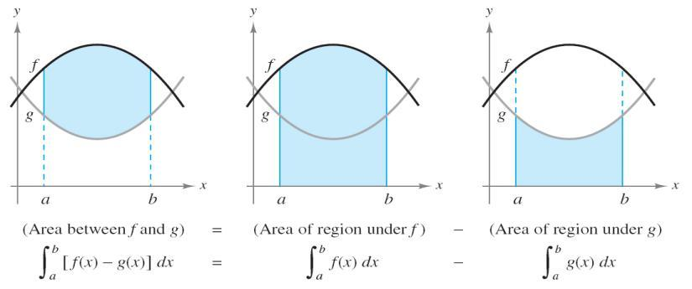

***Example***

Find the area of the region bounded by the graphs of  and  for 

*Solution*











***Example***

Find the area of the region bounded by the graphs of  and 

*Solution*

Determine the intersection between two functions: 





















***Consumer Surplus and Producer Surplus***

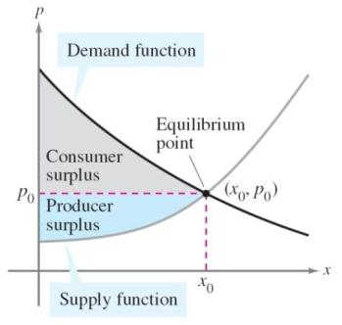

Demand Function: D(*x*)

Supply Function: S(*x*)





***Example***

The Demand and supply functions for a product are modeled by

*Demand*:  and *Supply*: 

Where *x* is the number of units (in millions). Find the consumer and producer surpluses for this product.

*Solution*









Consumer = 









Producer = 









***Example***

The projected fuel cost C (in millions dollars per year) for a trucking company from 2008 through 2020 is , where t = 8 corresponds to 2008. If the company purchases more efficient truck engines, fuel cost is expected to decrease and to follow the model .

How much can the company save with the more efficient engines?

*Solution*

Petroleum saved = 











= $ 39.36 *millions*

***Exercises*** ***Section* 4.5 – Area between Two Curves**

1. Find the area of the region bounded by the graphs of  and *x*-axis
2. Find the area of the region bounded by the graphs of  and 
3. Find the area bounded by , , , and 
4. Find the area between the curves 
5. Find the area of the region bounded by the graphs of  and  on [0, 4].
6. Find the area between the curves 
7. Find the area between the curves 
8. Find the area between the curves 
9. Find the area between the curves 
10. A company is considering a new manufacturing process in one of its plants. The new process provides substantial initial savings, with the savings declining with time *t* (in years) according to the rate-of-savings function



where  is in thousands of dollars per year. At the same time, the cost of operating the new process increases with time *t* (in years), according to the rate-of-cost function (in thousands of dollars per year)



1. For how many years will the company realize savings?
2. What will be the net total savings during this period?
3. Find the producers’ surplus if the supply function for pork bellies is given by



Assume supply and demand are in equilibrium at 

1. Suppose the supply function for concrete is given by



And that supply and demand are in equilibrium at  Find the producers’ surplus.

1. Find the consumers’ surplus if the demand function for grass seed is given by



Assuming supply and demand are in equilibrium at 

1. Find the consumers’ surplus if the demand function for olive oil is given by



And if supply and demand are in equilibrium at 