***Solution Section* 3.1 – Increasing and Decreasing Functions**

***Exercise***

Find the critical numbers and decide on which the function  is increasing or decreasing.

***Solution***









|  |  |
| --- | --- |
| **3 7 ∞** | |
| ***Decreasing*** | ***Increasing*** |











***Increasing***: (7, ∞)

***Decreasing***: (3, 7)

***Exercise***

Find the critical numbers and the open intervals on which the function is increasing or decreasing.



***Solution***





 

Critical numbers are .

|  |  |  |  |
| --- | --- | --- | --- |
| Interval(s) |  |  |  |
| Sign of |  |  |  |
| *Conclusion for* | *decreasing* | *increasing* | *decreasing* |

***Decreasing:*** .

***Increasing:*** .

***Exercise***

Find the critical numbers and the open intervals on which the function is increasing or decreasing.



***Solution***



Critical numbers are *x* = 1, and *x*=-1.

|  |  |  |  |
| --- | --- | --- | --- |
| Interval(s) |  |  |  |
| Sign of |  |  |  |
| *Conclusion for* | *decreasing* | *increasing* | *decreasing* |

***Decreasing:*** .

***Increasing:*** .

***Exercise***

Find the critical numbers and the open intervals on which the function is increasing or decreasing.



***Solution***



Critical numbers are , but the domain is .

|  |  |  |
| --- | --- | --- |
| Interval(s) |  |  |
| Sign of |  |  |
| Conclusion for | decreasing | increasing |

The function is decreasing on 

The function is increasing on 

***Exercise***

Find the open intervals on which the function  is increasing or decreasing

***Solution***









|  |  |
| --- | --- |
| **-∞ -2** | **2 ∞** |
|  | |
| *Increasing Decreasing Increasing* | |

***Increasing***: (-∞, -2) and (2, ∞)

***Decreasing***: (-2, 2)

***Exercise***

Find the open intervals on which the function  is increasing or decreasing

***Solution***







|  |  |
| --- | --- |
| **-∞ 0 ∞** | |
| < 0  *Decreasing* | > 0  *Increasing* |

***Decreasing***: (-∞, 0)

***Increasing***: (0, ∞)

***Exercise***

Find the critical numbers and the open intervals on which the function is increasing or decreasing



***Solution***

|  |  |
| --- | --- |
|  | |
|  |  |







The function is ***increasing***: 

The function is ***decreasing***: 

***Exercise***

A county realty group estimates that the number of housing starts per year over the next three years will be

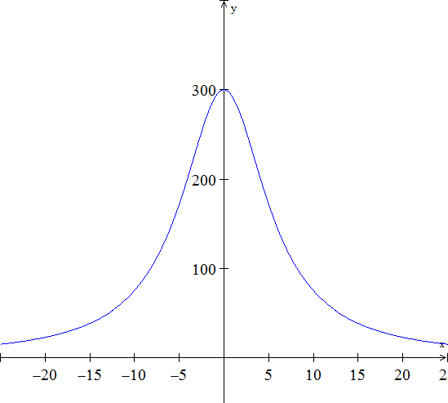

Where *r* is the mortgage rate (in percent).

1. Where is  increasing?
2. Where is  decreasing?

***Solution***







*a*)  is increasing on the interval 

*b*)  is decreasing on the interval 

***Exercise***

Suppose the total cost  to manufacture a quantity *x* of insecticide (in hundreds of liters) is given by . Where is  decreasing?

***Solution***





|  |  |  |
| --- | --- | --- |
| **0 8 10** | | |
|  |  |  |
| ***Increasing*** | ***Decreasing*** | ***Increasing*** |

 is decreasing (8, 10)

***Exercise***

A manufacturer sells telephones with cost function  and revenue function . Determine the interval(s) on which the profit function is increasing.

***Solution***















The profit function is increasing on the interval 

***Exercise***

The cost of a computer system increases with increased processor speeds. The cost *C* of a system as a function of processor speed is estimated as , where *x* is the processor speed in MHz. Determine the intervals where the cost function is decreasing.

***Solution***





|  |  |
| --- | --- |
|  | |
|  |  |
| ***Decreasing*** | ***Increasing*** |

The cost function is decreasing 

***Exercise***

The percent of concentration of a drug in the bloodstream *t* hours after the drug is administered is given by . On what time interval is the concentration of the drug increasing?

***Solution***



 















|  |  |
| --- | --- |
|  | |
|  |  |
| ***Increasing*** | ***Decreasing*** |

The concentration of the drug is increasing over 

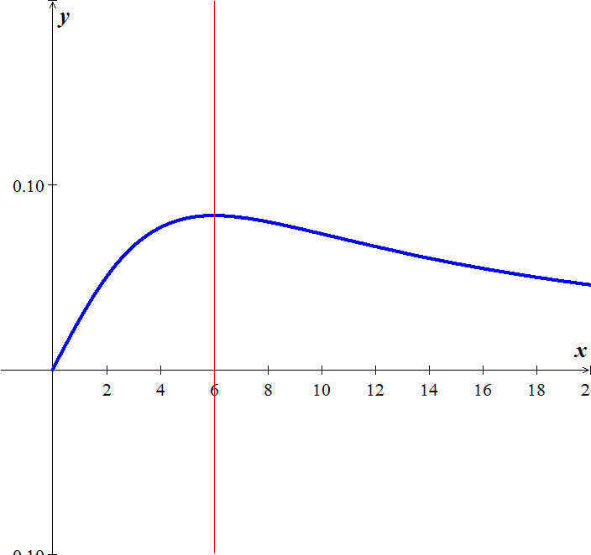 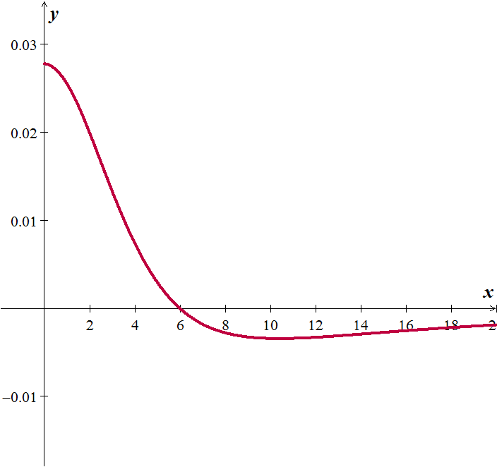

***Exercise***

A probability function is defined by . Give the intervals where the function is increasing and decreasing.

***Solution***







|  |  |
| --- | --- |
|  | |
|  |  |
| ***Increasing*** | ***Decreasing*** |

The function is increasing on  and decreasing on 

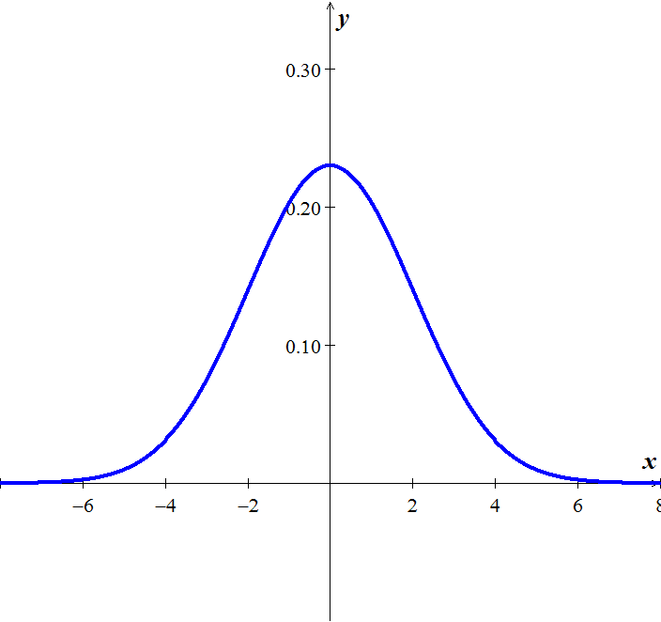

***Solution Section* 3.2 – Extrema and the First-Derivative Test**

***Exercise***

Find all relative extrema of the function 

***Solution***











|  |  |  |
| --- | --- | --- |
| **-∞  1 ∞** | | |
| *Increasing* | *Decreasing* | *Increasing* |

***RMAX***: ;

***RMIN***: 

***Exercise***

Find all relative Extrema of and Find the open intervals on which is increasing or decreasing

***Solution***









|  |  |  |
| --- | --- | --- |
| **-∞ 0 3 ∞** | | |
| < 0  Decreasing | < 0  Decreasing | > 0  Increasing |

**RMIN**: (3, -27);

Decreasing: (-∞, 3); Increasing: (3, ∞)

***Exercise***

Find all relative Extrema of and Find the open intervals on which is increasing or decreasing

***Solution***









 (0, 0) and (1, 1)

|  |  |  |
| --- | --- | --- |
| **-∞ 0 1 ∞** | | |
| > 0  *Increasing* | < 0  *Decreasing* | > 0  *Increasing* |

**RMAX**: (0, 0); **RMIN**: (1, 1);

***Increasing****:*(-∞, 0) and (1, ∞);

***Decreasing***: (0, 1)

***Exercise***

Find all relative Extrema as well as where the function is increasing and decreasing

***Solution***



The critical values are , but the domain of the function is [-2,2]. We can't go outside of that interval to test.

|  |  |  |
| --- | --- | --- |
| Interval(s) |  |  |
| Sign of |  |  |
| Conclusion for | increasing | decreasing |

The function has a RMAX of . Some texts also consider  as RMIN

***Exercise***

Find all relative Extrema as well as where the function is increasing and decreasing

***Solution***



Critical numbers are , but the domain is .

|  |  |  |
| --- | --- | --- |
| Interval(s) |  |  |
| Sign of |  |  |
| Conclusion for | *decreasing* | *increasing* |

The function has a RMIN of .

Some texts may also consider  as a RMAX.

***Exercise***

Find all relative Extrema as well as where the function is increasing and decreasing

***Solution***



Critical numbers are .

|  |  |  |  |
| --- | --- | --- | --- |
| Interval(s) |  |  |  |
| Sign of |  |  |  |
| Conclusion for | *decreasing* | *increasing* | *decreasing* |

The function has a RMIN of .

The function has a RMAX of .

***Exercise***

Find all relative Extrema as well as where the function is increasing and decreasing

***Solution***











|  |  |  |  |
| --- | --- | --- | --- |
| -∞ -2 0 2 ∞ | | | |
|  |  |  |  |
| *decreasing* | *increasing* | *decreasing* | *increasing* |



***Increasing: ***

***Decreasing:*** 

***RMIN:*** 

***RMAX:***  

***Exercise***

Find all relative Extrema as well as where the function is increasing and decreasing

***Solution***









|  |  |
| --- | --- |
| -∞  ∞ | |
|  |  |
| *decreasing* | *increasing* |

***Increasing: ***

***Decreasing:*** 

***RMIN:*** 

***RMAX:***  

***Exercise***

Coughing forces the trachea to contract, which in turn affects the velocity of the air through the trachea. The velocity of the air during coughing can be modeled by:  where *k* is a constant, R is the normal radius of the trachea (also a constant) and *r* is the radius of the trachea during coughing. What radius *r* will produce the maximum air velocity?

***Solution***









A trachea radius of zero minimizes air velocity (duh!). And a radius of 2/3 its normal size maximizes air flow.

***Exercise***

When a telephone wire is hung between two poles, the wire forms a U-shape curve called a Catenary. For instance, the function  models the shape of the telephone wire strung between two poles that are 60 *ft* apart (*x* & *y* are measured in *ft*). Show that the lowest point on the wire is midway between two poles. How much does the wire sag between the two poles?

***Solution***





Find the critical number(s)











⇒*x* = 0







Sag 7.7 *ft*

***Exercise***

The demand function for the product is modeled by where *p* is the price per unit in dollars and *x* is the number of units. What price will yield maximum revenue?

***Solution***



















***Exercise***

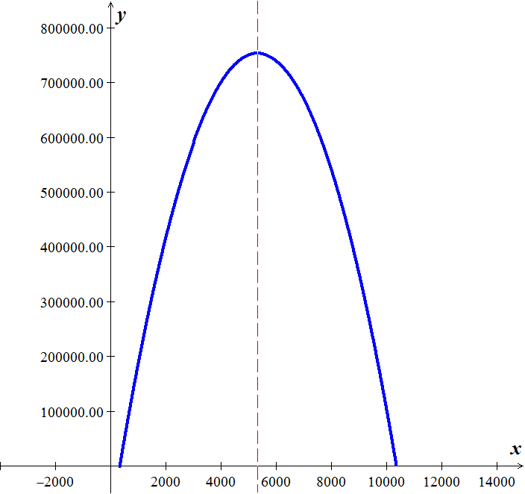The annual revenue and cost functions for a manufacturer of grandfather clocks are approximately  and , where *x* denotes the number of clocks made. What is the maximum annual profit?

***Solution***



















***Exercise***

Find the number of units, *x*, that produces the maximum profit *P*, if  and



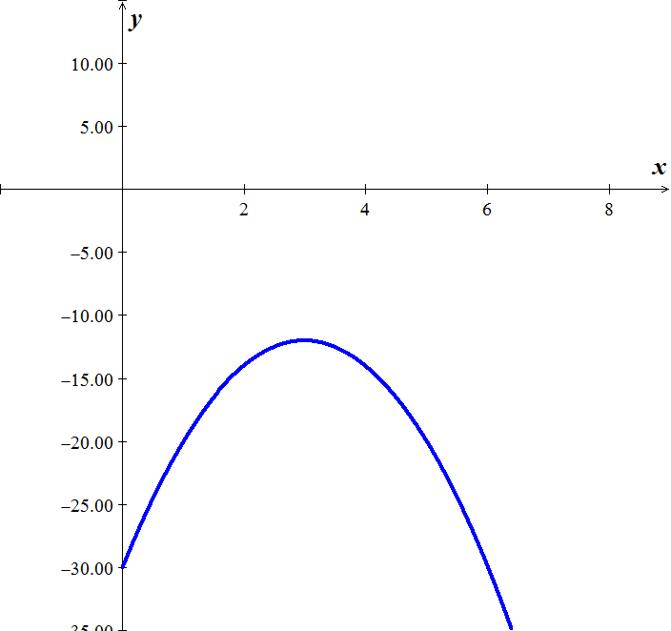***Solution***



















There is no profit.

***Exercise***

 is an approximation to the total profit (in thousands of dollars) from the sale of *x* hundred thousand tires. Find the number of hundred thousands of tires that must be sold to maximize profit.

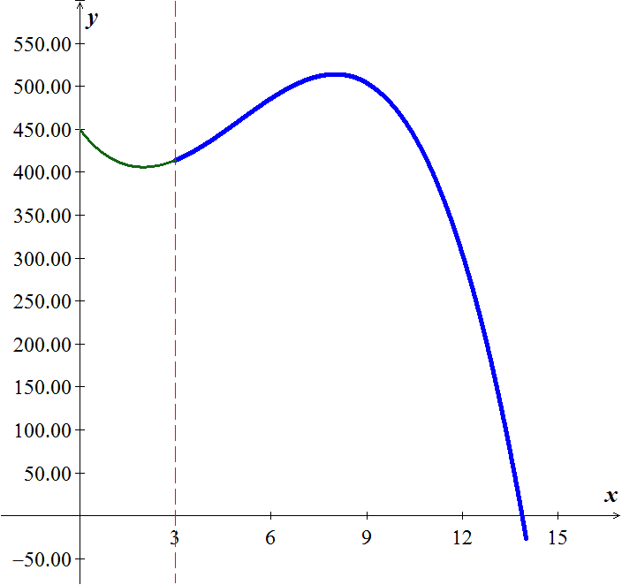***Solution***











The number of tires that must be sold to maximize profit is 800,000 tires

***Exercise***

 is an approximation to the number of salmon swimming upstream to spawn, where *x* represents the water temperature in degrees Celsius. Find the temperature that produces the maximum number of salmon.

***Solution***











12° is the temperature that produces the maximum number of salmon

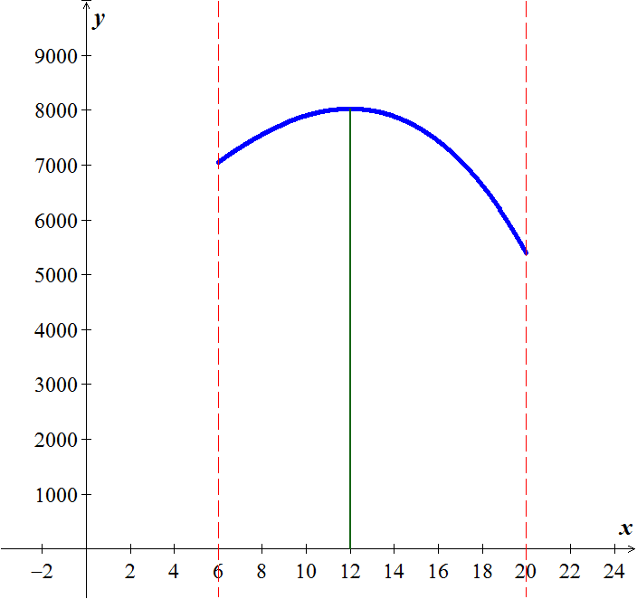

***Solution Section* 3.3 – Absolute Extrema**

***Exercise***

Find the absolute extrema of the function on the closed interval 

***Solution***







***RMAX***: 

***RMIN***: 

***Exercise***

Find the absolute extrema of the function on the closed interval 

***Solution***

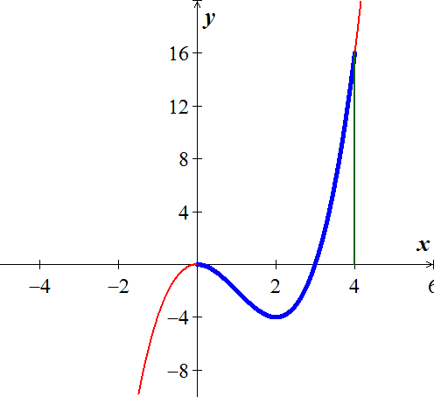









***RMAX***: 

***RMIN***: 

***Exercise***

Find the absolute extrema of the function on the closed interval 

***Solution***

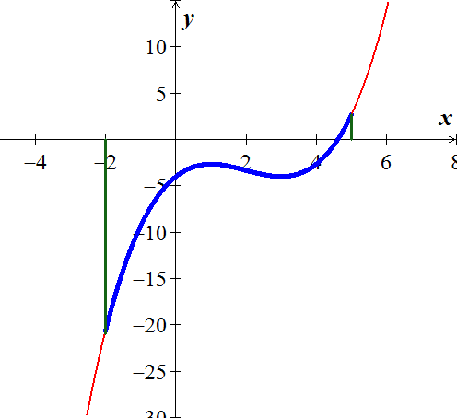











***RMAX***: 

***RMIN***: 

***Exercise***

Find the absolute extrema of the function on the closed interval 

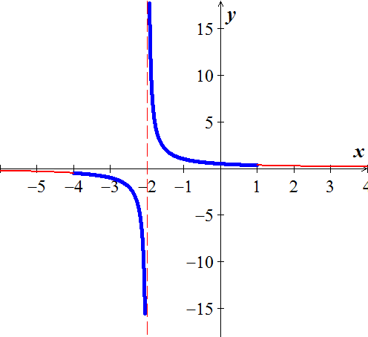***Solution***





There is no Relative Extrema.

***Exercise***

Find the absolute extrema of the function on the closed interval 

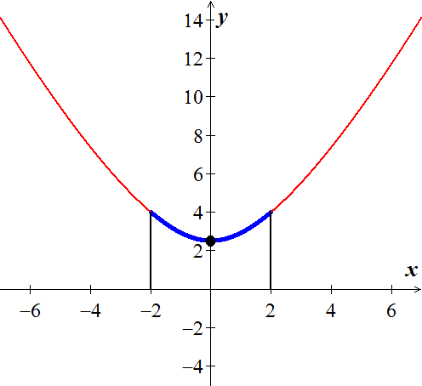***Solution***















***RMAX***: 

***RMIN***: 

***Exercise***

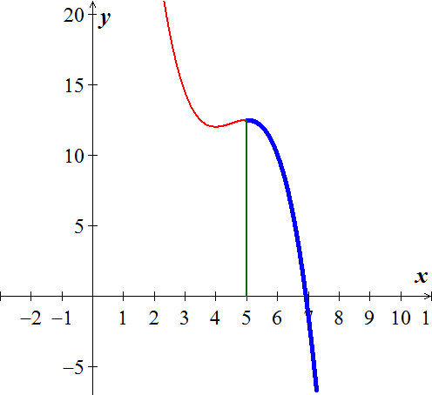 is an approximation to the total profit (in thousands of dollars) from the sale of *x* hundred thousand tires. Find the number of hundred thousands of tires that must be sold to maximize profit.

***Solution***









***Exercise***

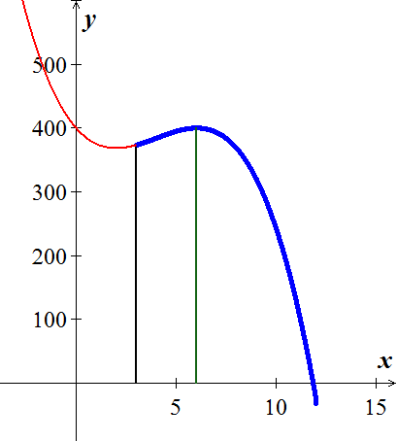 is an approximation to the total profit (in thousands of dollars) from the sale of x hundred thousand tires. Find the number of hundred thousands of tires that must be sold to maximize profit.

***Solution***









***Exercise***

Researchers have discovered that by controlling both the temperature and the relative humidity in a building, the growth of a certain fungus can be limited. The relationship between temperature and relative humidity, which limits growth, can be described by



where  is the relative humidity (in %) and *T* is the temperature (in °C). Find the temperature at which the relative humidity is minimized.

***Solution***











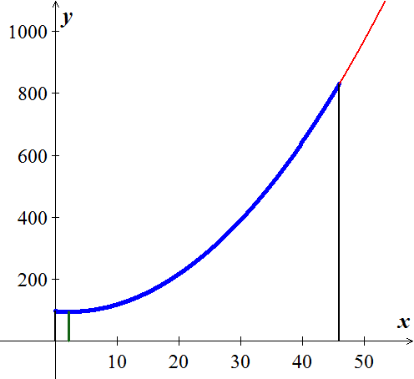

***Solution Section* 3.4 - Concavity and the Second Derivative Test**

***Exercise***

Determine the intervals on which the graph of the function is concave upward or concave downward.



***Solution***

















|  |  |
| --- | --- |
| -∞  ∞ | |
| >0  ***Upward*** | < 0  ***Downward*** |







*f* is concave upward on 

*f* is concave downward on 

***Exercise***

Find the largest open interval where the function is concave upward 

***Solution***





Concave downward on all *x*.

***Exercise***

Find the points of inflection. 

***Solution***







→ Point of inflection (3, 0)

***Exercise***

Find the second derivative of  and discuss the concavity of the graph

***Solution***





 for all *x > 0*

*f* is concave upward for all *x > 0*.

***Exercise***

Determine the intervals on which the graph of the function  is concave upward or concave downward

***Solution***









|  |  |
| --- | --- |
| -∞  ∞ | |
| >0  ***Upward*** | < 0  ***Downward*** |

Concave upward on  and concave downward on 

***Exercise***

Determine the intervals on which the graph of the function  is concave upward or concave downward.

***Solution***

















*Solve for x:*

















|  |  |  |
| --- | --- | --- |
| -∞   ∞ | | |
| > 0  ***upward*** | < 0  ***downward*** | > 0  ***upward*** |

f is concave upward on

*f* is concave downward on 

***Exercise***

Find the extrema using the second derivative test

***Solution***

 CN is *x* = 0



is a relative maximum *(RMAX)*

***Exercise***

Find all relative extrema of 

***Solution***







Points: (0, 1)  Test fails

(3, -26) ⇒ relative Minimum *(RMIN)*

***Exercise***

Discuss the concavity of the graph of f and find its points of inflection. 

***Solution***







For *x* = 0 

For *x* = 0 

|  |  |  |
| --- | --- | --- |
| **-∞ 0 1 ∞** | | |
| > 0  ***upward*** | < 0  ***downward*** | > 0  ***upward*** |

*f* is concave upward on 

*f* is concave downward on 

Points of inflection: (0, 1), (1, 0)

***Exercise***

The revenue *R* generated from sales of a certain product is related to the amount *x* spent on advertising by



Where *x* and *R* are in thousands of dollars. Is there a point of diminishing returns for this function?

**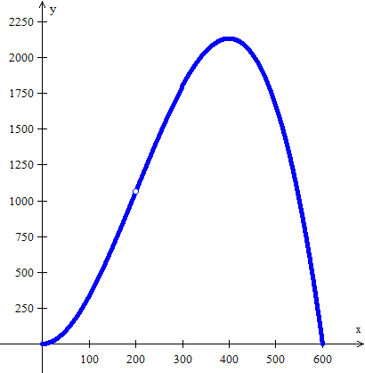*Solution***







*x* = 200 (or $200,000) is a ***diminishing point***

An increased investment beyond this point is usually considered a poor use of capital

***Exercise***

Find the point of diminishing returns (*x*, *y*) for the function



where represents revenue in thousands of dollars and *x* represents the amount spent on advertising in tens of thousands of dollars.

***Solution***













The point of diminishing returns is 

***Exercise***

The population of a certain species of fish introduced into a lake is described by the logistic equation



where  is the population after *t* years. Find the point at which the growth rate of this population begins to decline.

***Solution***

 



























The point at which the growth rate of this population begins to decline: 

***Solution Section* 3.5 - Curve Sketching (*Summary*)**

***Exercise***

Given 

***Solution***













|  |  |  |  |  |
| --- | --- | --- | --- | --- |
|  |  |  |  |  |
| (-∞, 0) |  | - | + | Decreasing, Concave up |
| *x* = 0 | 5 | 0 | 0 | RMAX |
| (0, 2) |  | - | - | Decreasing, Concave down |
| *x* = 2 | -11 | - | 0 | Point of Inflection |
| (2, 3) |  | - | + | Decreasing, Concave up |
| *x* = 3 | -22 | 0 | + | RMIN |
| (3, ∞) |  | + | + | Increasing, Concave up |

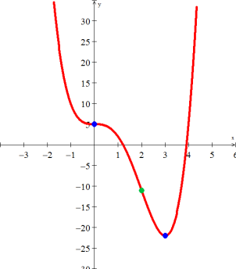

***Exercise***

Given 

***Solution***

**VA**: 

**HA**: 

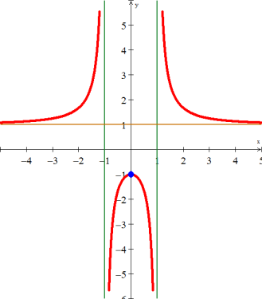





















|  |  |  |  |  |
| --- | --- | --- | --- | --- |
|  |  |  |  |  |
| (-∞, -1) |  | + | - | Increasing, Concave up |
| *x* = -1 | *Undef.* | *Undef.* | *Undef.* | Vertical Asymptote |
| (-1, 0) |  | + | - | Increasing, Concave down |
| *x* = 0 | *-1* | *0* | *-* | RMAX |
| (0, 1) |  | - | - | Decreasing, Concave down |
| *x* = 1 | *Undef.* | *Undef.* | *Undef.* | Vertical Asymptote |
| (1, ∞) |  | - | + | Decreasing, Concave up |

***Exercise***

Given 

***Solution***

















|  |  |  |  |  |
| --- | --- | --- | --- | --- |
| *x* |  |  |  |  |
| (0, 1) |  | - | + | Decreasing, Concave up |
| *x* = 1 | -4 | 0 | *+* | RMIN |
| (1, ∞) |  | + | + | Increasing, Concave up |

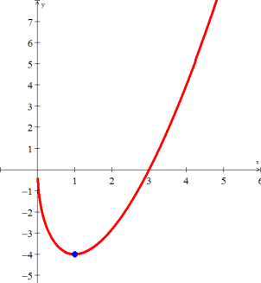

***Solution*** ***Section* 3.6 – Optimization**

***Exercise***

The product of two numbers is 72. Minimize the sum of the second number and twice the first number

***Solution***

 (1)



From (1)

















***Exercise***

Verify the function  has an absolute maximum when *x* = 6. What is the maximum volume?

***Solution***



















 is the maximum volume

***Exercise***

A net enclosure for golf practice is open at one end. The volume of the enclosure is  cubic meters. Find the dimensions that require the least amount of netting.

***Solution***



























***Exercise***

Find two numbers *x* and *y* such that their sum is 480 and  is maximized.

***Solution***

Given: 







*x* = 0, *y* = 320 actually gives a minimum for the function, while the solution that maximizes the function is ***x* = 320, *y* = 160**.

***Exercise***

If the price charged for a candy bar is *p*(*x*) cents, then *x* thousand candy bars will be sold in a certain city, where . How many candy bars must be sold to maximize revenue?

***Solution***

Recall that:





***x* = $820,000** candy bars gives a maximum

***Exercise***

 is an approximation to the number of salmon swimming upstream to spawn, where x represents the water temperature in degrees Celsius. Find the temperature that produces the maximum number of salmon.

***Solution***





Temperature that maximizes the number of salmon is **12** degrees C.

***Exercise***

A company wishes to manufacture a box with a volume of 52 cubic feet that is open on top and is twice as long as it is wide. Find the width of the box that can be produced using the minimum amount of material.

***Solution***

Given: , 

Substituting: 

Surface Area ( 2 long sides, 2 short sides, bottom):

















***Exercise***

A rectangular field is to be enclosed on four sides with a fence. Fencing costs $3 per foot for two opposite sides, and $4 per foot for the other two sides. Find the dimensions of the field of area 730 square feet that would be the cheapest to enclose.

***Solution***



It makes the most sense to let the short sides (w) cost $4 per foot.















***Exercise***

A page is to contain 30 square inches of print. The margins at the top and bottom of the page are 2 inches wide. The margins on the sides are 1 inch wide. What dimensions will minimize the amount of paper used?

***Solution***

Let the dimensions of the original sheet have width *x* and height *y*.

The dimensions of the print area would then be, (*x* - 2) and (*y* - 4) respectively.

Area of the print space: 



Area of the entire page: 



















***Answer***: Approximately 5.9 in. *x* 4.8 in.

***Exercise***

Find the points of  that are closet to (0, 3)

***Solution***



















***Exercise***

A manufacturer wants to design an open box that has a square base and a surface area of 108 in2. What dimensions will produce a box with a maximum volume?

***Solution***



Surface Area (S) = area of base + 4 (area of each side)







































***Exercise***

Suppose the spawner-recruit function for Idaho rabbits is , where S is measured in thousands of rabbits. Find  and the maximum sustainable harvest, .

***Solution***











Using a program: 

***Exercise***

A company wants to manufacture cylinder aluminum can with a volume 1000*cm*3. What should the radius and height of the can be to minimize the amount of aluminum used?

***Solution***





Surface Area 















s



***Exercise***

Find the maximum sustainable harvest of the given function , where S is measured in thousands.

***Solution***









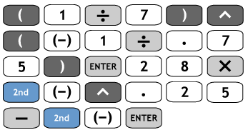





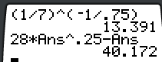 





***Exercise***

A rectangular page will contain 54 in2 of print. The margins at the top and bottom of the page are 1.5 *inches* wide. The margins on each side are 1 *inch* wide. What should the dimensions of the page be to minimize the amount of paper used?

***Solution***



 



















→*x* + 3 = 12

 → y + 2 = 8

***Dimension***: 8 by 12

***Exercise***

When a wholesaler sold a product at $40 per unit, sales were 300 units per week. After a price increase of $5, however, the average number of units sold dropped to 275 per week. Assuming that the demand function is linear, what price per unit will yield maximum total revenue?

***Solution***

 



















Since, *R* is maximum when 

***Exercise***

Find the number of units that must be produced to maximize the revenue function. What is the maximum revenue?

***Solution***



 *Solve for x *

 



125 units to maximize the revenue





***Exercise***

A manufacturer has a steady demand for 14,112 cases of sugar. It costs $4 to store 1 case for 1 year, $36 in set up cost to produce each batch, and $25 to produce each case. Find the number of cases per batch that should be produced to minimize cost.

***Solution***

***Given***: 

Number of cases: 

The manufacturer should produce **504** cases per batch.

***Exercise***

A restaurant has an annual for 920 bottles of California wine. It costs $2 to store 1 bottle for 1 year and it costs $4 to place a reorder. Find the optimum number of bottles per order.

***Solution***

***Given***: 



The optimum number of bottles per order is **61**.

***Exercise***

Every year, Dan sells 213,696 cases of Cookie Mix. It costs $1 per year in electricity to store a case, plus he must pay annual warehouse fees of $4 per case for the maximum number of cases he will store. If it costs him $742 to set up a production run, plus $7 per case to manufacture a single case, how many production runs should he have each year to minimize his total costs/

***Solution***

***Given***: 



The optimum number of runs is **36**.

***Exercise***

A certain company produces potting soil and sells it in 50 lb. nags. Suppose that 100,000 bags are to be produced each year. It costs $6 per year to store a bag of potting soil, and it costs $3,000 to set up the facility to produce a batch of bags. Find the number of bags per batch that should be produced.

***Solution***

***Given***: 



The manufacturer should produce **10,000 bags** per batch.

***Exercise***

Find the approximate number of batches (to the nearest whole number) of an item that should be produced annually if 100,000 units are to be made. It costs $3 to store a unit for one year, and it costs $460 to setup the factory to produce each batch.

***Solution***

***Given***: 



The manufacturer should produce **18 batches**.

***Exercise***

A bookstore has an annual demand for 67,000 copies of a best-selling book. It costs $0.40 to store one copy for one year and it costs $25 to place an order. Find the optimum number of copies per order

***Solution***

***Given***: 



The optimum number of copies per order is **2,894**.

***Exercise***

Find the approximate number of batches (to the nearest whole number of an item that should be produced annually if 170,000 units are to be made. It costs $3 to store a unit for one year, and it costs $520 to set up the factory to produce each batch.

***Solution***

The cost per batch: 520 + 3*x*

Total annual manufacturing cost: 

***Given***: 



The manufacturer should produce 22 batches.

***Exercise***

The homeowner judges that an area of 800  for the garden is too small and decides to increase the area to 1,250 . What is the minimum cost of building a fence that will enclose a garden with an area of 1,250 ? What are the dimensions of this garden? Assume that the cost of fencing remains unchanged.



Since *x* and *y* represent distances, we know that  and .

***Solution***





 ***x* > 0**

 

|  |  |
| --- | --- |
| 0 25 | |
| ***Decreasing*** | ***Increasing*** |

*Solve for* *x*: 





 has a local minimum at .





The minimal cost for enclosing a 1,250  is $400.00, and the dimensions are 25 feet by 50 feet, with one 25-foot side of wood fencing.

***Exercise***

An office supply company sells *x* permanent markers per year at $*p* per marker. The price-demand equation for these markers is . The total annual cost of manufacturing *x* permanent markers for the office supply company is.

1. What price should the company charge for the markers to maximize revenue?
2. What is the maximum revenue?
3. What is the company’s maximum profit?
4. What should the company charge for each marker, and how many markers should be produced?
5. The government decides to tax the company $2 for each marker produced. Taking into account this additional cost, how many markers should the company manufacture each week to maximize its weekly profit?
6. What is the maximum weekly profit?
7. How much should the company charge for the markers to realize the maximum weekly profit?

***Solution***

1. 



|  |  |
| --- | --- |
| 0 5,000 | |
| ***Increasing*** | ***Decreasing*** |









 has a local maximum at .



1. 

The price of a marker should be $5.00 for the company to realize maximum revenue of $25,000.

1. 

|  |  |
| --- | --- |
| 0 4,000 | |
| ***Increasing*** | ***Decreasing*** |













A maximum profit of $11,000 is realized when 4,000 markers are manufactured.

1. 

The company should charge $6.00 per marker to maximize the profit.

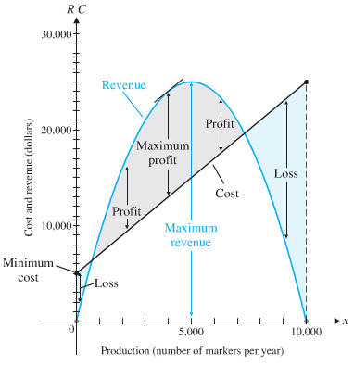

1. The tax of $2 per unit changes the company’s cost equation:

 





The new profit function is:











The company should manufacture 4,000 markers each week to maximize its weekly profit.

1. 

A maximum weekly profit of $4,000 is realized when 4,000 markers are manufactured.

1. 

The company should charge $7.00 per marker to maximize the new profit profit.

The company increases the charge $1.00 per unit with a resulting decrease of $7,000 in maximum profit.

***Exercise***

When a management training company prices its seminar on management techniques at $400 per person, 1,000 people will attend the seminar. The company estimates that for each $5 reduction in price, an additional 20 people will attend the seminar.

1. How much should the company charge for the seminar in order to maximize its revenue?
2. What is the maximum revenue?
3. After additional analysis, the management decides that its estimate of attendance was too high. Its new estimate is that only 10 additional people will attend the seminar for each $5 decrease in price. How much should the company charge for the seminar now in order to maximize revenue?
4. What is the new maximum revenue?

***Solution***

1. Let *x* represent the number of $5 price reductions.

Price per customer = 400 – 5*x*

Number of customers = 1,000 + 20*x*



Since price cannot be negative, then

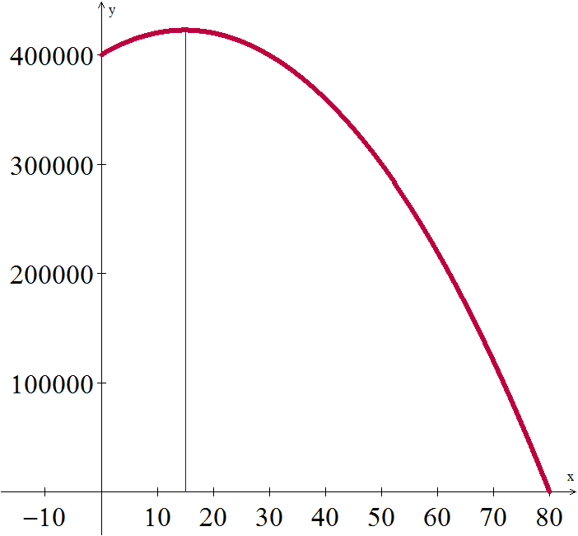 





 









Price per customer 

The company should charge $325.00 for the seminar.

1. 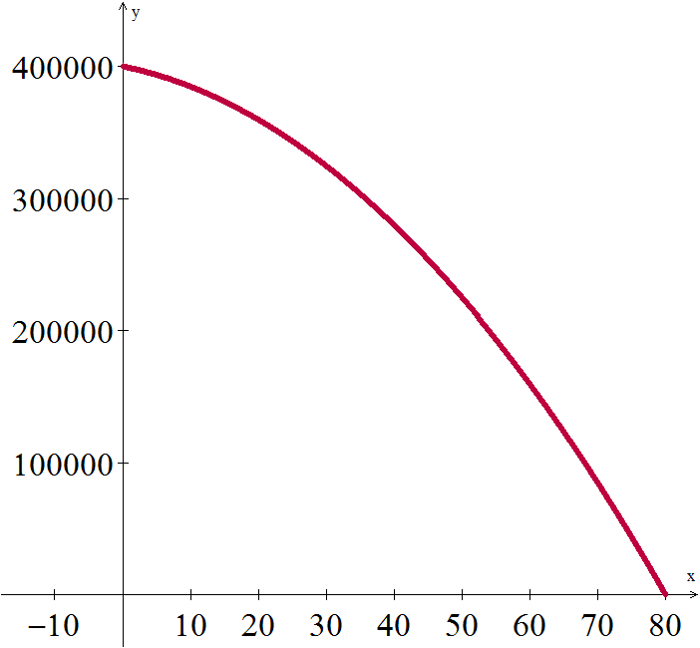



The maximum revenue is $422,500.

1.  









Since x is not in the interval 

Price per customer should be 

1. 



From the graph, it would be better to charge $400 per customer to maximize the revenue of $400,000.00.

***Exercise***

A multimedia company anticipates that there will be a demand for 20,000 copies of a certain DVD during the next year. It costs the company $0.50 to store a DVD for one year. Each time it must make additional DVDs, it costs $200 to set up the equipment. How many DVDs should the company make during each production run to minimize its total storage and setup costs?

***Solution***

Let assume that there are 250 working days and then the daily demand is: 

Let: *x*: number of DVDs manufactured during each production run.

*y*: number of production runs.

The number of DVDs in storage between production runs will decrease from *x* to 0, and the average number in storage each day is .

Since it costs $0.50 to store a DVD for one year, the total storage cost is .

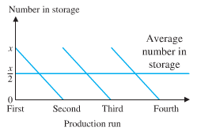The total cost is:

Total cost = setup cost + storage cost



The total number of DVDs produced is *xy*. 



 



|  |  |
| --- | --- |
| 0 4,000 | |
| ***Decreasing*** | ***Increasing*** |











The company will minimize its total cost by making 4,000 DVDs five times during the year.

***Exercise***

A company manufactures and sells *x* digital cameras per week. The weekly price-demand and cost equations are, respectively:



1. What price should the company charge for the cameras, and how many cameras should be produced to maximize the weekly revenue? What is the maximum revenue?
2. What is the maximum weekly profit? How much should the company charge for the cameras, and how many cameras should be produced to realize the maximum weekly profit?

***Solution***

1. *Revenue*: 

|  |  |
| --- | --- |
| 0 500 | |
| ***Increasing*** | ***Decreasing*** |













The maximum revenue is $100,000 when 500 cameras are produced and sold for $200 each.

1. 













The price that the company should charge is $280 to maximize the profit of $34,000.

***Exercise***

A company manufactures and sells *x* television sets per month. The monthly cost and price-demand equations are:



1. Find the maximum revenue.
2. Find the maximum profit, the production level that will realize the maximum profit, and the price the company should charge for each television set.
3. If the government decides to tax the company $5 for each set it produces, how many sets should the company manufacture each month to maximize the profit? What should the company charge for each set?

***Solution***

1. *Revenue*: 



 





 that implies *R* has an absolute maximum.

Maximum revenue: 

1. 











Thus, the maximum profit occurs when 3,500 television sets are produced.

The maximum profit is:



The price that the company should charge is:

 per set.

1. The taxes $5 for each set, then the profit function is given by











Thus, the maximum profit occurs when 3,375 television sets are produced.

The maximum profit is:



The price that the company should charge is:

 per set.

***Exercise***

A university student center sells 1,600 cups of coffee per day at a price of $2.40.

1. A market survey shows that for every $0.05 reduction in price, 50 more cups of coffee will be sold. How much should be the student center charge for a cup of coffee in order to maximize revenue?
2. A different market survey shows that for every $0.10 reduction in the original $2.40 price, 60 more cups of coffee will be sold. Now how much should the student center charge for a cup of coffee in order to maximize revenue?

***Solution***

1. 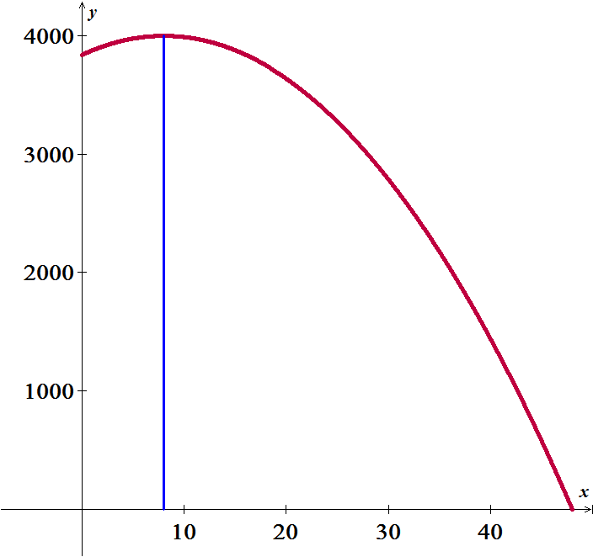Let *x*: number of price reductions

The price of a cup of coffee will be: 

The number of cups sold will be: 

*Revenue*: 









 that implies *R* has an absolute maximum.

Maximum revenue:  when 1,600 cups of coffee sold at the price  per cup.

1. *Revenue*: 







Thus,  is decreasing and its maximum occurs at  they should charge $2.40 per cup.

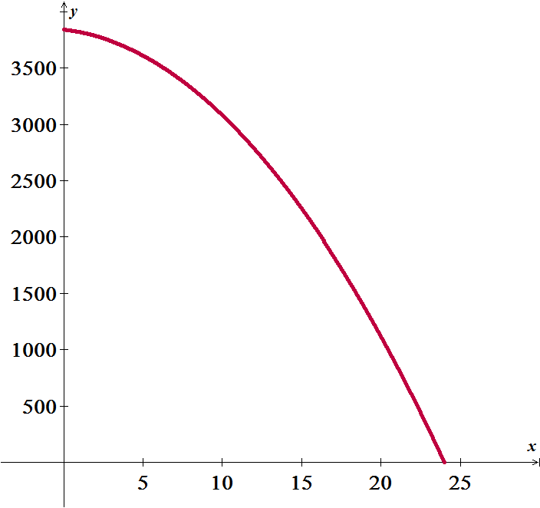

***Exercise***

A 300-room hotel in Las Vegas is filled to capacity every night at $80 a room. For each $1 increase in rent, 3 fewer rooms are rented. If each rented room costs $10 to service per day, how much should be the management charge for each room to maximize gross profit? What is the maximum gross profit?

***Solution***

Let *x*: number of dollar increases in the rate per night.

Total number of rooms rented: 

Rate per night: 

Total income = (total number of rooms rented) (rate − 10)











.

Maximum income: 

The rate per night: 

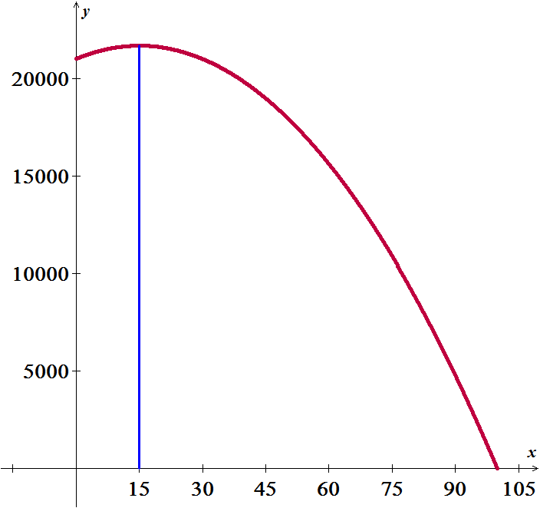

***Exercise***

A commercial pear grower must decide on the optimum time to have fruit picked and sold. If the pears are picked now, they will bring 30¢ per pound, with each tree yielding an average of 60 pounds of salable pears. If the average yield per tree increases 6 pounds per tree per week for the next 4 weeks, but the price drops 2 ¢ per pound per week, when should the pears be picked to realize the maximum return per tree? What is the maximum return?

***Solution***

Let *x*: number of additional weeks the grower waits to pick the pears.

Yield of a pear tree in pounds: 

Price per pound: 

The return will be:





 

Maximum income:  at  weeks.

***Exercise***

A pharmacy has a uniform annual demand for 200 bottles of a certain antibiotic. It costs $10 to store one bottle for one year and $40 to place an order. How many times during the year should the pharmacy order the antibiotic in order to minimize the total storage and reorder costs?

***Solution***

Let *x* be the number of times the pharmacy places order.

Let *y* be the number of demands.

The cost: 

We also have 





  since *x* > 0

 the function has an absolute minimum at 

 is the minimum cost.

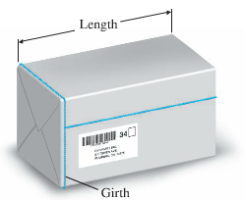***Exercise***

A parcel delivery service will deliver a package only if the length plus girth (distance around) does not exceed 108 inches.

1. Find the dimensions of a rectangular box with square ends that satisfies the delivery service’s restriction and has maximum volume. What is the maximum volume?
2. Find the dimensions (radius and height) of a cylinder container that meets the delivery service’s requirement and has maximum volume. What is the maximum volume?

***Solution***

1. Let *x*: length of the side of the square.



The volume of the box:













Therefore, the volume is maximum at 11,664  for an 18″ by 18″ by 36″ container.

1. Let *x*: radius and L: height of the cylindrical container.



















Therefore, the volume is maximum at 14,851  for a container of radius  and height of 36″.

***Exercise***

The owner of a retail lumber store wants to construct a fence an outdoor storage are adjacent to the store, using all of the store as part of one side of the area. Find the dimensions that will enclose the largest area if

1. 240 feet fencing material are used.
2. 400 feet fencing material are used.

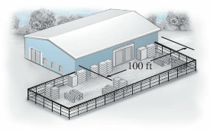

***Solution***

1. Let *x* and *y* be the width and the length of the rectangle respectively.







The area: 



 



 which is not in the domain.





Thus, the maximum occurs when  and 

1. 







 





Thus, the maximum occurs when  and 

***Exercise***

The cost per hour for fuel to run a train is  dollars, where *v* is the speed of the train in miles per hour. (Note that the cost goes up as the square of the speed.) Other costs, including labor are $300 per hour. How fast should the train travel on a 360-mile trip to minimize the total cost for the trip?

***Solution***

*x* = number of hours it take the train to travel 360 miles.

Then 

Cost: 











The cost has an absolute minimum at 



***Exercise***

A large grocery chain found that, on average, a checker can recall *P*% of a given price list *x* hours after starting work, as given approximately by



At what time *x* does the checker recall a maximum percentage? What is the maximum?

***Solution***



  has a local maximum at .







 has its absolute maximum at  with 96%

***Exercise***

Some birds tend to avoid flights over large bodies of water during daylight hours. Suppose that an adult bird with this tendency is taken from its nesting area on the edge of a large lake to an island 5 miles offshore and is then release.

1. If it takes only 1.4 times as much energy to fly over water as land, how far up the shore (*x*, in miles) should the bird head to minimize the total energy expended in returning to the nesting area?
2. If it takes only 1.1 times as much energy to fly over water as land, how far up the shore should the bird head to minimize the total energy expended in returning to the nesting area?

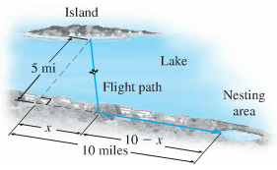

***Solution***

1. Let the energy to fly over land be 1 unit; then the energy to fly over the water is 1.4 units.

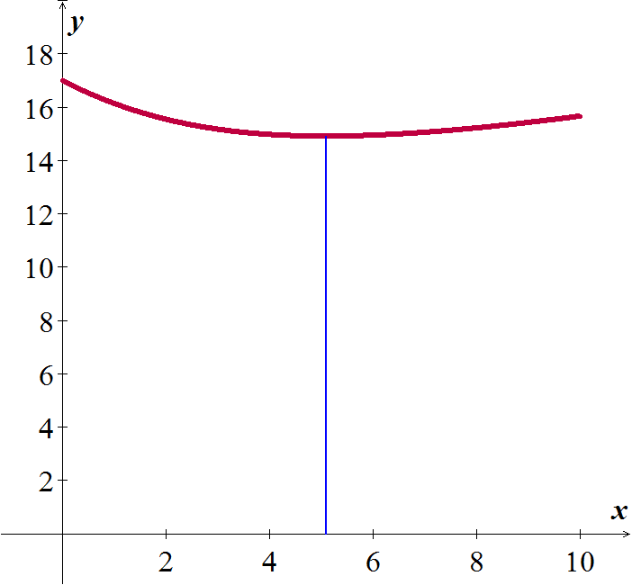

Total Energy:











 

|  |  |
| --- | --- |
| 0 5.1 | |
| ***Decreasing*** | ***Increasing*** |







Thus the critical value is 

Thus, the energy will be minimum when .





Thus, the absolute minimum occurs when  miles.

1.  



 







The critical value 





Therefore, the absolute minimum occurs when 

***Solution Section* 3.7 – Implicit Differentiation and related Rates**

***Exercise***

Find  for the equation 

***Solution***













***Exercise***

Find : 

***Solution***









***Exercise***

Find :  and evaluate the derivative at the given point 

***Solution***















***Exercise***

Find the rate of change of *x* with respect to *p*. 

***Solution***













***Exercise***

Implicit Differentiation: Find , 

***Solution***













***Exercise***

Find the slope of the tangent line to the circle  at the point (5, 1)

***Solution***









***Exercise***

The demand function for a product is given by. Find implicitly.

***Solution***









